Dynamic Stress-Strain investigation

By Adam Mayo
Physics BSc OME (ACAD 4007)
Contents
Notation 3
Table of figures 3
Abstract 4
1. Introduction 5
1.1 Context 5
1.2 What happens when a target is hit? 5
1.3 Laminated armour applications 6
1.4 Equations 7
2. Numerical models 8
2.1 Simulations 8
2.2 Limitations of numerical models 10
3. Results 10
4. Discussion 14
4.1 Results 14
4.2 Failed simulations 16
5. Conclusion 17
6. References 18

Notations
A – Elastic limit
B - characteristic constants of the plastic behaviour
N - characteristic constants of the plastic behaviour
${}_{0}$ – reference strain rate
$ε_{p}$ – plastic strain
${}_{p}$ – plastic strain rate
T – temperature of specimen
$T_{0}$ – initial temperature of specimen
$T_{m}$ – melting temperature of specimen
D₁- D₅ – damage model constants
$σ_{m}$ – mean stress
$σ_{eq}$ – equivalent stress

Table of figures
Figure 1, Hertzian cone shockwaves example. 6
Figure 2, Target Material Layout 8
Figure 3, Target colour coding 8
Figure 4, Simulation 1 Max principal at step 773. 10
Figure 5, Simulation 1 S12 at step 773. 11
Figure 6, Simulation 2 Max Principal at step 784. 11
Figure 7, Simulation 2 S12 at step 784. 12
Figure 8, Simulation 3 Max Principal at step 448. 12
Figure 9, Simulation 3 S12 at step 448. 13
Figure 10, Velocity trace of Simulation 1 13
Figure 11, Velocity trace of Simulation 2 14
Figure 12, Velocity trace of Simulation 3 14
Figure 13, titanium_Ti6Ai4V and plastic target simulation. 16
Figure 14, titanium_Ti6Ai4V with a refined mesh. 17

Abstract
This report compares different fracture energies for reinforced homogeneous armour (RHA); there are three energies the report reviews. The goal of this investigation is to find a suitable value that can be used for future simulations. To achieve this a finite element simulation software was used, where the material behaviour within a laminate target undergoing ballistic penetration was discussed. The laminate target is comprised of a brittle RHA and a plastic material which creates a good anti-ballistic armour that is discussed in this report. The report uses literature surrounding ballistic armour and laminated armour and how the different material layers can help absorb the impact energy of the ballistic. It was seen in the report the laminated target absorbed the impact energy in the intended way.

1. Introduction

1.1 Context
This report was aimed at comparing differing fracture energies of a metal within a metal-plastic laminate target. The fracture energy is the energy required to create a new surface layer in the material [1]. The metal used was RHA, as this armour is in active service the properties of it are restricted, but they were collected from metals that behave similarly, such as AISI-1045. The plastic used was predefined from the assignment brief. By altering the fracture energy of the RHA material, the report is exploring what happens at different fracture energies and to find a value that is a suitable and realistic value to be used in future simulations involving RHA. The report also aims to explore the effects of a target having laminated armour.
The research into these materials allowed a finite element simulation to be conducted. Abaqus Simulations was used for this as it is a proven software for simulating material behaviours [2]. This allows a review of the stress and strain within the target when a bullet impacts at a range of velocities.

1.2 What happens when a target is hit?
The type of impact an armour plate witnesses varies with the munition's design and intention. As the impact velocity may be low (250-500 m/s), or the munition can explosively form a projectile upon the impact of the target causing it to travel at 2+ km/s which causes it to act as a fluid within the target creating a different design challenge of the armour. Because of these variations in impacts armour is normally designed for what it is expected to witness. This report will focus on low impact velocity projectiles (500 m/s) in the form of bullets.
When a low-velocity projectile impacts a target, it causes the kinetic energy of the projectile to be transferred into the target, in the form of direct stress and shear stress. This causes stress waves to propagate through the material in an inverse cone which is referred to as a Hertzian cone [3]. However due to the armour being laminated this material behaviour only occurs within brittle materials, therefore the RHA will carry this out, but the plastic layers sandwiched between the RHA will not. Therefore, the shockwave will reflect off the plastic layers and will cause complex shockwave reactions within the RHA. The stress at the start of the simulation will be at its lowest.
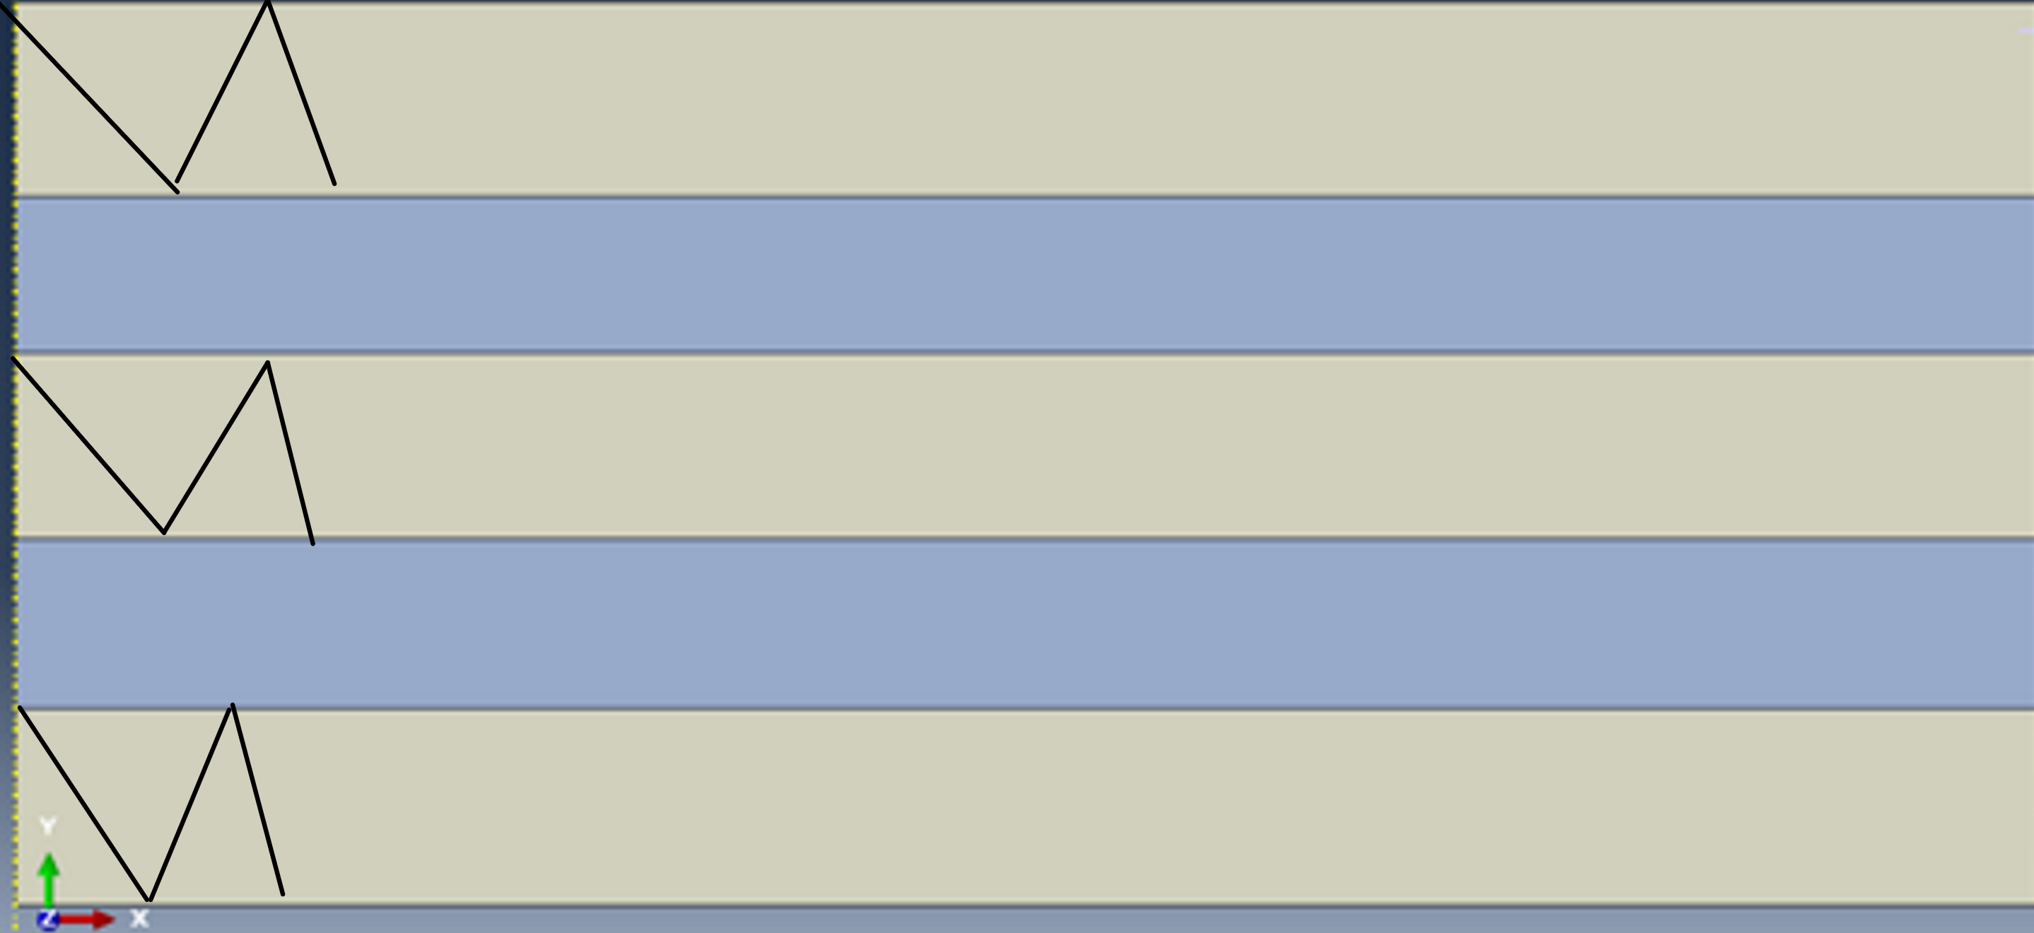
Figure 1, Hertzian cone shockwaves example.
With time progressing the strain will increase from more stress, leading to stretching of the materials. Until the atoms within the RHA will reach their fracture energies causing element deletion. The target may also experience delamination [4] of the material layers are they are subject to high stretching from the bullet. Adiabatic shear failure [5], is a mechanism of failure that occurs in metals, meaning an absence of heat transfer from its point of origin. When a large strain occurs in a small volume of material in a short period of time, the heat generated through plastic deformation does not have time to be conducted away. This causes shear bands to form and requires less energy for penetration to occur.
The plastic material will fail at lower stresses caused by the stretching of the RHA layers above before they reach their fracture energy.

1.3 Laminated armour applications
Armour is designed with the main intention of absorbing impact energy by dissipating it through the armour [6] and protecting contained or surrounding personnel. Armour can be used on aircraft to protect the fuselage or on an Armour fighting vehicle like tanks or personal carriers. Armour can also be seen to protect equipment exposed to ballistic threats or in the form of bullet-resistant glass, to protect people within a vehicle. Laminated body armour [4] is efficient as it provides the highest protection to weight ratio, which is a common problem for personal body armour and vehicle efficiency.

1.4 Equations
It is important to have an understanding of the effect of material properties when impacted by a ballistic bullet. In the majority of material modelling research Johnson-Cook (JC) material and damage models are widely used as they can generate equivalent plastic stress-strain curves in high rates of deformation. It has been proven by numerous research that JC provides a good agreement between physical and experimental data [7] .

Where A is the elastic limit, B and n are the characteristic constants of the plastic behaviour, C is the sensitivity to the strain rate, ${}_{0}$ is the reference strain rate (normally accepted as 1), $ε_{p}$ and ${}_{p}$ are the plastic strain and plastic strain rate respectively, T, $T_{a}$ and $T_{f}$ .

$$σ=\left[A+BƐ^{n}\right]\left[1+C\ln{(\frac{\dot{Ɛ}}{\dot{Ɛ_{0}}}}\right)][1-{\left(\frac{T-T_{0}}{T_{m}-T_{0}}\right)}^{m}]$$
Equation 1, Johnson-Cook equation [8]

The Johnson-Cook damage equation shows the equivalent plastic strain meaning. Johnson and Cook stated the idea that fracture strain depends on the stress triaxiality ratio, strain rate and temperature. In the equation below D₁ to D₅ are the damage model constants, $σ_{m}$ is the mean stress and $σ_{eq}$ is the equivalent of stress.

$$Ɛ_{f}^{pl}=\left[D_{1}+D_{2}\exp\left(D_{3}\left(\frac{σ_{m}}{σ_{eq}}\right)\right)\right][1+D_{4}ln⁡({\frac{\dot{\overline{Ɛ^{pl}}}}{\dot{\overline{Ɛ_{0}^{pl}}}})]}[1+D_{5}T^{*}]$$
Equation 2, Johnson-Cook damage equation [9]

2. Numerical models

2.1 Simulations
For this investigation, 3 laminate targets were made in ABAQUS, a computer simulation software that allows finite element modelling. The targets were comprised of RHA and plastic which were layered and acted like a laminate target for a steel bullet to impact. However, the three targets had differing RHA fracture energy values.
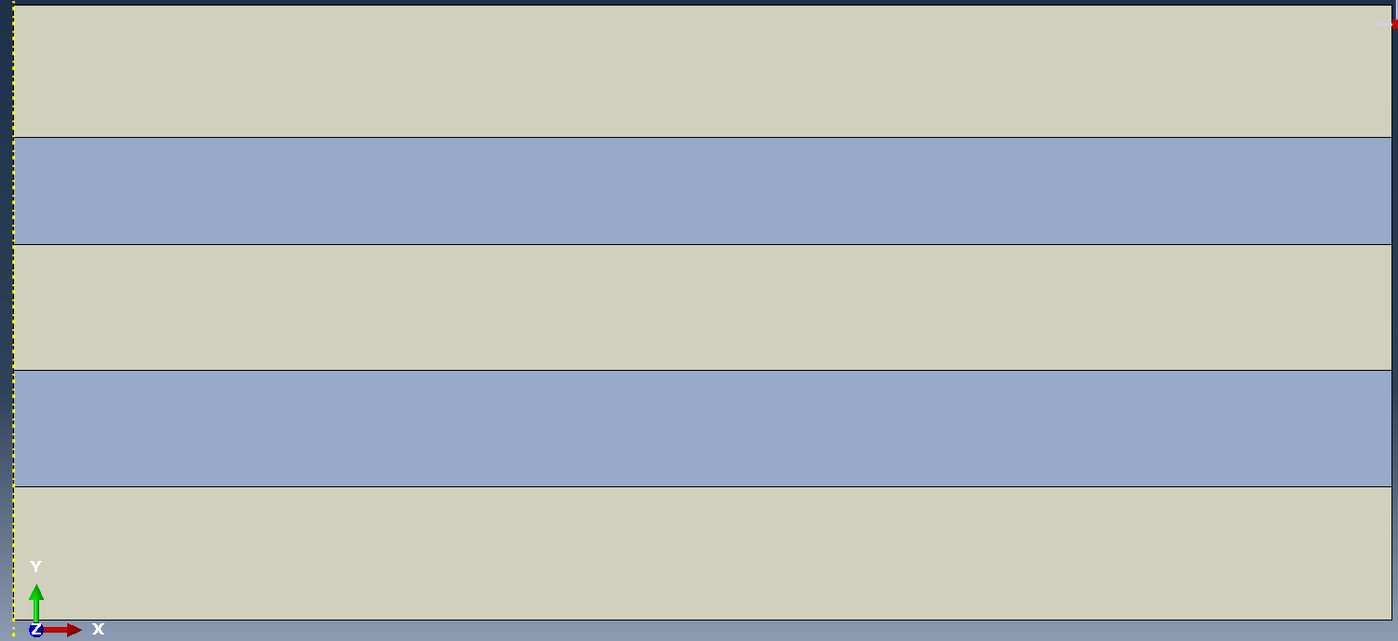
Figure 2, Target Material Layout
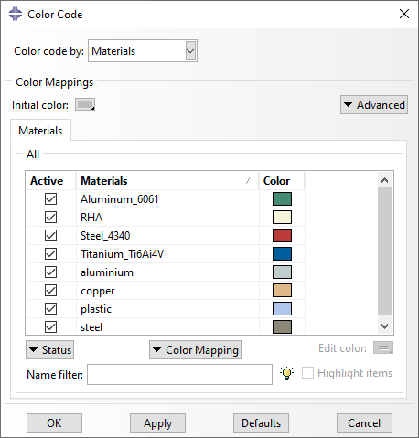
Figure 3, Target colour coding
The following data was used to model the relative materials:
Table 1, Johnson-Cook material parameters. [10]
Material | A (MPa) | B (MPa) | n | m | Melting Temperature | Transition Temperature
Plastic | 20000000 | 20 | 0.9 | 1 | 2000 | 1000
AISI-1045 (RHA) | 1832 | 1685 | 0.754 | 0.8 | 1783 | 1583

Table 2, Johnson-Cook Damage properties [11]
Material | d1 | d2 | d3 | d4 | d5 | Melting Temperature | Transition Temperature
Plastic | 0.8 | 0 | 0 | 0 | 0 | 2000 | 1000
AISI-1045 (RHA) | 0.04 | 1.519 | -6.905 | -0.023 | 1.302 | 1783 | 1583

Many ballistics papers have used the Johnson-Cook and Johnson-Cook damage models [2] [11] [12]. However, the biggest challenge it presents is how to gather these material properties. As previously discussed, RHA can be compared to like materials such as AISI-1045 steel. It was also necessary to make an assumption of the transition temperature of AISI-1045 was assumed to be 200°C lower than the researched melting temperature.

The bullet used in the simulations was travelling at a velocity of 500 m/s. But the bullet did not have a mesh or material models which would have made the simulation more realistic but the investigation focused on the target, not the bullet. The lack of a mesh meant the target witnessed more stress as no energy was being used for bullet deformation.

The target was constrained in place along the non-impact side to simulate a longer target without needing the calculations to simulate this, which saves time. A mixture of coarse and fine mesh was used due to areas of elements of interest.

Table 3, List of simulations
Simulation n° | RHA Fracture Energy
1 | 80e03
2 | 80e04
3 | 80e09

The simulations comprised of the above RHA fracture energy values. Once the simulations were complete the data was analysed looking into the max principal stress and the S12 shear stress in the XY plane, which show the direct and shear stresses within the target.

2.2 Limitations of numerical models
The purpose of simulations is to accurately recreate/perform physical experiments. However, simulations vary in accuracy due to many factors including how advanced the software is and the number of factors and calculations included in its simulations. It can be further improved by the use of a finer mesh meaning more elements/ data points, as well as reducing the noise in some graphs. This would draw much more time and processing power.
The deletion of elements as they reach their failure energy allows the simulation to run. However, the simulations should consider the conservation of mass, which states mass/ energy can neither be created nor destroyed. Implying that when the armour reaches its fracture energy it changes states from a solid to a gas state. Which may cause more stress within the material generated thermally.

3. Results
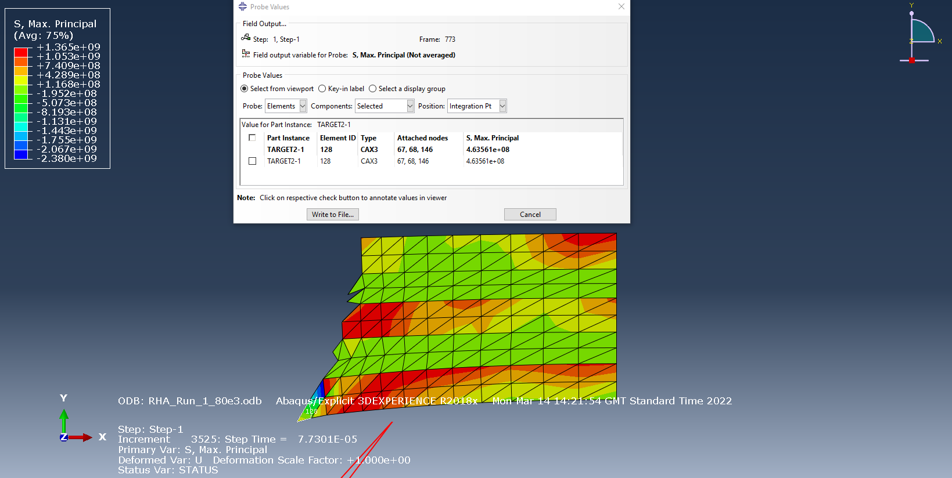
Figure 4, Simulation 1 Max principal at step 773.
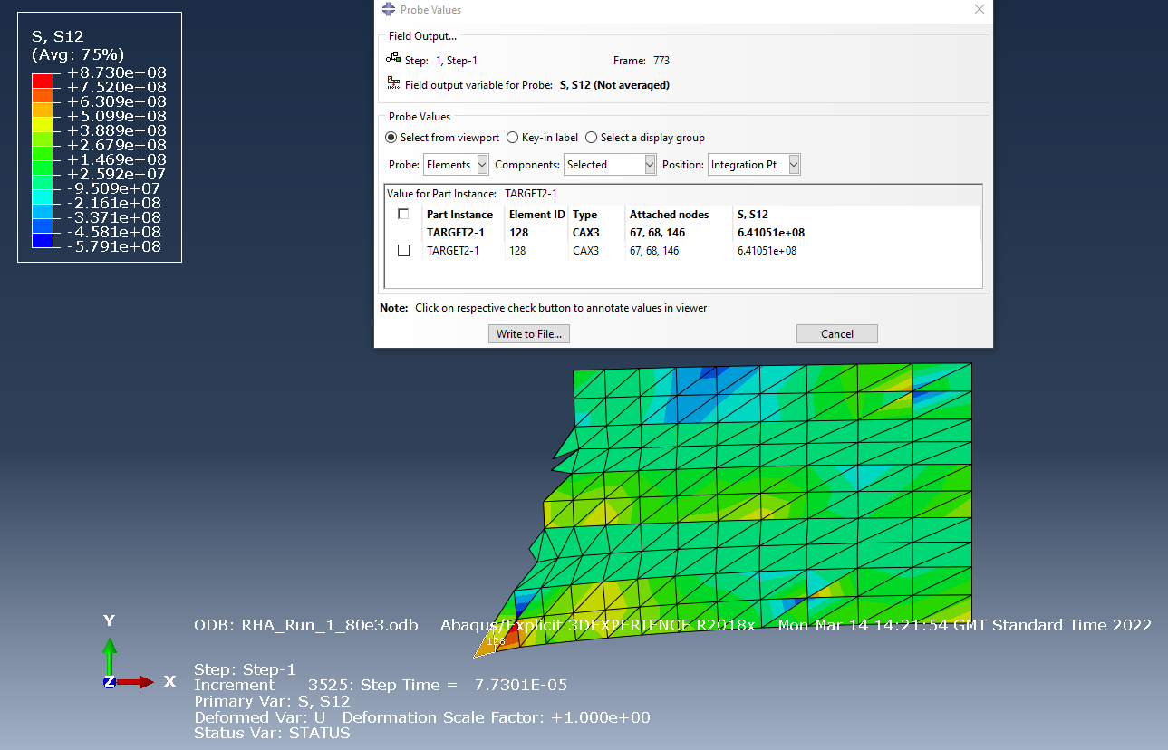
Figure 5, Simulation 1 S12 at step 773.
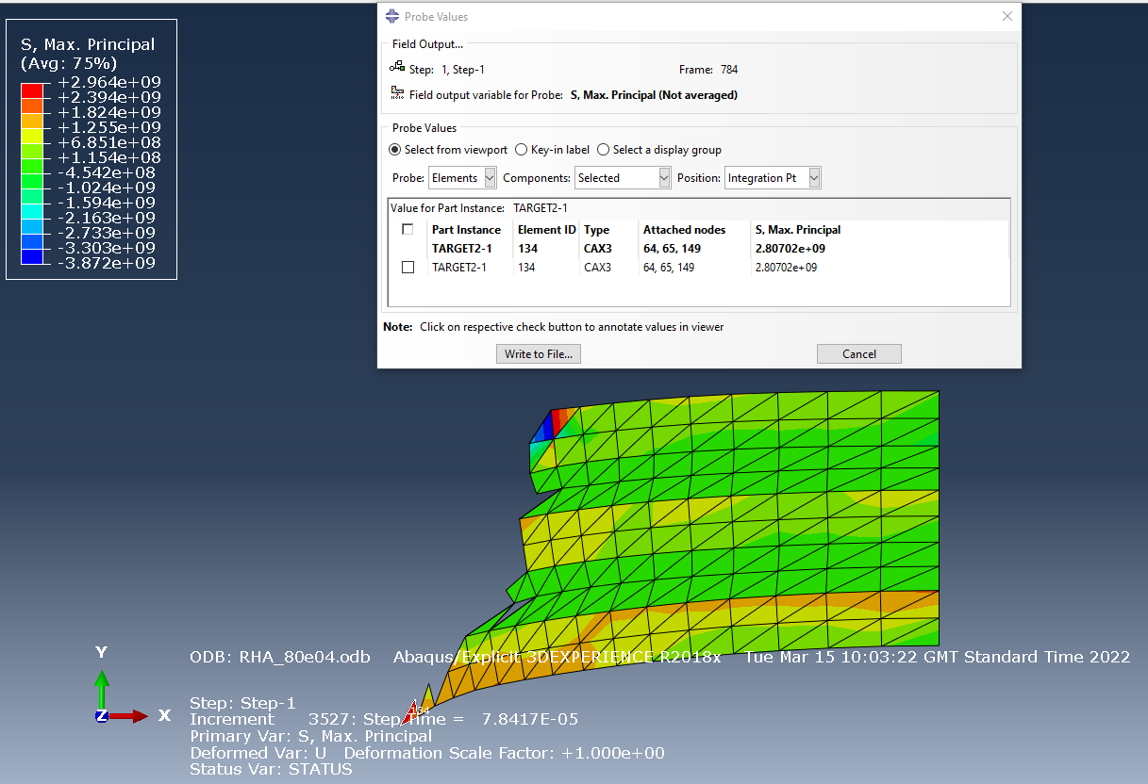
Figure 6, Simulation 2 Max Principal at step 784.
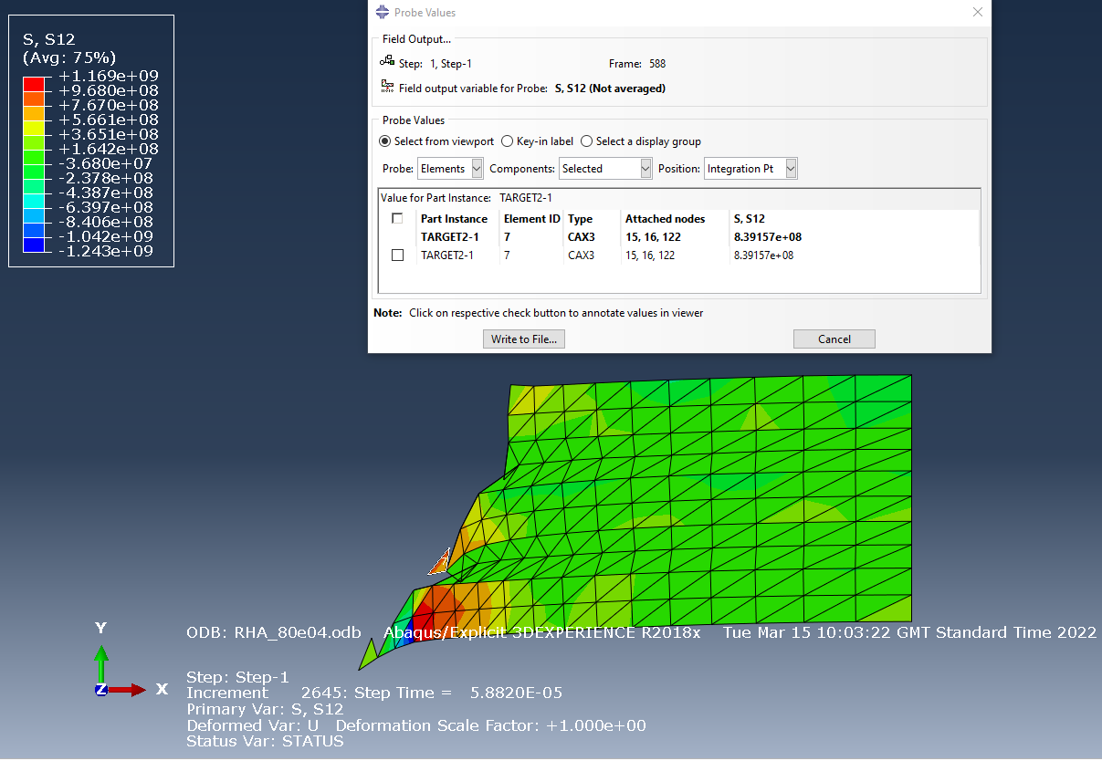
Figure 7, Simulation 2 S12 at step 784.
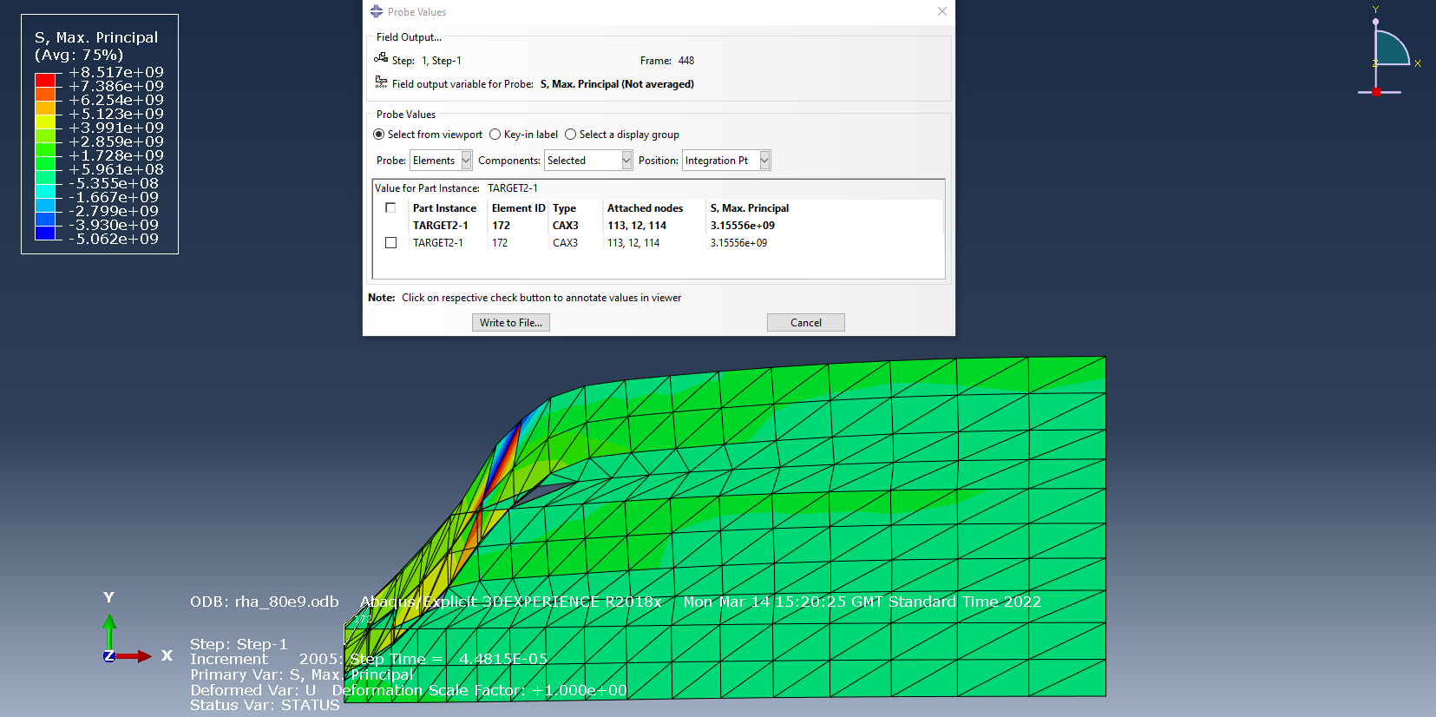
Figure 8, Simulation 3 Max Principal at step 448.
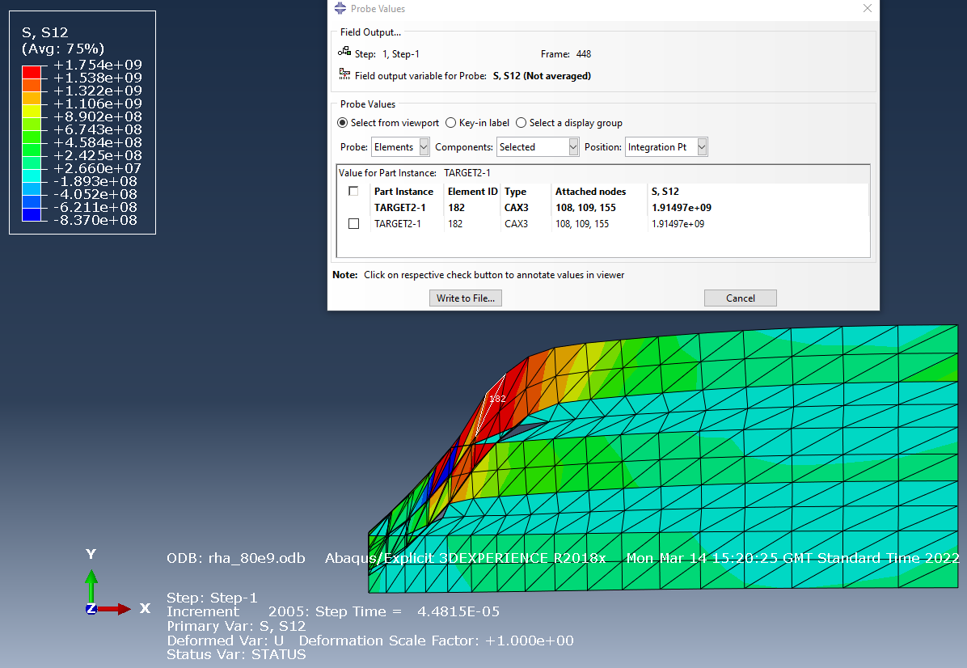
Figure 9, Simulation 3 S12 at step 448.
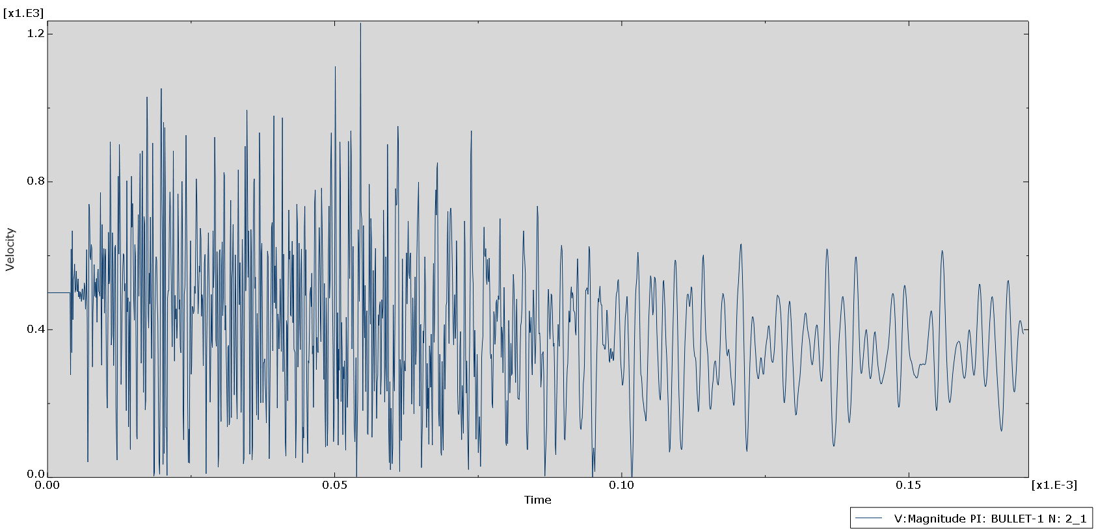
Figure 10, Velocity trace of Simulation 1

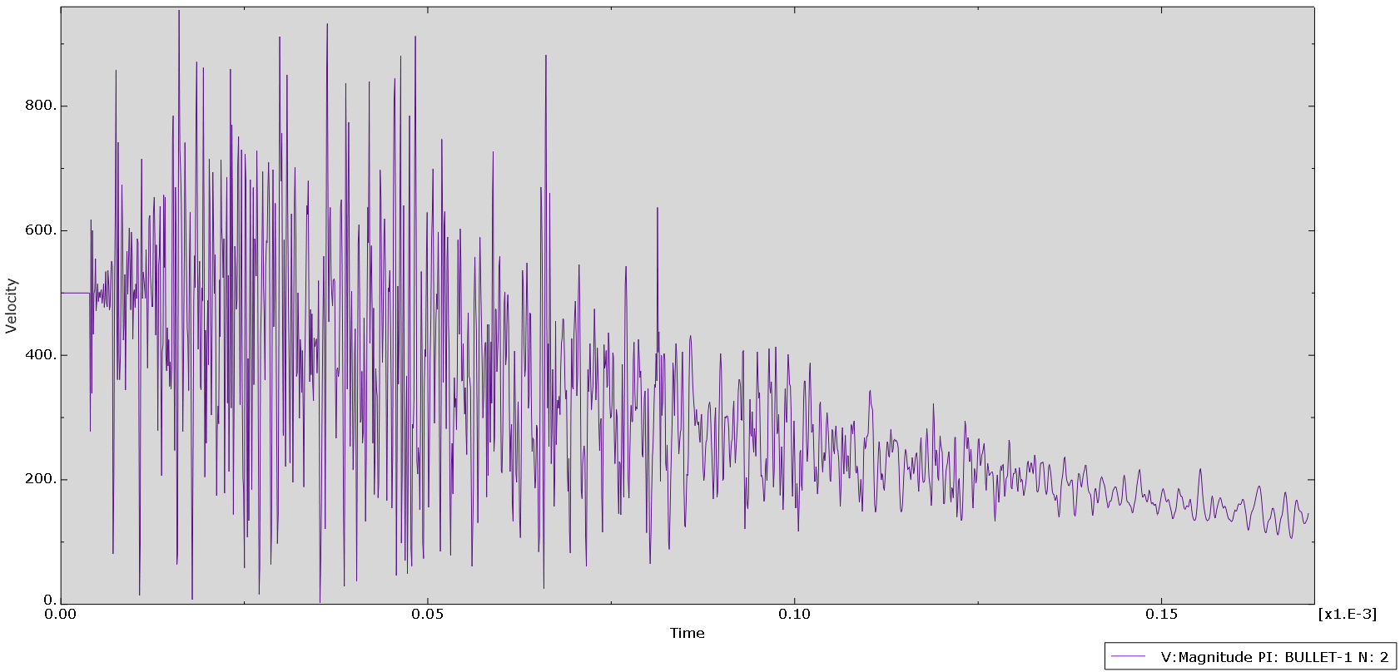
Figure 11, Velocity trace of Simulation 2
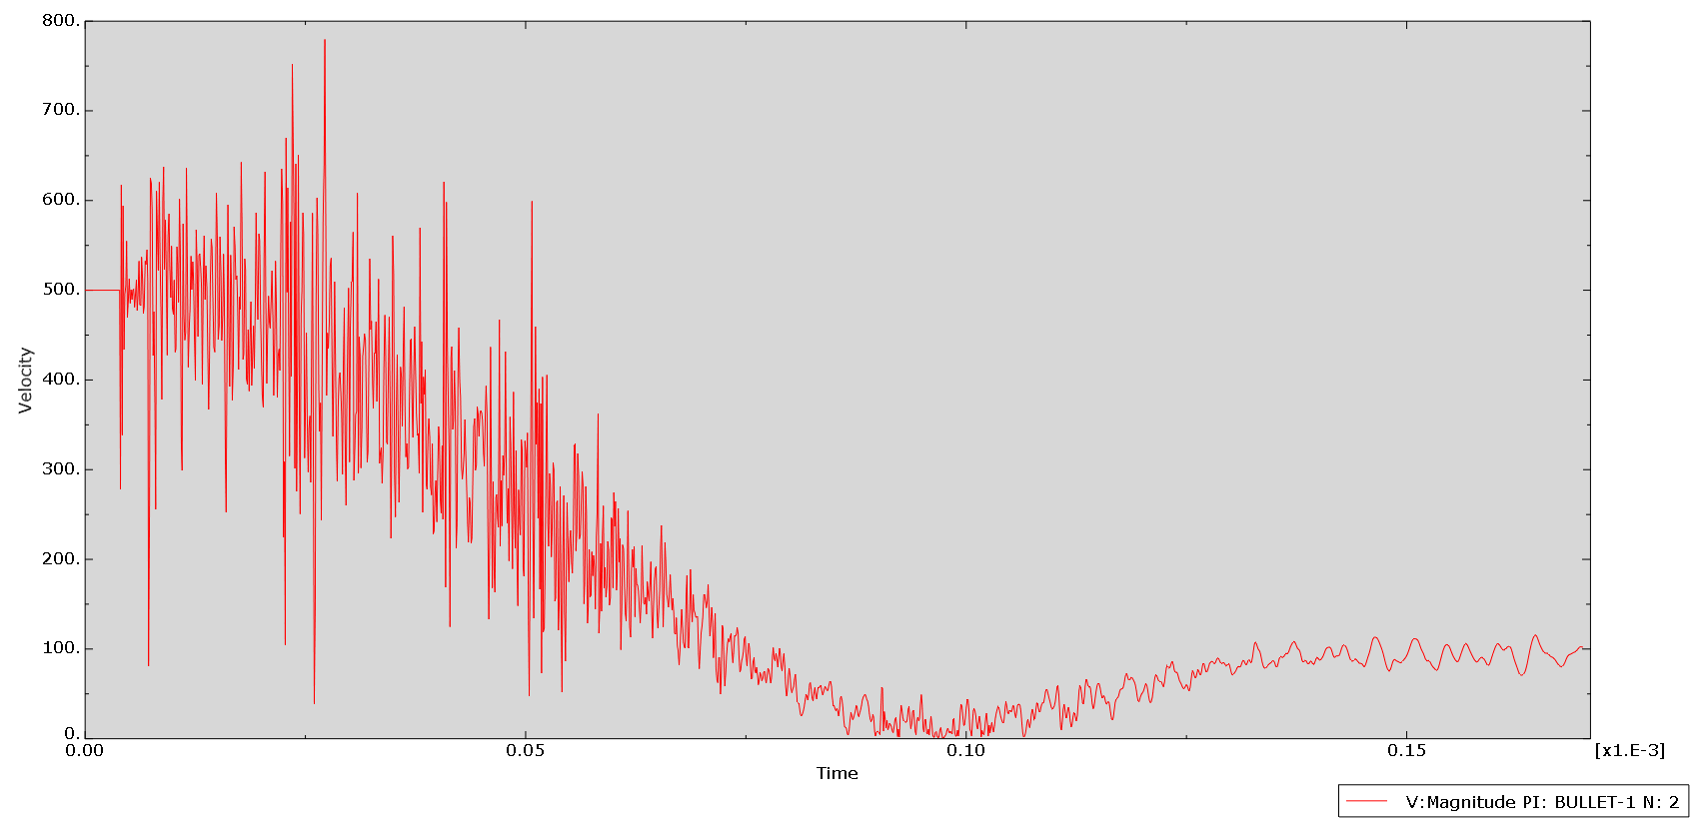
Figure 12, Velocity trace of Simulation 3

4. Discussion

4.1 Results
In Figure 3 high areas of stress can be seen in the RHA layers, as the stress waves propagate through each layer. These waves would have originated from the left-hand side where the layer had contact with the bullet or interactions from compression from above layers. The stress waves do propagate all the layers, however, the plastic layers absorb a large amount of energy because they can undergo large strain before fracture. The S12 shown in Figure 4 shows more movement in the RHA layers than the plastic as they are being stretched more as the plastic generally deletes quickly. However, the RHA is being deleted at a similar rate as the plastic, which suggests the fracture energy is too low allowing element deletion early in the simulation.

In simulation 2, Figure 5 shows the plastic layers undergoing tensile stress from the layers above which could lead to sprawling on the bottom of the target or failure of the material. The RHA is generating fewer stress waves in the top layers. This may be because of the bullet causing this in the lower layers and the top layers will have already absorbed their stress waves due to the time of the simulation being 0.05 seconds at the time of the screenshot, in relation, this is the middle of the simulation. The S12 graph in Figure 6 demonstrates the RHA layers stretching more noticeably as it is being pulled apart before element deletion. The plastic is moving in the opposite direction to the RHA as it is being compressed by the movement of the RHA layers.

In Figure 7 the RHA is seen to exhibit brittle material behaviour, that is resistant to small forces acting upon it. Small stress waves can be seen as each RHA layer comes into contact with the bullet. This was an aborted simulation as once the bullet interacts with the RHA layers it attaches each one to the bullet as one element is being stretched due to the high fracture energy of this simulation, which then causes the RHA layers to not interact with each other. This resulted in an aborted simulation as the calculations were not practical.
The S12 in Figure 8 shows a large stretching of the top RHA layers as they are not deleting due to their high fracture energy, the stretching of the elements reduces towards the non-contact side. The plastic layers are being compressed and are moving in the opposite direction to the RHA as it is being compressed by the movement of the RHA layers.

The velocity traces of the bullet in Figure 12, Figure 13 and Figure 14 show how well each target performed, however, the graphs have a lot of noise accounted as the bullet comes into contact with contact nodes in the simulation, it sees a new resistive force which slows the bullet down and speeds it up when it has overcome the node. But on average the following observations can be made, In Figure 12, the bullet velocity is seen to slowly reduce over time. Figure 13 shows the velocity of the bullet slowing at a faster rate than before due to the increased fracture energy increasing the target's ability to absorb impact energy. It can be seen in Figure 14 that the velocity slowly reduces before rapidly decreasing due to the effects of the failed simulation. To mitigate the effects of the noise in these graphs, a finer mesh should be considered to achieve more accurate data.

Overall, the results suggest that a suitable value of the fracture energy of the RHA works within Abaqus simulations to be 80e04 Nmm/mm² as this displayed realistic material properties before failing and deleting elements, however, any higher and the RHA would behave unrealistically as the layers within the target stopped interacting with each other.

4.2 Failed simulations
During this report, several target concepts and ideas were introduced. However due to problems with simulating them they were not pursued any further. Below are some examples of failed simulations that were run:
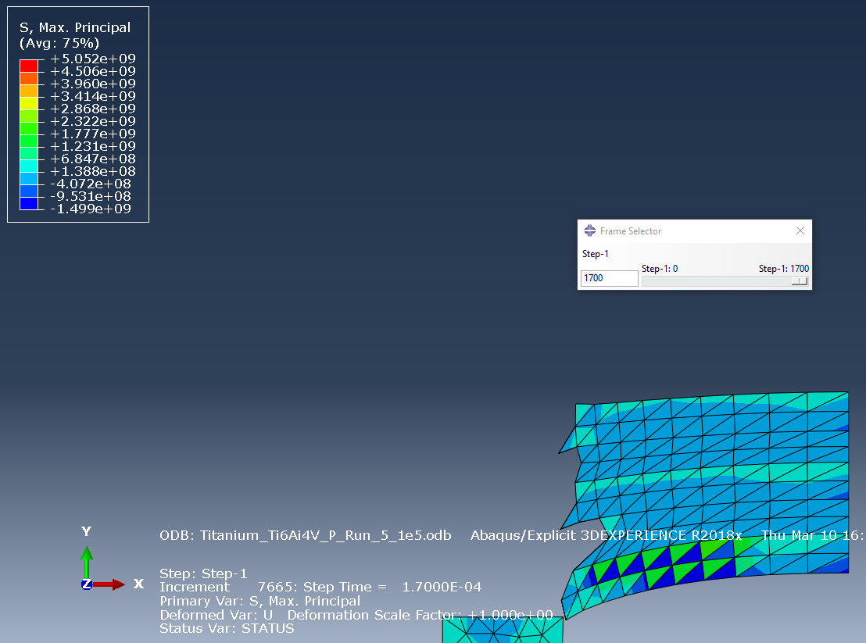
Figure 13, titanium_Ti6Ai4V and plastic target simulation.
This simulation worked very well however, the fracture energy of the titanium had to be significantly reduced from the value found in the research, leaving an unrealistic simulation.
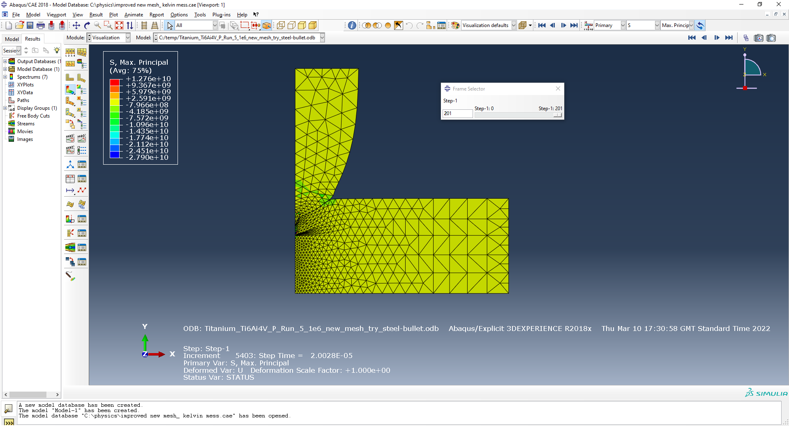
Figure 14, titanium_Ti6Ai4V with a refined mesh.
A refined mesh was experimented with, which gave more nodes towards the area of interest. To allow a more detailed understanding of the processes happening within the material and to improve the velocity data as well. However, this kept having issues that couldn’t be easily fixed.

5. Conclusion
This report set out to explore differing fracture energies of RHA within a metal laminated target and concluded that RHA with the fracture energy of 80e04 Nmm/mm² was the most suitable value for future simulations out of the 3 energies discussed in this report.
The second aim of this study was to investigate the effects of having laminated armour for ballistic protection. The results of the report show that concepts and phenomena such as Hertzian cones and shockwaves behave within these targets and cause complex interactions within the layers of materials in the targets.
Since the study was limited to a certain word count, it was not possible to fully explore a broad range of fracture energies, leaving room for future work into more specific fracture energies for RHA. The report was also limited by the lack of information on RHA, which would have allowed the report to focus on the effects of laminated ballistic armour.

6. References

[1] | I. D. Marinescu and M. Pruteanu, “Deformation and Fracture of Ceramic Materials,” Chapter 2 - Deformation and Fracture of Ceramic Materials, pp. 50-66, 2015.
[2] | R. Zahari, J. R. Pillai, A. Ordys and M. T. H. Sultan, “Ballistic impact analysis of double-layered metal plates,” 2018.
[3] | S. Chen, T. Farris and S. Chandrasekari, “Contact mechanics of hertzian cone cracking,” International Journal of Solids and Structures, vol. 32, no. 3-4, pp. 329-340, 1995.
[4] | T. Ping, “Numerical simulation of the ballistic protection performance of a laminated armor system with pre-existing debonding/delamination,” Composites Part B: Engineering, vol. 59, pp. 50-59, 2014.
[5] | H. K. T. Palleti, S. Gurusamy, S. Kumar and e. a. R. Soni, “Ballistic impact performance of metallic targets,” Materials & Design, vol. 39, pp. 253-263, 2012.
[6] | H. N. K. T. Palleti, S. Kumar and R. Soni, “Ballistic impact performance of metallic targets,” Materials & Design, pp. 253-263, 2012.
[7] | G. H. Majzoobi and F. Rahimi Dehgolan, “Determination of the constants of damage models,” Procedia Engineering, vol. Volume 10, p. 773, 2011.
[8] | M. Grazka, J. Janiszewski, L. Kruszka and e. al., “Identification Methods of Parameters for Johnson-Cook Constitutive Equation - Comparison,” Applied Mechanics and Materials, vol. 566, pp. 97-103, 2014.
[9] | A. S. Khoddami, D. Salimi-Majd and B. Mohammadi, “Finite element and experimental investigation of multiple solid particle,” Surface and Coatings Technology, vol. 372, pp. 173-189, 2019.
[10] | M. F. Lopez, W. Wright, S. R. Chen and G. T. Gray III, “Constitutive Equations for Aru-zealedMetals LInder Compression at High Strain Rates and High Temperatures,” p. 12, 15 October 1992.
[11] | K. WANG and B. ENG., “CALIBRATION OF THE JOHNSON-COOK FAILURE PARAMETERS AS THE CHIP SEPARATION CRITERION IN THE MODELLING OF THE ORTHOGONAL METAL CUTTING PROCESS,” 2016.
[12] | N. Gupta, M. Iqbal and G. Sekhon, “Effect of projectile nose shape, impact velocity and target thickness on deformation behavior of aluminum plates,” International Journal of Solids and Structures, vol. 44, no. 10, pp. 3411-3439, 2007.
[13] | “Johnson Cook Material and Failure Model Parameters Estimation of AISI-1045 Medium Carbon Steel for Metal Forming Applications,” 2019.

