3/24/2025
University of Wales Trinity Saint David
London campus
SPC Assignment on
Smart Home Device Manager System for Bright Minds Academy
Module Name: Scripting and Programming Concepts
Module Code: ACCA 5036

Student Name: Murat Yalcin
Student ID:2428669

Lecturer’s Name: Koushik Modak

Code Link: https://github.com/yalmur/SPC-Assignment-Code-Murat.git

Table of Contents
Introduction 2
1. Analysis 2
Requirements Analysis 2
2. Software Design and Development 4
Design: Pseudocode 4
Design: Flowcharts 7
2.3 Implementation Decisions: Data Structures 9
Implementation Decisions: Programming Constructs 10
2.4 Implementation Decisions: Python Modules and Libraries 10
Source Code: Code Listing and Screenshots 11
3. Testing and Debugging Report 17
(a) Importance of Testing 17
(b) Types of Programming Errors and How to Fix Them 17
(c) Test Cases and Validation 17
4. Evaluation 23
Conclusion 24
References 25

Introduction
Bright Minds Academy introduces smart devices such as lights, thermostats and projectors into the classroom. Currently, these devices are manually controlled, which makes it hard for staff to know the location and current status of the devices. To address this problem, a Smart Device Management System will be developed using Python. The system will enable staff to add devices, update their statuses, view all device records and search for specific devices, providing a simple and organised way to manage the academy’s smart classroom equipment.
As classrooms adopt more connected equipment, the lack of a central record becomes a practical problem rather than a minor inconvenience: staff cannot easily tell whether a projector is working, which room a spare smart light has been moved to, or whether a thermostat has already been reported for repair. Left unmanaged, this typically leads to duplicated maintenance requests, equipment left offline for longer than necessary, and time wasted walking between rooms to check a device’s status in person. The brief therefore calls for a lightweight, console-based solution that any member of staff can use without training, that keeps an accurate and persistent record of every device, and that can be extended as the academy adds more equipment over time. This report documents the analysis, design, implementation and testing of that solution: a Python console application that stores its data in a JSON file so records survive between sessions, structured so that each requirement identified in the Analysis section maps directly onto a function in the finished program.
- Analysis

Requirements Analysis
Before implementation began, the scenario set out by Bright Minds Academy was broken down into a clear set of functional and non-functional requirements, following standard requirements-engineering practice [1]. This ensured that every feature built into the Smart Device Management System could be traced back to a genuine need identified from the brief, rather than being added without justification.
Functional Requirements
The system needed to provide the following core functionality:
• Add New Devices: Staff can register a new device, such as “Smart Light A1” or “Projector B2”, together with the room it is located in, through the add_device() function.
• Update Device Status: Staff can mark any existing device as Online, Offline or Under Maintenance using update_device_status(), so equipment problems are reflected immediately.
• View Device List: Staff can call up a full list of every device, its room and its current status through view_devices(), giving an at-a-glance overview of the classroom equipment.
• Simple Search: Staff can type in a device name, or part of one, and see its status and location without scrolling through the whole list, using search_devices().
• User-Friendly Interface: The system uses a numbered text menu with clear prompts and error messages, so staff without advanced technical skills can use it confidently.
• Scalability: The list-of-dictionaries data structure and modular function design place no fixed limit on the number of devices, so new devices, rooms or statuses can be added later without redesigning the system.
Non-Functional Requirements
Beyond what the system does, several quality attributes were identified as important to how well it does it:
• Reliability: Input validation, duplicate-name checks and an automatic backup file work together so that device data stays accurate and is not lost even if something goes wrong while saving.
• Performance: Because the device list is small enough to hold in memory, adding, viewing and searching records all happen instantly, with no noticeable delay for staff.
• Security: Device data is kept in a local JSON file with a backup copy, reducing the risk of records being lost through file corruption or an interrupted save.
• Accessibility: The console interface uses plain language, numbered choices and consistent formatting, so it can be used by staff with a wide range of technical confidence.
The remainder of this analysis explains how the finished system puts each of these requirements into practice.
The main screen lets staff view all devices, showing each one's name, room and current status. For instance, "Smart Light A1" might show as located in "Room 101" and online. Keeping this format consistent means staff can check a device's location and condition at a glance.
Staff can also add new devices by entering a name, location and status (Online, Offline or Under Maintenance). Before saving, the system checks that the name and location fields aren't empty and that no other device already has the same name, which cuts down on duplicate or incomplete entries.
Updating a device's status works by typing in the device's full name and choosing a new status from a numbered list. If a projector breaks down, for example, its status can be switched from Online to Under Maintenance so other staff know to leave it alone until it's fixed. If the name entered doesn't match anything on record, the system shows an error instead of changing anything.
There's also a search function: staff can type in all or part of a device name, and it isn't case-sensitive, so "projector" and "Projector" return the same results. Matches show the full name, location and status, which beats scrolling through the whole list by hand.
Data is stored in a JSON file [2], so any devices added or statuses changed are still there the next time the program runs. Before saving new data, the system backs up the previous file, which helps avoid losing anything by accident.
A few non-functional points round this out. Input validation, duplicate checks and backups all support reliability. Performance should hold up fine given how many devices are expected, since adding, viewing and searching records are all quick operations. The menu structure, clear headings and error messages keep it usable for staff without a technical background. And because the code is split into separate functions for each task, it should be straightforward to add things later (removing devices, logging repair dates, assigning devices to staff) without having to rebuild the whole program.

Software Design and Development
This section documents how the requirements identified in the Analysis were translated into a working solution. It covers the design of the system through pseudocode and flowcharts, the implementation decisions behind the data structures, programming constructs and Python modules used, and the organisation of the source code itself.

Design: Pseudocode
Pseudocode was written for each core feature before any Python was typed, so that the logic of each menu option could be checked and refined on paper first. Writing the branches out in plain English made it easier to spot missing cases, such as what should happen if a search returns no matches, before they became bugs in the finished program.
MAIN MENU

START
LOAD devices from JSON file
REPEAT
DISPLAY main menu
INPUT user choice
IF choice = 1 THEN
View all devices
ELSE IF choice = 2 THEN
Add a new device
ELSE IF choice = 3 THEN
Update device status
ELSE IF choice = 4 THEN
Search for a device
ELSE IF choice = 5 THEN
DISPLAY exit message
ELSE
DISPLAY invalid option message
END
ADD NEW DEVICE MENU
INPUT device name

IF device name is empty THEN
DISPLAY error message
ELSE IF device name already exists THEN
DISPLAY duplicate device message
ELSE
INPUT device location
IF location is empty THEN
DISPLAY error message
ELSE
DISPLAY available statuses
INPUT status number
IF status number is valid THEN
CREATE new device record
ADD device to the list
SAVE devices to JSON file
DISPLAY success message
ELSE
DISPLAY invalid status message
END IF
END IF
END IF
UPDATE DEVICE STATUS
INPUT full device name
SEARCH for the device
IF device is found THEN
DISPLAY current device details
DISPLAY available statuses
INPUT new status
IF new status is valid THEN
UPDATE the device status
SAVE devices to JSON file
DISPLAY success message
ELSE
DISPLAY invalid status message
END IF
ELSE
DISPLAY device not found message
END IF

SEARCH FOR A DEVICE
INPUT device search text
IF search text is empty THEN
DISPLAY error message
ELSE
CONVERT search text to lowercase
SEARCH for matching device names
IF matches are found THEN
DISPLAY matching devices
ELSE
DISPLAY no devices found message
END IF
END IF

SIMPLE SEARCH ALGORITHM (Generic Linear Search)
The device search above is a specific case of the general linear search algorithm shown below, which checks each item in a list in turn until a match is found or the list is exhausted [3].
BEGIN SimpleSearch(list, target)
SET found = FALSE
FOR EACH item IN list
IF item = target THEN
SET found = TRUE
EXIT LOOP
END IF
END FOR
IF found = TRUE THEN
DISPLAY "Item found"
ELSE
DISPLAY "Item not found"
END IF
END SimpleSearch

Design: Flowcharts
Each flowchart below follows standard flowcharting conventions, using ovals for start and end points, rectangles for processing steps, and diamonds for decision points [4]. Presenting the logic visually alongside the pseudocode makes it easier to check that every branch of the program, for both valid and invalid input, leads to a sensible outcome before any code is written.
Main system flowchart
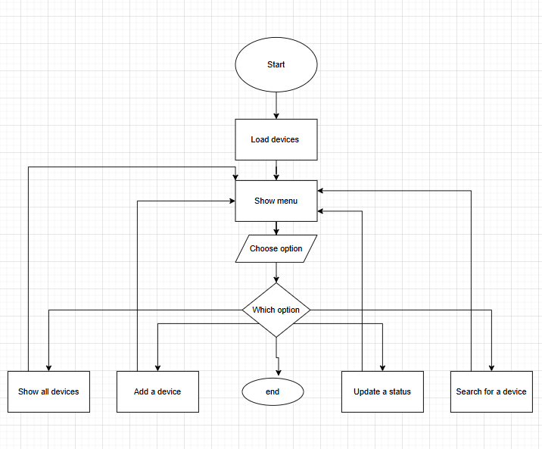
Figure 1

Add Device flowchart
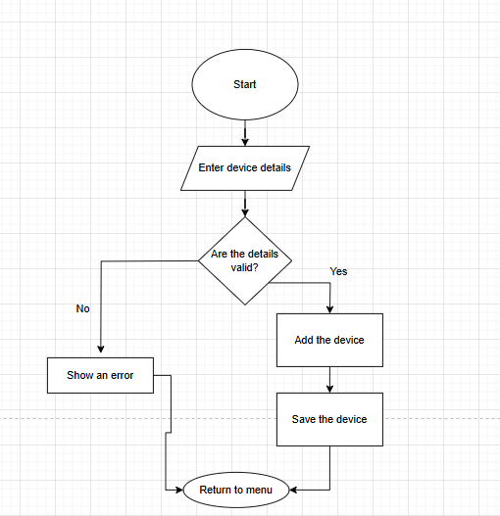
Figure 2
Update device flowchart
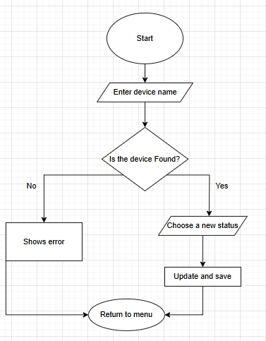
Figure 3

Search device flowchart
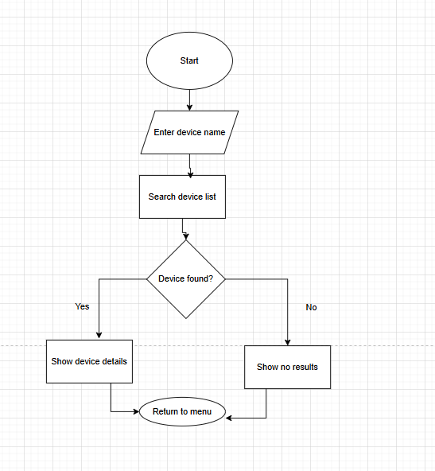
Figure 4

Implementation Decisions: Data Structures
The program's data structure is a list of dictionaries [5] the list holds every device, and each dictionary holds one device's details such as its name, room and status. A list makes sense because the system has to store more than one device and dictionaries keep each device's details labelled under name, room and status rather than sitting in an unlabelled sequence.
Devices holds the whole list, while device refers to a single device at a time. name, room and status store what the user types in for those sections. Choice holds whichever option the user picks from the main menu. Search text is what the user searches for, and matches holds the devices that search turns up.
A few values in the program stay fixed throughout. DATA_FILE and BACKUP_FILE are the main and backup JSON files. VALID_STATUSES lists the three statuses a device can have, for example, Online, Offline and Under Maintenance. DEFAULT_DEVICES holds the example devices the program falls back on when no saved file exists. Table 1 below summarises the main variables used across the program and what each one stores.

Variable | Description
devices | The full list of dictionaries, one per device, loaded from and saved to JSON.
device | A single device dictionary being read, added or updated at a given moment.
name / room / status | The individual fields typed in by the user for a device.
choice | The menu option selected by the user on the main menu.
search_text / matches | The text a user searches for, and the list of devices whose names contain it.
DATA_FILE / BACKUP_FILE | Constant filenames for the main and backup JSON files.
VALID_STATUSES | A constant list of the three statuses a device can hold.
DEFAULT_DEVICES | A constant fallback list used when no saved file exists.
Table 1: Key variables used in the Smart Device Management System.

Implementation Decisions: Programming Constructs
The if, elif and else statements handle the program's decisions, like checking which menu option was chosen, whether required information is missing, whether a device already exists, or whether a search turned anything up. These statements let the program respond correctly depending on what the user does.
A while loop keeps the main menu going until the user picks the exit option, so they can do several tasks in one run instead of restarting the program each time [6]. For loops step through the device list to display devices one at a time and also display the list of valid status options.
The code is split into functions like add_device(), view_devices(), update_device_status() and search_devices(), each handling one task, following standard Python naming conventions [7]. That keeps the code easier to read and change. A function like display_device() gets reused wherever a device needs to be shown.
The program also uses try and except handle errors. If the user types text where a number's expected, the program shows an error message instead of crashing. The same approach covers opening and saving files like if the main device file won't load, the program falls back to the backup file. Centralising error handling in this way, rather than checking for problems separately in every function, keeps the control flow easier to follow and ensures a single, consistent style of error message is shown to staff no matter which part of the program encounters unexpected input.

Implementation Decisions: Python Modules and Libraries
The json module saves and loads device information [8]. JSON works well for this because it can store the device list in an organised format, and can keep that information even after the program's been closed.
The shutil module makes a backup of the device file [9]: before new information is saved, the old file gets copied to devices_backup.json. That protects the device data if something goes wrong.
The Path class from pathlib handles file operations, letting the program check whether a file exists and open or replace files as needed [10]. All three modules are part of the Python standard library, so the system has no external dependencies to install, which keeps deployment on a school computer straightforward.

Source Code: Code Listing and Screenshots
The complete, fully functional source code is version-controlled and available in the GitHub repository linked on the title page. Throughout the project the code was kept organised into small, single-purpose functions with descriptive names, consistent indentation and inline comments explaining non-obvious steps, in line with widely used code-quality practices [11]. The annotated screenshots below walk through each part of the program in the order it executes, from importing modules and loading data through to the main menu loop.

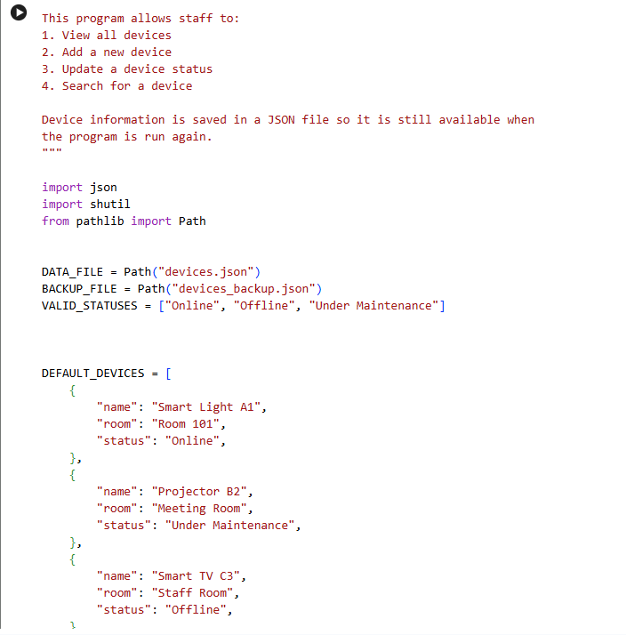
Figure 1: Importing and starting data
This section imports the modules the system needs. json loads and saves device records, shutil creates a backup, and Path handles files.
DATA_FILE and BACKUP_FILE hold the names of the main and backup files. VALID_STATUSES holds the three allowed statuses. DEFAULT_DEVICES stores three example devices, each with a name, room and status.

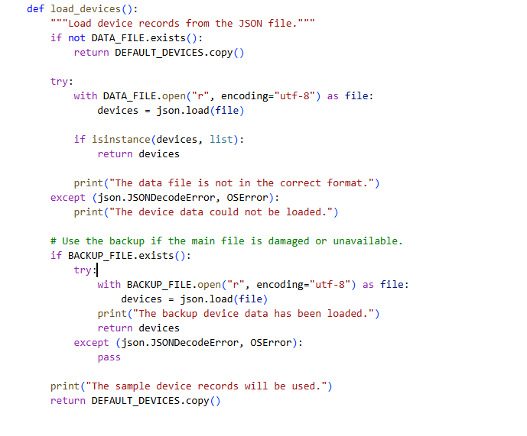
Figure 2: Loading devices
load_devices() loads the records when the program starts. It first checks if devices.json exists; if not, it falls back to the example devices.
The function uses try and except so a damaged file doesn't crash the program. If the main file can't be loaded, it tries the backup file, and if that fails too it falls back to the example records.
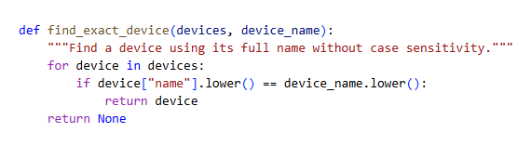
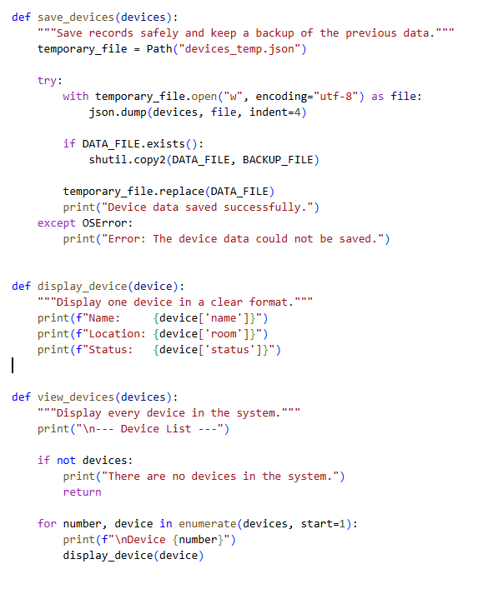
Figure 3: Saving, displaying, and finding devices function
The save devices() function writes the devices to a temporary JSON file. It also copies the old main file to the backup before replacing it, and if saving fails, it shows an error message.
display device() shows one device's name, location and status. view_devices() loops through this to display every device. find_exact_device() searches for a device by its full name, converting both names to lowercase so capital letters don't affect the match.

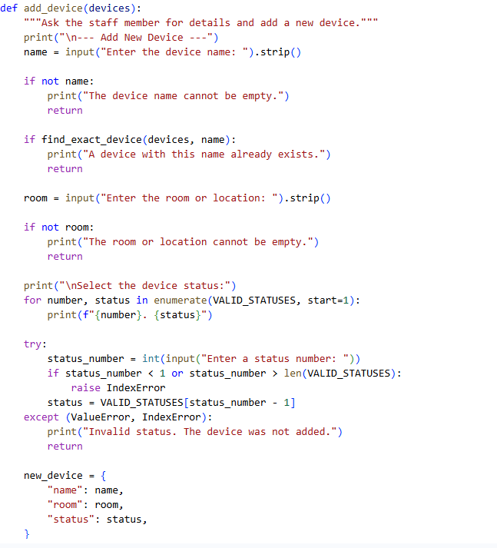
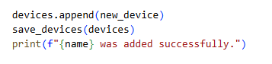
Figure 4: Device adding section
The add_device() function asks the user for a name, location and status, checking that the name and location aren't empty and that the device name isn't already in use.
The user picks a status by number, and an invalid entry shows an error message. Once everything checks out, a new device dictionary gets added to the list and saved.

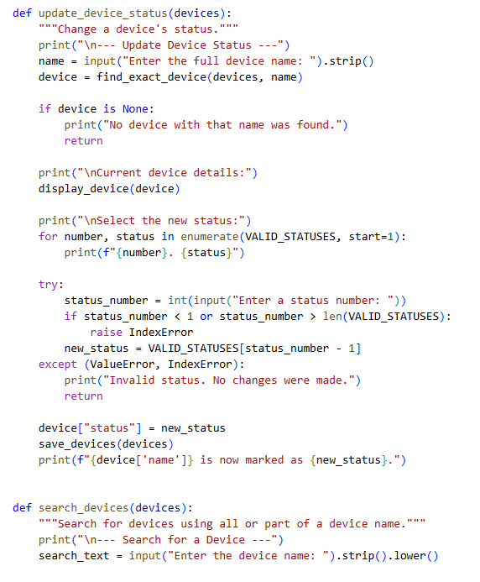
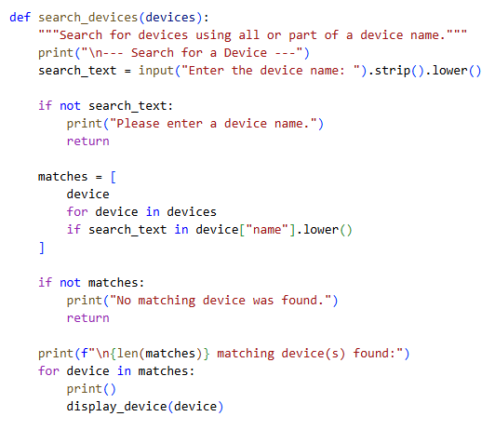
Figure 5: Updating and Searching section
update_device_status() searches for a device by its full name. If found it displays the current details, lets the user pick a new status, then saves the change. An invalid name or status shows an error.
search_devices() accepts all or part of a device name and isn't case-sensitive. Matching devices go into a list and get displayed, if there are none, the user is told so.
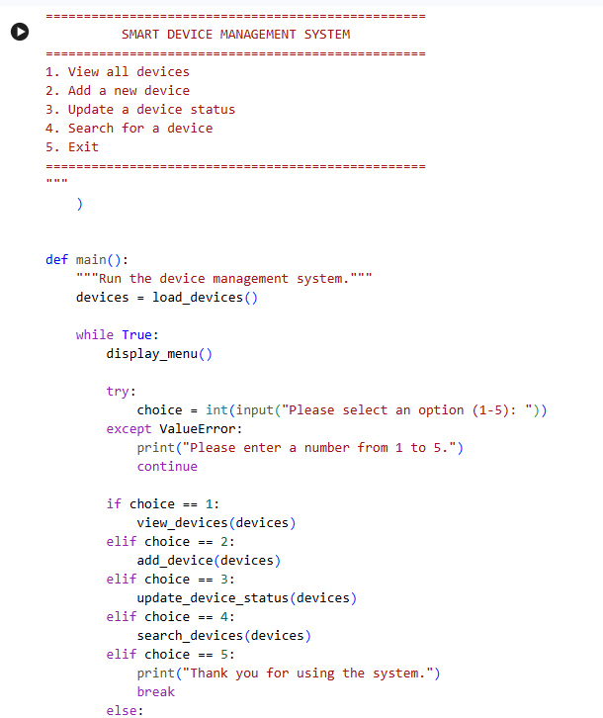
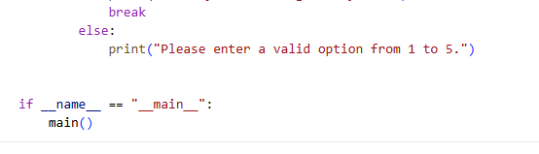
Figure 6: Menu and main program section
Display menu() shows the five menu options and main() loads the device data and uses a while loop to keep the menu running.
if and elif statements check the selected option and call the right function, while try and except handle non-number inputs. Selecting option 5 uses break to stop the loop. The final two lines call main() and start the program.

3. Testing and Debugging Report

(a) Importance of Testing
Testing is important because it checks that the software works correctly before anyone uses it [12]. It helps find errors it confirms each feature gives the expected result, and makes sure the program doesn't crash when it's fed bad data. This helps make the software more reliable and easier to use. Testing was carried out throughout development rather than only at the end, so that problems in one function, such as add_device(), were caught before later functions were built on top of it [13].
For the Smart Device Management System, testing can check whether staff can view, add, update and search for devices correctly [13]. It can also check situations like an empty device name, an invalid menu option, or searching for a device that doesn't exist. Catching these problems during development means they're fixed before the system reaches staff.

(b) Types of Programming Errors and How to Fix Them
A syntax error happens when the code breaks Python's rules, missing brackets, wrong indentation, or forgetting a colon after an if statement, for example [14]. Python normally shows the line where it happened, so the programmer can check that line, fix the syntax and run the program again.
A logical error happens when the program runs but gives the wrong result [15]. For example, the search function might only match devices when the capital letters line up, or a status number might select the wrong status. These are fixed by testing different inputs, checking the results against what's expected, and reviewing the code behind that feature. A runtime error happens while the program is running so converting letters into an integer could cause a ValueError, for example, or opening a damaged JSON file could raise an error of its own. Runtime errors like these are fixed by validating input and file state before the risky operation runs: wrapping the status-number conversion in a try and except block, for example, or checking that a file exists before opening it. That way the program can respond with a clear message instead of stopping unexpectedly [14].

(c) Test Cases and Validation
The following test cases were designed to check each functional requirement identified in Section 1 under both correct and incorrect input, with screenshots and comments demonstrating the outcome of each run.
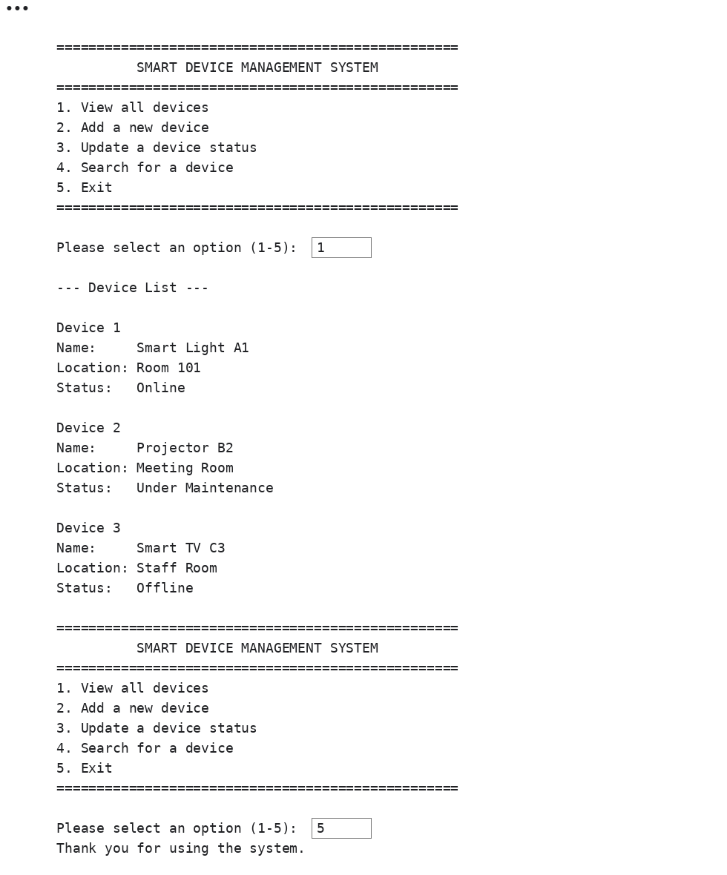
Figure 7: View devices screen
Figure 7 shows that selecting option 1 displays every device with its name, location and current status. The menu then reappears so the user can choose another option or exit.
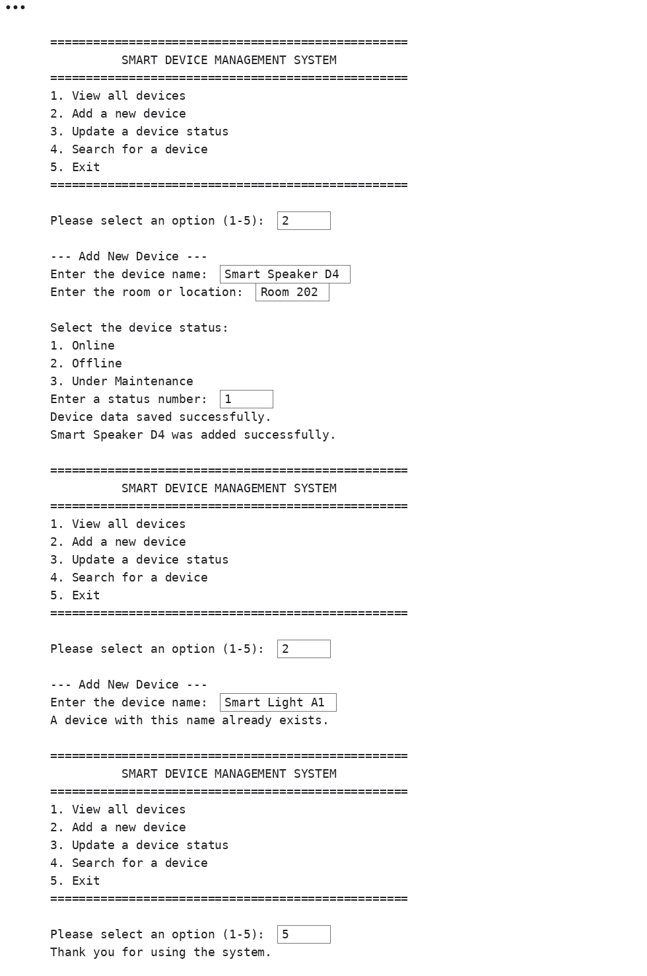
Figure 8: Adding a device screen
Figure 8 shows a new device being added using valid information. It also shows the duplicate-name validation which stops the user from adding a device whose name already exists.
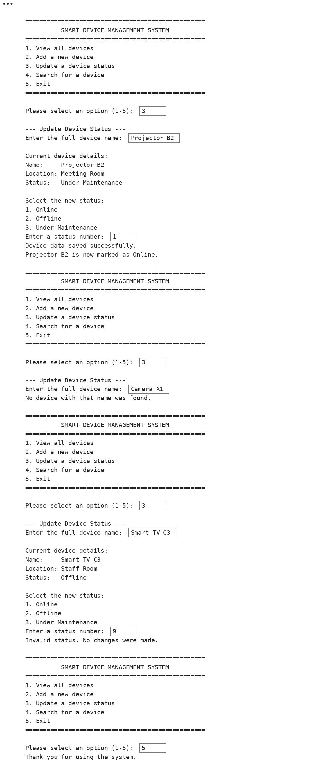
Figure 9: Updating a device status screen
Figure 9 shows a device's status being changed successfully. It also tests a device that doesn't exist and an invalid status number. Both incorrect inputs display an error without changing any information.

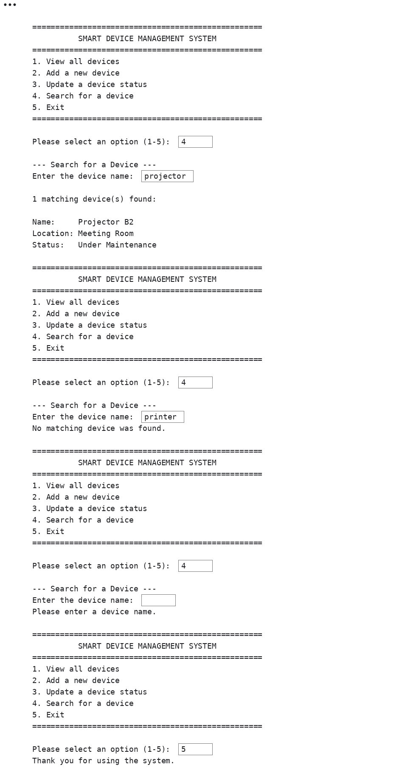
Figure 10: Searching for devices screen
Figure 10 shows a successful search using part of a device name. It also tests a device that doesn't exist and an empty search. The program displays a suitable message in each case.

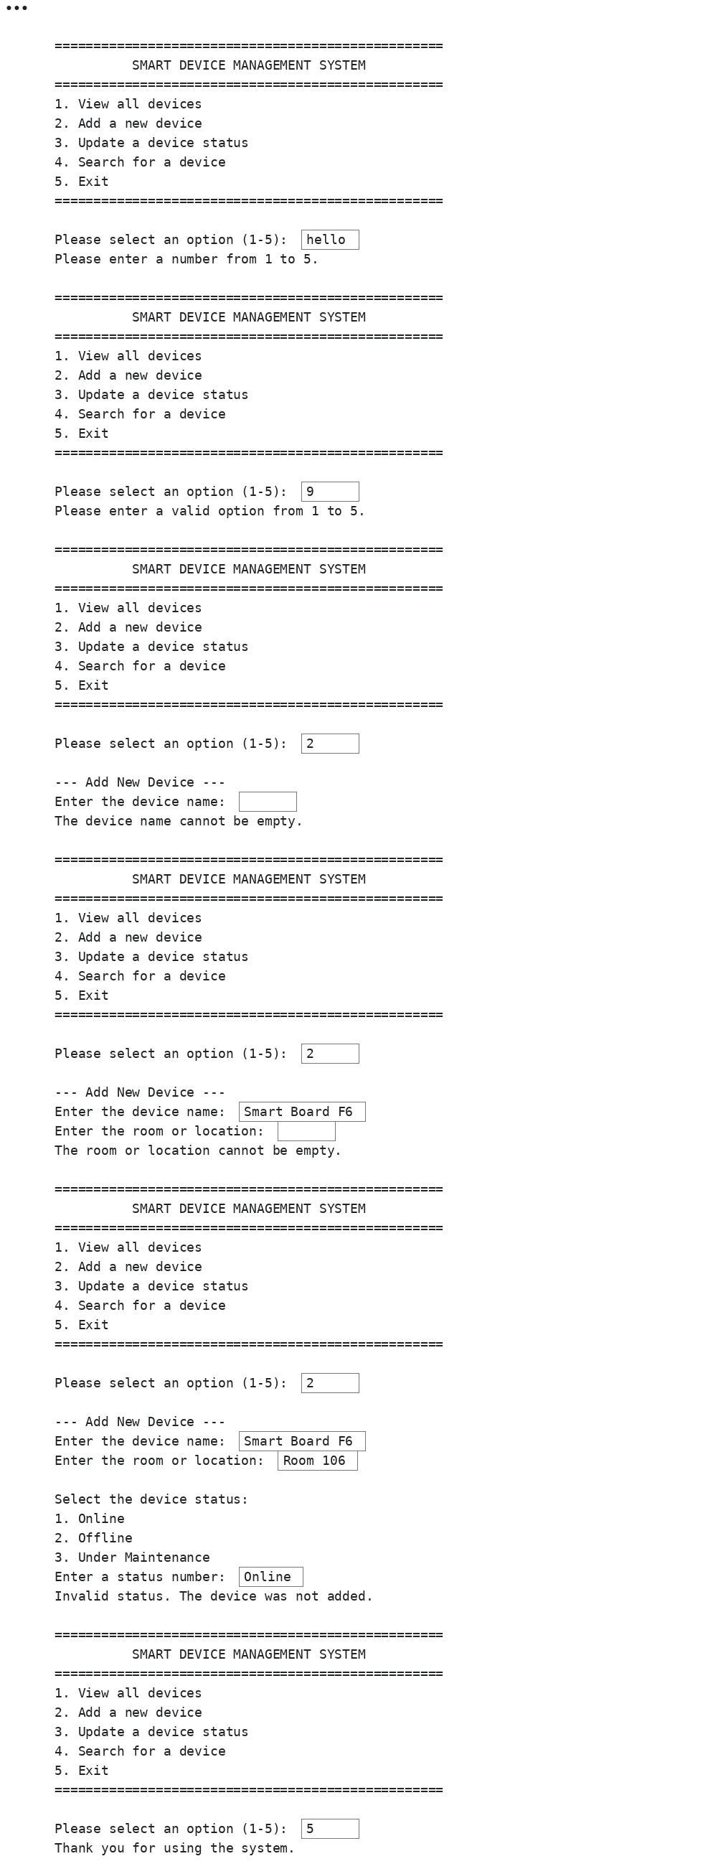

Figure 11: Incorrect input validation
Figure 11 tests several incorrect inputs, including letters and an invalid number in the main menu, an empty device name, an empty location, and text entered instead of a status number. The program handles each input without crashing.

4. Evaluation
Overall, developing the Smart Device Management System was a valuable exercise in building a complete, working console application from a set of real requirements, rather than an isolated exercise or snippet.
• Challenges Faced:
One of the main challenges was handling user input reliably. Early versions of add_device() and update_device_status() would crash whenever a user typed a letter instead of a number for the status choice, so try and except blocks had to be added around every numeric input to stop the program from crashing on bad data. Another challenge was making the search function feel genuinely useful: an early version only matched exact device names, so it was changed to convert both the search text and the stored names to lowercase and check for partial matches, which made “projector” and “Projector” return the same results as intended. Protecting the saved data was also tricky: a corrupted or missing devices.json file would originally stop the whole program from starting, which was solved by adding a backup file and a fallback to the default device list inside load_devices(). Finally, keeping the duplicate-name check working correctly while still allowing an existing device’s status to be updated took a few attempts, since the same comparison logic had to behave differently depending on whether a new device was being added or an existing one was being changed.
• Future Improvements:
There are several ways the system could be extended. A remove_device() function would let staff delete devices that are no longer in use, and a small edit history or repair log could record when a device was last serviced. Assigning devices to a specific staff member or classroom, and letting staff filter the device list by room or status rather than only by name, would also make the search feature more useful as the number of devices grows. On the technical side, moving from a JSON file to a lightweight database such as SQLite would make the system more reliable with larger amounts of data and reduce the risk of a single corrupted file losing every record. Longer term, replacing the text menu with a simple graphical interface would make the system more approachable for staff who are less comfortable with a command-line tool.
• Self-Reflections:
Working on this project improved my understanding of how the pieces of a Python program fit together in practice, rather than as separate exercises. Splitting the system into small, single-purpose functions such as display_device(), find_exact_device() and save_devices() made the code far easier to test and debug than a single long script would have been, and writing the pseudocode and flowcharts before coding made it much clearer where validation and error handling were actually needed. Working through the different kinds of errors (syntax, logical and runtime) while testing the program also gave me a better sense of how to read an error message, isolate the cause and fix it methodically instead of guessing. Overall, the project pushed me to think more like a developer: planning the structure of a program before writing it, anticipating how a user might misuse it, and treating testing as part of building the software rather than an afterthought.

Conclusion
This project set out to replace Bright Minds Academy’s manual approach to tracking smart classroom devices with a Smart Device Management System that gives staff a single, reliable place to view, add, update and search device records. Measured against the functional and non-functional requirements defined in the Analysis, the system satisfies each one: every required feature is implemented, and reliability, performance, security and accessibility have each been addressed through specific design choices rather than left as afterthoughts. The finished console application meets that aim: it lets staff see every device’s name, room and status at a glance, add new devices with validation against empty fields and duplicate names, change a device’s status through a guided menu, and search records by full or partial name regardless of capitalisation. Storing records in a JSON file with an automatic backup, combined with try and except handling throughout, means the system keeps working even when input is invalid or a data file is missing or damaged, and the modular function-based structure keeps the code easy to read, test and extend. Testing against a range of valid and invalid inputs, documented in Section 3, confirmed that the core features behave as intended and fail safely rather than crashing. Overall, the system delivers a simple, organised and dependable way for staff to manage the academy’s smart classroom equipment, while leaving a clear path, outlined in the Evaluation, for further features such as device removal, staff assignment and a graphical interface.

References
[1] International Organization for Standardization, International Electrotechnical Commission, and Institute of Electrical and Electronics Engineers, Systems and Software Engineering — Life Cycle Processes — Requirements Engineering, ISO/IEC/IEEE 29148:2018, 2018.
[2] ECMA International, "The JSON Data Interchange Syntax," ECMA-404, 2nd ed., Dec. 2017. [Online]. Available: https://www.ecma-international.org/publications-and-standards/standards/ecma-404/. [Accessed: 7-Aug-2026].
[3] T. H. Cormen, C. E. Leiserson, R. L. Rivest, and C. Stein, Introduction to Algorithms, 3rd ed. Cambridge, MA: MIT Press, 2009.
[4] International Organization for Standardization, Information Processing — Documentation Symbols and Conventions for Data, Program and System Flowcharts, Program Network Charts and System Resources Charts, ISO 5807:1985, 1985.
[5] Python Software Foundation, "5. Data Structures," The Python Tutorial. [Online]. Available: https://docs.python.org/3/tutorial/datastructures.html. [Accessed: 7-Aug-2026].
[6] Python Software Foundation, "4. More Control Flow Tools," The Python Tutorial. [Online]. Available: https://docs.python.org/3/tutorial/controlflow.html. [Accessed: 7-Aug-2026].
[7] G. van Rossum, B. Warsaw, and A. Coghlan, "PEP 8 — Style Guide for Python Code," Python Enhancement Proposals, 2001. [Online]. Available: https://peps.python.org/pep-0008/. [Accessed: 7-Aug-2026].
[8] Python Software Foundation, "json — JSON encoder and decoder," Python 3 documentation. [Online]. Available: https://docs.python.org/3/library/json.html. [Accessed: 7-Aug-2026].
[9] Python Software Foundation, "shutil — High-level file operations," Python 3 documentation. [Online]. Available: https://docs.python.org/3/library/shutil.html. [Accessed: 7-Aug-2026].
[10] Python Software Foundation, "pathlib — Object-oriented filesystem paths," Python 3 documentation. [Online]. Available: https://docs.python.org/3/library/pathlib.html. [Accessed: 7-Aug-2026].
[11] R. C. Martin, Clean Code: A Handbook of Agile Software Craftsmanship. Upper Saddle River, NJ: Prentice Hall, 2008.
[12] I. Sommerville, Software Engineering, 10th ed. Harlow, U.K.: Pearson, 2016.
[13] G. J. Myers, C. Sandler, and T. Badgett, The Art of Software Testing, 3rd ed. Hoboken, NJ: Wiley, 2011.
[14] Python Software Foundation, "Errors and Exceptions," The Python Tutorial. [Online]. Available: https://docs.python.org/3/tutorial/errors.html. [Accessed: 7-Aug-2026].
[15] ISO/IEC/IEEE, Systems and Software Engineering — Vocabulary, ISO/IEC/IEEE 24765:2017, 2017.

