
Title page
Student name: Nusrat Yasmin Shitara
Student number: 1712117
Module name: knowledge and information management skills for the workplace
Module code: BMSW5006
Assignment title: mid-term formative assessment
Tutor name: Dr Md Nazmul Hasan

Assignment Specification 1
1. Explain why the same set of data can be considered as useful information by some and useless data by others. Further, could this useful information be termed as “knowledge”? Why?
The same set of data may be considered as useful information by some and useless by others, as it may not suite their needs or be relevant to them.
E.g.1. a bus timetable is useful for someone who uses buses to commute to and from work on a daily basis, however is useless for someone who works from home and does not need to use a bus to commute to their workplace. This useful information could be termed as ‘knowledge’ as certain buses, routes and times apply to individuals and their needs, and may have been gathered through study or experience.
E.g.2. a medical note is useful for the person, their doctor, their employer and their educational institute, however would be useless to their colleagues, friends and bank. A medical note can be termed as knowledge as it informs yourself, your employer, educational institute and doctor of your whereabouts at a given date, and would have been gathered through study or experience.
2. Describe the ways in which “knowledge” differs from “data” and “information.” Justify your answer with a relevant diagram.
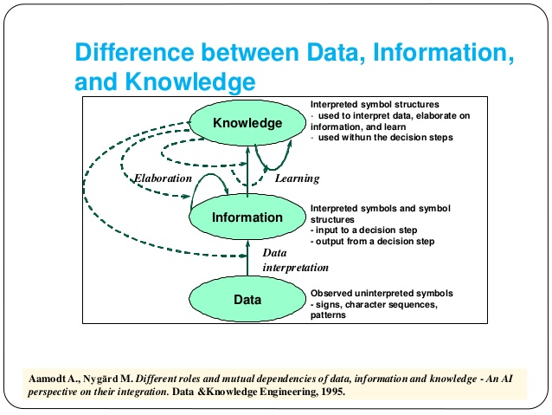
Data are observations or raw factors that are unstructured (such as alphabets, numbers or symbols), representing or referring to ideas, objects or conditions. They are considered to have little to no value until they have been transformed or processed into information. Information is data that has been processed so that they are meaningful. An example of information would be a bank statement or a lesson timetable. Information is meaningful once data is placed in some form of meaningful context. Knowledge is information that is processed in an individual’s mind. It is personalised information and may be gathered through study or experiences. Information is the refined form of data, helping us to understand the meaning, whereas knowledge refers to the understanding or awareness of a particular subject which is obtained through the study or experience of a person. : (BusinessDictionary.com, 2019) . (JAIN, 2019)

3. Does a player in a card game use tacit or explicit knowledge? Explain why. Define and explain the difference between the two.
Tacit knowledge is gained from personal experience, characterised by factors such as values, beliefs, perceptions, experience and intuition. The majority of it is held unconsciously and is difficult to express, as it is mainly expressed verbally. It is understood to be less valuable as there is no record of it as it is spoken and not documented. E.g. speaking a language is categorised as tacit knowledge as it very difficult to write down the rules of a language. It is universally accepted that learning a language requires you to immerse yourself in the task, using the language regularly, over long periods of time. (Spacey, 2016)

Explicit knowledge is captured easily and stored within document and other media taking the form of procedures, manuals and database files. It is easy to articulate, share and write down. It is highly valuable as it is documented and easy to share.
Different card games are governed by different sets of rules, so the type of knowledge used by the player is determined by the game and the rules it follows. In some games, the player may use both tacit and explicit knowledge. E.g. in a game of blackjack, the player will use explicit knowledge of the rules/instructions of the game that all of the players must follow, but will also use tacit knowledge based on their perceptions and intuitions to analyse the state of the game and formulate a strategy to win. (Alexander, 2018)

4. Consider five decisions you have made today (they could be simple such as taking a turn while driving or even choosing a soda at a convenience store). In each case determine the data, information, or knowledge that was involved in the decision.

These are the five decisions which I made today:
1. Sending an email to a friend
I would like to send an email to my friend. The data involved is the email address of the friend. The information is the selection and content of the email and sending it to the recipient. The knowledge involved is how the email is sent.
2. Going to the sea side
It’s a beautiful sunny day today so I would like to go to the sea side with my family. The data involved is the destination, the method of transportation and the directions there. The information involved is using the mode of transportation and directions to go to your destination. The knowledge involved is knowing how to follow the directions to reach the destination and actually knowing what the destination is.
3. Cooking a dish
My friend is coming to my house and I have decided to cook a special dish for her. The data involved are the ingredients, utensils and recipe needed to make the dish. The information involved is following the recipe and instructions given to make the dish. The knowledge involved is how I made the dish, by following the recipe.
4. Visit London by train
I’m going to London by train to attend a family party. The data involved is the destination (London), the train ticket to get there, the train station and the train timetable. The information involved is booking a ticket online, going to the station with the ticket and looking at the train timetable to make sure you depart on the correct train. The knowledge involved is knowing how to and actually booking the ticket, being able to read and understand the train timetable, knowing what station you are departing from and arriving to and being sure your destination is London.

5. Going out to eat
I have decided to go out to eat with my university friends. The data involved is the restaurant, the people that are going, the mode of transportation and the time. The information involved is reserving the table, informing every one of the place and time and making sure I can get there by my mode of transportation. The knowledge involved is knowing where the restaurant is and how to reserve a table, informing all attendees and knowing how to use my mode of transportation, booking a ticket if necessary.

5. Now consider how those decisions would have been influenced by the lack of pre-existing data, information, or knowledge.
How my decisions influenced by lack of pre-existing data, information, or knowledge:

- sending an email to a friend
If I didn’t know the recipient’s email address or didn’t know how to send an email, my lack of pre-existing data, information and knowledge would mean I am unable to actually send the email/ to the right person. Therefore, I would not be able to get my message across to my friend or might even send it to the wrong person, which could result in valuable or confidential information being spread.

- going to seaside
If I didn’t know have a mode of transportation or know the directions to get to the seaside, my lack of pre-existing data, information and knowledge would stop me from going there and knowing that I am going to the correct place and enjoying the weather. I would be missing out on a great experience with my family and may even make them upset.
- cook a dish
If I didn’t have the ingredients, utensils or recipe to make a certain dish, my lack of pre-existing data, information and knowledge would mean I wouldn’t be able to make it as I do not have the ingredients or devices to use and don’t have a recipe to follow to help me with quantities and times. This could lead to my dish tasting bad or bland, or being made incorrectly.

- visit London by train
If I did not know how or was not able to book the ticket, did not know what station to go to or could not follow the train timetable, my lack of pre-existing knowledge would mean I would not be able to go to London by train as I would not have a ticket, would not know what station to go to, would not go on the right train or might miss the train. This lack of pre-existing knowledge could result in me missing the family party, and in turn, upsetting members of my family.

- Going out to eat
If I did not know where the restaurant was and how to get there, and how to reserve a table, I wouldn’t be able to put that data of going out to eat in use. Also if I did not have enough information on who was attending then I might feel a little uneasy about going to that restaurant. If I was not able to get there due to not knowing all the information stated then I would be letting down all my friends. So my lack of pre-existing knowledge would mean I wouldn’t be able to eat out at the restaurant and would miss out on a valuable time with my friends.

6. You have recently invented a new product. Collect demographic data from a sample population, determine how you would use this data, and convert it into information and possibly knowledge for promoting the product.
The tangible product I have invented is a sweet dessert called rice pudding. This is made using my own unique recipe and very specific methods. My demographic target would be people who enjoy sweet desserts and catering groups, specifically those who cater at parties, weddings and celebratory events. This product is not targeted towards diabetics or people who have conditions caused or aggravated by sugar intake and people who want to reduce their sugar consumption.
I will promote my product by having a pop up/trial stall set up in a supermarket such as Tesco, allowing people who pass by to try a sample of my rice pudding and give their opinion on it, as I record their age, gender and ethnicity. I will have my family, friends and acquaintances advertise it through their social media pages, by handing out my business cards and by word of mouth, recommending my product. By setting up my own Instagram page for the product and having small events with free samples given to gather reviews and feedback, I would be given valuable information, which I can then use to improve my product. This is the population I will collect my data from.

Demographic data:
Age | No of people that enjoyed it
5-15 | 23
15-25 | 17
25-35 | 12
35-45 | 34
45-55 | 21
55-65 | 13
65-75 | 7
75+ | 3

Gender | No of people that enjoyed it
Male | 53
Female | 77

Ethnic group | No of people that enjoyed it
White | 29
Asian | 44
Black/African/Caribbean/ | 35
Mixed/Multiple ethnicities | 12
Other | 10

Through this data and information, I will be able to get a general understanding of what is the negative and positive feedback about the product, and start progressing from there, improving my product step by step. This will help me sell the product and know what the demand is like for the product and whether I am targeting the right or most suitable demographic. From my trial stall, I will analyse the data and conclude that people between ages 35-45, females and of Asian ethnicity enjoyed my product the most. However this was closely followed by males, people of black ethnicity and people between ages 5-15, as children are very fond of sweet products and desserts.
I will also look at my competitor’s products and see what they may be doing right or wrong and use that to improve my product. I will look at the similarities between our products and figure out a way to make mine stand out to consumers. At this stage, all the responses and comments received about my product would be my information. This information will then be turned into knowledge as I will study the reviews and feedback and use my own experiences to enhance and refine my product to make it the best I can possibly make it, given my budget, resources and time period. This knowledge will help me to produce more products, as I would have used it to produce the product to an excellent standard, having better reviews and more consumers, and in turn having a higher demand for the product. (SurveyMonkey, 2019)

Reference List

Alexander, R. (2018). Tacit, Explicit, and Implicit Knowledge: Definitions and Examples. [online] Bloomfire. Available at: https://bloomfire.com/blog/implicit-tacit-explicit-knowledge/ [Accessed 27 OCT. 2019].
BusinessDictionary.com. (2019). Good one to know!. [online] Available at: http://www.businessdictionary.com/definition/data.html [Accesses 20 OCT. 2019].
JAIN, P. (2019). Knowledge management system priyank. [online] Slideshare.net. Available at: https://www.slideshare.net/PRIYANKJAIN23/knowledge-management-system-priyank [Accessed 20 OCT. 2019].
Ontotext. (2019). Climbing the steps of the Data-Information-Knowledge-Wisdom Pyramid. [online] Available at: https://www.ontotext.com/knowledgehub/fundamentals/dikw-pyramid/ [Accessed 25 OCT. 2019].
Spacey, J. (2016). 10 Examples of Tacit Knowledge. [online] Simplicable. Available at: https://management.simplicable.com/management/new/10-examples-of-tacit-knowledge [Accessed 11 Nov. 2019].
SurveyMonkey. (2019). Gathering Demographic Information from Surveys | SurveyMonkey. [online] Available at: https://www.surveymonkey.com/mp/gathering-demographic-information-from-surveys/ [Accessed 11 Nov. 2019].

Title page
Student name: Nusrat Yasmin Shitara
Student number: 1712117
Module name: knowledge and information management skills for the workplace
Module code: BMSW5006
Assignment title: end of term assessment
Tutor: Dr Md Nazmul Hasan

Assignment Specification 2
Part 1- case study

- Describe how the overall approach adopted by American Airlines incorporated the basic competitive strategies of cost leadership and product differentiation.
Porter’s competitive strategy
Porter’s competitive strategy can be used to determine the direction of an organisation. Michael Porter uses 4 strategies that an organisation can choose from, believing that a company must choose a clear and efficient course to be able to beat the competition they are up against. (Mindtools.com, 2019)
The four strategies are:
- Cost Leadership
- Differentiation
- Cost Focus
- Differentiation Focus

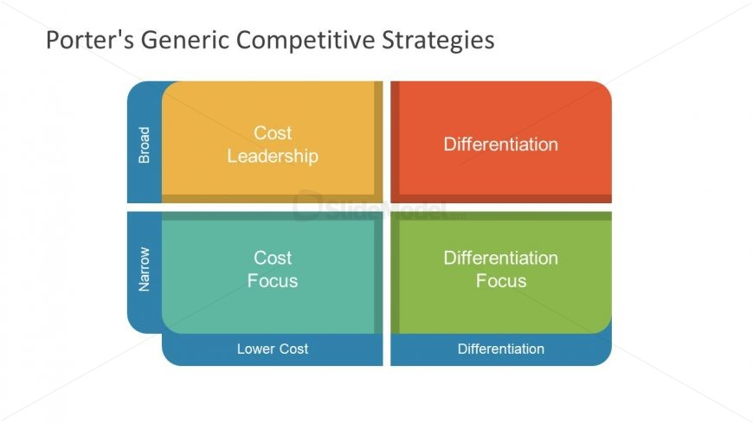
Figure 1: Porter’s competitive strategy
Source: Google images

Analyse the strategy:
The Semi-Automatic Business Research Environment (SABRE) is a global distribution system (GDS) that is a network that enables airlines, travel agencies and others within the travel industry to access travel services and products such as airline tickets, hotel bookings and vehicle rentals, in order to carry out transactions. The most crucial part is that they provide users with real-time access to pricings and inventories. SABRE is regarded as one of the biggest GDS systems and an estimation of around 60,000 travel agencies around the word use it to sell travel products. (Revfine.com, 2019)
The advantage of SABRE is that it has reduced the costs of making airline seat reservations and has been expanded to travel agents to make reservations, for hotels and rental cars, through online terminals, saving 30% on its investments. (Sanghi, 2013)
The disadvantage of SABRE is that the price alone is deterrent for many, as growing businesses may have more success if they invest their funds in other areas of their properties. (Sanghi, 2013)
Cost Leadership: The cost leadership strategy involves being the leader of your industry/market in terms of cost. A low cost producer must find and then exploit all sources of cost advantage, increasing profits by reducing costs, while continuing to charge industry-average prices. If they can sustain overall price leadership, they may be an above average performer in their industry. E.g. Primark.
American Airlines operated with a cost per seat-mile lower than their national competitors. They were the last to stay successful after all of their competitors went bankrupt between 2002-2005. However the bankruptcies allowed the competitors to rework existing union contracts and merge with rivals. As a result, American Airlines declared bankruptcy in November and planned to cut 13,000 jobs.
Product differentiation: The product differentiation strategy involves creating a product that is perceived by your industry as being unique. This reduces the risk of customers switching as you are able to tailor products to customers’ specific requests and requirements, offering an exceptional quality of service. E.g. John Lewis.
American Airlines was the first to start real time applications of concepts. This allowed the replacement of the handwritten system of the 1950’s with the web-based inter airline reservation system in the 2000’s. The SABRE system saved 30% on its investments, so the cost leadership was higher.

- In what ways did SABRE provide American Airlines with a competitive advantage? Your analysis should refer to concepts related to the strategic use of information systems, for example, entry barriers.
Porter’s five forces
Porter’s five forces is a simple but powerful tool that identifies and analyse the five competitive forces of any business environment. It is also help to determine the business strengths and weaknesses. The tool was created by Harvard business school professor Michael E. Porter in 1979. (CHAPPELOW, 2019)
These are the five forces:
- Bargaining power of buyers
- Bargaining power of suppliers
- Threat of new entrants
- Threat of substitutes
- Rivalry among existing competitors
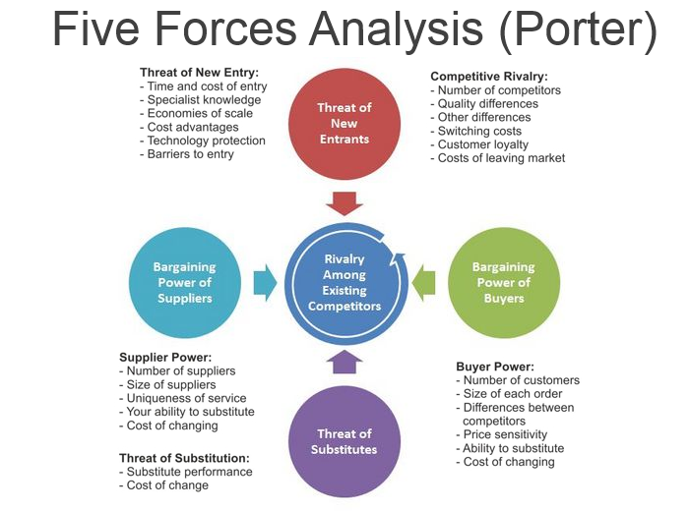

Figure 2: Porter’s Five Forces
Source: Google images

- Bargaining power of buyers – individual flyers buy plane tickets for a number of reasons, and this group of people is extremely diverse. The buyers are the organisation’s immediate customers. The buyers buy through online portals and travel agents, these groups work with multiple airlines to give the customers the best flight and cost possible. If the buyers are powerful enough, they might demand lower prices or improved services, which reduces profits. Overall, the bargaining power of buyers has low threat as there is not a wide range of systems and agents they can use, and SABRE has already reduced the costs of making airline reservations significantly and gives real-time access to prices and inventories.

- Bargaining power of suppliers – in this case, travel agents and online portal are the major suppliers. They supply what organisations need to produce the product or service, and if powerful enough, can reduce an organisations profit. The supplier power is likely to be high as there are only a few suppliers, the cost of switching to an alternative supplier can be high and suppliers can integrate forwards by cutting out the use of travel agents with low cost airlines.

- Threat of new entrants - the threat of new entrants is how easy it is for another company to enter the industry. The entry barrier is too high because you can’t make a system overnight. It is also very costly to create a system, so another company trying to enter the industry would need to have a fairly large amount of capital. Overall the threat of entry is low as the barriers to entry are high because it is very unlikely that a similar system to the SABRE system could be created in a short space of time.

- Threat of substitute – although substitute products are produced in a different industry, they still meet the same customer needs. If there are substitutes, the system’s firm will lower the charges, which in turn reduces profits. The extent of the threat depends on the price and performance of the substitute and how it compares to the industry’s product, switching costs and customer loyalty. A threat from a substitute means the system’s firm will have to improve the performance of their product. The threat here is low as the SABRE system is unique and it would be difficult to create a substitute.

- Rivalry among existing competitors – competitive rivals are organisations that have similar services and products aimed at the same target group and are direct competitors in the same industry. In this case, competitive rivals would be firms with systems targeted towards the same audience in the airline industry. The degree of rivalry would increase with equal size of competitors, low level of differentiation, high fixed costs, high exit barriers and aggressive seeking in leadership. The degree of competitive rivalry for SABRE is low as it is a unique system, so potential competitors would have a hard time reducing the differentiation between their system and SABRE.

SABRE provided American Airlines with a competitive advantage as it is a unique system and is highly developed, meaning it is time consuming and difficult for another firm to create a similar system. The threat of entry is low as the barriers to entry are high

- Although SABRE was undoubtedly successful, American Airlines was not able to maintain its competitive advantage beyond the late 1980s. What factors played a part in the erosion of the company’s lead over its competitors and how did the company react?

One of the things that played a big part in the erosion of American Airline’s lead over its competitors was the Airline Deregulation Act presented by Jimmy Carter in 1978. It is a law that removed government control over various aspects of the airline industry. The act gave airlines more free reign over how they control their business and made it easier for entry level airline companies to break into the industry. This opened up competition allowing more airline companies to enter the market. Low cost carriers began to thrive in the new free market of the commercial airline industry. As a direct consequence of opening up the market and the choice of airlines, this brought about cheaper flights, with a wider selection to choose from and increased the number of passengers using airlines to rapidly increase. Flying was previously a luxury, only really experienced by the rich, but during the 1980’s, the general public now had access to this.
Whilst this was good for consumers who were now spoilt for choice with airlines vying for their business, this was bad news for airlines like American Airlines, who previously were the major players in the aviation industry. American Airlines had to reduce its prices to now compete and its share of the consumer pool was diluted. (Rehal, 2019)

American Airlines sold its shareholding interest in SABRE in the year 2000. This was a disadvantage because it meant that SABRE would now be serving several airline travel providers and customers, rather than being owned by a specific airline with the purpose of serving solely serving them.
American Airline was experiencing a shortfall of cash and, as part of its initiative to raise cash, it decided to sell a ‘once in a lifetime’ unlimited first-class travel ticket to its existing customer base for US$ 250,000,000. Soon after the offer went out to the public, American Airlines realised this was not cost-efficient for them. In fact it was costing them more money than it was making and American Airlines decided to discontinue the perk in 1994, but it long experienced the financial repercussions of this. (Crockett, 2018)
American Airlines managed to keep the competition away long enough for it survive the 1980s and in 1982 it underwent a reorganisation and formed AMR, which is a collective group of 8 subsidiary companies and continued to expand its airline services into different continents from India to South America. To keep ahead of competition, AMR invested in programmes which focused on customer service and better value pricing. Automated check-ins and travel reward programmes, are some of the examples of the innovative programmes AMR came up with. The companies heavy investment in customer experience, widening of flight routes and expansion (AMR eventually brought TWA in the year 2001), meant AMR continued to succeed when other airlines failed.

Part 2 – Information Systems

- Define an information system;
Information system
An information system is an organised combination of software and hardware technologies designed to produce useful and accurate information for decision making purposes. A computer based information system is an information system that uses computer technology to carry out any tasks. (Information system, 2019)

These are the components of information system
- Hardware - hardware refers to machinery, including the Central Processing Unit (CPU) which is usually the computer itself, along with the equipment that supports it. These are devices such as keyboards, monitors, printers and processors, which work together to process and display information.
- Software - software refers to computer programs, which allow data to be processed by hardware, and the instructions that support them. Computer programs are instructions that can be read by machines that direct circuitry within parts of hardware in a CBIS and help with operating in ways that produce useful information from data. These programs are usually stored on tapes or disks.
- Data – data refers to facts that are used by programs for the production of useful information. It is usually stored on a disk or tape that can be read by machines.
- Procedures – procedures are commands/policies that combine the components to process information, produce an output and govern the operation of a computer system.
- People – people are required for a computer based system to be useful and have the largest influence on whether an information system is successful or a failure.

Example of an information system
Moodle:
An example of an information system is moodle, an online learning system employed by many universities in the UK and overseas. Moodle provides students with individual online accounts so they can login and upload work, access course material, contact tutors, track their grades and gain feedback. All work during the course is stored on moodle and can be accessed whenever and from a multitude of devices. (online learning college, 2019)

- Describe the categories of computer-based information systems, providing relevant business examples for each category identified;
Computer based information system:
A computer based information system is an integration of hardware, software and human elements which produce accurate and useful information for decision making purposes.
(Francis, 2010)
There are four types of computer based information systems:
- Transaction processing systems
A transaction processing system captures, stores, maintains, retrieves and updates transactional data to keep records of and input into others CBIS’s. They aim to improve routine business activities which all organisations depend on like transactions such as hiring employees, billing customers and placing orders which affect the whole organisation. These systems provide accuracy and speed. E.g. airline reservations and employee records.

- Management information systems
Management information systems are concerned with management function. They are systems that provide all levels of management the information needed to run a business smoothly. The information must be accurate, relevant and complete. E.g. logistic systems and computer planning systems.

- Decision support systems
Decision support systems provide business professionals information that may be unpredictable and may only be needed once. These systems respond to a wide range of requests, so they do not produce scheduled management reports and support managers in making decisions that are not highly structured, with no clear procedures for making the decision. The judgement of the manager plays a vital part in the decision making process, therefore the decision support system does not replace the judgement of the manager, but rather supports it. E.g. instant messaging software’s.

- Office automation systems
Office automation systems are multi-function, integrated systems that allow a variety of office activities to be performed electronically. These systems are being developed with the hope that they will increase the productivity and efficiency of office workers and professionals. E.g. Microsoft power point.

- Explain how computer-based information systems can support managers at each level of an organisation.

Examples of how Management information systems can support managers at each level of organisations.
Example one: a shop management system
Entry level: sales assistant
Each item in the shop has a unique barcode containing information relating to that product. The information is collected by the data processing system and stored in a central computer system. Upon the sales assistant scanning the item, it will provide the sales assistant will all the information relating to that item such as its price, item name etc. It will also collect raw statistical data.
Mid level: floor manager/supervisor
The data collected is useful information. The floor manager can use this information collected from the data processing system which feeds into the operational information system. This produces information about the business such as identifying the stock that the business is running low on and needs to re-order, complaints received, refunds made etc.
Senior level: unit manager
The information collected is then converted to knowledge. A unit manager will use all the data that has been collected to analyse the data on sales to identify trends. This information can then be used to determine the direction in which the business goes and will influence matters like the orders that are made, the price points, marketing and advertising, whether they need more warehousing facilities and/or employees. This is known as the management information system.
Ultimately, managers will use the data collected from the information systems to identify customers and be ready for the market trends.

Example two: a school management system
Entry level: students/parents/teachers
Software provides a medium by which parents can be updated and is a great tool to allow for teacher/parents to communicate, especially as in this busy day and age, parents are unable to visit the school in person.
Having software designated for students allows them to access all their course materials online, making it versatile and accessible anywhere. It can also provide them data on their personal performance in school such as grades, attendance records and so forth.
Mid level: deputy head teacher
The data collected from the apps for students and parents will result in information which the deputy head teacher can implement. Also, a data processing system will allow the head teacher and support staff to adequately deal with all administrative tasks which not only would be time efficient, but would allow information to be stored in one place, easily accessible to those who need it.
The head teacher can use management information systems to track the progress of students and plan lessons. It will also allow the head teacher to share a single platform with each other, which would allow for collaboration and sharing of best practices.
Senior level: head teacher/governors
A head teacher, together with the governors, can use information management systems for financial planning of the school, allowing the school to manage incoming/outgoing payments, keep a track of its payments, and budget ahead.
It would also allow review of the school’s performance on a holistic level and compare performance to previous years and even against competitor schools.

Reference List

CHAPPELOW, J. (2019). Porter's 5 Forces Definition. [online] Investopedia. Available at: https://www.investopedia.com/terms/p/porter.asp [Accessed 12 Nov. 2019].
CROCKETT, Z. (2018). The men who took 10,000 flights. [online] The Hustle. Available at: https://thehustle.co/aairpass-american-airlines-250k-lifetime-ticket/ [Accessed 25 Nov. 2019].
Francis, A. (2010). Computer Based Information Systems (CBIS) - Meaning and Types. [online] MBA Knowledge Base. Available at: https://www.mbaknol.com/management-information-systems/computer-based-information-systems-and-its-types/ [Accessed 20 Nov. 2019].

Ifm.eng.cam.ac.uk. (2019). Porter's Generic Competitive Strategies (ways of competing). [online] Available at: https://www.ifm.eng.cam.ac.uk/research/dstools/porters-generic-competitive-strategies/ [Accessed 12 Nov. 2019].
Indeed.co.uk. (2019). Store Manager Job Description Examples | Indeed.co.uk. [online] Available at: https://www.indeed.co.uk/hire/job-description/store-manager?aceid=&gclid=EAIaIQobChMI_IDq0feM5gIVAbTtCh3D6wVuEAAYASAAEgI79fD_BwE [Accessed 26 Nov. 2019].
Information Sytem. (2019). Computer Based IS (CBIS). [online] Available at: https://informationsystemis.wordpress.com/computer-based-is-cbis/ [Accessed 20 Nov. 2019].

iSAMS. (2019). School Management Information System - iSAMS. [online] Available at: https://www.isams.com/school-management-information-system-mis/ [Accessed 26 Nov. 2019].
Mindtools.com. (2019). Porter's Generic Strategies: Choosing Your Route to Success. [online] Available at: https://www.mindtools.com/pages/article/newSTR_82.htm [Accessed 12 Nov. 2019].
Online Learning College. (2019). What is Moodle? - Online Learning College. [online] Available at: https://www.online-learning-college.com/news/what-is-moodle/ [Accessed 25 Nov. 2019].
Recruiting Resources: How to Recruit and Hire Better. (2019). Sales Assistant job description template | Workable. [online] Available at: https://resources.workable.com/sales-assistant-job-description [Accessed 25 Nov. 2019].
Rehal, S. (2019). Why Did So Many Major US Airlines Decline In The 1980s? - Simple Flying. [online] Simple Flying. Available at: https://simpleflying.com/major-airline-decline-1980s/ [Accessed 20 Nov. 2019].
Revfine.com. (2019). Sabre GDS: What is the Sabre Global Distribution System?. [online] Available at: https://www.revfine.com/sabre-gds/ [Accessed 12 Nov. 2019].
Sanghi, M. (2013). Disadvantages of GDS. [online] Hotelogix.com. Available at: https://www.hotelogix.com/blog/2013/07/25/disadvantages-of-gds/ [Accessed 12 Nov. 2019].
Scheier, R. (2002). Technology Takes Flight. [online] Computerworld. Available at: https://www.computerworld.com/article/2578996/technology-takes-flight.html [Accessed 25 Nov. 2019].
Sites.google.com. (2019). Porter's Five Forces - Airline Industry Analysis. [online] Available at: https://sites.google.com/site/admn703ai/the-team [Accessed 12 Nov. 2019].

