Community Engagement - Assessment 2

  - Student Name: Valeria Peeva
  - Student Number: 2029005

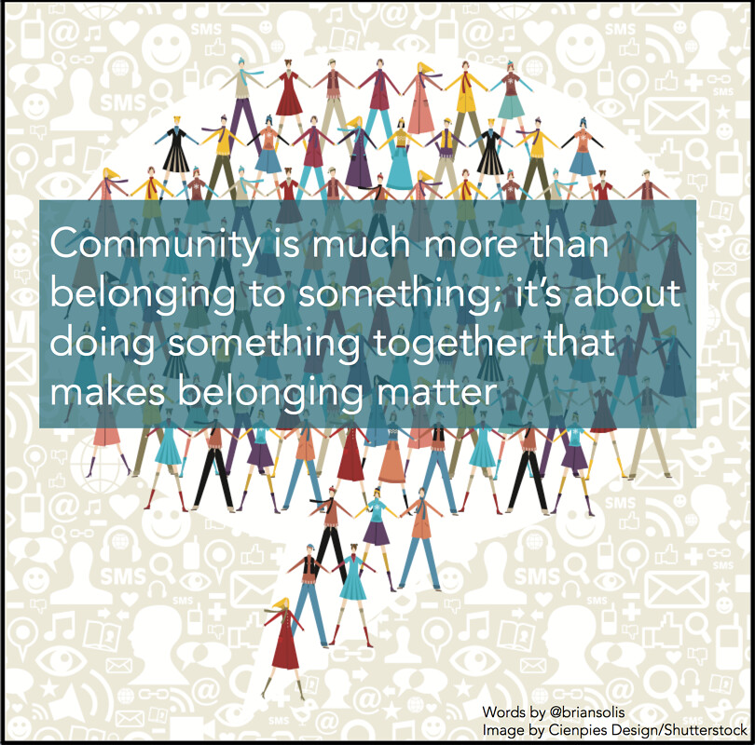
This Photo by Unknown Author is licensed under CC BY

Programme: BA Business Management
Module: Community Engagement
Module code: LCBB4002
Module Coordinator/ Lecturer: Toyin Adisa
Table of Contents
Introduction 3
Community engagement approaches and reflection 3
Successful community engagement 5
Community mapping 5
Social engagement 5
Impact analysis 6
Conclusion ………………………………………………………………………………………………………………………………………..7
References ………………………………………………………………………………………………………………………………………..8

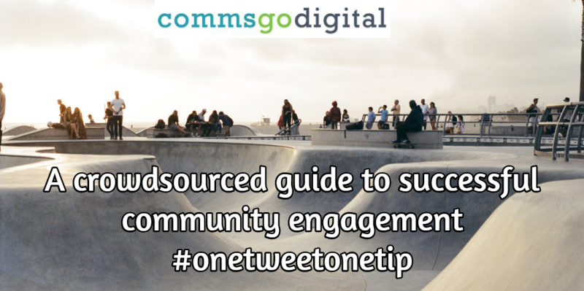
This Photo by Unknown Author is licensed under CC BY-SA-NC

Introduction
Community engagement is the process of bringing collaboration in the working of people with diverse geographic locations, societies, culture, interest etc. to solve the issues or address the problems that are affecting their well-being and calmness. There are various stages of commitment for individuals. It can vary from being discussed over a planned programme of activity, establishing the distribution of funds of a development, or being interested in the manner of a facility. Subject on the goals, the problem, and the public to be involved with, several methods could be more than appropriate than others. Third Age Project was founded in 1997 to provide the demands of 1 in 4 of the resident people who are over 60 years of age. Over the last two years it gets an essential and common service within the borough of Camden. They won an Innovation in Volunteering Award by putting a community time bank as an independent sister charity that brings successful intergenerational projects (e.g., annual Grandparents Day) that has made the generations all together in developing joint sense and faith. This report will exhibit a contemplation on exactly how to successfully manage a public engagement plan. It will also take into consideration the finest procedures, standards, methods, tactics, ethics, and requirements. The reflection will be crucial and understandable, it will put together a hypothetical position and implement appropriate prototypes to determine the knowledge.
Community engagement approaches and reflection
A range of public commitment techniques must be deemed when designing an investor affairs plan. Four common area meeting practices are public gatherings, attention classes, assessments, and virtual commitment – and there are pros and cons to utilizing each one. The methodologies you apply will be contingent on the classes of participants being discussed and the planned consequences of your programme. The existence is that various commitment procedures will possible be essential to convey with a selection of shareholders. Matters, goals, investor combination, and existing assets will all provide to establishing the ultimate structure for your participant meeting proposal. Neighbourhood conferences municipal or town hall gatherings know how to be a useful means of distributing evidence. The face-to-face environment of these issues delivers a fantastic prospect to establish honesty and clarity to participants. It is crucial to believe what will make your experience fascinating to investors – and inspire audience. The strengths are occasion to provide data and collect advice. Public conferences can be applied efficiently at the start of a project to describe methods and consequences. Excellent for gathering participants in person, and to establish openness. Can be helpful for neighbourhood outreach or to entice broadcasting awareness for your development or plan. The weaknesses are that turnout could be minimal. Shareholders are not expected to join except they consider directly impacted by results linked to your development or presentation. If a problem or design is especially contentious, this might not be the correct procedure for commitment. Media advertising can be damaging if the conference is hostile or not managed good. Attention classes promote conversation and perform good when moving out to lesser or disregarded shareholder parties. The dynamic conversation among participants is improved when questioned dedicated matters, and a comfy atmosphere is made. The strengths are that the tiny party set is an effective means to manage assets and recognize crucial problems. Focus groups can be organized and coordinated to achieve a certain alliance of investors or created over a specific subject. If there is disagreement, it can be treated more clearly in a little party. The weaknesses are that it must require a skilled mediator to guarantee the procedure goes effortlessly. Focus groups are not an efficient process to guarantee all investors and perceptions are characterized. Assessments or surveys frequently expect yes/no (or mounted) inquiries to parties of individuals to recognize public judgment. They are helpful for gathering outreach. The strengths are that is valuable to gather and organise mathematical data. Information can be applied to evaluate outcomes from another time or compared to various investor parties. It is a fast and cost-efficient approach to connect with larger classes of individuals. The weaknesses are that analyses are not generally practical to distinguish motives following investor thoughts. They are not as successful in creating public relations or creating conversation. Reaction costs can be reduced, assessment levels are frequently less than 20%. Third Age Project expands excellence of time across a broad varying weekly programme of available learning, healthy living, social and physical actions. They increase overall wellbeing and expertise with a 60+ health club where consumers maintain and inspire each other, join health discussions with experts. They also produce positive English speakers by operating English discussion groups and defeat severe isolation over chances to develop more relationships and individual aid systems. Community engagement, community leadership and community services are the most important ways by which community engagement can be obtained. Being engaged with the community in each person life is very important to channelize their optimum growth and development of the people within the community. Reflection is the method of remembering or describing what you faced. Evaluation is the process of assessing that reflected knowledge like identifying what functioned and/or what didn't. I have made extensive research about this project by reading all the articles available, by having discussions with people in the community and by making sure I have all the knowledge available to be able to write the report about the community project and now for the reflection of this project. Reading local newsletters helped me understand better the community centres and how they work and for what reasons. It showed me the strategies, planning and all the methods they use to bring people together. All the different projects they work on showed me how they help the people in need and how they evaluate all problems in a better and more efficient way. They help people learn about the local news and be aware of any changes due. They give you the opportunity to join different projects and to be involved in training and mentoring skills classes. This class offered me all the knowledge that I need to be able to compose the report and to be confident in giving the information about the reflection of my work.


This Photo by Unknown Author is licensed under CC BY-ND

Successful community engagement
Building healthy relationships and trust among the people can help to enable their connection to the project and oral processes for the people working in the community. It requires consistent efforts and measures to strengthen and the interrelated connectivity across the community. I understood that being engaged within a community helps every person around us to tackle the difficult situations easily and effectively by working in teams and developing solutions to the problems. There are many attributes, qualities, and skills that I think are very vital for a leader to constantly engage people and get engaged within the community, and cultural competencies for the betterment. It is important to show great leadership qualities that are essential for developing good community engagement among the people. Precise and intentional languages are very helpful for communicating with the members of the public and enhance the community engagement activities disregard of any disparity among them. These ways are very active to enhance the community engagement activities of the people and improve their overall perceptions towards community development. By utilising it the Third Age Project is helpful in achieving community engagement. I understood that knowledge can help to understand the community engagement by understanding the background of people and helping them to adjust with the community. Everyone should bring positive change by obtaining a collaborative corporation among the teams so that their awareness and knowledge can be utilised for creating better actions for the people.
Community mapping
Community planning (occasionally known as asset mapping) is all about engaging citizens in recognizing the resources of their area, looking at chances and making a perfect example of what it is like live there. Every society has benefits like amenities and archives and civic buildings, respected companies, gardens, and woodlands. But extremely crucially the individuals and their capabilities, established public parties or people who have abilities and gifts. All these ideas can be plotted to produce an image of the society which demonstrates its capability and its possibility. Public planning knows how to inspire communities developed effective supporters for the renovation of the areas in which they reside, developing further civically willing during action. It can likewise encourage a feeling of ecological and civic accountability in regional citizens.
Social engagement
Social engagement is the method of conveying (participating) in a virtual society. The discussion can take place on specific social media platforms such as LinkedIn, Twitter, Facebook, or in blogs, conferences, and third-party analysis sites. A powerful social engagement approach permits companies to continue in frequent communication with their clients by improving product concerns and reacting to response in a continuous phase. When corporations participate and react to client assistance demands over social media, those consumers end up paying 20% to 40% more cash with the corporation. Discussions concerning your association, your business, and your activities are continually happening online, whether you decide to contribute. Only once you enter a dialogue can you change its way and its consequence. The purpose of social engagement devices, alongside with a vibration approach and powerful messaging, permit you to cooperate with your consultation and structure the discussion encircling your style or invention. Social media is quickly developing the leading technique for interaction throughout the globe, producing equally a demand for effective reaction and a chance for product feeling progress. An efficient societal commitment policy is guided by community hearing and examination, which can be performed across a collective analytics implement, similar to Clarabridge Engage.

Impact analysis
The best practices for meaningful community engagement can be utilised because by representing populations in visualising and planning the community engagement activities. If a high number of views are obtained from different people who have lived different lives and have different experiences, they can provide important visions for planning the community engagement activities effectively. Influence assessment, additionally well-recognized as transformation impact analysis, was initially defined in 1996 by American software technologists Robert S. Arnold and Shawn A. Bohner in their paperback named Software Maintenance. In the hardcover, Arnold and Bohner acknowledged that affect evaluation is recognizing the possible effects of a shift or assessing whatever demands to be altered to achieve a difference. In preparation, impact analysis is a comprehensive survey of corporate interests, needs, and transportation. It shows how important goods and services are provided and explores the possible effect of a disturbing occurrence across period. Corresponding to Arnold and Bohner, there are three key sorts of impact analysis: traceability impact analysis describes the connections among conditions, requirements, layout components, and analyses, evaluating their interactions to establish the extent of an instigating adjustment. Physically deciding what will be impacted by a switch can be enormously time-exhausting in complicated tasks, which is where conditions managing package take place. The second is dependency impact analysis which is utilized to establish the extent of the influence on the structure. The third one is experiential impact analysis which reflect the previous knowledge of professionals in the business, practical impact analysis examines what occurred in comparable circumstances in the earlier period to ascertain what may possibly take place in the time to come.

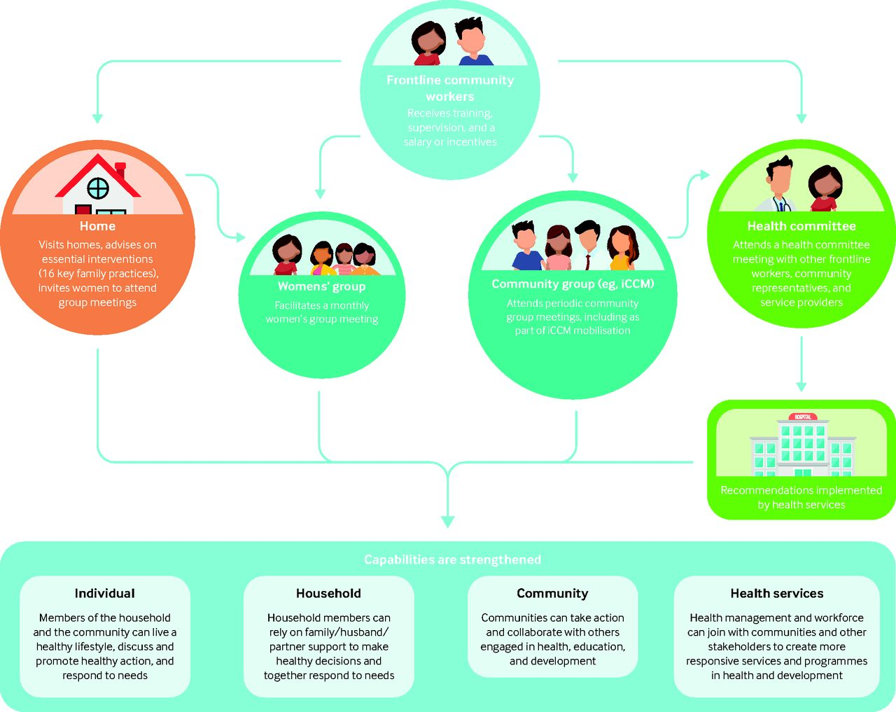
This Photo by Unknown Author is licensed under CC BY

Conclusion
It has been obtained from the report that community engagement is helpful to enhance the organisational community as well as the whole society of the people. Moreover, it has been describing the differences by evaluating the best practices of community engagement that requires the position of certain skills and abilities for the growth and development of our community. This paper reflects upon the problems and prospects the public representatives and associates confronted as they established common faith, and a feeling of general principles and objectives.


This Photo by Unknown Author is licensed under CC BY-NC

References
An overview of effective community engagement methods, Available at: https://www.sustainet.com/community-engagement-methods/ (Accessed on 20/04/22)
Community Engagement - What is it and why is it important, Available at: https://www.londoncouncils.gov.uk/node/5871 (Accessed on 20/04/22)
Evaluating community projects, Available at: https://www.jrf.org.uk/sites/default/files/jrf/migrated/files/1859354157.pdf (Accessed on 19/04/22)
Exploring Strategic Factors of Community Development, Available at: https://www.universalclass.com/articles/business/exploring-strategic-factors-of-community-development.htm (Accessed on 19/04/22)
Five Benefits to Community Involvement, Available at: https://www.getpushing.com/blog/2021/08/five-benefits-to-community-involvement/ (Accessed on 19/04/22)
Moon J. (2004) A handbook of reflective and experiential learning: theory and practice
Reflections on Community Engagement: Making Meaning of Experience, Available at: https://www.researchgate.net/publication/303985093_Reflections_on_Community_Engagement_Making_Meaning_of_Experience (Accessed on 19/04/22)
Social Media Engagement: Why it Matters and How to Do it Well, Available at: https://buffer.com/library/social-media-engagement/#:~:text=Social%20media%20engagement%20is%20a,Likes%20and%20Favorites (Accessed on 21/04/22)
Third Age Project, Available at: https://www.facebook.com/thirdageproject/ (Accessed on 21/04/22)
Useful Concepts for the Practice of Community Engagement, Available at: https://www.atsdr.cdc.gov/communityengagement/pce_useful.html (Accessed on 21/04/22)
What is social engagement?, Available at: https://www.qualtrics.com/experience-management/customer/social-engagement/#:~:text=Social%20Engagement%20is%20the%20process,and%20third%2Dparty%20review%20sites. (Accessed on 21/04/22)

