Early Assessment Engagement and Programme Completion among Mature Learners on a Widening-Participation Programme: A Secondary Quantitative Analysis of Three Level 4 Applied Leadership and Management Cohorts

Abstract
Mature learners on widening-participation programmes are a priority group in United Kingdom higher education, but programme-level evidence about non-completion and how early it can be identified remains limited (Gongadze, 2021). This study analysed three years of institutional data from a Level 4 Applied Leadership and Management programme at a Welsh university (168 enrolment records representing 159 students, 83.3% female, mean age 35.9 years). Five hypotheses were examined using chi-square, independent-samples and paired-samples t-tests, Pearson correlation and Welch's analysis of variance, with Spearman and Wilcoxon used as targeted sensitivity checks. Students who submitted the first assessment were far more likely to complete the remaining five modules than those who did not: 80.8% versus 7.9%, chi-square(1, N = 168) = 64.88, p < .001, φ = .64. Repeat-enrolment records averaged 9.64 marks lower, t(149) = 3.76, p < .001, g = 0.82. A higher number of non-submissions was associated with lower mean marks, r = -.38, p < .001. Mean marks did not differ across cohorts, Welch's F(2, 83.6) = 0.17, p = .842, or across the module sequence, t(127) = 0.32, p = .747. A person-level check confirmed these conclusions, by repeating the five main tests against the most recent enrolment record for each student, ensuring that findings were not caused by the difference between enrollments and actual students as 9 students reenrolled for a subsequent year. Formal confirmation of reasonable adjustments through a Statement of Compensatory Measures was recorded on 12 of the 168 analysed enrolment records, held by 10 of the 159 students; this represents 6.3% of students.

Keywords
assessment engagement; non-submission; programme completion; widening participation; mature learners; secondary data analysis

1. Introduction
Programme completion among mature learners on widening-participation (WP) programmes is a persistent concern for higher education institutions (Office for Students [OfS], 2021). In the United Kingdom, widening participation policy primarily focuses on access, retention and attainment for students from non-traditional backgrounds, including mature learners who enter higher education later in life and frequently combine study with employment and caring responsibilities (Moore et al., 2013; OfS, 2021).
At the University of Wales Trinity Saint David (UWTSD), Level 4 Applied Leadership and Management (ALaM) students in the Institute of Management and Health are predominantly mature learners, and the programme is delivered across five campuses in south and west Wales. Entry is open, in that admission considers relevant work and supervisory experience rather than prior formal qualifications and is reflected in a cohort mean age of 35.9 years.
Together, the open-entry route and mature learner course profile make this a widening-participation programme. However, the data contains no individual-level widening-participation indicators (Section 5.7).
Structured, strengths-based academic literacy support may therefore help students translate professional knowledge into academic work while supporting confidence, self-efficacy and belonging (Gilani & Thomas, 2025).
Research indicates that mature learners often arrive demonstrating strong commitment and motivation, while many initially experience uncertainty about belonging, confidence and academic expectations that can shift during study (Erb & Drysdale, 2017; Jones et al., 2025).
Supportive environments are associated with greater engagement and reduced disengagement (Chen et al., 2023), but stigma, uncertainty about services and self-doubt can limit the extent to which students, in practice, utilise the support available to them (Hyseni Duraku et al., 2023; Pollard et al., 2021). HE Sector reports indicate that progression and attainment remain uneven for disabled learners, with the integration of support into teaching and assessment identified as a key contributor (Advance HE, 2023).
On a work-based programme such as ALaM, the more important question may be whether students are able and willing to engage with support, not simply whether support exists.
Within the ALaM programme, academic support is available to all students. Internal programme monitoring suggests that patterns of non-submission, extenuating circumstances (ECs), completion and progression may vary between cohorts and across academic years. This raises an important practical question: can students at greater risk of non-completion be identified using information already held by the programme, and how early in the student journey does this information become available?
This is particularly relevant to widening-participation students, for whom academic self-efficacy, study strategies and sense of belonging are identified as intermediate outcomes associated with access, persistence and success (Thomson et al., 2022).
Given UWTSD’s commitment to widening participation and retention, routinely collected administrative data may help programmes identify students who could benefit from timely, targeted academic support. Such information cannot guarantee success, but it can identify patterns associated with risk and provide a basis for earlier, proportionate intervention. Early-alert systems can identify students at greater likelihood of discontinuation, though the effectiveness of the support that follows identification varies across settings (Larrabee Sønderlund et al., 2019; Villano et al., 2018).
Considering this, the study examines which early signs of assessment engagement and enrolment, already visible in university records, are associated with programme completion and academic attainment among Level 4 ALaM students, and reports descriptively on the prevalence and timing of formally confirmed reasonable adjustments. The aim is addressed through one main research question and three sub-questions:

Main research question: Which early signs of assessment engagement and enrolment, already visible in university records, are associated with programme completion and academic attainment among mature learners on a Level 4 work-based widening-participation programme?

SQ1. Is non-submission of the first assessment associated with completion of the remaining modules?
SQ2. Is repeat enrolment associated with differences in academic attainment?
SQ3. Is the number of assessment non-submissions associated with academic attainment?

2. Literature Review
2.1 Widening participation, mature learners, progression and achievement
The widening-participation literature identifies mature learners and those entering higher education through non-traditional routes, including students with limited prior qualifications or interrupted educational histories, as groups with distinctive strengths, circumstances and support needs, and documents persistent inequalities in their access, continuation, completion and attainment (Gongadze et al., 2021; OfS, 2021, 2024; Robinson & Salvestrini, 2020).
In 2021–22, entrants classified by the OfS as significantly disadvantaged had a continuation rate of 84.6%, 6.9 percentage points lower than other entrants and 5.1 percentage points lower than economically precarious entrants (OfS, 2024).
Mature learners often enter higher education with substantial life and work experience and may view study as a route to personal development, career progression or occupational change. However, many also balance study with paid employment, financial pressures, caring responsibilities and time constraints, which can affect engagement, continuation and academic outcomes (Gongadze et al., 2021; OfS, 2021).
Qualitative research with mature undergraduates suggests belonging and confidence can develop through course-based communities of practice, even where students initially feel uncertain about their place in higher education (Jones et al., 2025), and that beliefs about learning capacity can shift during study (Jones & McConnell, 2023). Academic and social engagement are independently associated with belonging and retention (Ahn & Davis, 2023), and among mature international students, provision recognising prior experience is linked to stronger belonging (Pervez et al., 2024).
Age itself should not be treated as a proxy for ability or motivation: outcome differences by age persist but are not explained by age alone (OfS, 2021, 2024), and mature students are a heterogeneous group shaped by study mode, prior qualifications, work and caring responsibilities and access to support (Gongadze et al., 2021). Age is therefore examined here descriptively, comparing records below and above the Student Finance England threshold of 25 years. These findings provide the backdrop for examining non-submission, assessment disruption and completion among Level 4 ALaM students, who are primarily mature learners on a widening-participation programme.

2.2 Engagement, non-completion and early assessment engagement
Research on non-completion has increasingly moved from asking which students leave to asking when their departure first becomes visible. Behavioural indicators drawn from routinely held records can outperform demographic ones: among first-year business and social science students, the proportion of subjects failed and not attended in the first semester carried significant predictive power for dropout (Ortiz-Lozano et al., 2024).
Assessment submission is among the earliest of these signals. Linden (2022) describes an Australian retention model built on monitoring submission of a single early assessment item, allowing students who had not engaged to be contacted before the first census date. The behaviour appears persistent rather than incidental: across two assessments in an online first-year course, students who submitted on time initially were most likely to do so again, whereas early non-submission was associated with continued non-submission or withdrawal, and marks did not differ meaningfully between submission categories (Cochrane et al., 2026).
Why students do not submit is less well established. At a United Kingdom widening-participation institution, two-thirds of the reasons students gave were situational, principally health, family and caring responsibilities, rather than dispositional (King & Loddick, 2026). This connects non-submission to the competing demands described in Section 2.1.
UK research shows growing use of learning analytics and early-alert systems to identify patterns associated with engagement, progression and retention. At the Open University, predictive indicators based on learner activity and assessment data are used to identify students at risk of not submitting their next tutor-marked assignment, enabling tutors and student-support teams to consider timely support (Boroowa & Herodotou, 2022). Recent UK case-study research similarly identifies student engagement, retention, progression and wellbeing as key uses of learning analytics, while also emphasising variation in institutional practice and the importance of interpreting data in context (Dixon et al., 2025).
Identification and effective response are separate problems, however, and the support provided after students are identified has variable effects across settings (Larrabee Sønderlund et al., 2019; Villano et al., 2018).
Enrolment pattern is a second routinely recorded indicator. Students who experience an initial interruption to enrolment are more likely to experience further interruptions and less likely to graduate (DesJardins et al., 2006). The direction is not uniform: where repetition of a full year is mandated rather than chosen, it has been found to raise subsequent grade point averages while also increasing first-year dropout (Tafreschi & Thiemann, 2016). Repeat enrolment may therefore mark disruption, remediation, or both, and is examined here as an association rather than an explanation.

2.3 Academic literacy, belonging, self-efficacy and support
For Level 4 ALaM students, transition into higher education may involve translating substantial professional and managerial experience into the forms of academic work required for assessment: academic writing, critical reading, the use of evidence and engagement with feedback. This may be particularly relevant for mature students entering through non-traditional routes, who may have limited recent experience of formal study but should not be understood through a deficit model (Farini & Scollan, 2021; Lyu et al., 2025). Academic-literacy support is therefore best understood as helping students engage with unfamiliar expectations while drawing on existing knowledge rather than assuming a lack of ability.
Belonging and academic self-efficacy are increasingly recognised as important in understanding engagement, persistence and success among widening-participation cohorts; at one such UK university the social dimension of learning was identified as an important source of academic self-efficacy among first-year students (Jones et al., 2025; McKenzie et al., 2024; Reilly et al., 2024).
These constructs are relevant because students' confidence, sense of legitimacy and willingness to seek help may shape engagement with assessment. They are not measured directly in the institutional dataset used here, and the study therefore treats them as plausible explanatory mechanisms rather than as measured variables.

2.4 Additional learning support and academic support in higher education
Research and sector guidance suggest that supporting student achievement is most effective when academic support, disability provision, wellbeing support and opportunities for social and academic integration are coordinated across the student journey rather than introduced reactively (Kutscher & Tuckwiller, 2019; Moriña & Biagiotti, 2022; Römhild & Hollederer, 2024). UK policy and sector reports indicate that progression and attainment for students with disabilities and additional learning needs remain uneven, and emphasise embedding support within curriculum design, delivery and assessment (Advance HE, 2023; OfS, 2019; Reardon et al., 2021).
The quantitative studies closest to the present design reach mixed conclusions. A scoping review of 46 empirical studies found disability-related services and testing accommodations less consistently associated with academic success than interventions promoting social and academic integration (Römhild & Hollederer, 2024), whereas in a large United States sample students who accessed support were more likely to persist or complete (Newman et al., 2021). Timing and sustained use may matter as much as access, though the pattern varies by disability group (Blasey et al., 2023; Freeman, 2025).
One reason for these inconsistencies is that support is not randomly allocated. Students who access it may already differ from those who do not, in disability-related need, prior educational experience and other characteristics associated with outcomes, so differences between support users and non-users cannot automatically be attributed to support itself (Balzer Carr & London, 2019; Römhild & Hollederer, 2024). Recorded use may also understate need: a systematic review of academic help-seeking identifies stigma, self-reliance and uncertainty about available services as recurring barriers (Martín-Arbós et al., 2021), and these may weigh more heavily on students with limited recent experience of formal education (Bornschlegl et al., 2020).
The present observational study therefore interprets any association between recorded adjustments and student outcomes cautiously and does not infer causation.

2.5 Limitations of the existing evidence and the contribution of the present study
The literature establishes that academic, disability and social support can be relevant to engagement, continuation and attainment for mature and widening-participation learners, but evidence on individual support use remains mixed. Much of the quantitative literature is based on North American disability-service contexts where support users and non-users differ in underlying need, so observed differences cannot readily be read as causal effects of support (Freeman, 2025; Newman et al., 2021; Römhild & Hollederer, 2024).
Nevertheless, there is limited published evidence examining whether routinely collected assessment-submission records and adjustment information can provide an early indication of completion risk within work-based, multi-campus programmes serving primarily mature learners. This is relevant because national statistics can show that outcomes differ across groups, but they cannot show how assessment engagement and support operate within a particular programme (OfS, 2024).
The present study addresses this gap through secondary analysis of three years of anonymised institutional data from the Level 4 Applied Leadership and Management programme at UWTSD. It examines associations between early assessment engagement, enrolment pattern, assessment disruption, academic attainment and Level 4 completion, and describes the prevalence and timing of formally recorded reasonable adjustments in the same cohort, adding programme-level evidence to a literature that has largely addressed national patterns, broad institutional interventions or online learning environments.
The study does not test whether support causes improved outcomes, nor does it directly measure academic literacy, belonging or self-efficacy; it evaluates whether data already recorded by the programme are associated with completion and attainment. Associations are interpreted cautiously, since support allocation is non-random and administrative records cannot capture all factors shaping engagement and progression.

3. Methodology
This study adopts a secondary quantitative, observational design using anonymised student-level institutional data for Level 4 Applied Leadership and Management (ALaM) students. A quantitative approach suits research questions about measurable associations between assessment engagement, enrolment pattern, assessment disruption and outcomes including marks and completion; because these variables are recorded numerically or categorically for the full cohort across three years, the dataset supports both descriptive and inferential analysis (Creswell, 2009; Saunders et al., 2019).
The study sits within a post-positivist tradition: it uses observable institutional records and hypothesis testing while recognising the data are observational rather than experimental, so findings are interpreted as probabilistic associations rather than causal effects. This applies with particular force to the SCM data, which record adjustments granted in response to identified need rather than assigned at random.

3.1 Researcher positionality and reflexivity
The researcher occupies an insider position, holding teaching and programme responsibilities on the ALaM programme. Positionality is relevant in quantitative as well as qualitative research because it can shape the questions selected and the interpretation of findings (Cohen et al., 2018; Holmes, 2020), and is treated here as part of the research design rather than only a limitation.
Insider status provides contextual knowledge of the programme and its coding conventions but also creates potential for bias (Saunders et al., 2019); the researcher taught 40 of the students in the dataset. All marks are subject to blind marking, internal moderation and external moderation by the awarding body, so the marks analysed are final agreed outcomes rather than marks as originally awarded, and access to anonymised data was restricted to the purposes of this study.
Several features reduce the potential influence of researcher expectations: hypotheses, variable definitions and the analytical strategy were specified before outcome data were examined, group-difference hypotheses were non-directional, sensitivity analyses test whether findings depend on reasonable alternative coding decisions (Appendix C), and a data dictionary documents variable construction, recoding and exclusions.

3.2 Data source and sample
The dataset comprises anonymised student-level records drawn from internal institutional administrative systems for all Level 4 ALaM students enrolled across three completed academic years, an appropriate source of secondary data where access is authorised, confidentiality protected and variables sufficiently documented (O’Leary & Hunt, 2017; Saunders et al., 2019).
No sampling procedure was used; the dataset is therefore a census of the accessible programme population for the study period rather than a sample drawn from it, and pooling records across three years reduces the extent to which findings may reflect a single cohort. Appendix F sets out how this dataset was built from the original source records.
The multi-year design does not remove potential cohort effects, so academic year is retained as a contextual variable and reported descriptively.

3.3 Variables and measures
The variables entering the hypotheses are non-submission count, whether a mark was recorded for module 1, modules attempted and enrolment pattern. Academic year, age at start and gender characterise the cohort and are reported descriptively rather than tested. Outcome variables are mean academic mark and completion, defined as a recorded mark for all six modules. Enrolment pattern distinguishes repeat-enrolment records (n = 28) from single-year records (n = 140). A repeat enrolment is a return to the programme to complete modules outstanding from an earlier enrolment rather than a first year of study; because a student may return from an enrolment that began before the study period, the 28 records are not confined to the nine students who appear twice within the three-year window (Section 4.1.1). Mean academic mark is calculated from full academic marks, the best available uncapped numeric mark for each module, including marks awarded following extenuating circumstances or late submission. Capped marks, the official marks after capping rules are applied, are held separately and are not analysed. Students may submit up to seven days after a module deadline and still receive a mark, capped at 40; a module is only treated as not submitted once that seven-day window has passed. Whether a mark exists for a module, whatever its value, is therefore normally known within eight days of the deadline. Presence of a Statement of Compensatory Measures (SCM) record and its creation date were obtained from Learner Support and are reported descriptively only, for the reasons set out in Section 3.7.
Age and marks are treated as scale variables; enrolment pattern, academic year, gender, module 1 submission status and completion as categorical; non-submission and EC totals as counts. Age was derived from date of birth at a single reference date, after which date of birth was removed from the working dataset.

3.4 Data preparation
The dataset was cleaned, coded and pseudonymised before analysis. Direct identifiers were removed and replaced with study codes, and a data dictionary records each variable, its source, coding, measurement level and derivation. Inclusion and exclusion decisions, duplicate records, implausible values and missingness were documented so that the analysis can be audited and repeated. Corrections applied during preparation are logged in the workbook's change record and summarised in Appendix C.
Missing marks, non-submissions, extenuating circumstances and deferred assessments were retained as analytically distinct states rather than recoded as zero. Because capping applies most often to records returning through re-enrolment, using uncapped full marks throughout gives those records their most favourable comparison. Appendix C sets out the coding rules and the sensitivity checks used to test whether reasonable alternative decisions changed the findings.

3.5 Hypotheses
The analysis tests five null hypotheses using procedures selected from the measurement level and structure of the variables rather than from the results obtained, each on between 128 and 168 records depending on the completeness of the variables required.
Each null hypothesis states that there is no association, correlation or difference in the wider population, and each alternative that one exists; all are non-directional. Where a variable formed part of an outcome definition the analysis was restructured to avoid circularity: because completion of all six modules includes Module 1, H1 defines the outcome as completion of Modules 2 to 6.

H1. No association between a recorded mark for Module 1 and completion of Modules 2 to 6.

H2. No difference in mean academic mark between single-year and repeat-enrolment records.

H3. No linear relationship between number of non-submissions and mean academic mark.

H4. No difference in mean academic mark across academic cohorts.

H5. No difference in mean marks between the first and second halves of the module sequence.

H4 and H5 are sensitivity checks on the dataset rather than substantive outcomes, testing whether findings depend on cohort or on position in the module sequence. The analysis therefore has three tiers. Five relationships are tested inferentially. Two are reported descriptively only: formally confirmed reasonable adjustments, which were the study's original focus but yield expected cell counts far below the conventional minimum at 12 cases; and gender. Neither forms part of a hypothesis, and in each the group sizes are such that only a large difference would be detectable, so a non-significant result would not distinguish the absence of a difference from insufficient evidence to detect one. A third focus, the comparison between records below and above the age of 25, is examined using supplementary exploratory inferential tests reported in Section 4.2.7 rather than as a formal hypothesis; the group is small, so these results are interpreted cautiously.

3.6 Data analysis
Descriptive statistics establish the composition of the dataset before inferential testing: frequencies and percentages for categorical variables, and means, standard deviations and ranges for age, marks and counts. Because cases with missing values are excluded test by test, the valid n is reported separately for each analysis.

3.7 Inferential analysis
Each test was chosen to match the variables and the design.
A chi-square test with Yates's continuity correction examined the relationship between module 1 submission and completion of modules 2 to 6 (H1), with phi reported as the effect size.
An independent-samples t-test compared mean marks for single-year and repeat enrolment records (H2), with Levene's test checking equal variances and Hedges's g reporting effect size.
Pearson correlation tested the relationship between non-submission count and mean mark (H3); Spearman's rank correlation was added as a targeted robustness check because non-submission is a count variable.
Welch's one-way analysis of variance compared mean marks across the three cohorts (H4), because the equal-variance assumption was not met.
A paired-samples t-test compared the first and second halves of the module sequence (H5), with Wilcoxon's signed-rank test used as a targeted robustness check.
Significance was assessed at p < .05, with results reported as the test statistic, degrees of freedom, exact p value, group statistics, 95% confidence intervals and effect sizes where appropriate.
Two analyses specified at the design stage were not conducted: a before/after comparison around the SCM date, abandoned for insufficient usable cases, and a multivariable completion model, abandoned because its strongest predictors are part of how completion is defined and produce complete separation. Both decisions followed from the data rather than any result; the full reasoning is set out in Appendix F6.

3.8 Ethics, access and data governance
Formal permission was obtained for access to the institutional records, and the study followed university research-governance and data-protection requirements. Only necessary variables were retained, direct identifiers were removed, files were stored securely, and outcomes are not reported separately for any group smaller than ten records, where doing so could permit indirect identification. Linkage between programme and Learner Support records was carried out by the institution's Head of Data rather than by the researcher, and only student identifier and record-creation date were transferred. Approval covers assessed coursework and internal course improvement; external publication would require further approval.
Contextual information about support was provided by the Head of Learning Support (personal communication, 18 August 2026): specialist one-to-one academic support is available to all students through the institution's General Study Skills provision, irrespective of disclosure, delivered bilingually by staff with SpLD qualifications beyond their teaching role.
This is material to interpreting the SCM data in Section 4.2.6, because it establishes that students without a formally confirmed adjustment cannot be characterised as unsupported. Uptake is not recorded and is identified as a limitation in Section 5.7.
In accordance with APA convention, personal communications are cited in the text only and are not listed in the references.

3.9 Reliability, validity and limitations
The strength of a secondary design lies in working with real student records generated through routine academic processes; its limitation is that the researcher has no control over which variables were collected or how they were coded (O'Leary & Hunt, 2017; Panchenko & Samovilova, 2020).
Following Saunders et al. (2019), three threats to internal validity are salient.
Mortality is the most direct, since students who withdrew are by definition those whose records are incomplete.
Instrumentation applies because module titles, assessment types and deadlines varied across the three cohorts.
Ambiguity about causal direction applies throughout, and with particular force to the SCM data, since a formally confirmed adjustment is typically obtained after a student has encountered difficulty.
The study therefore interprets findings as association and difference rather than proven impact (Creswell, 2009).

3.10 Software
Data were cleaned, coded and pseudonymised in Excel. All derived variables, descriptive summaries and inferential tests were computed in IBM SPSS Statistics (Version 30). Output confirming each analysis reported below is provided in Appendix E.

4. Results
4.1 Descriptive statistics
4.1.1 Sample characteristics
The analysed dataset comprised 168 enrolment records for Level 4 Applied Leadership and Management students, taught at Treforest, Bridgend, Cardiff, Swansea and Carmarthen over three academic years (2022/23, 2023/24 and 2024/25). These records were taken from 216 Exam Board source rows after 48 exclusions: 14 duplicate board entries, 33 records with no evidence of attendance, and one record for a student whose enrolment fell outside the three-year study period.
The 168 records represent 159 individual students, nine of whom appear twice. The analysis is therefore on the enrolment episode rather than the student: each record is one student's year on the programme.

Table 1. Sample characteristics
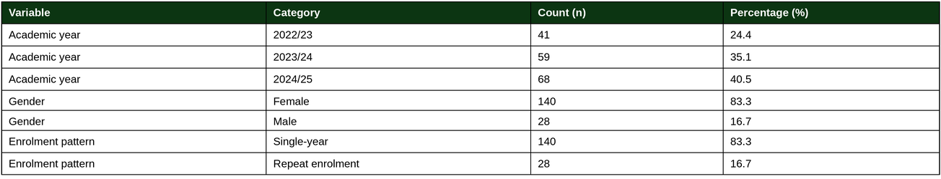

Figure 1. Enrolment records by academic year (N = 168)
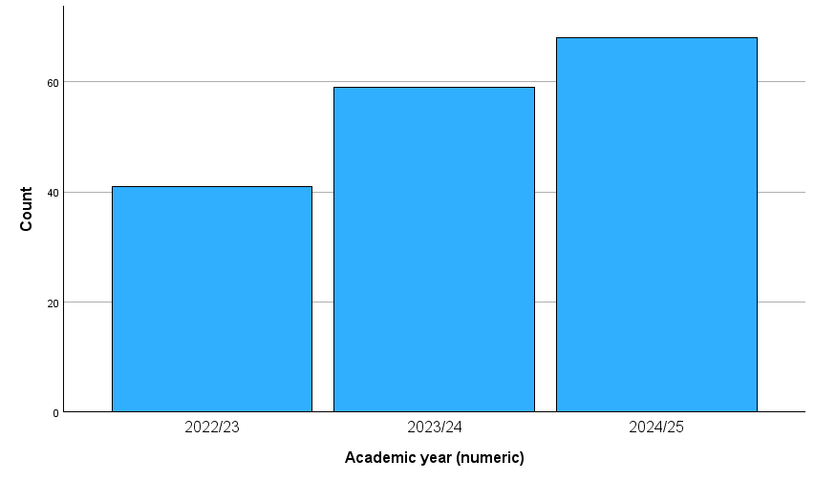

4.1.2 Age and marks
Age at the start of the relevant academic year was available for all 168 records and ranged from 19 to 69 years (M = 35.92, SD = 9.50). The number of modules with a recorded numeric mark was also available for all 168 records, ranging from 0 to 6 (M = 4.54, SD = 2.15). Mean academic mark could be calculated only for the 151 records with at least one numeric mark (M = 57.35, SD = 12.20, range 20–84); the remaining 17 records had no recorded marks and therefore no calculable mean.

Table 2. Age, attainment and engagement
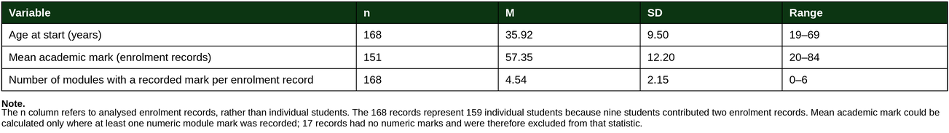
4.1.3 Non-submissions, EC/deferred submissions and progression
Most records had no non-submissions: 107 of the 168 enrolment records (63.7%) had submitted work for every module. However, 32 records (19.0%) had three or more non-submissions. On average, there was approximately one non-submission per enrolment record (M = 0.99, SD = 1.62). Extenuating circumstances or deferred submissions affected only three records (1.8%).
Overall, 105 of the 168 enrolment records (62.5%) had a recorded mark for all six required Level 4 modules and were classed as having completed the Level 4 qualification. Completion of all six Level 4 modules was higher among single-year enrolment records: 97 of 140 (69.3%) had a recorded mark in all six modules, compared with 8 of 28 repeat-enrolment records (28.6%).

Figure 2. Completion of all six modules by enrolment pattern
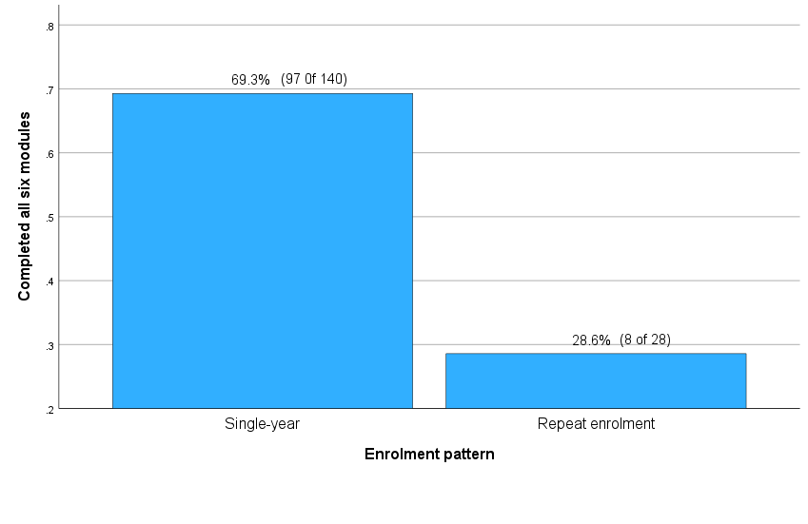
This difference is reported descriptively rather than tested statistically because repeat enrolment and completion are not independent: students who complete all six Level 4 modules would not normally need to re-enrol. Repeat-enrolment students were not repeating the whole Level 4 programme; they re-enrolled only to complete modules that they had not completed during an earlier enrolment. The relationship between enrolment and mean academic mark is tested separately in Section 4.2.2

Table 3. Non-submission, EC and progression
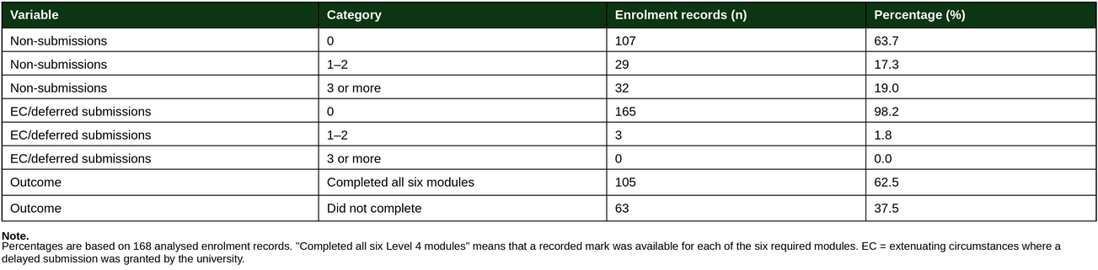

4.2 Inferential statistics

4.2.1 H1 – Module 1 submission and later completion
A chi-square test with Yates’s continuity correction tested whether having a recorded mark for Module 1 was associated with completion of Modules 2 to 6. Module 1 was excluded from the completion measure so that the analysis tested whether having a Module 1 mark was associated with completion of the other five modules. The number of records in each part of the table was large enough to use a chi-square test reliably.
There was a statistically significant, large association between having a recorded Module 1 mark and completing the remaining five modules, χ²(1, N = 168) = 64.88, p < .001, ϕ = .64. Fisher’s exact test gave the same conclusion. The null hypothesis was rejected.
Of the 130 enrolment records with a recorded Module 1 mark, 105 (80.8%) had a recorded mark in all of Modules 2 to 6. In comparison, only 3 of the 38 records without a recorded Module 1 mark (7.9%) completed the remaining five modules. The odds of completing Modules 2 to 6 were 49 times higher for records with a Module 1 mark than for those without one.
This finding shows a strong association, not proof that submitting Module 1 caused students to complete the remaining modules. Full results are shown in Table 4 and Figure 3.

Table 4. Completion by Module 1 submission status

Figure 3. Completion of modules 2 to 6 by module 1 submission status (N = 168).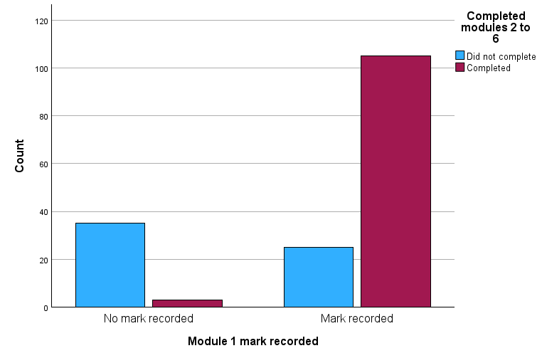

4.2.2 H2 – Single-year or repeat enrolment and mean marks
An independent-samples t-test compared mean academic marks for the 151 enrolment records with at least one numeric mark. Levene’s test was not statistically significant, F = 3.16, p = .077, indicating no evidence that the variation in marks differed between the groups. Therefore, the equal variances assumed result from SPSS was reported.
Single-year enrolment records had a higher mean academic mark (M = 58.95, SD = 12.10, n = 126) than repeat-enrolment records (M = 49.31, SD = 9.30, n = 25). The difference of 9.64 mark points was statistically significant, t(149) = 3.76, p < .001, 95% CI [4.58, 14.70]. The effect was large, Hedges’s g = 0.82, 95% CI [0.38, 1.26].
This comparison concerns mean academic marks, not whether every record completed all six modules. It is worth noting that this is an observed difference in the data; it does not show that repeat enrolment caused lower marks.

Table 5. Mean mark by enrolment pattern
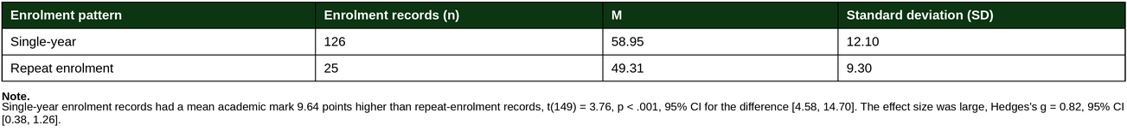
Figure 4. Distribution of mean academic mark by enrolment pattern (n = 151).
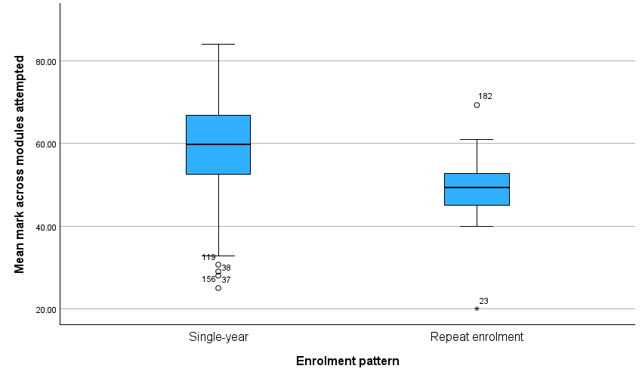

4.2.3 H3 – Non-submissions and mean marks
A Pearson correlation tested whether the number of non-submissions was associated with mean academic mark among the 151 enrolment records with at least one numeric mark.
There was a statistically significant moderate negative relationship between non-submissions and mean academic mark, r(149) = -.38, 95% CI [-.51, -.24], p < .001. This means that records with more non-submissions tended to have lower average marks. The non-submission count accounted for approximately 15% of the variation in mean academic marks (R² = .15).
Because non-submission is a count variable, Spearman’s rank correlation was also used as a check. It produced the same overall conclusion, ρ = -.29, p < .001. The null hypothesis was rejected.
The fitted line in Figure 5 was y = 59.99-3.21x. This estimates a mean mark of 59.99 for records with no non-submissions, decreasing by approximately 3.21 marks for each additional non-submission. This is an association, not evidence that non-submission caused lower marks.
Two additional relationships were also examined. The number of modules with a recorded mark was moderately and positively related to mean academic mark, r(149) = .44, 95% CI [.30, .56], p < .001. Mean marks from Modules 1–3 were strongly and positively related to mean marks from Modules 4–6, r(126) = .71, 95% CI [.61, .78], p < .001. Table 6 reports all three correlations and their confidence intervals, and Figure 5 shows the relationship between non-submissions and mean academic mark.

Table 6. Correlations between assessment-disruption and attainment
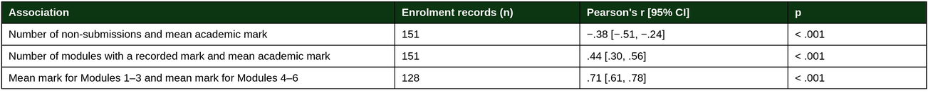
Figure 5. Number of non-submissions against mean academic mark, with fitted regression line (n = 151).
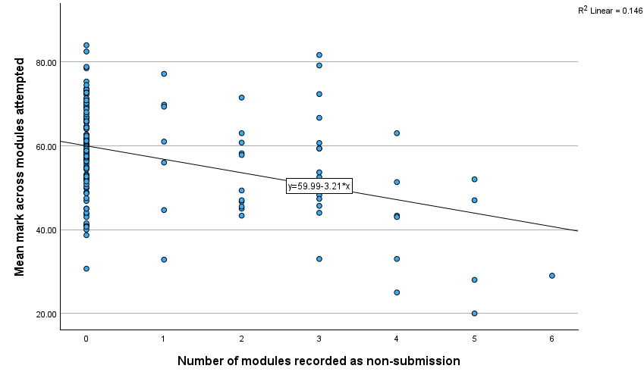

4.2.4 H4 – Academic-year cohort and mean marks
Welch’s one-way analysis of variance compared mean academic marks across the three academic-year cohorts for the 151 enrolment records with at least one numeric mark. Levene’s test was statistically significant, F(2, 148) = 3.57, p = .031, indicating that the variation in marks was not similar across the three cohorts. Therefore, Welch’s ANOVA, which is suitable when group variances are unequal, was used.
There was no statistically significant difference in mean academic marks between the academic-year cohorts, Welch’s F(2, 83.6) = 0.17, p = .842, η² = .002. The null hypothesis was not rejected.
The cohort means were very similar: 2022/23, M = 57.06, SD = 14.95, n = 37; 2023/24, M = 58.05, SD = 10.31, n = 56; and 2024/25, M = 56.86, SD = 12.12, n = 58.
The effect size was negligible, with academic-year cohort accounting for approximately 0.2% of the variation in mean academic marks. Table 7 summarises the test result.

Table 7. Mean mark by cohort
4.2.5 H5 – Mean marks in Modules 1–3 and Modules 4–6
A paired-samples t-test compared mean academic marks in Modules 1–3 with mean academic marks in Modules 4–6 for the 128 enrolment records with at least one numeric mark in each half of the Level 4 programme. The difference scores were approximately normally distributed, Shapiro–Wilk W = .987, p = .239, so the assumptions for a paired-samples t-test were met.
Mean marks were almost identical across the two halves: Modules 1–3, M = 59.34, SD = 11.41; and Modules 4–6, M = 59.09, SD = 11.26. The mean difference was 0.25 mark points and was not statistically significant, t(127) = 0.32, p = .747, 95% CI [-1.27, 1.77]. The effect size was negligible, Cohen’s dz = 0.03, 95% CI [-0.15, 0.20].
Wilcoxon’s signed-rank test was also used as a check and gave the same overall conclusion, Z = -0.50, p = .619. The null hypothesis was not rejected.
Table 8 summarises the group statistics.

Table 8. Mean mark, first vs second half (N = 128)
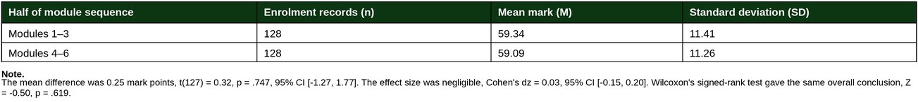
4.2.6 Formally recorded reasonable adjustments
No hypothesis was tested for formally recorded reasonable adjustments because the number of records was too small for reliable inferential analysis. The findings are therefore reported descriptively.
A formal record of reasonable adjustments, known as a Statement of Compensatory Measures (SCM), was recorded for 12 of the 168 analysed enrolment records (7.1%). These 12 records related to 10 of the 159 individual students in the dataset, meaning that 6.3% of students had an SCM record.
SCM record-creation dates ranged from June 2024 to March 2026. For three enrolment records, the SCM record was created after 31 August in the academic year to which that enrolment record related. Only two records had module marks both before and after the SCM record-creation date. This meant that there were too few suitable cases to compare marks before and after the record was created. No statistical test was therefore carried out.
The SCM date refers to when the administrative record was created. It does not necessarily show when a student first received support or reasonable adjustments. In addition, specialist academic support was available to all students, whether they had disclosed a need or had an SCM record. Therefore, students without an SCM record should not be assumed to have received no support.

Table 9. Formal confirmation of reasonable adjustments
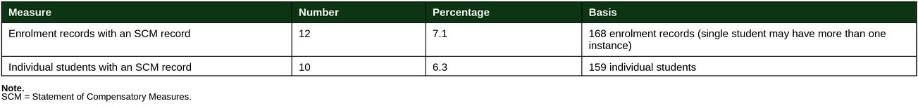
Table 10. SCM records by academic year (source rows)
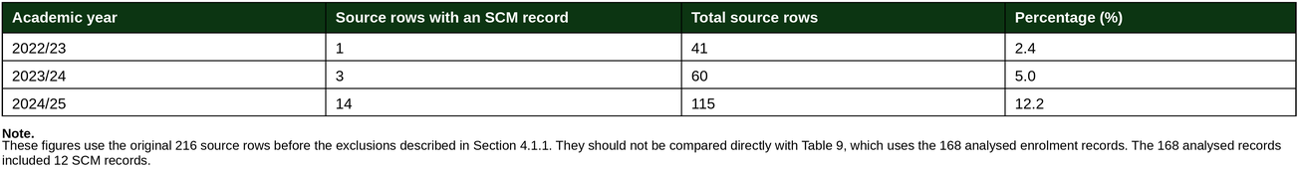
4.2.7 Additional checks
Three additional checks were carried out to help interpret the main findings. They were not part of the five main hypotheses.
First, Module 1 marks were compared between records that did and did not go on to complete Modules 2–6. Completers had a slightly higher mean mark (M = 62.15, SD = 14.10, n = 105) than non-completers (M = 56.56, SD = 14.49, n = 25), t(128) = 1.77, p = .079, Hedges’s g = -0.39, 95% CI [-0.83, 0.05] — not statistically significant, though with only 25 non-completers the test may lack power to detect a smaller effect. The earlier H1 result remains the stronger, earlier indicator: simply having a recorded Module 1 mark, not the mark itself, distinguished completers from non-completers.
Second, the 19 records for students under 25 at enrolment were compared with the rest. Under-25 records were less likely to have a recorded Module 1 mark (57.9% vs 79.9%, Fisher’s exact p = .042) and less likely to complete all six modules (42.1% vs 65.1%), though the completion difference was not statistically significant (p = .076). Fisher’s exact test was used because one expected cell count fell below five; given the small group size, both results should be interpreted cautiously.
Third, the five main hypothesis tests were repeated at person level, using the most recent enrolment record for each of the 159 individual students. The statistical conclusion of all five tests remained the same.
4.2.8 Summary of results

Table 11. Summary of hypothesis tests
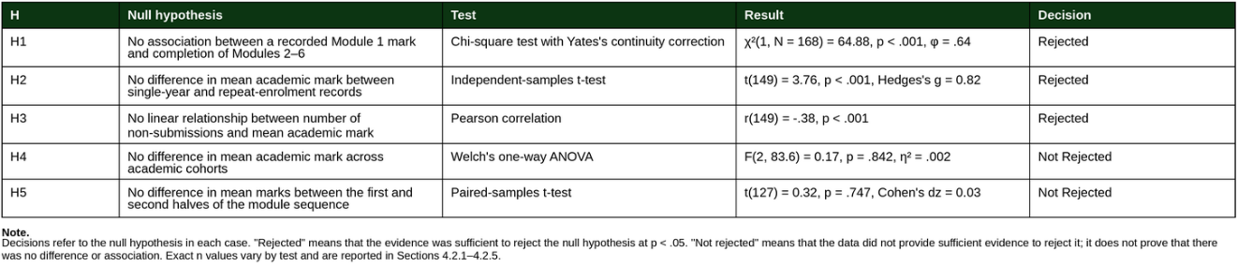
5. Discussion
5.1 Principal finding
Submission of the first assessment was strongly associated with subsequent completion. Students who submitted Module 1 completed the remaining five modules at more than ten times the rate of those who did not. However, among students who submitted Module 1, the mark achieved did not significantly distinguish completers from non-completers. The key difference therefore appears to be in submitting the first assessment, rather than in the academic mark achieved.
Attainment data from the first assignment arrives later, because assignments must be marked, moderated and confirmed. By contrast, submission status is known within hours of a deadline and requires no academic judgement to interpret. If the earliest observable difference between completers and non-completers is submission rather than performance, the information needed to identify students who may benefit from early supportive contact is available considerably earlier in the assessment cycle.
Other studies have found that early assessment activity can reveal potential difficulty before attainment data is available. Linden (2022) developed an institutional retention model based on submission of a single early assessment item. Ortiz-Lozano et al. (2024) found that assessments not attempted in the first semester had predictive value for dropout, while Cochrane et al. (2026) found that submission behaviour tended to persist across assessments even when marks did not differ meaningfully between submission groups.
This study shows the same pattern in a comparable UK classroom-based programme. Submission became visible before marks were available, creating an earlier opportunity for supportive contact. The Open University uses activity and assessment data in a similar way to identify students at risk of not submitting their next assignment (Boroowa & Herodotou, 2022).
This dataset cannot show why students did not submit. King and Loddick (2026) found that two-thirds of the reasons students gave for non-submission were situational, mainly health, family and caring responsibilities. Non-submission should therefore not automatically be read as disengagement.
Support-seeking may also play a role, though this dataset does not measure help-seeking or personal circumstances.

5.2 Enrolment pattern and attainment
Students returning through repeat enrolment achieved markedly lower mean marks than students enrolled for a single year: repeat-enrolment records scored, on average, 9.64 marks lower, a large difference. Completion rates showed a similar pattern, although this is reported descriptively because completing all six modules within one year means that a student has no reason to re-enrol. Among the 28 repeat-enrolment records, 8 completed all six modules (28.6%).
Studies of interrupted enrolment show a broadly similar pattern, although the evidence is not consistent. DesJardins et al. (2006) found that students whose enrolment was interrupted were more likely to experience further interruptions and less likely to graduate. However, Tafreschi and Thiemann (2016) found that where students were required to repeat a full year, their later grade point averages improved, even though first-year dropout increased. Repetition may therefore have different consequences depending on how and why it occurs.
Repeat enrolment in this study may reflect disruption rather than a planned opportunity to repeat and improve. This fits wider evidence that interrupted educational histories are linked to lower continuation and attainment, and that mature learners often balance financial pressure, caring responsibilities and limited time (Erb & Drysdale, 2017; Moore et al., 2013; OfS, 2021). The records do not show why individual students re-enrolled.
The data cannot distinguish between students who re-enrolled and resumed their studies and those who re-enrolled but did not go on to engage; intention to return was recorded only as text notes, not as an analysable variable. This is likely to affect few records, since 25 of the 28 repeat-enrolment records had at least one mark and 8 completed all six modules, suggesting most repeat-enrolment records represent genuine returns to study.
The analysis cannot show whether lower attainment reflects the circumstances that caused the initial interruption, the interruption itself, or the challenge of re-joining the programme partway through a subsequent year.

5.3 Stability of attainment
Mean marks did not differ significantly across the three cohorts or between the first and second halves of the 6 module sequence. Both findings were unchanged when robust and non-parametric alternatives were used.
These results do not show that the cohorts or module halves were equivalent; a non-significant result only shows that this dataset did not provide sufficient evidence of a difference. However, the findings make it less likely that the main results reflect large cohort differences or substantial changes in module assessment difficulty as the programme progressed.

5.4 Assessment disruption and attainment
More non-submissions were associated with lower mean marks, r = -.38.
This is consistent with evidence that assessments not attempted early in a programme can help identify students at risk of poorer later outcomes, using information institutions already hold (Ortiz-Lozano et al., 2024).
This finding is related to, but different from, the first-assessment result. A first non-submission provides an early warning at a single point in time and, in Module 1, separated completers from non-completers almost completely.
A higher number of non-submissions across the programme suggests that difficulties may have continued over time. The first non-submission can prompt early supportive contact; the total number shows whether non-submission has continued. Neither finding establishes causation, for the reasons set out in Section 5.6 (King & Loddick, 2026).

5.5 Formal confirmation of reasonable adjustments
The low recorded percentage should not be treated as a measure of how many students needed support. In 2022/23, 16.5% of UK higher education students had a declared disability, impairment, health condition or learning difference, compared with 6.3% of students in this study who had a formally recorded SCM (Higher Education Statistics Agency [HESA], 2024). These are not equivalent measures: a student’s disability declaration and formal confirmation of an adjustment involve different processes and thresholds. The comparison is therefore indicative rather than like-for-like. However, SCM records may include fewer students than personal student disability declarations.
These findings should not be read as indicating an absence of support before formal confirmation, since the General Study Skills provision described in Section 3.8 is available to every student, irrespective of disclosure. The issue may be less about whether support is available than whether students recognise that they need it, feel able to ask for it, and can access it early enough for it to make a difference. Stigma, attitudes towards help-seeking, previous experience, and perceived control can all shape whether students seek academic support (Bornschlegl et al., 2020). Students who do not submit an early assessment may therefore not be identified through ordinary support processes unless non-submission prompts proactive contact (Linden, 2022).

5.6 Other explanations and limits
The three threats to internal validity detailed in Section 3.9 are directly relevant to these findings. The most important limitation is that the records cannot distinguish between students who disengaged and students whose circumstances made it impossible to continue (Saunders et al., 2019).
A further explanation is that non-submission and non-completion may both result from circumstances not recorded here, such as health, caring responsibilities, employment or financial pressure, or programme fit. In that case, non-submission would not cause non-completion; it would be an early visible sign of the same underlying difficulty.
This does not change the practical point. Non-submission does not have to cause non-completion to be useful. It can still show that a student may benefit from early supportive contact, even if it does not explain why they did not submit.

5.7 Limitations
Five limitations should be considered when interpreting these findings.
First, the dataset is based on enrolment records rather than fully independent individual students. Nine students appear in two enrolment episodes. The five main hypothesis tests (H1–H5) were repeated using the most recent enrolment record for each of the 159 individual students, and the conclusions did not change.
Second, the dataset does not record use of the General Study Skills provision, which is available to all students. Students without a formally recorded reasonable adjustment should therefore not be assumed to have received no academic support.
Third, the available measures of student success were completion of all six Level 4 modules and mean academic mark. The dataset does not measure confidence, belonging, academic self-efficacy, professional capability, or the personal circumstances that may affect a mature learner’s engagement and progress (Jones et al., 2025; Jones & McConnell, 2023).
Fourth, the programme is treated as widening-participation provision because it has an open-entry route and a predominantly mature learner profile. However, the dataset contains no individual-level information on socio-economic background, participation quintile, care experience, first-in-family status, ethnicity, or prior qualifications. It cannot therefore show which individual students meet particular widening-participation criteria (Moore et al., 2013; OfS, 2021).
Fifth, this is a study of one Level 4 programme at one institution. The findings may be useful for this programme and similar work-based mature-learner provision, but they cannot be assumed to apply to other programmes, institutions, or student populations.
A further point relates to the small number of younger entrants. Eight enrolment records (4.8%) refer to students aged under 21 at the start of the academic year. This is below the usual threshold used to define mature students at entry (OfS, 2021). Outcomes for this group are not reported because it contains fewer than 10 records and further breakdowns could risk indirect identification. In line with the study’s disclosure-control protocol, results for groups smaller than 10 records were suppressed (Department for Education, 2026). The group is included because the programme is work-based and usually draws on workplace and supervisory experience; however, age is not a direct measure of that experience.

5.8 Implications
Non-submission of the first assessment could act as an early trigger for supportive contact. It is observable within days of a deadline, requires no academic judgement to identify, and was associated with non-completion of the remaining modules in 92.1% of cases. Students returning through re-enrolment may also benefit from particular attention: they completed at less than half the rate of single-year records and attained almost ten marks lower. Finally, the small number of formally confirmed adjustments, alongside support that is available to all students, suggests that open general study support should be promoted without waiting for students to disclose a support need.
Future research could examine whether attendance at General Study Skills sessions is associated with student outcomes. Linking session-attendance data to completion outcomes would allow an assessment of whether students who use this open support are more likely to complete, irrespective of whether they have a formally confirmed support need.
Developing a model to predict completion would require a larger dataset and predictors measured before the completion outcome is known. Suitable predictors might include early assessment submission, attendance, prior educational experience, and engagement with online learning materials. These academic, background, and behavioural indicators are commonly used in higher-education retention and dropout-prediction research (Tete et al., 2022; Ifenthaler & Yau, 2020). Where available, work experience could also be explored, particularly where employment or professional responsibilities may affect the time students have available for study.
A further question concerns programme fit for younger entrants, since the programme assumes access to a workplace and supervisory responsibility. The comparison in Section 4.2.7 raises this question but cannot answer it, as age is only a limited proxy for work experience; answering it would need a larger group of younger students and direct measures of that experience.

6. Conclusion and recommendations
This study examined three cohorts of Level 4 Applied Leadership and Management students to identify early indicators of module completion and attainment. Students who submitted the first assessment completed the remaining modules at approximately ten times the rate of those who did not submit, while first-assessment submission status differentiated completers from non-completers more strongly than the mark achieved. Re-enrolment was associated with substantially lower attainment, while attainment remained broadly stable across cohorts and across the module sequence. Formally confirmed reasonable adjustments applied to a small minority of records and were often confirmed late in the academic year. As too few records had confirmed adjustments for reliable inferential analysis, these findings are reported descriptively.
The most consistent finding was that whether students submitted the first assessment provided a stronger early indication of subsequent completion than the mark they achieved.
Module 1 non-submission should be piloted as a trigger for individual supportive contact, subject to checking the reason that no mark has been recorded. The indicator is normally available within 8 days of a module deadline (submission date plus 7 days capped), and 35 of the 38 records without a Module 1 mark (92.1%) did not complete Modules 2–6. As this evidence comes from a single observational study, the approach should be tested and evaluated rather than adopted as established policy.
A targeted support approach for students returning through re-enrolment should be piloted and evaluated, given their lower observed completion rate and attainment in this dataset.
Third, the General Study Skills provision should be promoted routinely rather than awaiting student disclosure.
The central claim of this study is deliberately modest: administrative data already held by the programme contains an early, actionable signal, and acting on it requires no new data collection or academic judgement. Where the widening-participation literature emphasises timely and integrated support (Advance HE, 2024; OfS, 2021), these findings suggest that submission status offers an additional early mechanism through which potential disengagement can become visible.

7. References
Advance HE. (2023). The disabled student commitment. https://www.advance-he.ac.uk/knowledge-hub/disabled-student-commitment
Advance HE. (2024). Framework for student access, retention, attainment and progression. https://www.advance-he.ac.uk/knowledge-hub/framework-student-access-retention-attainment-and-progression
Ahn, M. Y., & Davis, H. H. (2023). Students’ sense of belonging and their socio-economic status in higher education: A quantitative approach. Teaching in Higher Education, 28(1), 136–149. https://doi.org/10.1080/13562517.2020.1778664
Balzer Carr, B., & London, R. A. (2019). The role of learning support services in university students’ educational outcomes. Journal of College Student Retention: Research, Theory & Practice, 21(1), 78–104. https://doi.org/10.1177/1521025117690159
Blasey, J., Wang, C., & Blasey, R. (2023). Accommodation use and academic outcomes for college students with disabilities. Psychological Reports, 126(4), 1891–1909. https://doi.org/10.1177/00332941221078011
Bornschlegl, M., Meldrum, K., & Caltabiano, N. J. (2020). Variables Related to Academic Help-Seeking Behaviour in Higher Education – Findings from a Multidisciplinary Perspective. Review of Education, 8(2), 486–522. https://doi.org/10.1002/rev3.3196
Boroowa, A., & Herodotou, C. (2022). Learning analytics in open and distance higher education: The case of the Open University UK. In P. Prinsloo, S. Slade, & M. Khalil (Eds.), Learning analytics in open and distributed learning (pp. 46–62). Springer. https://doi.org/10.1007/978-981-19-0786-9_4
Chen, C., Bian, F., & Zhu, Y. (2023). The relationship between social support and academic engagement among university students: The chain mediating effects of life satisfaction and academic motivation. BMC Public Health, 23(1), 2368. https://doi.org/10.1186/s12889-023-17301-3
Cochrane, D., Erueti, B., & Jin, Y. (2026). Impact of a grace period on student submission behaviour and academic performance. Journal of Further and Higher Education, 50(5), 842–856. https://doi.org/10.1080/0309877X.2026.2634042
Cohen, J. (1988). Statistical power analysis for the behavioral sciences (2nd ed.). Lawrence Erlbaum Associates.
Cohen, L., Manion, L., & Morrison, K. (2018). Research methods in education (8th ed.). Routledge.
Creswell, J. W. (2009). Research design: Qualitative, quantitative, and mixed methods approaches (3rd ed.). Sage.
Department for Education. (2026). Statistical disclosure control policy for DfE data. https://assets.publishing.service.gov.uk/media/69dcee3aeb7e7bc5651702be/Statistical_disclosure_control_policy_for_DfE_data_-_Office_for_National_Statistics_Secure_Research_Service.pdf
DesJardins, S. L., Ahlburg, D. A., & McCall, B. P. (2006). The effects of interrupted enrollment on graduation from college: Racial, income, and ability differences. Economics of Education Review, 25(6), 575–590. https://doi.org/10.1016/j.econedurev.2005.06.002
Dixon, N., Howe, R., & Richter, U. M. (2025). Exploring learning analytics practices and their benefits through the lens of three case studies in UK higher education. Research in Learning Technology, 33, 3127. https://doi.org/10.25304/rlt.v33.3127
Erb, S., & Drysdale, M. T. B. (2017). Learning attributes, academic self-efficacy and sense of belonging amongst mature students at a Canadian university. Studies in the Education of Adults, 49(1), 62–74. https://doi.org/10.1080/02660830.2017.1283754
Farini, F., & Scollan, A. M. (2021). A hope to trust: Educational leadership to support mature students’ inclusion in higher education: An experience from Surrey, England. International Journal of Leadership in Education, 24(5), 717–742. https://doi.org/10.1080/13603124.2019.1657592
Field, A. (2024). Discovering statistics using IBM SPSS Statistics (6th ed.). Sage.
Freeman, J. A. (2025). Accommodating success: Examining the effects of accessing accommodations on degree completion among community college students with non-apparent disabilities. Exceptional Children, 91(4), 336–358. https://doi.org/10.1177/00144029251318568
Gilani, D., & Thomas, L. (2025). Understanding the factors and consequences of student belonging in higher education: A critical literature review. Journal of Learning Development in Higher Education, 34. https://doi.org/10.47408/jldhe.vi34.1385
Gongadze, S., Hume, S., & Styrnol, M. (2021). Supporting access and student success for mature learners: Evidence review. Transforming Access and Student Outcomes in Higher Education. https://cdn.taso.org.uk/wp-content/uploads/TASO-mature-students-literature-review-2021.pdf
Higher Education Statistics Agency. (2024). Higher education student statistics: UK, 2022/23 – Student numbers and characteristics (SB269). https://www.hesa.ac.uk/news/08-08-2024/sb269-higher-education-student-statistics/numbers
Holmes, A. G. D. (2020). Researcher positionality — A consideration of its influence and place in qualitative research — A new researcher guide. Shanlax International Journal of Education, 8(4), 1–10. https://shanlaxjournals.in/journals/index.php/education/article/view/3232
Hyseni Duraku, Z., Davis, H., & Hamiti, E. (2023). Mental health, study skills, social support, and barriers to seeking psychological help among university students: A call for mental health support in higher education. Frontiers in Public Health, 11, 1220614. https://doi.org/10.3389/fpubh.2023.1220614
Ifenthaler, D., & Yau, J. Y.-K. (2020). Utilising learning analytics to support study success in higher education: a systematic review. Educational Technology Research and Development, 68(4), 1961–1990. https://doi.org/10.1007/s11423-020-09788-z
Jones, J., & McConnell, C. (2023). Changing mindsets and becoming gritty: Mature students’ learning experiences in a UK university and beyond. Innovations in Education and Teaching International, 60(6), 883–893. https://doi.org/10.1080/14703297.2022.2117726
Jones, J., MacDonnell, J., & Aamir, A. (2025). Mature undergraduates’ experiences of a UK university induction programme: Accruing social capital, evolving habitus and developing a sense of belonging. Innovations in Education and Teaching International, 1–15. https://doi.org/10.1080/14703297.2025.2555959
King, S., & Loddick, A. (2026). Understanding the reasons why students fail to submit assignments. Discover Education, 5(1), Article 122. https://doi.org/10.1007/s44217-026-01186-6
Kutscher, E. L., & Tuckwiller, E. D. (2019). Persistence in higher education for students with disabilities: A mixed systematic review. Journal of Diversity in Higher Education, 12(2), 136–155. https://doi.org/10.1037/dhe0000088
Larrabee Sønderlund, A., Hughes, E., & Smith, J. (2019). The efficacy of learning analytics interventions in higher education: A systematic review. British Journal of Educational Technology, 50(5), 2594–2618. https://doi.org/10.1111/bjet.12720
Linden, K. (2022). Improving Student Retention by Providing Targeted Support to University Students who do not Submit an Early Assessment Item. Student Success, 13(1), 67–73. https://doi.org/10.5204/ssj.2152
Lyu, H., Nguyen, A., & Dang, C. T. (2025). Aligning support with the needs of mature students in Russell Group universities: A systematic literature review. The Journal of Continuing Higher Education, 73(2), 194–207. https://doi.org/10.1080/07377363.2025.2460248
Martín-Arbós, S., Castarlenas, E., & Dueñas, J.-M. (2021). Help-seeking in an academic context: A systematic review. Sustainability, 13(8), 4460. https://doi.org/10.3390/su13084460
McKenzie, S., Castle-Herbert, A., Verriès-Wade, A., & Silk, H. (2024). Building communities for student success: Facilitating student belonging through online inductions. Widening Participation and Lifelong Learning, 26(1), 145–165. https://oro.open.ac.uk/97391/1/97391.pdf
Moore, J., Sanders, J., & Higham, L. (2013). Literature review of research into widening participation to higher education: Report to HEFCE and OFFA. AimHigher Research & Consultancy Network. https://www.raggeduniversity.co.uk/wp-content/uploads/2015/09/Literature-review-of-research-into-WP-to-HE.pdf
Moriña, A., & Biagiotti, G. (2022). Academic success factors in university students with disabilities: A systematic review. European Journal of Special Needs Education, 37(5), 729–746. https://doi.org/10.1080/08856257.2021.2006902
Newman, L. A., Madaus, J. W., Lalor, A. R., & Javitz, H. S. (2021). Effect of accessing supports on higher education persistence of students with disabilities. Journal of Diversity in Higher Education, 14(3), 353–363. https://doi.org/10.1037/dhe0000170
O’Leary, Z., & Hunt, J. (2017). Secondary data: Existing data, online generated data and previous studies. In Z. O’Leary, The essential guide to doing your research project (3rd ed., pp. 264–294). Sage.
Office for Students. (2019). Review of support for disabled students in higher education in England (OfS 2019.05). https://www.officeforstudents.org.uk/media/a8152716-870b-47f2-8045-fc30e8e599e5/review-of-support-for-disabled-students-in-higher-education-in-england.pdf
Office for Students. (2021). Improving opportunity and choice for mature students (OfS Insight brief 9). https://www.officeforstudents.org.uk/media/7042/ofs-insight-brief-9-updated-10-may-2022.pdf
Office for Students. (2024). Student characteristics data: Student outcomes—how student outcomes have changed since 2010-11 (OfS 2024.46). https://www.officeforstudents.org.uk/media/poxj1jvx/student-characteristics-data-outcomes-report-2024.pdf
Ortiz-Lozano, J. M., Aparicio-Chueca, P., Triadó-Ivern, X. M., & Arroyo-Barrigüete, J. L. (2024). Early dropout predictors in social sciences and management degree students. Studies in Higher Education, 49(8), 1303–1316. https://doi.org/10.1080/03075079.2023.2264343
Panchenko, L., & Samovilova, N. (2020). Secondary data analysis in educational research: Opportunities for PhD students. SHS Web of Conferences, 75, 04005. https://doi.org/10.1051/shsconf/20207504005
Pervez, A., Dangeni, Koutrou, N., Miller, C., & Wisson, C. (2024). An investigation into the provision of support for mature international students at UK HEIs to foster belonging. Student Engagement in Higher Education Journal, 5(2), 148–168. https://doi.org/10.66561/sehej.v5i2.1206
Pollard, E., Vanderlayden, J., Alexander, K., Borkin, H., & O’Mahony, J. (2021). Student mental health and wellbeing: Insights from higher education providers and sector experts (DfE-RR1141). Department for Education. https://assets.publishing.service.gov.uk/media/60d47d55e90e0743a210e05e/Survey_of_HE_Providers_Student_Mental_Health.pdf
Reardon, K., Bromley, K., & Unruh, D. (2021). The promise of universal design in postsecondary education: A literature review. Journal of Postsecondary Education and Disability, 34(3), 209–221. https://files.eric.ed.gov/fulltext/EJ1325431.pdf
Reilly, D., Warren, L., Kristandl, G., & Lin, Y. (2024). An investigation into the self-efficacy of year one undergraduate students at a widening participation university. Teaching in Higher Education, 29(2), 639–656. https://doi.org/10.1080/13562517.2021.2015756
Robinson, D., & Salvestrini, V. (2020). The impact of interventions for widening access to higher education: A review of the evidence. Education Policy Institute and Transforming Access and Student Outcomes in Higher Education. https://cdn.taso.org.uk/wp-content/uploads/Widening_participation-review_EPI-TASO_2020.pdf
Römhild, A., & Hollederer, A. (2024). Effects of disability-related services, accommodations, and integration on academic success of students with disabilities in higher education. A scoping review. European Journal of Special Needs Education, 39(1), 143–166. https://doi.org/10.1080/08856257.2023.2195074
Saunders, M., Lewis, P., & Thornhill, A. (2019). Research methods for business students (8th ed.). Pearson.
Tafreschi, D., & Thiemann, P. (2016). Doing it twice, getting it right? The effects of grade retention and course repetition in higher education. Economics of Education Review, 55, 198–219. https://doi.org/10.1016/j.econedurev.2016.10.003
Tete, M. F., Sousa, M. de M., de Santana, T. S., & Silva, S. F. (2022). Predictive models for higher education dropout: A systematic literature review. Education Policy Analysis Archives, 30, (149). https://epaa.asu.edu/index.php/epaa/article/view/6845/2930
Thomson, H., Bellaera, L., Ilie, S., & Maragkou, K. (2022). Intermediate outcomes for higher education access and success. Transforming Access and Student Outcomes in Higher Education. https://cdn.taso.org.uk/wp-content/uploads/2022-11_-Report_Intermediate-outcomes-for-higher-education-access-and-success_TASO.pdf
Tyndall, J. (2010). AACODS checklist. Flinders University. https://fac.flinders.edu.au/dspace/api/core/bitstreams/e94a96eb-0334-4300-8880-c836d4d9a676/content
Villano, R. A., Harrison, S., Lynch, G., & Chen, G. (2018). Linking early alert systems and student retention: A survival analysis approach. Higher Education, 76, 903–920. https://doi.org/10.1007/s10734-018-0249

8. Appendices
Appendix A. Initial spreadsheet / variable list
A1. Data - Excel
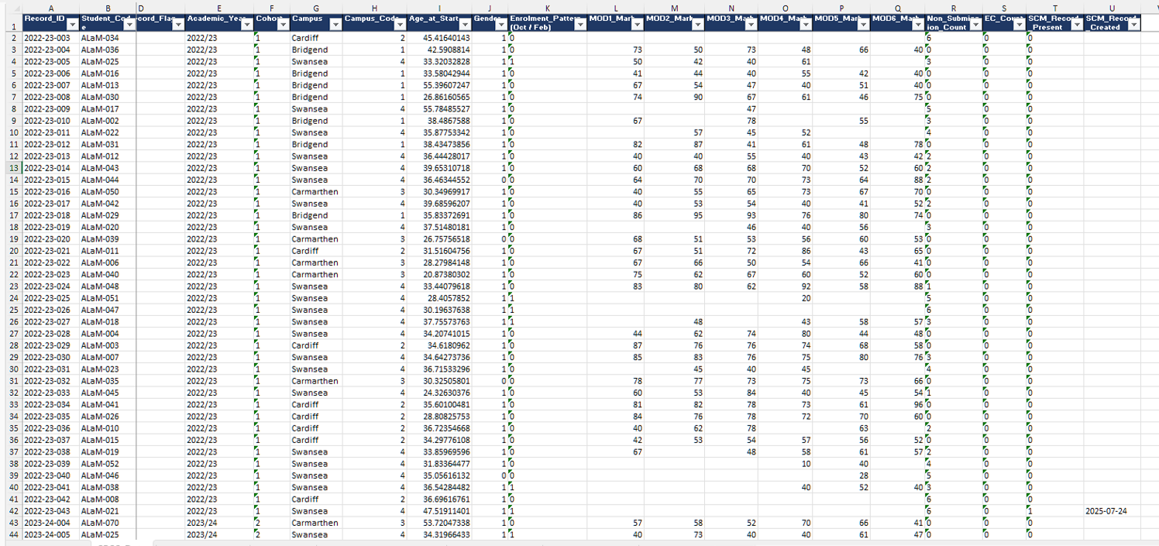
The working analysis dataset BMDP7009_SPSS_Base_Dataset.xlsx contains all 216 Exam Board source rows with an inclusion flag identifying the 168 analysed records derived from 216 initial records and a recorded reason for each of the 48 exclusions, together with a codebook giving the label, measurement level, value labels, missing-data rule and source of every variable. Student numbers and names are not carried into the workbook: each student is identified by a stable pseudonymous code. The workbook also holds the module-level evidence behind each mark, the record of corrections applied during preparation, and the decisions taken on each query raised at the cleaning stage. Example (first 44 rows) of the data set is included below.
A2. Data - SPSS
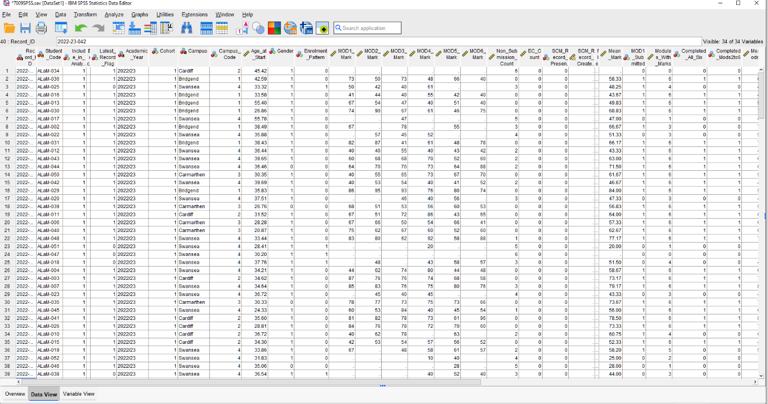

A3. Data - Variables

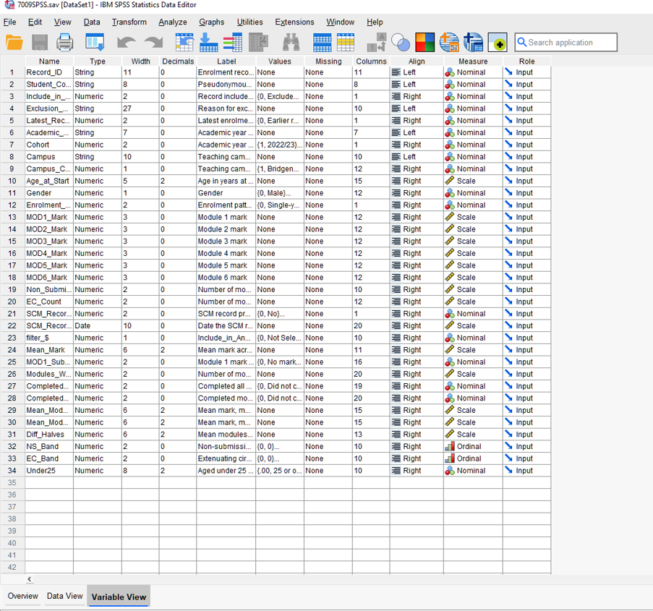

Appendix B. Additional statistical output

B1. Targeted non-parametric checks.
Two rank-based tests were retained where they added confirmation.
Both agreed with the main parametric result.

- H3, non-submissions and mean mark: Spearman's ρ = -.29, p < .001 (Pearson r = -.38, p < .001).

- H5, first against second half of the module sequence: Wilcoxon signed-rank Z = -0.50, p = .619 (paired t(127) = 0.32, p = .747).

B2. Assumption checks.
Mean academic mark:
- Shapiro-Wilk W = .987, p = .183.
- H2 equal variances: Levene's F = 3.16, p = .077.
- H4 equal variances: Levene's F(2, 148) = 3.57, p = .031, so Welch's robust ANOVA was used.
- H5 difference scores: Shapiro-Wilk W = .987, p = .239. H1 expected cell counts: minimum 13.6, all above 5.

B3. Person-level sensitivity analysis.
The 168 enrolment episodes from an initial 216 rows represent 159 individual students, with nine students contributing two episodes (returning students to a subsequent academic year). The five primary hypotheses were therefore repeated using the more recent enrolment episode for each student. The three significant findings remained significant, the two non-significant findings remained non-significant, and the effect sizes remained similar. The conclusions are therefore not explained by the nine students who contribute two episodes each.

B4. SCM records by academic year of enrolment (source rows). 2022/23.
1 of 41 (2.4%). 2023/24: 3 of 60 (5.0%). 2024/25: 14 of 115 (12.2%). These are source-row counts across all 216 rows, before the exclusions described in Section 4.1.1.

Appendix C. Coding, missing-data and sensitivity-analysis notes

C1. Assessment outcome coding.
Module-level outcomes in the institutional tracking sheets combine numeric marks with codes for non-submission (NS), extenuating circumstances (EC) and late submission (LS). Full academic marks are defined as the best available uncapped numeric mark for each module, including marks awarded after EC or late submission. Recorded or capped marks are the official marks after capping rules are applied, for example resits or late submissions capped at 40.

C2. Non-submission.
A true non-submission is an assessment recorded as NS with no subsequent numeric mark. Such cases contribute to non-submission counts but are not recoded as zero in full-mark averages, because a zero would misrepresent an assessment that was not completed. Where NS, EC or LS codes appear alongside a numeric mark, the numeric mark is used and the assessment is not treated as a current non-submission. EC and deferred assessments are counted separately as indicators of assessment disruption.

C3. Missing data.
Missing marks, non-submissions, ECs and deferred assessments are retained as analytically distinct states and are not collapsed. Cases with missing values are excluded on a test-by-test basis, so the valid n varies between analyses and is reported separately for each. Mean academic mark could be calculated for 151 of the 168 records; age was available for all 168; gender was available for all 168.

C4. Inclusion rules.
216 Exam Board source rows were reduced to 168 analysed records by 48 exclusions: 14 duplicate board entries, 33 records with no evidence of attendance, and one out-of-scope 2025 starter. Completion is defined as a recorded mark for all six modules. Because a record holds six marks if and only if it is classified complete, modules attempted and non-submission count were excluded as predictors of completion; a model including them produces complete separation. For the same reason H1 uses completion of modules 2 to 6 as its outcome, so that module 1 is not contained within the variable it predicts.

C5. Corrections applied to the source data.
One duplicated record identifier was renumbered. Thirty-four module marks were corrected where the mean of two attempts had been recorded rather than the higher mark; this had wrongly classified one record as passing with condonement. Academic period was realigned between the master dataset and the module audit for 38 December-board records. Sixty-five NS text strings were cleared from the numeric mark fields, with status preserved in separate result columns. Campus was collapsed to five sites and is used as a descriptive field only. One blank gender cell was restored from an earlier version of the master workbook, which records the same student as male; gender is therefore complete for all 168 analysed records.

C6. Derivation of age.
Age at start was derived from date of birth at a reference date of 1 October in the academic year of the record, then stored as a static value; date of birth was removed from the analysis workbook. The Student Finance England threshold of 25 years was used for any age grouping, in preference to a data-derived cut-point.

C7. Sensitivity analyses conducted.
Two focused checks were used. Spearman's rank correlation checked H3 because non-submission is a count variable, and Wilcoxon's signed-rank test checked H5. Both agreed with the main tests. The five primary hypotheses were also repeated at person level using the latest episode for each student; no conclusion changed.

C8. Analyses specified but not conducted.
A paired comparison of marks before and after creation of an SCM record was abandoned: only two records held marks on both sides of that date and one of those held only capped marks. A multivariable model predicting completion was set aside for the reason given in C4. Both decisions were taken from the design and the distribution of the data before any result was examined.

Appendix D. Ethics and data-governance record
Remember|!| access approval, ethical/governance determination, pseudonymisation process, , secure-storage arrangements and deletion date.

Appendix E. SPSS output
Screenshots of the SPSS dialog settings and output tables confirming each analysis reported in Section 4, numbered E01 to E19 in the order the analyses are presented. Each figure shows the procedure used, the selection and the result output.

E01. Filter confirmation - Frequency check for Completed_All_Six (N = 168)
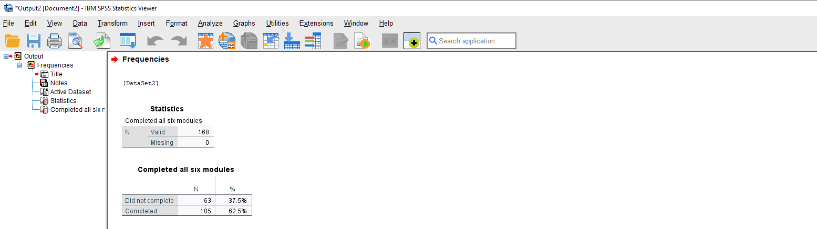

E02. Source for Table 1 - Gender, enrolment pattern and cohort frequencies
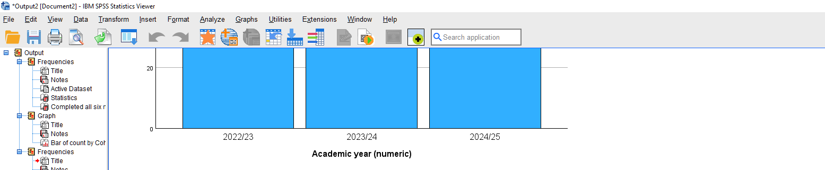

E03. Source for Table 2 - Descriptive statistics for age, marks and modules
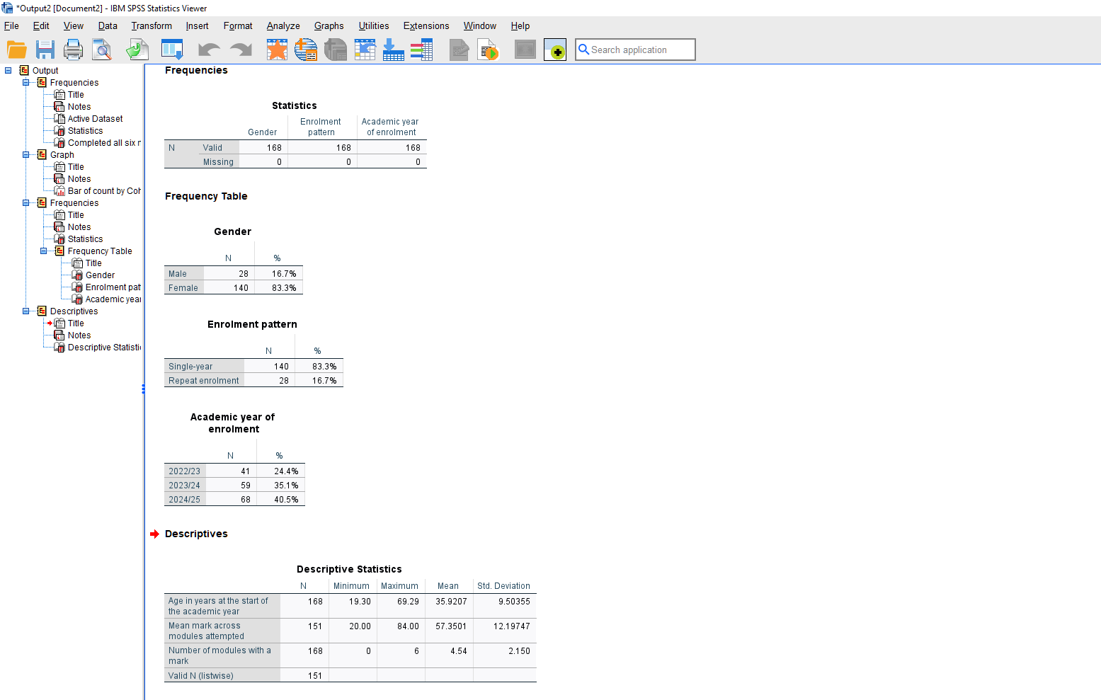
E04. Source for Table 3 - Non-submission, EC and completion frequencies
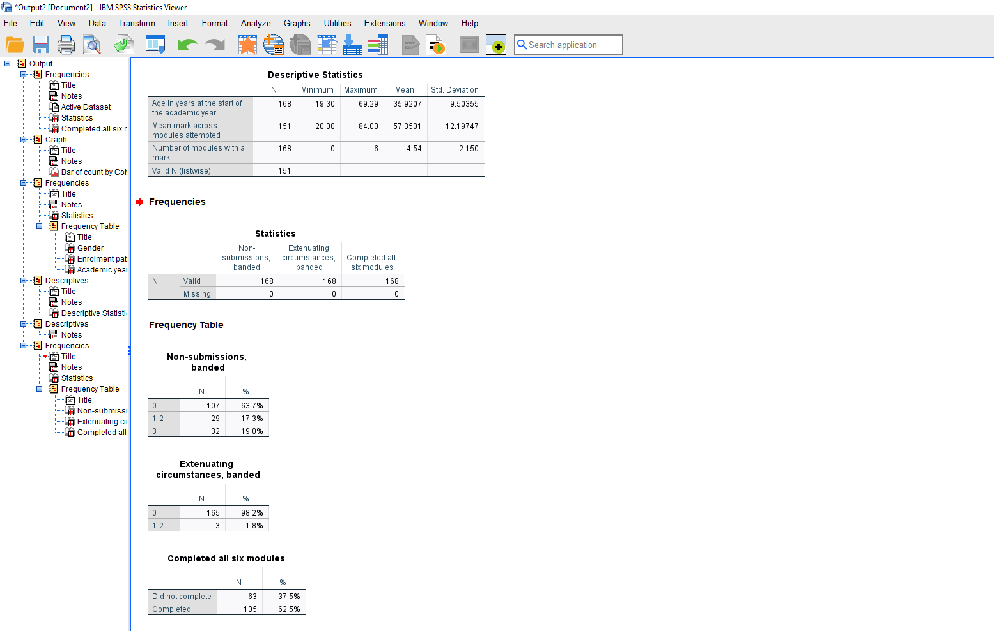

E05. Source for Table 4 and H1 - Crosstabulation, chi-square and symmetric measures
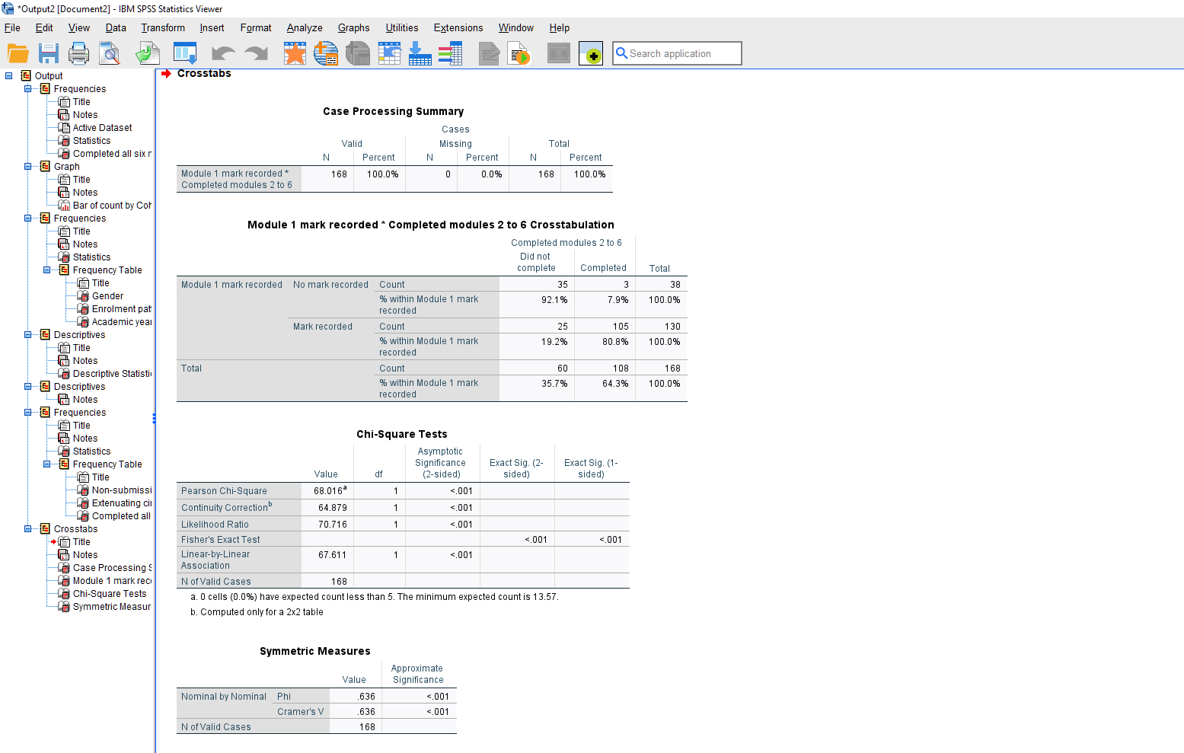

E06. Source for Figure 3 - Clustered bar chart of completion by Module 1 submission
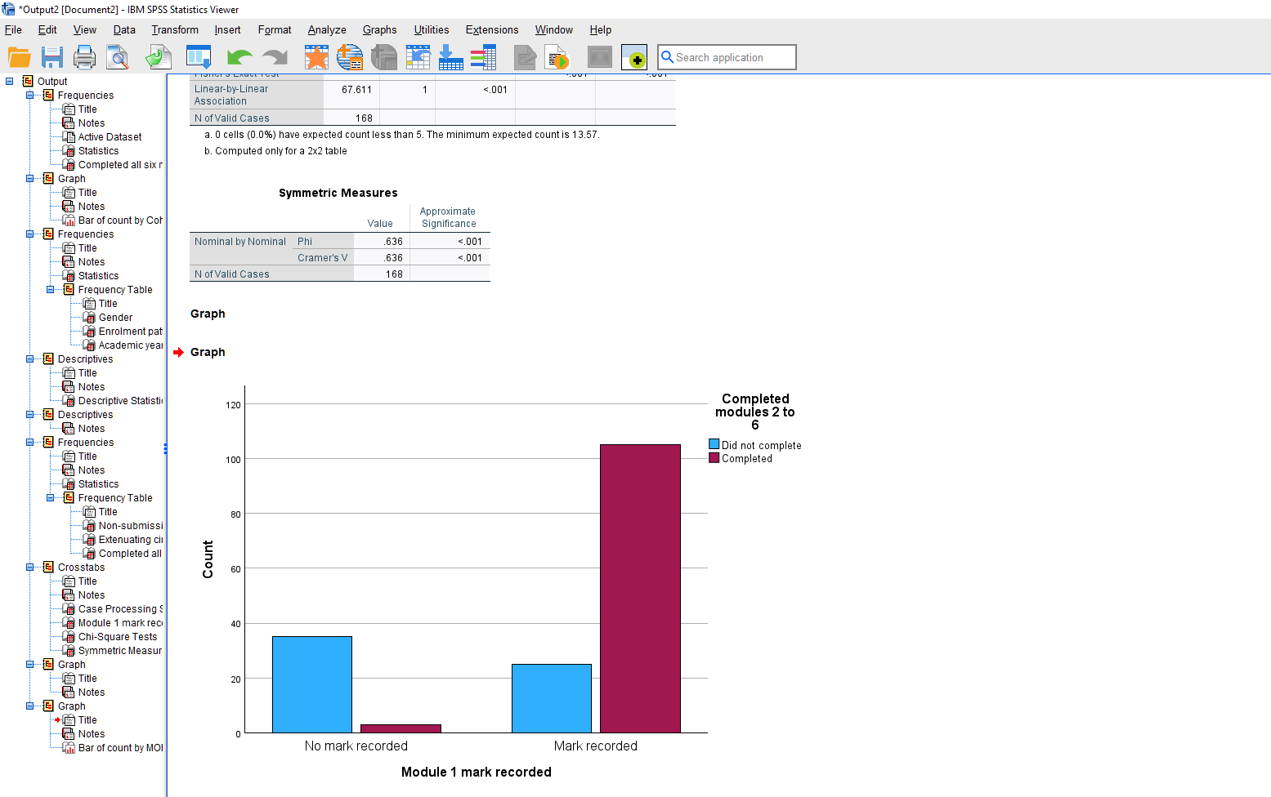

E07. Source for Table 5 and H2 - Independent-samples t-test
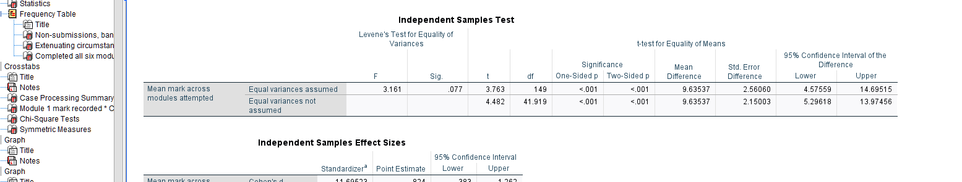

E08. Source for Figure 4 - Boxplot of mean mark by enrolment pattern
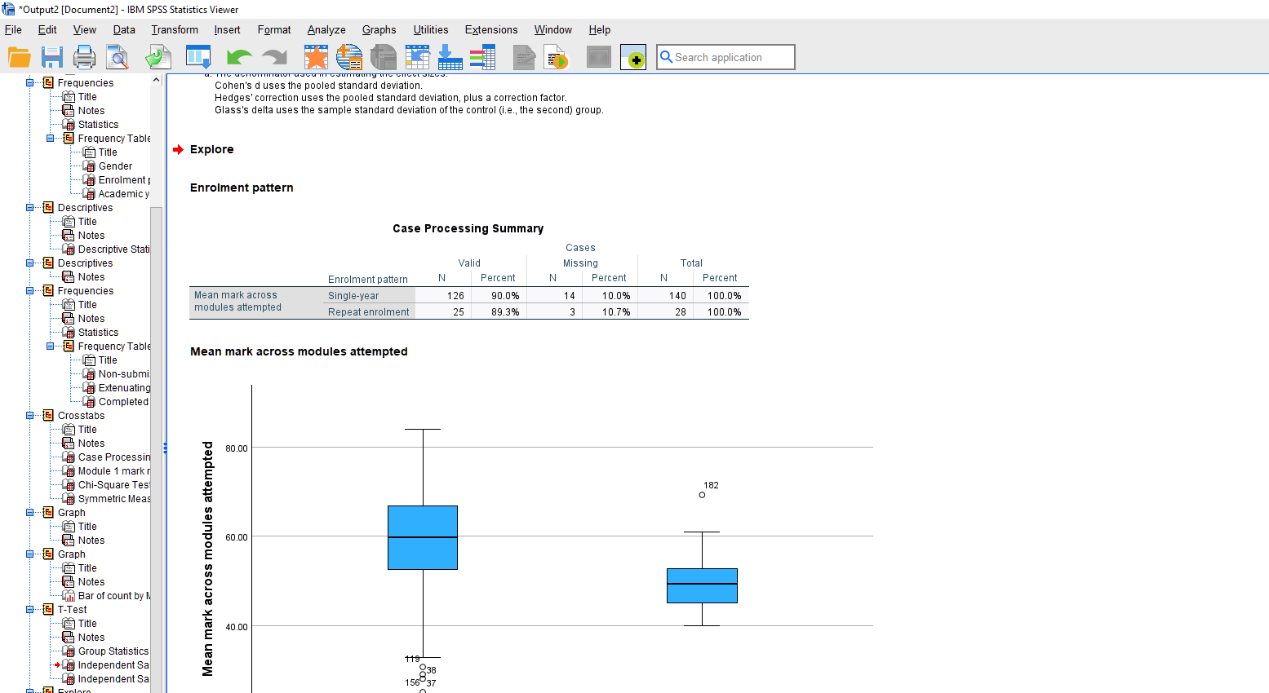

E09. Source for Table 6 and H3 - Correlation matrix
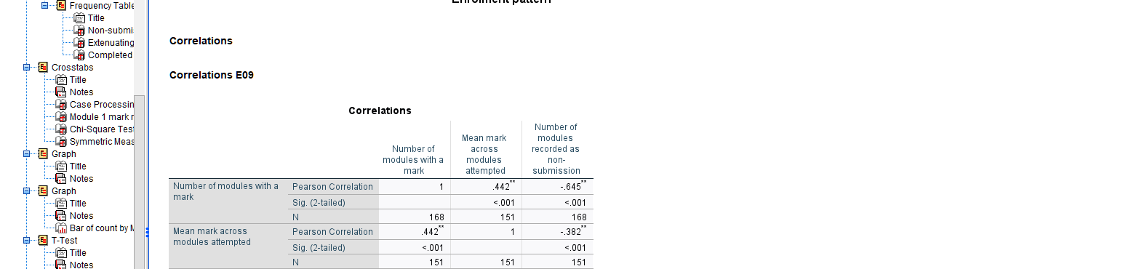

E10. Half-marks correlation check referenced in Section 4.2.5
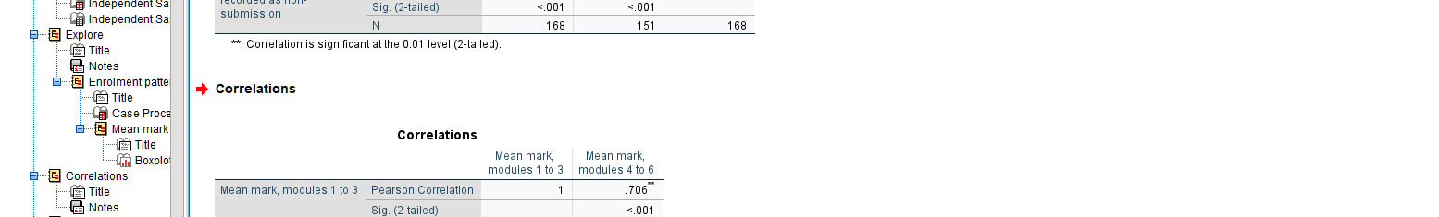

E11. Source for Figure 5 - Scatterplot with fitted line
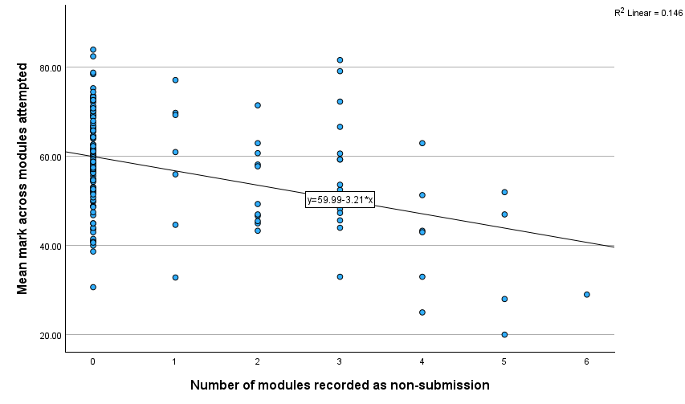

E12. Source for Table 7 and H4 - Homogeneity test and Welch’s ANOVA
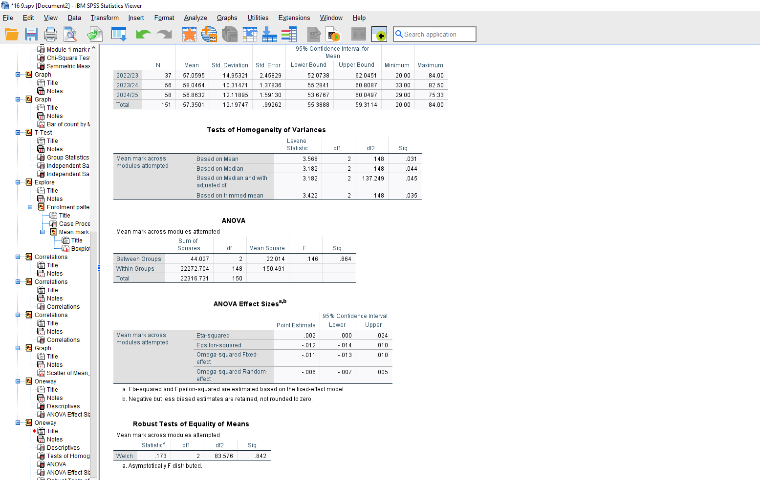

E13. Source for Table 8 and H5 - paired-samples t-test
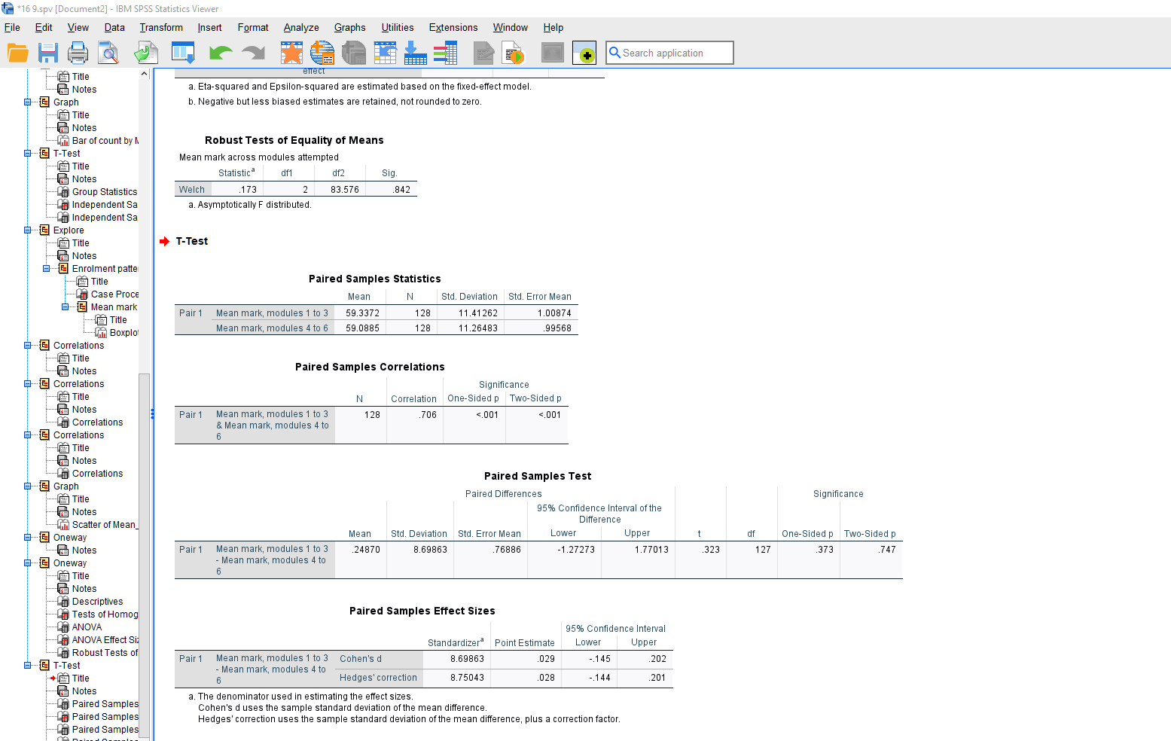

E14. Source for H5 - Wilcoxon signed-rank test
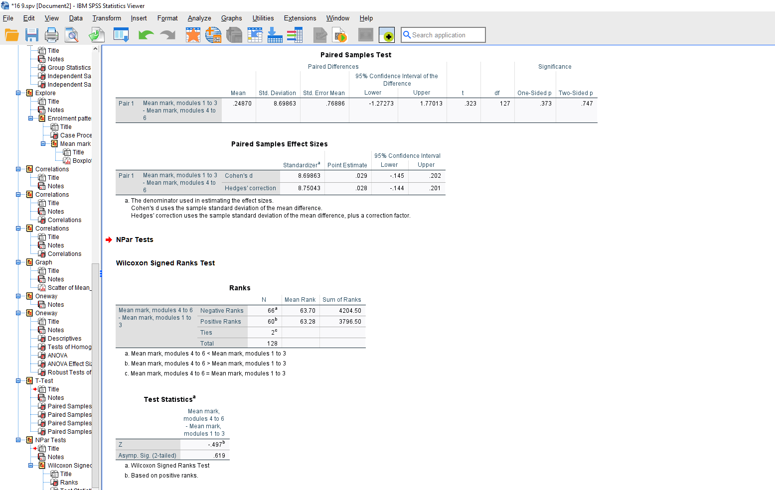

E15. Normality check for Mean_Mark (Section 4.1.2 / Appendix B2)
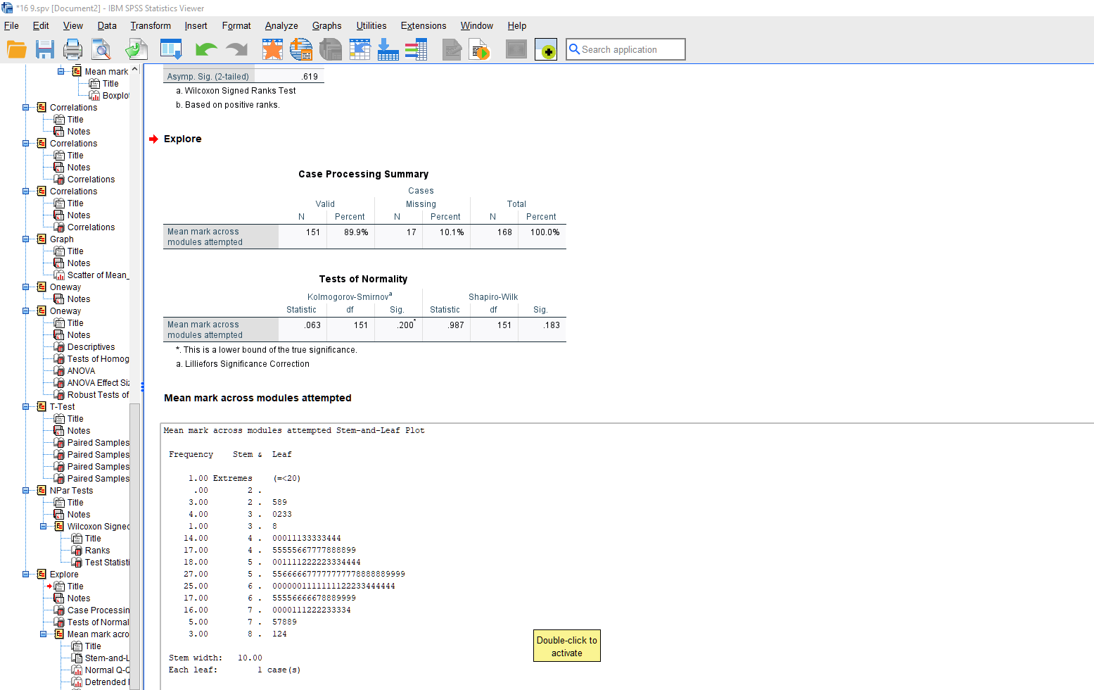

E16. Normality check for Diff_Halves (Section 4.2.5)
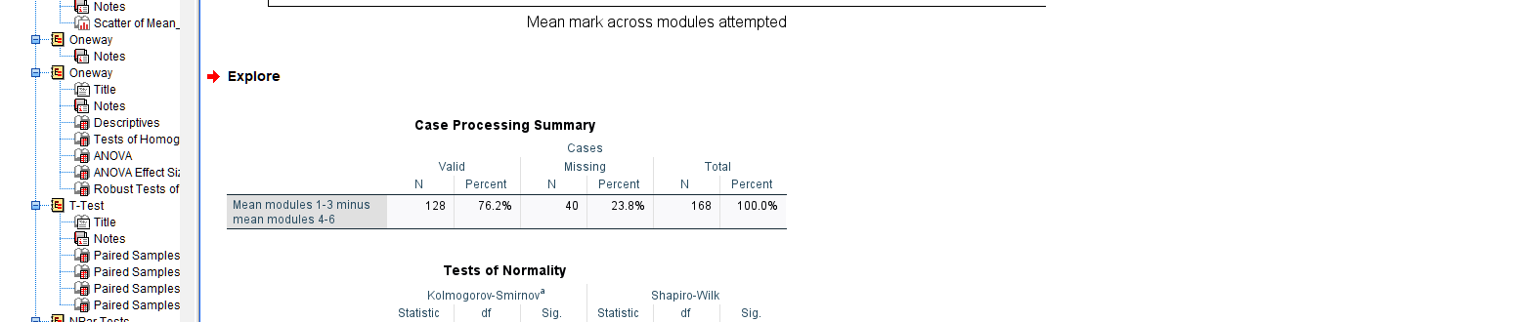

E17. Supplementary check - Module 1 mark by eventual completion (Section 4.2.7)
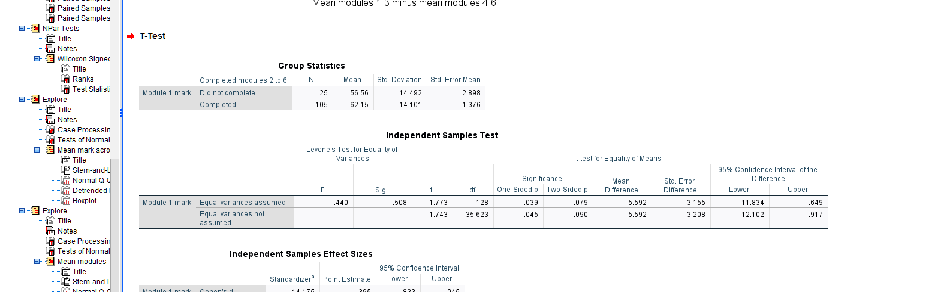

E18. Supplementary check - Under-25 comparison, Module 1 submission (Section 4.2.7)
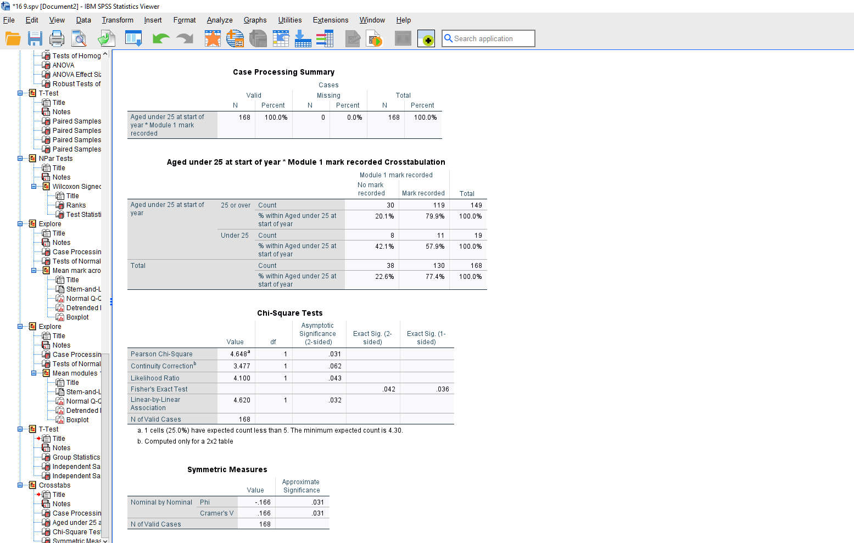

E19. Supplementary check - Under-25 comparison, six-module completion (Section 4.2.7)
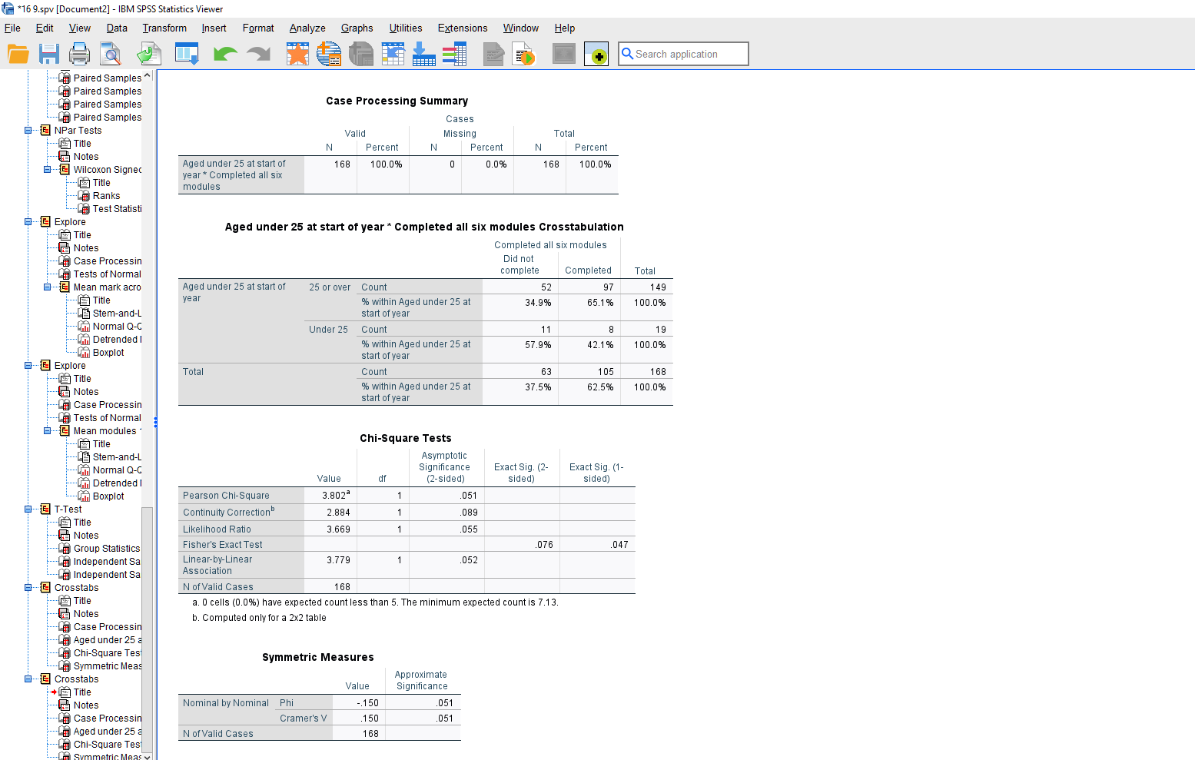

Appendix F. Hypothesis to conclusion
This appendix explains the decisions I made in the analysis, in the order I made them, so that someone who has never used SPSS can follow my thinking. What matters most is not which tests I ran, but why I chose them, what I checked first, and what I stopped doing when the data would not support it. Section F6 covers the two analyses I planned and then dropped.

F1. Where the study started, and why the question changed
I kept noticing the same thing in my own practice: students who do not complete the programme often start drifting away in the records long before anyone formally picks it up. My first question was about Statements of Compensatory Measures (SCM), the university’s record of formal adjustments, and whether having one was linked to marks and completion.
I changed that once I looked closely at what the SCM field actually records (Section F6 explains why). I moved to early assessment engagement instead, using three things recorded the same way for every student, every year, with no judgement needed to read them: whether the first assessment was submitted, how many assessments were missed, and whether the enrolment was a first attempt or a repeat.
This was a deliberate change. You cannot answer a question with variables that do not actually measure it, so I settled on: which early, administratively visible signs of assessment engagement are linked to programme completion among widening-participation mature learners on a Level 4 work-based leadership programme?

F2. Turning the question into hypotheses
I wrote five null hypotheses before running any test, each paired with an alternative saying the opposite. A null hypothesis assumes there is nothing going on; the test asks whether the data give me enough reason to reject that. I kept all five non-directional, I did not predict which way any difference would go, because the literature is not strong enough to justify a confident prediction in this population, and picking a direction after seeing the output would not be a real prediction anyway.

H1. There is no association between having a recorded mark for Module 1 and completing Modules 2 to 6.
H2. There is no difference in mean academic mark between single-year and repeat-enrolment records.
H3. There is no linear relationship between the number of non-submissions and mean academic mark.
H4. There is no difference in mean academic mark across the three academic cohorts.
H5. There is no difference in mean marks between the first and second halves of the module sequence.
H1 to H3 are the main questions. H4 and H5 check whether my findings are just an artefact of which year a student enrolled in, or where in the module sequence a mark was earned. If neither makes a difference, my main findings are more trustworthy, not less, which is why I report them too.

F3. Building the dataset
My data came from institutional Exam Board records and programme tracking documents for every Level 4 ALaM enrolment across 2022/23, 2023/24 and 2024/25, everyone eligible in those three years, not a sample. That is why I do not describe a sampling method, and why I treat the limits on generalising as real rather than a formality.
I started with 216 enrolment records and wrote my inclusion and exclusion rules down before looking at any results, so the rules could not be shaped by what I found. Then I applied them one at a time.
Rule one removed duplicates: a student recorded twice in the same year by the Exam Board, usually because a result was confirmed at more than one board. I found these by sorting on student identifier and year and checking each pair against the tracking document, 14 records. This is different from a student appearing in two different years, which is a genuine second enrolment and stays in.
Rule two removed empty records: students entered onto the system with no mark, no submission, nothing recorded in any of the six modules, no evidence they ever started. That is 33 records. Including them would have made non-completion look far more common than it is.
Rule three removed one 2025 starter who fell outside my three-year window.
Each excluded record kept its reason in a separate column rather than being deleted, so the count against each rule can be checked. That left 168 records to analyse, belonging to 159 individual students, nine students enrolled in more than one year and appear twice.
That records-versus-students distinction matters throughout, because every test I use assumes cases are separate from each other, and nine of mine are not entirely. Where I needed a figure per student rather than per record, I used each student’s most recent enrolment, which gives 159. I report both numbers rather than whichever suits the point I am making.
I kept the 48 excluded records in the file rather than deleting them. Deleting them would make the spreadsheet tidier but my exclusions impossible to check, the figure of 168 is only trustworthy if the 48 taken out, and the reason for each, are visible too. So they stay in the file with a reason attached, switched off at the point of analysis, which Section F5 explains. Table 10 deliberately uses all 216 records, because it reports how common SCM records are across the whole population rather than within my analysed group, and using 168 there would make the figure look smaller than it is.

F4. Cleaning decisions that change the answer
A few decisions about how to represent the data would have changed my results if I had made them differently.
A non-submission is not the same as a mark of zero, one is failing the work, the other is not doing it. Treating them the same would have dragged every average down for reasons that have nothing to do with academic quality, so I counted non-submissions separately and worked out mean marks across attempted modules only.
Extenuating circumstances and deferrals record a university decision about a student, not a student failing to engage, so I counted those separately too.
Capped and uncapped marks stayed as two separate variables, 35 module cells across 26 records show a capped mark of 40 with a higher real mark behind it, and merging the two would have hidden a real difference in what the mark represents. I say each time which one I used.
Where a student had no mark for a module, I left the cell empty rather than entering anything, so SPSS would treat it as missing rather than as a score of zero.

Correcting errors in the original spreadsheet
Before any of this could work, the spreadsheet had to be right, and it was not. The original extract had errors that would have stopped SPSS reading the data properly, or worse, let it read the data wrongly without complaining: one mark field held a year, 2025, where a mark should have been; one student’s gender code was blank; eight columns had been saved as text rather than numbers or dates, which SPSS cannot calculate with, cannot label, and will refuse several procedures on.

Why the analysis variables were built in SPSS and not in Excel
I chose not to work out my seven analysis variables in Excel. Mean mark, number of modules attempted, whether a student completed all six, and the rest were all calculated inside SPSS using Transform and then Compute Variable.
Compute Variable is SPSS’s calculator: give it a name for a new column and a formula, and it works that out for every record. The formula stays visible, stored in the file and the saved syntax, so anyone can check exactly how mean mark was arrived at. An Excel formula does not survive the same way: once numbers are copied into a new sheet, or pasted as values, the working disappears and only the answer remains. The screenshot of the Compute dialog is also evidence the calculation was done in SPSS as part of the analysis, rather than arriving in the file already finished.
For mean mark I used a version of the average called MEAN.1, rather than an ordinary average, because an ordinary average would still return a number for a student with no marks at all. MEAN.1 returns a blank instead, which is the answer I want, a student who has never been marked does not have a low average, they have no average. This is why my mean-mark analyses run on 151 records rather than 168: seventeen students have no marks to average.
These seven variables were built with the exclusions already switched on, so they exist for the 168 analysed records and are blank for the other 48. That is deliberate. Computing them across all 216 rows would have built averages and completion flags for students I had already decided to exclude, and any later mistake with the filter would then have produced a result that looked plausible rather than wrong. Table 10 is the one analysis that uses all 216 rows, and it uses only raw recorded variables such as cohort and SCM status, never the seven computed ones.

F5. Preparing Excel Data for SPSS
Before importing, I set the spreadsheet up as one row per enrolment record and one column per variable, with a single row of headings. Inside SPSS I then gave every variable a name, a plain-English label, labels for each numeric code, a measurement level and a rule for what counts as missing. This is relevant because SPSS behaves differently depending on what it thinks a variable is: it will not run a correlation on something it believes is a category, and it will happily calculate an average of a variable that should not have one.

Selecting the cases I wanted to analyse
This turned 216 records into the 168 I actually analyse.
My Excel file had 216 rows, but only 168 of them belong in the analysis. I needed SPSS to leave the other 48 out of every calculation without losing them from the file, otherwise every test uses all 216 and every figure is wrong.
I could have deleted the 48 rows, but that makes my exclusion decisions unverifiable, for the reason given in Section F3, and those decisions are a judgement I should be able to defend. Instead I kept every row and told SPSS which ones to use, through Data and then Select Cases. I gave it the rule Include_in_Analysis = 1, the column recording whether a record passed my three exclusion rules, and chose the option that filters cases out rather than the one that deletes them. SPSS creates its own column, filter_$, holding 1 for every record I want and 0 for the rest, and skips the zeros from that point on. In the data view the excluded rows are still visible, with a diagonal line struck through the row number.
The point is one file that contains everything, where the analysed group is defined by a rule anyone can read rather than by rows that quietly no longer exist. Keeping two files, an original and a working copy, is how versions drift apart without anyone noticing.

Why I checked the filter before every test
I checked the filter was still switched on before every single procedure, for a specific reason: it can come off without any warning. Reopening the file, or running a procedure that changes which cases are selected, can leave it switched off, and SPSS does not tell you. It simply analyses all 216 records and produces a table that looks entirely normal. Nothing is flagged.
The check itself takes a few seconds: if any table adds up to 216 instead of 168, the filter is off. Table 10 is the only place in my study where 216 is the number I want to see.
This is not a hypothetical risk. When I re-ran the analysis to verify my figures, the first table I produced reported 18 SCM records out of 216 rather than 12 out of 168. The filter had come off between sessions. Had I not been checking, I would have reported a prevalence of 8.3% instead of 7.1%, and the maximum date in Table 9 would have been wrong as well.

F6. Two analyses I planned and then did not use
I planned two analyses that I did not run, both stopped because of what the data showed me. I have kept them here because what you set aside says as much about an analysis as what you keep.
Comparing marks before and after the SCM date. I had assumed the recorded date was the point at which adjustments were agreed with the student. Learner Support told me it is actually the date somebody created the record during an administrative lookup in August 2026, a different thing altogether, and possibly long after any adjustments were in place.
So I tested whether the comparison was even possible. Working record by record, I compared every SCM date against the module submission deadlines for that student’s cohort, to see how many students had marks on each side of their own date. The answer was two. One of those two has capped marks of 40 all the way through, so any change I found for that student would just be the cap moving rather than real improvement. That leaves one usable case, and you cannot run a before-and-after comparison on one student. I set the analysis aside and put the evidence for that decision in my Methodology rather than removing it without comment.
A model predicting completion from several variables at once. The two variables that would predict completion best are the number of modules attempted and the number of non-submissions. Both of them are part of how completion is defined in the first place, because you cannot complete six modules without attempting six modules. Putting them into the model would get every single case right, regardless of the underlying pattern. A test only tells you something if it could have come out differently, and this one could not. The statistical name for the problem is complete separation. I set the model aside.
I also considered comparing outcomes between students who had an SCM record and students who did not, and rejected that too. A chi-square test works by comparing the numbers you actually see against the numbers you would expect if nothing were going on. When those expected numbers get very small the test stops being reliable, and the usual rule is that they should not fall below five (Field, 2024). Only 12 of my 168 records have an SCM record, which pushes the expected numbers well below that, and the test would have had almost no chance of finding a difference even if one existed. I therefore report the SCM data descriptively, as counts, percentages and dates, and make no statistical claim about it.

F7. Choosing a test for each hypothesis
I chose each test from four things: what type of variables I had, how many groups I was comparing, whether the observations were separate people or the same people measured twice, and what the distribution of the data looked like once I checked it. I made each choice before I saw the result.
The last of those four decides whether a test is parametric or non-parametric. A parametric test usually assumes the data follow a reasonably normal, bell-shaped distribution, though the exact assumption depends on the test; a non-parametric test makes no such assumption and works from the rank order of the values instead (Field, 2024). Parametric tests are preferred where their assumptions are met, because they use more of the information in the data and are better at detecting a real difference. Where the assumptions are not met, they can give a confident answer that is simply wrong, and the non-parametric version is the safer choice.

The table below sets out, for each hypothesis, what I was asking, what I checked, what my options were, and why I chose what I did.
H | What I wanted to find out | Variables and design | What I checked | Options available | Test chosen and why
H1 | Whether completing Modules 2 to 6 is linked to having a Module 1 mark | Two yes/no variables | Normality is not relevant for chi-square. I checked that the expected numbers in each cell were large enough. The smallest expected count was 13.57, so this assumption was met. | Chi-square; Fisher’s exact test if the expected counts were too small | Chi-square with Yates’s correction, because this was a 2 × 2 table and the expected counts were large enough.
H2 | Whether repeat students get different marks from single-year students | Two separate groups and one mark | I checked whether the marks in each group were roughly normally shaped. The single-year group was not quite normal, because a few low scores pulled it off shape, but with 126 records in that group the test still works well despite this. The repeat group was fine. Levene’s test gave p = .077, so the spread of marks in the two groups was similar enough. | Independent t-test; Welch’s t-test if the spreads were unequal; Mann-Whitney U if the data were unsuitable for a parametric test | Independent-samples t-test, because the assumptions were met. I used Hedges’s g to show the size of the difference because one group was relatively small.
H3 | Whether more non-submissions are linked to lower marks | Two numeric variables measured on the same records | I looked at the scatterplot first. The relationship was broadly a straight downward pattern. Because non-submissions are a count variable, I also checked the result using Spearman’s rho. | Pearson correlation; Spearman correlation; regression for a more detailed model | Pearson correlation as the main test, with Spearman’s rho as a check. Both showed the same general relationship.
H4 | Whether the three cohorts differ in mean mark | Three separate groups and one mark | I checked whether the spread of marks was similar across the three groups. Levene’s test gave p = .031, so the groups did not have equal variances. | One-way ANOVA; Welch’s ANOVA; Kruskal-Wallis | Welch’s ANOVA, because the groups had unequal variances. This is designed for that situation.
H5 | Whether marks changed between the first and second half of the modules | The same records measured twice | For a paired t-test, the important check is whether the differences between the two sets of marks are roughly normal. Shapiro-Wilk gave p = .239, so there was no evidence of a problem. | Paired t-test; Wilcoxon signed-rank test | Paired-samples t-test, because the difference scores were suitable for a parametric test. I also checked with Wilcoxon, which gave the same general conclusion.

.

What the significance level means, and why two-tailed
I set the significance level, alpha, at .05, the level of doubt I am prepared to accept. It means that if the null hypothesis were true, I would expect to see a result at least as strong as mine fewer than five times in a hundred by chance alone, so below .05 I treat that as sufficient evidence to reject it. This threshold is a convention rather than a law of nature: it tells me a result is unlikely to be an accident, not that it is important or large (Field, 2024).
I used two-tailed tests throughout. A one-tailed test looks for a difference in one direction only and is easier to pass, but it is only legitimate if you predicted the direction in advance and would have ignored a result the other way. I did not predict any directions, so a two-tailed test, which allows for a difference either way, is the honest and stricter choice.
Before software, you would compare your test statistic against a critical value looked up in a t table, using your degrees of freedom and chosen alpha. SPSS does the equivalent calculation and reports the exact probability instead, so I did not need the tables, but I still report degrees of freedom alongside every statistic, because they tell you which distribution the number is being judged against.
For every test I give the statistic, the degrees of freedom, the exact p value, the descriptive figures behind it, a confidence interval and a measure of effect size. A p value on its own only tells you whether something was detected. It does not tell you how big it is, or how sure anyone can be about it.

F8. Reading the output
SPSS gives you more than you need. Most procedures produce several tables and rows, and only some answer the question you asked, knowing which part to read is a large part of the skill.
For H1 I used a crosstab, a table counting how many records fall into each combination of two categories: students with a Module 1 mark who did or did not go on to complete, and the same for students without one. SPSS prints several versions of chi-square underneath it. I read the continuity correction row rather than the Pearson row above it, because the correction is the version designed for a two-by-two table, and the footnote below gives the smallest expected count, which decides whether the test can be used at all. Mine said 13.57, so it could.
In the t-tests, SPSS prints two rows: one for when the two groups are similarly spread out and one for when they are not. Levene’s test, printed just to the left, tells you which row to read. For H2, Levene’s was not significant, so I read the first row; for my supplementary comparison of Module 1 marks, Levene’s was not significant either, at p = .508, so I read the first row there too. Using the same rule in both places matters, because switching rows without explaining why looks like choosing whichever answer suits.
In the ANOVA, SPSS prints an ordinary table and then a second one underneath headed Robust Tests of Equality of Means. Robust here simply means the test still works when an assumption has failed. Because Levene’s test had failed, I read the robust table, reporting the ordinary one would have contradicted the assumption check I had described a paragraph earlier.
Across all the tests, how many records each one actually used ranges from 128 to 168, because not every student has every mark and SPSS leaves out any record missing a value the test needs, without saying so on the face of the table. A correlation between the two halves of the module sequence can only use students with marks in both halves, which is 128 of my 168. If I had reported a single sample size throughout, a reader would assume every finding rested on the same 168 records, and that is not true, so I give the number each time, and the degrees of freedom follow from it.

F9. Getting from a result to an interpretation
Three of my null hypotheses were rejected and two were not. I was careful about three things when interpreting them.
I did not turn an association into a cause. Nobody was allocated to a group at random; I am working with records of what already happened. I can say two things went together, not that one produced the other, so I say variables were associated with, or differed by, an outcome. Nothing in the study improved, caused or led to anything.
I did not treat a hypothesis I had failed to reject as one I had proved. A test can fail to find a difference for two quite different reasons: either there is no difference to find, or there is one but I did not have enough data to detect it. The p value alone cannot tell those apart, what separates them is how big the difference actually was and how precisely I managed to measure it.
For H4 and H5 the differences were very small as well as non-significant, at eta squared = .002 and Cohen’s dz = 0.03, with narrow confidence intervals around them. A confidence interval is the range of values the true difference is plausibly within. A narrow interval close to zero means I have measured a small difference fairly precisely, which points towards there being nothing much there. A wide interval would have meant I could not tell, and I would have had to say so. It is that combination of a small difference and a narrow interval, rather than the p value on its own, that lets me conclude that cohort and sequence position do not really affect my findings.
I did not resolve the SCM question in either direction. The recorded date tells me when an administrator created a record, not when a student’s adjustments started working. Support arriving too late to help and support being triggered by difficulty that was already visible would look exactly the same in my data. I cannot tell them apart, so I say so rather than choosing whichever reading suits my argument.

F10. What I concluded, and what I did not
My question was which early, visible signs are linked to completion. What I found is that whether a student submits the first assessment separates completers from non-completers much more clearly, and much earlier, than the mark they get on it. Among students who did submit Module 1, the mark itself did not significantly predict whether they completed, whereas submitting did. Whether the enrolment was a first attempt or a repeat is the second signal.
Four things limit what I can claim from that. First, the dataset does not record who used the General Study Skills service, which is open to every student whether or not they have disclosed anything, so I cannot describe students without a formal SCM as unsupported, something I cannot see may be doing some of the work, and this is both my biggest weakness and my clearest recommendation for further research. Second, my records are enrolment episodes rather than separate people, and nine students appear twice. Third, module structures, titles and deadlines changed across the three years, so I am not always comparing like with like. Fourth, this is one programme in one institution, so I am treating the findings as evidence about this group of students rather than about mature learners generally.

F11. Checking my own figures
A delay obtaining SPSS from UWTSD meant I initially used a trial v29 to produce my first findings and discussion. Once I had a proper UWTSD-licensed version, I re-ran every analysis from scratch in a fresh install of SPSS v30, one procedure at a time, and compared each result against what I had written. All the main results came back the same, but four things needed correcting.
The first was a supplementary comparison I had described as not significant. One of the expected counts in that table was 4.30, below the threshold of five. As explained in Section F6, chi-square becomes unreliable when the expected counts get that small, because it is an approximation that relies on the numbers being reasonably large. Fisher’s exact test does not approximate; it calculates the probability directly, which is why it is the one to read in this situation. Fisher’s gives p = .042, so the difference is significant after all, and I corrected the text.
The second was the Wilcoxon figures in Appendix B, which did not match my output. The figures I had originally reported came from a calculation made outside SPSS during an earlier check. Software differs slightly in how it handles tied values, meaning records where the two halves produced exactly the same mark, and my data contain two of those. That difference is enough to change the statistic in the second decimal place. I have used the SPSS figures, Z = -0.50, p = .619, because SPSS v30 is what I actually ran and what I would be asked to reproduce. The conclusion is unchanged either way.
The third was an inconsistency in how I had applied Levene’s test. In one t-test I had read the row for equal spread and in another I had read the row for unequal spread, even though Levene’s test was non-significant on both occasions and pointed to the same row both times.

The fourth was omission rather than error. Confidence intervals for the effect sizes, the exact number of records used in each test, and the effect size for the ANOVA were all sitting in my SPSS output but had not been carried into the paper. They are important because an effect size without an interval tells you the size of the difference but nothing about how precisely it has been estimated. I have added them.

