Embedding Sustainability within Organisations (BMSP7003D)

Lecturer – Dr Roisin Mullins

Assessment 1 – Report

Steven Saunders (1903236)

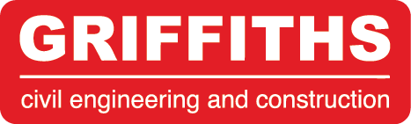 | 2nd November 2020

to: |  | Senior LEADERSHIP TEAM
from: |  | STEVE SAUNDERS (MBA SUSTAINABILITY GRADUATE)
subject: |  | ORGANISATIONAL SUSTAINABILITY ASSESSMENT
CC: |  | TARMAC SUSTAINABILITY DIRECTOR
Introduction and purpose
This report has been produced to assess the current level of sustainability within Griffiths. The report will assess the impact of the existing corporate sustainability strategy across the business, highlight any interrelated issues and/or conflicts of interest and provide a comparative understanding of the sustainability level of the business within the construction industry. In particular, this report will demonstrate that by dispelling the Prisoners' dilemma theory (Robèrt & Broman, 2016), Griffiths could gain a competitive advantage and increase market share by increasing sustainability levels within the business.
Strategy:
Griffiths have a corporate sustainability strategy – known as the Sustainability Challenge. Using the triple bottom line model, the Sustainability Challenge sets Economic, Social and Environment objectives and targets which measure the positive impact of sustainability initiatives across the business. Griffiths should be commended for having such a strategy that is linked to its purpose: ‘to provide the infrastructure to support a vibrant economy and cohesive communities without having a detrimental effect on the environment’.
However, the report Corporate Sustainability at a Crossroads (Kiron et al., 2017), lists articulating a practical sustainability vision and ambition that lays the foundation for new business practices as top of the list of their eight evidence-based factors that drive sustainable business practices. This is where Griffiths can improve.
The Sustainability Challenge is more a near-term plan for measuring and reporting environmental, social and economic improvements each year rather than a strategy which guides and drives sustainable businesses practices. Rather than having both a Business Plan and Sustainability Strategy covering the same period, why could a single Sustainable Business Plan be developed and place sustainability at the heart of the business?
Some of the most sustainable businesses are taking this approach. In the 2019 United Nations Global Compact - Accenture Strategy: CEO Study on Sustainability Alan Jope, CEO at Unilever said: “There is no difference between our business strategy and our sustainability strategy…they are totally integrated.”
Griffiths could take this approach to identify new markets, cost and resource saving initiatives which will help deliver the profitable growth target of £230m by 2021.
When compared to others in the industry, Griffiths are already benefiting from a competitive advantage over similar-sized regional contractors – this can be demonstrated through a number of industry awards in Wales and on a national level. In 2020, Griffiths’ St Athan Northern Access Road won Constructing Excellence’s Civils Project of the Year and the Llanbersi Flood Alleviation Scheme won the Sustainability Project of the Year. In 2019, Griffiths received Constructing Excellence’s National People Development Award, recognising school engagement and employability programmes, and the A379 Slapton Line Reconstruction won the Chartered Institution of Highways and Transportation Environmental Award for the protection of the Slapton Sands Site of Special Scientific Interest (SSSI) and National Nature Reserve.
However, its is Skanska, a multinational construction and development company based in Sweden, who are seen as industry leading. Their purpose and focus on sustainability is deeply engrained within the business. They are striving to grow from being a leader in each area of sustainability to being an industry leader and authority within sustainability as a whole and they have identified sustainability leadership as a a business advantage, contributing to delivering profit and creating shareholder value. Skanska have developed their own way of measuring “how green” they are. They have a tool called the Skanska Color Palette which is used to measure and guide sustainability initiatives. It has a range from vanilla to green to Deep Green, reflecting the stages between legal compliance and near-zero environmental impact.
Griffiths could develop a similar system based on external accreditations such as BREEAM, but focused solely on infrastructure rather than buildings. This would benefit the business by providing a standardised sustainability benchmarking tool which would be specific to infrastructure projects. It could also become a recognised verification award used by other contractors and help Griffiths become an industry leader and shape future legislation – like the examples of OK Petroleum, Volvo and IKEA as presented by Robèrt & Broman.
Leadership:
The Sustainability Challenge is endorsed by Director Huw Llywelyn. However, no Director or member of the Senior Leadership Team within the business has been identified as solely responsible for sustainability. A Sustainability Manager is identified on the organizational structure, however this individual sits within the Business Development and Marketing Department and is predominantly responsible for environmental and social value tender responses and work winning.
Change agents play a crucial role in driving the advancement of sustainability management and, thus, the organisational change for sustainability (Kiesnere and Baumgartner, 2019). This is highly relevant to smaller large-sized businesses, like Griffiths, with revenue of €50–300 million and employing more than 250 employees. Furthermore, in six case studies conducted by Siebenhüner and Arnold, it was found change agents were of central importance to the learning processes and often these agents were not in executive functions.
Griffiths should consider appointing a Sustainability Director or, at the very least, allocating responsibility to an existing Director and providing the necessary training to help integrate sustainability into the core business, such as circular economy and waste to wealth initiatives, and identify new business opportunities and increasing market share of renewable energy projects like the Tidal Lagoon Swansea or numerous wind farms across our operational area.
Griffiths’ Sustainability Manager should be able to recruit additional Sustainability Champions across the business. These could be existing employees who would take on dual roles or additional resource. This would not only improve our ability to deliver project and client-specific sustainability initiatives (detailed below) but also instigate a ‘sustainability movement’ within the business, improve sustainability measurement, reporting and performance.
However, the appointment of Sustainability Director and increased resource does not mean sustainability will instantly be integrated throughout the company. Prof Caroline Dale Ditlev-Simonse at BI Norwegian Business School says: “The best way to check to what extent sustainability is integrated in day-to-day operations is to show up at the company HQ entrance on Monday morning at 08.00 and ask employees on their way to work about the employer’s sustainability strategy and how it is implemented in their job” (Waugh, 2020). If this were to happen at a Griffiths construction site, I am not sure how many employees of our project delivery teams would know the Sustainability Challenge even existed – let alone how it impacted their day-to-day job.
Griffiths should invest in raising the profile of sustainability and the Sustainability Challenge across the Business. Using the three-phase model of incubate, launch, and entrench (Bhattacharya, 2018), ownership for sustainability should be extended beyond the Sustainability Manager (and proposed Sustainability Team) and place ownership with all employees.
I believe the Sustainability Challenge in its current form has already addressed the incubate phase. It sets a clear sustainability vision and has identified the issues most material to the business.
A Sustainability Launch event should be organised and the proposed Sustainability Director and Sustainability Manager should introduce the strategy to employees. This should be used as an opportunity to sell the benefits, such as contributing to the future well-being of both the company and society. Consideration should also be given to the development of a sustainability e-learning module for all employees to complete.
Entrenching is the process of making sustainability routine – something employees do in their day-to-day jobs. Griffiths need to create a ‘sustainability movement’. Using the process described by Derek Sivers in his 2010 TED Talk: How to start a movement, early adopters and contributors to the Sustainability Challenge need to be praised, rewarded and treated as an equal. It is these early adopters that will set the movement in motion. Individual and group success stories should be shared on the company internet, intranet, social media and company newsletter.
Initiatives:
The following tables identify the objectives and targets set by the Sustainability Challenge under the headings of Environment and Social. I will identify any interrelated issues and/or conflicts of interest and provide a comparative understanding of the sustainability level of the business within the construction industry.
Environment:
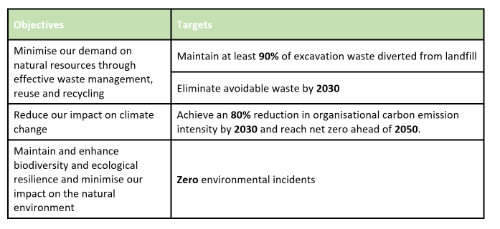
The Environment section of the Sustainability Challenge is led by the SHEQ Department. The objectives and targets set are comparable to other Main Contractors within the construction industry – demonstrated by Costain’s ‘Create a Green Future’ commitment and three underpinning actions (Costain, 2020):
- Always the low or zero carbon solution
- Eliminate waste through circular thinking
- Enhancing biodiversity value and natural capital
Griffiths should look to become industry leading in this area. Positive steps have already been made with Griffiths becoming the first private sector company to sign up to the Devon Climate Declaration in 2019 (Devon Climate Emergency, 2020). Further opportunities to align with key clients should be identified. This would also help address interrelated issues and conflicts of interest – demonstrated by the Portsmouth City Link Road Project for Portsmouth City Council, which was awarded to Griffiths, being shelved due to concerns over carbon emissions and air quality issues raised by statutory environmental bodies and local stakeholders. This could be seen as losing work, but by working with the Portsmouth City Council on the climate emergency agenda a new, larger business opportunity has been awarded. Funds for the link road have been reallocated for environmental improvements in the town centre which will be delivered by Griffiths.
By aligning environmental objectives with key clients, Griffiths will form stronger relationships with a client-base willing to join them on the net zero journey. This could potentially lead to increased market share and the opportunity to deliver higher valued, environmental improvement works in town centres – an area in which Griffiths is already highly successful.
Costain could be seen as early adopters in this area and plan to lead the construction industry’s drive to tackle climate change by offering all new and existing clients alternative low carbon options for projects. Costain chief executive Alex Vaughan said: “Eliminating carbon emissions is fundamental to ensure we help shape UK infrastructure to mitigate and adapt to the global challenge of climate change. We are developing and offering our clients low carbon, whole life solutions to ensure that we make a positive difference over the next decade” (Clark, 2020).
Like the examples given by OK Petroleum, Volvo and IKEA as presented by Robèrt & Broman, Costain could use their early adopter position as an a competitive advantage by calling for legislation, such as a carbon tax, which would put other, slower moving contractors at a disadvantage.
Griffiths should also seek to take a similar position on the circular economy agenda. By using the existing recycling capabilities, the business would get a double benefit of increasing the recycled material used in projects. First, reduced demand for diminishing natural aggregates, thus reducing costs and becoming more competitive. Second, and interrelated with the carbon agenda, recycled materials will significantly reduce the carbon emissions associated with infrastructure projects – evidenced by the carbon conversion factors within the Environment Agency’s Carbon Calculator.

Economy:
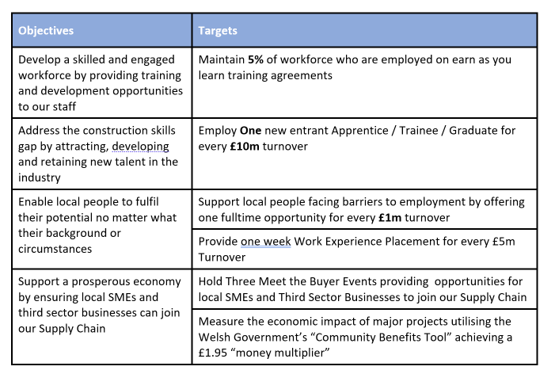
The Economic section of the Sustainability Challenge is led by the HR Department and Community Engagement Team – reporting to the Sustainability Manager.
Employment and training, particularly of apprentices and graduates, is an area in which Griffiths excels. This can be demonstrated by the company receiving Constructing Excellence’s National People Development Award in 2018 – despite competition from large multinationals, such as Faithful & Gold and Amey (Constructing Excellence, 2018).
The Economic targets have many interrelated issues and conflicts of interest. For instance, a positive example is the Apprentice+ Programme is positively impacting the staff turnover rate, helping to build diversity and reducing the average age of the workforce – an industry-wide risk. An example of a conflict of interest is that a client wishes to maximise the use of a local supply chain. However, local suppliers may not have the health and safety accreditations to undertake the work. Local suppliers may also increase costs as they don’t have the buying power of larger, national suppliers. The client would like to use local suppliers, but are they willing to pay the increased price and recognise some upskilling is required?
As a direct employer, Griffiths can use economic measurement tools to demonstrate higher local labour spends than most management contractors. This provides a competitive advantage as clients prefer spend on infrastructure to stay in the local economy and benefit from the local multiplier effect. However, despite this benefit, the conflict of interest comes when measuring impact. Tools such as the Social Value Portal recognise the economic benefit of employing apprentices and allocates an economic value of £25k per apprentice. However, the Social Value Portal does not recognise sustained employment – putting Griffiths at a disadvantage. Griffiths should engage with the Social Value Portal to develop an additional outcome, such as Apprentice Completions, or increasing scores for apprentices that progress from foundation to higher apprenticeships. The HR Department should also engage with clients to ensure understanding of KPIs and the benefits of our direct employment model over the hire and fire model.
Measurement & Reporting:
The Sustainability Challenge clearly addresses the environmental, economic and social issues most material to the business. However, to engage with a wider audience, across all operational areas, Griffiths should map objectives and targets with policy drivers – such as the seven Well-being Goals of the Future Generations Act (Welsh Government, 2015) and the 17 Sustainable Development Goals (United Nations, 2015). The Social Value Portal offer a good example of mapping their 37 social value outcomes against the Sustainable Development Goals.
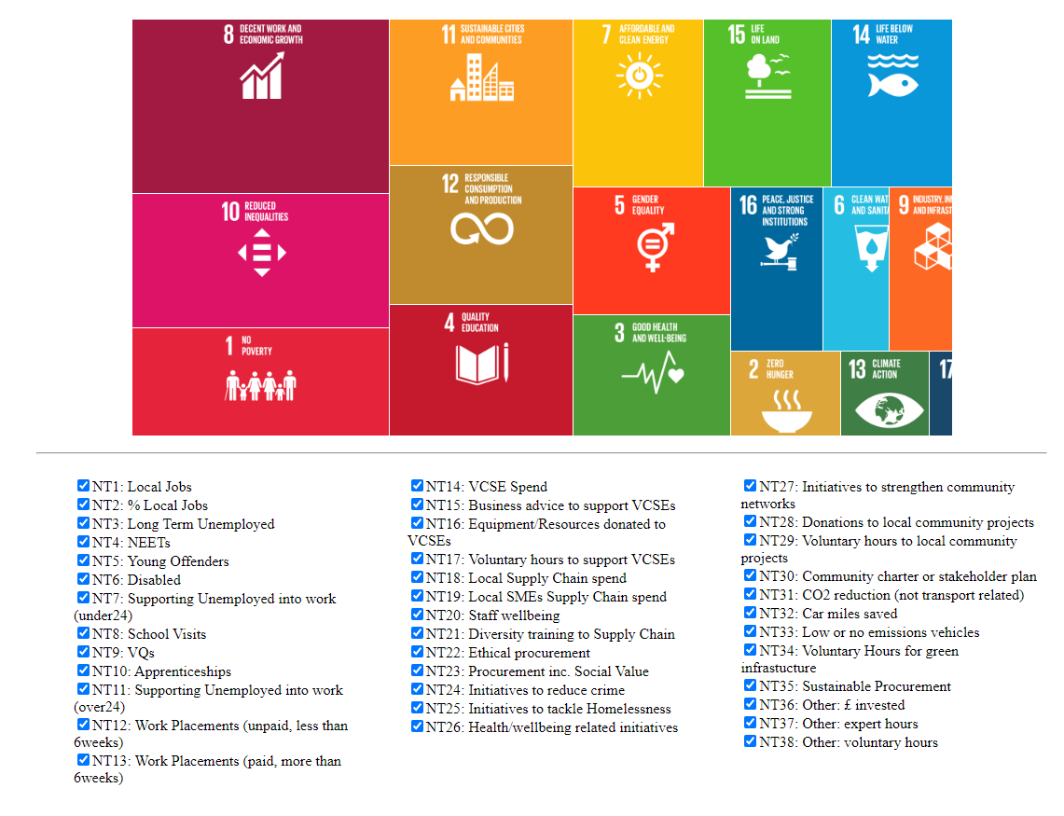
The Social Value Portal visualisation tool which maps 38 core measures against the 17 Sustainable Development Goals
Many competitors across the construction industry are using the Social Value Portal to measure the impact of their initiatives and place monetary values against what they deliver. Having promoted the tool to public sector clients as a way to report social value on construction contracts, early adopters, such as Balfour Beatty and Wilmot Dixon, are now beginning to gain a competitive advantage as local authorities are using the Social Value Portal as part of the tendering process. The initial investment in joining the Social Value Portal membership is now being repaid as social value tender responses can be weighted up to 25% of the overall procurement score. This demonstrates how public sector clients are getting to grips with the Public Services (Social Value) Act 2012 and embedding social value into their procurement processes.

Conclusion/Discussion
The business already has a strong sustainability strategy and the aim for the short-term should be entrenching it within the daily routines of all employees.
Griffiths need to overcome the thought that the cost of integrating sustainability will put them at a disadvantage. Instead, the theory proposed by Robèrt & Broman should be embraced and opportunities, like those identified in this report, used to identify new markets and position the business as sustainability leaders in the industry.

References:
Accenture, 2019, The United Nations Global Compact —Accenture Strategy: CEO Study on Sustainability 2019
Bhattacharya, CB. 2018: Harvard Business Review - How to Make Sustainability Every Employee’s Responsibility. Accessed online 01/11/2020 https://hbr.org/2018/02/how-to-make-sustainability-every-employees-responsibility
Clark, T. 2020: Costain to present clients with ‘low-carbon’ option. Accessed online 01/11/2020 https://www.newcivilengineer.com/latest/costain-to-present-clients-with-low-carbon-option-26-02-2020/
Constructing Excellence, 2018, Award Winners - The Griffiths Skills Academy. Accessed online 01/11/2020 https://constructingexcellence.org.uk/the-griffiths-skills-academy/
Costain, 2020: Being a responsible business. Accessed online https://www.costain.com/our-culture/being-a-responsible-business/
Devon Climate Emergency, 2020, Griffiths Becomes the First Private Sector Company to Sign Up to the Devon Climate Declaration. Accessed online 04/11/2020 https://www.devonclimateemergency.org.uk/griffiths-becomes-the-first-private-sector-company-to-sign-up-to-the-devon-climate-declaration/
Kiesnere, A L; Baumgartner, R J. 2019, Sustainability Management in Practice: Organizational Change for Sustainability in Smaller Large-Sized Companies in Austria
Kiron, D; Unruh, G; Kruschwitz, N; Reeves, M; Rubel,H; Meyer Zum Felde, A. 2017: Corporate Sustainability at a Crossroads: Progress Toward Our Common Future In Uncertain Times
Robèrt, K and Broman, G. 2017, Journal of Cleaner Production 140 (2017) 10 - 16: Prisoners' dilemma misleads business and policy making
Siebenhüner, B; Arnold, M. 2007, Organizational Learning to Manage Sustainable Development
Sivers, D. 2010: TED Talks: How to start a movement. Accessed online 03/11/2020 https://www.ted.com/talks/derek_sivers_how_to_start_a_movement?language=ky
United Nations, 2015, Sustainable Development Goals. Accessed online 03/11/2020 https://www.un.org/sustainabledevelopment
Waugh, R. 2020, Should you hire a head of sustainability? Accessed online 03/11/2020 https://www.telegraph.co.uk/business/ready-and-enabled/sustainability/should-you-hire-a-head-of-sustainability/
Welsh Government, 2015, The Well-being of Future Generations (Wales) Act - The Essentials. Accessed online 02/11/2020 https://www.futuregenerations.wales/wp-content/uploads/2017/02/150623-guide-to-the-fg-act-en.pdf

