

Investigating the effectiveness of a supervised learning algorithm for AI car control in racing games
by
Matthew Dickinson

Supervisor: Gordon Dickers
Second Marker: Andrew Baker

Project submitted as part of the requirements for the award of BSc (Hons) Games Development
June 2020

Declaration
I, Matthew Dickinson declare that I am the sole author of this Project; that all references cited have been consulted; that I have conducted all work of which this is a record, and that the finished work lies within the prescribed word limits.

This work has not previously been accepted as part of any other degree submission.

Signed : 

Date : 02/06/2020

Form of Consent
I Matthew Dickinson hereby consent that my Project, submitted in candidature for the B.Sc.(Hons) Games Development degree, if successful, may be made available for inter-library loan or photocopying (subject to the law of copyright), and that the title and abstract may be made available to outside organisations.

Signed :

Date : 02/06/2020

Acknowledgement
The author would like to thank the project supervisor for his support during the development of the project. The author would also like to thank family and friends for their support throughout the degree course. Finally, the author wishes to acknowledge the shared support between students of the Games Development course.

Abstract
This project aimed to investigate the effectiveness of supervised learning algorithms when used in the context of racing game AI. The project undertook a review of literature and developed an AI car controller using a supervised learning algorithm, the naïve Bayes classifier. The classifier was first prototyped in a Microsoft excel spreadsheet before being implemented within the Unity game engine as a C# script attached to a virtual car. The classifier was trained using driving data collected from the user as they drove through checkpoints placed at intervals along the track. The algorithm’s effectiveness and the overall implementation were evaluated by viewing its ability to navigate the track.
The naïve Bayes algorithm was found to output the correct decisions at the correct locations on the track using the training data collected. The car controller implementation would often steer the car off the track during straight sections due to the interval distance between checkpoints, requiring adjustments to be made to the steering angle when entering straight sections to enable the car to reach the following corner. Further work would include fine tuning of steering amounts and checkpoint distances, collecting more training data, and implementing other supervised learning algorithms to compare their performance.

Table of contents
Declaration i
Form of Consent i
Acknowledgement ii
Abstract iii
Table of contents iv
Table of figures vii
Table of tables vii
1. Introduction 1
1.1 Project Aims 1
1.2 Project Objectives 1
1.3 Report Structure 1
2. Project Background 2
2.1 Introduction 2
2.2 Background 2
2.2.1 Preface 2
2.2.2 AI in racing games 2
2.2.3 Supervised learning algorithms 4
2.2.4 Game engines 6
2.3 Related Works 7
2.4 Conclusion 7
3. Project Methodology 8
3.1 Introduction 8
3.2 Research Methodology 8
3.2.1 Philosophy 8
3.2.2 Approach 8
3.2.3 Strategies 8
3.2.4 Risks & Limitations 9
3.2.5 Validity, Reliability & Generalisability 10
3.2.6 Evaluation Methods 10
3.3 Development Methodology 11
3.3.1 Software Development Methodology 11
3.4 Resources used 11
3.4.1 Hardware Resources 11
3.4.2 Software Resources 11
3.5 Conclusion 11
4. Software Requirements 12
4.1 Introduction 12
4.2 Purpose 12
4.3 MoSCoW 12
4.4 User stories 13
4.5 Conclusion 13
5. Software Design 14
5.1 Introduction 14
5.2 Design overview 14
5.3 Design Iterations 15
5.3.1 Feature Driven Development 15
5.3.2 Design Prototypes 15
5.4 Final design 18
5.4.1 Code design within scripts 18
5.4.2 Design within Unity project 18
5.4.3 User interface design 19
5.5 Conclusion 20
6. Implementation 21
6.1 Introduction 21
6.2 Tools used 21
6.2.1 Blender 3D modelling software 21
6.2.2 The Unity editor 21
6.2.3 Microsoft Excel 22
6.3 Collection of training data 22
6.4 Prototyping the classifier 24
6.5 The naïve Bayes car controller 26
6.6 Other scripts implemented 30
6.7 Conclusion 31
7. Evaluation 32
7.1 Introduction 32
7.2 Evaluation of naïve Bayes 32
7.3 Evaluation of implementation 33
7.3.1 Improvements 34
7.3.2 Fulfilment of software requirements 35
7.3.3 Fulfilment of project objectives 35
7.4 Conclusion 35
8. Conclusions & Recommendations 36
9. Reflection 36
References 37
Appendices 42
A1 – Data Collection UML diagram 42
A2 – Naïve Bayes car controller UML diagram 42

Table of figures
Figure 1. Sector based node representation of racing lines [5, pp.440] 3
Figure 2. Overview of training process 14
Figure 3. Various test track prototypes created using Blender 16
Figure 4. Track designs using terrain painter and prefabs 16
Figure 5. Old (left) and new (right) car models 17
Figure 6. Old training data format 17
Figure 7. New file structure used to log data 18
Figure 8. Car gameObject composition example 18
Figure 9. Menu system for the example and training scenes 19
Figure 10. Heads-up display for user and AI controllers 20
Figure 11. Using the prefab system in track assembly 21
Figure 12. Checkpoints with BoxColliders 22
Figure 13. Current training data file format 23
Figure 14. File path of “logging and testing” data folder 23
Figure 15. Raw and categorised training data in Excel 24
Figure 16. The prior and conditional probabilities of each decision and attribute 25
Figure 17. The naive Bayes classifier implemented in Excel 25
Figure 18. Naive Bayes outputs on right turn 32
Figure 19. Naive Bayes outputs on left turn 32
Figure 20. Matching results between spreadsheet and Unity console outputs for checkpoint 5 33
Figure 21. Car driving straight off the track 33
Figure 22. Correction of steering angle on straight sections 34
Figure 238. Data collection UML diagram 42
Figure 249. Naive Bayes car controller UML diagram 42

Table of tables
Table 1. Internal risks to the project 9
Table 2. External risks to the project 10
Table 3. Timeboxes and the key features targeted 15

Introduction
This chapter introduces the aim of the project, the objectives required to meet this aim, and outlines the overall report structure.

Project Aims
The main aim of this development project is:
To develop, train and evaluate a supervised learning algorithm that can be used within a game engine to autonomously control a car.

Project Objectives
The main objectives of the project are as follows:
- Provide a review of relevant literature surrounding the area of AI in games and supervised learning algorithms.
- Design and develop a virtual testing environment within a game engine.
- Develop methods to collect user data for training the chosen algorithm.
- Test the algorithm by performing calculations on training data.
- Implement the algorithm into a car controller script.
- Analyse the performance of the car controller and suggest improvements.
- Evaluate the project development process and decision making involved.
Successful completion of these objectives will produce work capable of meeting the project aim.

Report Structure
The report will begin with a background research section, § 2, covering the topics of artificial intelligence in racing games, machine learning, and game engines. This will be followed by a section outlining the methodologies and resources chosen to help meet the project aim and objectives, § 3. The middle sections of the report, §§ 4–6, will contain requirements and design of the software developed during the project followed by a chapter describing the software implementation. In the final chapters, §§ 7–9 , the developed software will be evaluated, followed by an evaluation of the project overall.

Project Background

Introduction
This project aims to evaluate whether a machine learning algorithm could be utilized within the context of game development by implementing a supervised learning algorithm as part of an AI car controller. As a result, typical AI techniques used in racing games will be discussed, followed by an overview of supervised learning and a detailed discussion of a selected algorithm. Finally, some publicly available game engines will be evaluated, followed by an overview of some related works.

Background

Preface
In recent years, machine learning has experienced a large resurgence in popularity [1]. This is due to advances in Graphics Processing Units (GPUs) and Big Data, improving training speed and availability of datasets [1][2]. While AI in academia and enterprise aims to make highly accurate predictions and decisions, AI in video games exists to enhance a player’s experience and provide a beatable challenge [3, pp.1164][4]. Video game developers tend to avoid using machine learning algorithms as they can be difficult to debug and could negatively impact a games performance. Instead, developers make use of comparatively straightforward techniques such as finite state machines [5, pp.9][6].

AI in racing games
In racing games, the competency and performance of an AI controller is judged mainly by how well it can drive a car. The simplest method to implement AI in racing games is by using splines to design a racing line that contains the most optimal route around a race circuit [7].
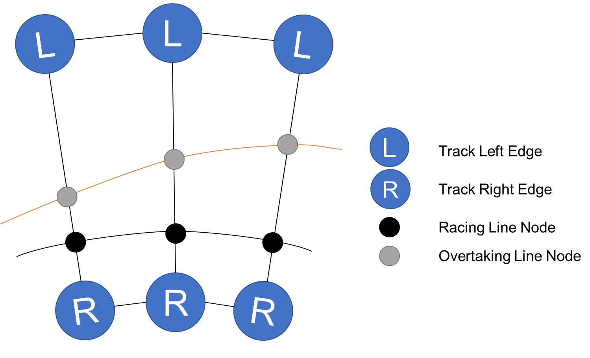
Figure 1. Sector based node representation of racing lines [5, pp.440]
This is usually realised as a list of nodes the AI controller follows, with different speed values stored for each node, implemented as sectors [5, pp.440][8, pp.194]. The racing line can also be accompanied by an overtaking line which can be utilised with state machines to incorporate overtaking behaviours. This approach has been used by many early driving games like Formula 1 [9] and Burnout [10], [11, pp.29]. To avoid the appearance of “on rails” driving behaviour, some AI drivers are given the same control inputs to the car as players and are affected by the same physics calculations as the player [12, pp.948]. To further improve the competitiveness of AI drivers, a “rubber banding” method can be used, where AI cars are teleported or given a speed boost to get closer to a player. However, this method can backfire by making players feel they have been cheated, breaking the enjoyment and immersion of the game [13].
In more recent efforts to improve competitiveness, racing games developers have tried implementing decision-based AI for their AI drivers to imitate player movements and behaviour more closely. Neural Networks were used by developers to build a driver behaviour model in Colin McRae's Rally2 [14]. The Forza Motorsport series [15][16, pp.240], has utilized both neural networks trained by the development team and supervised machine learning in their Drivatar system, where the players of the game are able to train their own AI avatar to race other players online [17][18]. The Drivatar is trained by having users complete track sections that frequently appear in the game [19, pp.284] [20, pp.137-138].

Supervised learning algorithms

Overview
There are many types of machine learning algorithm, the main types are:
- Supervised Learning Algorithms – learn to make predictions using labelled data that contains the desired solutions.
- Unsupervised Learning Algorithms – learn to find patterns and clusters in unlabelled data.
- Reinforcement Learning Algorithms – learn a strategy through rewards and penalties given to different actions [21, pp.8-14][22, pp.26-28].
Among supervised learning algorithms are two main types, classification, and regression. Classification algorithms output discrete categories such as “yes” or “no” for decisions and “red” or “blue” for colours. Regression algorithms output continuous values such as temperatures or weights [21, pp.8][22, pp.28-29].
Some of the most common supervised learning algorithms include:
- Naïve Bayes
- Decision Trees
- Logistic Regression
- k-Nearest Neighbour
- Support Vector Machines
- and Neural Networks [23][24].

No free lunch theorem
Each supervised learning algorithm has its advantages and disadvantages. The “no free lunch” theorem in machine learning states that no one algorithm is best suited to every problem [25][26]. As a result, researchers often test their newly developed machine learning algorithms against a baseline algorithm [27]. One of the most common baseline algorithms is the Naïve Bayes classifier, due to its ease of implementation and its good performance on datasets that do not match its naïve independence assumptions, [28]–[31].

The Naïve Bayes classifier
Bayes’ theorem is used to calculate the conditional probability of a class, $C$, given prior knowledge of the attributes related to it, $x$ [32]:
$$P\left(C\right|x)= \frac{P\left(x\right|C)×P(C)}{P(x)}$$
The naïve Bayes equation extends Bayes’ theorem to allow multiple attributes by making the “naïve” assumption of independence between the attributes of a class. This naïve Bayes equation is as follows [32][33, pp.499]:
$$P\left(C\right|x_{1}, …, x_{n})= \frac{\prod_{i=1}^{n}{P\left(x_{i}\right|C)×P(C)}}{\prod_{i=1}^{n}{P(x_{i})}}$$
Where the probabilities of the class attributes when the desired class outcome has occurred previously, $\prod_{i=1}^{n}{P\left(x_{i}\right|C)}$, are multiplied by the overall prior probability of the class outcome, $P(C)$, to calculate a new probability of the class outcome given its attributes, $P\left(C\right|x_{1}, …, x_{n})$ [32][34]. The denominator is used as a normalising constant between the class outcomes and can be discarded when used for classification [34][35]:
$$MAP\left(C|x\right)=max⁡(P(x|C)×P(C))$$
This is known as Maximum a Posteriori classification, where the largest probability of the class outcomes is selected as the solution [32][36].
The advantage to using the naïve Bayes classifier is the assumption of independence made between the class features. This simplifies the calculation and makes the naïve Bayes classifier easier to implement than other supervised learning algorithms [37][38]. The naïve Bayes classifier also compares well with other classifier algorithms when datasets are small [39].
The independence assumption can also be seen as a disadvantage because the features of classes in the real world are rarely independent of each other, causing a loss of accuracy in the probability estimation [30][40]. While the accuracy in the probability values is poor, the ranking of class outcomes performs well for classification [37][41].
When the final probability values are calculated using the product of the conditional probabilities, any class feature with a conditional probability of zero can set the probability of that class’ outcome to zero [39][42][43]. This error can be avoided using an additive smoothing technique such as Laplace smoothing to add a small, non-zero value to the frequency counts used to calculate the probabilities [39][43][44]. Another problem that arises when multiplying the conditional probability values, is the risk of numerical underflow due to multiplication of many small probability values leading to loss of precision when using floating point data types [35][42]. This issue is resolved by using logarithmic addition of the prior and conditional feature probabilities which produces values ranging from $-∞$ to 0 rather than between 0 and 1 [42][45].

Game engines

Overview
There are many publicly available modern games engines offering an array of powerful features that can be used by small or large game development teams. Game developers can license a game engine to build games far more efficiently than building essential tools and components in-house [3, pp.11].

Popular game engines
Among the most popular and versatile general-purpose game engines are the Unreal and Unity game engines. Unreal engine is popular among large AAA development studios, while Unity engine is very popular among smaller indie developers [46][47]. Both engines include many components such as graphics, physics, and audio systems [48].
Unreal engine 4
The Unreal engine, developed by Epic Games, was initially developed for the Unreal First-Person Shooter (FPS) series [49], and has since been modified to allow development for other game genres [3, pp.32][50]. It allows development through the C++ programming language and their node-based Blueprints Visual Scripting system [3][51]. Unreal engine 4 is free to use for non-commercial products, allowing full access to the engine source code, with 5% royalties paid if a game’s lifetime revenue exceeds $1,000,000 [52].
Unity engine
Developed by Unity Technologies, the Unity engine is designed to allow greater access to game development tools. Games can be developed for any genre in both 2D and 3D, for many platforms [3, pp.35][53]. Developers can program scripts in the C# programming language using the Unity scripting API and test their games using the editor’s play mode [3, pp.35][54]. A personal edition of the Unity game engine is free to use to create games royalty free until revenue reaches $100,000 per annum [55].

Related Works
Several examples of AI techniques implemented as car controllers in virtual environments have been created in the Open Racing Car Simulator (TORCS) [56]–[60].
The naïve Bayes algorithm is primarily used as a text classifier for tasks such as spam filtering [61][62], however, Lyu et al. [63] were able to utilise a Naïve Bayes classifier to navigate an unmanned ground vehicle through an orchard by classifying features such as tree stumps and free spaces.
Chan et al. [64] developed a car racing simulator in Unity using some of the driving AI techniques discussed in §2.2.2.

Conclusion
This section summarised the background research undertaken and provided context for the project work. Techniques utilised in racing games were examined, an overview of supervised learning algorithms was given with an in-depth discussion of the Naïve Bayes classifier. Following this the Unreal and Unity game engines were evaluated followed by a summary of related works. The following section will discuss the methodologies employed to meet the project aim and objectives.

Project Methodology

Introduction
This section will discuss the methods used to satisfy the project’s aim and objectives. This section also includes a brief risk analysis and a discussion of the chosen development methodology including any resources that were required.

Research Methodology
This project aimed to investigate the effectiveness of using a supervised machine learning algorithm as a solution to AI car control in a racing game.

Philosophy
The project undertook a positivist approach and relied upon the measurement of the performance of the chosen algorithm, the naïve Bayes classifier.

Approach
The approach of the project was deductive. The success of the implementation was determined by the car’s ability to navigate a full lap of a test track when controlled by the AI car controller.

Strategies
The strategies implemented within this project were a literature review of relevant works, followed by a software implementation and analysis.

Literature review
The literature review was used to investigate AI car control methods used in games, find an appropriate supervised learning algorithm for implementation, and to investigate game engines that would serve as an appropriate testing environment. The supervised learning algorithm selected was the naïve Bayes classifier due to its speed and simplicity, and the environment selected was the Unity game engine due to previous development experience and its features.

Software Development
The naïve Bayes classifier was chosen to be implemented as a car controller within the Unity game engine. A virtual racetrack was developed and user driving data was logged using sector-based checkpoints the user would drive through. The Naïve Bayes classifier was prototyped in spreadsheet software before implementation in a Unity C# script, to verify the algorithm’s accuracy. Once implemented in Unity, the outputs of the car controller were checked against the spreadsheet outputs and its success determined by its performance on the track.

Risks & Limitations
Several risks to the project development process were identified and separated into internal and external risk categories. Each risk was weighed and assigned a strategy to help mitigate its impact on development.
The following internal risks were considered likely to arise during development:
Risk | Likelihood | Impact | Mitigation
Gold plating of features | High | High | Focus on producing a minimum viable product
Changes in requirements | Medium | Medium | Identify key project requirements early
Unmanageable timeline | Low | High | Utilise an appropriate software development methodology
Difficulty in development | Low | High | Contain the scope of the project
Table 1. Internal risks to the project
These risks were managed by making use of an appropriate development methodology that prioritised key features and a minimum viable product before considering extra features. The external risks to the project that could have affected its completion were as follows:
Risk | Likelihood | Impact | Mitigation
Loss of project data | Medium | High | Use source control and cloud-based storage services
Theft or damage of hardware resources | Low | High | Use source control and cloud-based storage services
Loss of access to supervisor | Low | Medium | Use online team software (Skype for business, Microsoft Teams)
Loss of access to university building | Low | Low | Store important work on cloud services to enable work on home PC
Illness during development | Low | High | Incorporate flexibility in project plan
Table 2. External risks to the project
Loss of access to project work or resources would have been mitigated through use of cloud-based storage and source control software. The impact of losing access to the university building and project supervision was reduced using online resources provided by the university.

Validity, Reliability & Generalisability

Validity
The project has validity as the viability of naïve Bayes as an AI car controller was measured by the success of its implementation and its performance as a car controller.

Reliability
Were the naïve Bayes algorithm to be tested using the same testing environment and data collection methods, the results obtained could be replicated.

Generalisability
The results gained from this project could be applied to other research aiming to investigate alternative AI car control techniques. The results could also be used to compare with other supervised learning algorithms that have been used in car control.

Evaluation Methods
The project has been evaluated on the performance of the naïve Bayes car controller implementation. The implementation of the algorithm was evaluated on the accuracy of the AI car controller’s outputs when compared to a similar implementation within a spreadsheet. The performance of the car controller was evaluated based on its ability to navigate a full lap of the test track that the user trained it to complete.

Development Methodology
As the project required the development of software to test its aim, an appropriate software development methodology was required.

Software Development Methodology
The Agile Feature Driven Development (FDD) methodology was used to keep development restricted to essential features. This process used timeboxing to restrict development to fulfilling software requirements and producing key features within fixed time periods. This reduced the risk of scope creep and unnecessary gold plating of features.

Resources used
The project required both hardware and software resources for successful development. The resources used are detailed in the following sections.

Hardware Resources
The main hardware resource for developing the project was a windows PC that met the requirements for development within the Unity game engine. Another resource was an Xbox 360 gamepad to provide better driving control and higher quality training data.

Software Resources
The major software resource used during this project was the Unity editor. The version used was Unity 2019.2 8f1 downloaded from the Unity website [65]. Other required software resources included Microsoft Visual Studio 2019 [66] and Office 365 [67].

Conclusion
This section discussed the research and development methodologies undertaken to carry out the aims and objectives of the project. The next section will detail the design and implementation processes used during the software development phase.

Software Requirements

Introduction
The previous chapter identified methods to fulfil the project aims and objectives. This included implementation of the naïve Bayes classifier as part of an AI car controller script. In this chapter, the requirements of this software are discussed.

Purpose
The purpose of the software is to help fulfil the project aim by implementing the naïve Bayes classifier as part of a car controller within the Unity game engine. To use the naïve Bayes classifier for car control, training data needs to be collected from the user and correctly processed to train the classifier. The classifier will calculate the most probable decisions to take at each point in the track and these values will be passed on as inputs to the car controller.

MoSCoW
To best meet the project objectives, the major requirements of the of the software were identified and prioritised using the MoSCoW method [68]:
Must have:
- A virtual test track within the Unity game engine.
- A user drivable car for use on the test track.
- A method of collecting driving data from the user.
- A prototyped implementation of the naïve Bayes classifier.
- An AI car controller using the naïve Bayes classifier.
Should have:
- An AI controller able to navigate an entire lap of the test track.
- An on-screen display of the car’s physics and controller input values.
Could have:
- A menu system to navigate between training and testing the algorithm.
Would like to have:
- Additional driving behaviours through use of state machines.
- Other supervised learning algorithms implemented for comparison.
This categorisation of requirements allowed the identification of key features, leading to better use of the Feature Driven Development methodology.

User stories
Below are listed some of the software’s user stories followed by the requirements extracted from them:
- As a user, I want to drive on the test track, so that I can train the AI car controller.
- As a user, I want to view the AI car controller, so that I can witness the effect of the current training dataset on the AI car controller.
- As a user, I want to view the outputs of naïve Bayes while testing, so that I can observe the algorithm’s performance.
- As a user, I want to be able to switch control methods during testing, so that I can more efficiently test the AI controller.
From these user stories, some user interface functionality was required by the program to allow the user to choose between training and viewing the AI car controller. A heads-up display would also be required to feed information back to the user during training and testing.

Conclusion
This section outlined the main software requirements of the development project. The following section will explore the design decisions made during the development process that will fulfil many of these requirements.

Software Design

Introduction
The previous chapter identified the key software requirements. In this chapter, the design decisions made to fulfil these requirements are discussed along with any design prototypes made during development.

Design overview
To mimic player behaviour, the logging of a user’s driving inputs occurs at intervals along the length of the racetrack to feed regular updates to the AI controller.
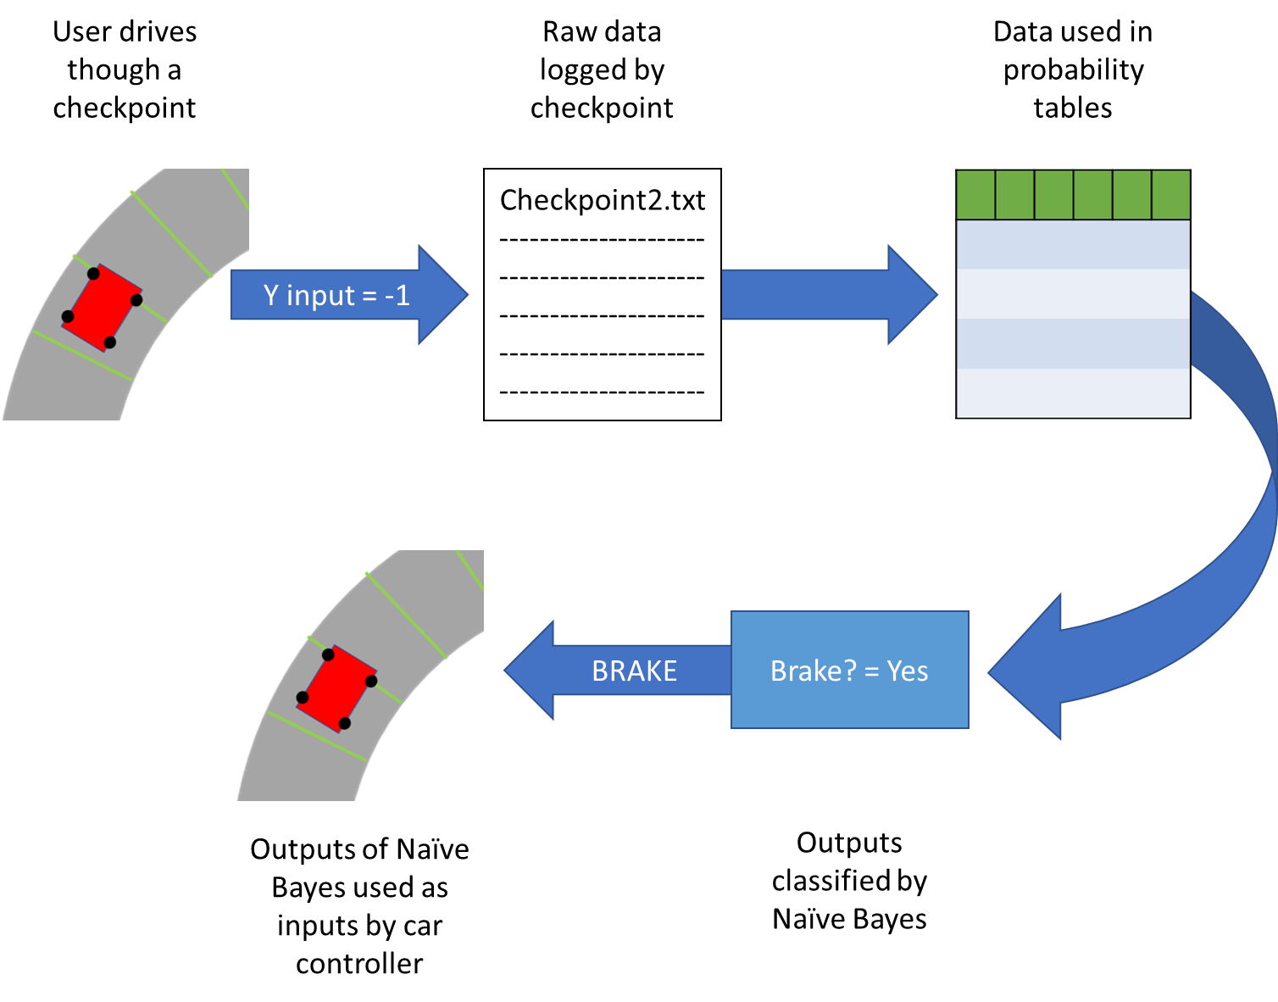
Figure 2. Overview of training process
This is achieved using checkpoints placed at intervals along the track which store the user’s driving data into text files as the user’s car passes through. These records of data are then binned into categories and used to calculate the conditional probabilities of the car’s attributes (speed) given different decisions (braking and steering). The naïve Bayes classifier then uses these conditional probabilities to calculate the most likely decision to take given the car’s properties at each checkpoint. Calculating the controller’s decisions per checkpoint allows the car’s position on the track be implicit in the naïve Bayes calculations.

Design Iterations

Feature Driven Development
Using the requirements obtained in the previous chapter, important software features were given higher priority during the development process by allocating timeboxes. These timeboxes also included weekly meetings with the project supervisor for guidance and to measure progress. Below is an overview of the development timeline.
Timeframe | Feature
October – November | Virtual test track
November – December | Controllable car
December – January | Data Collection
January – February | Prototype algorithm in excel
February – March | Implement algorithm to Unity
Table 3. Timeboxes and the key features targeted
The test track, drivable car, and data collection features were given high priority to avoid delays in collecting training data for the naïve Bayes classifier.

Design Prototypes
The following section describes the prototypes made when developing each of the project’s key features. Any problems encountered are discussed along with their solutions.

Virtual test track
Initially, test tracks were designed within Blender 3D modelling software [69] and exported into Unity with an aim to utilise mesh coordinates to obtain even intervals along the track.
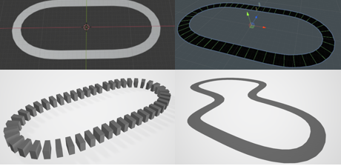
Figure 3. Various test track prototypes created using Blender
This early approach was deemed unfeasible and discarded due to difficulties that arose when attempting to access mesh data. This issue was resolved by instead utilising Unity’s prefab system to assemble sections of evenly spaced checkpoints containing BoxCollider components [70].
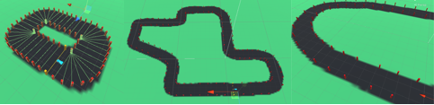
Figure 4. Track designs using terrain painter and prefabs
This method was combined with Unity engine’s terrain painter tool [71], to improve track visibility. Adopting these changes allowed rapid iteration of track designs.

Virtual car
Early in the project, attempts were made to pair car model asset packages from the Unity Asset Store with a custom car controller implementation. These early implementations often resulted in software bugs and unusual physics behaviour.
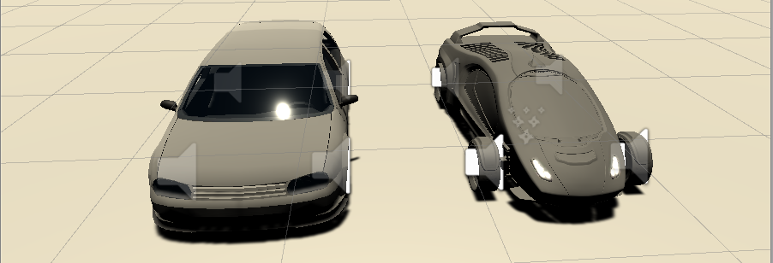
Figure 5. Old (left) and new (right) car models
Instead, a controllable car asset published by Unity Technologies as part of their Standard Assets package was used [72]. This implementation was chosen as it contained reliable script components for car handling and user input. As a result of this decision, more development time was spent on developing data collection methods and developing the naïve Bayes classifier implementation.

Data collection
Data collection was initially handled by storing all data from all checkpoints within a single text file.
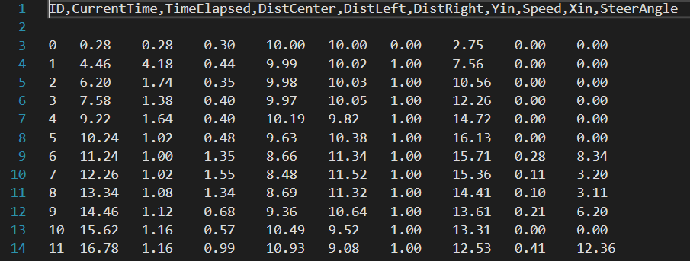
Figure 6. Old training data format
This made retrieving data for processing difficult, as the file would need to be sorted by each checkpoint’s ID value. To resolve this issue, a decision was made to separate logged data by allocating a dedicated file for each checkpoint.
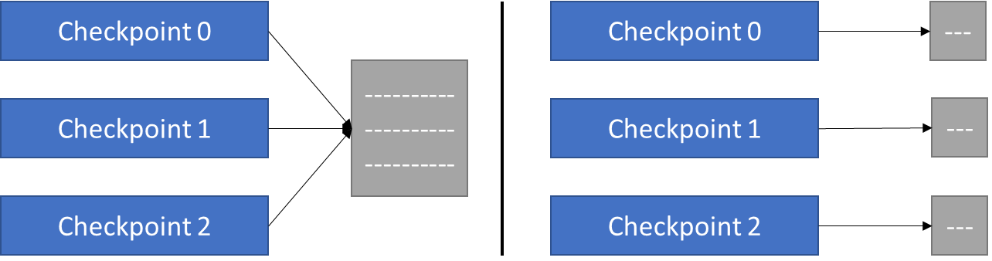
Figure 7. New file structure used to log data
This would allow easier management and processing of data when calculating the probability values for the naïve Bayes classifier.

Final design

Code design within scripts
The design of the scripts implemented do not feature heavy use of object-oriented programming concepts such as inheritance or interfaces, although all scripts created within Unity inherit from Unity’s MonoBehaviour base class by default [73]. This allows access to many important methods such as Start(), FixedUpdate() and OnTriggerEnter(). The GetComponent<T>() method is used extensively in the program to return references to other gameObjects and their components such as their Transform or BoxCollider. As a result, many scripts utilise composition by accessing these components. A Unified Modelling Language (UML) Diagram was created to represent the relationships within the data collection and the AI car controller scripts (Appendix A1, Appendix A2).

Design within Unity project
Within the Unity editor, scripts can be attached to gameObjects within the scene to provide custom behaviours and properties.
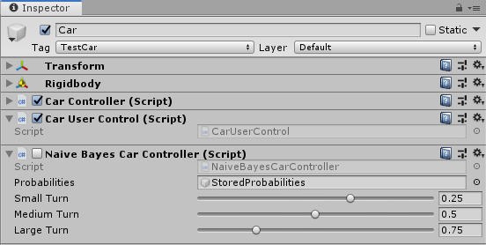
Figure 8. Car gameObject composition example
In Figure 8, for example, the Car gameObject contains both user and AI control functionality as it has both scripts attached as components. The parameters of variables within these scripts can be made visible in the inspector window by marking them as [Serializable], this can be seen in the NaiveBayesCarController script where the small, medium, and large turn values can be adjusted during runtime using sliders.

User interface design
To allow ease of use when training and testing the classifier, a basic menu system and user interface were implemented.
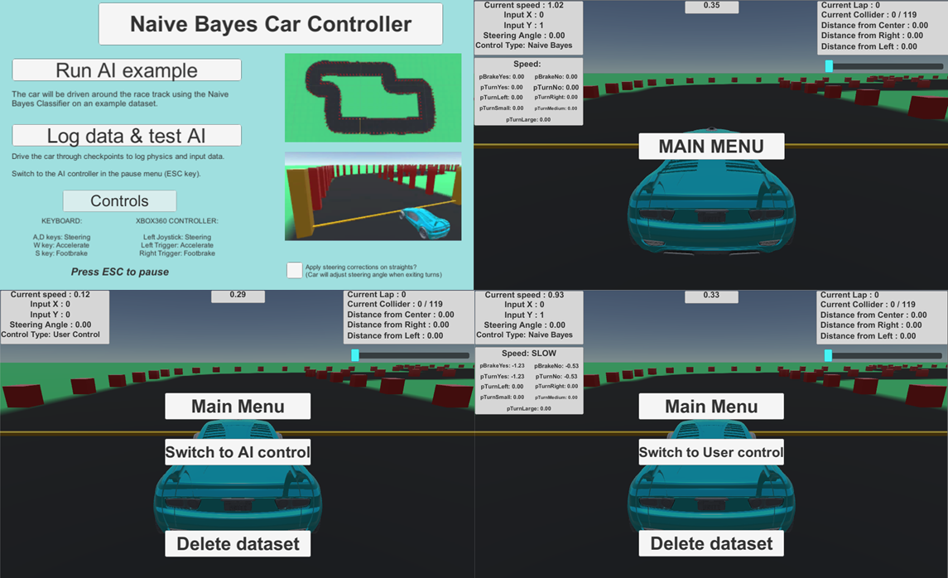
Figure 9. Menu system for the example and training scenes
On start up the user is presented with a menu displaying buttons that allow navigation to a scene containing a pre-trained example AI or a scene where they can train and test their own AI controller. Below these buttons are a list of controls and the option to enable steering correction on straight sections, this feature is explained further in the implementation chapter, Naïve Bayes car controller § 6.5.1.2.
When training or observing the AI, the user is presented with a heads-up display containing the current time, lap, checkpoint, and the position of the car on the track. The left side of the display also shows the current physics and input data of the car.
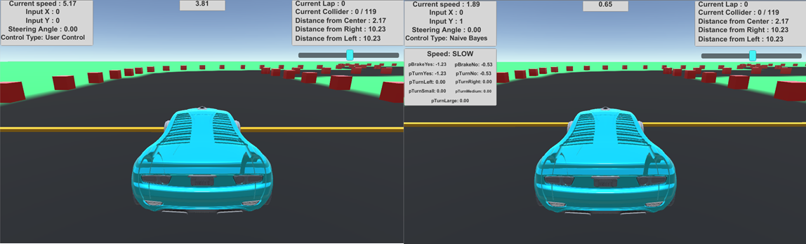
Figure 10. Heads-up display for user and AI controllers
When the AI controller is being tested, the current speed category of the car and the probabilities calculated by the naïve Bayes classifier are displayed.

Conclusion
This section discussed design decisions made to satisfy the software requirements and showcased previous design prototypes. The design decisions made in both C# script code and the Unity editor were highlighted, alongside a brief overview of the program’s UI system. The next section will detail the implementation process and final structure of the scripts used to implement the AI car controller.

Implementation

Introduction
This section will explore the implementation of the naïve Bayes car controller. This will begin by discussing the tools used to develop the software. The data collection process and the Excel implementation of the naïve Bayes classifier will be viewed in detail, followed by the implementation of the naïve Bayes classifier within the AI car controller script.

Tools used

Blender 3D modelling software
As mentioned in § 5.3.2.1, initial test tracks were produced using open source computer graphics software, Blender [69]. Track prototypes were made using Bezier curve tools and exported to Unity. This process was later abandoned in favour of existing tools within the Unity game engine.

The Unity editor
The main tool used in development was the Unity editor. It allowed for easier development of prototypes using its scene graph and rapid testing using its play mode. The project made great use of Unity’s prefab system by saving track sections as reusable assets which greatly improved efficiency during assembly of track prototypes.
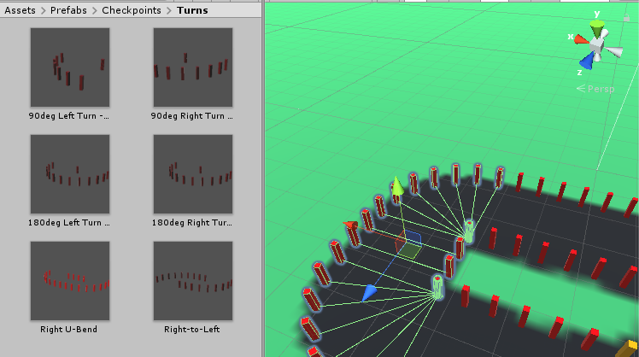
Figure 11. Using the prefab system in track assembly
The project also made use of the UI canvas system and SceneManagement library to incorporate an in-game heads-up display to present data to the user, and a menu system to allow the user to switch scenes and control types.

Microsoft Excel
Microsoft Excel was utilised to develop a prototype of the naïve Bayes classifier that could perform calculations on the training data folder exported from Unity. Developing the classifier within Excel first allowed any errors to be easily identified and corrected without contending with potential bugs from script interactions within Unity.

Collection of training data
The training data collection process was implemented using the following C# scripts in Unity:
- Checkpoint.cs
  - Detects when a collision with the car occurs and stores a record of its input and physics data at the point of collision.
- CheckpointManager.cs
  - Initialises the training data storage for every checkpoint on the track.

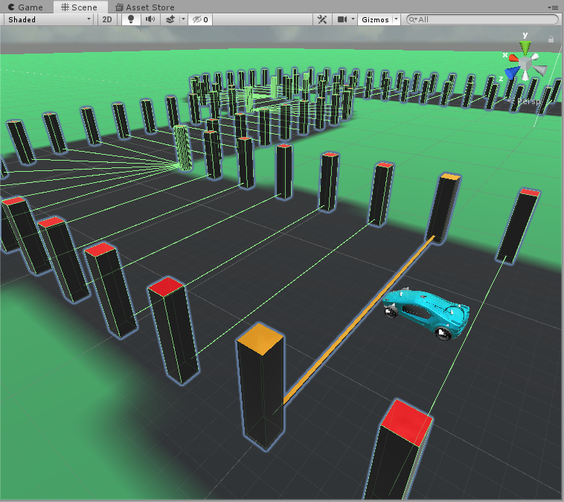
Figure 12. Checkpoints with BoxColliders
The user’s driving data is collected at regular intervals along the track distance using checkpoints composed of Unity BoxCollider components that span the track width. As the car’s BoxCollider component hits a checkpoint, the OnTriggerEnter() method in Checkpoint.cs is called. If the tag of the collider is “TestCar”, the method checks if the CarUserControl.cs script is active and calls the StoreCurrentData() method. StoreCurrentData() stores the car’s physics and input data at the current checkpoint to a string and appends the string to the data file assigned by the CheckpointManager.cs script.
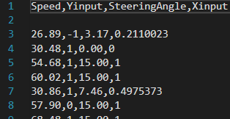
Figure 13. Current training data file format
The CheckpointManager.cs script collects all its child gameObjects with the tag “Checkpoint” and stores them to a list. This list is used to count the number of checkpoints in the scene and specify the final checkpoint of the lap.
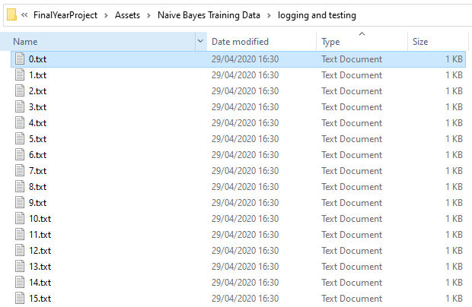
Figure 14. File path of “logging and testing” data folder
The method InitialiseDataStorage() creates a folder called “Naïve Bayes Training Data” and creates sub-folders for each scene in the project. This creates a different set of training data for each scene, allowing multiple racetracks to be developed. Within these scene folders, a file is created for each checkpoint in the checkpoint list.

Prototyping the classifier
Collected training data was exported from the training data folder to a Microsoft Excel spreadsheet as a table and sorted into categories based on their values. Speed values were converted to SLOW, MEDIUM, and FAST; the user’s vertical inputs to ACCEL, NONE, and BRAKE; steering angles to SMALL, MEDIUM, and LARGE; and the user’s horizontal inputs to LEFT, NONE, and RIGHT.
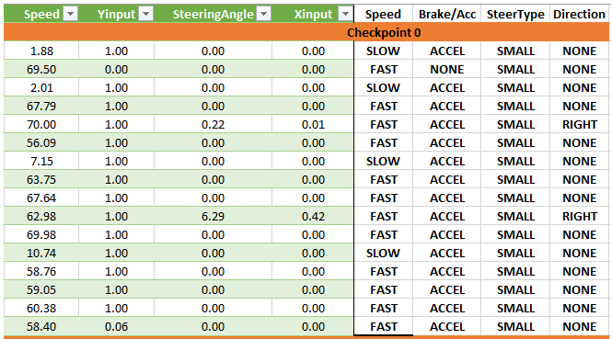
Figure 15. Raw and categorised training data in Excel
The prior probabilities of each decision made by the user and the conditional probabilities of each attribute given those decisions were calculated. To avoid division by zero errors, the frequency counts were smoothed using an additive smoothing technique called Laplace smoothing by adding 1 to all frequencies [39][44].
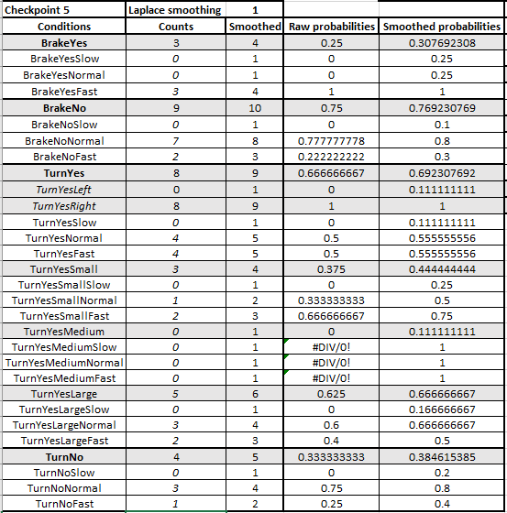
Figure 16. The prior and conditional probabilities of each decision and attribute
The probabilities of each possible decision given a chosen speed were calculated using log addition of the corresponding prior and conditional probabilities. Log addition was used because the multiplication of probabilities often produces numbers too small to be accurately represented by floating point data types [42][45].
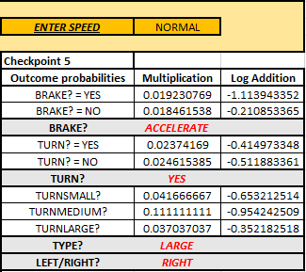
Figure 17. The naive Bayes classifier implemented in Excel
The decisions that output the larger probability values were highlighted. These outputs were verified by checking the left and right turn decisions were correct at the corresponding left and right corners. This process can be repeated to find the predicted outcome, given the car’s speed, at any checkpoint on the track.

The naïve Bayes car controller
Once the naïve Bayes classifier was successfully implemented within a Microsoft Excel spreadsheet it was implemented within the Unity game engine. The final implementation of the naïve Bayes car controller was implemented using the following C# scripts in Unity:
- GenerateProbabilities.cs
  - Reads the data stored in each checkpoint’s file to calculate the required probabilities. Stores the probability values of every checkpoint in a ProbabilityTable list.
  - ProbabilityTable – class
    - Holds the probability values calculated for a checkpoint.
- NaiveBayesCarController.cs
  - Uses each checkpoint’s corresponding probability table to calculate the most likely action to take as the car crosses each checkpoint. Sends the calculated actions as input values to the Standard Assets CarController.cs script.

Generation of Probabilities
The probability table for each checkpoint is generated before the level is loaded using the Monobehaviour.Awake() method. In the RetrieveDataFromFiles() method, the records for each attribute in a checkpoint data file are parsed and stored in lists. These lists of real values are used to construct lists of categorised values.
//Add a new list for a new checkpoint
binnedYinputData.Add(new List<Y_Input>());

//Convert each Y_input value into a category.
for(int record = 0; record < rawYinputData[checkpoint].Count; record++)
{
if (rawYinputData[checkpoint][record] > 0) //If Y_input is greater than 0 -> accel.
{
binnedYinputData[checkpoint].Add(Y_Input.ACCELERATE);
}
if (rawYinputData[checkpoint][record] < 0) //If Y_input is less than 0 -> braking.
{
binnedYinputData[checkpoint].Add(Y_Input.BRAKE);
}
if (rawYinputData[checkpoint][record] == 0) //If Y_input is equal to 0 -> no input.
{
binnedYinputData[checkpoint].Add(Y_Input.NONE);
}
}
The categorised lists are used to find the frequency of each decision made at a checkpoint, along with the frequency of these decisions given each speed category.
//Number of times brakes were not used.
float countBrakeNo = init;
//Number of times brakes were not used at different speeds.
float countBrakeNoSlow = init, countBrakeNoNormal = init, countBrakeNoFast = init;

The previously mentioned additive smoothing technique, Laplace smoothing, is applied by setting the “init” variable to 1.0f.
//Prior probability of NOT braking.
this.checkpoints[checkpoint].pBrakeNo = countBrakeNo / (binnedYinputData[checkpoint].Count + init);
//Posterior probabilities of speeds given NOT braking
this.checkpoints[checkpoint].pBrakeNo_Slow = countBrakeNoSlow / countBrakeNo;
this.checkpoints[checkpoint].pBrakeNo_Normal = countBrakeNoNormal / countBrakeNo;
this.checkpoints[checkpoint].pBrakeNo_Fast = countBrakeNoFast / countBrakeNo;
The CheckpointProbabilities class holds every probability value calculated for a checkpoint. The “checkpoints” list of CheckpointProbabilities is used to store the probability values calculated for all checkpoints on the track. A reference to the GenerateProbabilities gameObject is given to the NaiveBayesCarController script to give allow these values to be accessed.

Naïve Bayes car controller
The outputs of the naïve Bayes classifier are implemented by sending vertical and horizontal inputs to the Move() method in the Standard Assets CarController.cs script in the same way as the CarUserControl.cs script.
public void Move(float steering, float accel, float footbrake, float handbrake)
As the AI controlled car moves along the track it collides with a track checkpoint. This checkpoint’s ID is stored and used to retrieve its corresponding probability table.
NaiveBayes_TurningAndBraking(int id)
This method determines if the car will turn or brake at the current checkpoint. The speed of the car is checked and used to set the current speed category.
//GET THE CAR'S CURRENT SPEED
float currentSpeed = m_Car.CurrentSpeed;

//CATEGORISE THE CURRENT SPEED.
if (currentSpeed >= pTable.fastSpeed)
{
speedCategory = Speed.FAST;
GameManager.Instance.SpeedCategory = "FAST";
Debug.Log("SPEED = FAST");
}
if (currentSpeed < pTable.fastSpeed
&& currentSpeed > pTable.slowSpeed)
{
speedCategory = Speed.NORMAL;
GameManager.Instance.SpeedCategory = "NORMAL";
Debug.Log("SPEED = NORMAL");
}
if (currentSpeed <= pTable.slowSpeed)
{
speedCategory = Speed.SLOW;
GameManager.Instance.SpeedCategory = "SLOW";
Debug.Log("SPEED = SLOW");
}
Both decisions, turning and not turning, are given a list to hold their conditional probability values to be multiplied in the classification step. The speed category is used to filter out probabilities unrelated to the car’s current speed using a switch statement.
//Prior probabilities of steering
Turn_Yes.Add(pTable.checkpoints[id].pTurnYes);//Prior probability of turn
Turn_No.Add(pTable.checkpoints[id].pTurnNo);//Prior probability of no turn

//Posterior probabilities of steering
switch (speedCategory)
{
case Speed.FAST:
Turn_Yes.Add(pTable.checkpoints[id].pTurnYes_Fast);//turn given fast speed
Turn_No.Add(pTable.checkpoints[id].pTurnNo_Fast);//no turn given fast speed
break;
case Speed.NORMAL:
Turn_Yes.Add(pTable.checkpoints[id].pTurnYes_Normal);//turn given normal speed
Turn_No.Add(pTable.checkpoints[id].pTurnNo_Normal);//no turn given normal speed
break;
case Speed.SLOW:
Turn_Yes.Add(pTable.checkpoints[id].pTurnYes_Slow);//turn given slow speed
Turn_No.Add(pTable.checkpoints[id].pTurnNo_Slow);//no turn given slow speed
break;
}
Once all relevant probabilities have been added to the decision lists, each decision’s probability is calculated using the logarithmic addition of the conditional probabilities stored in each list.
//Classification
foreach (var probability in Turn_Yes)
{
//Log addition of probabilities
doTurn += Math.Log10(probability);
}
foreach (var proability in Turn_No)
{
//Log addition of probabilities
dontTurn += Math.Log10(proability);
}
//Compare the final values.
if (doTurn > dontTurn)
{
turning = true;
}
The probability of each decision is compared, and the outcome is stored in the “turning” Boolean variable for future use. This classification process is repeated for the braking and not braking decisions.
//Compare the final values.
if (doBrake > dontBrake)
{
Debug.Log("BRAKING");
vertical_input = -1.0f;//brake
}
else
{
Debug.Log("ACCELERATING");
vertical_input = 1.0f;//accelerate
}
In this case, the outcome decides the vertical input value sent to the car’s movement function, Move().
NaiveBayes_TurningAmount(int id)
If the “turning” Boolean stored during the turning classification returns false, the horizontal input value is set to 0. If “turning” is true, the classification process is repeated for each type of turn.
//Classification
//Log addition of probabilities
foreach (var probability in Turn_YesSmall)
{
doTurnSmall += Math.Log10(probability);
}
foreach (var proability in Turn_YesMedium)
{
doTurnMedium += Math.Log10(proability);
}
foreach (var proability in Turn_YesLarge)
{
doTurnLarge += Math.Log10(proability);
}

…
//Use final class proabilities to select turn style
if (doTurnSmall > doTurnMedium && doTurnSmall > doTurnLarge)
{
turnCategory = Steering.SMALL;
Debug.Log("SMALL TURN");
}
else if (doTurnMedium > doTurnSmall && doTurnMedium > doTurnLarge)
{
turnCategory = Steering.MEDIUM;
Debug.Log("MEDIUM TURN");
}
else if (doTurnLarge > doTurnSmall && doTurnLarge > doTurnMedium)
{
turnCategory = Steering.LARGE;
Debug.Log("LARGE TURN");
}
The probabilities of turning left and right are compared to decide if a positive or negative horizontal input value is sent to the car’s Move() method.
//SET THE HORIZONTAL INPUT VALUE HERE...
switch (turnCategory)
{
case Steering.SMALL:
if (pTable.checkpoints[id].pTurnYes_Left > pTable.checkpoints[id].pTurnYes_Right)
{
//If a left turn is normally taken at this checkpoint then...
Debug.Log("TURNING LEFT = -" + smallTurn);
horizontal_input = -smallTurn;
}
else
{
//if a right turn is taken then...
Debug.Log("TURNING RIGHT = " + smallTurn);
horizontal_input = smallTurn;
}
break;
The values of each turn type can be adjusted in the using slider bars in the Inspector window of the car gameObject.
CourseCorrection()
During early testing of the implementation, it was found that the car would drive in a straight line during the straight sections of the track. However, if the car was not aligned with the direction of the straight, the car was found to drift off the track. To avoid this problem, an adjustment to the car’s steering angle is made when it is driving through straight sections of the track. The angle between the forward vector of a checkpoint and the forward vector of the car is calculated.
float angle = Vector3.Angle(carForward, currCheckptFwdDirection);
float sign = Mathf.Sign(Vector3.Dot(carForward, checkRight));
The angle is converted into a horizontal input value between -1.0 and 1.0 before being sent to the car controller’s Move() method.
if (sign > 0)
//turn left at full angle.
horizontal_input = -(angle / maxSteeringAngle);
else
//turn right at full angle.
horizontal_input = (angle / maxSteeringAngle);
This allows the car to stay on the track during the straight sections.

Other scripts implemented
The remaining scripts that were developed are used to provide functionality to the user when training and testing the naïve Bayes car controller.
- MainMenu.cs
  - Provides navigation to an example AI controller scene and the AI training and testing scene.
- ExampleAI_PauseMenu.cs
  - Provides pause menu functionality and allows the user to navigate back to the main menu.
- LogDataTestAI_PauseMenu.cs
  - Provides pause menu functionality and allows the user to return to the main menu, also allows the user to reset their current training dataset.
- GameManager.cs
  - Holds the persistent scene data required by the scene manager and the in-game UI display. Implemented as a singleton.
- UserDriveHUD.cs
  - Provides relevant data to the UI canvas while the User is driving the car.
- NaiveBayesHUD.cs
  - Provides relevant data to the UI canvas while the naïve Bayes algorithm is driving the car.

Conclusion
This section discussed the tools and methods used to implement the naïve Bayes car controller. The section contained a rundown of the key features required to implement the naïve Bayes classifier as an AI car controller and an overview of other scripts used by the program.
The following section will analyse the implementation and evaluate whether the project’s objectives were met.

Evaluation

Introduction
In this section, the implementation and performance of the naïve Bayes car controller are evaluated. The development process is also evaluated based on the project objectives.

Evaluation of naïve Bayes
The naïve Bayes classifier was found to successfully output the correct decisions at correct points on the track. The car steered in the correct direction at each corner and would brake at corners that the user would brake at.
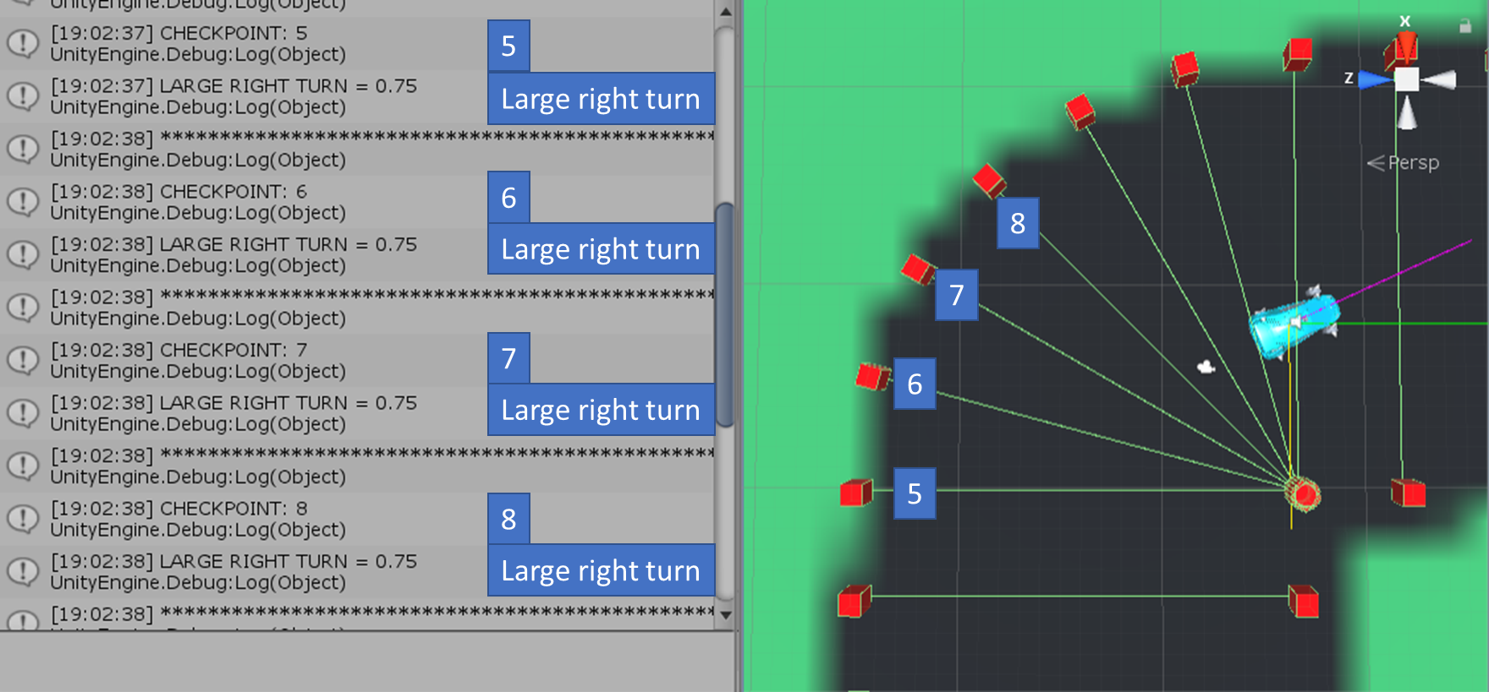
Figure 18. Naive Bayes outputs on right turn
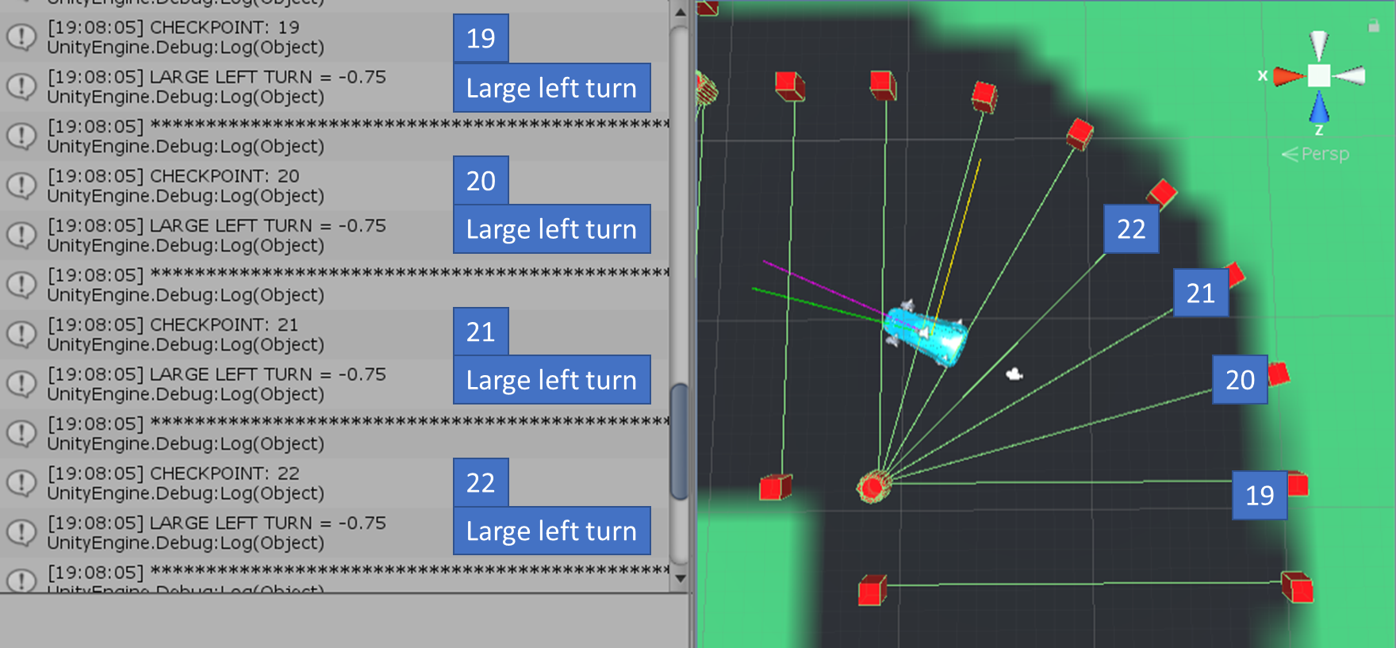
Figure 19. Naive Bayes outputs on left turn
However, without correction of the car’s steering angle before straight sections, the car would steer off the track. This can be attributed to the implementation of the car controller rather than the performance of the algorithm itself as the outputs of the naïve Bayes classifier simply reflect the training data collected from the user. These issues are discussed further in the following section.

Evaluation of implementation
The naïve Bayes classifier implemented in the NaïveBayesCarController.cs script in Unity outputs identical values to the prototyped implementation in excel, showing that the classifier was implemented into Unity correctly.
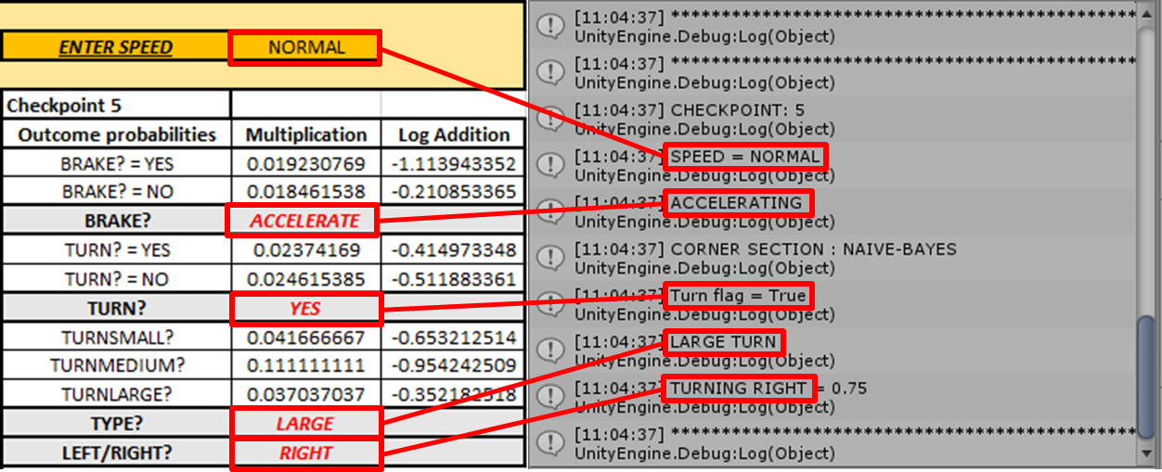
Figure 20. Matching results between spreadsheet and Unity console outputs for checkpoint 5
When enabled, the AI car controller makes the same turning and braking decisions at each checkpoint as the human player it is trained by. However, if left unassisted, the AI controlled car will leave the track as the car’s horizontal track position on entering a corner will affect where it will exit.
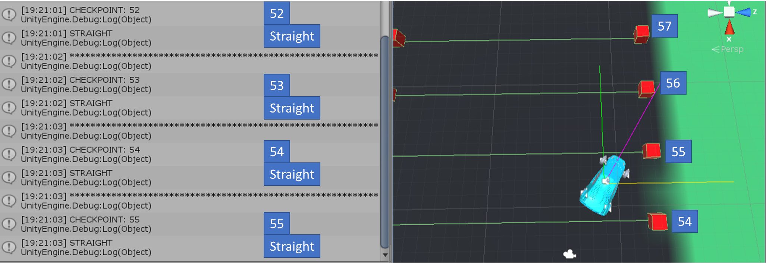
Figure 21. Car driving straight off the track
The car will also exit the track during the straight sections if it exits a corner without being aligned with the track direction. This is because on the straight sections, the user will also not be steering. Therefore, the AI will make no adjustments to its direction and leave the track. To solve this problem, a correction calculation is made using the forward direction vectors of the checkpoint and car to realign the car’s steering angle during the straight sections.
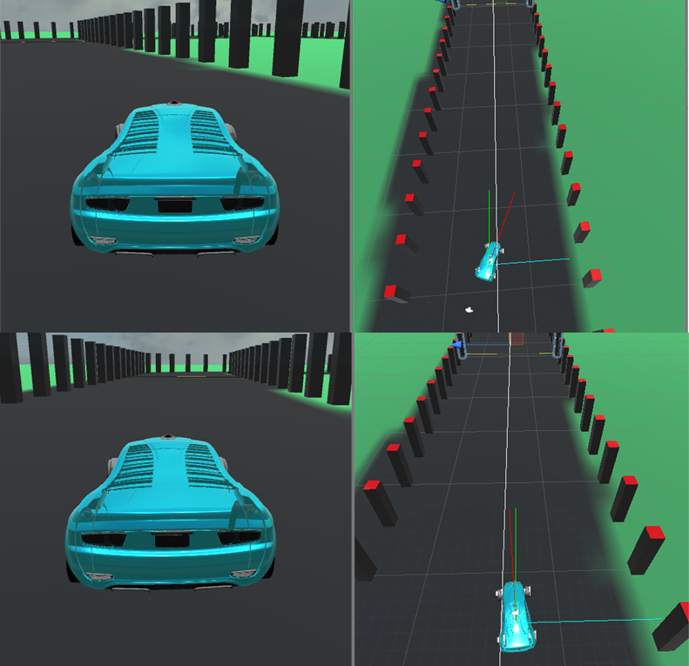
Figure 22. Correction of steering angle on straight sections
This allows the car to successfully navigate a full lap of the test track. After some time however, the horizontal position of the car drifts towards the track edges, and the car leaves the track.

Improvements
To improve this implementation, the steering correction calculation could be adjusted to direct the car towards the centre of the track, aligning the car’s position rather than just its direction. This will allow a larger margin for error as it drives through a corner. The number of checkpoints could also be increased, lowering the distance between checkpoints to allow finer control over the car by the car controller. The categorisation of steering outputs could also be refined to better reflect the user’s data. Currently the steering angle values are categorised as SMALL, MEDIUM, and LARGE based on percentages of the car’s maximum possible steering angle, rather than the minimum and maximum steering angles made by the user. This can lead to larger or smaller turns than what is necessary.

Fulfilment of software requirements
Many of the software requirements were fulfilled. The must have, should have, and could have requirements from the MoSCoW criteria were implemented such as a menu system and a working implementation of a naïve Bayes car controller. The display of data to the user, identified using user stories, was also implemented in the form of a heads-up data display.

Fulfilment of project objectives
The project objectives that relate to the implementation are as follows:
- Develop a virtual testing environment within a game engine.
- Develop methods to collect user data for training the chosen algorithm.
- Test the algorithm by performing calculations on the logged user data.
- Implement the algorithm into a car controller script.
- Analyse the performance of the car controller and suggest improvements.
Each objective has been met successfully. An appropriate testing environment was developed and a drivable car implemented utilising the tools and assets provided in the Unity editor, training data was collected from users by using checkpoints to store records in text files, the algorithm was tested for its viability by first being implemented within an Excel spreadsheet to verify the outputs, and the algorithm was found to have been successfully implemented within Unity by checking the values produced in the Debug console and the in-game display.

Conclusion
The naïve Bayes classifier was found to output the correct actions at the correct points in the track based on user training data. This was verified using an implementation developed in Microsoft Excel. The development phase met each project objective and successfully implemented a supervised learning algorithm, the naïve Bayes classifier, as a car controller within the Unity game engine, with some improvements to the implementation offered.

Conclusions & Recommendations
The project aim, “… develop, train and evaluate a supervised learning algorithm that can be used within a game engine to autonomously control a car”, was achieved. Each of the objectives required to meet this aim were also completed.
The supervised learning algorithm, the naïve Bayes classifier, was found to output the same decisions at each checkpoint on the track that a user would make and was be implemented as a car control script within the Unity game engine. However, the implementation required some additional assistance to remain on the racetrack. This implementation could be improved as outlined in the Improvements section, § 7.3.1.
Further work upon this project could involve the implementation of other supervised learning algorithms as part of a comparative study of their effectiveness as AI car controllers. It could also involve the addition of other AI techniques from racing games to further improve the performance of the AI car controller.

Reflection
On reflection of the project process, there are several areas where improvement could have been made, primarily surrounding time management during the background research phase of the project. For the development aspect of the project, the design and implementation phases went well, although once again, time management became an issue. Prior to the project, there was an unfamiliarity with the software development methodologies and processes involved in developing a long-term software project. A greater appreciation of the techniques and methods used to successfully produce high quality software in the software development industry has been gained. The overall project process has been an invaluable experience.

References
[1] K. C. Morris, C. Schlenoff, and V. Srinivasan, “Guest Editorial A Remarkable Resurgence of Artificial Intelligence and Its Impact on Automation and Autonomy,” IEEE Transactions on Automation Science and Engineering, vol. 14, no. 2. Institute of Electrical and Electronics Engineers Inc., pp. 407–409, 01-Apr-2017.
[2] Royal Society, Machine learning : the power and promise of computers that learn by example, vol. 66, no. January. 2017.
[3] J. Gregory, Game Engine Architecture, 3rd ed. CRC Press, 2019.
[4] M. O. Riedl and A. Zook, “AI for Game Production.”
[5] S. Rabin, “Ai Game Programming Wisdom,” 2002. [Online]. Available: http://books.google.com/books?id=4f5Gszjyb8EC&pgis=1. [Accessed: 01-Jun-2020].
[6] W. Blewitt, G. Ushaw, and G. Morgan, “Applicability of GPGPU computing to real-time AI solutions in games,” 2013.
[7] L. Cardamone, D. Loiacono, P. L. Lanzi, and A. Pietro Bardelli, “Searching for the optimal racing line using genetic algorithms,” in Proceedings of the 2010 IEEE Conference on Computational Intelligence and Games, CIG2010, 2010, pp. 388–394.
[8] Schwab Brian, AI Game Engine Programming, 2nd ed. Course Technology, 2009.
[9] Bizarre Creations, “Formula 1.” Psygnosis, Sony Interactive [Playstation and PC], 1996.
[10] Criterion Software, “Burnout.” Acclaim Entertainment, [Multiple platforms], 2001.
[11] G. W. Lecky-Thompson, AI and artificial life in video games. Charles River Media/Cengage Technology, 2008.
[12] I. Millington, Artificial Intelligence for Games, 2nd ed. CRC Press, 2009.
[13] E. Jimenez, “The Pure Advantage: Advanced Racing Game AI,” 2009. [Online]. Available: http://www.gamasutra.com/view/feature/3920/. [Accessed: 02-Jun-2020].
[14] J. Hannan, “ai-junkie.” [Online]. Available: http://www.ai-junkie.com/misc/hannan/hannan.html. [Accessed: 22-Jan-2020].
[15] Turn 10, “Forza Motorsport.” Microsoft, [Multiple Platforms], 2017.
[16] M. S. El-Nasr, A. Drachen, and A. Canossa, Game analytics : maximizing the value of player data. Springer, 2013.
[17] R. Moss, “Gamasutra - 7 examples of game AI that every developer should study,” 2016. [Online]. Available: https://www.gamasutra.com/view/news/269634/7_examples_of_game_AI_that_every_developer_should_study.php. [Accessed: 01-Jun-2020].
[18] G. Enrico, “Gaming mirrors at play through ludic data-selves,” Acad. Int. Sci. J., vol. 16, pp. 88–104, Jul. 2017.
[19] Y. Miyake, “Current Status of Applying Artificial Intelligence in Digital Games,” in Handbook of Digital Games and Entertainment Technologies, Singapore: Springer Singapore, 2017, pp. 253–292.
[20] G. N. Yannakakis and J. Togelius, Artificial intelligence and games. 2018.
[21] A. Géron, Hands-On Machine Learning with Scikit-Learn, Keras, and TensorFlow, 2nd ed. O’Reilly, 2019.
[22] G. James, D. Witten, T. Hastie, and R. Tibshirani, “Springer Texts in Statistics An Introduction to Statistical Learning.”
[23] S. B. Kotsiantis, “Supervised Machine Learning: A Review of Classification Techniques,” 2007.
[24] S. Uddin, A. Khan, M. E. Hossain, and M. A. Moni, “Comparing different supervised machine learning algorithms for disease prediction,” BMC Med. Inform. Decis. Mak., vol. 19, no. 1, p. 281, Dec. 2019.
[25] R. Caruana, “An Empirical Comparison of Supervised Learning Algorithms.”
[26] S. Ali and K. A. Smith, “On learning algorithm selection for classification,” Appl. Soft Comput. J., vol. 6, no. 2, pp. 119–138, Jan. 2006.
[27] O. Demasi, K. Kording, and B. Recht, “Meaningless comparisons lead to false optimism in medical machine learning,” 2017.
[28] A. Kołcz and W.-T. Yih, Raising the Baseline for High-Precision Text Classifiers. 2007.
[29] S. Wang and C. D. Manning, “Baselines and Bigrams: Simple, Good Sentiment and Topic Classification,” 2012.
[30] J. D. M. Rennie, L. Shih, J. Teevan, and D. R. Karger, “Tackling the Poor Assumptions of Naive Bayes Text Classifiers.”
[31] J. Vaidya and C. Clifton, “Privacy preserving Naïve Bayes classifier for vertically partitioned data,” 2004.
[32] D. Berrar, “Bayes’ theorem and naive bayes classifier,” in Encyclopedia of Bioinformatics and Computational Biology: ABC of Bioinformatics, vol. 1–3, Elsevier, 2018, pp. 403–412.
[33] S. Russell and P. Norvig, Artificial Intelligence: A Modern Approach, 3rd ed. Pearson Education, 2010.
[34] D. D. Lewis, “Naive(Bayes)at forty: The independence assumption in information retrieval,” in Lecture Notes in Computer Science (including subseries Lecture Notes in Artificial Intelligence and Lecture Notes in Bioinformatics), vol. 1398, 1998, pp. 4–15.
[35] B. Liu, E. Blasch, Y. Chen, D. Shen, and G. Chen, “Scalable sentiment classification for Big Data analysis using Naïve Bayes Classifier,” in Proceedings - 2013 IEEE International Conference on Big Data, Big Data 2013, 2013, pp. 99–104.
[36] M. Osborne, “Using maximum entropy for sentence extraction,” in Proceedings of the ACL-02 Workshop on Automatic Summarization -, 2002, vol. 4, pp. 1–8.
[37] B. Zadrozny and C. Elkan, “Obtaining calibrated probability estimates from decision trees and naive Bayesian classifiers.”
[38] D. J. Hand and K. Yu, “Idiot’s Bayes: Not So Stupid after All?,” Int. Stat. Rev. / Rev. Int. Stat., vol. 69, no. 3, p. 385, Dec. 2001.
[39] N. A. Zaidi, J. Jes´, J. Cerquides, M. J. Carman, and G. I. Webb, “Alleviating Naive Bayes Attribute Independence Assumption by Attribute Weighting,” 2013.
[40] K. Netti and Y. Radhika, “A novel method for minimizing loss of accuracy in Naive Bayes classifier,” in 2015 IEEE International Conference on Computational Intelligence and Computing Research, ICCIC 2015, 2016, pp. 1–4.
[41] P. Domingos and M. Pazzani, “Beyond Independence: Conditions for the Optimality of the Simple Bayesian Classifier,” Mach. Learn., pp. 105–112, 1996.
[42] B. Chandra and M. Gupta, “Robust approach for estimating probabilities in Naïve-Bayes classifier for gene expression data,” Expert Syst. Appl., vol. 38, no. 3, pp. 1293–1298, Mar. 2011.
[43] A. Y. Ng and M. I. Jordan, “On Discriminative vs. Generative classifiers: A comparison of logistic regression and naive Bayes.”
[44] S. Mocherla, A. Danehy, and C. Impey, “Evaluation of Naive Bayes and Support Vector Machines for Wikipedia,” Appl. Artif. Intell., vol. 31, no. 9–10, pp. 733–744, Nov. 2017.
[45] G. Hamerly and C. Elkan, “Bayesian Approaches to Failure Prediction for Disk Drives Deep Learning for Medical Time Series View project Evaluation Methodology View project Bayesian approaches to failure prediction for disk drives,” 2003.
[46] M. Toftedahl and H. Engström, “A Taxonomy of Game Engines and the Tools that Drive the Industry,” 2019.
[47] B. Cowan and B. Kapralos, “A survey of frameworks and game engines for serious game development,” in Proceedings - IEEE 14th International Conference on Advanced Learning Technologies, ICALT 2014, 2014, pp. 662–664.
[48] E. Christopoulou and S. Xinogalos, “Overview and Comparative Analysis of Game Engines for Desktop and Mobile Devices,” Int. J. Serious Games, vol. 4, no. 4, Dec. 2017.
[49] Epic Games, “Unreal.” GT Interactive, [PC], 1998.
[50] “Example Game Projects | Unreal Engine Documentation.” [Online]. Available: https://docs.unrealengine.com/en-US/Resources/SampleGames/index.html. [Accessed: 02-Jun-2020].
[51] “Blueprints Visual Scripting | Unreal Engine Documentation.” [Online]. Available: https://docs.unrealengine.com/en-US/Engine/Blueprints/index.html. [Accessed: 02-Jun-2020].
[52] “Frequently Asked Questions - Unreal Engine.” [Online]. Available: https://www.unrealengine.com/en-US/faq?active=release. [Accessed: 02-Jun-2020].
[53] “Unity - Manual: Unity User Manual (2019.3).” [Online]. Available: https://docs.unity3d.com/Manual/. [Accessed: 02-Jun-2020].
[54] “Unity - Developing Your First Game with Unity and C# | Microsoft Docs.” [Online]. Available: https://docs.microsoft.com/en-us/archive/msdn-magazine/2014/august/unity-developing-your-first-game-with-unity-and-csharp. [Accessed: 02-Jun-2020].
[55] “FAQ New subscription - Unity.” [Online]. Available: https://unity3d.com/unity/faq. [Accessed: 02-Jun-2020].
[56] B. Wymann, C. Dimitrakakis, A. Sumner, E. Espié, and C. Guionneau, “TORCS: The open racing car simulator,” 2015.
[57] J. Muñoz, G. Gutierrez, and A. Sanchis, “Controller for TORCS created by imitation,” in CIG2009 - 2009 IEEE Symposium on Computational Intelligence and Games, 2009, pp. 271–278.
[58] L. Cardamone, D. Loiacono, and P. L. Lanzi, “Learning drivers for TORCS through imitation using supervised methods,” in CIG2009 - 2009 IEEE Symposium on Computational Intelligence and Games, 2009, pp. 148–155.
[59] K. J. Kim, J. H. Seo, J. G. Park, and J. C. Na, “Generalization of TORCS car racing controllers with artificial neural networks and linear regression analysis,” Neurocomputing, vol. 88, pp. 87–99, Jul. 2012.
[60] A. El Sallab, M. Abdou, E. Perot, and S. Yogamani, “Deep reinforcement learning framework for autonomous driving,” in IS and T International Symposium on Electronic Imaging Science and Technology, 2017, pp. 70–76.
[61] V. Metsis, V. Metsis, and et al., “Spam Filtering with Naive Bayes -- Which Naive Bayes?,” THIRD Conf. EMAIL ANTI-SPAM (CEAS, 2006.
[62] L. Zhang and Y. Tian-Shun, “Filtering Junk Mail with A Maximum Entropy Model.”
[63] H.-K. Lyu, C.-H. Park, D.-H. Han, S. Kwak, and B. Choi, “Orchard Free Space and Center Line Estimation Using Naive Bayesian Classifier for Unmanned Ground Self-Driving Vehicle,” Symmetry (Basel)., vol. 10, no. 9, p. 355, Aug. 2018.
[64] M. T. Chan, C. W. Chan, and C. Gelowitz, “Development of a Car Racing Simulator Game Using Artificial Intelligence Techniques,” International Journal of Computer Games Technology, 2015. [Online]. Available: https://www.hindawi.com/journals/ijcgt/2015/839721/. [Accessed: 02-Jun-2020].
[65] “Unity - Download Archive.” [Online]. Available: https://unity3d.com/get-unity/download/archive. [Accessed: 22-May-2020].
[66] “Visual Studio 2019 IDE - Programming Software for Windows.” [Online]. Available: https://visualstudio.microsoft.com/vs/. [Accessed: 02-Jun-2020].
[67] “Office 365 Login | Microsoft Office.” [Online]. Available: https://www.office.com/. [Accessed: 02-Jun-2020].
[68] E. Miranda, “Time boxing planning,” ACM SIGSOFT Softw. Eng. Notes, vol. 36, no. 6, pp. 1–5, Nov. 2011.
[69] “blender.org - Home of the Blender project - Free and Open 3D Creation Software.” [Online]. Available: https://www.blender.org/. [Accessed: 21-May-2020].
[70] “Unity - Scripting API: BoxCollider.” [Online]. Available: https://docs.unity3d.com/ScriptReference/BoxCollider.html. [Accessed: 21-May-2020].
[71] “Unity - Manual: Terrain tools.” [Online]. Available: https://docs.unity3d.com/Manual/terrain-Tools.html. [Accessed: 21-May-2020].
[72] “Standard Assets (for Unity 2017.3) | Asset Packs | Unity Asset Store.” [Online]. Available: https://assetstore.unity.com/packages/essentials/asset-packs/standard-assets-for-unity-2017-3-32351. [Accessed: 21-May-2020].
[73] “Unity - Scripting API: MonoBehaviour.” [Online]. Available: https://docs.unity3d.com/ScriptReference/MonoBehaviour.html. [Accessed: 21-May-2020].

Appendices

A1 – Data Collection UML diagram
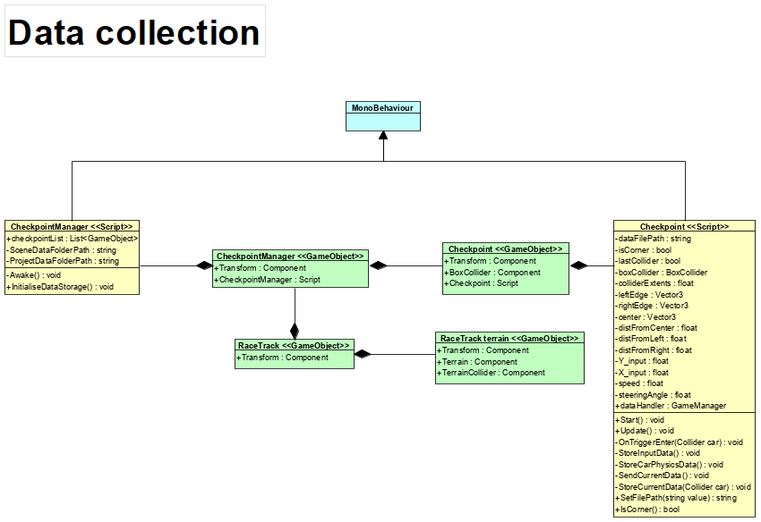
Figure 238. Data collection UML diagram

A2 – Naïve Bayes car controller UML diagram
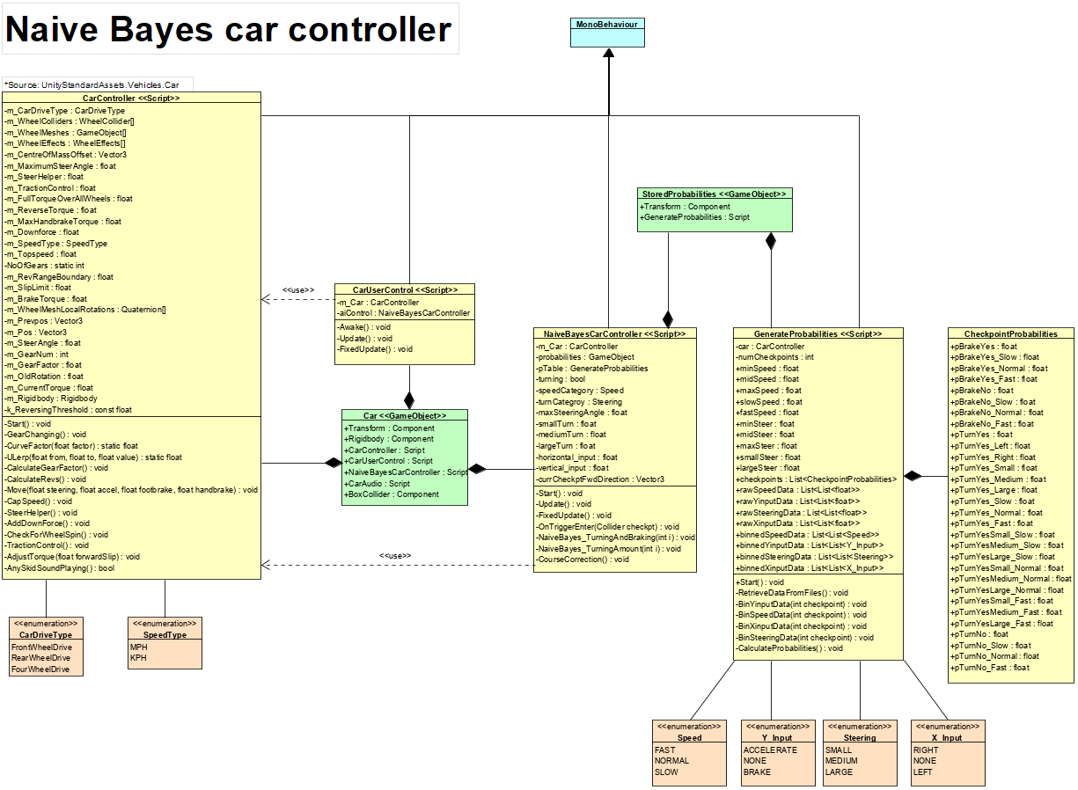
Figure 249. Naive Bayes car controller UML diagram

