BMSW6102
Developing Innovation and Creativity for Business Advantage
Coursework (Innovative Service Plan)
Task 1
Student Name: Rashid Ali
Student ID: 1912549
Lecturer: Khaza Ahmed

Table of Contents
1. Introduction 2
2.1 Innovative service proposition 3
Description of the innovative service 3
Indication of the emerging customer needs 4
Description of the target customers and benefit to the customers 5
Competitors' analysis and their value proposition 5
Ways to sustain this innovative business 6
2.2 Proposal to set up the E-commerce store 6
Introduction of specialised e-commerce platforms 6
Description of the website content 7
Supplies and equipment required for setting up an e-commerce store 7
Staff and payment services required in the e-commerce store 8
2.3 Marketing 8
Description of promoting the innovative service 8
Explanation of reaching the target customers 8
Analysis of the customer journey 9
Planning of the pre-launch promotion 10
3. Conclusion 10
References 10

1. Introduction
The study is going to investigate the importance of innovative plans and ideas in business. The ways to integrate innovation in business practice will be explored in the study. For this purpose, I intend the proposal to launch an online grocery service namely ‘Ali's grocery online.’ This will be selected as the new adaptive and innovative service in this study. The importance of e-commerce service will be demonstrated in the study and the marketing strategies for promoting the new products will be discussed.

2.1 Innovative service proposition

Description of the innovative service
In this study, the proposed online grocery business has been chosen as the innovative service. After the Covid-19 Pandemic, the sales of online retail products have been boosted significantly by almost 13.1% (Tidd and Bessant, 2020). Consumers nowadays are spending more time on smartphones, and they are preferring to buy products from online e-commerce websites. The demand for grocery products is also increasing in recent days and it can be considered an innovative idea as several food grains, masala, household items and vegetables are not available in the local offline stores, however, these products can be sold through online web portals (Cooke et al., 2011). If a customer makes an order for a specific grocery item, that item can be delivered within 60 minutes.

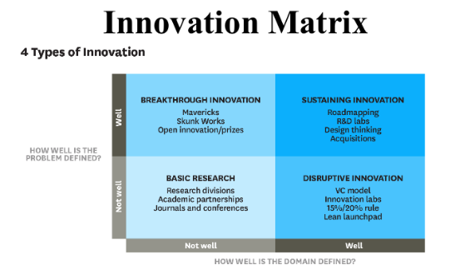
Figure 01: Innovation Matrix
(Source: Trott, 2008)
Breakthrough innovation refers to such innovations where the innovation is formulated, however, the domains of it are still somehow unclear. This innovation is known as revolutionary innovation as it can create paradigm shifts (Kavadias and Hutchison-Krupat, 2021). If the basis of competition is changing for technological development then the company becomes better at innovating products (Mousavi et al., 2018). This type of innovation is known as disruptive innovation. Incremental innovations are known as sustaining innovation. In this type of innovation, some operations are required to be performed better as compared to other innovations (Latifah et al., 2020). Sustainable innovations are very natural innovations in the industry. Apple, Cisco Systems, Pandora, and Verizon are some of the biggest disruptors in the last decade. The proposed innovative idea of business is a sustainable business idea as all the business operations are going digital nowadays (Brem et al., 2019). Within this business, the business heads are required to integrate innovative technologies such as augmented reality, virtual reality and blockchain (Brem et al., 2019).

Indication of the emerging customer needs
Innovation is pivotal for any type of business proposition as it helps the corporation to adapt, it also helps the organisation to evolve in the market. Innovation involves all the processes including technology development, idea generation and marketing of a new product (Biemans, 2018). If the organisation is focusing on launching new products in the market then this type of innovation is known as product innovation. If the organisation is altering their manufacturing process, then it is known as management innovation. Management innovation involves total quality management, introducing SAP (Systems, Applications & Products in Data Processing) and “Enterprise Resource Planning (ERP),” (Mishchenko et al., 2021). Sometimes innovation in the organisation also includes novel approaches to sales, new financial arrangements (Smith et al., 2019). There are several models of innovation such as the Technology-driven model and the Market-pull model. Linear models of innovation that are technology-driven start with research and development. Then from the research appropriate manufacturing processes are selected. The economic growth of a company can be increased by almost 50%. Innovation can effectively enhance the effectiveness of the entire physical capital and the productivity of human capital can also be magnified.

Description of the target customers and benefit to the customers
Many customers appreciate online grocery services as home deliveries are available for these services. It can save the time of the consumer. Nowadays, people are remarkably busy with their work schedules, and they do not have time to visit offline stores to purchase products. For people with less or limited mobility, online grocery shopping will be a smart choice. Here, customers can order their daily necessities just with a few clicks (Liu et al., 2021). Customers will not have to walk around store to store for purchasing a product. On the other hand, online portals will allow the customers to compare the products. Here the customers can check the reviews of other customers to justify the quality of the product (Brattström et al., 2018). More options and greater variety are also available and that is why most customers around the world are shifting towards online shopping.

Competitors' analysis and their value proposition
Many companies have already established their brand as the online shopping giant. The strength of online grocery shopping is convenience, timesaving, and ease. On the other hand, the weakness of this business is increasing competition, inadequate substitutions and so on. The opportunity of this type of business is that after gaining success in the local market the company can easily expand their operation in the international market (Hopkins and Schwanen, 2018). Several threats are also associated with this type of business as it is costly compared to in-store offline business and the service cost is also high (Di Vaio and Varriale, 2018). If wrong items are delivered to the customers, then it can effectively damage the reputation of the company.
Companies like Amazon, Asda, Marks, and Spencer are focusing on providing value-oriented experiences to their customers. However, in this business proposal, the company needs to provide the best product in the grocery market (Le et al., 2020). The company is required to be more productive with less amount of effort.

Ways to sustain this innovative business
To sustain itself in the market, the company needs to effectively identify their target audience. The company needs to carry out extensive market research to effectively understand customer demand in the market (Vadastrean et al., 2021). It will allow the company to effectively target their audience. An arrangement of inventory and funding should be ensured by the organisation. The company needs to focus on accessibility and ease. Excellent quality products are required to be guaranteed by the organisation (Beuren et al., 2019). In this way, the company is required to ensure that the proposition of the business is sustainable and a sustainable business plan will help the business to maintain a competitive advantage.

2.2 Proposal to set up the E-commerce store

Introduction of specialised e-commerce platforms
E-commerce is a part of the electronic business that involves purchasing and selling products on online platforms. It encompasses several things such as customer support, marketing, planning and so on. E-commerce can have several perspectives as well such as communication, service, and business process. In E-business, there are, three types of marketplaces (Stilgoe et al., 2020). In this proposed innovative idea, the business needs to effectively set up an e-commerce platform to sell its products. There are several advantages of e-commerce platforms over brick-and-mortar stores and that is why e-commerce has been chosen for the proposed innovative business model (Sakka et al., 2019). It will allow the company to highlight their product range. Web technology is available everywhere so people can order products from anywhere around the globe (Smith et al., 2019). The richness of e-commerce technology is also remarkably high and it will reduce the information cost of the company and it will force the company to enhance the quality of products. Through this innovative technology, the company will be able to deliver a personalised message to the individual based on the characteristics of the individual (Quesado and Silva, 2021). The business can utilise the Software as a Service (SaaS) technology as here the company does not need to maintain or install the software. The company will be able to access the software through the internet (Liu et al., 2021). SaaS technology will reduce the cost of operation of the business and it will improve the integration and scalability of the business as well as aid managing, forecasting IT costs. This technology of providing software application and information to the end-users are effective. It can provide flexibility advantage to the business as well. The proposed business can also use several specialised e-commerce platforms such as, Shopify, eBay or Amazon. These e-commerce platforms will enhance the buying process of the customers. It will also allow the business to conduct affordable marketing and advertising. There is no reach limitation to this type of business (Smith et al., 2019). Customers will be able to compare the price and products of several grocery items. However, it is better for businesses to use SaaS technology for creating their own brand identity (Brasil and Eggers, 2019). In SaaS, platform software will be installed on the premise and it should be maintained by the business head and stakeholders of the company.

Description of the website content
Apart from using the SaaS technology, the company needs to develop their own websites where the customers can easily check in and visit the products of the organisation. Creating a website will increase the credibility and brand recognition of the company. It will generate leads and produce organic traffic for the company. If the company need to promote any update and announcement, it can be easily done through the website of the company (Smith et al., 2019). A website will provide a professional look to the business (Zawislak et al., 2018). The website can act as a tool to attract customers. Through the website, the products and services of the company can be easily highlighted. The company websites should contain the following contents to encourage the websites such as product demo videos, blog posts, and reviews of the customers. FAQs, interactions on social media and so forth.

Supplies and equipment required for setting up an e-commerce store
To make an e-commerce website, the financial cost of the business can be high, the company will be required to invest in a content management system. The expense for an e-commerce website and hosting can also be exceedingly high. In addition to this, the company needs online payment tools, tracking and analytical tools, email marketing tools, and several website developments tools such as WooCommerce, WordPress (Haskamp et al., 2021). The financial cost of creating an e-commerce website might be extremely high, thus the corporation will need to invest in a software package (Trott, 2008). The cost of an e-commerce domain and server can be quite significant as well. The organisation also requires online payment services, monitoring and statistical models, and email marketing tools to successfully operate their operation.

Staff and payment services required in the e-commerce store
As the company will operate on online platforms that is why it is extremely important for the company to hire incredibly talented employees in the organisation who are well versed with modern technology. The company needs to introduce several payment methods in its business operations so that customers can easily purchase their products online. The company can introduce credit card payment as it will allow the customers to pay in both online and offline mode (Mousavi et al., 2018). The company is also required to deploy alternative methods of paying such as Google Pay, Pay Pal etc.
Alis Grocery Online needs to ensure that they are complying with the issues related to PCI compliance. If a company does not comply with the PCI, then it can lead to a substantial fine for that company (Brem et al., 2019). Companies are becoming very much vulnerable to data breaches and fraud. However, The PCI DSS can be very much technical as it involves installing security solutions (Romano, 2019). In addition to this, several system malware protections and data encryption should be addressed by the organisation.

2.3 Marketing

Description of promoting the innovative service
The online grocery items in the proposed business idea can be promoted through social media platforms. The marketing heads of the organisation need to develop several effective strategies on social media like Facebook and Instagram. The reasons for choosing these platforms are simple it will reduce the advertisement cost of the company. The company can promote their products on these websites for free of cost. Additionally, the company will be able to reach a huge amount of audience as the number of social media users is increasing day by day (Hopkins and Schwanen, 2018). Marketing through social media will increase and improve the loyalty of the brand. Paid search engines can also be used by the organisation as they will increase the ranking of the website (Ma and Zhang, 2021). The paid search engine will allow the business to reach its target audience. It will help the business to maintain consistent traffic to the website. Through paid search engines the analytics are also quite easy to measure.

Explanation of reaching the target customers
To reach the customers, the proposed company is required to effectively analyse their customer base. Sometimes conducting client interviews can also be a highly effective way to understand the needs of the customers. Google Analytics can be used by the company to determine its target audience. The reasons for picking Facebook and Instagram are quite straightforward: they will lower the company's advertising costs (Di Vaio and Varriale, 2018). The corporation can use these platforms and networks to promote its products for free. Furthermore, because the number of people using social media is growing every day, the business will be able to attract a large audience. Brand loyalty will vastly improve because of social media marketing.

Analysis of the customer journey
SaaS platform will allow the business to effectively cut down the cost. It will also help the business to focus on several other aspects that can collectively generate revenue. The company needs to create awareness about its newly launched product. There are several ways such as brochures, advertising through magazines or articles, and online ads through which the company can generate awareness. If the product is good then word of mouth can also help the customers to consider the product (Vadastrean et al.,2021). Customers will consider the product when they receive positive feedback and reviews about the products. The company needs to directly email their target customers so that the customers consider their products. The customer will purchase the product when they see that the product rating is high and the customer review is also positive. After purchasing the products, the company needs to retain their customers. Customer retention can be achieved through many technologies such as event evaluation, blog posts, online communities and social networks.

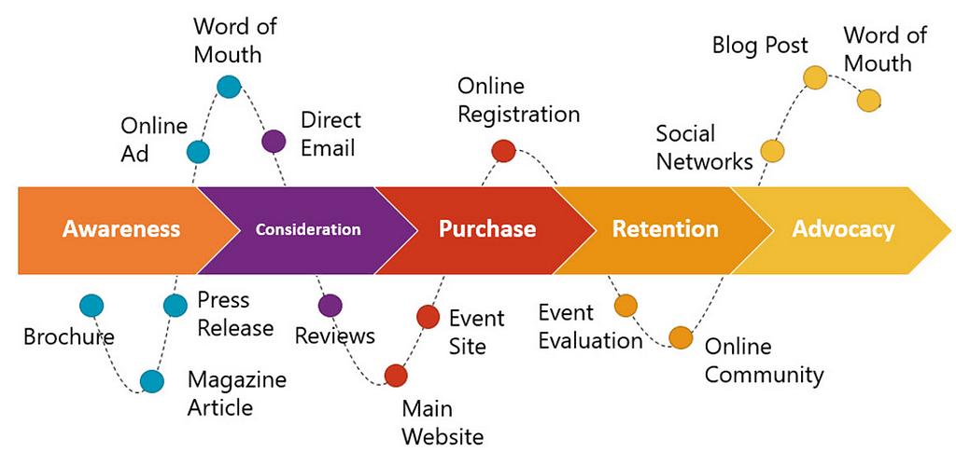
Figure 02: Customer Journey Map
(Source: Vadastrean et al., 2021)

Planning of the pre-launch promotion
Several strategies are required to plan for the pre-launching of a product. The company need to ensure that they have a loyal audience who will refer others to buy their product. The company also need to ensure that the company have a decent number of social media followers and they need to maintain a search engine-optimised website (Stilgoe et al., 2020). It is also important for the business to effectively establish good relationships with influencers. The company needs to effectively define the persona of its target customers. Budget consideration and sales goals are also required to be taken into account by the company.

3. Conclusion
The study has discussed the process of integrating innovative ideas in business. E-commerce is a type of digital business that involves purchasing and selling goods over the internet. It includes a variety of functions such as customer service, branding, and marketing. The company's products and services can be simply shown on the website. Product demo videos, blog pieces, and consumer reviews should all be included on corporate websites to entice visitors to visit them. The economic cost of creating an e-commerce website can be substantial, and the company will be forced to contribute to a document management system.

References
Beuren, I.M., de Souza, G.E. and Bernd, D.C., 2019. Effects of budget system use on innovation performance. European Journal of Innovation Management.

Biemans, W.G., 2018. Managing innovation within networks. Routledge.

Brasil, V.C. and Eggers, J.P., 2019. Product and innovation portfolio management. In Oxford research encyclopedia of business and management.

Brattström, A., Frishammar, J., Richtnér, A. and Pflueger, D., 2018. Can innovation be measured? A framework of how measurement of innovation engages attention in firms. Journal of Engineering and Technology Management, 48, pp.64-75.

Brem, A., Tidd, J., and Daim, T.U. eds., 2019. Managing Innovation: Understanding and Motivating Crowds (Vol. 32). World Scientific.

Cooke, P., Asheim, B., Boschma, R., Martin, R., Schwartz, D. and Todtling, F. eds., 2011. Handbook of regional innovation and growth. Edward Elgar Publishing.

Di Vaio, A. and Varriale, L., 2018. Management innovation for environmental sustainability in seaports: Managerial accounting instruments and training for competitive green ports beyond the regulations. Sustainability, 10(3), p.783.

Haskamp, T., Lorson, A., Paula, D.D. and Uebernickel, F., 2021, March. Bridging the Gap–An Analysis of Requirements for Performance Measurement Systems in Digital Innovation Units. In International Conference on Wirtschaftsinformatik (pp. 587-605). Springer, Cham.

Hopkins, D. and Schwanen, T., 2018. Automated mobility transitions: Governing processes in the UK. Sustainability, 10(4), p.956.

Kavadias, S. and Hutchison-Krupat, J., 2020. A framework for managing innovation. In Pushing the Boundaries: Frontiers in Impactful OR/OM Research (pp. 202-228). INFORMS.

Latifah, L., Setiawan, D., Aryani, Y.A. and Rahmawati, R., 2020. Business strategy–MSMEs' performance relationship: innovation and accounting information system as mediators. Journal of Small Business and Enterprise Development.

Le, H.M., Nguyen, T.T. and Hoang, T.C., 2020. Organizational culture, management accounting information, innovation capability and firm performance. Cogent Business & Management, 7(1), p.1857594.

Liu, W., Beltagui, A. and Ye, S., 2021. Accelerated innovation through repurposing: exaptation of design and manufacturing in response to COVID‐19. R&D Management, 51(4), pp.410-426.

Ma, X. and Zhang, Y., 2021. Digital innovation risk management model of discrete manufacturing enterprise based on big data analysis. Journal of Global Information Management (JGIM), 30(7), pp.1-14.

Mishchenko, S., Naumenkova, S., Mishchenko, V. and Dorofeiev, D., 2021. Innovation risk management in financial institutions. Investment Management and Financial Innovations, 18(1), pp.191-203.

Mousavi, S., Bossink, B. and van Vliet, M., 2018. Dynamic capabilities and organizational routines for managing innovation towards sustainability. Journal of cleaner production, 203, pp.224-239.

Quesado, P. and Silva, R., 2021. Activity-based costing (ABC) and its implication for open innovation. Journal of Open Innovation: Technology, Market, and Complexity, 7(1), p.41.

Romano, L., 2019. Explaining growth differences across firms: The interplay between innovation and management practices. Structural Change and Economic Dynamics, 49, pp.130-145.
Sakka, O., St-Pierre, J. and Bahri, M., 2019. Innovation collaborations in low-to-medium tech SMEs: The role of the firm’s innovation orientation and use of external information. International Journal of Innovation Management, 23(02), p.1950011.

Smith, M., Busi, M., Ball, P. and Van Der Meer, R., 2019. Factors influencing an organisation’s ability to manage innovation: a structured literature review and conceptual model. Managing Innovation: What Do We Know About Innovation Success Factors? pp.69-90.

Stilgoe, J., Owen, R. and Macnaghten, P., 2020. Developing a framework for responsible innovation. In The Ethics of Nanotechnology, Geoengineering and Clean Energy (pp. 347-359). Routledge.

Tidd, J., and Bessant, J.R., 2020. Managing innovation: integrating technological, market and organizational change. John Wiley & Sons.

Trott, P., 2008. Innovation management and new product development. Pearson education.

Vadastrean, A., Bot, A., and Szabo, F.F.I., 2021. Innovation Capability-the Main Factor for Wealth.

Zawislak, P.A., Fracasso, E.M. and Tello-Gamarra, J., 2018. Technological intensity and innovation capability in industrial firms. Innovation & Management Review.

