

Programme: Master of Business Administration
Module: Marketing Management
Module code: LCMB7024

Assignment Title: Assessment Component 1: Marketing Environment Analysis

Student Name: Dhruv Jitubhai Mangukiya
Student Number: 2611141
Word Count: 2601
Submission Date:22/10/2026

Table of Contents
Introduction 3
Task 1: Marketing Environment Analysis 3
1.1 Selection of one major metals or mining company 3
1.2 Critical analysis of three major external Actors 4
Task 2: Strategic Growth and Competitive Positioning 8
2.1 Evaluation of strategic growth approach using Ansoff Matrix 8
2.2 Competitive Advantage using the TBL model 10
Task 3: Managerial and Professional Reflection 12
3.1 Reflection on the key decisions made throughout the report 12
3.2 Reflection on the limitations of analysis 13
Conclusion 13
Reference List 14
List of Figures
Figure 1: Recent company performance by BHP 5
Figure 2: PESTLE analysis for Australia 6
Figure 3: National GHG emission rate of Australia in the past decade 7
Figure 4: Mining operations across different parts of Australia 8
Figure 5: Sustainable tech adoption in Australian marketplace 10
Figure 6: Application of Porter’s Generic strategy for BHP 13
Figure 7: GHG emissions level of BHP in recent times 15

List of Tables
Table 1: The potential implications of Ansoff Matrix implications 11
Table 2: Different aspects of TBL approach 13

Introduction
The term marketing environment is regarded as the combination of internal and external elements used by 21st-century corporate professionals for developing positive business relationships with target customers (Kotler et al., 2024). The report is about the current challenges faced by the Australia-based business enterprise called Broken Hill Proprietary (BHP) towards developing carbon-neutral mining conditions in the local industry to achieve sustainable future growth opportunities. The Ansoff Matrix is going to be employed here to suggest a suitable strategic growth approach for BHP towards ensuring eco-friendly mining operations in Australia.

Task 1: Marketing Environment Analysis

1.1 Selection of one major metals or mining company
Broken Hill Proprietary, also known as BHP, is considered one of the largest mining corporations in Australia, which was established in the year 1885 for extracting industrial ores and minerals. In current times, over 80,000 employees and third-party contractors operate for BHP around the world, enabling the mining brand to generate sizable profitability from mineral extraction (BHP, 2026).
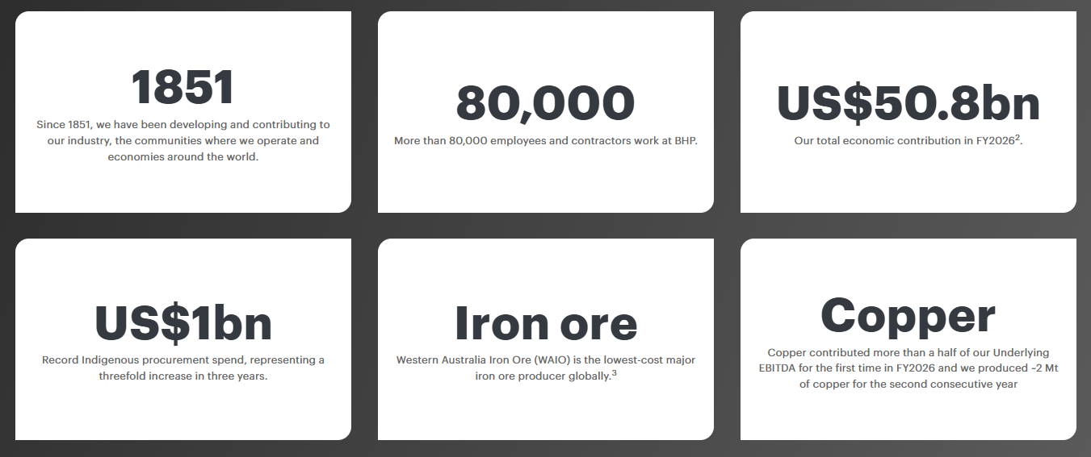

Figure 1: Recent company performance by BHP
(Source: BHP, 2026)
On the other hand, BHP officials have also reported total economic contribution in the fiscal year 2026 to be around 50.8 billion US dollars through performing mining operations around the world (BHP, 2026). Since 2020, the administration body of BHP has also been working towards implementing scope 1 and scope 2 emission plans to successfully lower GHG production by nearly 33% in key functions (BHP, 2026). As a result, the sustainable mining policies and healthy economic contributions generated by BHP have allowed the Australian enterprise to become a viable selection in terms of carbon-free operations.

1.2 Critical analysis of three major external Actors
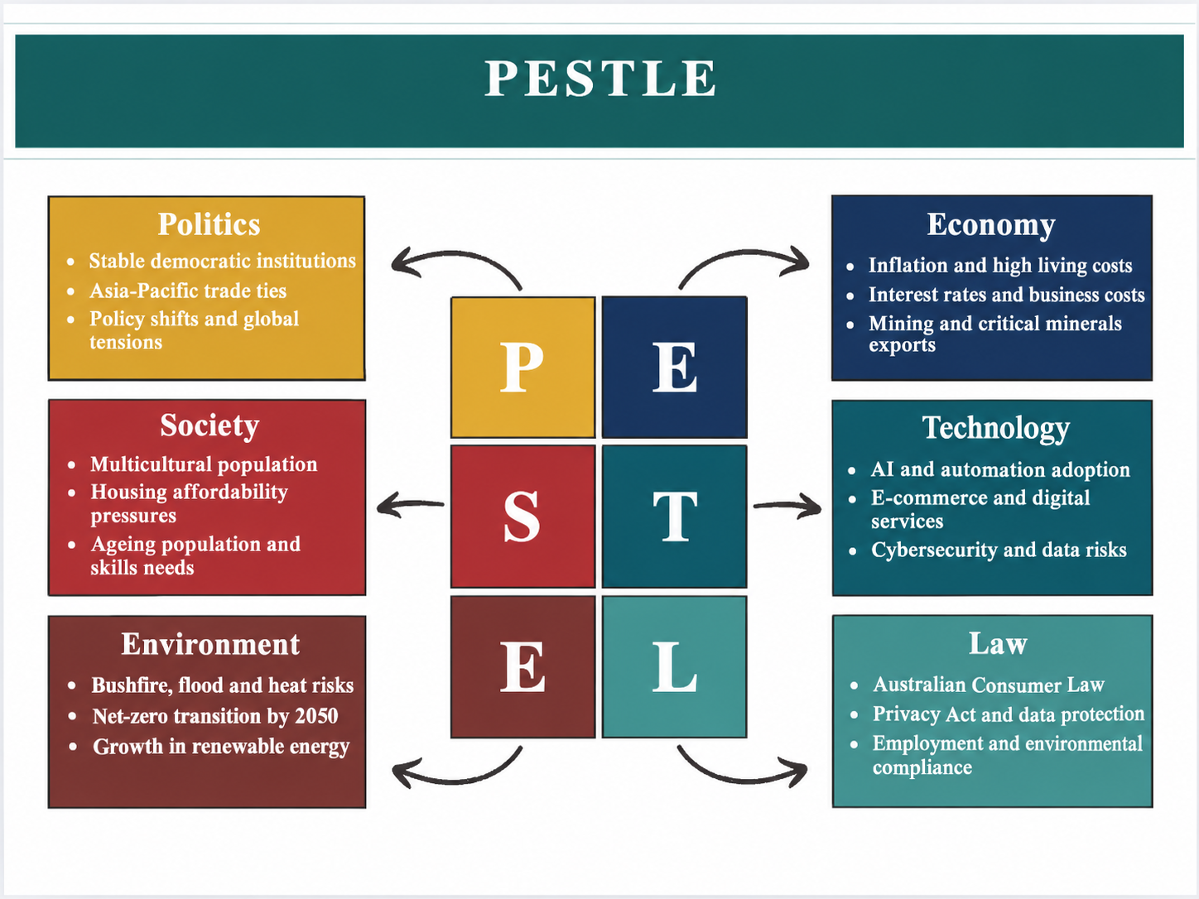

Figure 2: PESTLE analysis for Australia
(Source: Self-developed)
Environmental Actor
Based on the above PESTLE analysis, the environmental actors have played a critical role for BHP that directly influences the mining operations for the Australian brand to introduce sustainable and low-carbon practices. For instance, in terms of Greenhouse gas emission levels, the Australian business industry and residential areas have been responsible for generating almost 524.11 million tonnes of GHG compounds in the financial year 2017 (Statista, 2025). Apart from that, in 2024, the national carbon emission levels of Australia have been recorded to be around 435.74 million metric tonnes, which showcases a slight reduction from the previous decade (Statista, 2025). It can be mentioned that the positive measures taken by the Australian government and adjacent industry have been effective towards lowering carbon production and improving environmental elements. Hence, the current leadership of BHP ought to learn from the current GHG reduction pattern in Australia towards increasing investment towards sustainable mining practices to transition toward lower-carbon production processes.
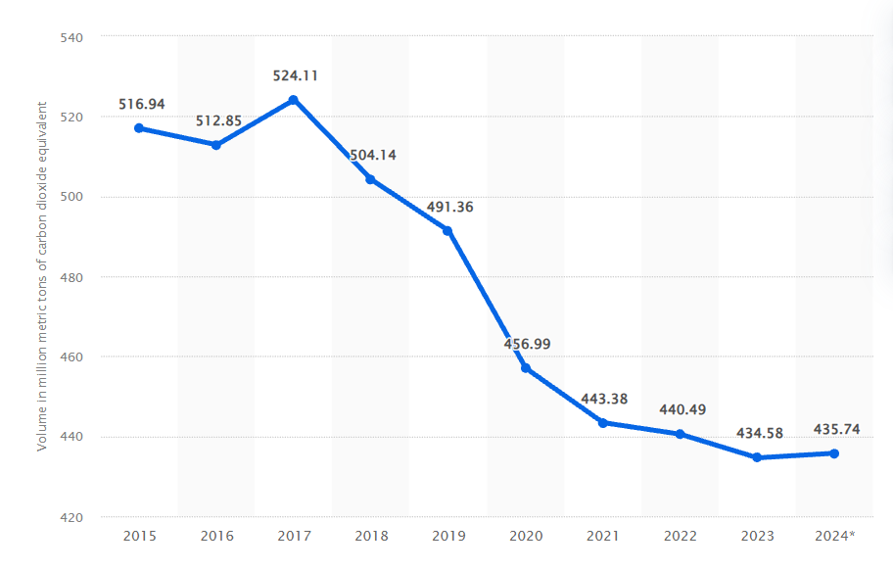

Figure 3: National GHG emission rate of Australia in the past decade
(Source: Statista, 2025)
The 21st-century mining operations in Australia have also instigated a public health emergency and health loss among regular citizens due to an increase in pollution and the GHG emission index. For example, in 2023, almost 719 active mining operations have been registered in Australia, responsible for extracting heavy minerals and natural ores across the Western Australian regions (Cortes‐Ramirez et al. 2025). On the other hand, the conventional extraction techniques employed by mining corporations similar to BHP have also been responsible for emitting toxic chemicals into the air, water and land during mining operations. Nearly 58% of Australian residents living near mining corporations have reported major healthcare-related issues because of increased exposure towards mining operations and their GHG-based by-products (Cortes‐Ramirez et al. 2025). As a result, global mining enterprises like BHP are to focus on reducing GHG production across their ore extraction and other mining operations to lower pollution levels in residential areas of Australia.
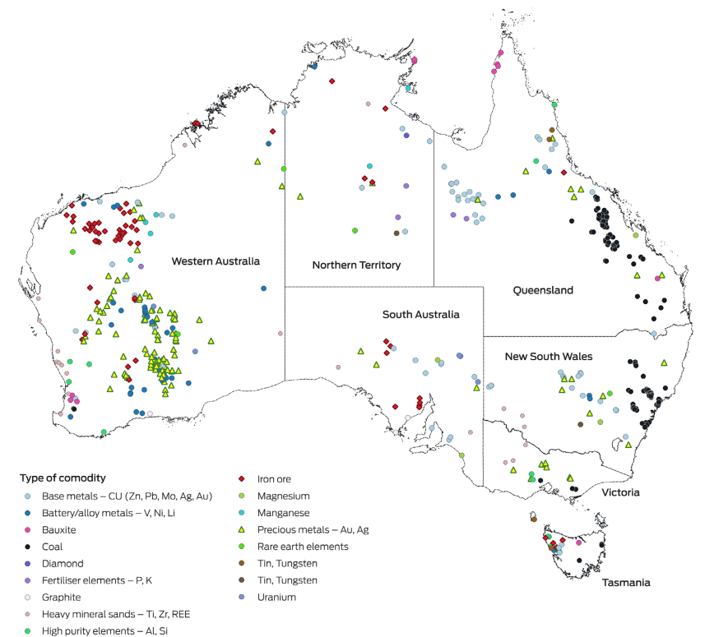

Figure 4: Mining operations across different parts of Australia
(Source: Cortes‐Ramirez et al. 2025)
The procurement of Australian government aid has been prominent in the national mining industry for encouraging local actors to introduce eco-friendly operations and sustainable practices on a daily basis. For example, almost 23 billion Australian dollars’ worth of government packages have been announced by the local authorities in recent times to motivate mining corporations to invest in renewable energy sources (Muschter, 2025). Apart from that, in 2024, the coal mining market value in Australia has also experienced a drastic reduction to almost 106 billion US dollars, indicating a reduction in local corporate interest towards conventional mining (Muschter, 2025). It can be mentioned that the decline in coal mining and the governmental aid provided by the Australian government have been critical towards inspiring BHP officials to move towards sustainable mining functions. Therefore, the declining environmental factors, increased emission rates and health problems have been prevalent in the Australian marketplace, which can motivate mining corporations such as BHP to revise current eco-friendly policies
Legal Actor
Depending on the PESTLE evaluation from Figure 2, the Australian government and legislative body have introduced multiple environment-friendly policies such as the Environment Protection and Biodiversity Conservation (EPBC) Act from 1999 (DCCEEW, 2026). It has also empowered the legislative body of Australia to undertake swift legal actions against individuals and local corporations to undertake eco-friendly practices for lowering carbon emission levels. Apart from that, the Climate Change Act implemented by the Australian government has also introduced a scope 1 target of a 43% carbon reduction plan within the fiscal year of 2030 (GOV AU, 2024). In scope 2, the Australian administration has also introduced a net-zero plan to be achieved within 2050 for gradually diminishing national GHG emissions and creating a carbon-neutral environment (GOV AU, 2024). Therefore, the current Australian climate legislation and the EPBC Act can prove to be major external legal elements that can motivate the BHP administration towards enhancing eco-friendly policies in future mining operations.
Technological Actor
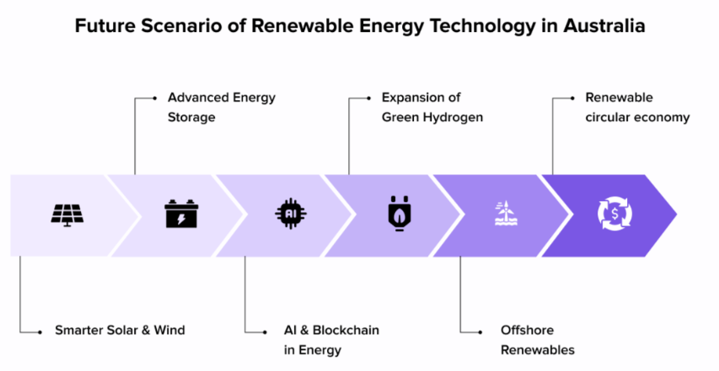

Figure 5: Sustainable tech adoption in Australian marketplace
(Source: Sharma, 2025)
The PESTLE analysis also showcases the positive implications of eco-friendly technologies used by modern enterprises to lower negative climate impacts and create a carbon-neutral environment (Kotler et al., 2024). For example, the use of liquid cooling and smart airflow management technology has been prevalent in the Australian corporate industry for gradually lowering electricity consumption by 43% in daily business operations (Experion AU, 2026). In the case of BHP and its industrial mining operations, the Australian enterprise can employ smart airflow management and liquid cooling systems to lower electricity usage across corporate offices and mitigate its GHG footprint. On the other hand, sustainable tech initiatives undertaken by the Australian corporate entities have been highly impactful towards generating 500,000 tonnes of e-waste products in annual business operations (Experion AU, 2026). It can be highlighted that the BHP officials need to focus on implementing relevant recycling technology in daily mining operations to gradually mitigate the creation of harmful waste compounds. Therefore, the use of smart airflow management and recycling technologies has been promoted in the Australian business industry, which can become relevant for BHP administration to create a carbon-neutral ecosystem.

Task 2: Strategic Growth and Competitive Positioning

2.1 Evaluation of strategic growth approach using Ansoff Matrix
The BHP administration can employ the Ansoff matrix towards developing sustainable growth policies based on the environmental, legal and technological factors discussed in the previous section (Kotler et al., 2024).
Ansoff Matrix elements | Highlights
Market Penetration | - Highest market capitalisation for BHP in 2024 (Muschter, 2025b).  - BHP market revenue is around 55.6 billion U.S. dollars (Muschter, 2025b).
Market Development | - Expansion of mining operations for BHP in Europe.  - EU plan for lowering GHG emission levels by almost 55% within 2030 (Europa, 2026).
Product Development | - Site waste management plan (SWMP) for reducing waste handling processes by around 50% (Kolaventi et al., 2022).  - Introduction of a waste management programme and recycling technology.
Diversification | - Reduce waste diversion towards landfills by almost 42% (Kolaventi et al., 2022).  - Introduction of BHP's new waste management processes.

Table 1: Potential implications of Ansoff Matrix implications
(Source: Self-developed)
Market Penetration
In the global mining industry, BHP has achieved the highest market capitalisation, which showcases the effectiveness of organisational ore extraction and transportation operations in countries like Australia. For example, in 2024, the market capitalisation value for BHP and its industrial operations was registered at around 160 billion US dollars, which further showcases organisational market penetration levels (Muschter, 2025b). Hence, despite the GHG emission levels from mining operations, the BHP officials have achieved a healthy market penetration level from existing extraction and transportation practices.
Market Development
The expansion of mining operations for BHP can help the Australian mining brand to enhance organisational marketing policies based on local environmental norms and achieve a sustainable strategic growth approach. For instance, the European Union and subsequent nations such as Austria have introduced the 8th Environment Action Programme to lower GHG emission levels by almost 55% within the economic year of 2030 (Europa, 2026). As part of GHP’s market development operations in EU nations like Austria, the organisation needs to abide by the local Environment Action Programme to strengthen current mining operations by lowering carbon production.
Product Development
The introduction of recycling technology and a waste management programme can prove to be a major product development approach for BHP towards lowering GHG emissions in existing markets in Australia. For example, the use of a site waste management plan (SWMP) has been effective for modern business enterprises in reducing waste handling processes by around 50%, positively influencing the local environmental elements (Kolaventi et al., 2022). Therefore, the administrative body of BHP can employ the SWMP plan to gradually lower waste creation from ore extraction and transportation across different mining sites in Australia and achieve sustainable business growth in the future.
Diversification
The introduction of BHP's new waste management processes and recycling techniques in the EU markets of Australia can become an effective diversification policy for elevating strategic footprint in the global industry. For instance, the introduction of SWMP technology also helps reduce waste diversion towards landfills by almost 42%, which can lower the pollution level in the immediate neighbourhood (Kolaventi et al., 2022). Hence, the BHP administration can also create a positive brand value in the EU mining industry by introducing new and innovative waste reduction plans among the local officials of the EU market.
Porter’s Generic Strategy

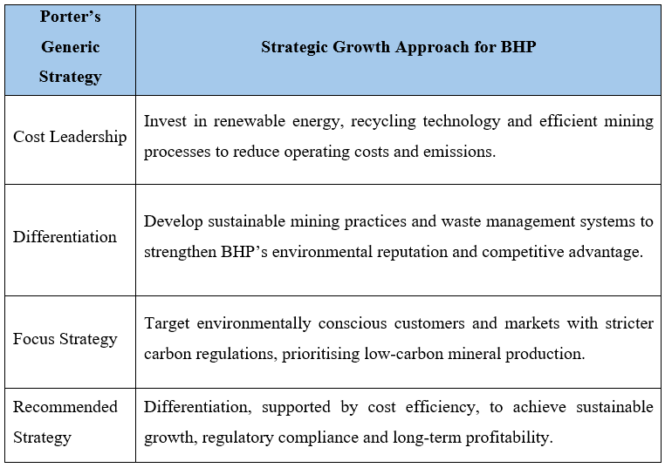Figure 6: Application of Porter’s Generic strategy for BHP
(Source: Self-Created)
According to Figure 6, BHP's differentiation strategy through being a sustainable miner, recycler, and low-carbon producer can protect its competitive advantage. This will enhance its reputation, comply with laws and regulations, and bring long-term benefits and sustainable growth.

2.2 Competitive Advantage using the TBL model
The deployment of the TBL model can help BHP officials introduce ethical and environmentally friendly operations in 21st-century mining operations to gain a sustainable competitive edge.
TBL Factors | Implications
Planet | - Sustainable mining operations for BHP to lower emission levels.  - The CO2 emission level of BHP was recorded at around 9.1 million tonnes (Statista, 2024).
People | - Implementation of team-based learning for BHP.  - In 2026, almost 41.5% of the gender balance was reported by BHP (BHP, 2026).
Profit | - Introduction of sustainable mining operations for maximising profitability.  - Enhancement in profitability margin from 20% to 85% for publicly listed firms (Cerciello et al., 2023).

Table 2: Different aspects of TBL approach
(Source: Self-developed)
Planet
The introduction of sustainable mining operations for BHP can prove to be highly effective towards lowering organisational GHG emissions in the coming years and gaining a competitive edge over rival corporations through safeguarding the environment. In 2024, the CO2 emission level of BHP was recorded at around 9.1 million tonnes, which has seen a significant decline from the previous year's value of nearly 10.2 million tonnes (Statista, 2024).
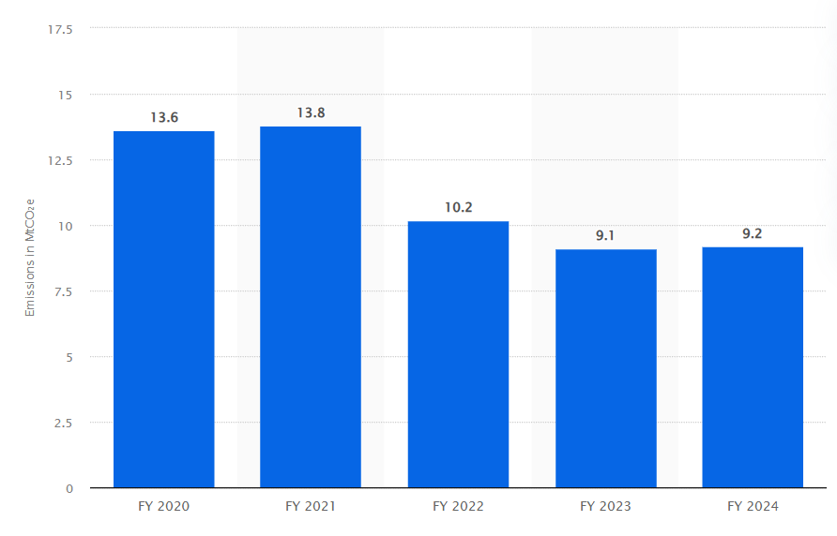

Figure 7: GHG emissions level of BHP in recent times
(Source: Statista, 2024)
People
The implementation of team-based learning can also help BHP administration to better accustom the organisational workforce towards new recycling and waste management functions in key systems. For example, in 2026, almost 41.5% of gender balance has been achieved by the BHP administration, which can help introduce new and innovative recycling ideas for the mining firm to achieve sustainable competitive advantage (BHP, 2026).
Profit
The introduction of sustainable mining operations can prove to be useful for BHP towards maximising future organisational profitability without compromising global market competition. For instance, in 2017, publicly listed business corporations published ESG reports, which showed an increase in profitability margin from 20% to 85% within a span of 6 fiscal years (Cerciello et al., 2023).

Task 3: Managerial and Professional Reflection

3.1 Reflection on the key decisions made throughout the report
Reasons behind company selection
The mining Organisation I have chosen to study for this report is BHP, as it is Australia's largest mining company, which is striving to reduce greenhouse gas emissions. I thought BHP would be a good study subject because the mining industry has a very obvious dilemma on how an organisation can be profitable without harming the environment. Studying BHP has made me realise that to be truly successful in business, organisations must respond well to environmental issues and changing stakeholder expectations.
Choice of environmental actors
I selected legal, environmental and technological factors to incorporate within the PESTLE as I believe they have the greatest impact on BHP's decision to move towards sustainable mining. It was the environmental aspect that made me aware of the need to cut down on emissions, pollution and waste. The legal aspect informed me of Australian climate targets, and the legal pressures of the environment can affect business choices. The technological aspect of recycling systems, renewable energy and innovative mining technologies has assisted in the areas of more sustainable business practices (Pouresmaieli et al., 2023).
Choice of growth strategies
During the formulation of the growth strategy, I chose the Ansoff Matrix as a comparison of the options open to BHP. I saw product development in the form of recycling technology and waste management as a feasible prospect. The implementation of recycling technology adds to the corporation's resources and helps mitigate the environmental impact of mining operations (Gairola et al., 2025). My suggestion of market development as a route for international expansion and the use of Triple Bottom Line enabled me to recognise the need to balance benefits for the people, planet and profit.

3.2 Reflection on the limitations of analysis
Gaps exist
During the course of writing this report, I became aware of some limitations of my analysis. In particular, the experience of relying on secondary sources, including company reports, published research and industry data, became clear. It was not always possible to check the validity of the given figures and compare them with other reports over time. I became aware that the report didn't necessarily fully differentiate between BHP's direct emissions and those from its supply chain.
Additional information required
In future reports, I would collect more recent information in regard to emissions, more accurate investment estimates, viability of particular technologies, and employee/local community input. The positive aspects of recycling technologies are critical for 21st-century businesses for lowering waste creation and mitigating carbon footprint in global markets (Wilson et al., 2024). I would also compare BHP's environmental performance with that of rival mining companies. Overall, this assignment increased my perception of how managerial recommendations should be based on evidence. I also learnt that a well-grounded proposal needs sound information, critical analysis and balancing of environmental factors with commercial factors.

Conclusion
Based on the above findings, it can be concluded that BHP and its global mining operations have contributed significantly to GHG emissions and elevated surrounding pollution levels. The report has employed the PESTLE analysis for evaluating 3 major external market actors such as environmental, legal and technological solutions for continuous carbon-free operations.

Reference List
Core Text
Kotler, P., Armstrong, G., Harris, L.C. and He, H. (2024) Principles of marketing. 19th edn. Harlow: Pearson.
Academic Articles
Cerciello, M., Busato, F. and Taddeo, S., (2023). The effect of sustainable business practices on profitability. Accounting for strategic disclosure. Corporate social responsibility and environmental management, 30(2), pp.802-819. https://onlinelibrary.wiley.com/doi/pdfdirect/10.1002/csr.2389
Cortes‐Ramirez, J., Michael, R.N., Toms, L.M. and Haswell, M., (2025). The public health impacts of mining in Australia. Medical Journal of Australia, 223(10), pp.541-549. https://onlinelibrary.wiley.com/doi/pdf/10.5694/mja2.70005
Gairola, S.U., Khanduri, A.K. and Bhuvaneswari, V., (2025). Sustainable mining: reducing waste and enhancing resource efficiency. Discover Civil Engineering, 2(1), p.75. https://link.springer.com/content/pdf/10.1007/s44290-025-00233-9.pdf
Kolaventi, S.S., Momand, H., Tezeswi, T.P. and Kumar, M.S., (2022). Implementing site waste-management plans, recycling in India: barriers, benefits, measures. In Proceedings of the Institution of Civil Engineers-Engineering Sustainability (Vol. 175, No. 1, pp. 30-51). Thomas Telford Ltd. https://www.academia.edu/download/80236594/jensu.21.pdf
Pouresmaieli, M., Ataei, M., Qarahasanlou, A.N. and Barabadi, A., (2023). Integration of renewable energy and sustainable development with strategic planning in the mining industry. Results in Engineering, 20, p.101412. https://www.sciencedirect.com/science/article/pii/S259012302300539X
Wilson, D.C., Paul, J., Ramola, A. and Filho, C.S., (2024). Unlocking the significant worldwide potential of better waste and resource management for climate mitigation: with particular focus on the Global South. Waste Management & Research, 42(10), pp.860-872. https://journals.sagepub.com/doi/pdf/10.1177/0734242X241262717
Website Sources
BHP (2026). About us, Available at: https://www.bhp.com/about [Accessed: 9th Oct 2026]
DCCEEW (2026). Environment Protection and Biodiversity Conservation Act 1999 (EPBC Act), Available at: https://www.dcceew.gov.au/environment/epbc [Accessed: 8th Oct 2026]
Europa (2026). Environmental policy: general principles and policy framework, Available at: https://www.europarl.europa.eu/factsheets/en/sheet/71/environment-policy-general-principles-and-basic-framework [Accessed: 8th Oct 2026]
Experion AU (2026). Sustainable Tech, Available at: https://experion.au/sustainable-tech/ [Accessed: 8th Oct 2026]
GOV AU (2024). Australian Government Climate Change Commitments, Policies and Programs, Available at: https://www.aofm.gov.au/sites/default/files/2024-02-02/Climate%20change%20slides%20updated%20February%202024.pdf [Accessed: 8th Oct 2026]
Muschter, R. (2025a). Mining industry in Australia - statistics & facts, Available at: https://www.statista.com/topics/4671/mining-industry-in-australia/?srsltid=AU7gw4UUHNBNwv8r9QjGRbXGCmlQQHGUX0fyDzcA2-_4vWIJJ3EtbHSb#topicOverview [Accessed: 9th Oct 2026]
Muschter, R. (2025b). Sustainable Tech, Available at: https://www.statista.com/topics/3401/bhp-billiton/?srsltid=AU7gw4XaHTa_JwqYgPS_W1FLPcCpH2OoLEJxsC9Nzf3T_AT-P1KnU_aP [Accessed: 8th Oct 2026]
Statista (2024). BHP's operational greenhouse gas emissions from FY 2020 to FY 2024, Available at: https://www.statista.com/statistics/1407581/bhp-operational-emissions-of-greenhouse-gases/?srsltid=AU7gw4U3HB0T27S6Npv3flqpqdixawhB9eYdP7sbXCJYaHtlz-UyUn1- [Accessed: 8th Oct 2026]
Statista (2025). Annual volume of greenhouse gas emissions in Australia from 2015 to 2024, Available at: https://www.statista.com/statistics/1014951/australia-yearly-greenhouse-gas-emissions/?srsltid=AU7gw4VW7xNRwLZLB21rrDNFgHAR1PpirIX6wILXySQdSIddvXKzEgdp [Accessed: 9th Oct 2026]
Sharma, N. (2025). 10 Ways Technology is shaping the renewable energy industry in Australia. [online] Appinventiv. Available at: https://appinventiv.com/blog/technology-shaping-renewable-energy-in-australia/ [Accessed: 10 Oct 2026].

