

Research of data security management system

Programme: Computer Networks and Cyber Security
Module: Data Security, Governance and Compliance
Name:Yi Zheng
Student ID:2009514
Date:2021.01.03

Abstract
The rapid development of Internet and communication technology makes the society become more and more information and intelligent, but when more and more enterprises and individuals enjoy the convenient services brought by the development of technology, various security attacks are also born. Network security has become an important issue of public concern, and various countries have issued laws and regulations and security frameworks on network security. This paper introduces three security frameworks or models of ITIL, ISO27000 and IATF, and analyzes their advantages and disadvantages. ITIL after years of development and accumulation, the global market has grown rapidly and gradually mature. ISO27000 series standard is an international standard organization for information security management system. IATF, originally proposed by the US government, aims to protect the information security of government and important enterprises and ensure the normal operation of infrastructure. This paper analyzes blue Mountain coffee, and gives some solutions based on ITIL and ISO27000.

1.ITIL

1.1 The concept of ITIL

ITIL (Information Technology Infrastructure Library) IT infrastructure database is mainly composed of six modules: business management, service management, ICT infrastructure management, IT service management planning and implementation, application management and security management. This architecture database was organized and formulated by the British government department in the late 1980s, and managed by the British Ministry of Commerce. ITIL lists the relationship between the objectives, activities and other process nodes in each service work, and coordinates the functions to be realized by a process and the relationship between other processes. The core concept of ITIL is that all IT departments are IT service providers and need to maintain and provide efficient IT services. ITIL is essentially a management of IT work with a service as its goal.

1.2 The development of ITIL

ITIL development so far has been updated 3 versions, although 2011 has made some amendments to ITIL version, but did not redefine the version.

The core idea of ITIL's initial design is to ensure the value of IT, reduce the risk of management, and control resources reasonably.

ITIL development process is shown in the figure：

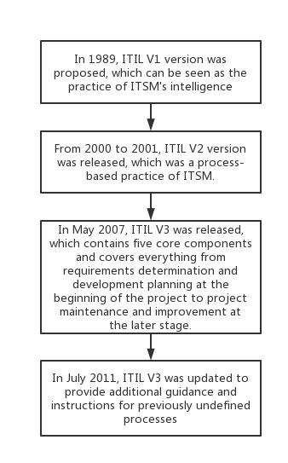

1.3 ITIL V2 Service management knowledge framework
The core idea of ITIL is "process as the main line", which is composed of six core modules.

The framework consists of six main modules: business perspective, service management, infrastructure management, application management, security management and service management implementation planning. For ITIL, its most core module should be the service management module, service management module to work, will take the process as the "means". The so-called process is ten core processes and a management function, which is the result of service management module management activities summarized.

Ten core processes and one management function are divided by IT Service management into two major aspects: service support and service provision, which are further refined, as shown in the Figure:

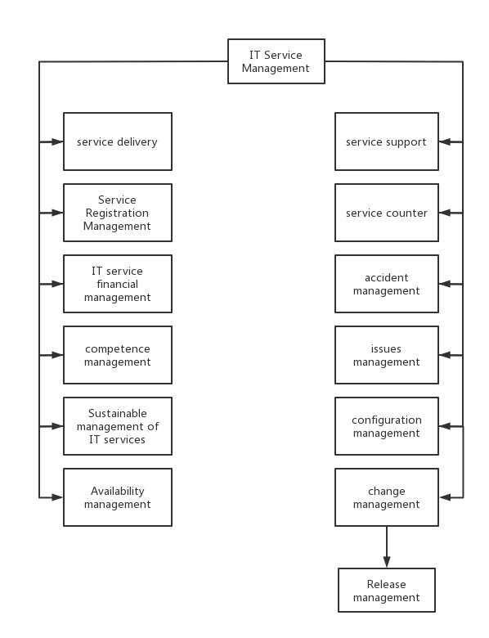

Ten processes are briefly explained:
Service level management: ensure that customers are assigned service levels consistent with customer requirements.
IT service financial management: through accounting and other means, so that enterprises can provide IT services to customers at the lowest cost.
Capacity management: The purpose of this project is to provide the best service management process, and at the same time, reasonable allocation of resources, as far as possible not to cause the waste of resources. Of course, business needs need to be prioritized when managing resource usage.

Continuous management of IT services: When some accidents occur in an enterprise, in order not to affect the normal provision of services to customers, IT is necessary to make a reasonable allocation of management resources, even capital and technology, required by continuous management to maintain services.
Availability management: Availability management is to ensure the ever-increasing availability requirements for management processes that enterprises need to optimize for the availability of their infrastructures
Service desk: Different from other management processes, the service desk is only the management function of IT service management. The function of the help desk is to provide interfaces to other modules. At the same time, as a module in contact with users, the service desk is also responsible for recording problems in the process of system operation.
Incident management: Ensure that customers can maintain service availability levels that meet their requirements. In layman's terms, when the company has an accident, the incident management module needs to resume service as soon as possible.
Problem management: Unlike the task of incident management to restore service as soon as possible, problem management is to find the root cause of an incident, document it and submit it. Avoid the termination of the customer service process due to the same problem again.
Configuration management: Records the configuration of the enterprise infrastructure and provides information to other modules that require information about these facilities.
Change management: When a change occurs, change management ensures that the change is in accordance with the rules and must be able to track all change information.
Release management: Ensuring that the infrastructure's software and hardware are standards-tested technologies.

1.4 Advantages and disadvantages
According to my own work practice and research, I summarize the advantages of ITIL as follows:
1. Improve it service satisfaction of users and customers.
2. Enhance the availability of services, immediately raise the profits and income of enterprises.
3. Economize fund loss caused by doing poorly done work over again and waste of time, improve resource monitor and use.
4. Make better new commodities and services.
5. Improve decision making and optimize hazard.
And the disadvantages as follow:
1.Too aggressive project expectations and plans
2. Focus on ITIL best practices and ignore the business position of the enterprise itself
3. Ignore the value of process owner
4. Ignoring the change of ITIL culture
5. Consider ITIL as a set of independent processes
2. ISO27000
2.1 IS027000 Information security management system introduction
ISO 27001 was preceded by BS 7799 Part II. BS7799 was written by the UK department of trade and industry and published by the British standards institute (BSD) in 1995.
BS7799 has been released in three major parts so far. The first part "information security management implementation rules" mainly contains the best practices of information security management. The second part of BS7799 "Information security Management System specification" was released in 1999. Bs7799-2 points out and elaborates on the establishment of information security management system (ISMS) according to the organization's own information security architecture and control points. The third part of BS7799 was released in 2005, covering risk analysis and management.
2.2 IS027000 Series Members Introduction
At present, ISO/IEC 27000 series standards have become a global general safety standard series accepted by many organizations which is the most basic and the most important members are introduced as follows:
IS027000 - "Information security management system principles and terminology" - mainly describes the basic principles of information security management system and common terms.
IS027001 - "Information security Management System Requirements" - mainly puts forward the basic requirements of information security management system.
IS027002 - "Information security Management Practice Rules" - mainly put forward the information security management system establishment method and rules.
IS027003 - "Information security management System implementation Guide" - mainly provides guidance for the establishment, implementation, maintenance and improvement of information security management system.
IS027004 - Measurement and Indicators of Information Security Management - This standard describes the implementation effect and related indicators used to measure information security management.
IS027005 - "Information security Risk Management" - the main information security management system risk assessment, risk management standards.

2.3 IS027000 standard information security management system construction process
IS027000 series of standards under the information security management system construction of the basic process, is based on IS027001 developed, mainly consists of the following seven main steps:
(1) Preliminary preparation: collect background information of the organization, current situation and characteristics of the information system; Establish information security management system construction team members, clear information security management system construction schedule;
(2) Risk assessment: Develop risk assessment plans, carry out surveys and interviews as planned, collect asset information, collect the status of total assets/threats/weak spots, and identify risks;
(3) Risk analysis: comprehensive analysis of the results of risk assessment, determine the control scope of the information security management system;
(4) Risk control and the establishment of information security system: according to the control scope of information security management system, the establishment of IS027001 standard information security management system framework, design a new information security management process, improve the existing insufficient information security management process;
(5) Internal audit and management review: internal audit personnel and related senior personnel conduct internal audit evaluation, and timely correct deficiencies found;
(6) Audit and approval: the organization's information security management system is assessed and certified by external reviewers;
(7) Continuous improvement: during the operation of the information security management system, the process is repeated regularly or irregularly to improve the new information security management problems;
It can be seen from the standard process of IS027000 information item security management system that the information security management system is a cycle process in accordance with the Deming ring, as shown in the figure. At the same time, it can also be seen that since the birth of information security management system, risk assessment and risk control is the key content of IS027000 standard system, they not only need to be carried out at the beginning of the establishment, but also need to be in the process of operation, repeatedly, cyclic.

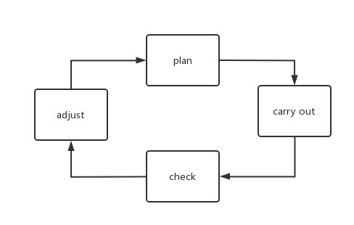

- IATF
3.1 Introduce of IATF
Information Security Technology framework, IATF for short. It was developed by the U.S. Security Agency. It is an industrial and administrative information defense design idea, which aims to protect the information security of government and important enterprises and ensure the normal operation of infrastructure. IATF implements network defense by detecting information privacy, validity, and acceptability of infrastructure, network infrastructure, network edge, and computing environment, and provides self-protection, reconnaissance, and automatic maintenance capabilities for networks. The three core elements of IATF are users, operations, and technology. It emphasizes the privacy and security of user information, the accuracy of operation and the perfection of technology. Understandably, users, operations and technology are at the heart of network security. The design idea of IATF information security defense model is to strengthen the use of static and dynamic defense resources, reduce the use of virus and intrusion response resources, and pay attention to protection and detection. This design can reduce network exposure time and prevent the system from creating new security vulnerabilities during the implementation of defense.
IATF is different from common security protection policies. In order to ensure the security of system information, IATF files adopt new security management policies. Technical personnel can only enter the system through standardized operations; otherwise, they will be denied access. But from the current development and application of computer technology, it can not meet the security requirements of computer system. Computer system security requirements: （1） In the protection of information security, but also to consider the integrity and availability of information; （2）The response ability and detection ability of the system also have a very important impact on the storage and recovery of information. In order to design the network defense system that meets the security requirements, the construction should be carried out according to the actual needs by considering the technology, management, design and strategy.
3.2 The composition of IATF
The network security system based on IATF is composed of internal network, access control module, external network and service network, which constitute a three-layer network framework. This design makes it easier to deploy network facilities and isolate information, ensuring the security of information in the internal network and service network. External networks are more effective in maintaining the entire network connection, and are easy to manage and control multiple points at the same time.
Internal network is the basic business network and the network that users can contact directly.
The external network transmits information to the Intranet, including network firewalls, routers, and switches. External networks are most vulnerable to network intrusion because they are generally oriented to the public network with external resource interfaces.
The service network is responsible for the output of network functions and provides application and code download interfaces for production, life and entertainment.
The access control module contains the IATF information security defense model and is the core of the system security defense.
3.3 How to achieve security
In the design of IATF-based network security system, in order to ensure the security of the Intranet, we need to do the following:
- Establish an appropriate security defense mechanism to control the transmission and access of network information and avoid directly invoking or accessing information.
- Use PKI/CA as the user login authentication agent to solve resource information problems from multiple perspectives.
- Establish a virtual isolation network for the external network and remotely access the virtual isolation network using ipsec. In this way, the external network can directly isolate viruses and intrusions.
4. Case analysis
4.1 Case background
CoffeeBlue sells Blue Mountain Peak coffee from Jamaica, one of the best and most sought-after blends in the world. CoffeeBlue has extensive presence around the globe. The company uses cloud services to deliver IT services to its staff and clients. It is estimated that almost 95% of the company's network is wireless based. The company also has a massive online presence and social media presence to promote its activities.Owing to its large staff and international customer base, the company has recently come under immense pressure to allow both its staff and customers to use their personal devices to access the company's network/resources. Security of personal staff's data and client's data is the company's major concern. The company is also concerned about protecting its intellectual properties, which is worth billions. Information Security is a priority to the company, but everything is in disarray. There is no established policy covering their security need.
CoffeeBlue has a large demand for wireless based business, and needs a lot of online social media promotion work. Now social network security is very important. Both employees and customers need to access the company's network resources online, which has great security risks. Employees' personal information, customer information and the company's billions of dollars worth of intellectual property rights are available Risk of leakage. This paper will build a security framework for Caribbean coffee company based on ITIL and ISO27000.
4.2 Solution
IT departments need to provide protection services for employees' personal information, customer data and the company's billions of dollars worth of intellectual property rights to prevent the huge losses caused by the disclosure of company or personal information. Social media accounts should adopt certain protection measures to prevent individuals from using company accounts at will. And set to prevent copying, downloading and other technical support, to prevent the company's employees from divulging confidential information. Establish a unified service platform. With a unified service platform, design workflow. Distinguish employee functions, such as: first line, second line, etc. The first line refers to the customer service staff of the service desk, whose responsibility is to receive problems, track problems, deal with simple, a large number of repetitive problems and record them in the knowledge base, so as to reduce the pressure of the second and third line technicians. The second-line and third-line technicians can get out of the daily complicated maintenance work to study the problems with great technical difficulty and great impact on the business, and record the treatment methods and solutions to these problems in the knowledge base, so that when the problem occurs again, the front-line customer service personnel can deal with it, and really give play to the strength of the technical personnel. And it needs the system to record the problems involved in the information system one by one, including the solutions and solutions, so as to collect a huge knowledge base for the enterprise. Then through the supplement of all aspects of enterprise information, the content of knowledge base is constantly enriched. Through the record of knowledge base, the infrastructure and application systems involved in the information department can be recorded, creating an iron camp for the information department, no longer afraid of the loss and change of personnel. It department keeps updating and maintaining the company's system.
4.3 Risk management
Risk control is to use the results of risk assessment to give appropriate and rational decision-making and judgment process. According to the IS027001 risk control requirements, the company's risk control implementation process is shown in the figure:



