

Student name: Abosede Dehinbo
Student ID: 2313077

Module name: Empowering the Older Person
Module code: BMHP6027_LON
Lecturer’s name: Dr. Laila Surani

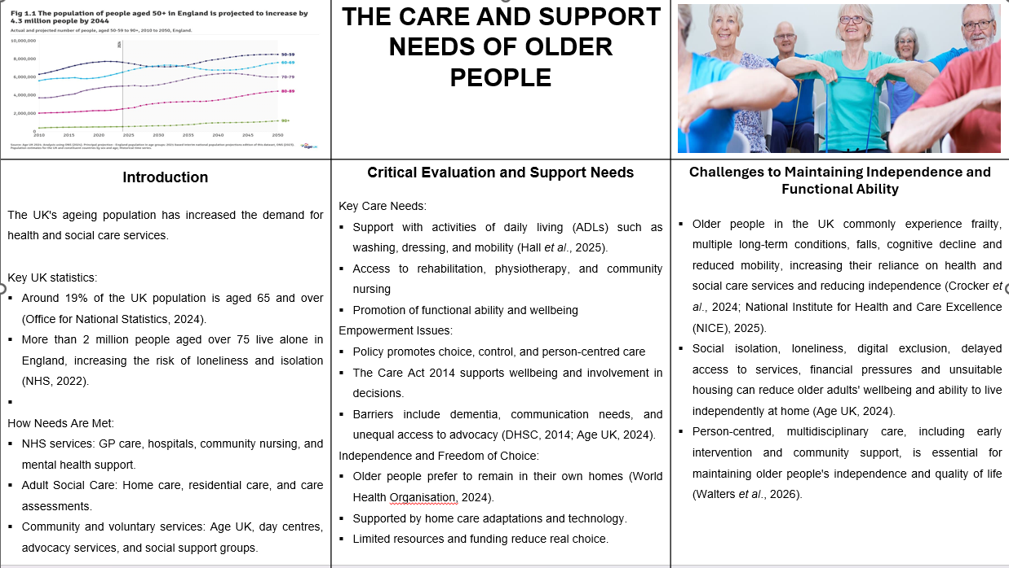
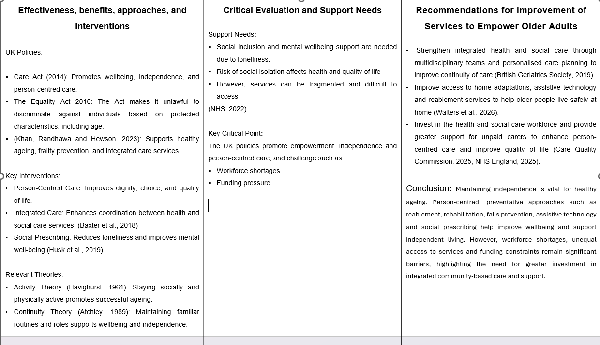

References
Abdi, S., Spann, A., Borilovic, J., de Witte, L., and Hawley, M. (2019) ‘Understanding the care and support needs of older people: a scoping review and categorisation using the WHO International Classification of Functioning, Disability and Health Framework (ICF),’ BMC Geriatrics, 19, p. 195. Available at: https://doi.org/10.1186/s12877-019-1189-9 (Accessed: 22 June 2026).
Age UK (2024). Later life in the United Kingdom. London: Age UK. Available at: https://www.ageuk.org.uk/siteassets/documents/reports-and-publications/later_life_uk_factsheet.pdf (Accessed: 22 June 2026).
Age UK (2024). State of health and care of older people in England 2024. Available at: https://www.ageuk.org.uk/discover/2024/september/state-of-health-and-care-of-older-people-in-england-2024/ (Accessed: 28 June 2026).
Baxter, S., Johnson, M., Chambers, D., Sutton, A., Goyder, E., and Booth, A. (2018). ‘The effects of integrated care: a systematic review of UK and international evidence,’ BMC Health Services Research, 18, article 350. Available at: https://doi.org/10.1186/s12913-018-3161-3 (Accessed: 22 June 2026).
British Geriatrics Society (2019) 8. CGA in primary care settings: care and support planning. Available at: https://www.bgs.org.uk/8-cga-in-primary-care-settings-care-and-support-planning (Accessed: 28 June 2026).
Care Quality Commission (2025). The state of health care and adult social care in England 2024/25. Available at: https://www.cqc.org.uk/publications/major-report/state-care/2024-2025 (Accessed: 28 June 2026).
Crocker, T.F., Ensor, J., Lam, N., Jordão, M., Bajpai, R., Bond, M., Forster, A., Riley, R.D. and Clegg, A. (2024) ‘Community-based complex interventions to sustain independence in older people: systematic review and network meta-analysis,’ BMJ, 384, e077764. Available at: https://doi.org/10.1136/bmj-2023-077764 (Accessed: 28 June 2026).
Department of Health and Social Care (2014) Care Act 2014: statutory guidance. London: Department of Health and Social Care. Available at: https://www.gov.uk/government/publications/care-act-statutory-guidance/care-and-support-statutory-guidance (Accessed: 22 June 2026).
Hall, A., Davey, V., McGarrigle, L., Astbury, J., Lazo Green, K., Ahmed, N. et al. (2025) OPFPRU HAPRU Homecare Quality Project – Full Report 29.10.24. Manchester: University of Manchester. Available at: https://doi.org/10.5281/zenodo.16895867 (Accessed: 23 June 2026).
Husk, K., Elston, J., Gradinger, F., Callaghan, L., and Asthana, S. (2019). Social prescribing: where is the evidence?’ British Journal of General Practice, 69(678), pp. 6–7. Available at: https://doi.org/10.3399/bjgp19X700325 (Accessed: 27 June 2026).
Khan, N., Randhawa, G., and Hewson, D. (2023) ‘Integrated care for older people with different frailty levels: a qualitative study of local implementation of a national policy in Luton, England,’ International Journal of Integrated Care, 23(1), 15, pp. 1–13. Available at: https://doi.org/10.5334/ijic.6537 (Accessed: 22 June 2026).
National Institute for Health and Care Excellence (NICE) (2025) Falls: assessment and prevention in older people and in people 50 and over at higher risk (NG249). Available at: https://www.nice.org.uk/guidance/ng249 (Accessed: 28 June 2026).
NHS (2022) Loneliness in older people. Available at: https://www.nhs.uk/mental-health/feelings-symptoms-behaviours/feelings-and-symptoms/loneliness-in-older-people/ (Accessed: 22 June 2026).
Office for National Statistics (2024) Living longer: older people and ageing in the UK. Available at: https://www.ons.gov.uk/peoplepopulationandcommunity/birthsdeathsandmarriages/ageing (Accessed: 22 June 2026).
Walters, K., Frost, R., Barrado-Martín, Y., Kalwarowsky, S., Marston, L., Pan, S., et al. (2026) ‘Enabling health and maintaining independence for older people at home: the “Home Health” randomised controlled trial,’ Health Technology Assessment, 30(43), pp. 1–22. Available at: https://doi.org/10.3310/GJKW1909 (Accessed: 28 June 2026).
World Health Organisation (2024). Ageing and health. Available at: https://www.who.int/news-room/fact-sheets/detail/ageing-and-health (Accessed: 22 June 2026).

