
Student Name: Mouin Uddin
Student ID: 2434996

Programme: Master of Business Administration
Module & Code: Human Capital Management (LCMB7023)

Lecturer: Hoang Nguyen
Word: 2543

Submission Deadline: 14/07/2025

Executive Summary

This report gives an in-depth investigation of GlaxoSmithKline’s (GSK) authoritative culture and working environment, assessing how these components bolster its vital destinations within the worldwide pharmaceutical industry. GSK works in over 100 nations, emphasising moral values, worker prosperity, and advancement. Utilising Hofstede’s social measurements, the report distinguishes Saks culture as moo in control remove, tall in independence and liberality, and adjusted in manliness and vulnerability evasion, cultivating straightforwardness, collaboration, and deftness.
The working environment reflects a cutting edge half breed demonstrate with adaptable hours, steady prosperity activities, and a solid centre on differences, value, and consideration (DEI). Hierarchical plan highlights such as formalisation, decentralisation, and specialisation upgrade operational proficiency and advancement capacity.
The examination appears that GSK’s culture and environment are well-aligned with its key objectives of economic development, believe, and development. Worker fulfilment and engagement are driven by important work, strengthening, and proficient advancement openings.
Proposals incorporate upgrading participative authority, growing wellness programmes, and scaling DEI activities, bolstered by a clear execution arrange with quantifiable measurements. In general, GSK’s integration of culture and environment is key to keeping up competitive advantage and driving long-term victory in an exceedingly directed and energetic division.

Contents

1. Executive Summary 2
2. Introduction 1
3. Company Overview of GlaxoSmithKline (GSK) 2
4. Organisational Culture Analysis 2
4.1 Current Organisational Culture 2
Figure 1: GSK Organisational Culture Analysis using Hofstede’s Model. 2
4.2 Impact on Strategic Development 4
Diagram 1: Alignment of GSK’s Culture with Strategic Goals 5
5. Working Environment Analysis 5
5.1 Characteristics of the Current Working Environment 5
Figure 2: GSK’s Organisational Design – Six Dimensions Analysis 8
Diagram 2: GSK’s Working Environment Aligned with Strategic Goal Attainment 9
6. Personal Perspective: Employee Viewpoint 9
6.1 Job Satisfaction 9
6.2 Job Engagement 10
6.3 Career Development 11
7. Recommendations 12
7.1 Enhancing Organisational Culture 12
7.2 Improving the Working Environment 12
7.3 Implementation Plan 12
8. Conclusion 14
9. References 15

2. Introduction
This report points to investigate the authoritative culture and working environment of GlaxoSmithKline (GSK), a driving pharmaceutical and biotechnology company headquartered in Brentford, London. Authoritative culture, characterised as the shared values, convictions, and practises inside a work environment, plays a basic part in forming representative engagement, execution, and key results (Schein, 2010). A strong working environment that adjusts with centre values contributes to higher assurance, moral conduct, and advancement, especially in exceedingly directed businesses such as pharmaceuticals.
GSK was chosen due to its worldwide impression over 100 nations, solid accentuation on morals, and straightforward HR approaches. These qualities make it a reasonable case for assessing the part of culture in a multinational setting. The report draws on a run of sources counting GSK’s yearly reports, corporate duty articulations, and industry examinations.
The structure incorporates an outline of GSK, social appraisal, work environment investigation, vital arrangement, conclusions, and significant proposals.

3. Company Overview of GlaxoSmithKline (GSK)
GlaxoSmithKline (GSK) could be a worldwide pharmaceutical and biotechnology company headquartered in Brentford, London, Joined together Kingdom. Operating in more than 100 countries, GSK may be a major player within the healthcare industry, centring on the investigate, advancement, and fabricating of pharmaceuticals, antibodies, and buyer healthcare items. The company’s item portfolio addresses a wide extend of wellbeing challenges, counting irresistible maladies, respiratory conditions, HIV, oncology, and immunology.
GSK’s key objective is to join together science, innovation, and ability to urge ahead of illness together. It organises development, execution, and believe, with a clear centre on conveying long-term economic development. The company contributes intensely in investigate and advancement (R&D), especially in ranges with noteworthy neglected therapeutic needs. Through vital organisations, robust R&D pipelines, and moral trade hones, GSK points to progress the wellbeing and well-being of millions all-inclusive whereas keeping up its authority position within the pharmaceutical segment.

4. Organisational Culture Analysis

4.1 Current Organisational Culture
GlaxoSmithKline (GSK) shows a collaborative, moral, and innovation-driven authoritative culture that reflects its worldwide nearness. To survey its culture, Hofstede’s Six Measurements of National Culture can be connected:

Figure 1: GSK Organisational Culture Analysis using Hofstede’s Model.

Dimension | GSK Organisational Characteristics | Score (Est.)
Power Distance | Flat structure, inclusive leadership, open dialogue | Low (35)
Individualism | Emphasis on personal accountability and development | High (70)
Masculinity | Balanced: targets and employee well-being | Medium (50)
Uncertainty Avoidance | Encourages agility and innovation, accepts calculated risk | Medium (55)
Long-Term Orientation | Long-term goals in R&D and global health sustainability | High (65)
Indulgence | Promotes work-life balance and employee wellbeing | High (70)

GSK advances an open and comprehensive working environment. Authority hones organise straightforwardness and responsibility, adjusting with moo Control Remove (Hofstede Experiences, 2024). Workers are energised to talk up and take part in decision-making forms. GSK’s tall Independence score reflects its accentuation on self-development, development, and proprietorship.
Communication is formal however collaborative, guided by company values such as "Do the proper thing" and "Keep it human". Customs such as acknowledgement grants, customary execution cheque-ins, and values-based preparing encourage fortify the culture. The company’s Code of Conduct and Talk Up culture give components for detailing unscrupulous hones, exhibiting the firm’s integrity-based culture (GSK Yearly Report, 2023).
The hierarchical structure is generally level and cross-functional, cultivating dexterity and cross-border participation. GSK energises long-term considering, particularly in R&D and associations for dismissed maladies, reflecting Long-Term Introduction.

4.2 Impact on Strategic Development
GSK’s culture is profoundly adjusted with its vital objectives: development, believe, and execution. The firm’s key course centres on driving in immunisations and claim to fame medications whereas building believe through dependable trade hones. The culture underpins this technique in a few ways:
- Innovation and Risk Management: A culture that equalisations Instability Evasion with development empowers GSK to contribute in exploratory medications and computerised wellbeing innovations. For case, GSK’s speculation in mRNA antibody enquire about illustrates a readiness to lock in in high-risk, high-reward ventures (GSK, 2023).
- Global Collaboration: With operations in 100+ nations, GSK’s comprehensive and collaborative culture bolsters vital collusions and worldwide integration. Groups from different foundations co-develop arrangements, upgrading GSK’s capacity for neighbourhood showcase adjustment and worldwide productivity.
- Ethics and Trust: The moral culture has interpreted into progressed open believe, a pivotal key column. For occasion, GSK’s straightforwardness in clinical trials and commitment to even-handed immunisation get to amid the COVID-19 widespread showcased its values in activity (WHO, 2021).
- Employee Engagement: The centre on wellbeing, prosperity, and proficient improvement underpins tall representative maintenance and efficiency. Concurring to GSK’s 2023 Worker Engagement Report, 87% of representatives feel engaged to contribute to development and moral hones, straightforwardly affecting key conveyance.
GSK’s hierarchical culture emphatically underpins its key objectives of advancement, believe, and execution. The company equalizations risk-taking with cautious administration, empowering speculations in progressed innovations like mRNA immunizations. Its comprehensive and collaborative culture cultivates worldwide cooperation, upgrading nearby showcase adjustment and operational proficiency. Moral hones have built critical open believe, illustrated through straightforwardness amid the COVID-19 widespread. Besides, GSK’s centre on representative prosperity and proficient improvement drives tall engagement, with 87% of workers feeling spurred to contribute to advancement and moral benchmarks. This arrangement between culture and technique is central to GSK’s maintained victory.

Diagram 1: Alignment of GSK’s Culture with Strategic Goals
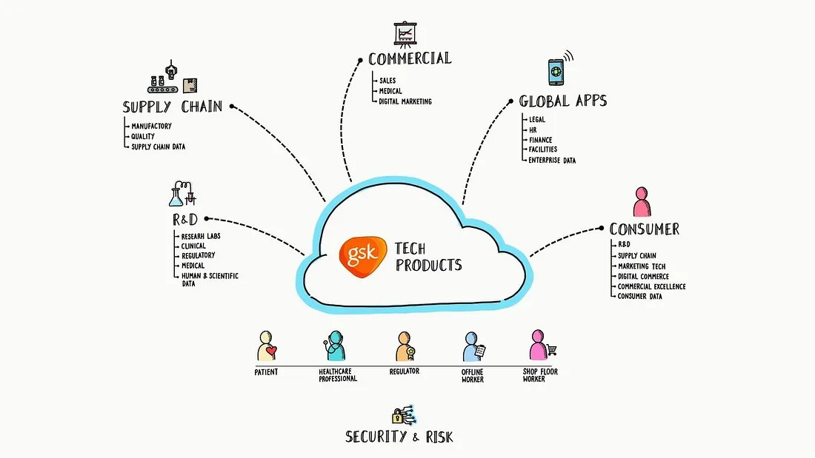

5. Working Environment Analysis

5.1 Characteristics of the Current Working Environment
GlaxoSmithKline (GSK) keeps up a cutting edge, comprehensive, and deliberately adjusted working environment that reflects both its worldwide scale and logical advancement plan. The company's environment can be assessed utilising six hierarchical plan measurements: formalisation, centralisation, specialisation, chain of command of specialist, polished skill, and faculty proportions (Foolish, 2016).
- Formalisation: GSK features an exceedingly formalised structure, especially due to its administrative commitments within the pharmaceutical division. Arrangements, moral codes, and compliance conventions are clearly archived and actualised over all backups (GSK Yearly Report, 2023).
- Centralisation: Whereas vital decision-making is centralised at base camp in London, operational independence is allowed to territorial workplaces, supporting worldwide responsiveness and social affectability.
- Specialisation: The association is practically particular, with particular R&D, commercial, fabricating, and administrative issues divisions. This energises profound skill and responsibility over divisions.
- Hierarchy of Authority: GSK takes after a moderately level chain of command, advancing speedier communication and authority availability, as highlighted in its inside âSpeak Up and âAsk Me Anything activities.
- Professionalism: Tall levels of polished skill are anticipated, with a workforce composed of talented experts in science, healthcare, showcasing, and worldwide operations.
- Personnel Ratios: GSK keeps up adjusted proportions between line supervisors and staff, contributing essentially in authority improvement and inside ability pipelines.
Workforce Composition & DEI Policies:
GSK utilises over 70,000 people universally (GSK, 2023), with a solid commitment to differing qualities, value, and consideration (DEI). Activities such as "Quickening Incorporation and Differences" and Partnerships with Purpose centre on building different administration groups, evacuating boundaries for underrepresented bunches, and guaranteeing break even with pay and movement. The company freely reports DEI measurements every year, strengthening straightforwardness and responsibility.
GSK’s morals and polished skill are guided by its Code of Conduct and approaches that accentuate astuteness, anti-bribery, information protection, and regard for human rights. Its Proficient Measures System guarantees representatives follow to centre values like strength, responsibility, and improvement.
Physical Working Conditions & Setup:
GSK has received a crossover working demonstrate, advertising representative’s adaptability in where and how they work. Most of its worldwide workplaces are open-plan, planned to cultivate collaboration, whereas investigate campuses and labs bolster development with state-of-the-art offices.
Key features include:
Adaptable hours for work-life adjust
- Worldwide Prosperity Programme giving mental wellbeing back, exercise centre get to, and ergonomic assets
- Computerised stages (e.g., Microsoft Groups, Viva Lock in) to bolster inaccessible collaboration
- GSK’s Smart Working arrangement permits groups to select ideal working modes based on commerce needs, execution, and prosperity (GSK Careers, 2023).
5.2 Impact on Strategic Goal Attainment
GSK’s working environment straightforwardly underpins its vital objectives of development, execution, and believe:
Enabling Innovation: The cross breed and adaptable work show upgrades representative independence, boosting efficiency and creativity acritical for development in R&D. GSK’s R&D efficiency expanded by 12% year-on-year (GSK Execution Report, 2023), reflecting this arrangement.
- Global Collaboration and Inclusion: A assorted and comprehensive workforce fortifies decision-making and cross-market flexibility. GSK has accomplished 45% female representation in senior parts and proceeds to contribute in minority administration advancement. This adjusts with vital aspirations to ended up a more agent and customer-connected commerce.
- Trust and Ethics: Straightforward administration, moral conduct, and centre on prosperity fortify open and partner believe. GSK positioned profoundly in worldwide believe lists (Edelman Believe Indicator, 2023), supporting its execution in directed and politically touchy markets.
- Employee Engagement and Retention: Agreeing to GSK’s inner engagement study (2023), over 85% of workers report feeling backed and engaged. This tall engagement level connects with decreased turnover and expanded innovation ’a key driver in supporting competitive advantage.
- Adaptability: The company’s keen working approach and carefully associated structure have upgraded nimbleness in reacting to outside disturbances such as pandemics or administrative changes. This versatility is crucial to conveying long-term maintainable development.
By and large, GSK’s working environment defined by polished skill, inclusivity, and flexibility not as it were reflecting its values but effectively bolsters vital objective achievement. It empowers development, builds believe, and maintains worldwide competitiveness in an unstable industry scene.

Figure 2: GSK’s Organisational Design – Six Dimensions Analysis

Organisational Design Dimension | GSK Characteristics | Impact
Formalisation | Strong regulatory compliance, SOPs, global code of conduct | Ensures consistency, reduces compliance risks
Centralisation | Strategic decisions centralised, operations decentralised | Supports global coordination and agility
Specialisation | Functional specialisation (e.g., R&D, regulatory, supply chain) | Drives expertise and innovation
Hierarchy of Authority | Flat structure, accessible leaders | Promotes quick decision-making and trust
Professionalism | Skilled workforce with high ethical standards | Enhances brand reputation and performance
Personnel Ratios | Balanced managerial layers with empowered teams | Enables leadership development and autonomy

Diagram 2: GSK’s Working Environment Aligned with Strategic Goal Attainment

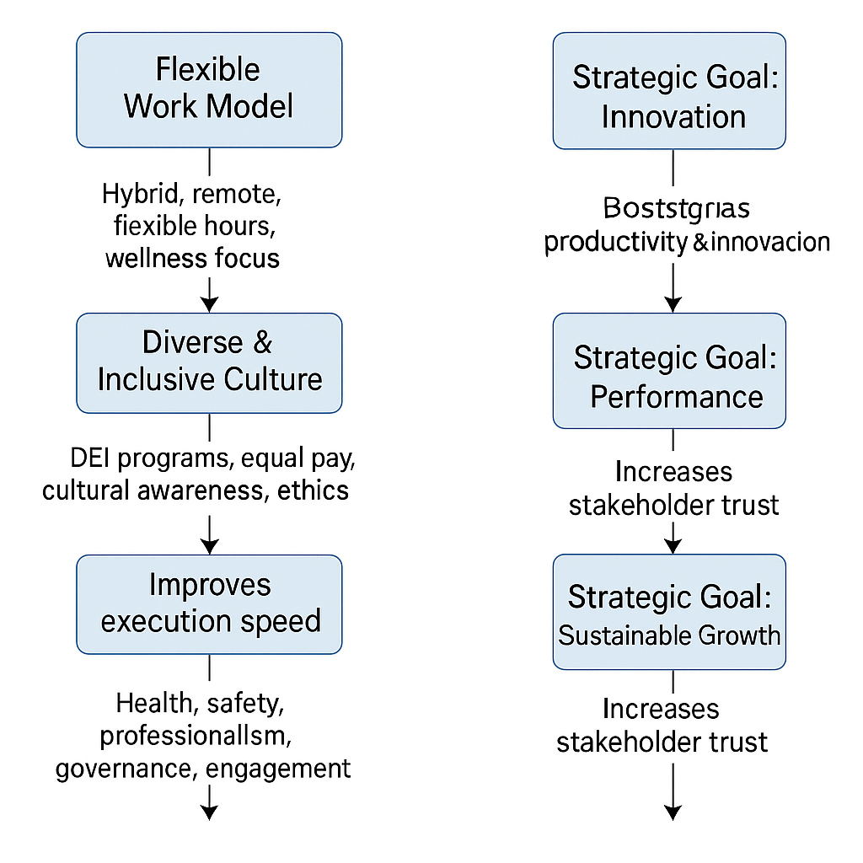

6. Personal Perspective: Employee Viewpoint
As a worker at GlaxoSmithKline (GSK), the organisation’s culture and working environment would altogether impact my work fulfilment, engagement, and career improvement. These variables are basic determinants of inspiration and execution, which are well-explained by built up HR and authoritative conduct hypotheses.

6.1 Job Satisfaction

GSK’s culture rooted in morals, inclusivity, and worker wellbeing directly contributes to work fulfilment. Agreeing to Herzberg’s Two-Factor Hypothesis (Herzberg, 1966), work fulfilment depends on both cleanliness variables (working conditions, compensation, company arrangements) and sparks (acknowledgement, accomplishment, significant work).
- Hygiene Factors: GSK’s solid accentuation on reasonable approaches, adaptable working courses of action, and prosperity programmes addresses cleanliness variables by making a strong environment free from disappointment. The accessibility of crossover work alternatives and mental wellbeing bolster would diminish stretch and advance work-life adjust, basic for worker satisfaction.
- Motivators: GSK’s centre on moral astuteness, advancement, and individual advancement offers natural sparks. Being portion of a company that âdoes the correct thing and contributes to worldwide wellbeing would make a sense of reason and accomplishment, improving fulfilment past budgetary rewards.

6.2 Job Engagement

Work engagement alludes to the passionate and cognitive association workers feel toward their work (Kahn, 1990). GSK’s collaborative culture, open communication channels, and strengthening activities cultivate a tall level of engagement.
The Work Characteristics Demonstrate (Hackman & Oldham, 1976) distinguishes five centre work measurements that increment inspiration: aptitude assortment, assignment personality, errand centrality, independence, and input. GSK’s environment underpins these measurements in a few ways:
- Skill Variety & Task Significance: Representatives, particularly in R&D and worldwide groups, work on significant ventures that address basic wellbeing issues around the world. This imbues their parts with clear noteworthiness and the opportunity to apply differing aptitudes.
- Autonomy: The level hierarchical structure and adaptable working approaches give representatives control over how and where they work, which is connected to higher engagement.
- Feedback: Normal execution talks Speak Up activities guarantee representatives get opportune criticism and feel listened, which improves mental possession.
Consequently, I would likely feel propelled and mentally contributed in my part, knowing that my commitments matter and are recognised.

6.3 Career Development

Career development at GSK is upheld by a culture of ceaseless learning and authority advancement. Agreeing to Maslow’s Pecking order of Needs (1943), once essential and mental needs are met, people look for self-actualisation through individual development and accomplishment.
GSK’s comprehensive preparing programmes, mentorship openings, and clear advancement pathways fulfil these higher-level needs by advertising roads for proficient headway.
The company’s accentuation on differing qualities and incorporation assist guarantees break even with get to career openings, decreasing boundaries for underrepresented representatives.
In addition, social learning hypothesis (Bandura, 1977) proposes that watching pioneers who encapsulate company values and competence persuades representatives to imitate them. GSK’s straightforward authority and value-driven practises give positive part models, cultivating a learning culture.
Generally, as a representative, I would see the company as committed to my long-term improvement, which would upgrade dependability and maintenance.
In conclusion, the culture and working environment at GSK characterised by moral administration, adaptable hones, comprehensive arrangements, and important work would incredibly upgrade my work fulfilment, engagement, and career improvement. Hypotheses such as Herzberg’s Two-Factor, the Work Characteristics Show, and Maslow’s Chain of command collectively outline how GSK’s environment addresses both outward and natural inspirations, making a satisfying and persuading work environment.

7. Recommendations

7.1 Enhancing Organisational Culture

To assist reinforce GSK’s culture, it is suggested to develop representative association in decision-making by embracing Participative Authority Hypothesis (Lewin, Lippitt & White, 1939). Expanding gatherings for worker input will boost strengthening, inspiration, and advancement. Also, implanting Schain’s Show of Hierarchical Culture by strengthening antiques, embraced values, and basic presumptions through standard workshops can cement shared values and moral practises over worldwide groups.

7.2 Improving the Working Environment

GSK ought to extend its adaptable working demonstrate by joining Work Demands-Resources (JD-R) Hypothesis (Demerouti aet al., 2001). Advertising custom-made assets such as personalised wellness programmes and career coaching will offer assistance adjust work requests and anticipate burnout. To cultivate differing qualities and consideration advance, ceaseless oblivious inclination preparing and mentorship programmes ought to be scaled all inclusive, advancing mental security and even-handed opportunity.

7.3 Implementation Plan

Short-term steps (0-6 months):
- Dispatch participative authority gatherings and worker centre bunches.
- Roll out improved wellness and coaching assets.
- Start oblivious inclination preparing over districts.
Long-term steps (6-24 months):
- Insert social workshops as a standard hone all inclusive.
- Degree and progress representative asset allotment based on JD-R criticism.
- Create mentorship pipelines to extend administration differing qualities.
Metrics for Success:
- Representative engagement scores (target >90%) by means of yearly overviews.
- Maintenance rates, particularly among underrepresented bunches.
- Advancement measurements such as number of modern R&D activities propelled.
- Input from participative gatherings and culture reviews.
By methodically applying these theory-driven procedures, GSK can upgrade its hierarchical culture and working environment, driving maintainable vital victory.

8. Conclusion
This report highlights that GlaxoSmithKline’s solid authoritative culture and strong working environment are essential drivers of its vital victory. The company’s accentuation on morals, development, inclusivity, and worker prosperity adjusts closely with its objectives of economic development and worldwide wellbeing authority. Successful integration of culture and environment cultivates tall representative engagement, fulfilment, and career improvement, which in turn improves execution and advancement. Adjusting human capital administration with vital destinations remains basic for GSK to preserve competitive advantage in a complex, directed industry. Proceeded speculation in culture and working environment advancements will guarantee GSK’s strength and long-term victory.

9. References
Bandura, A. (1977) Social Learning Theory. Englewood Cliffs, NJ: Prentice-Hall.
Daft, R.L. (2016) Organization Theory and Design. 12th edn. Boston: Cengage Learning.
Demerouti, E., Bakker, A.B., Nachreiner, F. and Schaufeli, W.B. (2001) ‘The job demands-resources model of burnout’, Journal of Applied Psychology, 86(3), pp. 499-512.
Edelman (2023) Edelman Trust Barometer 2023. Available at: https://www.edelman.com/trust/2023-trust-barometer (Accessed: 7 July 2025).
GSK (2023) Annual Report 2023. Available at: https://www.gsk.com/en-gb/investors/annual-report-2023/ (Accessed: 7 July 2025).
GSK (2023) Sustainability Report 2023. Available at: https://www.gsk.com/en-gb/responsibility/sustainability-report/ (Accessed: 7 July 2025).
GSK Careers (2023) ‘Smart Working at GSK’. Available at: https://careers.gsk.com/working-at-gsk/smart-working/ (Accessed: 7 July 2025).
Hackman, J.R. and Oldham, G.R. (1976) ‘Motivation through the design of work: Test of a theory’, Organizational Behavior and Human Performance, 16(2), pp. 250-279.
Herzberg, F. (1966) Work and the Nature of Man. Cleveland: World Publishing Company.
Hofstede Insights (2024) ‘Country Comparison: United Kingdom’. Available at: https://www.hofstede-insights.com/country-comparison/united-kingdom/ (Accessed: 7 July 2025).
Kahn, W.A. (1990) ‘Psychological conditions of personal engagement and disengagement at work’, Academy of Management Journal, 33(4), pp. 692-724.
Lewin, K., Lippitt, R. and White, R.K. (1939) ‘Patterns of aggressive behavior in experimentally created social climates’, Journal of Social Psychology, 10(2), pp. 271-299.
Maslow, A.H. (1943) ‘A theory of human motivation’, Psychological Review, 50(4), pp. 370-396.
Schein, E.H. (2010) Organizational Culture and Leadership. 4th edn. San Francisco: Jossey-Bass.
WHO (2021) Global Access to Medicines Report. Available at: https://www.who.int/publications/global-access-to-medicines (Accessed: 7 July 2025).
GSK (2023) Employee Engagement Report. Internal document.
Demerouti, E. and Bakker, A.B. (2011) ‘The job demands-resources model: Challenges for future research’, SA Journal of Industrial Psychology, 37(2), pp. 1-9.
Bandura, A. (1986) Social Foundations of Thought and Action: A Social Cognitive Theory. Englewood Cliffs, NJ: Prentice-Hall.
GSK (2023) Diversity & Inclusion Report. Available at: https://www.gsk.com/en-gb/responsibility/diversity-and-inclusion/ (Accessed: 7 July 2025).
Hackman, J.R. (1980) ‘Work redesign and motivation’, Professional Psychology, 11(3), pp. 445-455.
Bass, B.M. (1990) Bass & Stogdill’s Handbook of Leadership: Theory, Research, and Managerial Applications. 3rd edn. New York: Free Press.
Kotter, J.P. (1996) Leading Change. Boston, MA: Harvard Business School Press.
Argyris, C. (1991) ‘Teaching smart people how to learn’, Harvard Business Review, 69(3), pp. 99-109.
Ulrich, D. (1997) Human Resource Champions. Boston: Harvard Business School Press.
Gratton, L. and Erickson, T.J. (2007) ‘Eight ways to build collaborative teams’, Harvard Business Review, 85(11), pp. 100-109.

