Breeam.
Face building, energy assignment.

Introduction.

The University of Wales Trinity Saint David is in the process of constructing new buildings within its campuses. At this moment, this University is going to build two new buildings in the SA1 Waterfront Development: the new FACE building and the new Library. I have been tasked with being in charge of the energy section of the face building project.

Methodology.

There is a collection of information on Moodle which I will use to BREEAM assess the project, the collection of information is on the SA1 face building and SA1 library. The documents I will be using are, 10_-_BRUKL_Output_Document_Library_.pdf, 27_-_Exterior_Luminaire_Selection_WA0168-E-63-SP-001.pdf and 56_-_Electrical_Scope_of_Works_%28FACE_TECH%29_-_Rev_C.pdf. I will sift through the information in the documents to find the relevant information to the energy consumption of the Face building on the new SA1 campus. I will use social media to keep in contact and work with the rest of my SA1 group. The reason we will keep in contact is to double check numbers and data with one another and help each other form the documents. Calculations may be needed to show things such as percentages for how far away or how under a target the project may be. Other calculations may be needed which will be stated further into the document. I will be working out how much energy is currently used in different areas of the building and if there Is any way to reduce these figures.

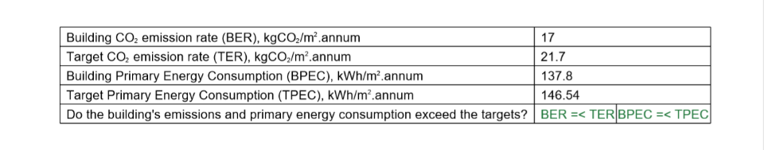
Data and results.

External lighting- 1 point (max points).
Reduction of energy use and carbon emissions- 5-7 points (excellent).

