

School of International Hotel Management
BA International Hotel Management

Module Handbook Spring Term 2024
BMIH5001 Entrepreneurship
Word Count: 2154 words
Student Name: Madalina Ionela Preda
Student ID: 2213175

LEVEL 5
Module Lecturer:
Ka Po Chong

Table of Contents
Introduction 3
Main Body 3
Conclusion 7
Reference List 8-9
Appendices 10-11
Appendix 1 Business Model Canvas 10
Appendix 2: Test Results 11

Introduction
Entrepreneurship has been gradually evolving as one of the most preferred fields by individuals, requiring investments in the form of time, money and effort in the present situation without having an idea of the consequences or distribution of returns in the future (Venkataraman, 2019). Following this, the essay will carry out a detailed explanation of the Business Model Canvas for developing an entrepreneurial business in the form of a Bistro in the United Kingdom. This new and innovative business revolves around the idea of offering organic food items at Salt and Sprout, S&S while stating competitive stances and key choices.

Main Body
Part 1: Essay
The business that has been implied in terms of being undertaken for the provision of exclusive services relies on the organic food items ensured by Salt and Sprout or S&S, a Bistro, within the hospitality business sector. Bistro is considered to be a unique shopping and dining pop-up experience currently indulged in celebrating the benefits ensured by organic products (Go Organic, 2022). The organic menu is identified to be designed revolving around food items working in harmony with the benefits of nature while being an “Instagrammable” and exclusive tasting board. This business has been following the purpose of going entirely organic while being free of pesticides and working in a close ambience with nature. Such tasting experiences are likely to include chocolate soils, nectar-infused treats, edible flowers and delicious salads. In terms of justifying the new and innovative business idea, it can be stated that organic food items are currently considered to reduce the health risks of farm workers and their families along with other general public and consumers (OTA, 2023).
This can be made possible by minimising the exposure of individual entities to persistent and toxic chemicals. It indicates that S&S needs to hire a sustainable supply team in terms of delivering eco-friendly raw materials or resources for the Bistro. This is implied on the business model canvas that has been formed in terms of launching and promoting the new business idea (refer to the Appendix). It also involves key partners to be delivery service providers based on online sales in this rapidly changing world of digitalisation. For instance, global e-commerce sales based on such delivery partners are forecasted to reach $6.5 trillion in 2024, an increase from $4.2 trillion in the prior year (Almalaky, 2023). Based on this, the role of delivery services can evolve into a major responsibility of the new business concept. For instance, Deliveroo in the United Kingdom is considered to be the fastest service delivery provider, capable of supplying raw materials in the form of grocery items and cooking ingredients within a short span of time (Deliveroo, 2024).
It has been engaged with a wide range of partners such as One Stop, ASDA, Morrisons and Sainsbury’s. In terms of key activities, organic food items are likely to be sold at a reasonable price at the Bistro through both in-store service and online delivery. Value-based pricing can be the vital idea for the launch of this new and innovative business idea, S&S, at the Bistro. In justification for affordable price rates, value-based pricing is considered to be a strategic decision for setting the price of goods and services based on the perceived value of consumers instead of historical backgrounds (CFI, 2024). Value proposition or Unique Selling Proposition has been considered to be one of the most essential elements included within a business model canvas. In the case of this Bistro in the form of the new business idea, Salt and Sprout, the USP of the concept recedes in its exceptional service, inexpensive organic food items, both continental and English, and delivery of ordered products within 20 minutes.
However, one slight issue is that, in terms of delivering food items within 20 minutes of ordering, may reduce the reach-out area of the business since remaining within the locality can be feasible for maintaining its idea. This can be modified with the help of selecting delivery partners based on their localisation and increasing the count of outlets over the years. Since the competitive environment for organic food is currently intense in the United Kingdom, following the strategic ideas of competitors may enhance the innovative concept of S&S. For instance, Natural Kitchen in London initiated its journey as an organic deli and now owns a broad count of London cafes (Visit London, 2024). Other competitors such as Hally’s, also in London, are engaged in offering responsibly sourced treats such as health-conscious and West Coast-inspired salads and dishes. To engage in healthy competition, S&S may convert the fusion of English and continental dishes from the best suppliers of each within the nation.
This may take more financial investments for the new idea but can be feasible in the long run since the best suppliers of English and continental are likely to influence the taste of organic food, attracting meat lovers in the process. Furthermore, in competition with other organic outlets in the UK such as Daylesford, an organic bakery, and Lu-Ma Café (Visit London, 2024). This cafe invites customers for breakfast with organic eggs and homemade baked beans while providing lunchtime dishes such as lentil curries or bean burgers that may be slightly different from other vegan restaurants. Such restaurants have been the source of information for developing the business model canvas and providing the innovative idea of a Bistro offering organic food items. To engage in healthy yet intense competition, S&S can take into account the strategic opportunities of The Hive, in London. For instance, The Hive offers a wide range of organic dishes such as its signature puffed quinoa granola along with sandwiches, keto bowls and wraps with cold-pressed juices and other organic drinks (Visit London, 2024).
Following this, the Bistro can stand out amidst the intensely competitive environment by ensuring the provision of both continental and English food items based on organic structures. One of the most alluring concepts that the new business can include as a product and USP may be vegan meat. For instance, the food market for vegan meat has been estimated to grow by 0.6 kilograms or more than 48.49% by the end of 2028 (Wunsch, 2023). Vegetarian meat is made up of dairy products and organic eggs and is also known as plant-based meat. Customer relationships have been identified as a major implication within the Business Canvas Model. In the case of this new Bistro, customer relationships have been emphasised through a customer support team that needs to be active for most hours of the day, going off at only the prescribed time. In today’s rapidly changing and accepted world of social media, Instagram and Facebook have grown to be the most viable solutions for maintaining healthy relationships with customers.
Paid promotions on Facebook and influencer marketing on Instagram can instantly grab the attention of target audiences. Instagram is an efficacious social media application that facilitates businesses to engage in social interaction with consumers while letting influencers build a large network of followers within several niches (Jin, Muqaddam and Ryu, 2019). Email marketing and personalisation can also be implemented within the business model canvas for S&S since it has currently evolved as the key to exclusive customer experience. For instance, 80% of consumers are likely to purchase from brands engaged in the provision of personalised or customised products and services, leading to the establishment of brand loyalty (Covello, 2021). Email marketing is the medium through which personalised sales can be made possible. This is because email marketing is primarily utilised in terms of promoting new or innovative products, offers, discounts, brand repositioning and content leading individuals towards the official website of a business (Desai and Vidyapeeth, 2019). In terms of improving the idea of the Bistro, S&S may take into account email marketing and influencer marketing to ensure personalised items while enhancing the knowledge of target audiences regarding organic food.
For customer segment, middle-class or moderate-income earners have been selected to target, between the ages of 18-64 years. Both males and females and couples and families can visit the Bistro, however, the age group can be more specific for S&S. For instance, in the year 2023, around 4% of individuals between the ages of 20-29 responded to follow a vegan diet, under fifty age groups had been inclined on organic food than those above (Wunsch, 2024). It is thereby expected that the target audience of S&S can be specified between the ages of 20-29, moderate-income earners with a preference for a vegan lifestyle and an understanding of online operations. With key resources involving waiters, professional chefs, digital marketing experts and a budget, channels such as in-store dining, social media and a customer service team are recognised as essential sources for the Bistro. This can be beneficial since budgeting is a crucial aspect of allocating organisational resources while the UK is home to 57.10 million active social media users accounting for 84.4% (Hassan, 2023; Kemp, 2023). The BMC involves a cost structure of rents and wages to generate revenue through online applications.
Part 2: Reflective Essay
Gibb’s Reflective Cycle is identified as a theoretical model often utilised by students as a plausible framework requiring reflective writing of lecture assignments (Sekarwinahyu et al., 2019). In the description, I have developed an understanding of entrepreneurship and its relevance in today’s developing world. For instance, in an entrepreneurial business set-up, it is primarily essential to know target audiences and collect a wide range of information regarding potential consumers (Williams, 2021). I have been capable of developing better ideas on entrepreneurial skills leading to the establishment of the Business Model Canvas, detailed with the key requirements for setting up the innovative business of S&S or Salt and Sprout. In terms of feelings, I believe that I have been able to enhance my leadership and managerial skills based on entrepreneurial assessments.
To evaluate the situation, I can take the help of the Burns Model referring to the idea that entrepreneurs are made or born. Entrepreneurs are considered to have traits associated with owner-managers while having additional “almost magical qualities” that such managers do not have, making entrepreneurs different (Burns, 2011). To analyse the given situation at hand, I may take the help of the Trait Theory of Leadership to underpin my qualities along with the weaknesses that I have as a potential entrepreneur.
The trait perspective of leadership emphasises leadership to be a property possessed in diverse degrees by a wide range of individuals (Northouse, 2021). I may not be able to invest huge amounts of finance to start a business since I am not confident about undertaking risks, differentiating myself from experienced leaders. For an action plan, I believe that I can learn from authentic online sources, motivating me to serve as an entrepreneur. For instance, social technologies can connect individuals from across the world with the current internet penetration rate in the UK being 98% (Evans, Bratton and McKee, 2021; Petrosyan, 2023).
After undertaking the GET2 test to evaluate my enterprising nature, I scored 63% in it. This illustrates that I have strengths in certain enterprising characteristics. This test mainly helps to identify the characteristics of a person through certain metrics such as motivation, creative tendency and several others (GET2, 2024). The test results demonstrate that I would be most satisfied and illustrate enterprising traits while managing employment-related processes. This would be in the form of an intrapreneur working on a limited number of projects in the general course of operations. Additionally, it also outlines that I would demonstrate enterprising qualities while participating in voluntary community-based projects.
More specifically, the test has clarified to me that, I can be successful if ambition can be combined with a growth-oriented innovative business. Herein, it has been recommended that I should look to improve my knowledge base associated with business and attempt to enhance my business competencies. In this regard, open learning online modules have been suggested through which effective technological skills can be developed which I lack. Lastly, the test results also outline that I should start a small enterprise in my community to better comprehend the different requirements for executing a business and gaining crucial experience in running it smoothly. Finally, to become more enterprising, I need to obtain an achievement in general and thereby, test results communicate that I am ‘occasionally enterprising’.

Conclusion
The discussion above helps in deriving that the Bistro being fostered with key resources through a Business Model Canvas may be successfully established with improved operations. For instance, the business has been named after its organic food items, Salt & Sprout or S&S. This has been further emphasised on the key resources such as delivery partners capable of providing services within a few minutes along with enhanced digital systems for customers leading to easy payments. With a proper budget along with analysed competitive stances, S&S seems all ready to be set out as an innovative idea of offering organic food.

Reference List
Part 1
Almalaky, N. (2023) The role of delivery services in e-commerce. Available at: https://www.linkedin.com/pulse/role-delivery-services-e-commerce-nesmtalmalaky (Accessed: 25 January 2024).
CFI (2024) What is Value-Based Pricing? Available at: https://corporatefinanceinstitute.com/resources/management/value-based-pricing/ (Accessed: 25 January 2024).
Covello, L. (2021) Why Personalization Is The Holy Grail Of Loyalty. Available at: https://www.forbes.com/sites/forbestechcouncil/2021/11/09/why-personalization-is-the-holy-grail-of-loyalty/?sh=20fa8e34e77c (Accessed: 25 January 2024).
Deliveroo (2024) Order your favourite groceries straight to your door. Available at: https://deliveroo.co.uk/cuisines/grocery-takeaway (Accessed: 25 January 2024).
Desai, V. and Vidyapeeth, B. (2019) Digital marketing: A review. International Journal of Trend in Scientific Research and Development, 5(5), pp.196-200.
Go Organic (2022) Nature’s Choice Bistro - A Pop-Up Cafe Celebrating Organic. Available at: https://goorganicuk.com/blog/articles/natures-choice-bistro-store (Accessed: 25 January 2024).
Hassan, A. (2023) The Importance of Budgeting for Business Success. Available at: https://www.linkedin.com/pulse/importance-budgeting-business-success-ammar-ul-hassan (Accessed: 25 January 2024).
Jin, S.V., Muqaddam, A. and Ryu, E. (2019) Instafamous and social media influencer marketing. Marketing Intelligence & Planning, 37(5), pp.567-579.
Kemp, S. (2023). Digital 2023: The United Kingdom. Available at: https://datareportal.com/reports/digital-2023-united-kingdom#:~:text=There%20were%2066.11%20million%20internet,percent%20of%20the%20total%20population. (Accessed: 25 January 2024).
OTA (2023) Health Benefits of Organic. Available at: https://www.ota.com/health-benefits-organic#:~:text=Organic%20products%20reduce%20public%20health,are%20especially%20vulnerable%20to%20pesticides. (Accessed: 25 January 2024).
Venkataraman, S. (2019) The distinctive domain of entrepreneurship research. In Seminal ideas for the next twenty-five years of advances (pp. 5-20). Emerald Publishing Limited.
Visit London (2024) 9 best organic restaurants in London. Available at: https://www.visitlondon.com/things-to-do/food-and-drink/restaurant/vegan-vegetarian-organic/organic (Accessed: 25 January 2024).
Wunsch, N. (2023) Per-capita consumption of meat substitutes in the UK. Available at: https://www.statista.com/statistics/1276683/united-kingdom-meat-substitute-consumption-per-capita/ (Accessed: 25 January 2024).
Wunsch, N. (2024) Share of vegans in the United Kingdom 2023, by age group. Available at: https://www.statista.com/forecasts/1261046/adults-following-vegan-diet-in-uk-age-group#:~:text=Share%20of%20vegans%20in%20the%20United%20Kingdom%202023%2C%20by%20age%20group&text=In%202023%2C%20about%20four%20percent,be%20vegans%20than%20those%20over. (Accessed: 25 January 2024).
Part 2
Burns, P. (2011) “Entrepreneurship & small business: Start-up, growth & maturity” 3rd edition, Basingstoke: Palgrave MacMillan.
Evans, D., Bratton, S. and McKee, J. (2021) Social media marketing. AG Printing & Publishing.
GET2 (2024) REFLECT ON YOUR POTENTIAL Available at: http://www.get2test.net/ (Accessed: 31 January 2024).
Northouse, P.G. (2021) Leadership: Theory and practice. Sage publications.
Petrosyan, A. (2023) Internet usage in the United Kingdom (UK) - Statistics & Facts. Available at: https://www.statista.com/topics/3246/internet-usage-in-the-uk/#topicOverview (Accessed: 25 January 2024).
Sekarwinahyu, M., Rustaman, N.Y., Widodo, A. and Riandi, R. (2019) Development of problem-based learning for online tutorial program in plant development using Gibbs’ reflective cycle and e-portfolio to enhance reflective thinking skills. In Journal of Physics: Conference Series (Vol. 1157, No. 2, p. 022099). IOP Publishing.
Williams, S. (2021) FT Guide to Business Start-Up 2021-2023. Pearson UK.

Appendices

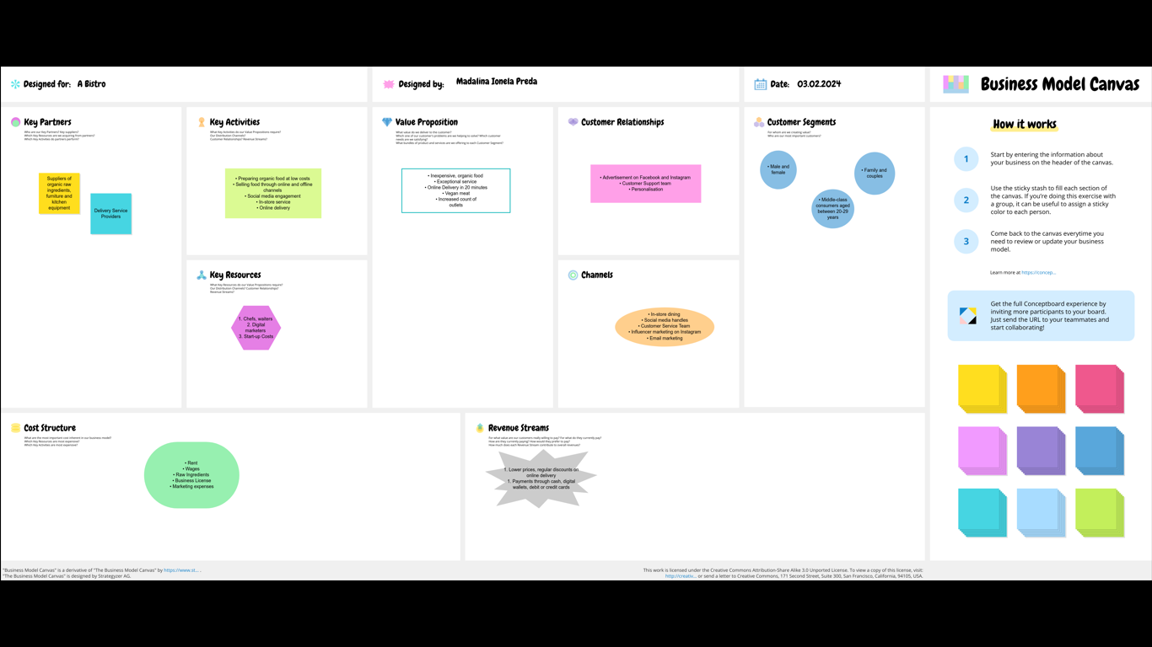

Appendix 2: Test Results


