

Change-makers: Creativity and Value Creation
Professions (BMHP5014)
Component 1: Online portfolio
Student name: Jamila Zakari
Student number: 2322381
Lecturer’s name: Laila Suran

Table of contents
INTRODUCTION
TASK 1: Defining Key Concepts in Practice……….
TASK 2: Mind Map………………………………
TASK 3: Self-Reflection of Group Activity………….
TASK 4: Case Study Analysis of a UK Innovation…
TASK 5: Research Case……………………………….
TASK 6: Exploring Digital Innovation in Health and Social Care….
TASK 7: Understanding the NHS Leadership Framework……………
TASK 8: Self-Reflection Journal Entry ……………………………………
REFERENCES………………………………………………………

Introduction
This online portfolio demonstrates a comprehensive engagement with key module themes, including innovation, creativity, value creation, and change within health and social care. The purpose of this task is to define and critically apply these four interrelated concepts to professional practice. Each concept is supported by relevant academic literature and linked to a recognised mode framework. This discussion will show how these ideas underpin service improvement, leadership, and the development of effective and sustainable health and social care provision.

Task 1: Defining Key Concepts in Practice
innovation
Innovation is the introduction of something new and effective into the world. It is vital in health and social care to address evolving patient needs and resource constraints. For example, the adoption of robotic-assisted surgery allows for faster recovery times and shorter hospital stays. Rogers’ Diffusion of Innovation Theory explains how these current ideas and technologies spread through organisations and are gradually adopted by staff (Rogers, 2003).

Creativity
Creativity is an act of creating new ideas, imagination and possibilities (Amabile 1996). In practice, it allows care providers to develop person-entered interventions that move beyond standardised care, such as using music therapy for dementia patients to improve cognitive engagement.

Value Creation
Value creation in healthcare refers to the improvement of health outcomes that matter to patients compared to the cost of care. This is essential for ensuring the sustainability of services while keeping high-quality standards. An example is the implementation of integrated care systems that reduce diagnostic delays through better data sharing. Porter explains that value in healthcare is created when services improve patient outcomes compared to the cost of delivering care (Porter, 2010).

Change
Change is the transition of individuals or systems from a current state to a desired future state to enhance performance. In social care, change is necessary to adapt to legislative updates or new safeguarding protocols, ensuring that practice stays safe and effective. Lewin’s Change Management Model suggests change occurs through unfreezing current practice, implementing new behaviours, and stabilising the improvement (Burnes, 2017).

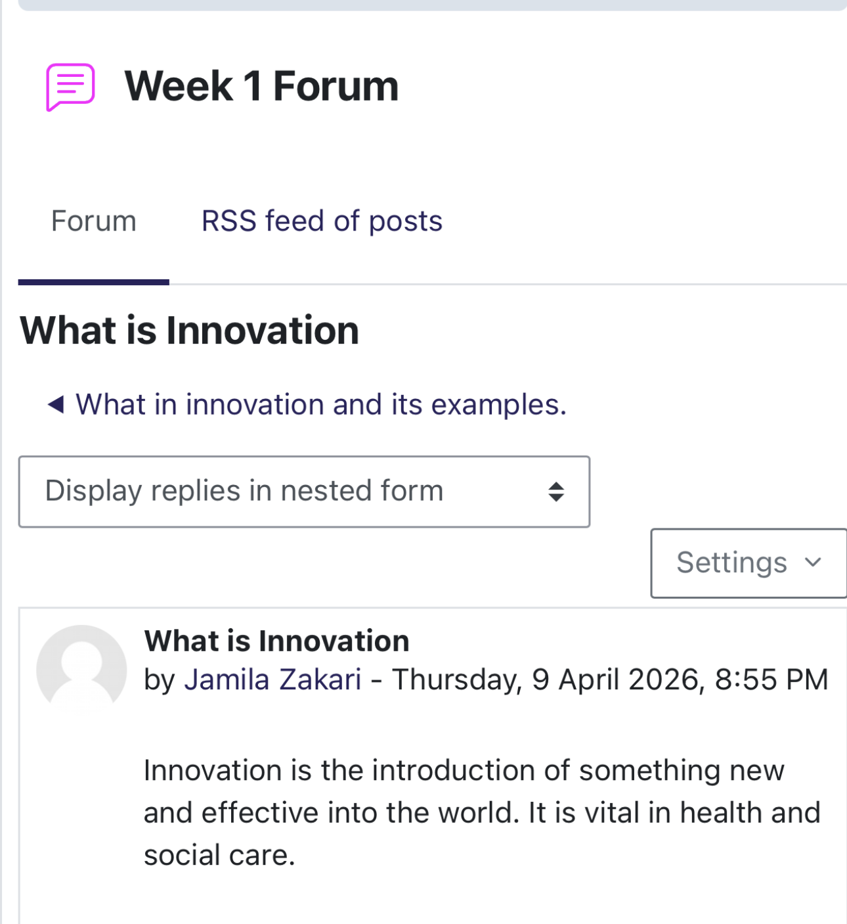

Task 2 - Mind Map

Cardiovascular disease (CVD) is a major public health concern in the London Borough of Newham, where prevalence is still high. This issue is important because untreated CVD increases the risk of heart attacks, strokes and premature mortality while placing significant demand on the National Health Service. The mind map shows interconnected causes, including smoking obesity physical inactivity, hypertension, and diabetes. A systems thinking perspective suggests this risk factors are shaped by wider social determinants such as income environment access to healthy food and health literacy. (Meadows 2008). These interacting factors contribute to higher disease prevalence and poorer outcomes for middle aged adults particularly those aged 40–67. If the issue is not addressed, health inequalities may widen, and healthcare demand may increase. Proposed solutions include NHS health checks, early screening, lifestyle education, weight management support, and community prevention programmes targeting modifiable risk factors.
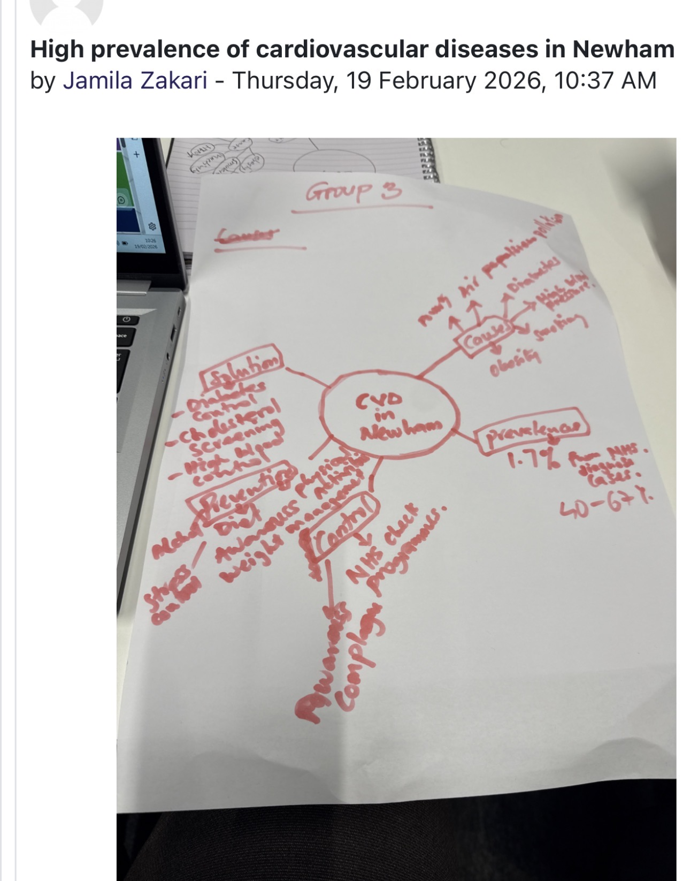
Task 3 - Self-Reflection of Group Activity

This reflection will apply Gibbs’ Reflection cycle(1988) to analyse my experience in the convergent and divergent thinking group activity description. During the activity our group had to generate ideas and then decide on the most suitable solution. Divergent thinking refers to the process of generating a wide range of creative ideas and possibilities, while Convergent thinking focuses on analysing those ideas and selecting the rightest solution(Cropley, 2006). The activity was structured so that we first brainstormed workable solutions before evaluating them as a group.
Feelings
At the beginning, I felt more comfortable using convergent thinking because I tend to prefer structured and logical decision-making. However, during the brainstorming stage I realised that suspending judgement allowed more creative ideas to appear from the group.
Evaluation
A key moment occurred when our group struggled to agree on the best idea. I suggested that we create a simple pros and cons list for each choice. This approach helped us apply convergent thinking by critically evaluating the ideas produced during the divergent stage.

Analysis
This experience helped me recognise that my natural tendency is to move quickly towards evaluating ideas rather than exploring a broad range of possibilities. However, effective teamwork requires both thinking styles, as divergent thinking encourages creativity while convergent thinking supports logical decision-making.
Action
Overall, I learned that balancing creativity with structured evaluation improves group Problem-solving. In future activities, I would challenge myself to contribute more ideas during the divergent stage before moving too quickly towards selecting a solution.

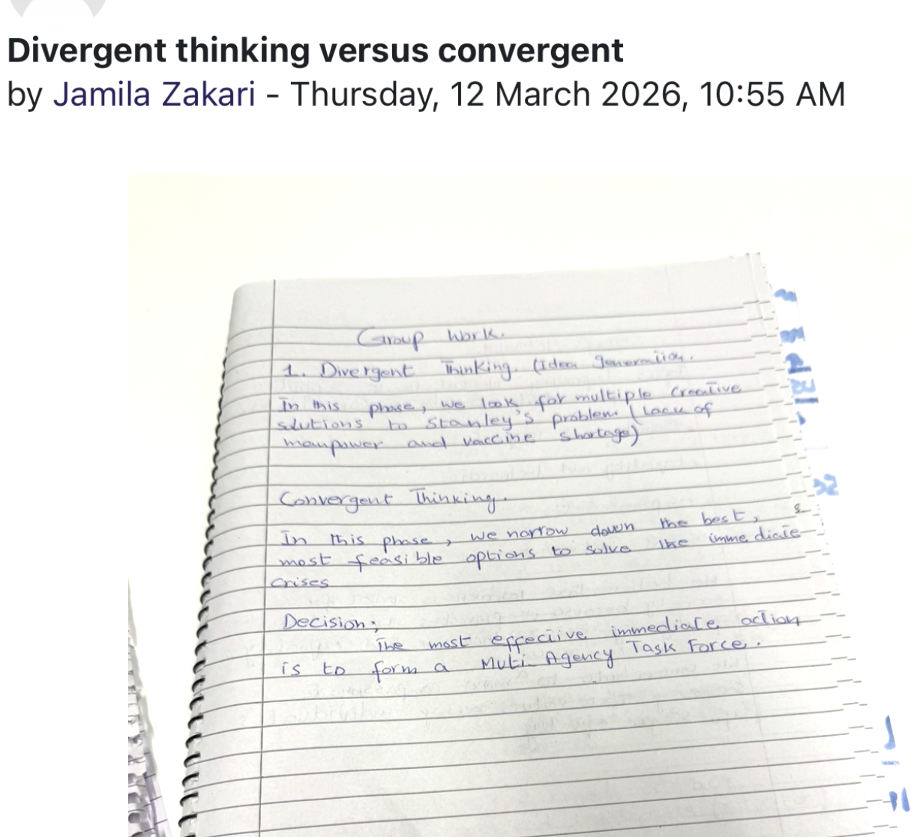

Task 4 – Case Study Analysis of a UK Innovation
A key innovation within the NHS is the development of virtual wards, which allow patients to receive hospital-level care at home through remote monitoring technologies.
Problem
The NHS has faced increasing pressure due to rising patient demand, limited hospital beds, and long waiting times. Many patients, particularly those with frailty or respiratory conditions, require close monitoring but do not always need to remain physically in the hospital. Virtual wards were introduced to support earlier discharge and prevent unnecessary admissions while keeping safe and effective care (NHS England, 2023).
Creativity in the Solution monitoring devices, mobile applications, and regular remote clinical reviews. This approach reimagines the traditional hospital ward by moving care from hospital settings into patients’ homes. According to Rogers’ Diffusion of Innovation Theory, innovative ideas are adopted when they are perceived as beneficial, practical, and compatible with existing systems (Rogers, 2003). Virtual wards align with this theory by providing a practical solution that improves care delivery while staying manageable for healthcare staff.
Value
Virtual wards create value for patients, staff, and the healthcare system. Patients receive help from receiving care in a familiar home environment, which can improve comfort and recovery. Evidence from NHS evaluations shows that virtual wards can reduce hospital admissions and shorten hospital stays while keeping elevated levels of patient satisfaction (NHS England, 2023; NHS Confederation, 2023). Additionally, the model helps reduce pressure on hospital resources and improves system efficiency.
Overall, NHS virtual wards show how creative use of digital technology can transform healthcare delivery and provide scalable solutions for managing increasing demand within the health system.

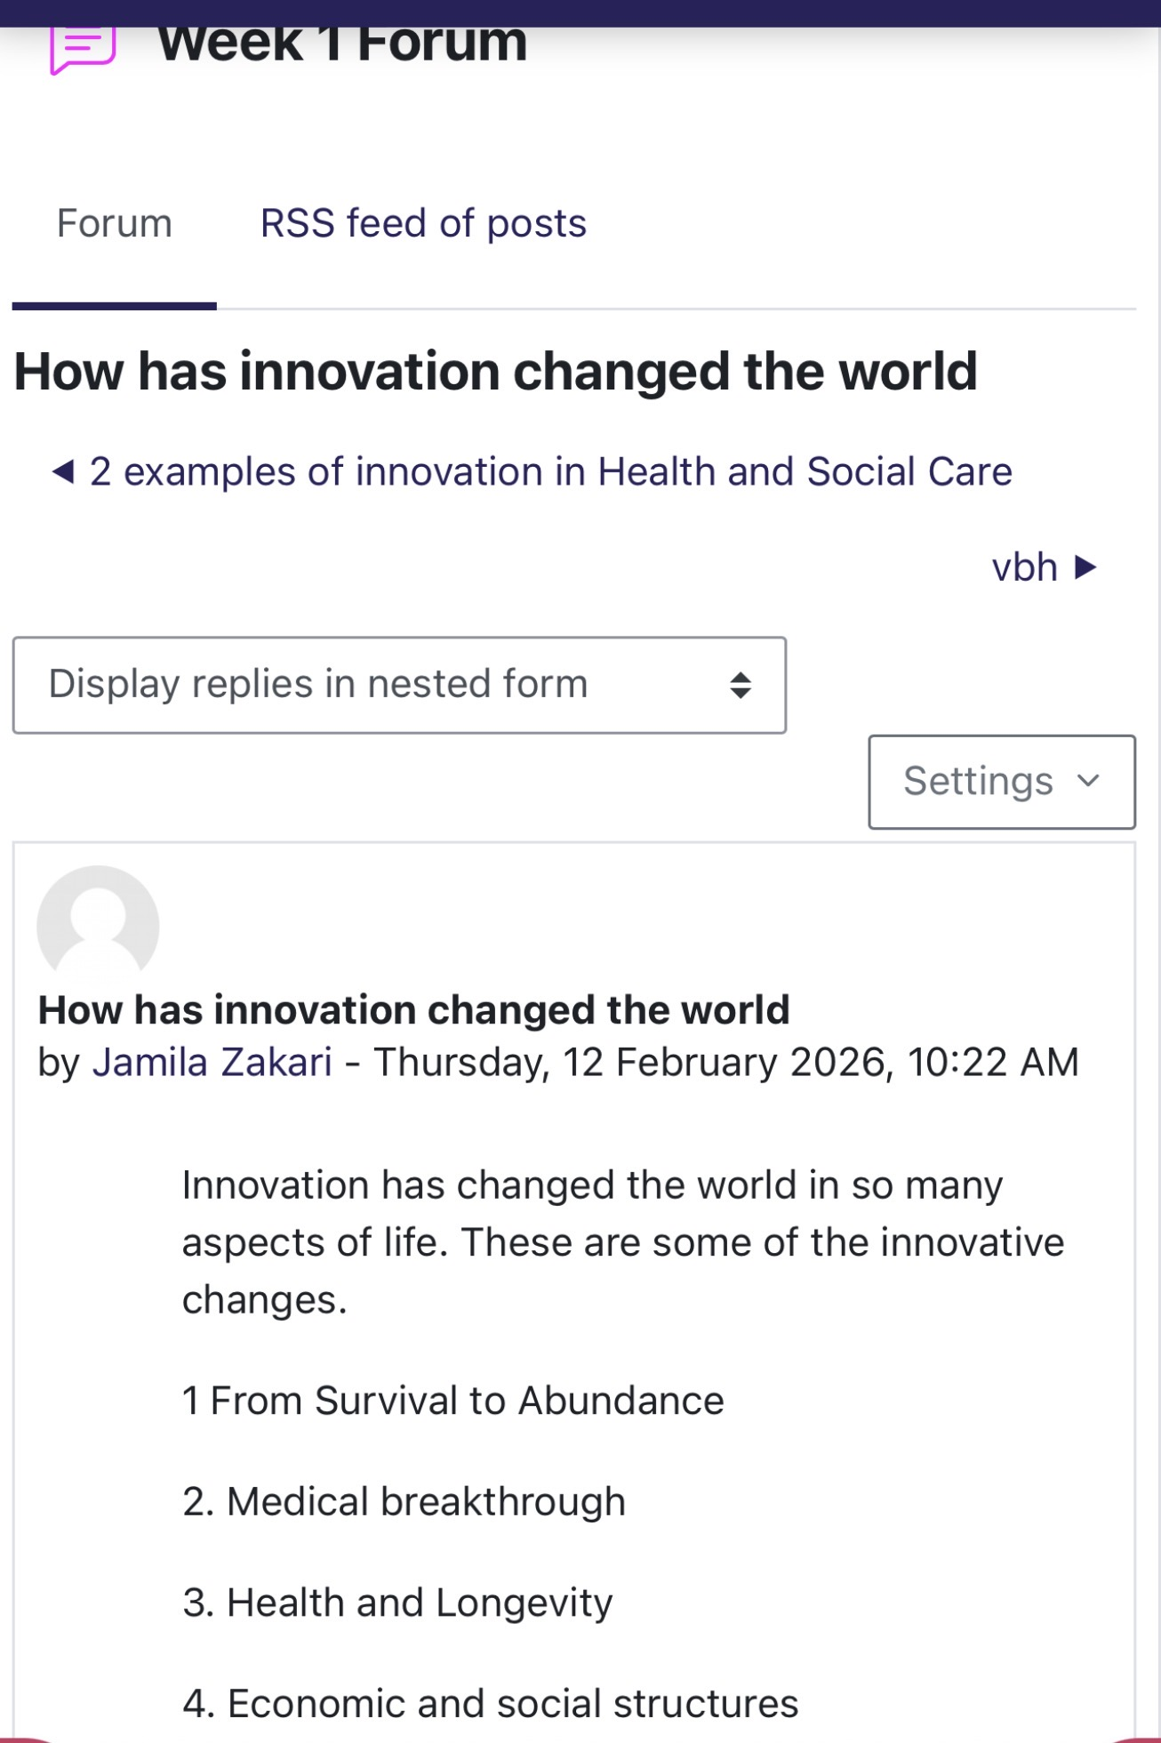

Task 5 - Research Task
A significant current issue within the NHS is increasing staff stress and burnout, which can affect staff wellbeing, patient safety, and service quality. Research shows that several organisational and emotional factors contribute to this problem in healthcare settings.
One important explanation is provided by Christina Maslach and Michael Leiter, whose research on burnout finds three key dimensions: emotional exhaustion, depersonalisation and reduced personal accomplishment (Maslach and Leiter, 2016). Their work suggests that high workload, limited control over work, and lack of organisational support are major causes of burnout among healthcare staff. This framework helps explain why staff working in busy hospital environments often experience chronic stress when staffing levels are low and demand is high.
Similarly, West et al. (2018) examined workplace conditions in healthcare organisations and found that leadership style, workload pressure and workplace culture strongly influence staff wellbeing. Their research highlights that when healthcare organisations lack supportive leadership and adequate staffing, stress levels increase and staff engagement declines.
Both studies agree that staff stress is caused by systemic organisational pressures rather than individual weakness. However, Maslach and Leiter focus more on the psychological experience of burnout, while West et al. emphasise organisational and leadership factors. In real healthcare settings, this issue appears through staff shortages, increased sickness absence, and reduced morale. Understanding these causes is important for developing strategies such as supportive leadership, improved staffing levels, and wellbeing programmes to reduce burnout and improve care quality

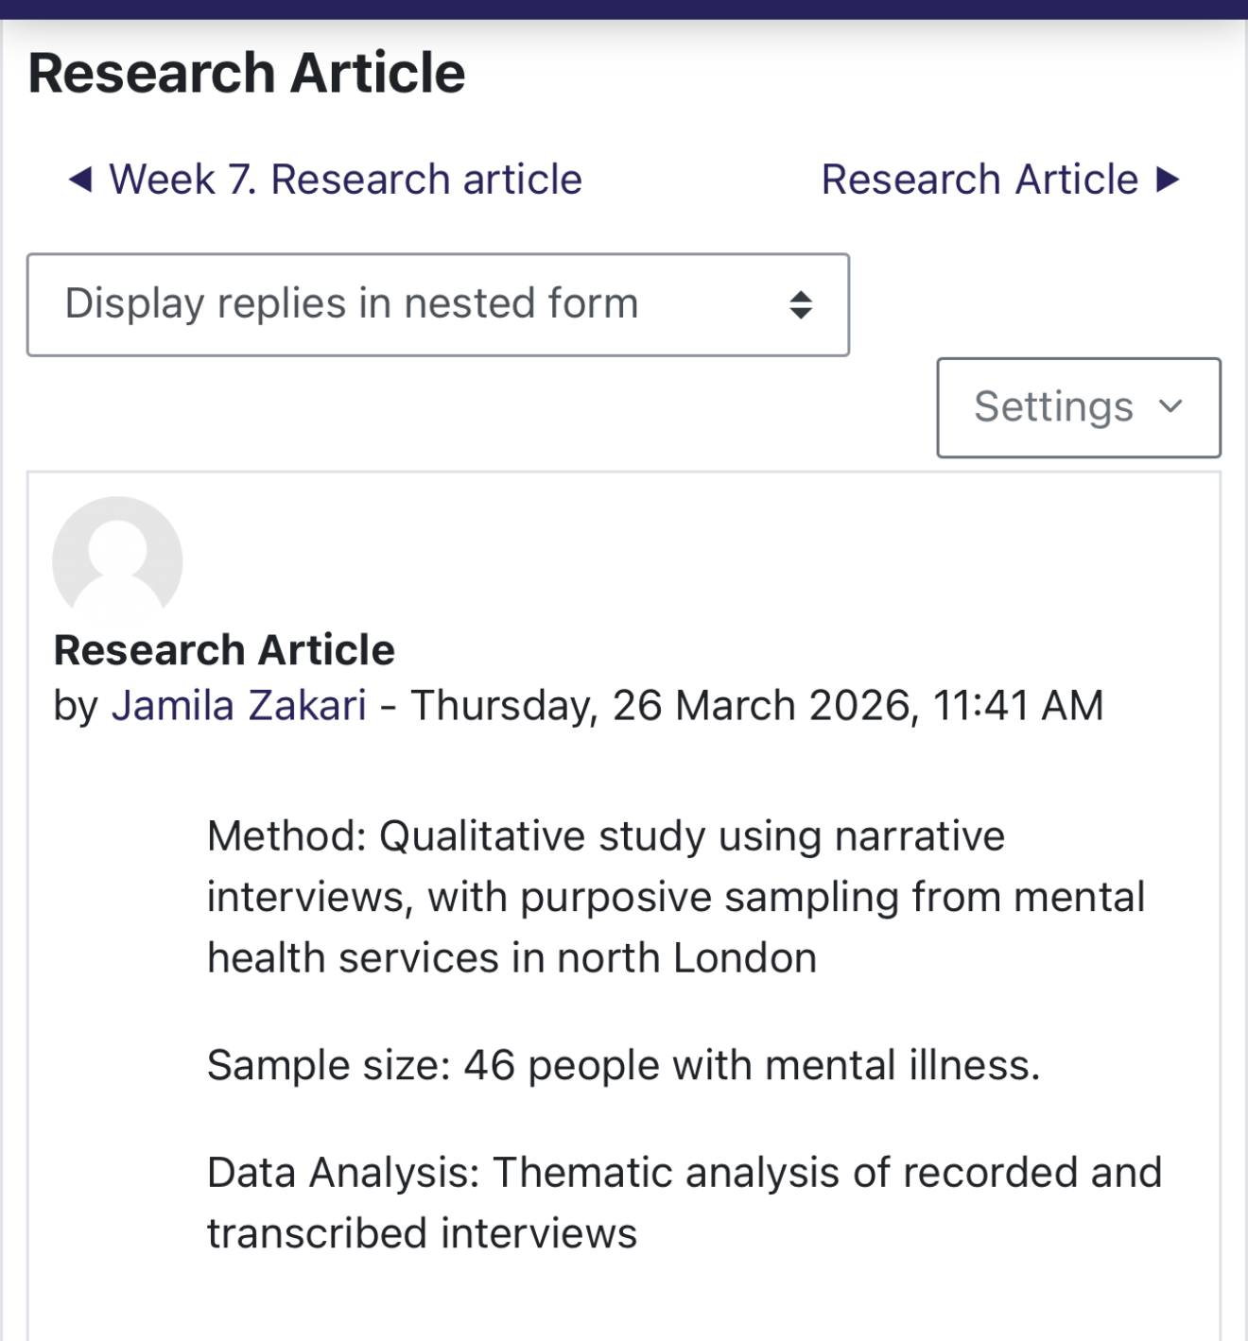

.

Task 6 Exploring Digital Innovation in Health and Social Care
Benefit of Wearable Health Technologies in Managing Chronic Conditions
Wearable technologies, such as smartwatches and fitness trackers, support the management of chronic conditions by enabling continuous monitoring of health indicators like heart rate and sleep. This allows early detection of issues, such as Atrial Fibrillation, leading to quicker intervention and improved outcomes. They also encourage patients to take an active role in their health while providing clinicians with real-time data (Piwek et al., 2016). Their ease of use and usefulness support adoption, as explained by the Technology Acceptance Model (Davis, 1989).

How Electronic Health Records Improve Communication
Electronic Health Records (EHRs) store and share patient information digitally, improving communication between healthcare professionals. This is especially important in systems like the NHS, where patients receive care from multiple providers. EHRs reduce errors, improve patient safety, and support better decision-making by providing instant access to accurate data (Buntin et al., 2011). Their perceived usefulness also increases adoption (Davis, 1989).
Digital Technology for Preventative Care and Health Promotion
Digital technologies, including mobile apps and online platforms, support preventative care by promoting healthy behaviours and early intervention. For example, the NHS App allows users to manage appointments and access health information. These tools make healthcare more accessible and encourage engagement in preventative behaviours (Sántha, 2018). According to the Technology Acceptance Model, adoption is higher when tools are user-friendly and beneficial (Davis, 1989).
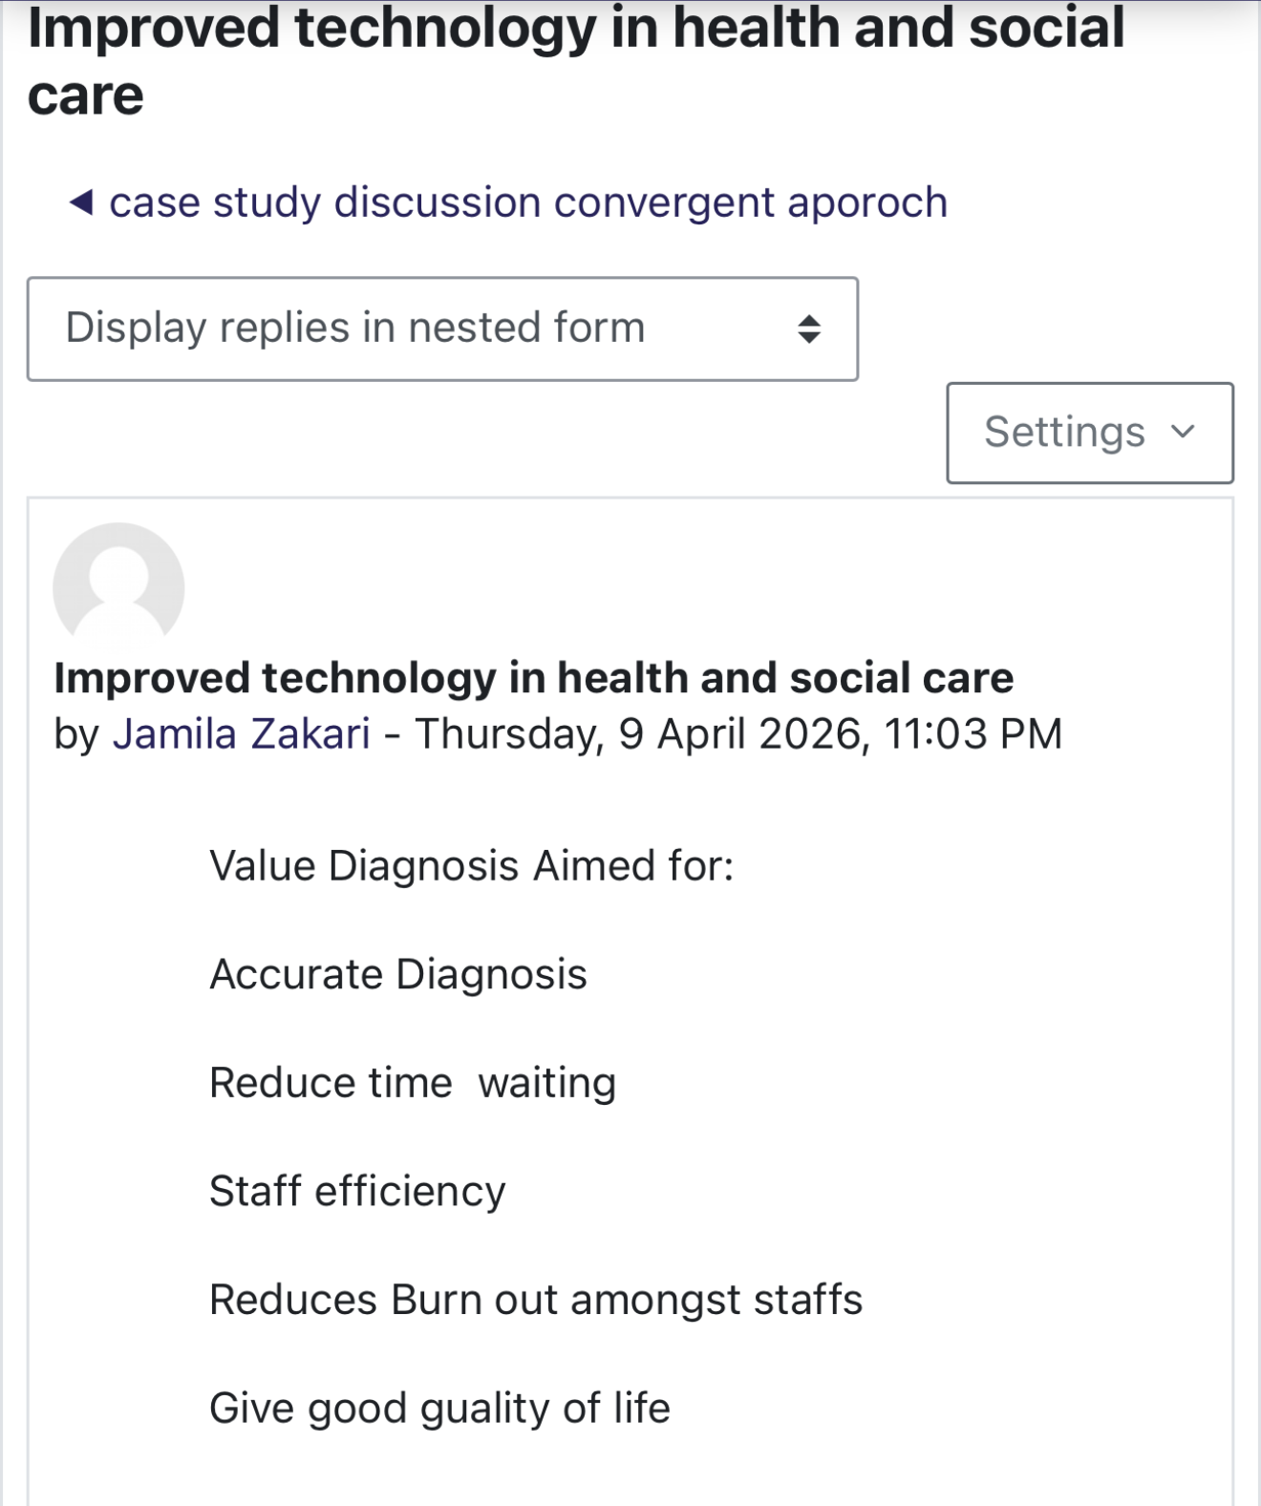

Task 7 - Understanding the NHS Leadership Framework
NHS Leadership Framework
The NHS Leadership Framework outlines essential leadership behaviours for delivering high-quality care. These include inspiring shared purpose, leading with care, evaluating information, engaging teams, and driving improvement (NHS Leadership Academy, 2013). Effective leadership improves staff performance, patient safety, and service quality by promoting teamwork, communication, and innovation. Positive leadership is linked to better staff engagement and patient outcomes (West et al., 2015), helping professionals manage change and deliver person-centred care.
Leadership Behaviour
Inspiring shared purpose involves motivating staff by linking their roles to meaningful patient outcomes. This reflects transformational leadership, which focuses on inspiring teams to achieve change (Bass and Avolio, 1994). For example, involving staff in developing solutions to reduce waiting times can encourage innovation and improve service delivery.

Reflective Journal Entry
This module has broadened my understanding of creativity and value creation in healthcare. I now recognise creativity as vital for improving services, not just as an artistic concept. Activities such as group work on thinking styles and innovation case studies showed how creative ideas and structured evaluation work together. I also learned the importance of leadership and organisational culture in supporting innovation. In future practice, I aim to apply collaborative and innovative approaches to improve patient experience, staff wellbeing, and service quality.
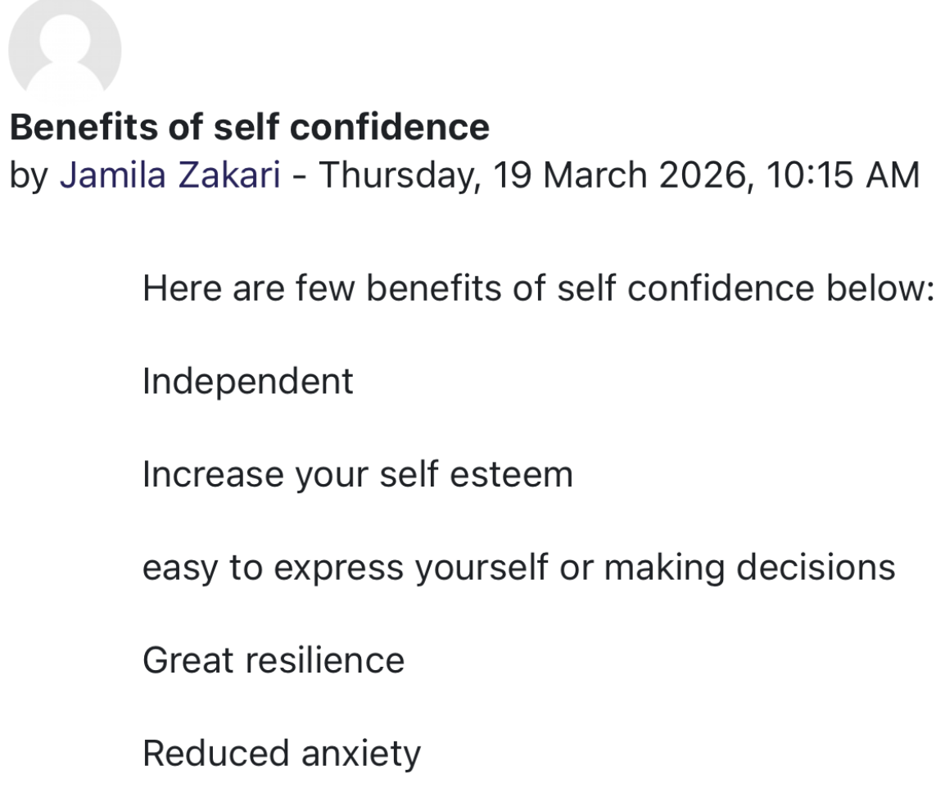

Task 8 – Self-Reflection Journal Entry

This reflection uses Kolb's Experiential Learning Cycle to evaluate my learning about creativity, innovation and value creation in health and social care. At the start of the module, creativity was related to artistic thinking. However, the convergent and divergent thinking activity helped me understand how creativity supports problem-solving and service improvement in healthcare. Reflecting on this experience helped me recognise the importance of generating ideas before evaluating solutions. According to Kolb (1984), learning develops through experience and reflection. In future placements, I will apply creative thinking and reflective practice to contribute to innovative ideas that improve patient care and service delivery.

References
Amabile, T. M. (1996). Creativity in Context. Westview Press
.
Burnes, B. (2017). Managing Change. 7th edn. Pearson Education.
Buntin, M., Burke, M., Hoaglin, M. and Blumenthal, D. (2011) ‘The benefits of health information technology: a review of the recent literature’, Health Affairs, 30(3), pp. 464–471.
Bass, B.M. and Avolio, B.J. (1994) Improving Organizational Effectiveness Through Transformational Leadership. Thousand Oaks: Sage.
Cropley, A. (2006). In Praise of Convergent Thinking. Creativity Research Journal, [online] 18(3), pp.391–404. doi:https://doi.org/10.1207/s15326934crj1803_13.
‌
Buntin, M., Burke, M., Hoaglin, M. and Blumenthal, D. (2011) ‘The benefits of health information technology: a review of the recent literature’, Health Affairs, 30(3), pp. 464–471.
Davis, F.D. (1989) ‘Perceived usefulness, perceived ease of use, and user acceptance of information technology’, MIS Quarterly, 13(3), pp. 319–340.
Gibbs, G. (1988). Learning by doing: a Guide to Teaching and Learning Methods. Programmed Learning & Educational Technology, 25(2).
‌

Meadows D 2008 Thinking in Systems A Primer White River Junction Chelsea Green Publishing
Kolb, D.A. (1984) Experiential Learning: Experience as the Source of Learning and Development. New Jersey: Prentice Hall.
Maslach, C. and Leiter, M.P. (2016) Burnout. In: Fink, G. (ed.) Stress: Concepts, Cognition, Emotion and Behaviour. London: Academic Press.
NHS England (2023). NHS England. [online] England.nhs.uk. Available at: https://www.england.nhs.uk.
‌NHS Confederation (2023) Realising the potential of virtual wards. Available at: https://www.nhsconfed.org(Accessed: 11 March 2026).
NHS Leadership Academy (2013) The Healthcare Leadership Model. London: NHS Leadership Academy.
‌Piwek, L., Ellis, D., Andrews, S. and Joinson, A. (2016) ‘The rise of consumer health wearables’, PLOS Medicine, 13(2).
Porter, M. E. (2010). What is value in health care? New England Journal of Medicine, 363(26), pp. 2477-2481.
Rogers, E. (2003) Diffusion of Innovations. 5th edn. New York: Free Press.
West, M., Dawson, J., Admasachew, L. and Topakas, A. (2018) NHS staff management and health service quality. London: The King’s Fund.
West, M., Eckert, R., Collins, B. and Chowla, R. (2015) Caring to Change: How Compassionate Leadership Can Stimulate Innovation in Health Care. London: The King’s Fund.
Sántha, Á. (2018). Deborah Lupton: Digital Health. Critical and Cross-Disciplinary Perspectives. Acta Universitatis Sapientiae, Social Analysis, 8(1), pp.109–112. doi:https://doi.org/10.2478/aussoc-2018-0007.
.

