Electronics II Assignment –
Critical Evaluation of Braun’s Multiplier and Wallace Tree Multiplier Using VHDL

Corey Taylor - 1708443

BEng Electrical and Electronic Engineering - ACDA6002

Wales Institute for Science and Art
University of Wales Trinity Saint David



Lecturer : Jenifer Prince Devaraj Submission Deadline : 15.01.2024
Contents
Introduction 3
Background Research 3
Array Multipliers: - 3
Half adder: - 4
Full adder: - 5
Braun Multiplier: - 6
Wallace Multiplier: - 7
Booth Multiplier: - 8
What is VHDL? 8
Task 1 – Braun’s Multiplier 9
System Operation Flowchart: - 10
Braun’s Multiplier Circuit Diagram: - 11
Braun Multiplier Vivado simulation and screenshots: - 12
Task 2 – Wallace Tree Multiplier 19
Dot Diagram: - 19
Wallace Tree Multiplier Circuit Diagram: - 20
Wallace Tree Multiplier Vivado simulation and screenshots: - 20
Task 3 28
Braun’s multiplier longest delay: - 29
Wallace Tree multiplier longest delay: - 30
Longest delay comparison: - 31
Power consumption and comparison: - 33
Further recommendations: - 35
Conclusion 35
References 36
Appendices 37
1. Braun Multiplier Code 37
2. Wallace Tree Multiplier Code 48

Introduction
Digital circuit multipliers are fundamental components of various digital signal processing and computer arithmetic applications.
This report investigates the uses of Braun’s and Wallace Tree Multipliers and provide insight into the strengths and weaknesses of the multipliers. Employing VHDL as the chosen programming language and Xilinx Vivado software for code writing and synthesis, the report aims to give a deeper understanding of their applicability and efficiency in digital circuit design.
The primary objective is to create, synthesize and conduct a thorough comparative analysis and critical evaluation on Braun’s and Wallace Tree Multipliers through 8-bit versions of each, assessing the performance attributes of these two multiplication techniques.

Background Research

Array Multipliers: -
An array multiplier is a combinational digital circuit used to multiply 2 binary numbers together by employing an array of full and half adders. The array is used for the addition of each of the product terms involved. To form the terms, an array of ‘AND’ gates is used. [1] [2]
What is an Adder?
An adder is a digital logic circuit in electronics used for the addition of numbers. In many computers and other types of processors, adders are used to calculate addresses and related activities. These can be built for many numerical representations, such as excess-3 or binary coded decimal. Adders are basically classified into two types: Half Adder and Full Adder.
What are Half Adder and Full Adder Circuits?

Half adder: -
A half adder circuit has two inputs – A & B, which add two binary input digits to result in two outputs, known respectively as a ‘carry’ and a ‘sum’. The ‘sum’ operation is performed by applying XOR to both inputs, and an AND gate is applied to both inputs to generate a ‘carry’ operation.
Simple addition can be carried out with the help of logic gates in the form of half adders.
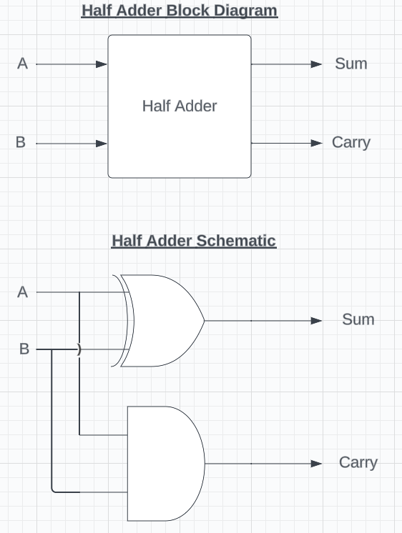
- Block diagram and schematic of a Half adder created using ‘Lucid Chart’.
Half adder truth table: -
INPUTS |  | OUTPUTS
A | B | SUM | CARRY
0 | 0 | 0 | 0
0 | 1 | 1 | 0
1 | 0 | 1 | 0
1 | 1 | 0 | 1
[3]

Full adder: -

The main difference between a half adder and a full adder is that a full adder circuit has three inputs – A, B & C-in, which add three binary input digits to again, generate a ‘carry’ and a ‘sum’. The output produced is a 2-bit output and these are referred to as ‘output carry’ and ‘sum’. The full adder is more complex than the half adder, and therefore extra steps are needed to implement them.

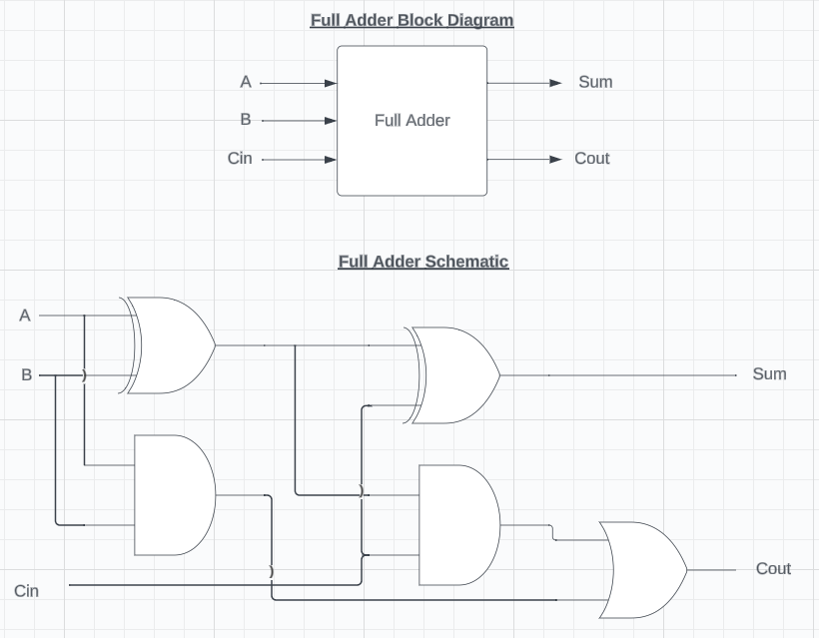
- Full adder block diagram and schematic created using ‘Lucid Chart’. The full adder contains a third output, ‘C-in’, and incorporates two Half adders in its circuit.
Full adder truth table: -
INPUTS |  |  | OUTPUTS
A | B | C-IN | C-OUT | SUM
0 | 0 | 0 | 0 | 0
0 | 0 | 1 | 0 | 1
0 | 1 | 0 | 0 | 1
0 | 1 | 1 | 1 | 0
1 | 0 | 0 | 0 | 1
1 | 0 | 1 | 1 | 0
1 | 1 | 0 | 1 | 0
1 | 1 | 1 | 1 | 1
[4]
In a multiplier, using Half and Full adders, a sequential operation of micro-operations is performed to check the bits of the array, one at a time. Using a multiplier is a quick way of multiplying two numbers, as all it takes is the time for the signals to transmit through the AND gates in the array. [5]
There are several types of multipliers, some of which are discussed below.

Braun Multiplier: -
In the world of digital circuits, the Braun multiplier is considered a noteworthy approach for the multiplication of binary numbers. This multiplier stands out for its simplicity relying on a network of switches and wires to streamline the multiplication process. This simplicity makes Braun multipliers particularly well suited for applications where resource efficiency is paramount. They find practical use in scenarios demanding low power consumption, such as in embedded systems and devices operating under stringent resource constraints. The Braun multiplier’s design represents a strategic choice in situations where computational efficiency must be balanced with minimal hardware complexity. [6]
Below is a table containing some advantages and disadvantages of Braun multipliers in digital circuits: -
Advantages | Disadvantages
Low hardware complexity | Limited scalability for large operands
Simplicity in design and implementation | Slower performance compared to other multipliers
Lower power consumption | Increased latency for certain operand sizes
Reduced area requirements | Can be less efficient for certain types of data patterns
Ease of integration into digital systems | Limited flexibility with operand sizes
Well-suited for small to medium sized operands | Less common in modern high-performance processors
Cost-effective for specific applications
[7]

Wallace Multiplier: -
A Wallace multiplier is a sophisticated digital circuit that performs the task of multiplying binary numbers in a highly efficient manner. Instead of following the conventional approach, it incorporates a tree-like structure composed of adders and compressors. This arrangement minimizes the generation of partial products during multiplication, significantly enhancing both speed and overall computational efficiency. By adopting the Wallace multiplier architecture, digital systems can perform multiplication operations swiftly and with reduced complexity compared to traditional methods. This design proves particularly beneficial in fields like digital signal processing (DSP) and arithmetic-intensive applications, contributing to improved performance in tasks such as communication systems and image processing. [8] [9]
Below is a table containing some advantages and disadvantages of Wallace tree multipliers: -

Advantages | Disadvantages
Higher performance compared to Braun multipliers | Higher hardware complexity
Improved scalability for larger operands | Increased power consumption
Efficient for parallel multiplication | Larger area requirements
Reduced latency for certain operand sizes | Complex in design and implementation
Suitable for high-speed multiplication | Higher cost in terms of hardware resources
Better efficiency for specific data patterns | May not be as cost-effective for certain applications
Commonly used in high performance processors
[7]

Booth Multiplier: -
A Booth Multiplier is another type of digital circuit used for binary multiplication. This method involves using a technique known as ‘Booth encoding’, which identifies sequences of consecutive identical bits in the multiplier and replaces them with special codes. This results in fewer operations compared to some other common types of multipliers. The Booth multiplying method improves speed significantly and reduces the complexity of the multiplication process, its applications commonly include DSPs and GPUs, as well as other various embedded systems where fast multiplication is essential. [10]

What is VHDL?
VHDL, or ‘VHSIC (Very High-Speed Integrated Circuit) Hardware Description Language’, is a standardized programming language used for the description, simulation, and synthesis of digital circuits. Developed by the U.S. Department of Defence in the 1980s, VHDL has become a vital tool in the field of electronic design.
VHDL’s primary purpose is to facilitate the design of digital systems, including integrated circuits and FPGAs (Field Programmable Gate Arrays). VHDL allows engineers to model complex digital circuits, simulate their behaviour, and then synthesize them into actual hardware.
One of the major advantages of using VHDL is that it is specifically designed for hardware description, making it well suited for describing and simulating digital circuits. Other, more general-purpose programming languages such as Java or Python are designed with more broader applications in mind, such as data analysis or software development. VHDL’s focus on hardware description allows engineers to efficiently capture the structure and behaviour of hardware systems. VHDL does however have a steeper learning curve compared to some other hardware description languages, which can be seen as a drawback. Despite this, VHDL is still a widely used language in the world of digital design and FPGA programming.
In VHDL, hexadecimal notation is preferred over binary for its conciseness and readability. Hexadecimal is more compact and easily converted into binary. Its use aligns with common programming methods and facilitates compact code. Hexadecimal has other advantages over binary, such as aligning with memory address conventions and simplifying grouping bits in vectors, enhancing overall use in hardware description. [11] [12]

Task 1 – Braun’s Multiplier
Task 1 requires the design of an 8-bit Braun’s Multiplier. The multiplier below is designed by modifying any two unsigned numbers and is used to generate partial products by multiplying bits A & B and adding together the results of the partial products.
The report also contains a logic circuit design for Braun’s multiplier, which is then implemented in VHDL and the full multiplier built using port maps in Xilinx Vivado.
The multiplier is then simulated in Vivado and its schematic and results are obtained and evaluated. The multiplier is finally synthesized, and timings/power usages are determined and observed.
- For code, see Appendix 1.

System Operation Flowchart: -

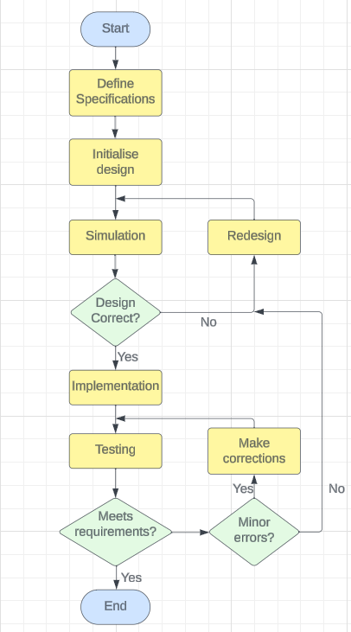

The above flowchart shows the process for designing and carrying out operations of the Braun multiplier in Vivado. This process was repeated in Task 2 when designing the Wallace Tree Multiplier (See Task 2). [13]

Braun’s Multiplier Circuit Diagram: -

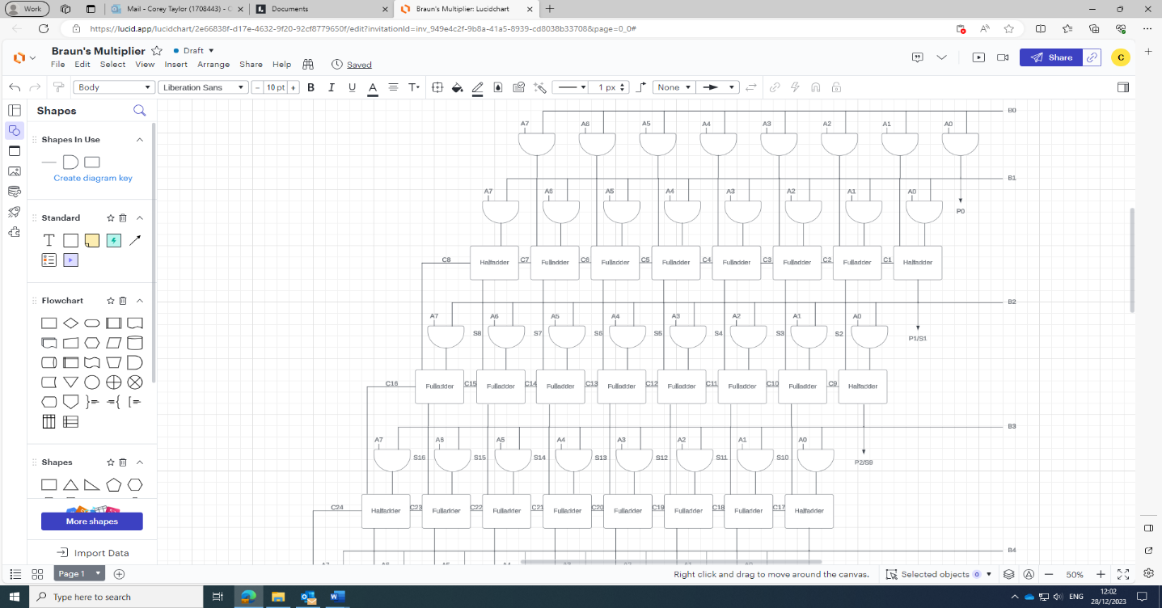
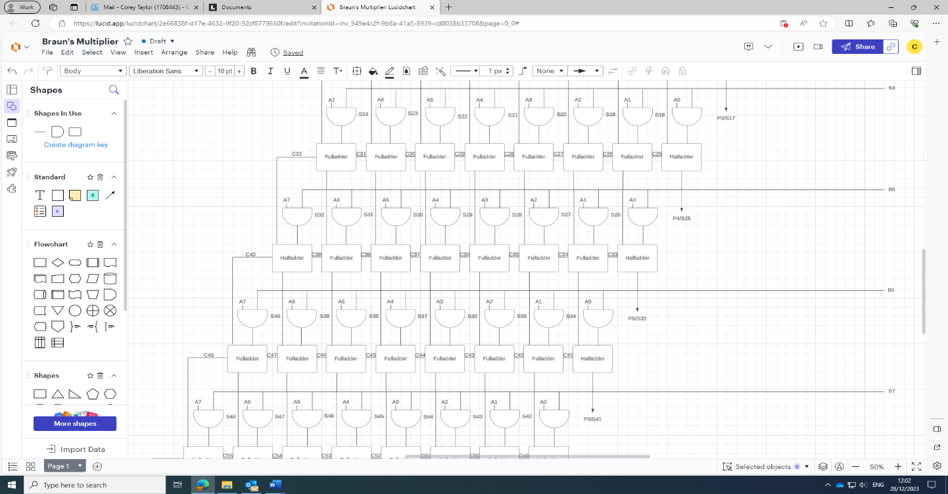
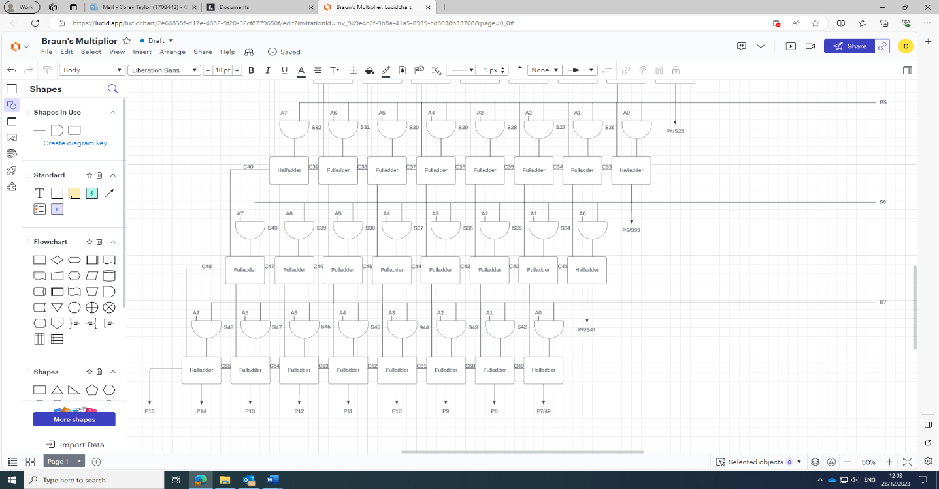

The above image shows the circuit diagram for an 8-bit Braun’s multiplier logic circuit diagram, created using ‘Lucid Chart’. The circuit diagram contains a combination of Half and Full adders in sequence to create the multiplier. [13]

Braun Multiplier Vivado simulation and screenshots: -
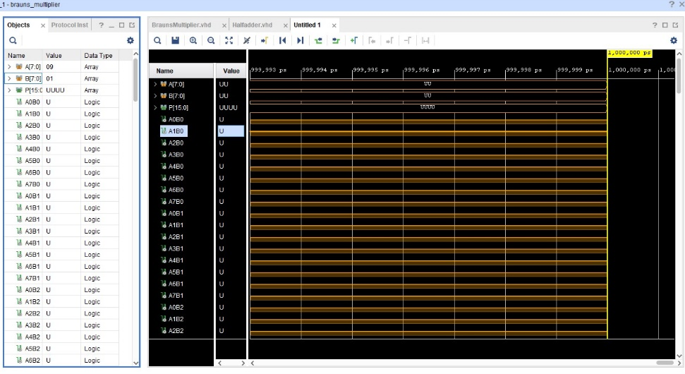
Screenshot of initial design simulation.
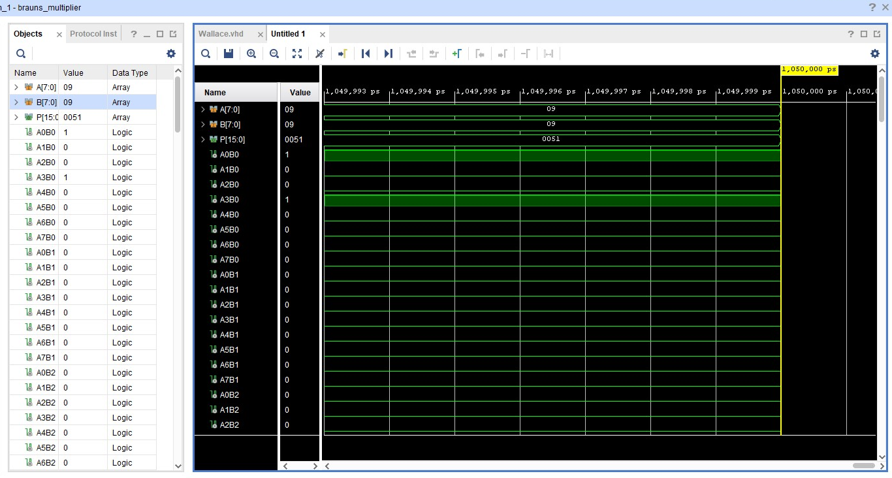
Design simulation with clocks forced to 1/0 and constant forced to 9.

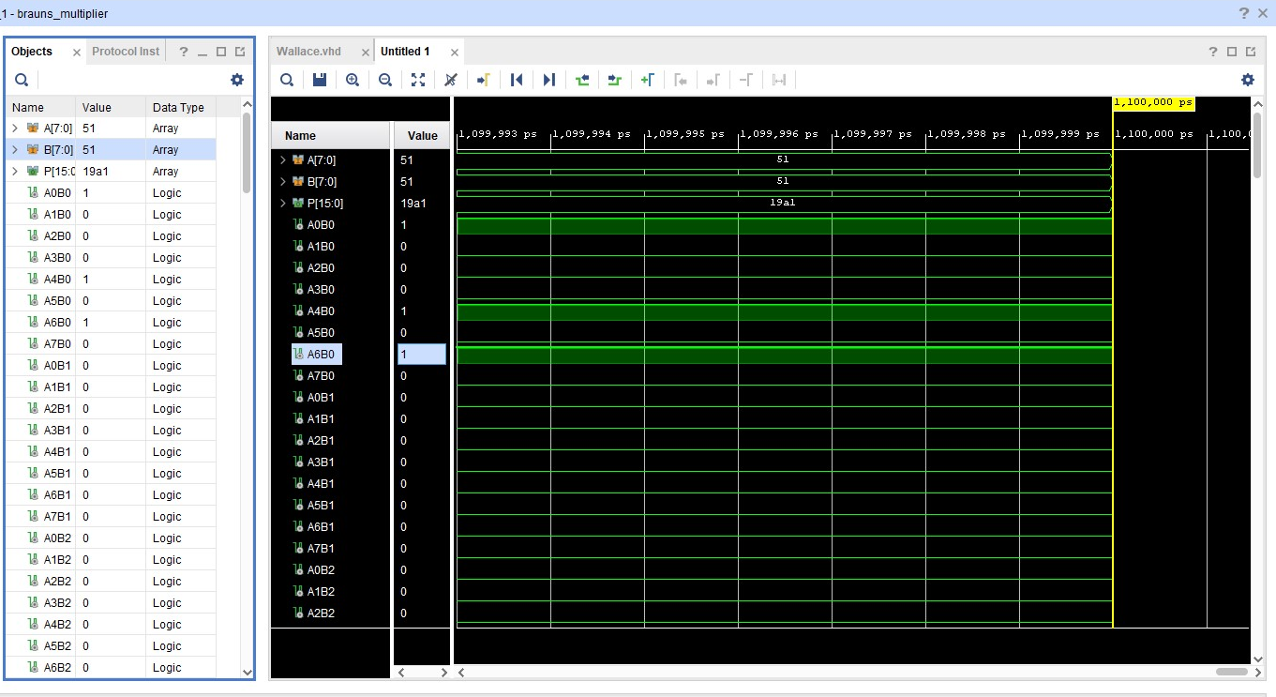
Design simulation with clocks forced to 1/0 and constants forced to 51.
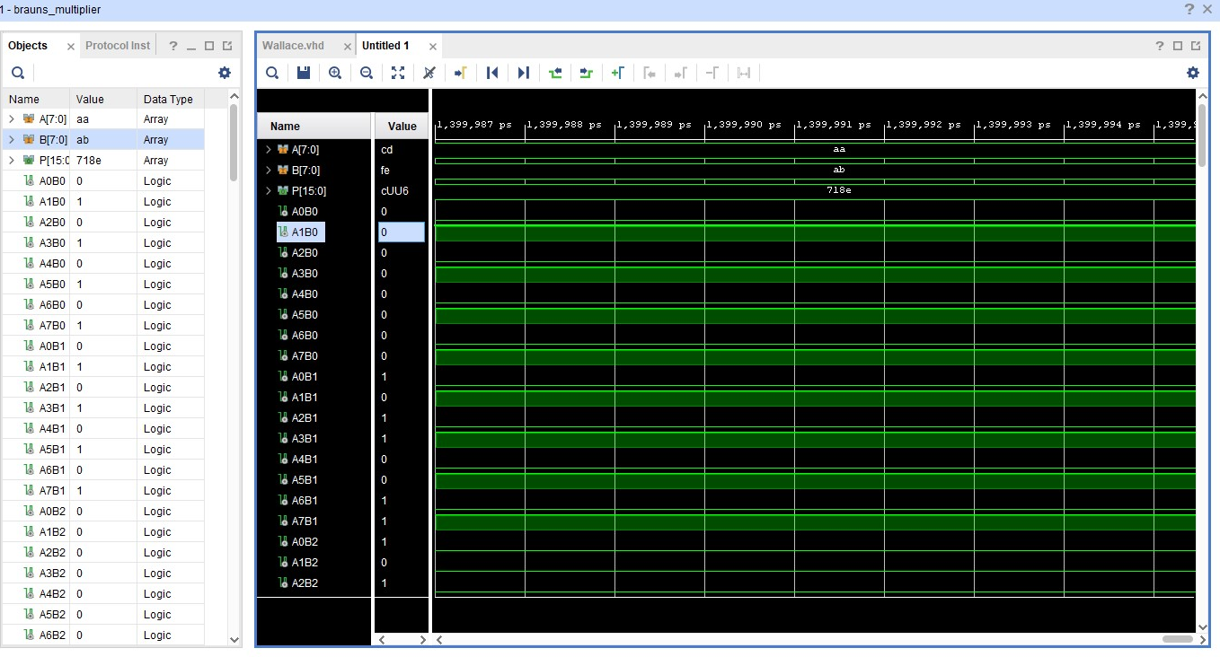
Design simulation with clocks forced to 1/0 and constants forced to aa/ab.

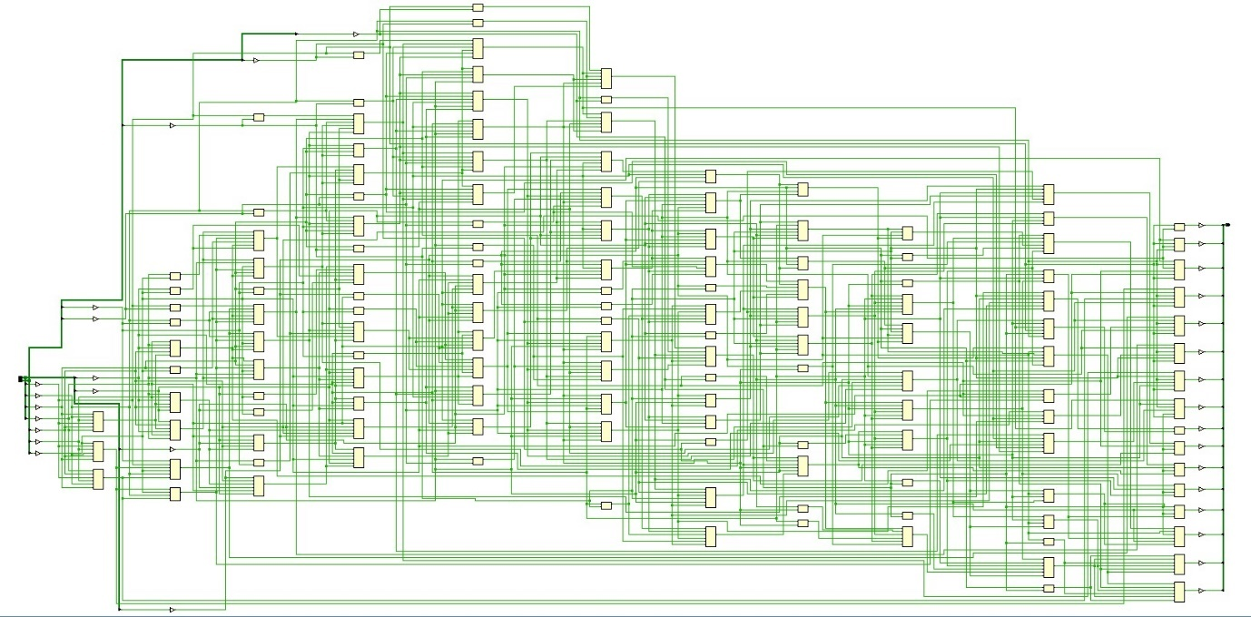
Design schematic
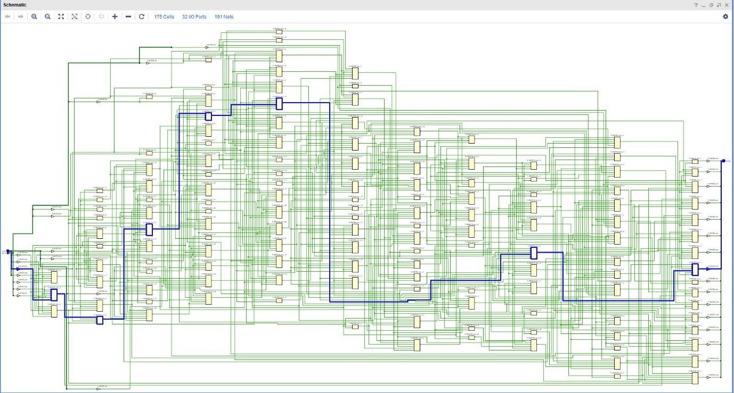
Critical path
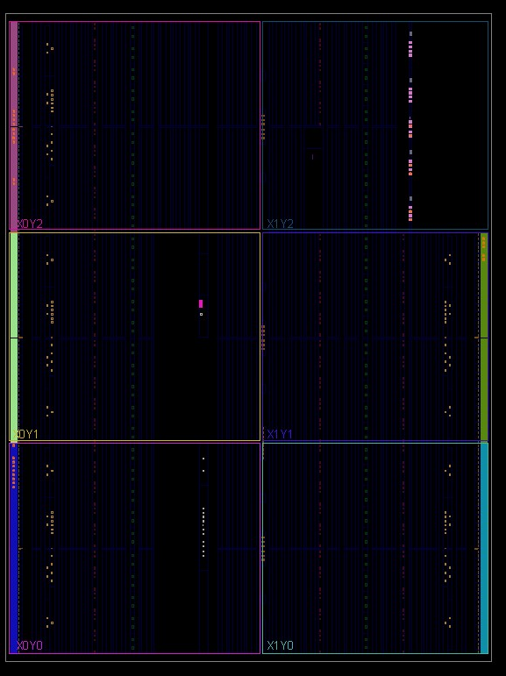
Synthesized design/device view
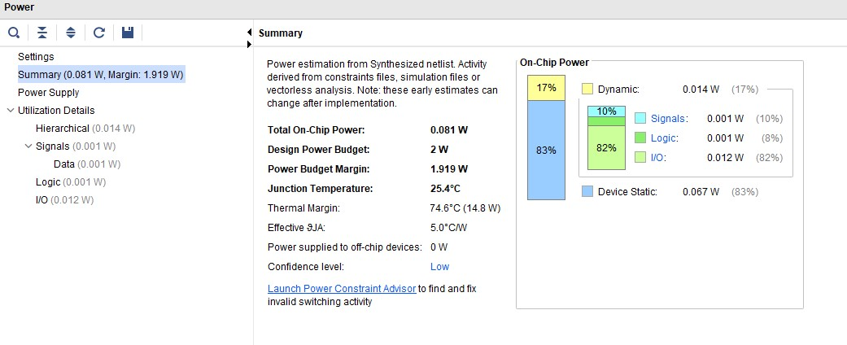
Power Usage
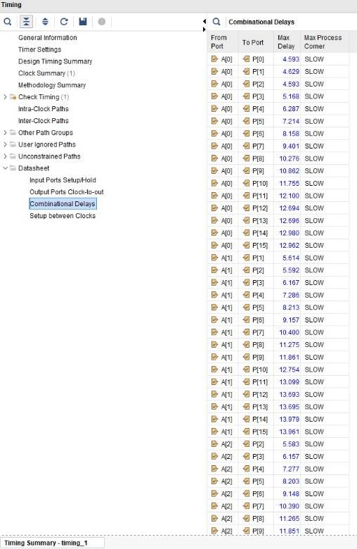
Timing
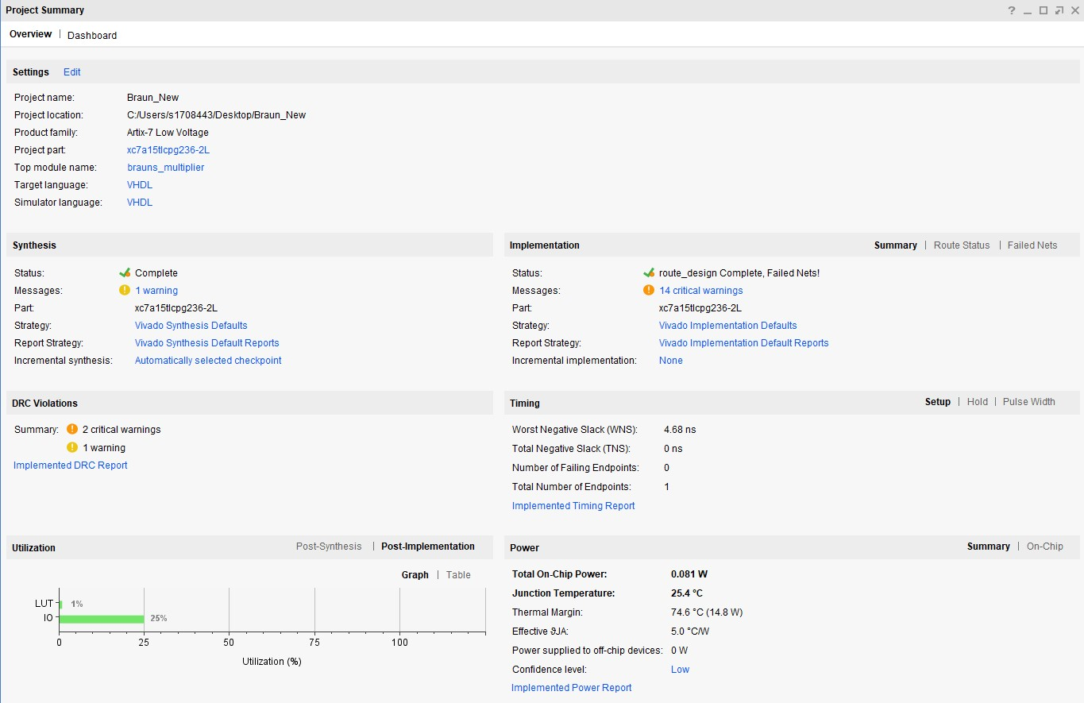
Project summary
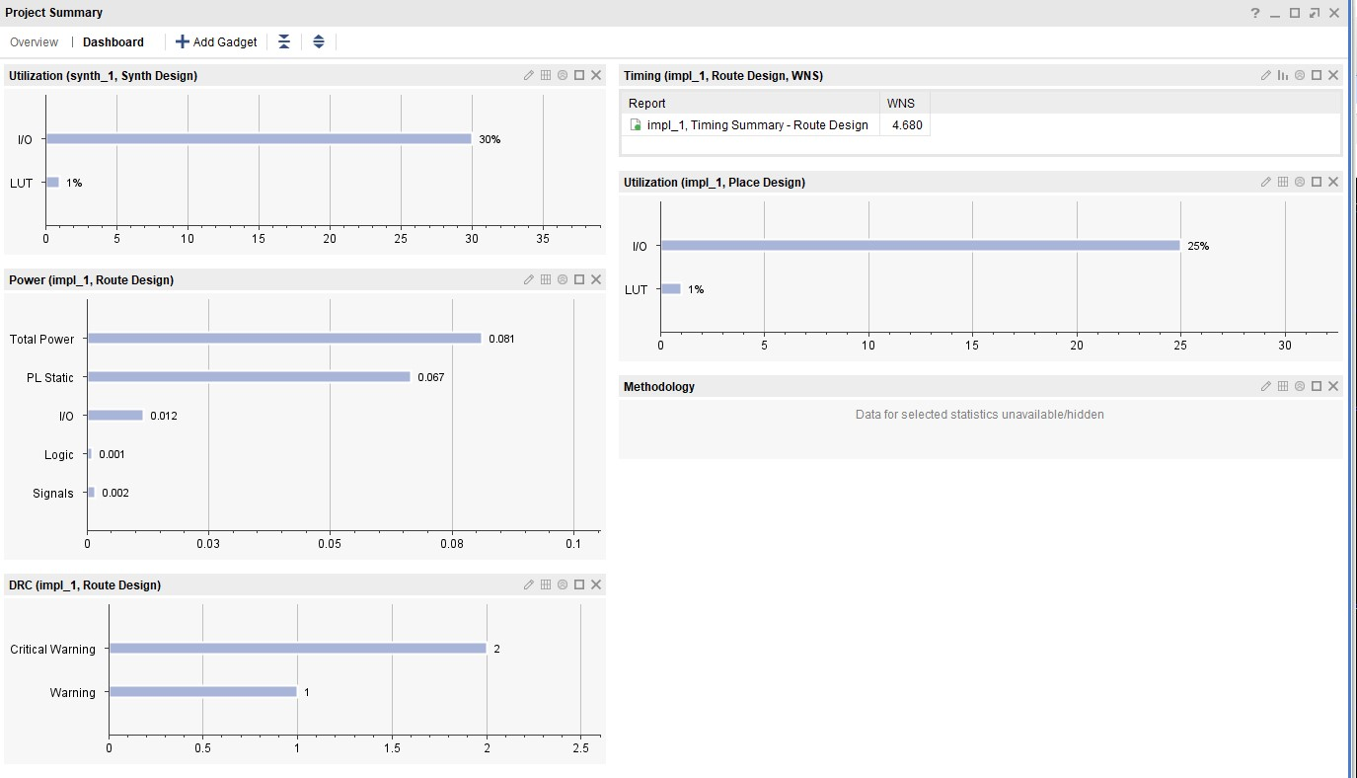
Project summary 2
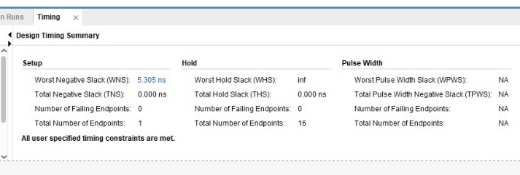
Worst negative stack – 5.305ns, this means the signal is arriving to the application too quickly and is therefore wasting power.
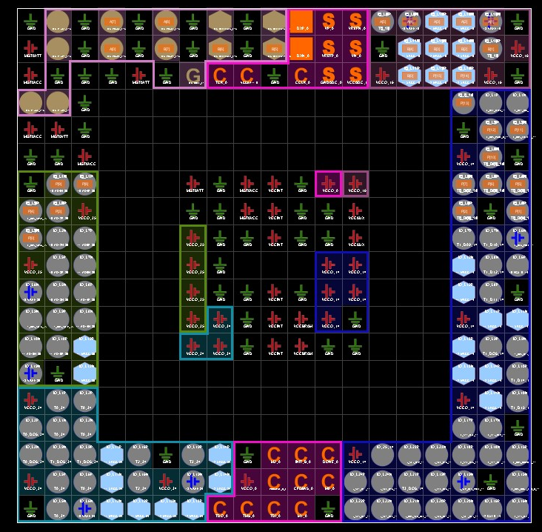
Pin Package (I/O plan)

Task 2 – Wallace Tree Multiplier
Task 2 involves the implementation of a Wallace Tree Multiplier to a parallel multiplication using an 8x8 bit unsigned number. A dot diagram, giving visual representation of the Full and Half adders comprised in the design and full circuit logic diagram are included below. The multiplier is then implemented in VHDL using Xilinx Vivado, as was the Braun’s in Task 1, and similar steps are carried out to build the full multiplier using port maps.
The multiplier is then simulated and synthesized, and its schematic results obtained and evaluated, comparable to the Braun’s build, which will then allow the two to be compared and critically evaluated with one another.
- For code, see Appendix 2.

Dot Diagram: -

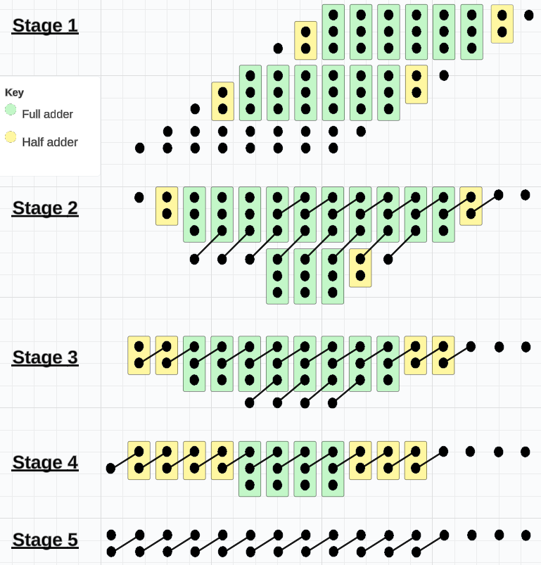
- Dot diagram of 8-bit Wallace tree multiplier, created using ‘Lucid chart’. [13]
The dot diagram above contains 18 Half adders and 37 Full adders.

Wallace Tree Multiplier Circuit Diagram: -

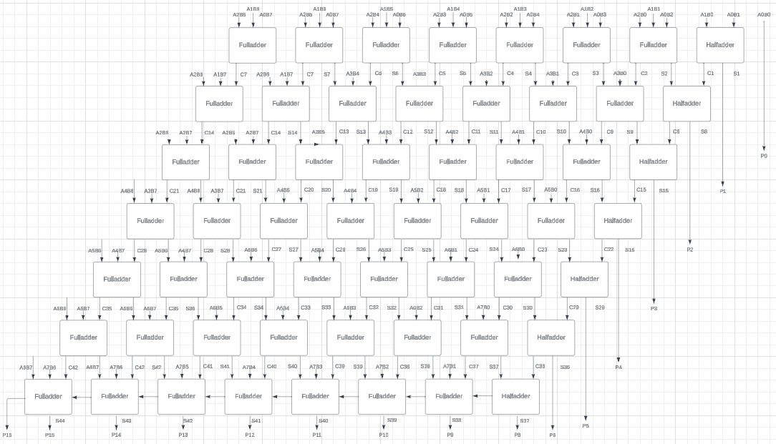
The above image shows the circuit diagram for an 8-bit Wallace Tree multiplier logic circuit diagram, created using ‘Lucid Chart’. [13]

Wallace Tree Multiplier Vivado simulation and screenshots: -
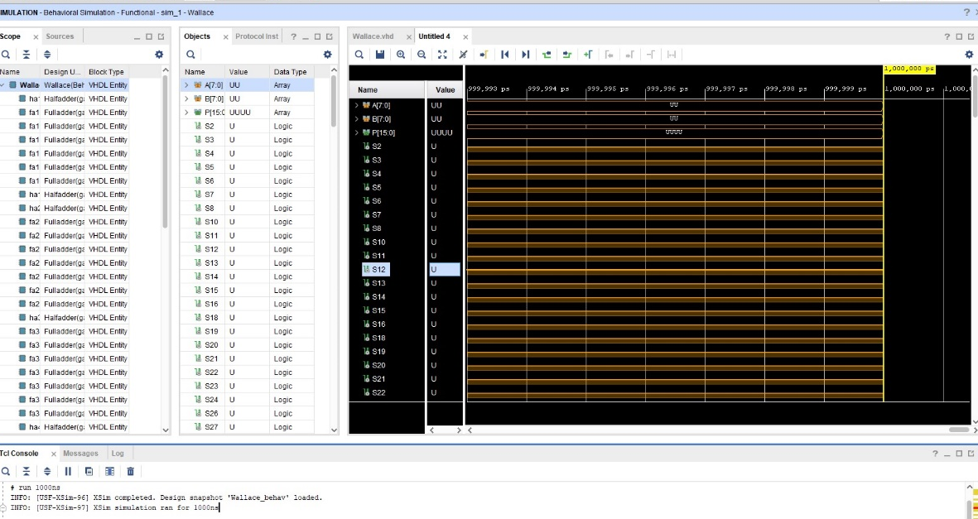
Screenshot of design simulation
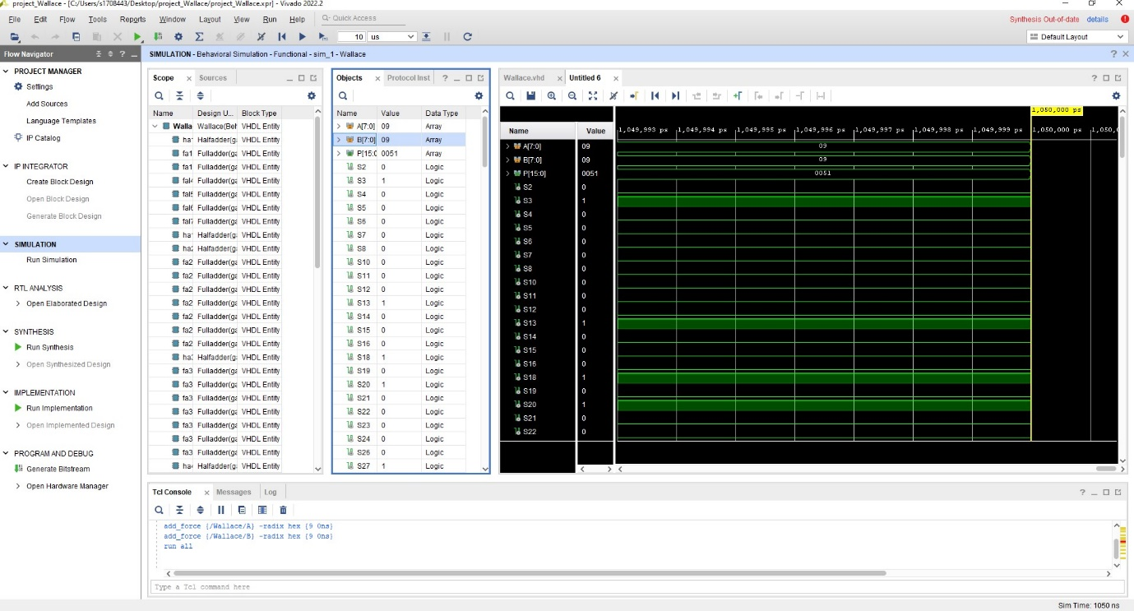
Design simulation once clocks are forced to 1/0 and constant is forced to 9
Design simulation once clocks are forced to 1/0 and constants are forced to 51
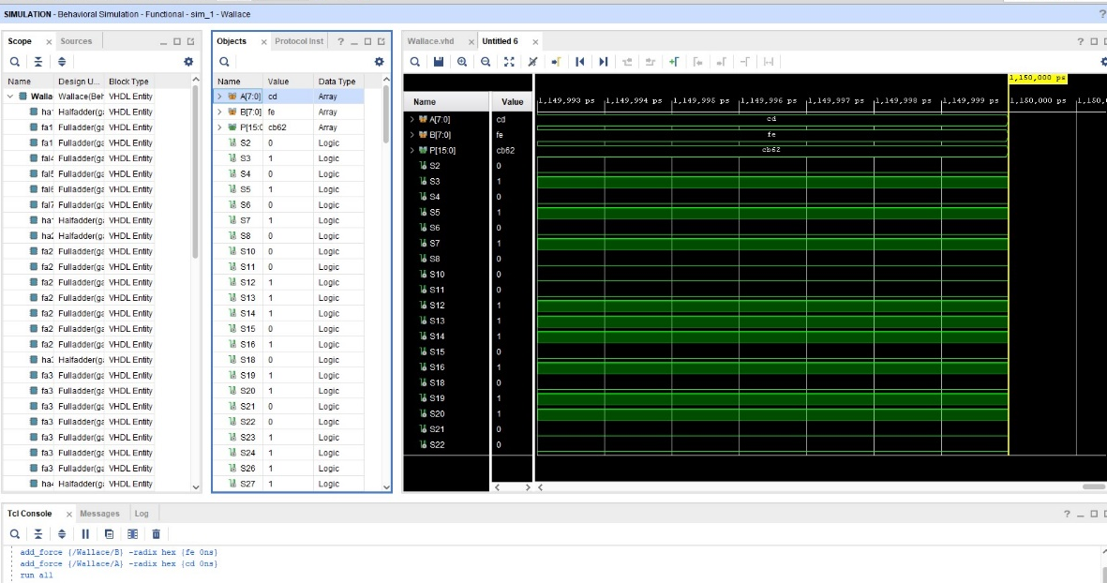
Design simulation once clocks are forced to 1/0 and constants are forced to cd/ef.
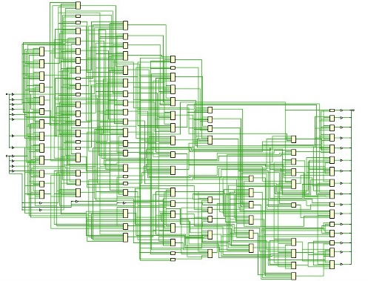
Design schematic
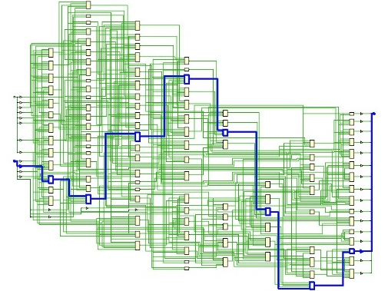
Critical path
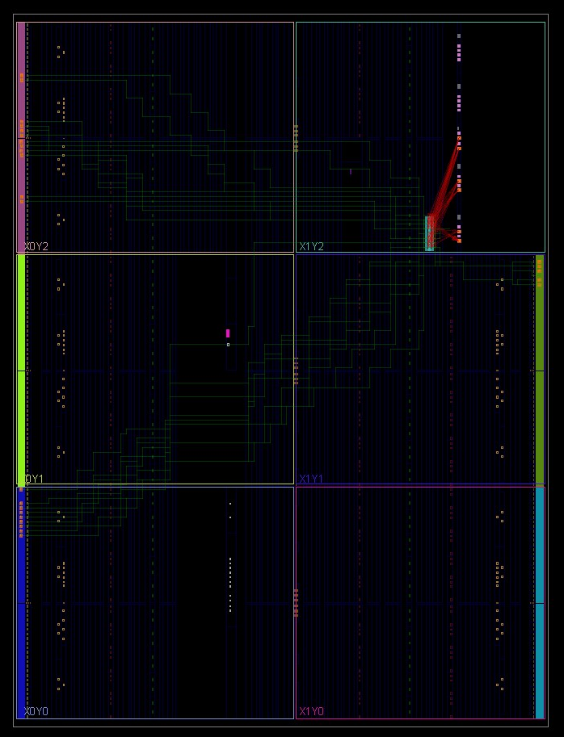
Device view
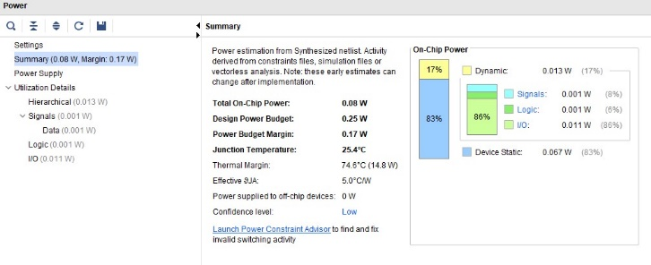
Power Usage
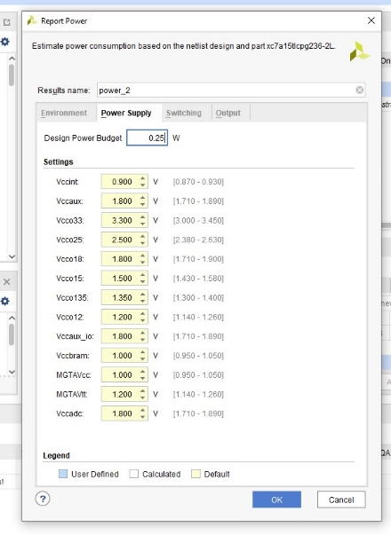
Power usage 2
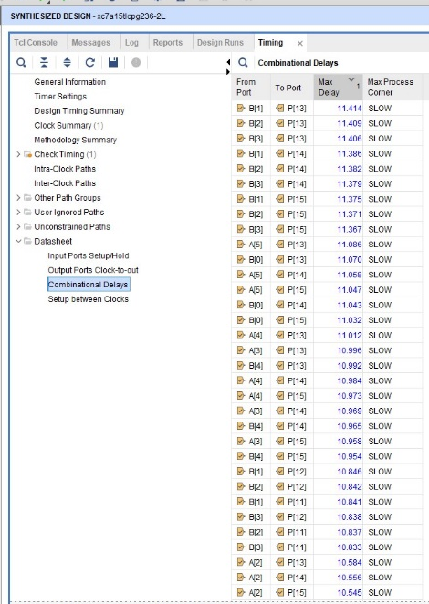
Timing
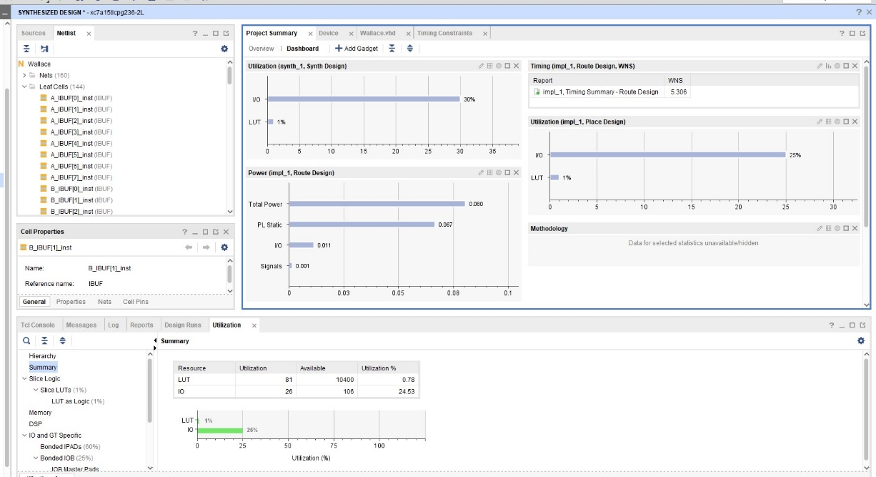
Project summary
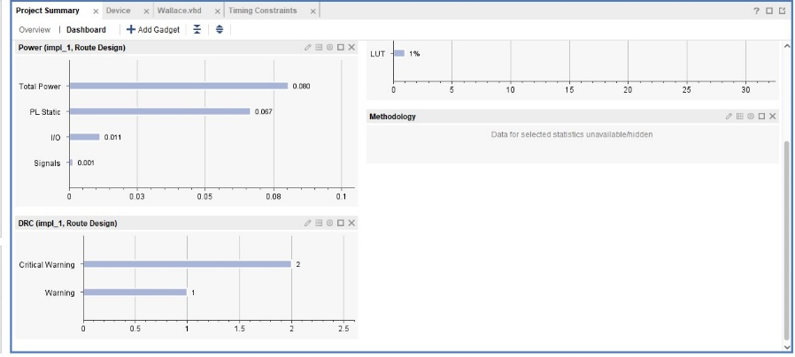
Project summary 2
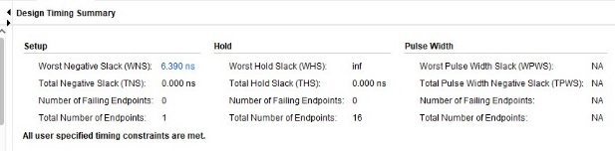
Worst negative Stack – 6.390ns, this means too fast like the Braun equivalent and wasting power.
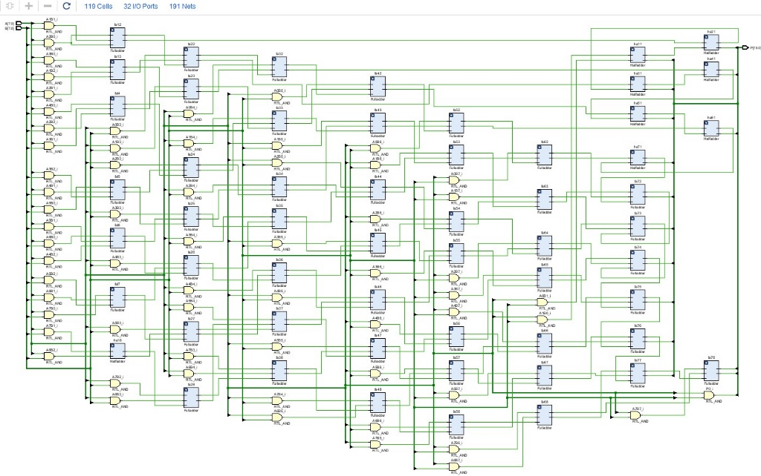
Full schematic showing adders and gates incorporated into the Wallace multiplier.
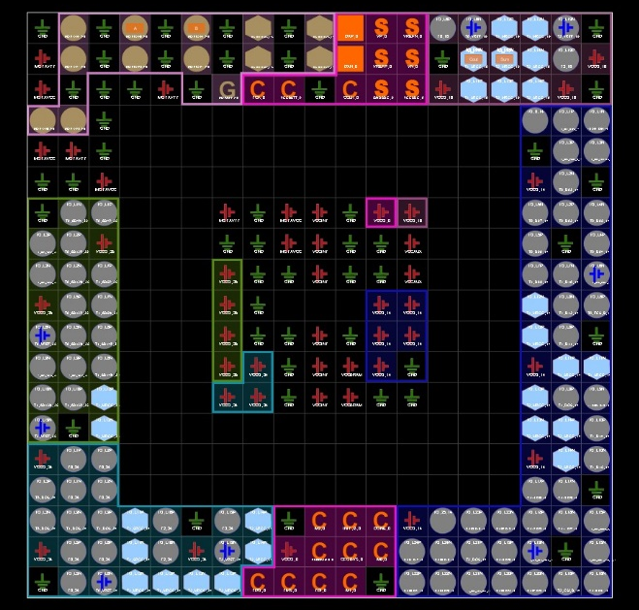
Pin package (I/O plan)

Task 3

This section of the report looks at critical evaluation of both multipliers from Tasks 1 and 2, and compares their performance by considering speed, delays, and power consumption.
Assuming$t_{g}=1ns$, and n adder delay is $t_{ad}=2ns$, the longest delay for each of the multipliers can be determined.
To determine the longest delay, the critical path of each multiplier must be considered, and equations must be solved.

Braun’s multiplier longest delay: -
Below is the critical path, followed by the equation and manual workings for the Braun multiplier’s longest delay: -
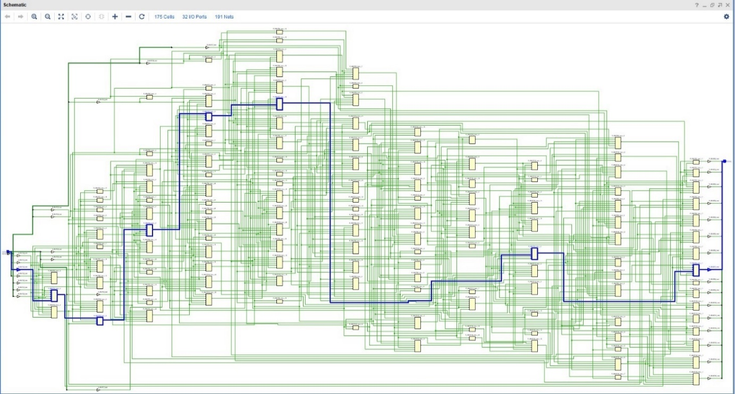
Braun Multiplier’s critical path from the Xilinx Vivado simulation.

Each AND gate introduces a delay of $t_{g}=1ns$. Following the equation $\frac{n(n+1)}{2}$ using AND gates, the total delay for an 8-bit Braun multiplier through the AND gates would be $\frac{8(8+1)}{2}$ ns.
Assuming a ripple-carry for the final addition, and each full adder has a delay of $t_{ad}$ = 2ns, if there are ‘n’ full adders in the final stage, then the total delay through the addition stage would be $n × t_{ad}$.
To solve the equation: -

$$Total Delay= \frac{n(n+1)}{2}+n × t_{ad}$$

$$Total Delay= \frac{8(8+1)}{2}+8 × t_{ad}$$

$$Total Delay= \frac{8×9}{2}+8 × t_{ad}$$
Assuming $t_{ad}$ = 2ns:

$$Total Delay=36+16ns$$
$$Total Delay= 52ns$$

Wallace Tree multiplier longest delay: -

Below is the critical path, followed by the equation and manual workings for the Wallace Tree multiplier’s longest delay: -

Wallace Tree Multiplier’s critical path from the Xilinx Vivado simulation.
Like the Braun multiplier, each AND gate introduces a delay of $t_{g}=1ns$.
Following the equation $\frac{n(n+1)}{2}$ using AND gates, the total delay for an 8-bit Braun multiplier through the AND gates would be $\frac{8(8+1)}{2}$ ns.
Assuming a Wallace Tree structure with stages of full adders, the delay through each stage is $t_{ad}$. If there are $\log_{2}{(n)}$ stages, the total delay through the Wallace Tree structure would be $\log_{2}\left(n\right)× t_{ad}$.
To solve the equation: -
$$Total Delay= \frac{n(n+1)}{2}+\log_{2}{(n)}×t_{ad}$$

$$Total Delay= \frac{8(8+1)}{2}+3×t_{ad}$$

$$Total Delay= \frac{8 ×9}{2}+3×t_{ad}$$
Assuming $t_{ad}$ = 2ns:

$$Total Delay= 36+6ns$$

$$Total Delay= 42ns$$
[14]

Longest delay comparison: -

When comparing the overall delay of the two multipliers, by the generic calculations above there is a 10ns difference between the two. Generally, a Wallace Tree multiplier tends to have a lower delay due to its parallel structure, allowing for faster multiplication.
The cases from Tasks 1 and 2 prove this, where in both simulations the power usage is monitored (see images below), and in both the generic cases and the simulation cases, the Braun’s multiplier had a longer max delay than the Wallace equivalent. This is due to the Braun’s multiplier having more of a step-by-step structure, using sequential AND gates and a final addition stage. This sequential approach creates a longer critical path (as shown in the images above), which causes an increase in delays to the multiplication process and therefore an extended overall maximum delay compared to the Wallace multiplier, using the parallel structure.

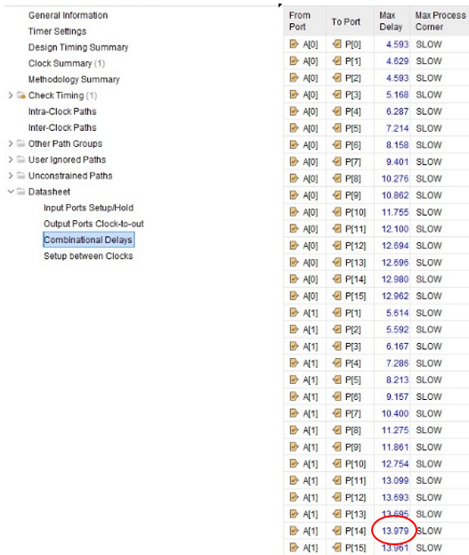
Braun longest delay – 13.979
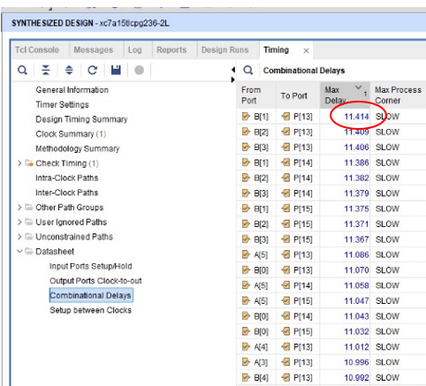
Wallace longest delay – 11.414

Power consumption and comparison: -

Power consumption is a key aspect in the performance evaluation of Braun and Wallace Tree multipliers. Braun multipliers often produce lower power and are therefore generally more efficient compared to Wallace multipliers, due to reduced hardware complexity. On the other hand, Wallace Tree multipliers tend to have higher power consumption due to their parallel structure and faster multiplication capabilities. The trade-off between speed and power consumption can be the decision maker in choosing which of these multipliers to use, and the specific requirements of the digital circuit should be considered when making the choice between the two.
The images below show the data for power consumption in the two multipliers created in Tasks 1 and 2: -

Braun power usage – On chip power: 0.081W
Wallace power usage – On chip power: 0.08W

Looking at these two images, it can be determined that there isn’t much of a difference between the two multipliers in this instance. During the simulation process, the observed on-chip power consumption for the Braun multiplier is slightly higher at 0.081W, compared to the Wallace Tree multiplier’s equivalent power, recorded at 0.08W. The slight difference in power between the two designs could be attributed to various factors, including the characteristics of the Braun and Wallace Tree structures, simulation settings and specific implementation details.
The simulated designs are also rather small, which may account for why the power consumption for both are so similar. In a real-world setting (not just a simulation), the multipliers are likely to be much larger, allowing for easier comparison due to sizeable differences, as well as actual power consumption using physical hardware may vary based on factors such as clock frequencies and operating conditions. Analysis of a real-world scenario would most likely give much better comparative data and would show the difference between both multipliers much clearer compared to that of a simulated test.

Further recommendations: -

Recommendations for more accurate and insightful results if repeating this exercise would include varying simulation conditions, such as altering forced constant and forced clock input patterns for each multiplier and operand sizes, to simulate a more uniform test. Further and possibly more accurate evaluation could also be achieved by carrying out an exercise in real-world conditions, using hardware etc. to give a more comprehensive understanding of the multipliers’ behaviour across different scenarios.
Carrying out a more detailed simulation with varying factors will ultimately lead to further understanding and more in-depth monitoring and analysis of both Braun and Wallace Tree multipliers and will assist in the decision-making process when using these in a real-world setting.

Conclusion
In conclusion, both the Braun and Wallace tree have their purposes in digital circuit logic and depending on requirements, choosing one over the other can prove to be beneficial.
The decision on which to implement into a circuit generally comes down to complexity, and where priorities lie in terms of speed and power consumption.
The report shows the difference between the two multipliers in a simulated environment, highlighting contrasts between the power consumption, speed and delays of each, and will help give an awareness on why each may be chosen in a particular circuit over the other.

References

[1] | “Multipliers in digital logic,” [Online]. Available: http://dspace.unimap.edu.my/bitstream/handle/123456789/1934/Literature%20review.pdf?sequence=4&isAllowed=y#:~:text=The%20speed%20will%20be%20slow%20for%20a%20very%20wide%20multiplier.&text=One%20advantage%20of%20the%20Wallace,has%20irregular%20wires%20%5B.
[2] | “Multiplier Basics,” https://www.analog.com/media/en/training-seminars/design-handbooks/Multiplier-Applications-Guide/multipliers-some-basics.pdf.
[3] | “Half adder in digital logic,” [Online]. Available: https://www.geeksforgeeks.org/half-adder-in-digital-logic/?ref=lbp.
[4] | “Full adder in digital logic,” [Online]. Available: https://www.geeksforgeeks.org/full-adder-in-digital-logic/.
[5] | “Half and Full adders,” [Online]. Available: https://www.elprocus.com/half-adder-and-full-adder/.
[6] | “Braun Multiplier,” [Online]. Available: https://www.ijser.org/paper/Design-of-Braun-Multiplier-with-Kogge-Stone-Adder-Its-Implementation-on-FPGA.html.
[7] | “Braun and Wallace multiplier comparisons,” [Online]. Available: https://medium.com/multiplier-techniques-in-vlsi/comparison-between-braun-multiplier-and-wallace-multiplier-technique-c26c38a17c69.
[8] | 2. A. MADHU GUDHIMETLA, “COMPARISON OF DIFFERENT TYPES OF MULTIPLIERS”.
[9] | N. M. Patel, “High Speed Area Efficient 32 Bit Wallace Tree”.
[10] | “Booth's Multiplier Algorithm,” [Online]. Available: https://www.geeksforgeeks.org/booths-multiplication-algorithm/.
[11] | “What is VHDL?,” [Online]. Available: https://www.doulos.com/knowhow/vhdl/what-is-vhdl/.
[12] | “What is VHDL? (2),” [Online]. Available: https://www.allaboutcircuits.com/technical-articles/hardware-description-langauge-getting-started-vhdl-digital-circuit-design/.
[13] | “Lucid Chart Programme,” [Online]. Available: https://lucid.app/.
[14] | M. H. A. Mijalli, “Braun's Multiplier - A Delay Study”.

Appendices

Braun Multiplier Code

library IEEE;
use IEEE.STD_LOGIC_1164.ALL;
use IEEE.std_logic_arith.ALL;
use IEEE.std_logic_unsigned.ALL;

-- Uncomment the following library declaration if using
-- arithmetic functions with Signed or Unsigned values
--use IEEE.NUMERIC_STD.ALL;

-- Uncomment the following library declaration if instantiating
-- any Xilinx leaf cells in this code.
--library UNISIM;
--use UNISIM.VComponents.all;

entity brauns_multiplier is

Port ( A : in std_logic_vector (7 downto 0);
B : in std_logic_vector (7 downto 0);
P : out std_logic_vector (15 downto 0));

end brauns_multiplier;

architecture behavioral of brauns_multiplier is

signal A0B0 : std_logic;
signal A1B0 : std_logic;
signal A2B0 : std_logic;
signal A3B0 : std_logic;
signal A4B0 : std_logic;
signal A5B0 : std_logic;
signal A6B0 : std_logic;
signal A7B0 : std_logic;

signal A0B1 : std_logic;
signal A1B1 : std_logic;
signal A2B1 : std_logic;
signal A3B1 : std_logic;
signal A4B1 : std_logic;
signal A5B1 : std_logic;
signal A6B1 : std_logic;
signal A7B1 : std_logic;

signal A0B2 : std_logic;
signal A1B2 : std_logic;
signal A2B2 : std_logic;
signal A3B2 : std_logic;
signal A4B2 : std_logic;
signal A5B2 : std_logic;
signal A6B2 : std_logic;
signal A7B2 : std_logic;

signal A0B3 : std_logic;
signal A1B3 : std_logic;
signal A2B3 : std_logic;
signal A3B3 : std_logic;
signal A4B3 : std_logic;
signal A5B3 : std_logic;
signal A6B3 : std_logic;
signal A7B3 : std_logic;

signal A0B4 : std_logic;
signal A1B4 : std_logic;
signal A2B4 : std_logic;
signal A3B4 : std_logic;
signal A4B4 : std_logic;
signal A5B4 : std_logic;
signal A6B4 : std_logic;
signal A7B4 : std_logic;

signal A0B5 : std_logic;
signal A1B5 : std_logic;
signal A2B5 : std_logic;
signal A3B5 : std_logic;
signal A4B5 : std_logic;
signal A5B5 : std_logic;
signal A6B5 : std_logic;
signal A7B5 : std_logic;

signal A0B6 : std_logic;
signal A1B6 : std_logic;
signal A2B6 : std_logic;
signal A3B6 : std_logic;
signal A4B6 : std_logic;
signal A5B6 : std_logic;
signal A6B6 : std_logic;
signal A7B6 : std_logic;

signal A0B7 : std_logic;
signal A1B7 : std_logic;
signal A2B7 : std_logic;
signal A3B7 : std_logic;
signal A4B7 : std_logic;
signal A5B7 : std_logic;
signal A6B7 : std_logic;
signal A7B7 : std_logic;

signal S2,S3,S4,S5,S6,S7,S8,S10,S11,S12,S13,S14,S15,S16,S18,S19,S20,S21,S22,S23,S24,S26,S27,S28,S29,S30,S31,S32,S34,S35,S36,S37,S38,S39,S40,S42,S43,S44,S45,S46,S47,S48 : std_logic;
signal C1,C2,C3,C4,C5,C6,C7,C8,C9,C10,C11,C12,C13,C14,C15,C16,C17,C18,C19,C20,C21,C22,C23,C24,C25,C26,C27,C28,C29,C30,C31,C32,C33,C34,C35,C36,C37,C38,C39,C40,C41,C42,C43,C44,C45,C46,C47,C48,C49,C50,C51,C52,C53,C54,C55,C56: std_logic;

component Fulladder is
Port ( A : in STD_LOGIC;
B : in STD_LOGIC;
Cin : in STD_LOGIC;
Sum : out STD_LOGIC;
Cout : out STD_LOGIC);
end component;

component Halfadder is
Port ( A : in STD_LOGIC;
B : in STD_LOGIC;
Sum : out STD_LOGIC;
Cout : out STD_LOGIC);
end component;

begin

A0B0 <= A(0)and B(0);
A1B0 <= A(1)and B(0);
A2B0 <= A(2)and B(0);
A3B0 <= A(3)and B(0);
A4B0 <= A(4)and B(0);
A5B0 <= A(5)and B(0);
A6B0 <= A(6)and B(0);
A7B0 <= A(7)and B(0);

A0B1 <= A(0)and B(1);
A1B1 <= A(1)and B(1);
A2B1 <= A(2)and B(1);
A3B1 <= A(3)and B(1);
A4B1 <= A(4)and B(1);
A5B1 <= A(5)and B(1);
A6B1 <= A(6)and B(1);
A7B1 <= A(7)and B(1);

A0B2 <= A(0)and B(2);
A1B2 <= A(1)and B(2);
A2B2 <= A(2)and B(2);
A3B2 <= A(3)and B(2);
A4B2 <= A(4)and B(2);
A5B2 <= A(5)and B(2);
A6B2 <= A(6)and B(2);
A7B2 <= A(7)and B(2);

A0B3 <= A(0)and B(3);
A1B3 <= A(1)and B(3);
A2B3 <= A(2)and B(3);
A3B3 <= A(3)and B(3);
A4B3 <= A(4)and B(3);
A5B3 <= A(5)and B(3);
A6B3 <= A(6)and B(3);
A7B3 <= A(7)and B(3);

A0B4 <= A(0)and B(4);
A1B4 <= A(1)and B(4);
A2B4 <= A(2)and B(4);
A3B4 <= A(3)and B(4);
A4B4 <= A(4)and B(4);
A5B4 <= A(5)and B(4);
A6B4 <= A(6)and B(4);
A7B4 <= A(7)and B(4);

A0B5 <= A(0)and B(5);
A1B5 <= A(1)and B(5);
A2B5 <= A(2)and B(5);
A3B5 <= A(3)and B(5);
A4B5 <= A(4)and B(5);
A5B5 <= A(5)and B(5);
A6B5 <= A(6)and B(5);
A7B5 <= A(7)and B(5);

A0B6 <= A(0)and B(6);
A1B6 <= A(1)and B(6);
A2B6 <= A(2)and B(6);
A3B6 <= A(3)and B(6);
A4B6 <= A(4)and B(6);
A5B6 <= A(5)and B(6);
A6B6 <= A(6)and B(6);
A7B6 <= A(7)and B(6);

A0B7 <= A(0)and B(7);
A1B7 <= A(1)and B(7);
A2B7 <= A(2)and B(7);
A3B7 <= A(3)and B(7);
A4B7 <= A(4)and B(7);
A5B7 <= A(5)and B(7);
A6B7 <= A(6)and B(7);
A7B7 <= A(7)and B(7);

--stage 1

P0 : P(0) <= A(0) and B(0);

P1 : Halfadder port map (A=>A1B0, B=>A0B1, SUM=>P(1), Cout=>C1);

S2_1 : Fulladder port map (A=>A2B0, B=>A1B1, Cin=>C1, Sum=>S2, Cout=>C2);
P2 : Halfadder port map (A=>A0B2, B=>S2, Sum=>P(2), Cout=>C9);

S3_1 : Fulladder port map (A=>A3B0, B=>A2B1, Cin=>C2, Sum=>S3, Cout=>C3);
S10_1: fulladder port map (A=>A1B2, B=>S3, Cin=>C9, Sum=>S10, Cout=>C10);
P3 : Halfadder port map (A=>A0B3, B=>S10, Sum=>P(3), Cout=>C17);

S4_1 : Fulladder port map (A=>A4B0, B=>A3B1, Cin=>C3, Sum=>S4, Cout=>C4);
S11_1 : Fulladder port map (A=>A2B2, B=>S4, Cin=>C10, Sum=>S11, Cout=>C11);
S18_1 : Fulladder port map (A=>A1B3, B=>S11, Cin=>C17, Sum=>S18, Cout=>C18);
P4 : Halfadder port map (A=>A0B4, B=>S18, Sum=>P(4), Cout=>C25);

S5_1 : Fulladder port map (A=>A5B0, B=>A4B1, Cin=>C4, Sum=>S5, Cout=>C5);
S12_1 : Fulladder port map (A=>A3B2, B=>S5, Cin=>C11, Sum=>S12, Cout=>C12);
S19_1 : Fulladder port map (A=>A2B3, B=>S12, Cin=>C18, Sum=>S19, Cout=>C19);
S26_1 : Fulladder port map (A=>A1B4, B=>S19, Cin=>C25, Sum=>S26, Cout=>C26);
P5 : Halfadder port map (A=>A0B5, B=>S26, Sum=>P(5), Cout=>C33);

S6_1 : Fulladder port map (A=>A6B0, B=>A5B1, Cin=>C5, Sum=>S6, Cout=>C6);
S13_1 : Fulladder port map (A=>A4B2, B=>S6, Cin=>C12, Sum=>S13, Cout=>C13);
S20_1 : Fulladder port map (A=>A3B3, B=>S13, Cin=>C19, Sum=>S20, Cout=>C20);
S27_1 : Fulladder port map (A=>A2B4, B=>S20, Cin=>C26, Sum=>S27, Cout=>C27);
S34_1 : Fulladder port map (A=>A1B5, B=>S27, Cin=>C33, Sum=>S34, Cout=>C34);
P6 : Halfadder port map (A=>A0B6, B=>S34, Sum=>P(6), Cout=>C41);

S7_1 : Fulladder port map (A=>A7B0, B=>A6B1, Cin=>C6, Sum=>S7, Cout=>C7);
S14_1 : Fulladder port map (A=>A5B2, B=>S7, Cin=>C13, Sum=>S14, Cout=>C14);
S21_1 : Fulladder port map (A=>A4B3, B=>S14, Cin=>C20, Sum=>S21, Cout=>C21);
S28_1 : Fulladder port map (A=>A3B4, B=>S21, Cin=>C27, Sum=>S28, Cout=>C28);
S35_1 : Fulladder port map (A=>A2B5, B=>S28, Cin=>C34, Sum=>S35, Cout=>C35);
S42_1 : Fulladder port map (A=>A1B6, B=>S35, Cin=>C41, Sum=>S42, Cout=>C42);
P7 : Halfadder port map (A=>A0B7, B=>S42, Sum=>P(7), Cout=>C49);

S8_1 : Fulladder port map (A=>A7B1, B=>C7, Cin=>C7, Sum=>S8, Cout=>C8);
S15_1 : Fulladder port map (A=>A6B2, B=>S8, Cin=>C14, Sum=>S15, Cout=>C15);
S22_1 : Fulladder port map (A=>A5B3, B=>S15, Cin=>C21, Sum=>S22, Cout=>C22);
S29_1 : Fulladder port map (A=>A4B4, B=>S22, Cin=>C28, Sum=>S29, Cout=>C29);
S36_1 : Fulladder port map (A=>A3B5, B=>S29, Cin=>C35, Sum=>S36, Cout=>C36);
S43_1 : Fulladder port map (A=>A2B6, B=>S36, Cin=>C42, Sum=>S43, Cout=>C43);
P8 : Fulladder port map (A=>A1B7, B=>S43, Cin=>C49, Sum=>P(8), Cout=>C50);

S16_1 : Fulladder port map (A=>A7B2, B=>C8, Cin=>C15, Sum=>S16, Cout=>C16);
S23_1 : Fulladder port map (A=>A6B3, B=>S16, Cin=>C22, Sum=>S23, Cout=>C23);
S30_1 : Fulladder port map (A=>A5B4, B=>S23, Cin=>C29, Sum=>S30, Cout=>C30);
S37_1 : Fulladder port map (A=>A4B5, B=>S30, Cin=>C36, Sum=>S37, Cout=>C37);
S44_1 : Fulladder port map (A=>A3B6, B=>S37, Cin=>C43, Sum=>S44, Cout=>C44);
P9 : Fulladder port map (A=>A2B7, B=>S44, Cin=>C50, Sum=>P(9), Cout=>C51);

S24_1 : Fulladder port map (A=>A7B3, B=>C16, Cin=>C23, Sum=>S24, Cout=>C24);
S31_1 : Fulladder port map (A=>A6B4, B=>S24, Cin=>C30, Sum=>S31, Cout=>C31);
S38_1 : Fulladder port map (A=>A5B5, B=>S31, Cin=>C37, Sum=>S38, Cout=>C38);
S45_1 : Fulladder port map (A=>A4B6, B=>S38, Cin=>C44, Sum=>S45, Cout=>C45);
P10 : Fulladder port map (A=>A3B7, B=>S45, Cin=>C51, Sum=>P(10), Cout=>C52);

S32_1 : Fulladder port map (A=>A7B4, B=>C24, Cin=>C31, Sum=>S32, Cout=>C32);
S39_1 : Fulladder port map (A=>A6B5, B=>S32, Cin=>C38, Sum=>S39, Cout=>C39);
S46_1 : Fulladder port map (A=>A5B6, B=>S39, Cin=>C45, Sum=>S46, Cout=>C46);
P11 : Fulladder port map (A=>A4B7, B=>S46, Cin=>C52, Sum=>P(11), Cout=>C53);

S40_1 : Fulladder port map (A=>A7B5, B=>C32, Cin=>C39, Sum=>S40, Cout=>C40);
S47_1 : Fulladder port map (A=>A6B6, B=>S40, Cin=>C46, Sum=>S47, Cout=>C47);
P12 : Fulladder port map (A=>A5B7, B=>S47, Cin=>C53, Sum=>P(12), Cout=>C54);

S48_1 : Fulladder port map (A=>A7B6, B=>C40, Cin=>C47, Sum=>S48, Cout=>C48);
P13 : Fulladder port map (A=>A6B7, B=>S48, Cin=>C54, Sum=>P(13), Cout=>C55);

P14 : Fulladder port map (A=>A7B7, B=>C48, Cin=>C55, Sum=>P(14), Cout=>C56);

P15 : P(15) <=C56;

end behavioral;

Wallace Tree Multiplier Code

library IEEE;
use IEEE.STD_LOGIC_1164.ALL;

-- Uncomment the following library declaration if using
-- arithmetic functions with Signed or Unsigned values
--use IEEE.NUMERIC_STD.ALL;

-- Uncomment the following library declaration if instantiating
-- any Xilinx leaf cells in this code.
--library UNISIM;
--use UNISIM.VComponents.all;

entity Wallace is
-- Port ( );
Port ( A : in STD_LOGIC_VECTOR (7 downto 0);
B : in STD_LOGIC_VECTOR (7 downto 0);
P : out STD_LOGIC_VECTOR (15 downto 0));
end Wallace;

architecture Behavioral of Wallace is

component Fulladder is
Port ( A : in STD_LOGIC;
B : STD_LOGIC;
Cin : in STD_LOGIC;
Sum : out STD_LOGIC;
Cout : out STD_LOGIC);
end component;

component Halfadder is
Port ( A : in STD_LOGIC;
B : in STD_LOGIC;
Sum : out STD_LOGIC;
Cout : out STD_LOGIC);
end component;

signal S2,S3,S4,S5,S6,S7,S8,S10,S11,S12,S13,S14,S15,S16,S18,S19,S20,S21,S22,S23,S24,S26,S27,S28,S29,S30,S31,S32,S34,S35,S36,S37,S38,S39,S40,S42,S43,S44,S45,S46,S47,S48: std_logic;
signal C1,C2,C3,C4,C5,C6,C7,C8,C9,C10,C11,C12,C13,C14,C15,C16,C17,C18,C19,C20,C21,C22,C23,C24,C25,C26,C27,C28,C29,C30,C31,C32,C33,C34,C35,C36,C37,C38,C39,C40,C41,C42,C43,C44,C45,C46,C47,C48,C49,C50,C51,C52,C53,C54,C55, C56: std_logic;

signal A0B0 : std_logic;
signal A1B0 : std_logic;
signal A2B0 : std_logic;
signal A3B0 : std_logic;
signal A4B0 : std_logic;
signal A5B0 : std_logic;
signal A6B0 : std_logic;
signal A7B0 : std_logic;

signal A0B1 : std_logic;
signal A1B1 : std_logic;
signal A2B1 : std_logic;
signal A3B1 : std_logic;
signal A4B1 : std_logic;
signal A5B1 : std_logic;
signal A6B1 : std_logic;
signal A7B1 : std_logic;

signal A0B2 : std_logic;
signal A1B2 : std_logic;
signal A2B2 : std_logic;
signal A3B2 : std_logic;
signal A4B2 : std_logic;
signal A5B2 : std_logic;
signal A6B2 : std_logic;
signal A7B2 : std_logic;

signal A0B3 : std_logic;
signal A1B3 : std_logic;
signal A2B3 : std_logic;
signal A3B3 : std_logic;
signal A4B3 : std_logic;
signal A5B3 : std_logic;
signal A6B3 : std_logic;
signal A7B3 : std_logic;

signal A0B4 : std_logic;
signal A1B4 : std_logic;
signal A2B4 : std_logic;
signal A3B4 : std_logic;
signal A4B4 : std_logic;
signal A5B4 : std_logic;
signal A6B4 : std_logic;
signal A7B4 : std_logic;

signal A0B5 : std_logic;
signal A1B5 : std_logic;
signal A2B5 : std_logic;
signal A3B5 : std_logic;
signal A4B5 : std_logic;
signal A5B5 : std_logic;
signal A6B5 : std_logic;
signal A7B5 : std_logic;

signal A0B6 : std_logic;
signal A1B6 : std_logic;
signal A2B6 : std_logic;
signal A3B6 : std_logic;
signal A4B6 : std_logic;
signal A5B6 : std_logic;
signal A6B6 : std_logic;
signal A7B6 : std_logic;

signal A0B7 : std_logic;
signal A1B7 : std_logic;
signal A2B7 : std_logic;
signal A3B7 : std_logic;
signal A4B7 : std_logic;
signal A5B7 : std_logic;
signal A6B7 : std_logic;
signal A7B7 : std_logic;

begin

A0B0 <= A(0)and B(0);
A1B0 <= A(1)and B(0);
A2B0 <= A(2)and B(0);
A3B0 <= A(3)and B(0);
A4B0 <= A(4)and B(0);
A5B0 <= A(5)and B(0);
A6B0 <= A(6)and B(0);
A7B0 <= A(7)and B(0);

A0B1 <= A(0)and B(1);
A1B1 <= A(1)and B(1);
A2B1 <= A(2)and B(1);
A3B1 <= A(3)and B(1);
A4B1 <= A(4)and B(1);
A5B1 <= A(5)and B(1);
A6B1 <= A(6)and B(1);
A7B1 <= A(7)and B(1);

A0B2 <= A(0)and B(2);
A1B2 <= A(1)and B(2);
A2B2 <= A(2)and B(2);
A3B2 <= A(3)and B(2);
A4B2 <= A(4)and B(2);
A5B2 <= A(5)and B(2);
A6B2 <= A(6)and B(2);
A7B2 <= A(7)and B(2);

A0B3 <= A(0)and B(3);
A1B3 <= A(1)and B(3);
A2B3 <= A(2)and B(3);
A3B3 <= A(3)and B(3);
A4B3 <= A(4)and B(3);
A5B3 <= A(5)and B(3);
A6B3 <= A(6)and B(3);
A7B3 <= A(7)and B(3);

A0B4 <= A(0)and B(4);
A1B4 <= A(1)and B(4);
A2B4 <= A(2)and B(4);
A3B4 <= A(3)and B(4);
A4B4 <= A(4)and B(4);
A5B4 <= A(5)and B(4);
A6B4 <= A(6)and B(4);
A7B4 <= A(7)and B(4);

A0B5 <= A(0)and B(5);
A1B5 <= A(1)and B(5);
A2B5 <= A(2)and B(5);
A3B5 <= A(3)and B(5);
A4B5 <= A(4)and B(5);
A5B5 <= A(5)and B(5);
A6B5 <= A(6)and B(5);
A7B5 <= A(7)and B(5);

A0B6 <= A(0)and B(6);
A1B6 <= A(1)and B(6);
A2B6 <= A(2)and B(6);
A3B6 <= A(3)and B(6);
A4B6 <= A(4)and B(6);
A5B6 <= A(5)and B(6);
A6B6 <= A(6)and B(6);
A7B6 <= A(7)and B(6);

A0B7 <= A(0)and B(7);
A1B7 <= A(1)and B(7);
A2B7 <= A(2)and B(7);
A3B7 <= A(3)and B(7);
A4B7 <= A(4)and B(7);
A5B7 <= A(5)and B(7);
A6B7 <= A(6)and B(7);
A7B7 <= A(7)and B(7);

--stage 1
P0 : P(0) <= A (0) and B (0) ;

ha11 : Halfadder Port map ( A=>A1B0, B=>A0B1, Sum=>P(1), Cout=>C1);
fa12 : Fulladder Port map ( A=>A2B0, B=>A1B1, Cin=>A2B0, Sum=>S2, Cout=>C2);
fa13 : Fulladder Port map ( A=>A3B0, B=>A2B1, Cin=>A1B2, Sum=>S3, Cout=>C3);
fal4 : Fulladder Port map ( A=>A4B0, B=>A3B1, Cin=>A2B2, Sum=>S4, Cout=>C4);
fal5 : Fulladder Port map ( A=>A5B0, B=>A4B1, Cin=>A3B2, Sum=>S5, Cout=>C5);
fal6 : Fulladder Port map ( A=>A6B0, B=>A5B1, Cin=>A4B2, Sum=>S6, Cout=>C6);
fal7 : Fulladder Port map ( A=>A7B0, B=>A6B1, Cin=>A5B2, Sum=>S7, Cout=>C7);
ha18 : Halfadder Port map ( A=>A7B1, B=>A6B2, Sum=>S8, Cout=>C8);

-- Stage 2
ha21 : Halfadder Port map ( A=>S2, B=>C1, Sum=>P(2), Cout=>C9);
fa22 : Fulladder Port map ( A=>A0B3, B=>S3, Cin=>C2, Sum=>S10, Cout=>C10);
fa23 : Fulladder Port map ( A=>A1B3, B=>S4, Cin=>C3, Sum=>S11, Cout=>C11);
fa24 : Fulladder Port map ( A=>A2B3, B=>S5, Cin=>C4, Sum=>S12, Cout=>C12);
fa25 : Fulladder Port map ( A=>A3B3, B=>S6, Cin=>C5, Sum=>S13, Cout=>C13);
fa26 : Fulladder Port map ( A=>A4B3, B=>S7, Cin=>C6, Sum=>S14, Cout=>C14);
fa27 : Fulladder Port map ( A=>A5B3, B=>S8, Cin=>C7, Sum=>S15, Cout=>C15);
fa28 : Fulladder Port map ( A=>A7B2, B=>A6B3, Cin=>C8, Sum=>S16, Cout=>C16);

-- Stage 3
ha31 : Halfadder Port map ( A=>S10, B=>C9, Sum=>P(3), Cout=>C17);
fa32 : Fulladder Port map ( A=>A0B4, B=>S11, Cin=>C10, Sum=>S18, Cout=>C18);
fa33 : Fulladder Port map ( A=>A1B4, B=>S12, Cin=>C11, Sum=>S19, Cout=>C19);
fa34 : Fulladder Port map ( A=>A2B4, B=>S13, Cin=>C12, Sum=>S20, Cout=>C20);
fa35 : Fulladder Port map ( A=>A3B4, B=>S14, Cin=>C13, Sum=>S21, Cout=>C21);
fa36 : Fulladder Port map ( A=>A4B4, B=>S15, Cin=>C14, Sum=>S22, Cout=>C22);
fa37 : Fulladder Port map ( A=>A5B4, B=>S16, Cin=>C15, Sum=>S23, Cout=>C23);
fa38 : Fulladder Port map ( A=>A7B3, B=>A6B4, Cin=>C16, Sum=>S24, Cout=>C24);

--Stage 4
ha41 : Halfadder Port map ( A=>S18, B=>C17, Sum=>P(4), Cout=>C25);
fa42 : Fulladder Port map ( A=>A0B5, B=>S19, Cin=>C18, Sum=>S26, Cout=>C26);
fa43 : Fulladder Port map ( A=>A1B5, B=>S20, Cin=>C19, Sum=>S27, Cout=>C27);
fa44 : Fulladder Port map ( A=>A2B5, B=>S21, Cin=>C20, Sum=>S28, Cout=>C28);
fa45 : Fulladder Port map ( A=>A3B5, B=>S22, Cin=>C21, Sum=>S29, Cout=>C29);
fa46 : Fulladder Port map ( A=>A4B5, B=>S23, Cin=>C22, Sum=>S30, Cout=>C30);
fa47 : Fulladder Port map ( A=>A5B5, B=>S24, Cin=>C23, Sum=>S31, Cout=>C31);
fa48 : Fulladder Port map ( A=>A7B4, B=>A6B5, Cin=>C24, Sum=>S32, Cout=>C32);

--Stage 5
ha51 : Halfadder Port map ( A=>S26, B=>C25, Sum=>P(5), Cout=>C33);
fa52 : Fulladder Port map ( A=>A0B6, B=>S27, Cin=>C26, Sum=>S34, Cout=>C34);
fa53 : Fulladder Port map ( A=>A1B6, B=>S28, Cin=>C27, Sum=>S35, Cout=>C35);
fa54 : Fulladder Port map ( A=>A2B6, B=>S29, Cin=>C28, Sum=>S36, Cout=>C36);
fa55 : Fulladder Port map ( A=>A3B6, B=>S30, Cin=>C29, Sum=>S37, Cout=>C37);
fa56 : Fulladder Port map ( A=>A4B6, B=>S31, Cin=>C30, Sum=>S38, Cout=>C38);
fa57 : Fulladder Port map ( A=>A5B6, B=>S32, Cin=>C31, Sum=>S39, Cout=>C39);
fa58 : Fulladder Port map ( A=>A7B5, B=>A6B6, Cin=>C32, Sum=>S40, Cout=>C40);

--Stage 6
ha61 : Halfadder Port map ( A=>S34, B=>C33, Sum=>P(6), Cout=>C41);
fa62 : Fulladder Port map ( A=>A0B7, B=>S35, Cin=>C34, Sum=>S42, Cout=>C43);
fa63 : Fulladder Port map ( A=>A1B7, B=>S36, Cin=>C35, Sum=>S43, Cout=>C45);
fa64 : Fulladder Port map ( A=>A2B7 ,B=>S37, Cin=>C36, Sum=>S44, Cout=>C47);
fa65 : Fulladder Port map ( A=>A3B7, B=>S38, Cin=>C37, Sum=>S45, Cout=>C49);
fa66 : Fulladder Port map ( A=>A4B7, B=>S39, Cin=>C38, Sum=>S46, Cout=>C51);
fa67 : Fulladder Port map ( A=>A5B7, B=>S40, Cin=>C39, Sum=>S47, Cout=>C53);
fa68 : Fulladder Port map ( A=>A7B6, B=>A6B7, Cin=>C40, Sum=>S48, Cout=>C55);

--Stage 7
ha71 : Halfadder Port map ( A=>S42, B=>C41, Sum=>P(7), Cout=>C42);
fa72 : Fulladder Port map ( A=>S43, B=>C43, Cin=>C42, Sum=>P(8), Cout=>C44);
fa73 : Fulladder Port map ( A=>S44, B=>C45, Cin=>C44, Sum=>P(9), Cout=>C46);
fa74 : Fulladder Port map ( A=>S45, B=>C47, Cin=>C46, Sum=>P(10), Cout=>C48);
fa75 : Fulladder Port map ( A=>S46, B=>C49, Cin=>C48, Sum=>P(11), Cout=>C50);
fa76 : Fulladder Port map ( A=>S47, B=>C51, Cin=>C50, Sum=>P(12), Cout=>C52);
fa77 : Fulladder Port map ( A=>S48, B=>C53, Cin=>C52, Sum=>P(13), Cout=>C54);
fa78 : Fulladder Port map ( A=>A7B7, B=>C55, Cin=>C54, Sum=>P(14), Cout=>P(15));

end Behavioral;

