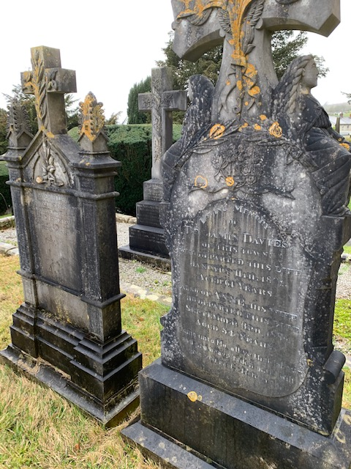 | Davies  Augmentation  - Cross with writhe and artistic design  - Siting women  Material slate  Trad type  Family grave  First addition 1891  Died age 52  To latest 1917  Died age 41  Placement B1
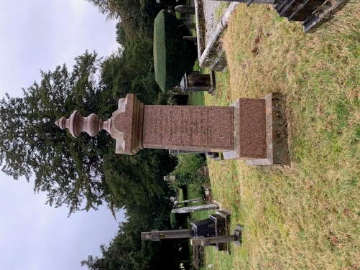 | calangly  Augmentation  - Closed Ern  Plinth type  Family grave  Material red granite  First addition 1874  Last 1946  Placement B2
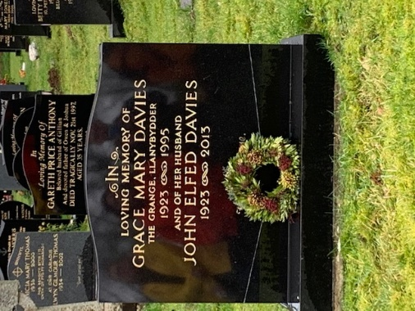 | Grace mary Davies  1923-1995  John elfed Davies  1923-2013  Material reconstituted granite  Type trad  No augmentation  Placement of a writhe due to tradition  Placement I1
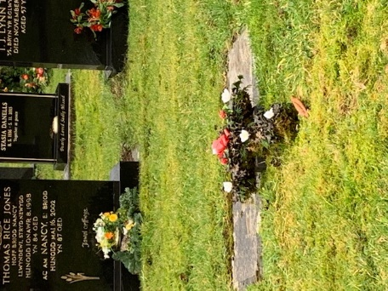 | Removed placement due to danger  Ivy cross placed with flowers  No name or date  Placement I2
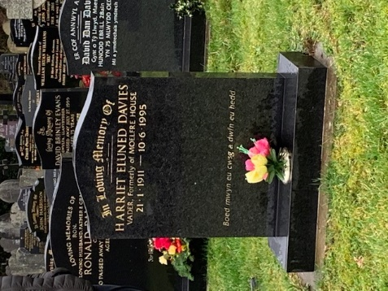 | Harriet eluned Davies  21/1/1911-10/6/1995  Material reconstituted granite  Type trad  Inscription  Welsh  additions  - “Boed mwyn eu cwsg a dwfn eu hedd”  - Permeant fake flower placement  Placement I8
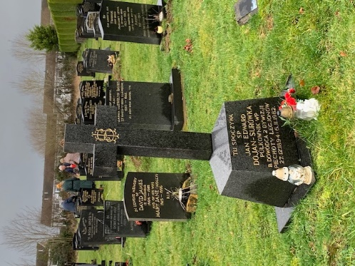 | Jan Edward  23/12/1894-6/11/1982  Material reconstructed granite  Type plinth  Additions  - Shaping as a cross  - “SHI” inscription  In polish  Placement H1
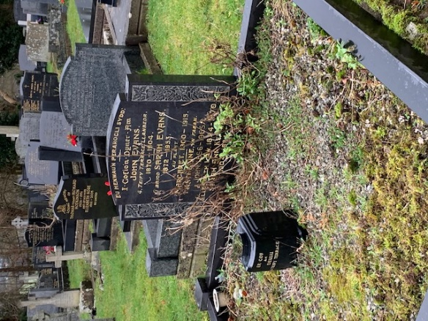 | Evans  Family grave  Material reconstructed granite  First burial 1872-1904  John  Last burial 1924-1970  Elisabeth  Additions  - Rose type inscription  - Type trad with a border around site  Placement D1
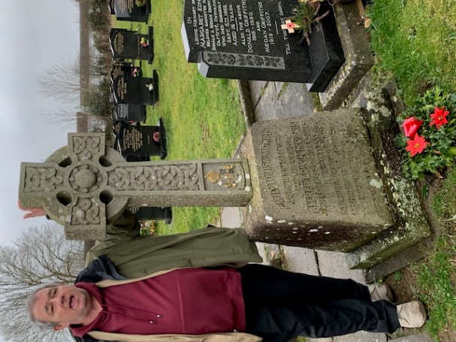 | Emily louisa Morris  1899-1968  Alfred Edwin Morris  1924-1945  States profession of  - Professor at trinity st David university  - Bishop  - Archbishop  Emily louisa Morris  1899-1968  Material concrete  Cornerstone to introduce graves in to new arias  Type plinth  Additions  Celtic type cross  Bishops crest  Placement D2
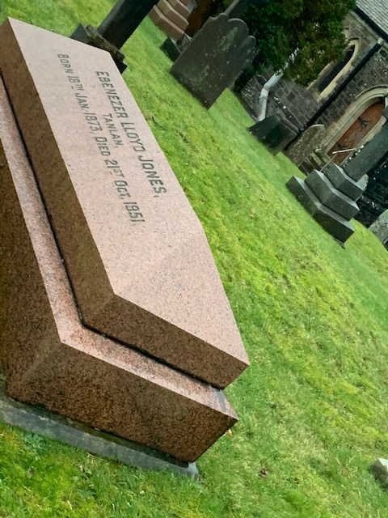 | Ebenezer Lloyd Jones  18/1/1873-21/10/1951  Material concrete  Type table with toom influence  No inscriptions  Placement F1
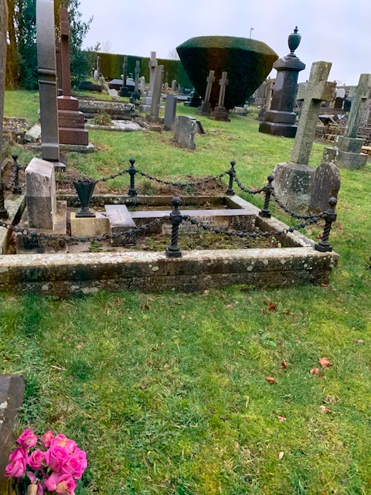 | James Davies  Only readable date 1874  family grave  type table  material concrete  additions  - spiked surrounding chain  - concrete border  - cross shaped table  - metal vase  - trad type head stone  placement D3
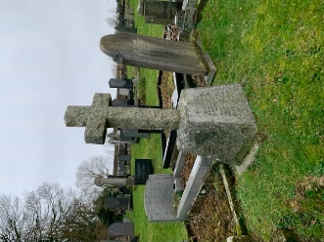 | Serier langly  No readable date  Welsh inscription  Type plinth  Additions  - cross  placement D4
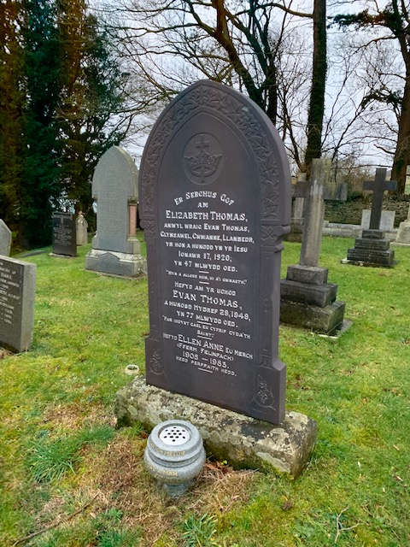 | Elizabeth Thomas  1920  Evan Thomas  1949  Ellen Anne  1905-1953  Type trad  In welsh  Additions  Inscription  - Crown and cross  - Ivy  - Pillars  - Arch  vase for flowers with date  placement F2
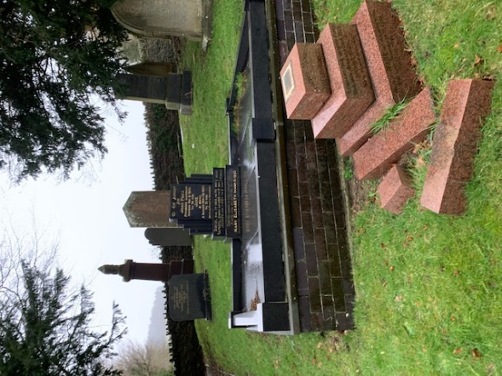 | Price  Family grave  1856-1975  Material Reconstructed granite  Type trad  additions  - Artistic style decoration made fashionable and modern due to rich influence  - Border  - Made level with bricking  - Placed in prestigious place  Placement in F3
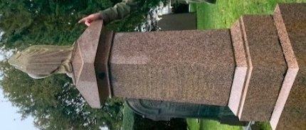 | Langly  1865-1907  Family grave  Material red granite  Type plinth  Additions  - Ern with a covering  - Greek style carving  - Permanent flower vase  Placement A1
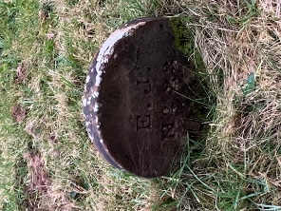 | L.E  No. 33  Foot stone  Type trad  Proper’s grave  Material Slate  Placement A2
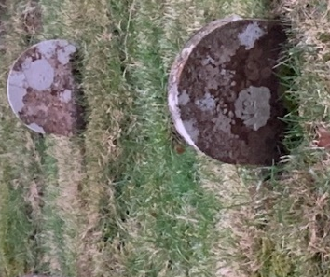 | B.M.F  N2.72  Footstone  type trad  footstone  proper’s grave  material slate  placement A3
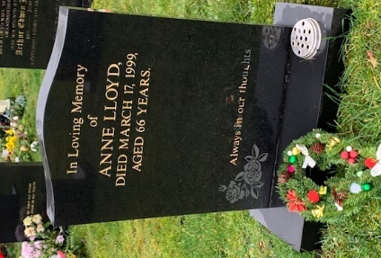 | Anne Lloyd  17/3/1999  Age 66  Inscription “always in our thoughts”  Type trad  Material reconstructed granite  Additions  - Rose inscriptions  - Permanent flower vase  Placement I3
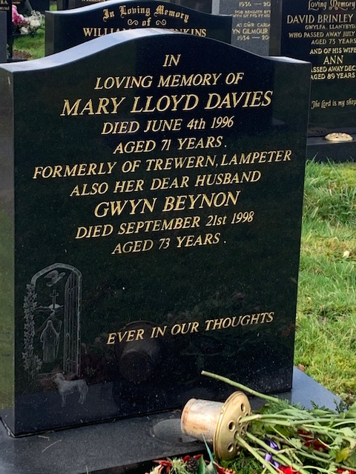 | Mary Lloyd Davies  4/6/1996  Age 71  Gwyn Beynon  21/10/1998  Age 73  Type trad  Material reconstructed granite  Inscriptions  “ever in our thoughts”  Additions  Etching of someone walking though a door with a calf possibly to heaven  Placement I7
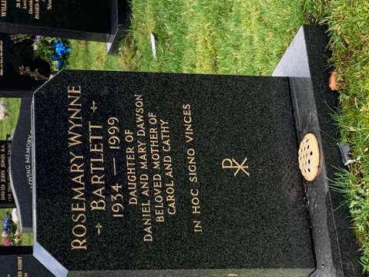 | Rosemary wynne Bartlett  1934-1999  Inscription  - Describes relation to daughters and parents  - “in moc signo vinces”  - P with a cross  Additions  - Permanent flower placement  - Cut edges  Placement I4
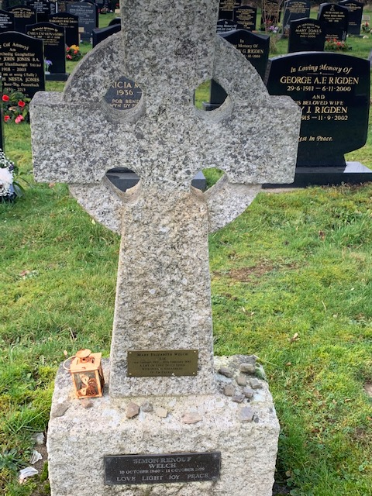 | Mary Elizabeth Welch  liz  4/1/1967-10/2/2013  Simon renilf welch  12/10/1960-11/10/1999  Material limestone  Type plinth  Additions  - Celtic cross  - Metal lantern  - Names on metal plates  Inscription of “LOVE, LIGHT, JOY, PEACE”  “a life of love truly lived with oceans and oodles of Em energy”  Placement I5
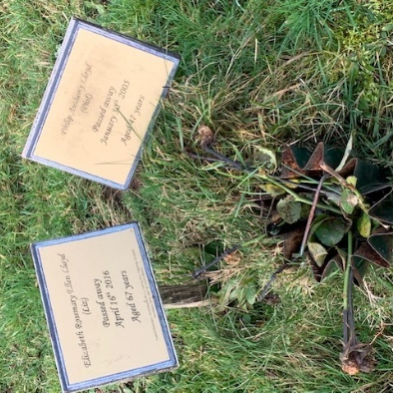 | Elizabeth Rosemary Lillen Lloyd  16/4/2016  Age 67  Philip Anthony Lloyd  30/1/2005  Age 47  Type tree  Rose bush  Placement I6
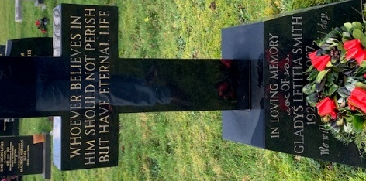 | Gladys Letitia Smith  1927-2007  Material reconstrued granite  Type plinth  Additions  - Cross shaping  - Increased thickness  Inscription  - “whoever believes in him should not perish but have eternal life”  Placement G2
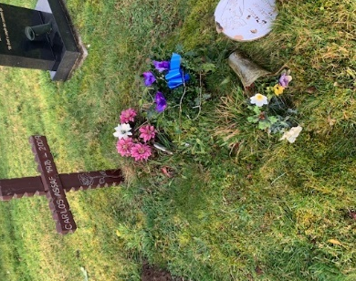 | Carlos Assaf  1976-2009  Material wood  Type trad  Additions  - Cross shaping  Inscriptions  - Rose  Placement I7
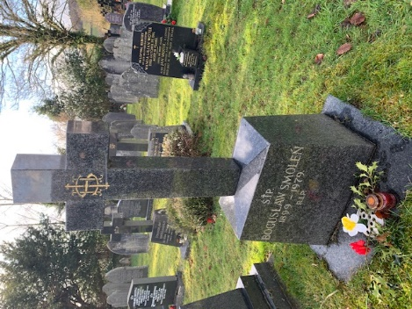 | Boguslaw smolen  1899-1979  Material reconstrued marble  Type plinth  Additions  - Cross shape  - Increased thickness  - IHS and R.I.P inscription  - Permanent flower vase  Placement G3
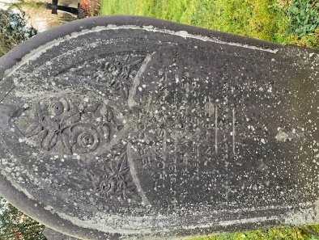 | Thomas colins  1899  Welch inscriptions  Additions  - Arch shaping  - Rose and passion flower  Material slate  Type trad  Placement G4
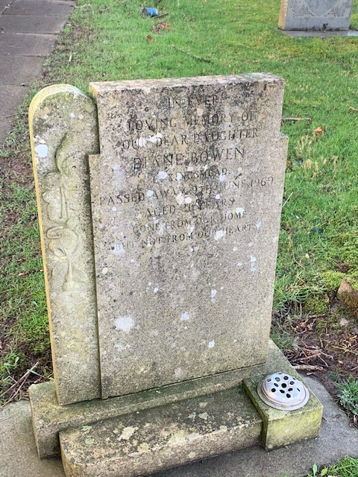 | Diane Bowen  1969  Age 21  Material cement  Type trad  Additions  - Vine inscriptions  - Inscriptions  - “in ever loving memory of are dear daughter”  - “gone from our home but not from our heart”  - Permeant flower vase  Placement G5
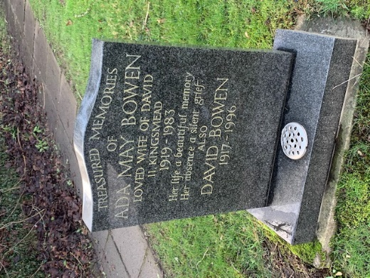 | Ada may bowen  1919-1983  David brown  1917-1996  Type trad  Material reconstructed granite  Inscription  - “her life a beautiful memory her absence a silent grief”  Additions  - Permanent flower vase  Placement E1
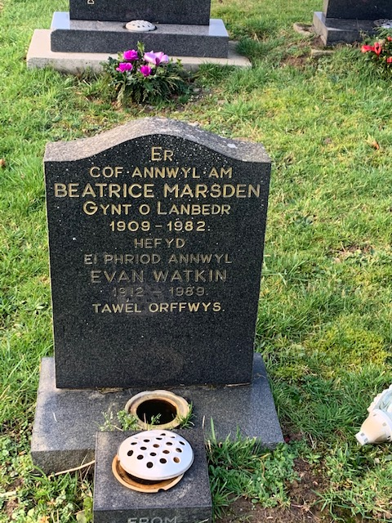 | Beatrice Marsden  1909-1982  Even Watkin  1912-1989  Tawel orffwys  Material reconstructed granite  Type trad  Addition  - Permeant flower vase  - Place of birth of top name  Placement D6
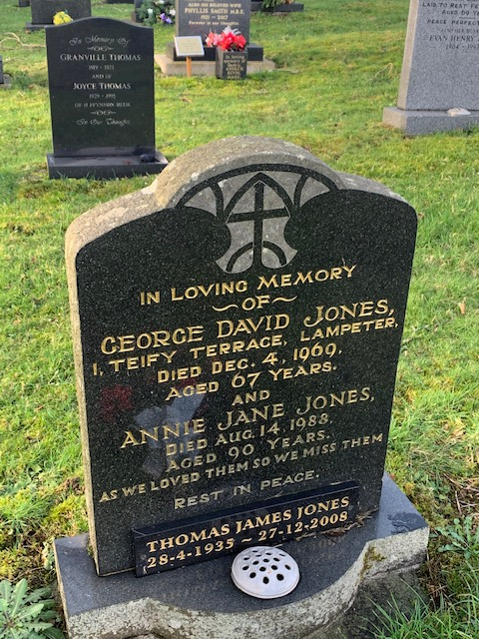 | George David jones  4/12/1969  Age 67  Annie jane Jones  14/8/1988  Age 90  Thomas James Jones  28/4/1935-27/12/2008  Material reconstructed granite  Type trad  Additions  - Permeant flower vase  - Arch inscriptions  Placement E2
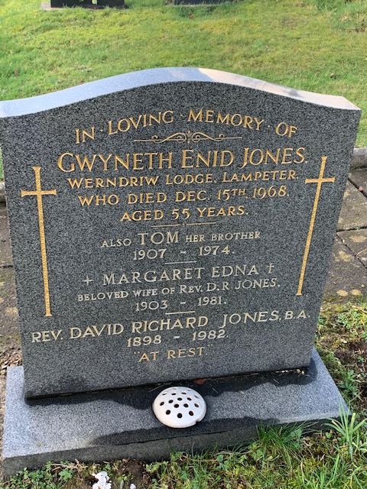 | Gweneth Enid Jones  15/12/1968  Tom  1907-1974  Margret Edna  1903-1982  Type trad  Material marble  Additions  - Permeant flower vase  Inscriptions  - Cross  - “At rest”  Placement D5
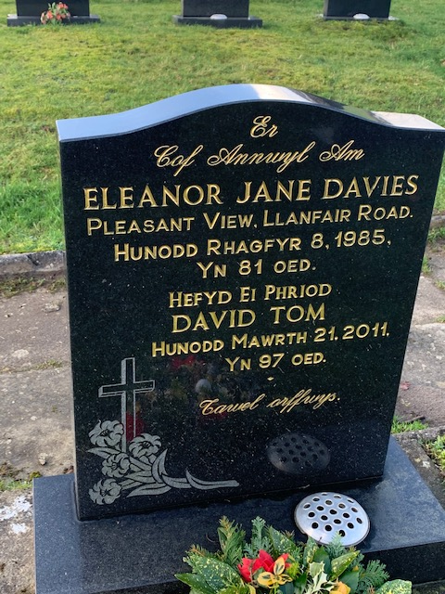 | Eleanor Jane Davies  8/10/1985  Age 81  David Tom  21/3/2011  Age 97  Material reconstrued granite  Type trad  Additions  - Permeant flower vase  - Etching  - Cross  - Passion flowers  - Welsh weighting  Placement H2
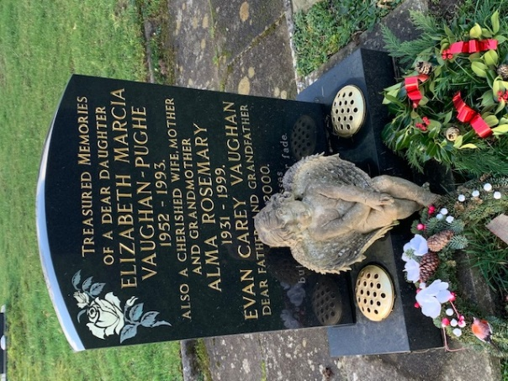 | Elizabeth Marcia Vaughan-pughe  1952-1993  Alma Rosemary  1931-1999  Evan Carey Vaughan  1956-2000  Material reconstructed granite  Type trad  Additions  - Two permanent flower vases  - Cherub (hiding third name)  - Inscriptions  - White Rose  - Links to family  Placement H3
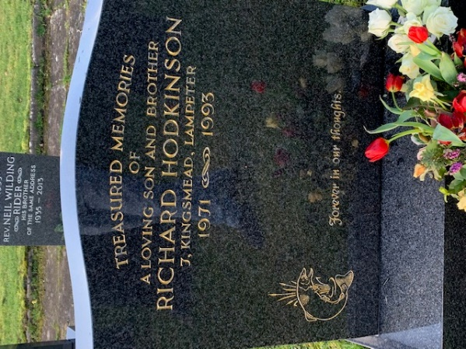 | Richard Hodkinson  1971-1993  Material reconstructed granite  Type trad  Additions  - Trout and river plant inscription  - “forever in our memory”  - Family relation  - “treasured memories of”  Placement H5
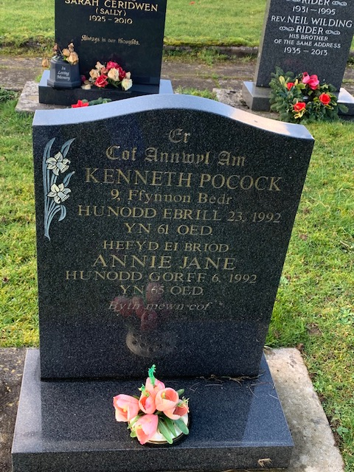 | Kenneth Pocock  23/4/1992  Annie Jane  6/10/1992  Material reconstructed granite  Type trad  Additions  - Permeant flower vase and artificial flowers  - Inscription  - Daisies  - “flyth mewn cof”  - In welsh  Placement H6
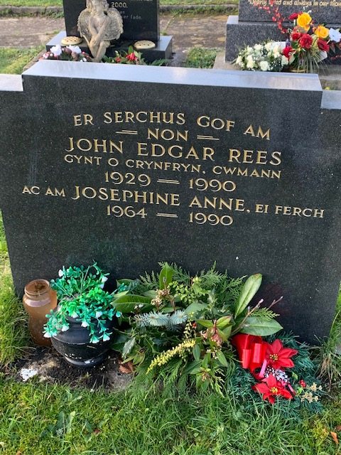 | John Edgar Rees  1929-1990  Josephine Anne  1964-1990  Material reconstructed granite  Type trad  Additions  - Cut angled shaping  - Artificial flowers  - Potts from family  - Welsh inscriptions  Placement H7
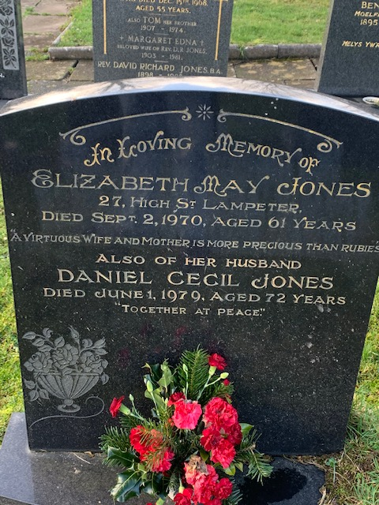 | Elizabeth May Jones  2/10/1970  Age 61  Daniel Cecil Jones  1/6/1979  Age 72  Material reconstrued granite  Type trad  Additions  Inscriptions  - Boll of roses  - Artificial flowers  - “a virtuous wife and mother is more precious than rubies”  - “together at peace”  - “in loving memory”  Placement D7
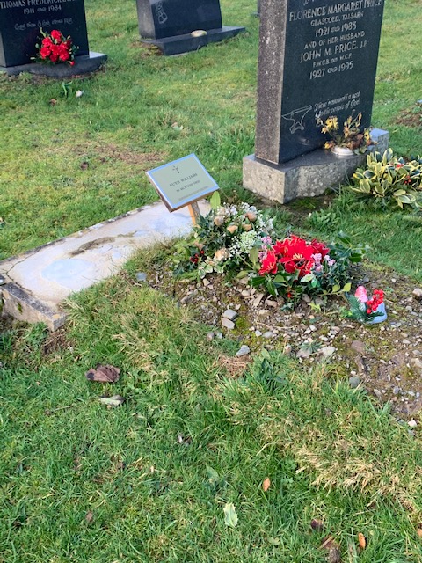 | Keth Wrihsis  1983  Material wood and steel  Type flat  Additions  - Writhe  - Cross  Placement H8
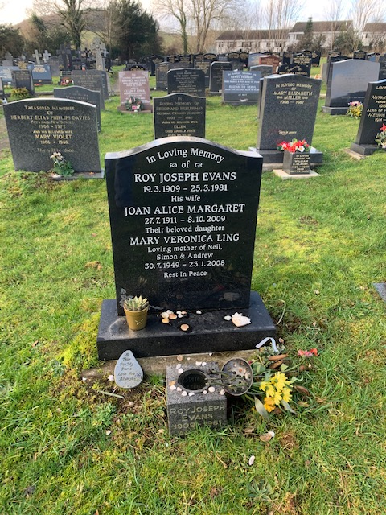 | Roy Joseph Evans  19/3/1909-23/3/1981  Joan Alice Margaret  27/7/1911-8/10/2009  Mary Veronica Ling  Simon and Andrew  30/7/1949-23/1/2008  Material reconstructed granite  Type trad  Additions  - Permanent flower vase  - Artificial flowers  - Inscribed stone  - “rest in peace”  - Family relation  Placement H9
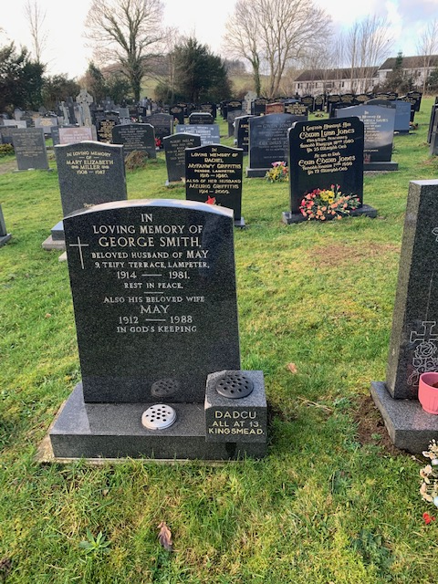 | George Smith  1914-1981  May  1912-1988  Material reconstructed granite  Type trad  Additions  - Simple cross  - “in gods keeping”  - Two permeant flower vases  - Place on origin and main residence  - Relation between them  Placement H10
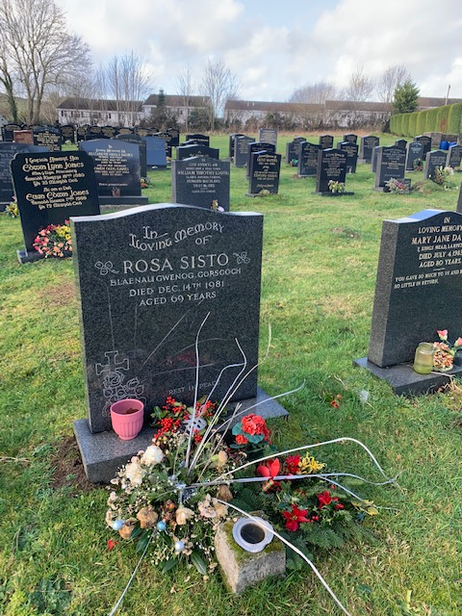 | Rosa Sisto  14/12/1981  Age 69  Material reconstructed granite  Type trad  Additions  - Permeant flower vase  - Writhe  - Etched cross with roses and passion flowers  - Cup  Placement H11
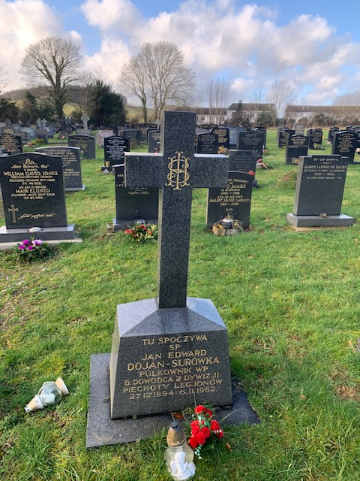 | Jan Edward Dojan-surowka  27/12/1894-6/11/1982  Material reconstructed granite  Type plinth  In polish  Additions  - HIS inscription  - Artificial flowers  - Lamps  - Increased with on base and Hight  - Cross shaping  Placement G6
Beatrice Marsden
1909-1982
Evan Watkin
1912-1989
In welch
Material reconstructed granite
Type trad
Additions
- Permeant flower vase
- “tawel orffwys”
- Curved top
Placement G7
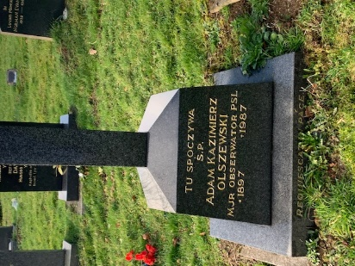 | Adam Kazimierz  1897-1987  Material reconstructed granite  Language polish  Type plinth  Additions  - Wide base  - Cross shaping  - HIS inscription  Placement G7
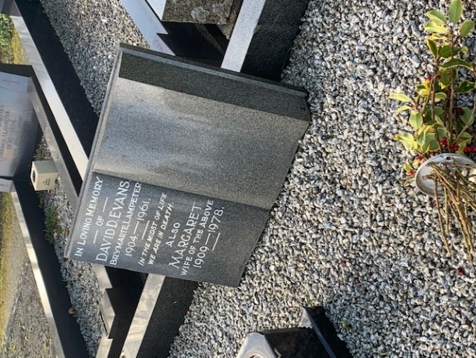 | David Evans  1904-1961  Margret  1909-1987  Material reconstructed granite  Type flat  Additions  - Book shaping open  - Gravel  - Border  - Permeant flower vase  - “in the midst of life, we are in death”  - Artificial flowers  Placement D8
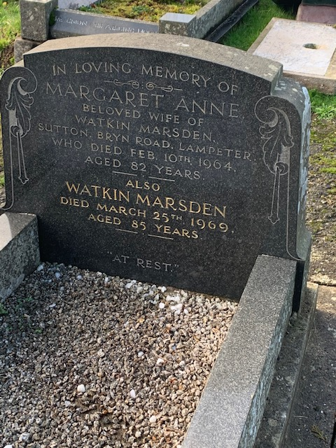 | Margret Anne  10/2/1964  Age 82  Watkin Marsden  25/3/1969  Age 85  Type trad  Material reconstructed granite  Additions  - Gravel  - Border  - “at rest”  - Place of origin  - Bell and leaf inscription  Placement D9
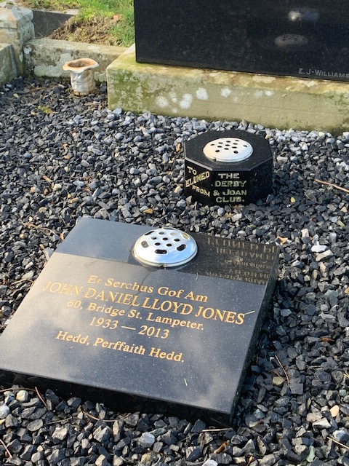 | John Daniel Lloyd Jones  1933-2013  Material reconstructed granite  Type bed  Language welsh  Additions  - “Dedd, perffaith Hedd”  - Place of resident  - Permeant flower vase (donated)  Placement D10
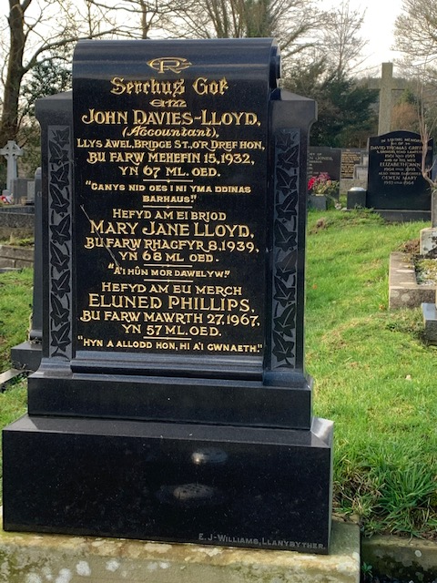 | John Davies Lloyd  15/3/1932  Age 67  Mary Jane Lloyd  8/10/1939  Age 68  Eluned Phillips  27/3/1967  Age 57  Material reconstructed granite  Type trad  Additions  - Scroll shaping  - Vine eching  - “canys nid oes I ni yma ddinas barhaus”  - “a’I hu8n mor dawel yw”  - “hyn a allodd hon hi a’I gwnaeth”  - Family crest  - Increased base Hight  Placement D11
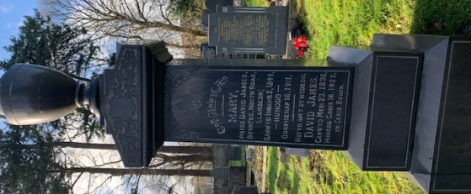 | Mary  16/7/1844-16/1/1911  David James  23/5/1836-16/3/1922  Material reconstructed granite  Type plinth  Additions  - Vines  - Family crest  - Classical Greek design  - Urn  Placement F5
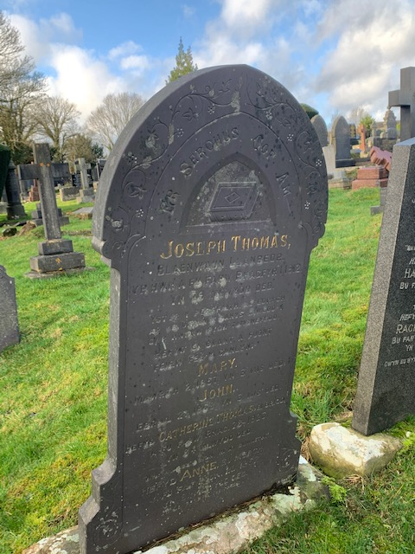 | Joseph Thomas  19/1/1912  Mary  3/2/1837  John  27/5/1873  Catherin  23/6/1829  Thomas  28/5/1923  Anne  18/6/1927  Material slate  Language welsh  Type trad  Additions  - Vines  - Closed book  - Inscription  - Elder flower  Placement F4
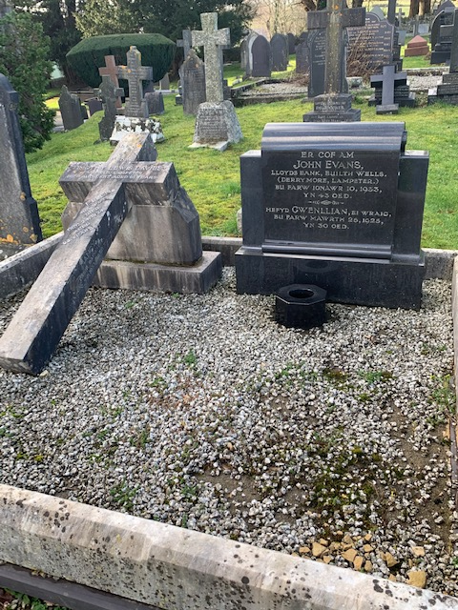 | John Evans  10/10/1933  Age 43  Hefyd Gwenllian  26/3/1926  Age 30  Material reconstructed granite  Type trad  Additions  - Permeant flower vase  - Gravel  - Scroll shaping  Dmies family grave  Language welsh  Material concrete  Type bed  Additions  - Leaning cross  - border  placement
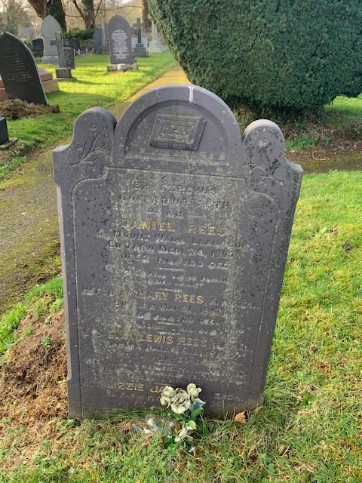 | Daniel Rees  24/3/1967  Mary Rees  24/7/1942  Evan Lewis Rees  12/4/1849  Lizzie Jane  14/8/1819  Type trad  Material slate  Additions  - Closed book  - Passion flowers  - Artistic shaping  - Planted flower  Placement F7
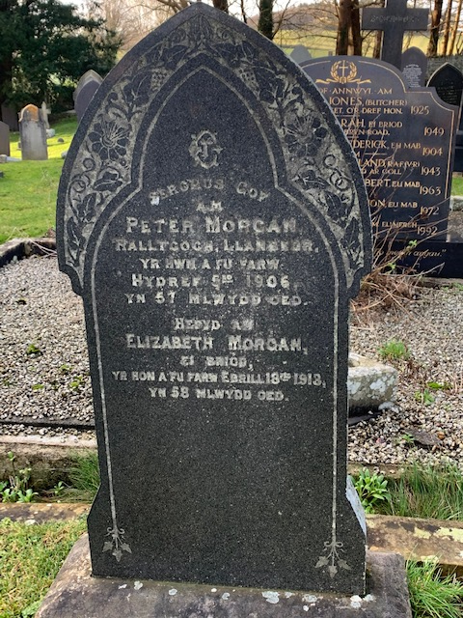 | Peter Morgan  3/8/1906  Age 57  Elizabeth Morgan  18/2/1913  Age 58  Material granite  Type trad  Additions  - spade shaping  - passion flower  - vines  - widened base  - family crest  placement F8
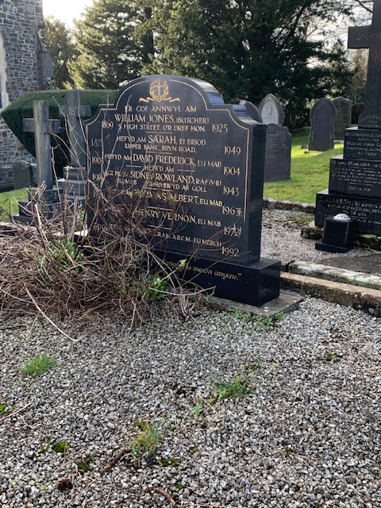 | William Jones  1925  Sarah  1949  David Fredrick  1904  Sidner Rowland  1945  Thomas Albert  1963  Henry Vernon  1972  Vincent  1992  Material reconstructed granite  additions  - Writhed cross  - Gravil  - Border  - Artistic shaping  - Professions  Placement F9
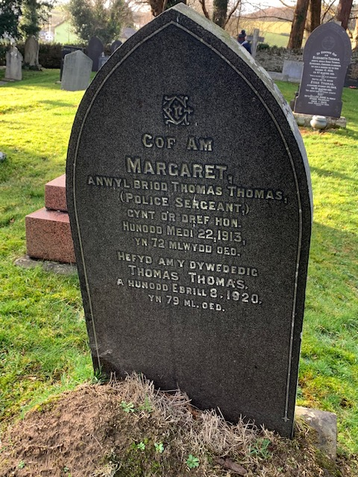 | Marcret  22/6/1913  Age 72  Thomas Thomas  8/8/1920  Age 79  Type trad  Material reconstructed granite  Language welsh  Additions  - Pointed shape  - Widened base  - Husbands profession  - Family crest  Placement F10
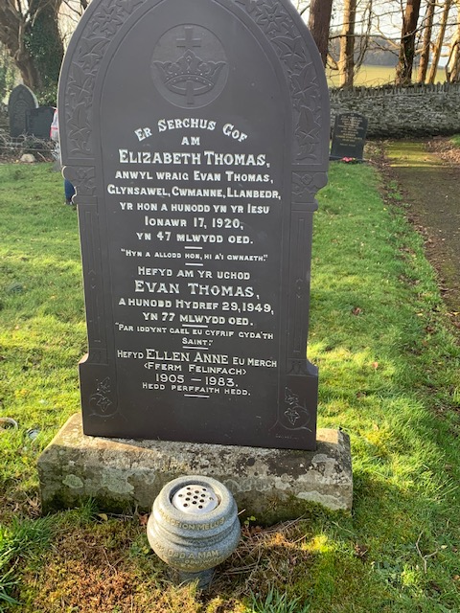 | Elizabeth Thomas  17/9/1920  Age 47  Even Thomas  29/3/1949  Age 77  Ellen Anne  1905-1983  Material slate  Additions  - Cross with a crown  - Arch shaping  - Pillar  - Vines  - Widened base  - Increased hight  Permeant marble flower vase
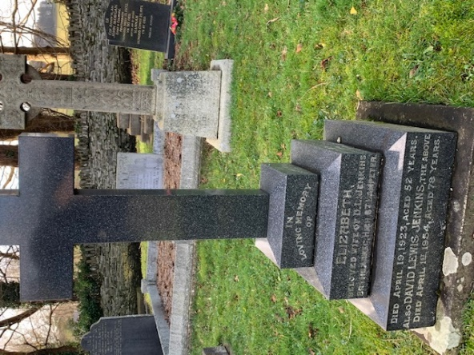 | Elizabeth  19/4/1923  Age 52  David Lewis Jnkins  1/4/1954  Age 78  Material reconstructed granite  Type plinth  Additions  - Relation  - Cross shaping  - Step shaping base  - Stabilising concreate base  Placement F11
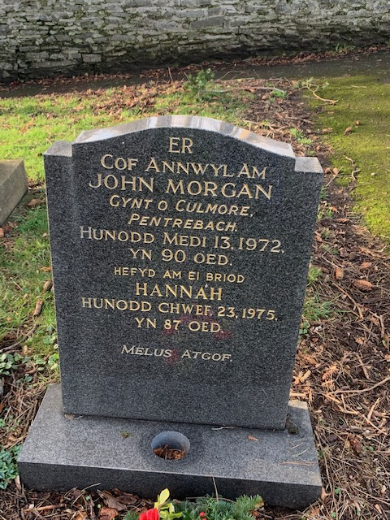 | John Morgan  13/5/1972  Age 90  Hannah  23/7/1975  Age 87  Material granite  Language welsh  Type trad  Additions  - Perment flower vase  - Curved cut artistic shaping  - “melus atgop”  Placement 12
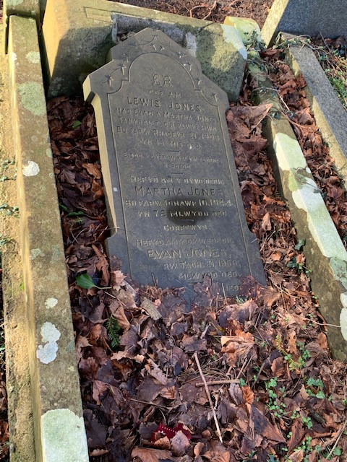 | Lewis Jones  21/7/1903  Age 15  Martha Jones  19/5/1944  Age 72  Evan Jones  18/6/1956  Age 83  Material concrete  Language welsh  Type trad  Collapsed for safety  Additions  - Border  - Housing  - Vines  - Cut edges artistic style  - Family initials  Placement F13
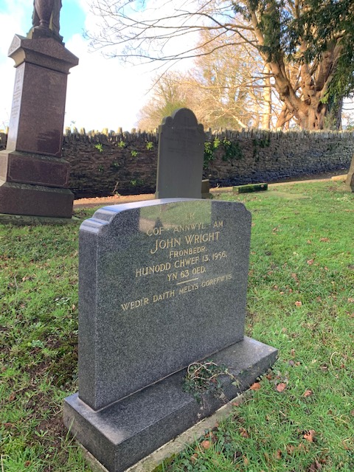 | John Wright  13/9/1956  Age 63  Material granite  Type trad  Language welsh  Additions  - “wedir daith melys gorffwys”  - Family initials  - Permanent flower vase  - Extended base  - Job  Placement F14
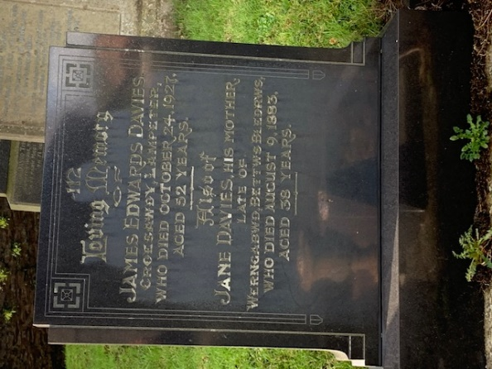 | James Edwards Davies  24/10/1927  Age 52  Jane Davies  9/8/1883  Age 38  Material reconstructed granite  Type trad  Additions  - Artistic modern design sphere shaping and inscription  - Relation (mother)  - Increased with and Hight of base  Placement F15
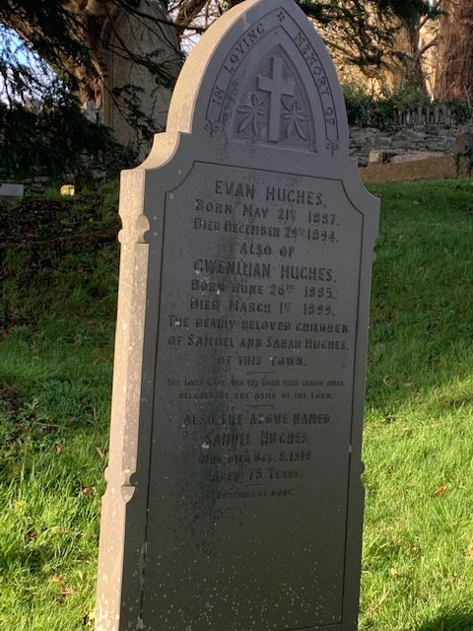 | Evan Huches  21/5/1887-29/12/1894  Cwennillian Huches  26/6/1885-1/3/1899  Samuel Huches  8/5/1918  Age 75  Material concrete  Type trad  Additions  - Cross  - Vines  - “in loving memory” writhe  - Pillar shaping  - Pointed shaping  Placement F16
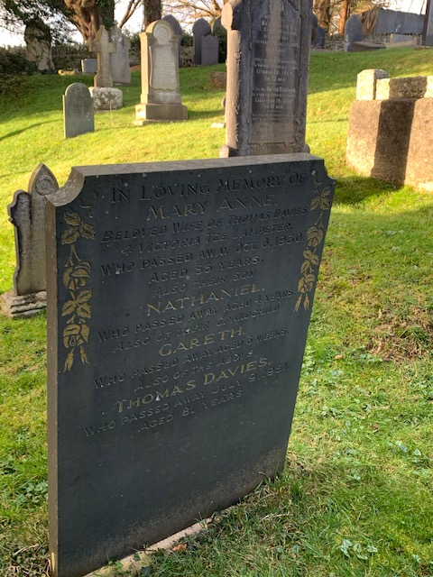 | Mary Anne  6/9/1920  Age 55  Nathaniel  Age 4  Gareth  Age 6 weeks  Thomas Davies  9/6/1951  Age 80  Material slate  Type trad  Additions  - Rose vines  - Box shaping  Placement F17
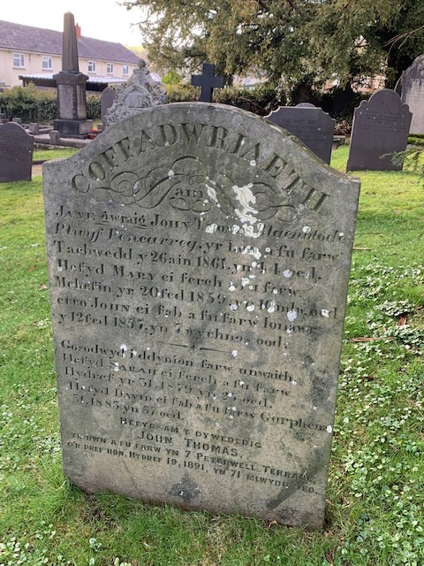 | Jane Gwraig and Johy Thomas  26/11/1861  Age 44  Hefyd mary  20/3/1859  John Thomas  19/6/1891  Age 71  Material concrete  Type trad  Additions  - Swooping underlining  - Poetry  - Curved top  - “COFFADWRIAETH”  Placement A4
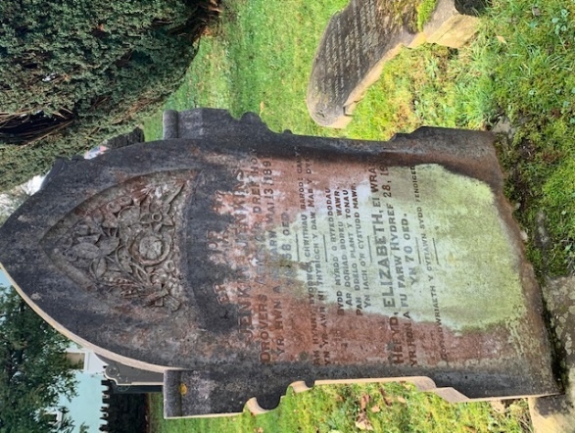 | Jenkin Jenkins  13/5/1891  Age 58  Elizabeth  28/8/1900  Age 70  Material concrete  Type trad  Additions  - Vines, roses, daisies, wheat  - Arched designs  - Pillars  - Medieval artistic style  Placement A5
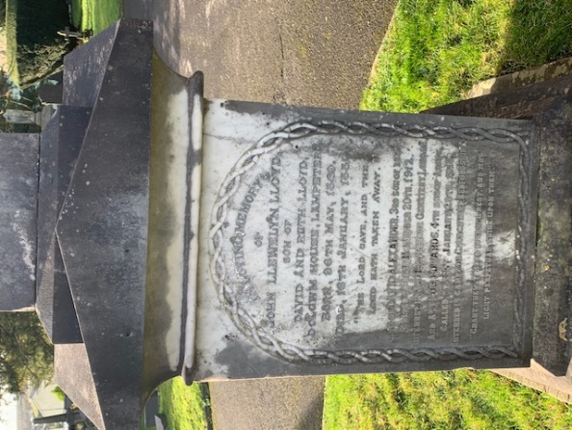 | John Llewelyn Lloyd  26/5/1869-26/1/1881  Material marble  Type plinth  Additions  - Egyptian pillar top  - Greek styling  - Woven arch design  - “grant them lord eternal rest, and may light perpetually shine upon them”  - “the lord gave, and the lord taken away”  - Linking to heritage and achievements  Placement A6
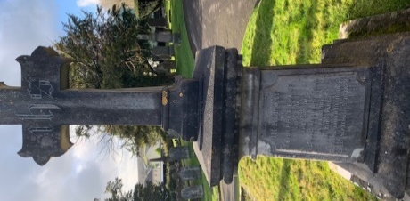 | John price Evans  10/11/1853-5/9/1878  Material concrete  Type plinth  Additions  - Embellished Cross  - t.h.s  - widened base  - arched top  - name plate design  placement B3
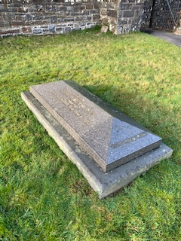 | James Albert Arthur  10/2/1880-21/6/1967  Type table  Material granite  Additions  - Pyramid top  - Concreate base  Placement C1
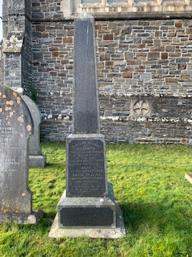 | Elicabeth  25/5/1894  Age 49  David Thomas  26/5/1898  Age 62  Material concrete  Type plinth  Additions  - Place of residence  - “in the most of life we are in death”  - Marble name plate  - Egyptian needle top  Placement C2
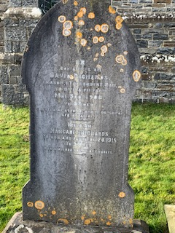 | David Richards  5/5/1908  Age 57  Margret Richards  20/3/1915  Age 57  Language welsh  Material concrete  Type trad  Additions  - Spade shaping  - “HYN A ALLODD HOH HYI AI CWNAETII”  - Family crest  - Widened base  Placement C3
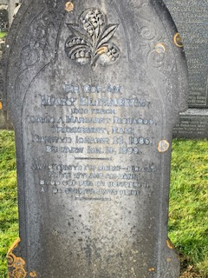 | Margret Richards  23/8/1885-13/3/1899  Material concrete  Type trad  Language welsh  Additions  - Wheat  - Swirling pattern  - Poetry  Placement C4
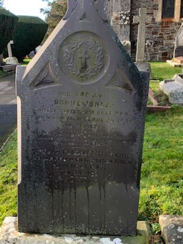 | Daniel Jones  24/7/1884  Age 35  Elizabeth  23/6/1849  Age 34  Material slate  Type trad  Language welsh  Additions  - Church style shaping  - Spire top  - Writhed cross  - Reeds  - Widened concreate base  Placement C5
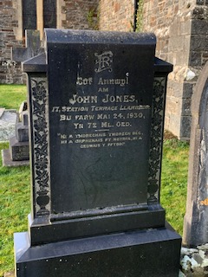 | John Jones  24/5/1930  Age 72  Material reconstructed granite  Type trad  Language  Additions  - Scroll shape  - Initials  - Passion flowers  - Widened base  Placement C6
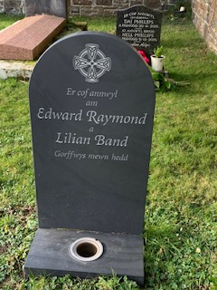 | Edward Raymond  Material slate  Type trad  Language welsh  Additions  - Stylised Celtic cross  - Permeant flower vase  - Extended base  Placement C7
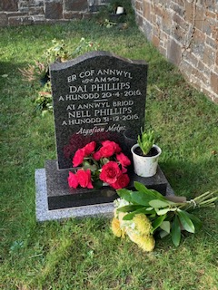 | Dai Phillips  20/4/2016  Nell Philips  31/12/2016  Material reconstructed granite  Type trad  Language welsh  Additions  - Permeant flower vase artificial flowers  - Potted plant  - Extended base  - Marble base  - “atgafem Malget”  Placement C8
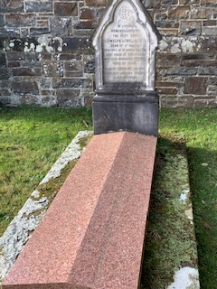 | Llewelyn Lewellin  1859  Age 30  Material marble and granite  Type trad and table  Additions  - Church shaping  - HIS symbolism  - Widened concrete base  - Red granite covering  Placement C9
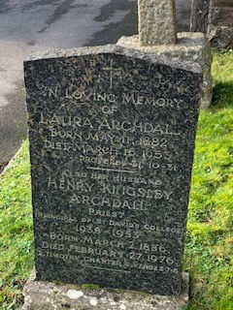 | Laura Archdal  11/5/1882-16/3/1853  Henry Kingsley Archdall  3/3/1886-27/2/1976  Material granite  Type trad  Additions  - Cross  - Cut shaping  - Profession (priest)  - Concreate base  - Place of employment  Placement C10
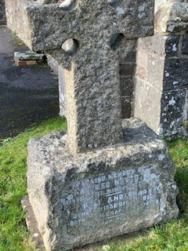 | Alfred Noyes  23/5/1939  Neli  12/6/1888-13/12/1938  Material lime stone  Type plinth  Additions  Circled cross  Widened base  Profession (vicar)  Placement C11
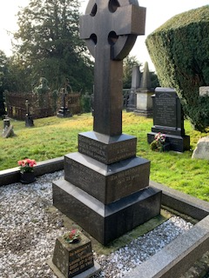 | John Fowden  17/6/1901  Age 67  Anne  23/3/1912  Age 79  Material reconstructed granite  Type plinth  Additions  - Encircled cross  - Permeant flower vase  - Stepped and widened base  - Border  - Gravel  Placement B4
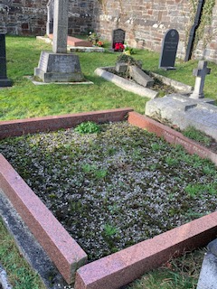 | Lember  2/3/1989  Relem  19/4/1954  Witter  7/4/1978  Material reconstructed red granite  Type bed  Additions  - Gravel  - Concrete base  - “in loving memory”  Placement C12
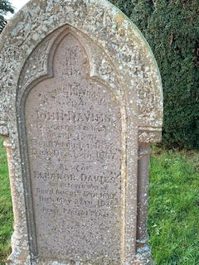 | John Davies  1/4/1832-18/7/1877  Elanor Davies  17/10/1904-27/5/1945  Material concrete  Type trad  Additions  - Arch shaping  - Greek pillar shaping  - Initials  - Vines  - Passion flowers  Placement B5
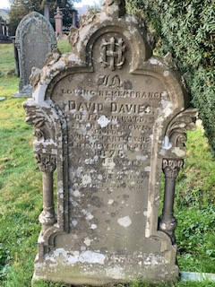 | David Davies  21/11/1875  Materials concrete  Type trad  Additions  - heavy ornamentation  - Roman pillars  - HIS symbolism  - Vine  - Initials  - Wheat  Placement B6
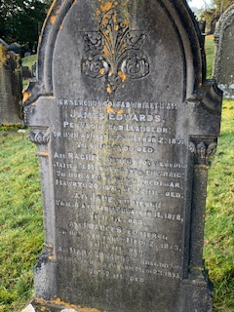 | James Edwards  2/10/1871  Age 68  Jane  18/11/1878  Age 38  Janeite  2/4/1873  Age 57  Harry Edwards  23/5/1873  Age 62  Material marble  Type trad  Additions  - Roman pillars  - Arch shaping  - Crest= cut wheat, closed roses, vines  Placement B7
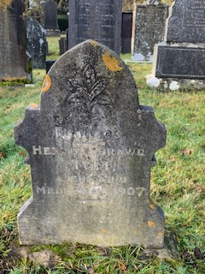 | Henry Drawe  19/5/1907  Material concrete  Type trad  Foot stone  Small  Language welsh  Additions  - Five leafed plant  - Church shaping  Placement B8
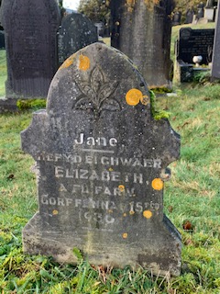 | Jane or Elizabeth  15/8/1936  Material concrete  Type trad  Language welsh  Foot stone  small  Additions  • Five leafed plant  • Church shaping  Placement B9
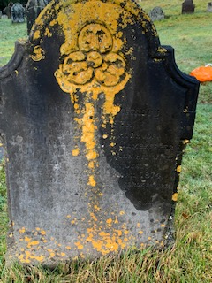 | Sarah James  1874  Material concrete  Language welsh  Type trad  Additions  - Artistic curved shaping  - Passion flower  - Description of relation and employment  - Outlining  Placement B10
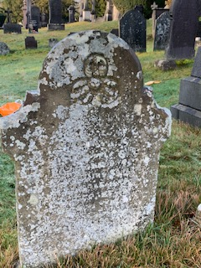 | 1873  Material concreates  Type trad  Additions  - Artistic curved shaping  - Passion flower  - Description of relation and employment  - Outlining  Placement B11
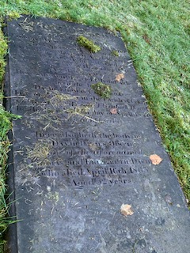 | John Jenkins  1834  Material concrete  Type table  Language welsh  Additions  - Family connections  - Bible verse  Placement B12
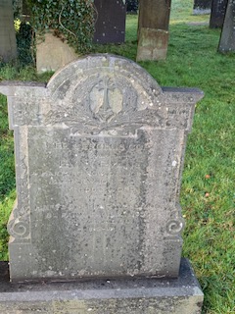 | Evan Evans  4/4/1911  Age 66  Mary  12/3/1920  Age 70  Material concrete  Type trad  Language welsh  small  Additions  - Writhed cross  - Wheat  - Widened base  - Greek accents  Placement B13
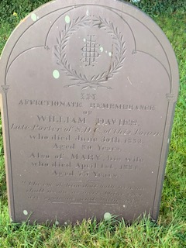 | William Davies  30/6/1884  Age 30  Mary 1/4/1881  Material marble  Type trad  Additions  - Curved shape  - Arch etching  - Writhe  - HIS symbol  - Bible verse  - Job  - Three Xs  Placement B14
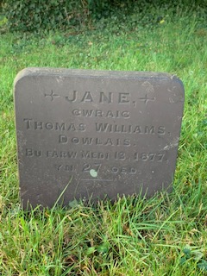 | Thomas Williams  13/3/1877  Age 27  Material slate  Language welsh  Type trad small possible footstone  Additions  - JANE  - Arrows for Jane  Placement B15
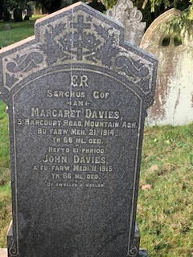 | Margret Davies  21/3/1914  Age 68  John Davies  11/5/1915  Age 66  Language welsh  Additions  - Crown and cross  - Writhe  - Stars  - Edged and pointed shaping  - Aria of residence  - “dt awmllys a waliik”  - Swirling patterns  - Widened base  Placement B16
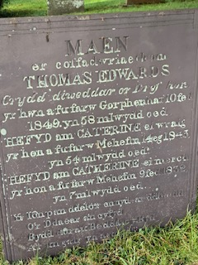 | Thomas Edwards  10/11/1849  Age 58  Catherine  14/7/1843  Age 54  Catherine  9/2/1832  Age 7  Material slate  Type trad  Language welsh  Additions  - Relation to each other  - MAEN  - Edge shaping on sides  - Bible verse  Placement B17
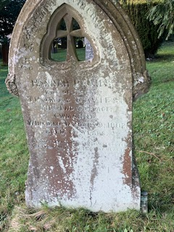 | Hannah Davies  Thomas Davies  1802  material concrete  type trad  language welsh  additions  - pointed shape  - clover shape with carved out cross  - grapes  - bible verse  - edge  placement B18
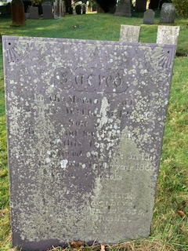 | Will Davies  1868  Material slate  Type trad  Language welsh  Additions  - Accents on corners  - Bible verse  Placement B21
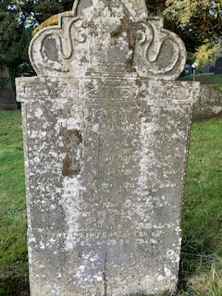 | John  1812  Material marble  Type trad  Language welsh  Additions  - Top placement  - Chest  - Vines  - Spiral on side  Placement B20
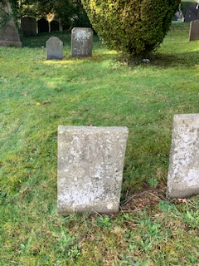 | Childs grave  1868  6-month-old  Material slate  Type trad  Apprentice practice piece  Language welsh  Additions  • Bible verse  • Mothers words  Placement B19
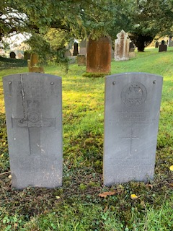 | War memorials  1945  Material slate  Type trad  Additions  - Poppies  - Cross  - Description of dedication  - Army seal  Placement B22
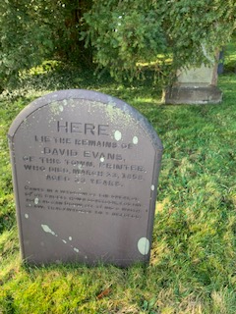 | David Evans  22/3/1858  Age 23  Material slate  Type trad  Additions  - Smoothed/curved sides  - Welsh description of life  - Town of origin  Placement B23
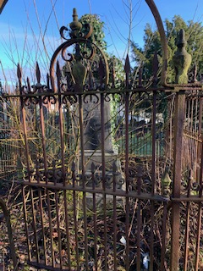 | John Westminster  10/12/1806-30/4/1836  Type trad  Material concrete  Language welsh  Additions  - Iron fence  - Two level concrete base  - Increased Hight and mass  - Left to rot  Placement B24

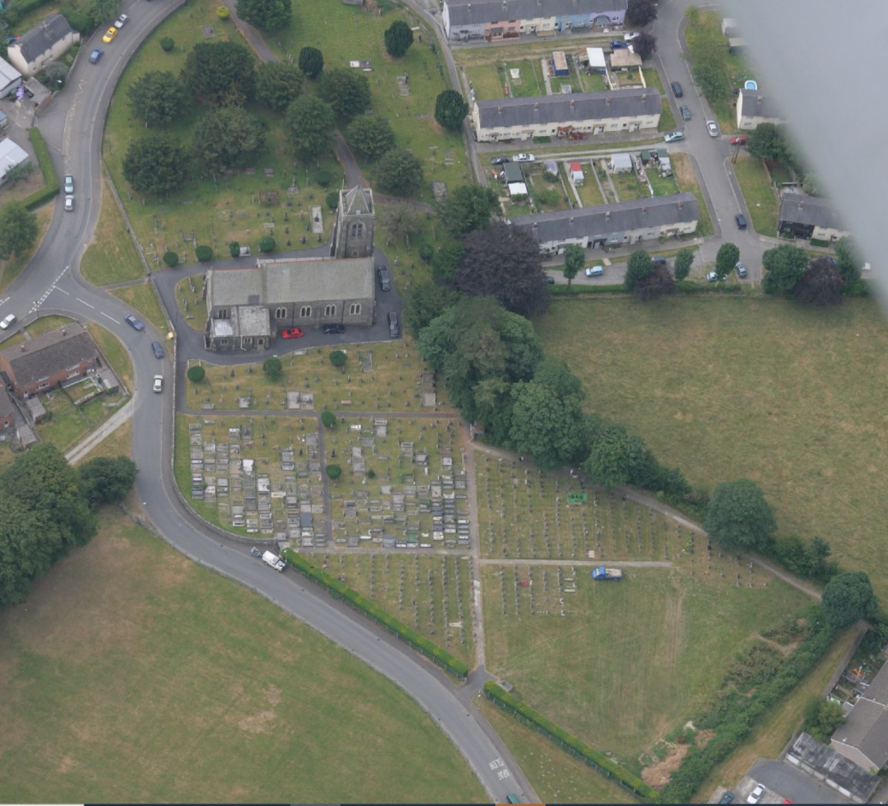
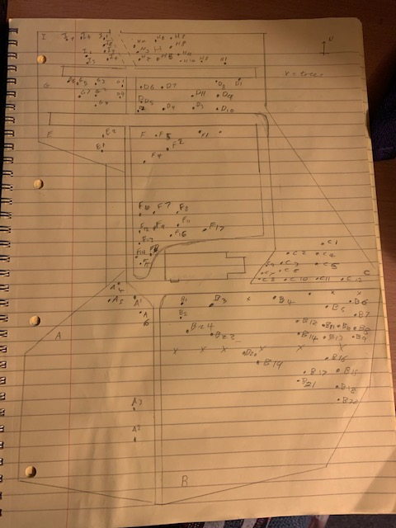
photo | Name:  Date:  Type:  Material:  Language:  Additions:  Placement:

