Module-Research Methods-M7X01371
The effectiveness and implementation of modern technologies into Altrads (mechanical) fabrication and quality controls to produce a more efficient Quality Management System
(Connecting Manufacturing)
Author: - Adrian Devonald

The purpose of this study is to examine the current quality management system in which Altrad (mechanical) currently implement within the organisation and to explore possible areas that could be improved to enable a more sufficient working system. For this, the aim is to explore a number of different controls that are currently in place within the organisation from the handling and issue of materials, fabrication control from concept right through to site installation. My goal is to develop a single system into which integrates all aspect of fabrication quality control which can be implemented company wide, to allow users to view a live system which enables live access to all pending, ongoing and complete activities within the organisation, bringing together aspect of quality, commercial and safety to produce a more efficient system.

Literature Review
Altrad, are a global leader in the provision of industrial services, generating high added value solutions principally for the Oil & Gas, Energy, Power Generation, Process, Environment and Construction sectors. The group is also a recognised leader in the manufacturing of equipment dedicated to the Construction and Building market. (Altrad.com, 2018)

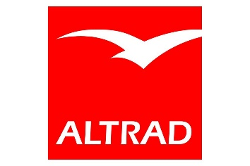
(Altrad.com, 2018)
Altrad’s multidisciplinary services range from engineering and technical services to maintenance, access solutions and specialised services for industry leaders. The Group, headquartered in France, employs around 42,000 people and owns established international brands including Cape, Hertel and Prezioso Linjebygg. (Altrad.com, 2018)
At present, there are a number of legislations, industry standards that are to be applied when producing structural steel and process piping fabrications. Within the Pembroke workshop, we produce both in which we must be certified to BSEN 1090 for all steel work structures, and ASME V B31.3 for all pipe work fabrications.
The objective of this paper is to analyse the possible influences and the positive effects of implementation of ISO 9001 (del Castillo-Peces et al., 2018) in to which are adapted and put into place within the Altrads system. Areas of potential improvement are evident into the way controls are currently implemented in the Altrads QMS, adding to this are the inheritance of new procedures.
Altrad have recently acquired Cape Plc, Redhall Engineering, Hertel and Hertel Mechanical into the business, all of which all had their own quality management systems in place. I plan to research how all fabrication was controlled within each company prior to the takeover to enable me to concentrate on the positives features in which could be implemented into the concept. I will send out questionnaires to each divisions Quality managers to assess how all fabrication and quality controls are implemented within their facility. Once the information is received and reviewed, my aim is to develop a system/software in which standardises the way in which the company manage and handle all quality factors within the fabricating/ welding activities within the organisation. This can be from maintenance works, projects and turnaround activities emphasising on information received and the way into which it is stored and communicated with another parties, internally and externally. One sole data base within an organisation (Altrad), specific to our works which will enable live access to all in process and works complete. Further to this, the aim is to introduce third parties to the software, for example NDT companies, painting contractors and transportation resources to enable the whole process to be managed from one system. Currently there are a number of separate data bases, forms to be filled out to enable each action to be arranged and process. So, enabling other parties access to see only authorised information, the process as a whole should be more efficient and easier for the user to control. Software development (SD) is a complex process, executed in the contexts quite far from the certainty with changing technology and requirements (Stacey, 2002). (Ochodek and Kopczyńska, 2018). Further to this, the environmental factor of reducing the amount of paper waste is crucial into the systems development.

Methodology/ Research Objectives
Altrad are a certified ISO 9001 :2015 organisation. ISO 9001 is the international standard that specifies requirements for a quality management system (QMS). Organizations use the standard to demonstrate the ability to consistently provide products and services that meet customer and regulatory requirements. It is the most popular standard in the ISO 9000 series and the only standard in the series to which organizations can certify. (Asq.org, 2018)
Within Altrad, we control and monitor all our activities throughout. But I feel there is a down fall due to the amount of different systems, software used and inherited from previous companies into which are put in place to adhere to the requirements in ISO 9001 (ASME B31.3 and BSEN 1090).

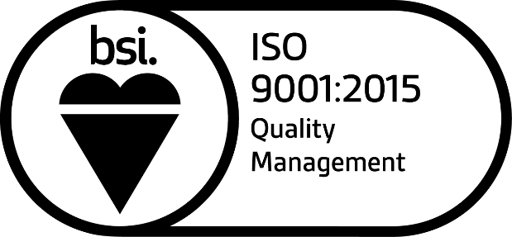
(Bsigroup.com, 2018)
My aim is to examine the variables into the way in which goods are received, put into manufacturing and then released for shipping in detail, picking up on any down falls into which can be addressed. Within Altrad, there are many separate databases/ drives into which information is kept, that only specific/ approved personnel can view with permitted access. Therefore, producing a system in which can control all these factors from one location would be more effective and productive within the organisation. Following on are a number of factors in which I feel are the most critical to incorporate within the system due to the high level of management and surveillance throughout the fabrication process.
Material Control/Issue
Material issue/control is an integral part of our organisation. We only receive goods from approved supplies in which Altrad have audited and have built relationships with over the years. We implement a in house system called the ‘goods inwards inspection certificate’ (GIIC) into which is complete when any materials are delivered to site. All deliveries are sent to our good inwards location into which everything is held prior to inspection/signed in by a competent store man.
Material control refers to the various measures adopted to reduce the amount of loss of materials at the time of receiving, storing and issuing the raw materials. Material control in practice is exercised through records and reports relating to purchasing, storage and issuing of materials, fabrication, inspection and sign off. (Your Article Library, 2018).
As mentioned, Altrads material controllers fill out a ‘goods inwards inspection certificate’ into which is complete once materials are delivered/received. They are recorded per job/project number into which the certificate number on the GIIC is transferred onto the materials so as when all materials issued, traceability is present when quality checks are carried out.
The time and resource that are put into material control at present are much to be improved into a more efficient procedure. Introducing electronic hand scanners with bar codes is an example in which could be implemented to allow a quicker process when receiving and issuing materials. All to which will be recorded back to the master database to enable full traceability throughout the fabrication process. Following on from this, any surplus materials which remain after the job is complete, can be identified on the system, therefore creating less waste and taken into consideration when sourcing materials for further works.
Welding Control/Consumables
As a mechanical engineering company, welding is a hugely important discipline within the organisation. We fabricate a number of different items form storage tanks, stair ways, platforms, process piping and alike. We have clients all over the world into which we have to accommodate as per client’s requests. But predominantly all our works are covered under the standard industry codes: - For the Plating fabrication we are accredited to BSEN 1090, and for the piping, we are certified to ASME V, B31.1. and B31.3
BSEN 1090
BSEN 1090 is the harmonised standard which covers constructional steel and aluminium. Since 2014, products within the scope of this standard must comply and be marked with the CE Markings when realised to the customer. (Bsigroup.com, 2018). Within Altrad, all structural steel items manufactured will have a certificate in which will be kept on file and sent to the client to state its complies with BS EN 1090. The director of the company is the only person legally to sign the certificate prior to release.
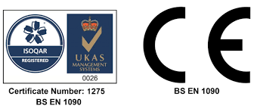
(Bsigroup.com, 2018).

ASME V, B31.3.
B31.3 is a construction code for the manufacturing and testing of new pipework. It has been defining piping safety since 1922. ASME B31.3 contains requirements for piping typically found in petroleum refineries; chemical, pharmaceutical, textile, paper, semiconductor, and cryogenic plants; and related processing plants and terminals. It covers materials and components, design, fabrication, assembly, erection, examination, inspection, and testing of piping. (Asme.org, 2018)

(Asme.org, 2018)
Within each fabrication workshop, Altrad employ a full-time welding inspector into which oversees all welding activities. From the control and issuing of welding consumables, to the fabrication process, welding and quality checks. The system would incorporate a live welding database into which would create a up to date status of each job issued within the workshop enabling full traceability and status to all supervision, managers and alike as well as easily available information for clients of their fabrications with ease. Further to this, productivity per welder and facility can easily be access by managers and directors to see if there are any downfall in these certain areas. Again, a hand-held device allowing the user to access work packs at the work face, with electronic copies of the drawings issued for construction also available. All NDT requests could be sent electronically from the database as would be directly linked to email/third party contractors.
Quality Management
Efficient productivity is key within the fabrication industry. When clients specify items in which are required, companies have to react and produce quality products in a timely manner. An effective quality system within the organisation is the key element to producing quality products
The ISO 9001 standard cannot only be considered as an initial step to simple conformation to quality requirements but also as a framework for the improvement of the effectiveness of the quality management system (QMS) (McGuire and Dilts 2008). (Psomas and Antony, 2014)
Quality manuals, test procedures, industry standards, product specifications, equipment calibration etc are all crucial documents relating to all fabrication factors within the organisation. All these would be loaded onto the system to enable access when required by approved personnel. Along with this, all the training records of personnel employed by Altrad can all be uploaded in which is really available when required. For example, when compiling a final handover QA Dossier for a client, all information would be available on one program, from material certification, welding/fabrication log, welder qualifications, NDT reports, paint reports and any other documentation in which the client request. Further information like third parties’ qualifications could also be uploaded for full traceability when external contractors carry out any works- e.g. NDT, painting contractors.
Connecting Manufacturing (Paperless)
As the nation becomes more environmentally and economically conscious, many businesses and organization are investigating paperless processes. “The terms ‘paperless,’ electronic,’ and ‘digital’ are often used interchangeably to describe work which previously was done with paper, but which now has been adapted to information and communication technology devices and software.” (Brusco, 2011)
Although we as a company recycle paper waste accordingly, I feel the amount of work that involves hard copies can be that of the past introducing new technologies into Altrads facilities. With relation to the subjects mentioned above, the number of different documents that are involved are vast. Although following company procedures, a lot of these could be made redundant if an electronic system where to be introduce. Altrad have many forms/documents in which are printed/filled out on a daily basis and sent to client’s worldwide, with original copies being archived on site.
The days of filing cabinets stuffed with paper files may be coming to an end. More and more companies and organizations are making the shift toward electronic filing, saving space and increasing security. Large computer servers have the ability to store mass quantities of information in a secure state and location. The integrity of files also can be maintained more easily via an electronic format. (Brusco, 2011)
With the world rapidly evolving and new technologies produce daily, I feel we as a company still adopt a very manual system into which improvements can be made.
The concept will consider the amount of paper used and recycled and will try and reduced the requirements for paper. Hand held mobile electronic devices with the system readily available for updates would be issued to the workshop to record all daily activities. Materials can be recorded and logged in as per delivery/ job. Supervision can update on progress at the work face allowing up to date information to senior supervisor and mangers with ease.
Ethical Considerations
All Altrads or third party’s information and qualification that would be uploaded onto the system would be stored with the upmost confidentiality. Not everyone using the program would have access to this information, but personnel who would require access, as in training managers and quality managers would be granted access. The system would also aim to highlight training records in which are due for renewal or prolongation (welder qualifications).
Along with in house qualifications and training records, all third-party qualifications, for example NDT technician’s certification could be uploaded with consent, to enable this information to be part of the final quality dossier in which would be sent to clients or alike.
Project Milestones
The overall aim of this software system is to create and implement a sufficient way to manage all quality factors and fabrication within the organisation. A single system in which can control all the above factors, materials, fabrication controls and quality from concept right through to installation to enhance the business efficiency/ productivity. An electronic program creating a paperless system therefore having an impact on environmental factors.
Developing and creating such software could lower associated costs, reduce the required number of interfaces and provide a much higher degree of delivery to associated clients.

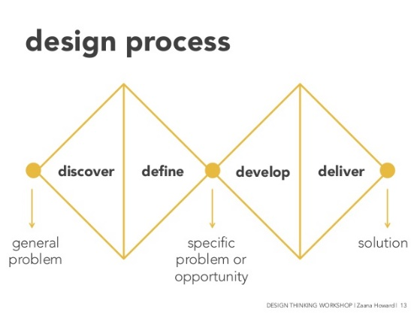
(Slideshare.net, 2018)

As the illustration above states, the aim is to discover a problem within, research and define my recording, develop a system to create a more efficient concept, and to implement the system accordingly within Altrads organisation.
Further to this, once initial development of the software has been established within all Altrads fabrication workshops, the aim would be to further the scope and explore third party contractors in which they too could have access to the relevant sectors of the software applicable to their organisation, whereas works can be book/scheduled e.g. NDT, in a more sufficient manner.
I recently visited one of our most commonly used third party NDT companies for a vendor audit, into which I discussed the concept with the facility manager into which feedback was positive. I plan to discuss further and record all findings with an official meeting with a number of companies in which all comments will be implemented when developing the concept.
Resources Needed
Not all companies can adopt quality management methods at the same pace, nor can they all achieve the same level of QMS effectiveness. Firm characteristics such as company size, industry type or process type are often considered as important factors that may affect whether and how well quality management practices are applied in organisations (Zu et al. 2011). (Psomas and Antony, 2014)

This concept will explore the areas mentioned in this paper in more detail and analyse the data to see how improvements can be implemented accordingly. Taking the factors of other manufacturing branches into consideration, my aim will be to develop and send out survey to all levels of employment within the business from supervision in the workshop to commercial managers to see how they manage the above factors and how they feel any improvements can be implemented to make a more sufficient process in which will befit the organisation going forward.

Reference
Altrad.com. (2018). Altrad, learning more about the industrial services company - Altrad Group. [online] Available at: https://www.altrad.com/en/altrad-at-a-glance.html [Accessed 1 Nov. 2018].
del Castillo-Peces, C., Mercado-Idoeta, C., Prado-Roman, M. and del Castillo-Feito, C. (2018). The influence of motivations and other factors on the results of implementing ISO 9001 standards. European Research on Management and Business Economics, 24(1), pp.33-41.
Ochodek, M. and Kopczyńska, S. (2018). Perceived importance of agile requirements engineering practices – A survey. Journal of Systems and Software, 143, pp.29-43.
Asq.org. (2018). ISO 9001:2015 - What is the 9001 Version 2015 Standard? | ASQ. [online] Available at: http://asq.org/learn-about-quality/iso-9000/iso-9001-2015/ [Accessed 1 Nov. 2018].
Bsigroup.com. (2018). Certification for ISO 9001 Quality Management | BSI Group. [online] Available at: https://www.bsigroup.com/en-GB/iso-9001-quality-management/Certification-for-ISO-9001/ [Accessed 1 Nov. 2018].
Your Article Library. (2018). Material Control: Meaning, Objectives, Necessity and Importance. [online] Available at: http://www.yourarticlelibrary.com/material-management/material-control-meaning-objectives-necessity-and-importance/26145 [Accessed 2 Nov. 2018].
Bsigroup.com. (2018). [online] Available at: https://www.bsigroup.com/LocalFiles/en-GB/Kitemark/EN1090/BSI-EN-1090-Structural-Steel-Guide-UK-EN.pdf [Accessed 6 Nov. 2018].
Asme.org. (2018). ASME - STANDARDS - Process Piping. [online] Available at: https://www.asme.org/products/codes-standards/b313-2016-process-piping [Accessed 5 Nov. 2018].
Psomas, E. and Antony, J. (2014). The effectiveness of the ISO 9001 quality management system and its influential critical factors in Greek manufacturing companies. International Journal of Production Research, 53(7), pp.2089-2099.
Brusco, J. (2011). Trending Toward Paperless. AORN Journal, 94(1), pp.13-18.
Slideshare.net. (2018). design process discover deﬁne develop. [online] Available at: https://www.slideshare.net/zaana/design-thinking-for-designing-and-delivering-services-35376919/14-design_processdiscover_dene_develop_deliverdiverge [Accessed 13 Nov. 2018].
Psomas, E. and Antony, J. (2014). The effectiveness of the ISO 9001 quality management system and its influential critical factors in Greek manufacturing companies. International Journal of Production Research, 53(7), pp.2089-2099.

