Student Name: Alina-Adriana Badea  Student ID: 2234830  Module Title: Foreign Languages & Cultural Awareness  Module Code: BMIH5003  Lecturer: Lisa Bassler  Date: 09 February 2024 | 
ASSIGNMENT 1: PORTFOLIO
(4 Components)

Component 1: Professional Reflection (500 words +/- 10%)

Weighting: 25%
While working within the Food & Beverage Operations for the Belton Woods Hotel, I had the opportunity to witness an incident which made me realise the importance of cultural awareness in the workplace. The incident happened at the beginning of a wedding reception. The colleague working behind the bar had been tasked with walking around the ballroom and offering the guests a free drink. He was also told that the wedding party consisted mainly of Muslim and Christian guests. My colleague filled his tray with alcoholic drinks only and proceeded to offer them to the guests present, however, it did not take long until one of the Muslim guests took offense to being offered alcohol and asked to see a manager.
I believe that in this example, the cultural misunderstanding was caused by a lack of awareness regarding the religious beliefs and preferences of the wedding guests.
This has taught me that a very important skill one must have when working the hospitality sector is cultural awareness and sensitivity. This is needed to help understand and respect the customs, beliefs, and preferences of different cultural and religious groups. All this falls under the ‘intangible’ aspects of culture of which Abramson and Moran talk in their book Managing Cultural Differences (Abramson and Moran, 2018, p. 51).
Another important skill someone working behind the bar should have, is active listening, as I believe if my colleague would have been actively listening to the briefing received from his manager, he would have asked further questions related to the guest’s background and requested clarification as to why this information was important (Deresky, 2017, p. 194).
However, I feel like it is not just my bar-colleague who should benefit from an upskilling, but also the Food & Beverage Operations Manager who could improve their communication skills. According to John Kotter, Harvard Business School professor, a mistake made by many leader is that they ‘under-communicate’ their expectations (Gallo, 2022). This situation could have been avoided if the manager would have made it clear to the team what the expectation was, and not leave it up to them to understand the implications of what the guest’s background meant.
Attention to detail is another key skill that both the bar colleague and the manager could benefit from developing. The manager should have noticed that his employee only had alcoholic drinks on his tray and advise him of the correct process before the bar colleague started walking amongst the wedding party. But at the same time, my colleague should have been able to tell that some of the guests felt offended by him offering them an alcoholic drink and stop to question why this might be.
In conclusion, I feel like everyone working in the hospitality business, including myself, should prioritise cultural awareness training to avoid finding themselves in uncomfortable situations and causing offence to customers. Ideally, when joining this field, one should already have skills such as active listening, good communication and attention to detail, but there is always room for improvement, and you should never stop trying to develop your own skills.

References:
Abramson, NR. and Moran, RT. (2018) Managing Cultural Differences. 10th edn. Oxon: Rutledge.
Deresky, H. (2017) International management : managing across borders and cultures. 9th edn. Harlow: Pearson Education Limited.
Gallo, C. (2022) ‘How Great Leaders Communicate’, Harvard Business Review, 23 November. Available at: https://hbr.org/2022/11/how-great-leaders-communicate (accessed: 5th February).

Component 2: Training Plan (500 words +/- 10%)

Weighting: 25%

Identified cultural misunderstanding (in a few words) :
Recently, one of our staff members from Food & Beverage operations has generated a customer complaint due to a lack of understanding of another culture’s religious beliefs and preferences. This highlighted several areas of improvement needed for all staff members, including management.
Training plan (Why/What//Who/Where/When):
The following training plan is required so that staff at Belton Woods Hotel can gain a deeper understanding of the influence that the presence of different cultural backgrounds has on the guest experience. It will also look at helping them improve their attention to details and active listening skills as well as developing their communication skills. Lastly, the training plan will aim to explain how to modify their service delivery to accommodate various religious and cultural preferences, while encouraging employees to work in an inclusive and professional atmosphere.
To begin with, we will look at discussing how crucial it is to recognise and value the distinct cultural backgrounds of each guest. To do so, we will be considering the concept of cultural competence and its connection to providing excellent customer service. Cultural competence will be trained by using a technique described in Hofstede’s book ‘Cultures and organizations: software of the mind : international cooperation and its importance for survival’ where a group of employees will be asked to identify “pure cultures” from a selection of 10 “synthetic cultures”, by then having to use their selected culture to problem-solve several situations (Hofstede, Hofstede and Minkov, 2010, p. 216).
Second, we will look at improving their active listening skills, and with this, their communication skills. To achieve this we will also resort to group training where we will encourage staff to respond to the information being communicated by “reflecting back” through questions and body language (Thomson, 2018, p. 96).
Third, in order to improve staff’s attention to details skills, we will provide management with a checklist for service delivery, including considerations relating to how to meet different cultural preferences. We will also strive to teach employees to notice non-verbal indicators related to culture, such as food habits, language preferences, and religious practices.
Lastly, we will look at providing both staff and management with conflict resolution skills when it comes to cultural misunderstandings, by teaching them how to resist applying stereotypes and viewing other people's deeds, morals, and views through the prism of their culture. They will be asked to study as much as they can about the cultures of each side in order to combat this inclination. This entails researching not just the behaviours and customs of various cultures but also the justifications for the behaviours and customs that individuals follow. (Shonk, 2023).
The effectiveness of this training will be evaluated through the following methods: feedback from guests on how they felt about the cultural sensitivity and awareness of staff members; carry out post-training assessments to verify the program's effectiveness and identify areas that require development; and finally, by obtaining feedback from staff on their perceptions of their own knowledge related to cultural awareness.
References:
Hofstede, G., Hofstede, GJ. and Minkov, M. (2010) Cultures and organizations: software of the mind : international cooperation and its importance for survival. 3rd edn. New York: McGraw-Hill.
Thomson, N. (2018) Effective communication: a guide for the people professions. 3rd edn. London: Palgrave Macmillan.
Shonk, K. (2023) ‘How to Resolve Cultural Conflict: Overcoming Cultural Barriers at the Negotiation Table’ Program of Negotiation – Harvard School, 03 August. Available at: https://www.pon.harvard.edu/daily/conflict-resolution/a-cross-cultural-negotiation-example-how-to-overcome-cultural-barriers/ (accessed: 5th February 2024).
Component 3: Student Self-Reflection (500 words +/- 10%)

Weighting: 25%
Over the past five weeks, I have had a significant shift in my understanding of the importance of cultural awareness in the hospitality industry. Initially, my understanding of the topic was limited to the core concepts of respecting guests' cultural variety and providing services that take these differences into consideration. I knew how important it was to avoid cultural misunderstandings and provide guests of all origins a sense of appreciation and belonging.
I became more and more fascinated by the complex dynamics of cross-cultural encounters in hospitality settings as I learned more about the topic. I understood that meeting the needs of varied guests effectively takes a deeper grasp of cultural conventions, attitudes, and behaviours than just making shallow gestures. This is known as cultural awareness (Muchazondida, 2010, p. 273-274). As an example, I can refer to how surprised I felt when learning that in Russia it is insulting to show someone a thumbs up, a gesture that is so positive and harmless in other cultures. This only showed me how much I still have to learn if I want to be successful in this field.
Through my studies, I learned that cultural awareness is not only a moral or ethical imperative for businesses in the hospitality sector, but it is also a strategic benefit for those organisations and institutions. I realised this while working on my presentation for this module, when I understood how a gesture as simple as asking a Spanish guest about their family can significantly impact the outcome of a business meeting. Increased levels of customer satisfaction and loyalty, as well as overall corporate success, are a result of pleasant experiences and inclusive environments for guests. This only made me understand that perhaps cultural intelligence plays a more significant role in hospitality than emotional one (Bakir et al. , 2017).
With the help of examples provided by colleagues and my lecturer during class, I began to examine a wide range of cultural awareness variables, including language skills, culinary preferences, religious considerations, and interaction techniques. I understood that rather than merely reacting to cultural differences when they occur, it is necessary to make proactive attempts to anticipate and accommodate a variety of needs in order to demonstrate cultural competency.
Furthermore, I'm curious as to why cultural awareness is important in the hospitality industry. The answer lies in the core of hospitality, which is based on welcoming and caring for guests from a range of backgrounds. Positive word-of-mouth, customer satisfaction, and loyalty will all rise as a result. As described by Walker and Walker in their book ‘Introduction to Hospitality Management’, globalisation and diversity are 2 of the main trends happening currently in hospitality (Walker and Walker, 2014, p. 40), and in order to be successful ones needs to adapt to these trends.
To sum up, my journey on cultural awareness in hospitality has been profound. I have gained greater understanding of the topic, insightful knowledge from my experiences, and realised the critical role that cultural sensitivity plays in hospitality. I am dedicated to lifelong learning, development, and the practical implementation of cultural sensitivity concepts in order to establish surroundings that are inclusive and friendly to all visitors.

References:
Bakir, A., Wickens, E., Boluk, K., & Avgeli, V. (2017), ’Cross-cultural issues in tourism and hospitality’ , Tourism and Hospitality Research, Vol. 17, Issue 3 (June). DOI: https://doi.org/10.1177/1467358416653868 .
Muchazondida, M. (2010) ‘Cultural Awareness and the Global Hospitality Business’ , Tourism Analysis, Vol. 15, Issue 2 (July): 273-278. DOI:10.3727/108354210X12724863553686 .
Walker, JR. and Walker, JT. (2014) Introduction to Hospitality Management, 4th edn. Harlow: Pearson Education Limited.

Component 4: Training Presentation (6 Slides)

Weighting: 25%
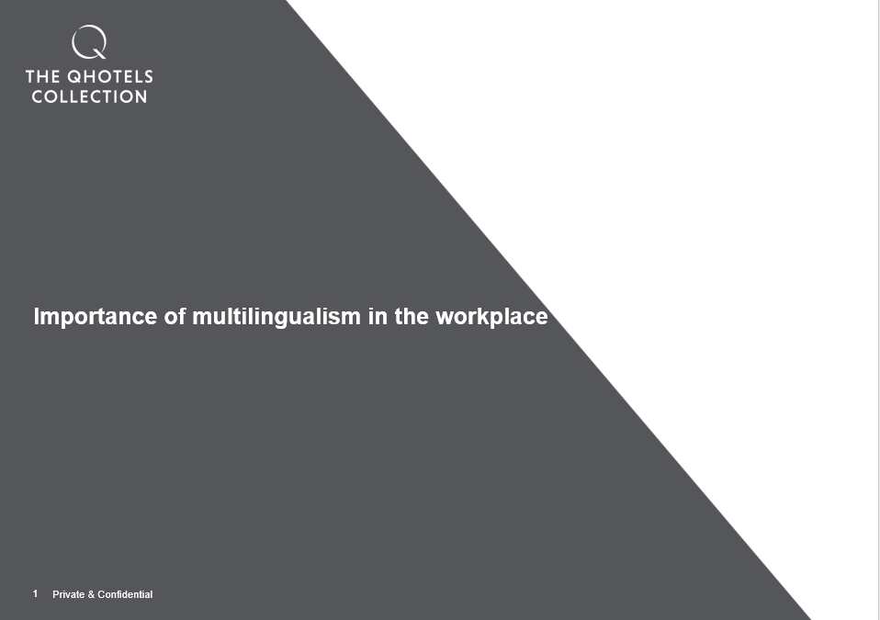
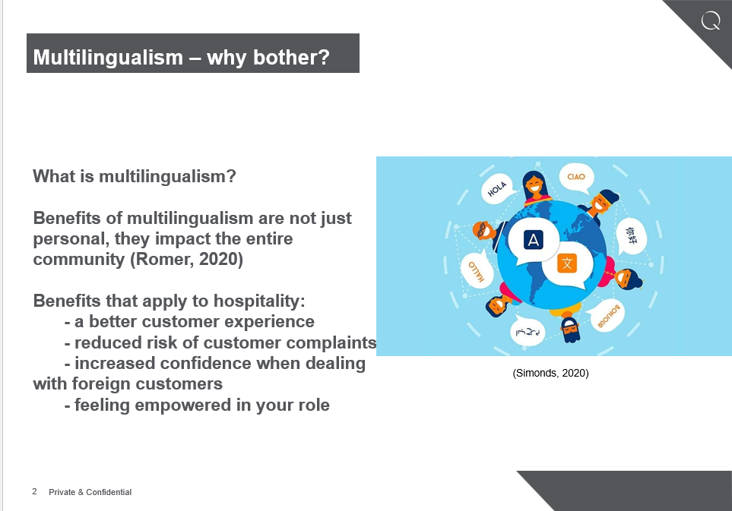
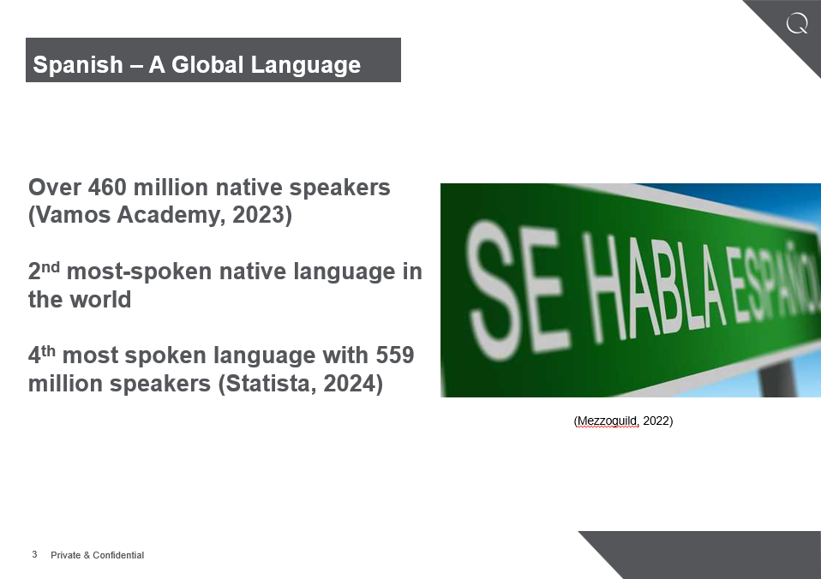
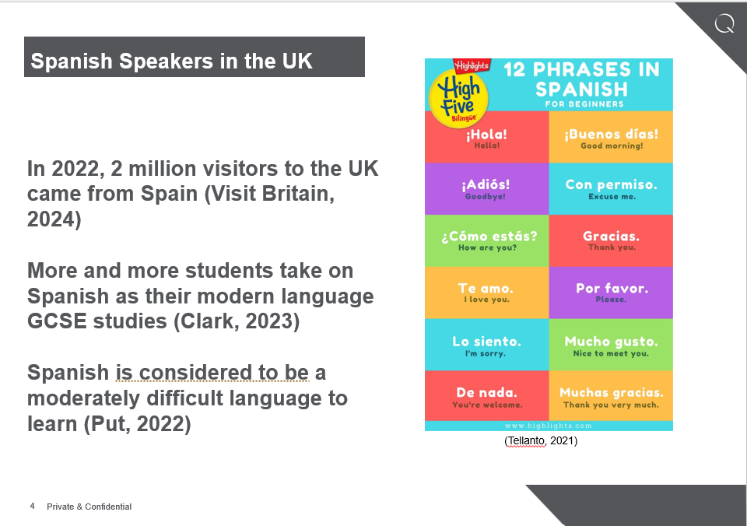
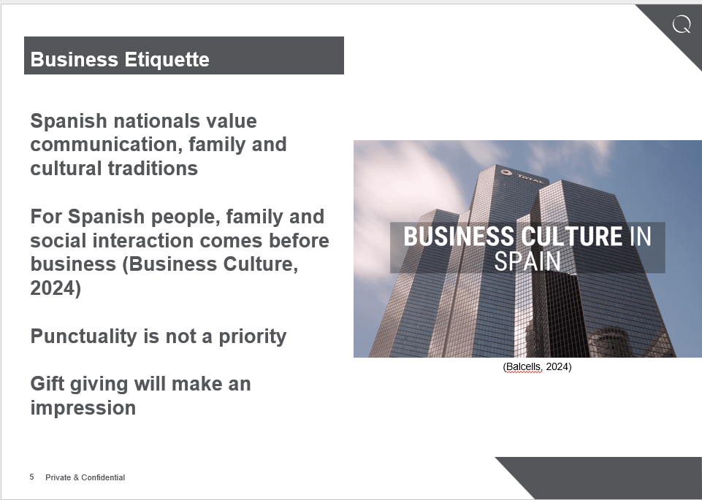
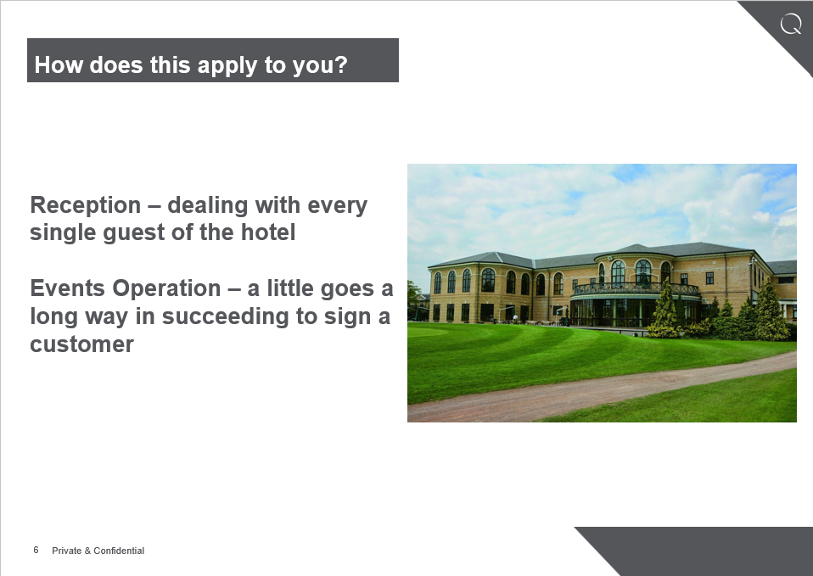
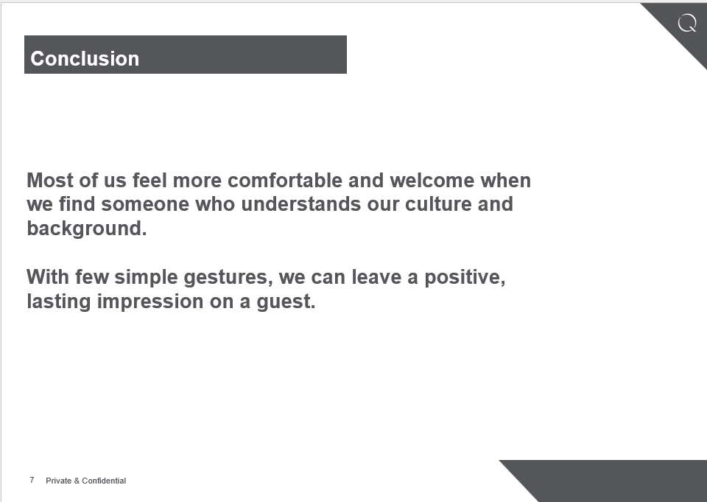
References (no screenshots):
Business Culture (2024) ‘Business etiquette’. Available at: https://businessculture.org/southern-europe/business-culture-in-spain/business-etiquette-in-spain/ (accessed: 3rd February 2024).
Clark, D. (2023) ‘Languages in the UK - Statistics & Facts’, Statista, 20 December. Available at: https://www.statista.com/topics/2288/languages-in-the-united-kingdom/#topicOverview (accessed: 3rd February).
Put, O. (2022) ‘Is Spanish Hard to Learn?’, Homeschool Spanish Academy, 28 January. Available at: https://www.spanish.academy/blog/is-spanish-hard-to-learn/ (accessed: 3rd February 2024).
Romer, K. (2020) ‘Multilingualism: The language of sustainable development’ The Life Long Learning Blog, 21 February. Available at: https://thelifelonglearningblog.uil.unesco.org/2020/02/21/multilingualism-the-language-of-sustainable-development/ (accessed: 3rd February 2024).
Statista (2024) ‘The most spoken languages worldwide in 2023’. Available at: https://www.statista.com/statistics/266808/the-most-spoken-languages-worldwide/ (accessed: 3rd February 2024).
Vamos Academy (2023) ‘The Evolution of Spanish Language Over the Centuries’, 19 October. Available at: https://vamospanish.com/discover/the-evolution-of-spanish-language-over-the-centuries/ (accessed: 3rd February 2024).
Visit Britain (2024) ‘Spain’. Available at: https://www.visitbritain.org/research-insights/inbound-markets/spain (accessed: 3rd February 2024).

Image References
Balcells (2024) ‘Business Culture in Spain: Management Culture, Communication and Etiquette’. Available at: https://balcellsgroup.com/business-culture-in-spain/ (accessed: 3rd February).
Lopez, J. (2022) ‘Here Are 21 Countries Where Spanish Is An Official Language’, Mezzoguild. Available at: https://www.mezzoguild.com/spanish-countries/ . (accessed: 3rd February).
Tellanto (2021) ‘How To Become Fluent in Spanish in 3 Months?’. Available at: https://www.tellanto.com/blog/become-fluent-spanish/ (accessed: 3rd February 2024).
Simonds, B. (2020) ‘The Pros and Cons of Multilingualism’ Little Meetings, 4 May. Available at: https://medium.com/@littlemeetings/the-pros-and-cons-of-multilingualism-d654169ddfe . (accessed: 3rd February 2024).

