University of Wales Trinity Saint David
Wales Institute of Science and Art


Electronics Circuit Testing and Application

Vehicle Electronics ACHA4031

Will McPherson
2501006
19/04/2026
Contents
1 Task 3 1
1.1 Scope Time Division Calculations (6) 1
1.2 Function Generator output square wave (6) 1
1.3 Capacitor charge and discharge wave marked at correct points. (6) 1
1.4 Basic Capacitor Calculations (6) 1
1.5 Capacitor discharge table (5) 1
1.6 Plot log(V) Gradient (5) 1
1.7 Gradient Calculations and Compare(8) 1
1.7.1 Gradient Calculations 1
1.7.2 Comparison table 1
1.8 Capacitor Uses (5) 1
1.9 Inaccuracies Question (4) 2
1.10 Risk Question (10) 2
2 References 3

Task 3

Scope Time Division Calculations (6)

Function Generator output square wave (6)
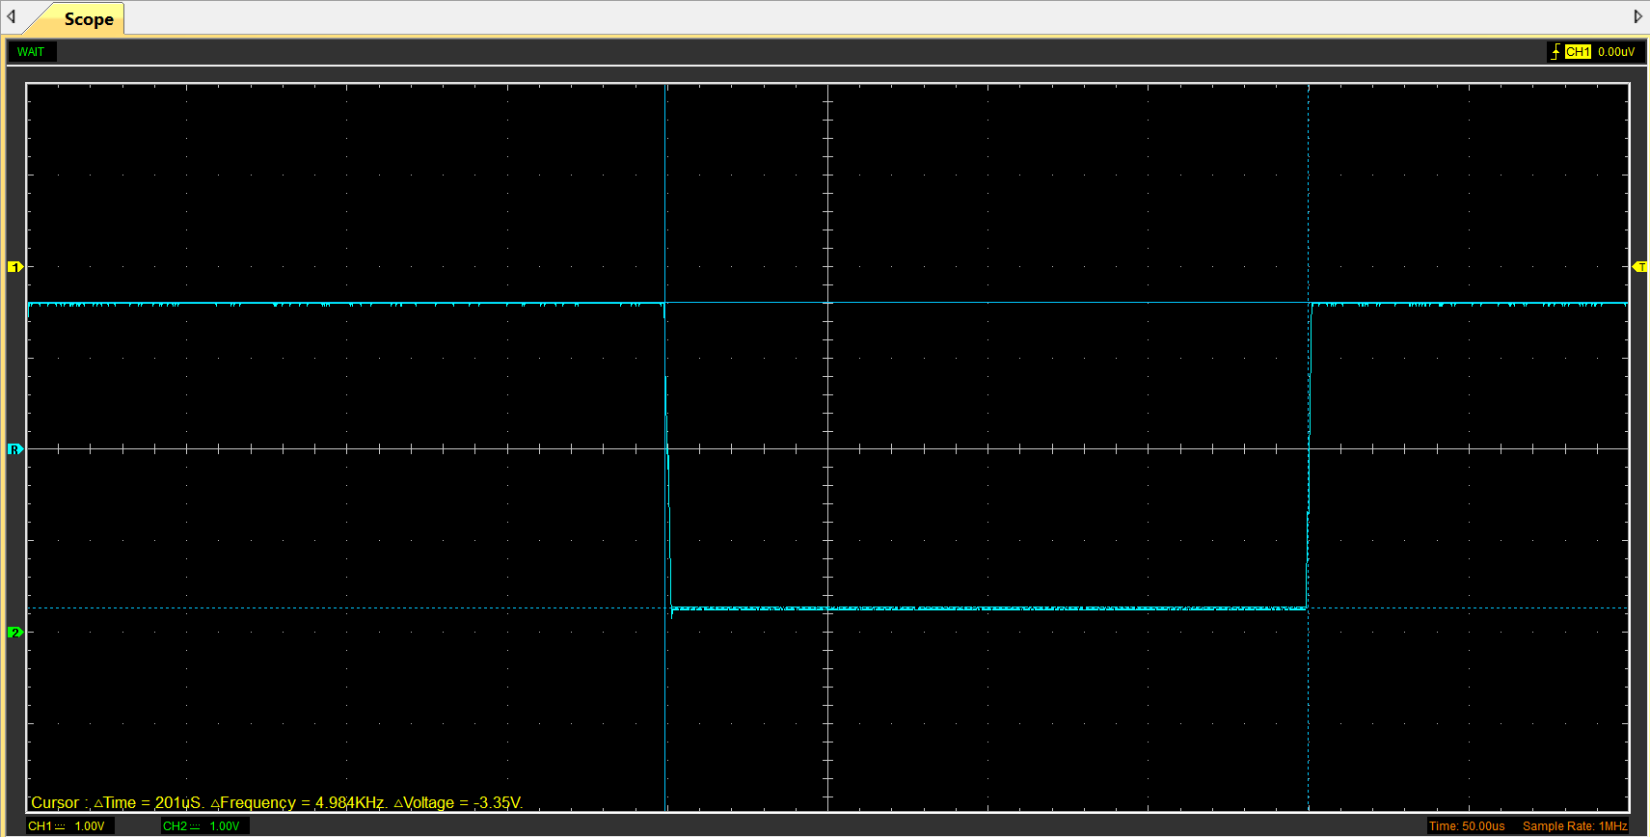

Capacitor charge and discharge wave marked at correct points. (6)
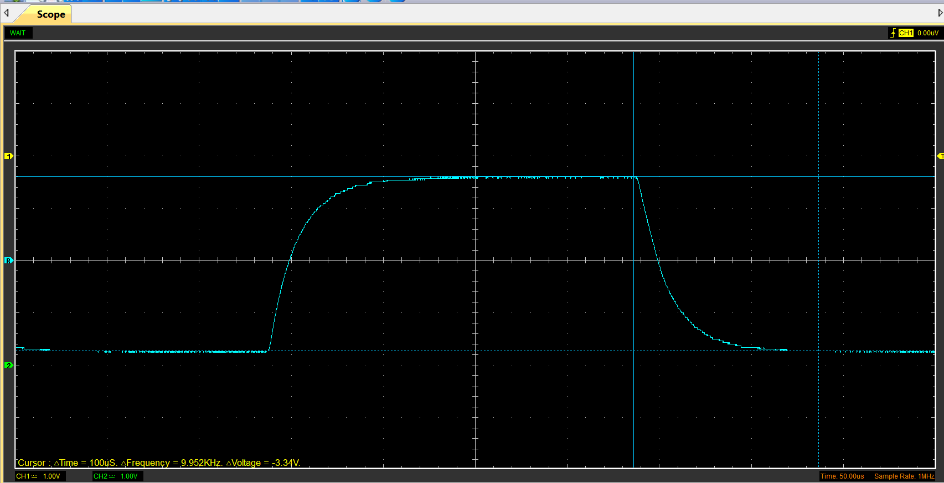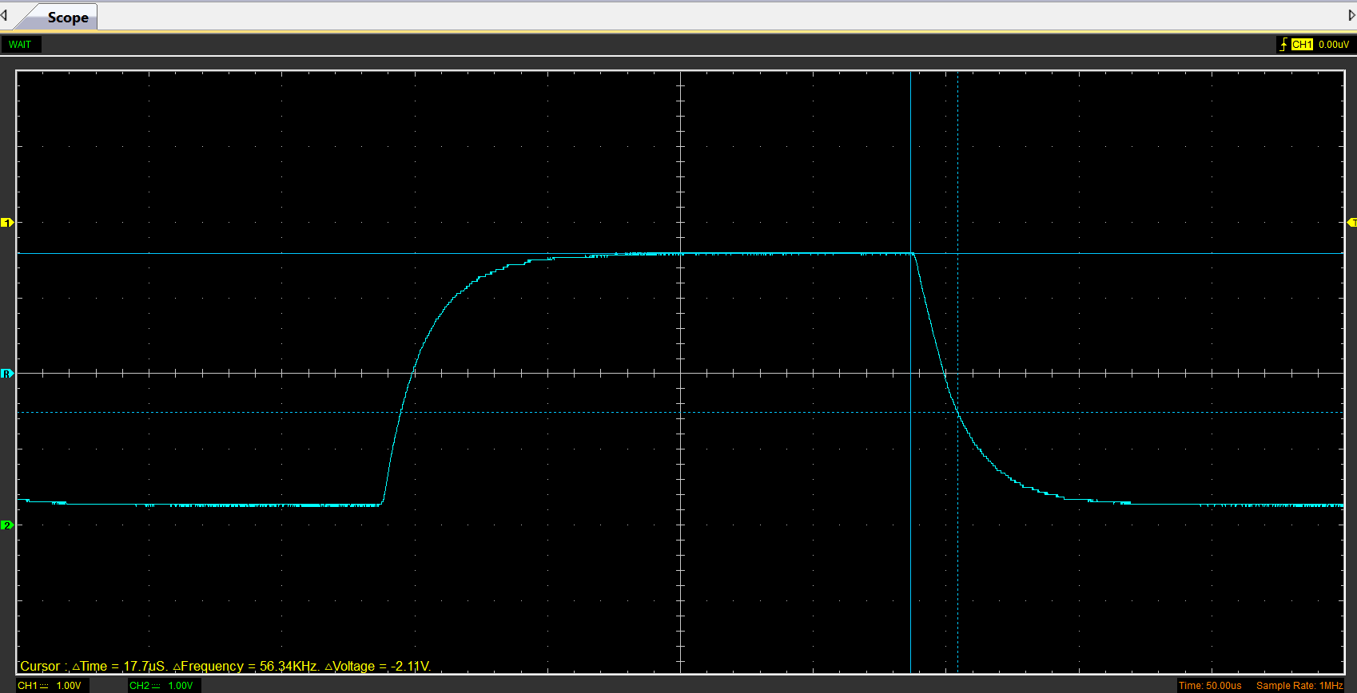

Basic Capacitor Calculations (6)
Since the change in voltage is 3.34V, the time constant will be the amount of time it takes to drop to 2.11V which is 63% or 1-e⁻¹. This is seen in the graph above with a time reading of 17.7µs. Since τ=RC 17.7x10⁻⁶/100 gives a value for capacitance of 0.17µF.

Capacitor discharge table (5)
Time (µs) | Voltage (V) | ln (V) | dy = y2 – y1  dy = ln(V)2-ln(V)1 | dx = x2- x1  dx = Time2 – Time1 | dy/dx
0 | 3.30 | 1.193922 | x | x | x
10 | 2.12 | 0.75043 | -0.443493 | 0.00001 | -44349.25
20 | 1.23 | 0.208106 | -0.542324 | 0.00001 | -54232.43
30 | 0.74 | -0.30272 | -0.510826 | 0.00001 | -51082.56
40 | 0.44 | -0.81355 | -0.510826 | 0.00001 | -51082.56
50 | 0.30 | -1.21901 | -0.405465 | 0.00001 | -40546.51
60 | 0.20 | -1.62448 | -0.405465 | 0.00001 | -40546.51
70 | 0.098 | -2.31762 | -0.693147 | 0.00001 | -69314.72
80 | 0.049 | -3.01077 | -0.693147 | 0.00001 | -69314.72
90 | 0.031 | -3.47377 | -0.462998 | 0.00001 | -46299.79

Plot log(V) Gradient (5)
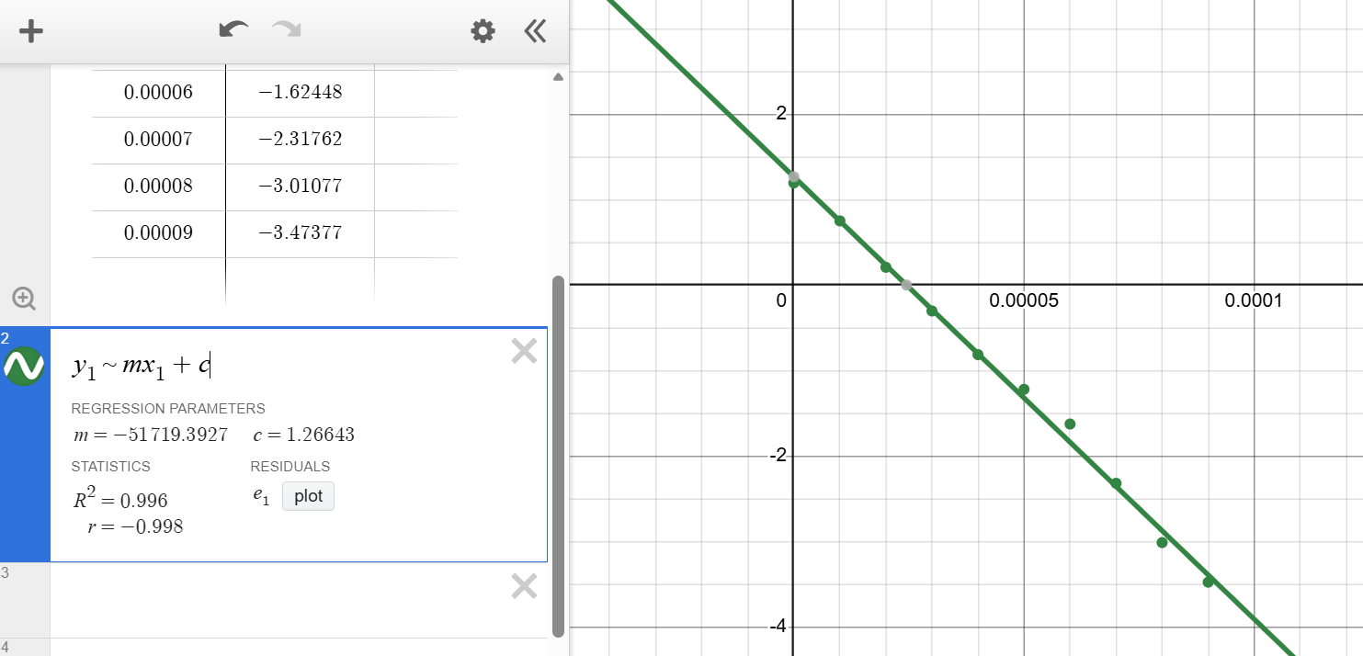
This graph of ln(V) against time shows very strong negative correlation with a correlation coefficient (r) of -0.998. The gradient (m) is -51719.3927 which is equal to -1/RC and the y-intercept (c) is 1.26643 which equals ln(V₀).

Gradient Calculations and Compare(8)

Gradient Calculations
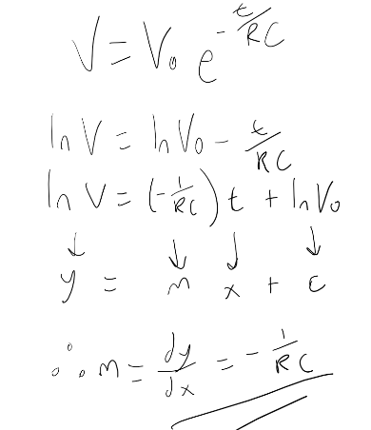
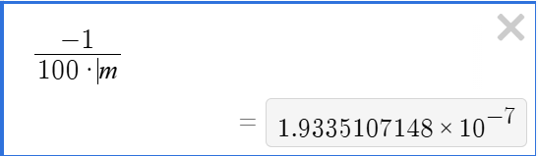
The method on the left is to show how the equation for a discharging capacitor can be rearranged to get a linear equation following y=mx+c where the gradient (dy/dx) is equal to -1/RC. The value for dy/dx came out as -51719.3927 meaning the capacitance will equal the negative reciprocal divided by the resistance (100 Ohms in this case). Therefore, the capacitance calculated was ≈ 0.19µF.

Comparison table
 | Capacitance | Delta | Percentage difference
Actual | 1 µF | x | X
Marker Calculation | 0.17µF | 0.83 µF | 83%
Gradient Calculation | 0.19µF | 0.81µF | 81% ^{ꙭ}

Capacitor Uses (5)
- Power supply smoothing – to smooth voltage spikes from the alternator in a car.
- Decoupling – placed between the voltage supply and the ground to smooth noise and store voltage.
- Ignition systems – capacitors are used to improve spark efficiency by reducing arcing across breaker points.
- Timing circuits – RC circuits define a time constant in circuits meaning anything that requires a specific time delay can be set by an RC circuit.
- Regenerative breaking – capacitors store charge meaning electric energy harvested from breaking can be stored and later released when power is required.
- Snubber circuits – placed across motors to absorb voltage spikes caused by inductive loads to protect the components.
- Fluid level sensors – two conductive surfaces are placed in a fluid, and a potential difference is applied. Since the voltage and resistance of the circuit are known, the capacitance can be calculated which will correlate to the level of the fluid.
- Audio systems – the capacitors stabilise the voltage to amplifiers during load spikes like bass/vocals. This prevents distortion and keeps the sound smooth.
- EMI filtering – used across components and wiring to suppress electromagnetic interference.
- Start capacitors – used in single phase motors to create a phase shift and generate a starting force.
(Matan, 2026).

Inaccuracies Question (4)
The capacitance value calculated from the gradient of the graph was very inaccurate at only 20% of the expected 1µF. This could be due to several things including, unreliable equipment such as the function generator and the scope, tolerance in the resistor making it a smaller resistance, but most likely an error in the method.

Risk Question (10)
The Control Area Network (CAN) bus is the electronic communications system that allows different parts of the vehicle to talk to each other, including the engine, the transmission and the brakes. In effect, it’s a car’s central nervous system. (Denton, 2020). The CANBUS system has a lack of built in security which makes it venerable to cyber-attacks. The standard ISO/SAE 21434:2021 provides a guideline for identifying and mitigating risks.
ISO/SAE 21434 uses a risk-based approach through Threat Analysis and Risk Assessment (TARA), where potential attacks are identified and evaluated based on impact and likelihood. It requires cybersecurity to be integrated throughout the vehicle lifecycle, including concept, development, production, and post-production phases. Security goals are defined early, and controls such as authentication, encryption, and intrusion detection are implemented to reduce risk to acceptable levels (ISO/SAE, 2021).
The key access points for a cybersecurity attack on the CANBUS system are through the OBD port, or via Wifi or Bluetooth systems. A cyber attacker would need to have access to the physical car to gain access via the OBD port making this a less likely attack that through over the air access points. Telematics units and over-the-air (OTA) update systems also present attack vectors, allowing adversaries to inject malicious CAN messages if proper isolation and authentication are not implemented (Checkoway et al, 2011).
The CANBUS system has a few inherent weaknesses. These include a lack of message authentication and encryption meaning any messages sent within the network will necessarily be trusted by the other vehicle components. As well as this, its broadcast architecture allows all ECUs to receive all messages, increasing the risk of spoofing and replay attacks. These limitations make CAN particularly susceptible to malicious message injection and denial-of-service attacks (Koscher et al, 2011).
Over the air (OTA) systems will be particularly venerable to attacks when updating. Without sufficient authentication and security, malware will have an opportunity to get into the systems when they are rebooted after/during updates. This may result in data breaches through the infotainment systems, or failures in the electrically operated components of the vehicle.
Some mitigation strategies include network segmentation which involves dividing the CANBUS network into smaller segments, intrusion detection systems and message authentication. These mitigations are outlined in the ISO/SAE 21434 meaning manufacturers can reduce the risk of cyber attacks by adhering to the ISO standards.

References
(Format to Harvard style as per handbook)
How it works: CAN bus | Institute of The Motor Industry. (n.d.). Retrieved April 18, 2026, from https://tide.theimi.org.uk/industry-latest/motorpro/how-it-works-can-bus
ISO/SAE 21434:2021 - Road vehicles — Cybersecurity engineering. (n.d.). Retrieved April 18, 2026, from https://www.iso.org/standard/70918.html
(PDF) Comprehensive Experimental Analyses of Automotive Attack Surfaces. (n.d.). Retrieved April 18, 2026, from https://www.researchgate.net/publication/259753269_Comprehensive_Experimental_Analyses_of_Automotive_Attack_Surfaces

