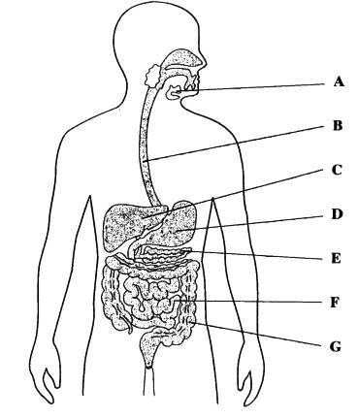
Label the organs:
A –
B –
C –
D –
E –
F –
G –

Protease

Where is it made?

Where does it work?

What does it do?

Amylase

Where is it made?

Where does it work?

What does it do?

Lipase

Where is it made?

Where does it work?

What does it do?

Why do we need to digest food?
Acids and alkalis

Name the acid in the stomach

Why do we have acid in the stomach?

Where is bile produced?

What is the function of bile?
Digestive Enzymes

