University of Wales, Trinity Saint David

Software Development – ACCA4017
Anton Hall
Programs in C and Documentation (Part C)
Contents
Introduction 1
1. Part C 1
1.1 Problem 1
1.2 Pseudocode 1
1.3 Annotated Code 2
1.4 Testing 6
1.4.1 Normal 6
1.4.2 Erroneous 13
Conclusion 14

Introduction

The purpose of this assignment is to demonstrate the development and testing of a C program that allows a user to play a version of a popular card matching game.

1. Part C

1.1 Problem
This program is intended to showcase all different elements of C that have been taught this semester as part of the software development module. The program needs to be a version of a popular card matching game. As this program is a game, the pairs must be in a different order each time the game is played, so random numbers will need to be generated in order to swap the positions of the pairs in the array. The player will need to be able to turn over two cards at a time. If these two cards are a match, then we will need to tell the player and illustrate to them that these are now a match and can’t be picked again, decisions such as If and else can be used to do this. It is also a requirement to use functions within the program. As arrays cannot be passed to different functions either a global variable will need to be declared for the array (not best practise) or pointers will need to be used to pass and return the array to multiple functions. As the aim of the game is to get the most pairs with the least amount of turns, scores will need to be recorded throughout the game so the player can be told their result at the end, incorporating while loops will help here. We could also incorporate a current high score, but this will need to be stored in an external file.

1.2 Pseudocode

main
set play = x
set pairs = 1,1,2,2,3,3,4,4,5,5,6,6
print Welcome to the game, do you want to play?
Store play

while play is Y
random (pairs)
game (pairs)
print Do you want to play again.
Store play

Random (pairs)
set i, j, k, temp, high, low
for 0 – 100 (counting loop)
set j = random number between low and high
set k = random number between low and high
set temp = pairs(j)
set pairs(j) = pairs(k
set pairs(k) = temp
return pairs to main

game(pairs)
set i, matched Pairs = 0, card1, card2, turn Count = 0, remaining = 1,2,3,4,5,6,7,8,9,10,11,12, used = -,-,-,-,-,-,-,-,-,-,-,-
while matched Pairs less than 6
print Positions Remaining:
print Positions used:
print Pick a Card Position
store card1
print Pick a Second Card Position
store card2
while card1 = card2
print You entered the same card as number one, please enter your Second card Position
store card2
card1 = card1 - 1
card2 = card2 - 1
if pairs(card1) = pairs(card2) & used(card1) != M & used(card2) != M
print Its a match, you matched the 's
set used(card1) = M
set used(card2) = M
set matched Pairs = matched Pairs + 1

else if pairs(card1) = pairs(card2) & used(card1) = M & used(card2) = M

Print You already matched these, please try again

else

print Try Again! you picked a ? & ?

set turn Count = turn Count + 1

if matched Pairs = 6

scoreboard(turn Count)

scoreboard(turn Count)
set current high, file

file = open High Score
read file for current high

if turn Count < current high
file = open High Score
file = write turn Count
print Well done you got a new high score of: ? turns

else
print You didn’t get a high score, better luck next time

1.3 Annotated Code

#include <stdio.h> //declare libraries
#include <stdlib.h>
#include <time.h>

int random(int*); //prototype
void game(int*); //prototype
void scoreboard(int); //prototype

void main() { //main function
char play = 'x'; //declare play to be x
int pairs[12] = { 1,1,2,2,3,3,4,4,5,5,6,6 }; //declare the pairs variable
srand(time(NULL)); //seed random with current time
printf("***Welcome to the card matching game*** \nDo you want to play? (Y/N):");//Welcome player to the game and ask them if they want to play
scanf(" %c", &play); //store players answer to previous question

while (play == 'y' || play == 'Y') { //start a while loop to run while the player wants to play
random(pairs);//use the random function to randomise the order of the pairs array - pass the pairs variable to the function
game(pairs);//use the game function to allow the player to play the game - pass the pairs variable to the function
printf("\nDo you want to play again? (Y/N):"); // ask the player if they want to play again
scanf(" %c", &play); // store the users answer in the play variable which will restart the current while loop if the player wants to play again
}
}

int random(int *pairs) { //random function - set as integer as pairs will be passed back to main, and set pairs variable as a pointer
int i, j, k, temp, high = 11, low = 0; //declare variables
for (i = 0; i < 100; i++) {//start a counting loop using the variable i to run 100 times
j = (rand() % high - low + 1) + low; //get a random number between the high and low values and store in variable j
k = (rand() % high - low + 1) + low; //get a random number between the high and low values and store in variable k
temp = pairs[j]; //store the number held in the array at random index number j in the temp variable
pairs[j] = pairs[k]; //swap the value held in the array at index number j with the value held at index number k
pairs[k] = temp; //swap the value held previously in index j and now stored in temp with value stored in index k
}
return *pairs; //return pairs as a pointer
}

void game(int *pairs) { //game function -set as void as nothing will be passed back to main, and set pairs variable as a pointer

int i, matchedPairs = 0, card1, card2, turnCount = 0, remaining[12] = { 1,2,3,4,5,6,7,8,9,10,11,12 }; //declare variables
char used[12] = { '-','-','-','-','-','-','-','-','-','-','-','-'}; //declare variables
/*for testing..
for (i = 0; i < 12; i++) {
printf("%d: %d ", (i+1),*(pairs + i));
}
for testing..*/
while (matchedPairs < 6) //start a while loop to run until the player has matched all 6 pairs
{
printf("\n\nPositions Remaining:\n"); //print the available positions available to the player
printf("%d: %c %d: %c %d: %c %d: %c %d: %c %d: %c ", remaining[0], used[0], remaining[1], used[1], remaining[2], used[2], remaining[3], used[3], remaining[4], used[4], remaining[5], used[5]);
//^ print the remaining and used cards
printf("\n%d: %c %d: %c %d: %c %d: %c %d: %c %d: %c ", remaining[6], used[6], remaining[7], used[7], remaining[8], used[8], remaining[9], used[9], remaining[10], used[10], remaining[11], used[11]);
//^ print the remaining and used cards
printf("\nPick a Card Position(1 - 12):\n"); //ask the play to pick the first card position between 1 and 12
scanf("%d", &card1); //store the players choice in card1
while (card1 < 1 || card1 > 2) { //check whether the integer entered is valid
printf("invalid input please try again:");//tell the user it is invalid
scanf("%d", &card1);//store the players choice again
}
printf("Pick a Second Card Position(1 - 12):\n"); //ask the play to pick the second card position between 1 and 12
scanf("%d", &card2); //store the players choice in card2
while (card2 < 1|| card2 > 12){ //check whether the integer entered is valid
printf("invalid input please try again:");//tell the user it is invalid
scanf("%d", &card2);//store the players choice again
}
card1 = card1 - 1; //subtract one from each of the players card choices as arrays start from 0
card2 = card2 - 1;
if(card1 == card2) //start a while loop that checks the player isnt picking the same card twice
{
printf("You entered the same card as number one, please enter your Second card Position(1 - 12):\n");//tell the player they picked the same card twice and ask them for card2 again
scanf("%d", &card2); //store the players choice in card2
}
else if (*(pairs + card1) == *(pairs + card2) && used[card1] != 'M' && used[card2] != 'M')// start an if statement to check whether the player has matched a pair and that its not been matched already
{
printf("\nIts a match, you matched the %d's", *(pairs + card1)); // tell the player they have matched and pair and what pair it was
used[card1] = 'M'; //change the - to and M in the used array to show the player this card has been used
used[card2] = 'M'; //change the - to and M in the used array to show the player this card has been used
matchedPairs = matchedPairs + 1; //add 1 to the amount of matched pairs the player has made
}
else if (*(pairs + card1) == *(pairs + card2) && used[card1] == 'M' && used[card2] == 'M') //next argument in the if statement that lets the player know they have already matched the cards they have picked
{
printf("\nYou already matched these, please try again"); //tell the player they have already matched these cards
}
else
{
printf("\nTry Again! you picked a %d & %d", *(pairs + card1), *(pairs + card2)); //last argument for the if statement that tells the player they have not matched any cards
}
turnCount = turnCount + 1; //add 1 the the amount of turns the player has had in this game
if (matchedPairs == 6) //start an if statement that will run the scoreboard function once the player has made six matches
{
scoreboard(turnCount);//run the scorebaord function passing the turncount variable to it
}

}
}

void scoreboard(int turnCount) { //scoreboard function

int currenthigh; //declare variables

FILE *fp; //create pointer to communicate with a file

fp = fopen("HighScore.txt", "r"); //open the HighScore.txt and read the current high score
fscanf(fp, "%d", &currenthigh); //store the high score in the currenthigh variable
fclose(fp); //close the file

if (turnCount < currenthigh) { //start an if statement to check whether the player has a new high score
fp = fopen("HighScore.txt", "w"); //if a player does have a high score open the HighScore.txt in write mode
fprintf(fp, "%d", turnCount); //print the new highscore to the file
fclose(fp); //close the file
printf("\n ***Well done you got a new high score of: %d turns!***", turnCount); //tell the player they got a new highscore and tell them what it is
}
else{ //last argument for the if - if the players turncount is greater than the current highscore then

printf("\nYou didnt get a high score, better luck next time..."); //tell the player they didnt get a highscore this time
}

}

fscanf(fp, "%d", &currenthigh); //store the high score in the currenthigh variable
fclose(fp); //close the file

if (turnCount < currenthigh) { //start an if statement to check whether the player has a new high score
fp = fopen("HighScore.txt", "w"); //if a player does have a high score open the HighScore.txt in write mode
fprintf(fp, "%d", turnCount); //print the new highscore to the file
fclose(fp); //close the file
printf("\n ***Well done you got a new high score of: %d turns!***", turnCount); //tell the player they got a new highscore and tell them what it is
}
else{ //last argument for the if - if the players turncount is greater than the current highscore then

printf("\nYou didnt get a high score, better luck next time..."); //tell the player they didnt get a highscore this time
}

1.4 Testing
Please note that the random pairs have been printed to the program in order to aid some parts of testing. These will be removed for normal game play.

1.4.1 Normal
If the user decides to play the game:
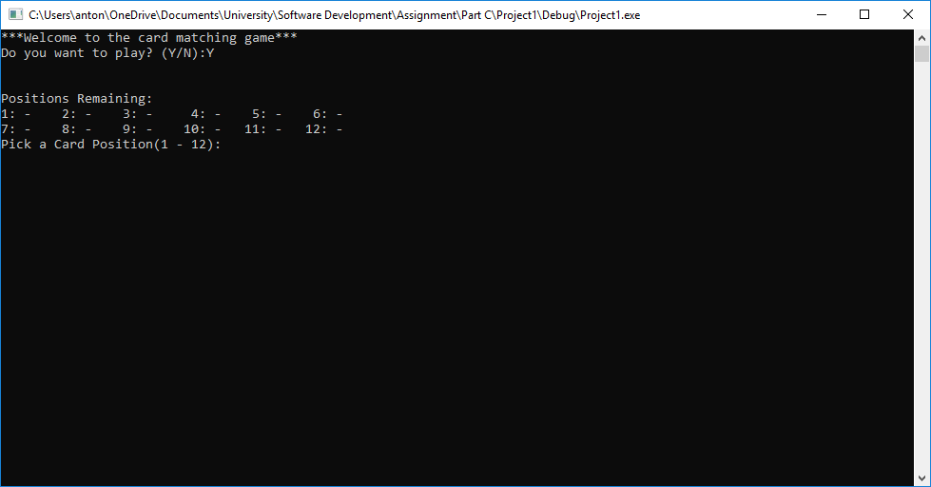
Result: Program runs as expected.

If the user decides not to play the game:
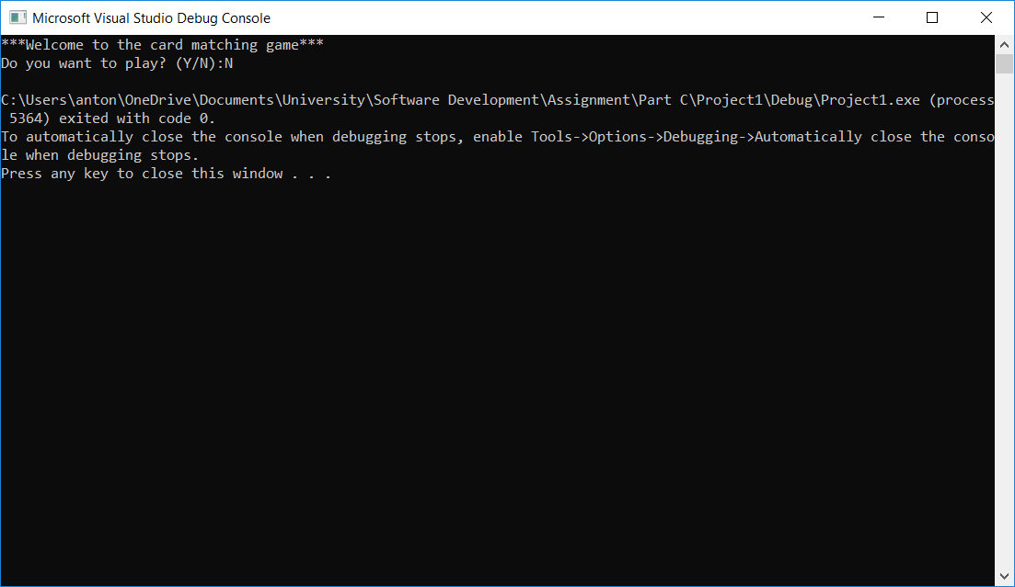
Result: Program runs as expected.
If the user gets a match:
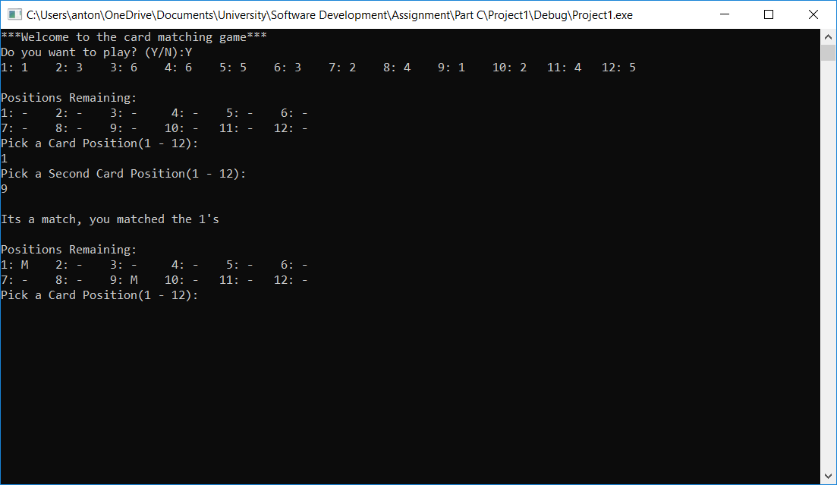
Result: Program runs as expected.

If the user doesn’t get a match:
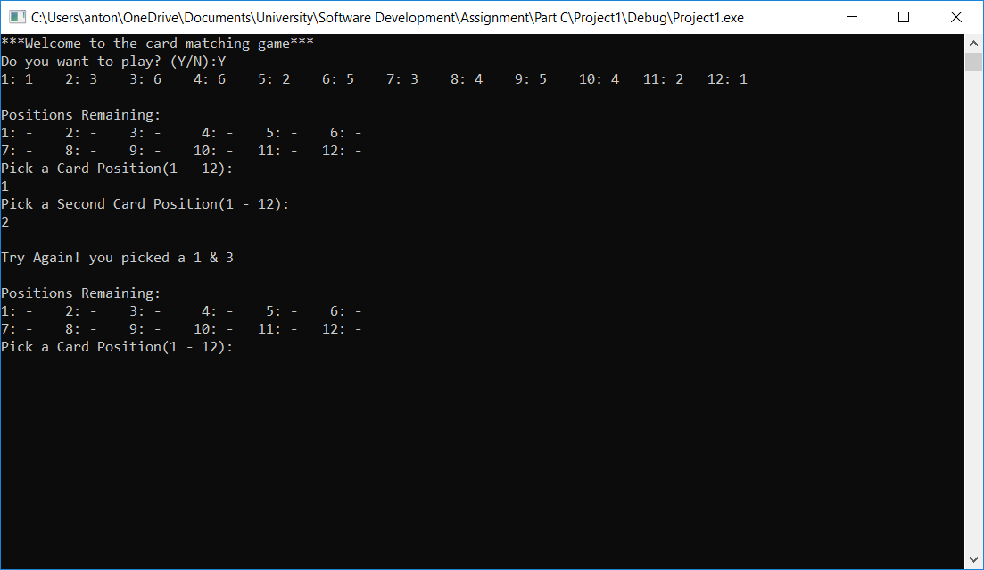
Result: Program runs as expected.

If the user gets a high score:
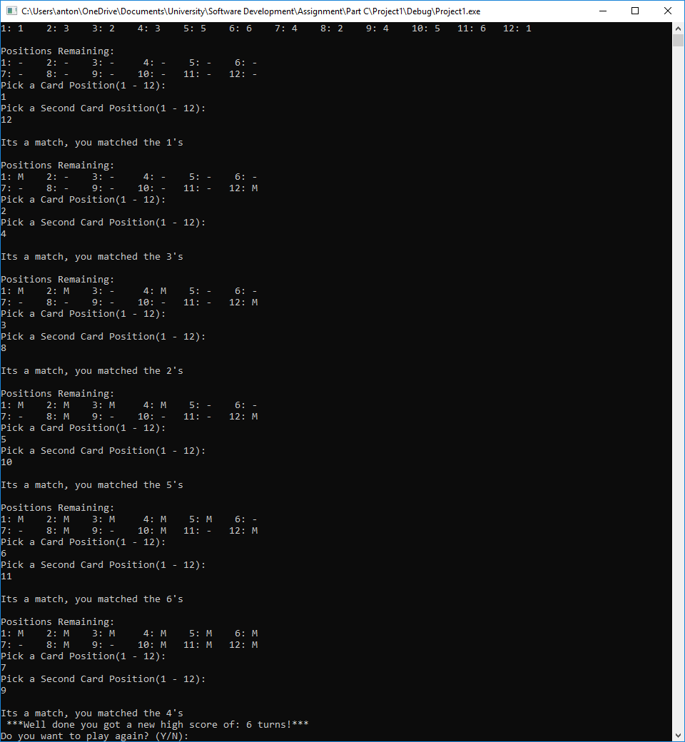
Result: Program runs as expected.

If the player doesn’t get a high score:
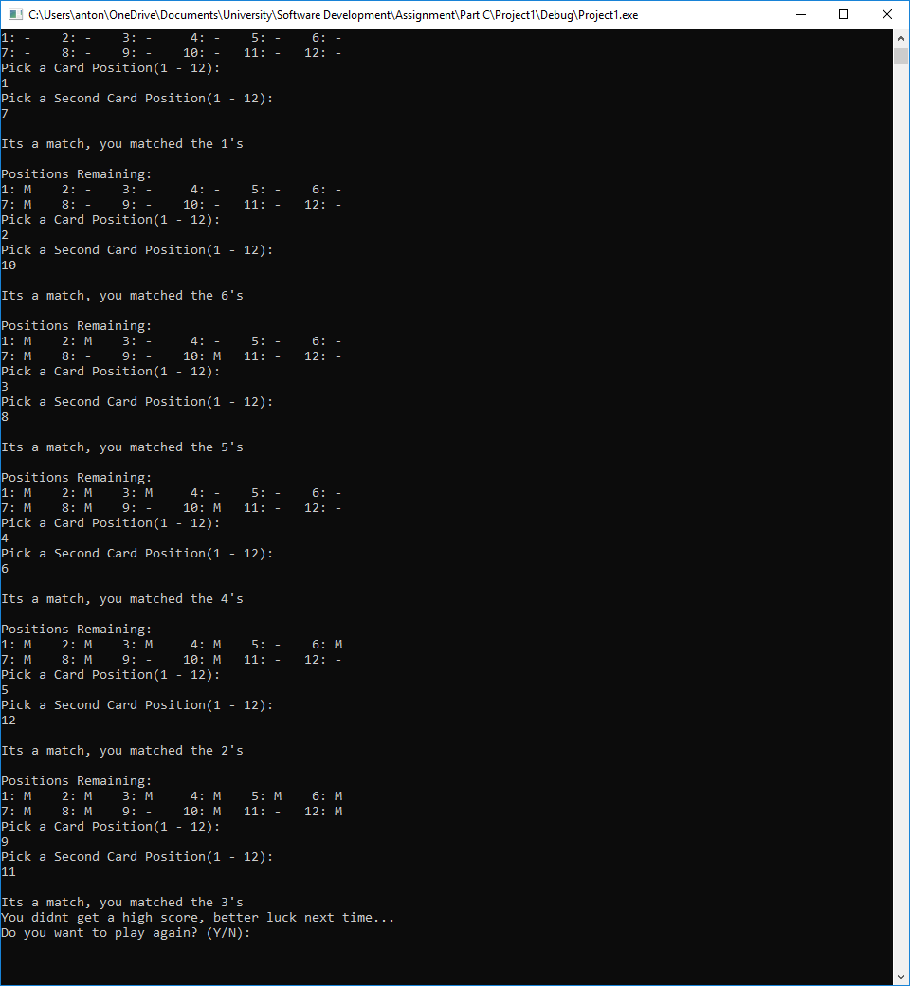
Result: Program runs as expected.

If the player wants to play again:
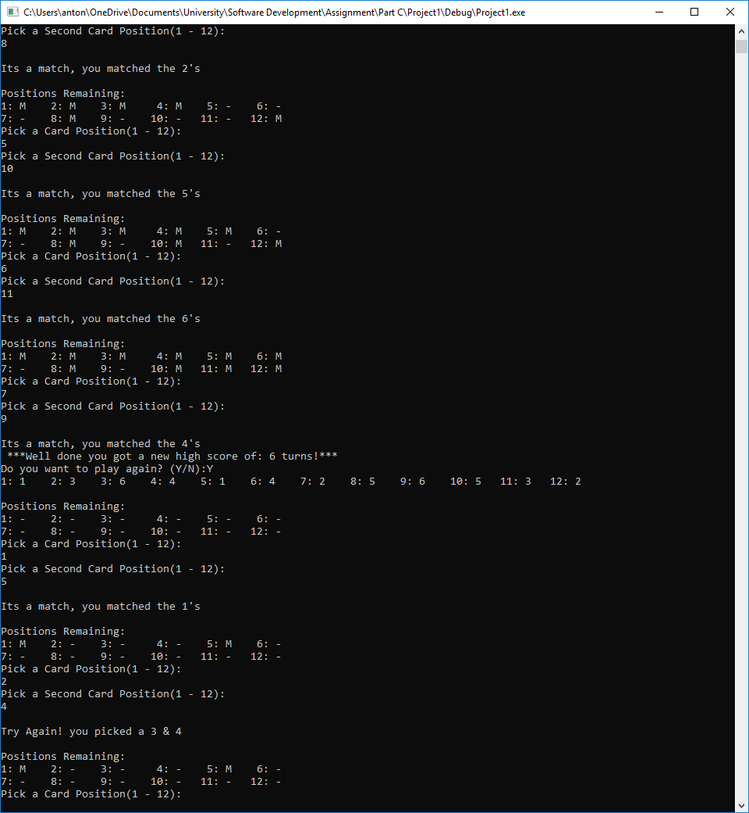
Result: Program runs as expected.

Player chooses the same card twice:
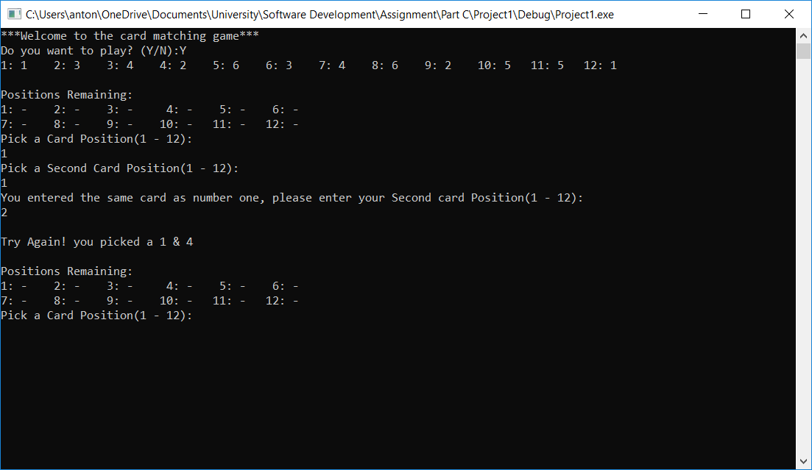
Result: Program runs as expected.

Player chooses a set of cards that has already been matched:
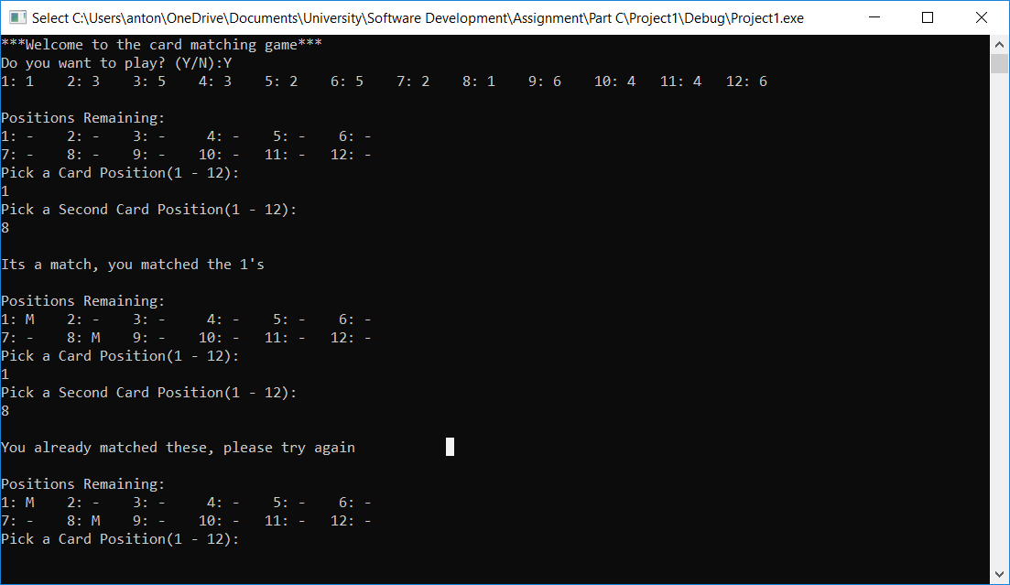
Result: Program runs as expected.

1.4.2 Erroneous
Player uses wrong values to play the game:
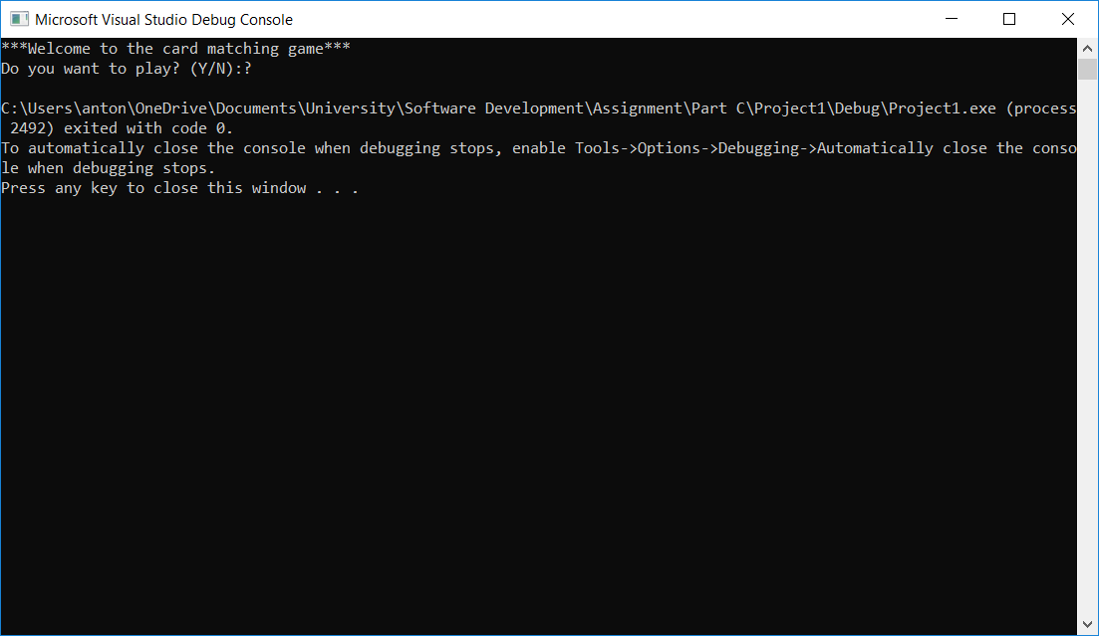
Result: Program runs as expected.

Player chooses an invalid card number:
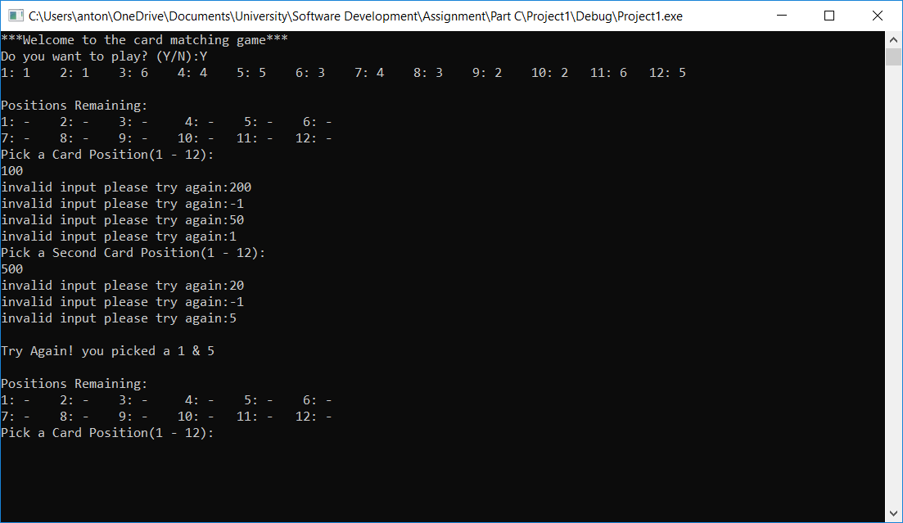
Result: Program runs as expected.

Conclusion
The above report demonstrates the development of a program in c that allows a user to play a version of a well-known card matching game. It identifies the specific problems faced when completing the exercise and demonstrates the logical stages that are required for the program to run effectively. It shows the code that was written for the program along with annotations and testing that ensures the program performs as it is intended to do so.

