

Assignment 2: Professional Development Plan (PDP)
ACCA4025

Student name: Syed Ahmed
Student ID: 2545458
Date: 14-08-2026 by2.00 pm
Lecturer’s name: Anees Baqir

Table of Contents

Task 1: Self-Evaluation
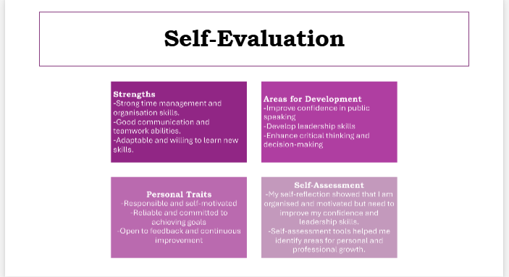

Task 2: PDP
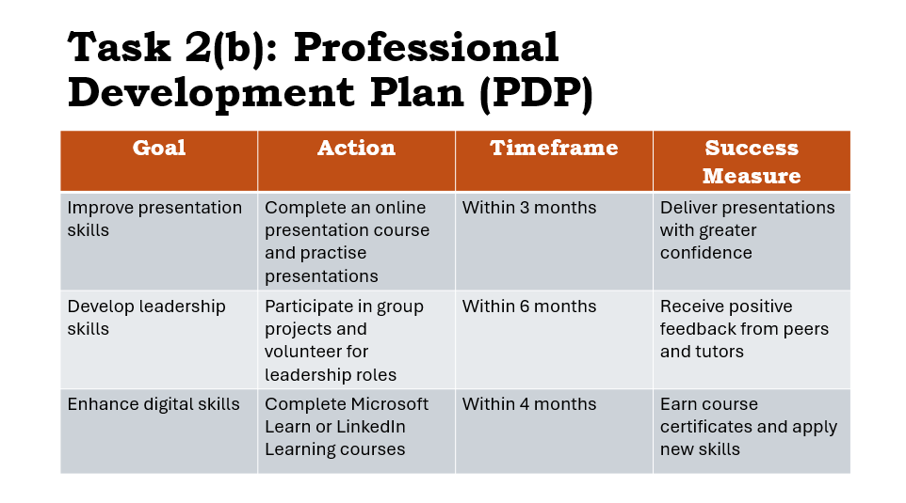

Task 3: Unit 4 Topic Summary
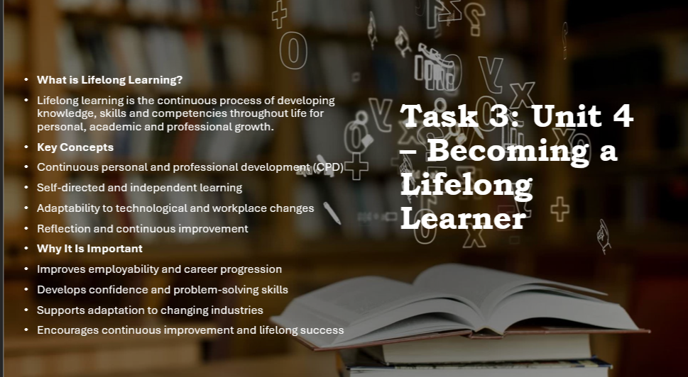

Task 4: Video Presentation
https://youtu.be/mRoar7q9qrU?is=iRGsipBrzRlpty7j


Appendix (presentation):


