

LOCATION: Swansea | LLEOLIAD: abertawe
LEVEL 5 | LEFEL 5
EXAMINATION PERIOD | CYFNOD ARHOLIADAU
March 2025 | MAWRTH 2025

MODULE CODE: ACDA5018
Distributed Intelligent Systems Practical
TIME: 2 HOURS
Complete all sections

you may access any previous work you have done on this course.
You may not access the internet for any external materials.

This practical test account for 50% of the module marks.

The proetus file named DIS Practical folder is available to you on moodle (DIS Practical), please copy this folder to your desktop and unzip it on to the desktop.

Open the folder and goto the Proteus folder and open the “DIS practical.pdsprj” file.

The circuit in front of you, shown below, contains a 2 * PIC18F2525, 2 * twoline LCD, 4 leds, 4 buttons and a i2c 8kb memory organised as 1kByte.

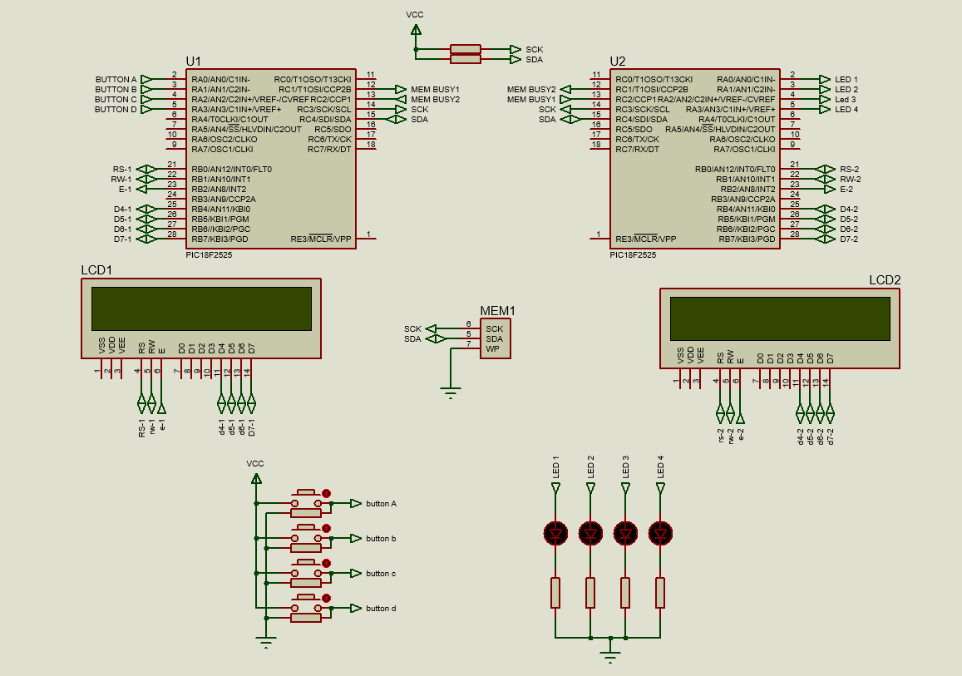

You are required to : -

1 Read the value of the buttons.

1 Mark

2 write the value of the buttons into the memory at location 0x06 and display the value on to bottom line of LCD 1

5 Marks

3.read the value of the memory location 0x06 into pic 2. And display it on the bottom line of LCD 2

5 marks

4 confirm the value of the data received by writing the data into memory location 0x07 and display the value on line 1 of LCD 2

5 Marks

5 Display the last press status of the buttons on the LEDS.
5 Marks

6 On pic 1 read the data back from memory location 0x07 and display it on line 1 of lcd1.
5 Marks

The software should set the hand shaking lines before writing to the memory after checking to see it the other device is not currently writing to it and clear the handshaking line when finished writing.
12 Marks

If all is correct the values displayed on the LCDs should all be the same, if not issue an Error on the first line of LCD 1.
12 Marks

This is a practical assessment during which you may access any previous work you have done.

A zipped copy of this practical examination folder should be uploaded to the Assignment folder Uploads section of the Moodle page for this module. UNDER the PRACTICAL tab

A zipped copy of this practical examination folder should be saved on the desktop of this laptop clearly marked as “FREYA’S DIS SUBMISSION”

Please ensure that all files are closed before they are zipped.

