Lecturer: Timothy Hopkins

Effective teamwork and Communication
Alessia Bonelli (2022998) University of Wales Trinity Saint David Certificate of Higher education in Health and Social Care

Table of Contents
Introduction 2
Discussion 3
The Shannon and Weaver model (1948) 3
The Schramm’s Model of communication 4
Berlo’s model 6
Conclusion 11
References 11

Introduction

Communication is the exchange of a message, an information between two or more people. In the process, there is a sender or source, a message, and a receiver (audience). To make sure to have an effective communication, it is very important to be clear sending the message, which can be verbal or nonverbal. Verbal that means made by words and non-verbal as gesture, proxemic and eye contact basically. The meaning is understandable, when verbal and nonverbal communication express the same concept, when verbal and nonverbal communication match. The body language is made by gesture, posture, eye contact, hand, eyes, or head movement and proxemic, which means the space that we establish between us and other people during a conversation. To make sure that the meaning of the message has been received it is important that what we say and what our body shows is associated. Sometimes, someone want to show his strength and confidence during a conference but at the same time his hands and legs are shaking. The audience will see what he is communicating but also, what he feels while he is talking. In the selling sector for example, it is important to show confidence to get the client’s trust and let him buy a particular product. The body language is the confirmation of the verbal communication. By a simple handshake, someone as a behaviourist can interpret a personality. In this report, we will talk about all the modules of communication that we have been through, explaining di differences, the barriers, and the solutions in terms of communication.

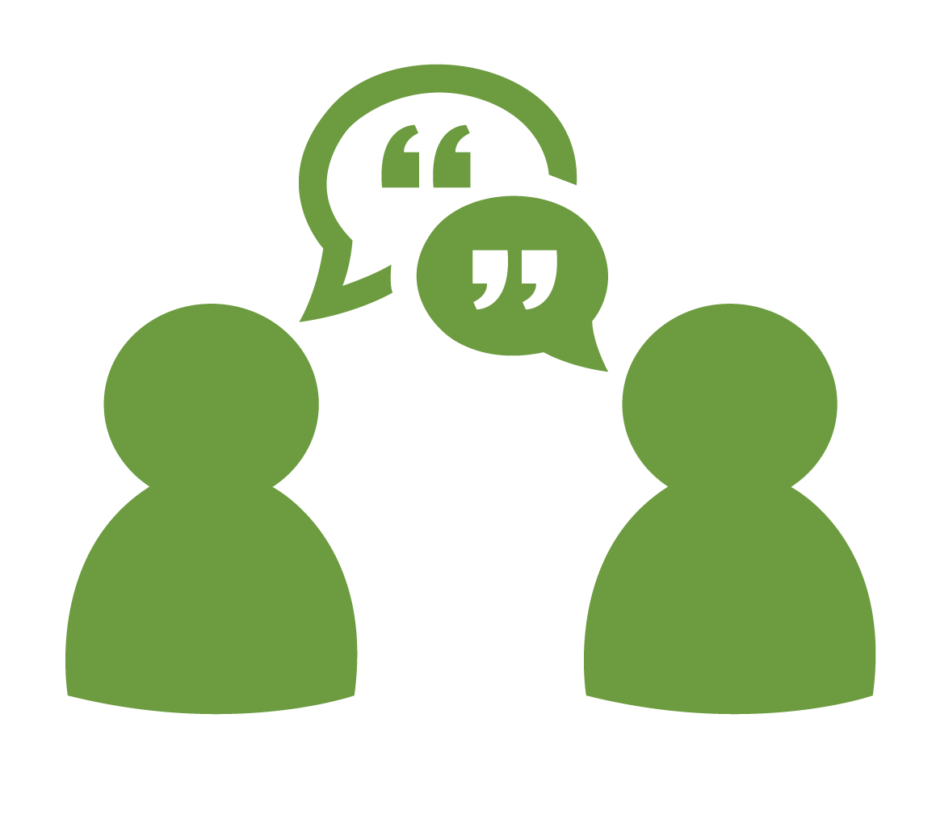
This Photo by Unknown Author is licensed under CC BY-SA-NC

Discussion

There are three different Model of Communication, developed by Shannon and Weaver in the 1948: the Schramm’s Model and the Berlo’s ones. All of them, have something in common, like the sender the receiver and the message but the differences are made by the process.
The Shannon and Weaver model (1948) explain that there is a sender (or source) that has a primary role and a receiver with a secondary role. The sender encodes a massage with his words and his body language, so the transmitter, then a channel that can be a videocall, a lesson in a classroom or a phone call for example. The noise, that it may be, which is represented as a problem in the conversation, made by a dog barking or cars horning, for example. The reception, where the message is decoded as learning activity, an interpretation or reading for example and at the end, the destination represented by the receiver. E.g., In a classroom, the sender is the lecturer, the transmitter is his or her words accompanied by his or her body language, gesture, eye contact, proxemic which it is, as we mentioned before, the use of the space. The channel, (the classroom), that can be disturbed by the whispering of the students. The reception, that could be the listening or the learning activity and the destination, made by the audience (students). Based on the message the students will give their feedback answering to the lecturer questions. 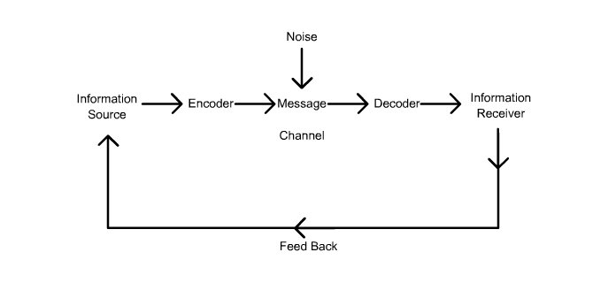

The Schramm’s Model of communication
Then we have The Schramm’s Model of communication (1954), where the communication is more like a cycle, where there is a message that is decoded, interpreted, encoded to reply with another message which in turn is decoded, interpreted, and encoded to the sender which will reply with another message, as answer. Always taking as example the classroom, a lecturer sends the message, the students will decode, interpreter and decoding to give an answer (or feedback), the sender again will receive the message, will decode, interpreter and decoding to reply with another message.

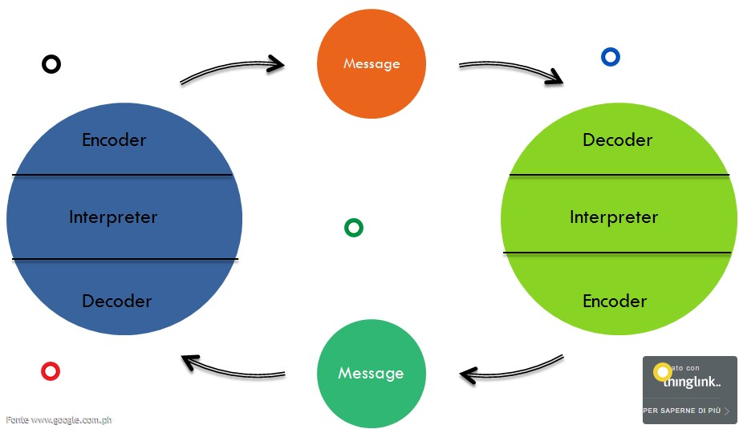

Berlo’s model
And at the end the Berlo’s model (1960), which has a sender or source, influenced by his or her skills, knowledge, culture, attitude. A message so, the content, an element, a treatment, or a code. The channel, which embody, this time, our 5 senses (hearing, seeing, touching, smelling, and tasting) and the receiver with his or her skills, culture, knowledge, and attitude. For example, this time is like the message is sent by the lecturer that can have a certain number of skills, that has a degree, so knowledge, a good attitude and can be from an Indian or British culture. The message, what he is trying to explain as much as possible. The channel, his way to see, to touch, to hear, to smell and taste and the receiver which will interpret depending on his or her skills, knowledge, attitude and culture.

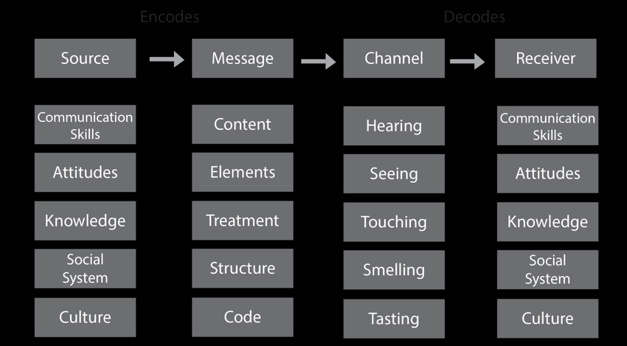

In each communication, we can identify one or more Model. We have seen in the case of Maria and Pedro’s study case, about the misunderstanding between the word kitchen and chicken, due to the background noise in Pedro’s location of work. What happened, is that Maria called Pedro to ask him to buy a chicken when he gets home but the problem is, that when he come back he totally misunderstood the phone , for the background noise on his workplace and at the end, when Maria ask him if he took the chicken, he said no, because he understood that Maria said that when he will be back home, he will find her in the kitchen. The best model of communication identified in this specific case study is the Shannon and weaver one, because the main problem has been the noise in the channel.
Shannon and Weaver’s model e.g.:

Pedro
(Receiver)
Phone calling disturbed by background noise
(Channel)
“Can you get me a chicken on the way home?” (Message)
Maria (Sender or Source)

But it could be also, The Schramm Model e.g.:

Maria (Message)
“Can you get me a chicken on the way home?”

(Maria)
Decoder
Interpreter
Encoder
(Pedro)
Decoder
Interpreter
Encoder

Pedro’s answer (Message) “ok”
“

But what went wrong in the Maria and Pedro’s example of communication? What could have been a good example to avoid the misunderstanding? Probably with a proper feedback response like in Shannon and Weaver model, let’s try:

Message decoded by Pedro

Noise
Message
Phone call

Encode
“Can you get me a chicken on the way back home?” (message)
Maria (sender or source)

Feedback

As feedback Pedro should have asked more question to Maria like for example “So I will find you in the kitchen?” and Maria would explain that he was wrong or for example. Pedro should also, have moved in a quite place to better catch what Maria was saying.
Instead, the “professor and the village” study case, that it talks about a professor largely educated, who was living in a house close to a village full of people very different from him, unfortunately too uneducated as him. One night, because he fell asleep with is pipe the house was on fire and he asked for help to the village people saying that “The edifice was being consumed by a great conflagration!’ but no one paid attention and no one know who he was, because he were never been to that village before so, no one helped him and when they realize that his house was on fire, it was too late. No one understood what he was asking, for the complicated use of words.
The appropriate model is the Berlo’s one, because the professor is asking for help but in a very diplomatic way, with a difficult language and no one in the village understand what he was saying, so everything depends about the knowledge and the culture about the sender and the receiver.

Berlo’s model e.g.:

S: (Sender or Source) The professor, influenced by his knowledge, skills, and way to speak
M: (Message or content) ‘The edifice is being consumed by a great conflagration!’
C:(Channel) Screaming\ hearing
R: (Receiver) Village people and their poor skills, poor knowledge, and poor education

And in this case how the professor could have done better? Perhaps, trying to explain himself using different words, easier language also, trying to establish a relation with his neighbours without any bias.

The Schramm’s Model, instead, is more like a cycle of mutual understanding and exchanging of a concept. For this mode, l I could talk about my workplace, where one of my colleagues, for example, is more trained than me so, she will show me a certain treatment, step by step. She is the sender, the message is made by oral word, gesture, and demonstration of a certain treatment, I will encode, interpret, and decode this message and I will reply to her with active listening to demonstrate that I am attentive on what she is telling me and giving her my interpretation to see if I have totally got the message.
Anyway, each of these case study, taken by simple examples helped me to understand in a proper way, what means to have an effective communication but mostly what are the keys to excel in verbal and nonverbal communication. K (as know yourself), E (evaluate the professional context) Y (Your communication interaction) S (for step back and reflect). Another pivotal thing for an effective communication it is also, the active listening, the way how the sender is showing his interest in the conversation. Keeping eye contact constantly or giving to the speaker verbal fillers (e.g., um, like, yes, ok). Because there is difference between listening and hearing. When we hear, we just detect a sound but when we listen, we can observe, analyse in our mind, deciding what means the message for us.
The barriers of an effective communication are failing to limit distraction; do not focus on the message; do not be an active listener and to avoid these mistakes we should improve our listening, be careful on what has been said; concentrated on the meaning and being neutral so, excluding our bias and beliefs. The distraction in a conversation could be the internal and external noise for example. The internal noise that comes from internal conditions, our mood, our thoughts, what we are thinking while the sender is speaking. On the other hand, the external noise is the disturb from outside, like loud music or a notification from a cell phone, everything that keep us distracted to better be focused.
To better explain how a message can be easily misunderstood we can think about a workplace. Let’s say that I am a nurse and I come from another clinic, where I have learned how to do a certain treatment for my patients. I also, come from another country so, things in my previous place were different and even the patients treated were different. I start in this new place, which is located abroad in a foreign country, after did the interview and be hired to my role, everyone is explaining me how to execute a treatment for a specific patient, I am an active listener, so I am listening, but it is hard anyway, to be focused on what they are explaining to me, because it is a different language as well. I am influenced by my old workplace how they told me to get the job done. By this example we can understand how could be difficult to communicate. In this case the model would be the Berlo’s one, because of my knowledge about the rules and our different culture, but also the Schramm because I am listening, I am giving feedback, like in Schramm’s model. The Shannon and Waver as well, because while I am listening, at the same time I am overthinking about the internal noise in my mind and what I have learned before. In this situation, it can happen then when I will be working on a patient by myself, I could make some mistakes because of my distraction during the explaining of the process or maybe I had misunderstood the meaning of certain words because I am not a mother tongue. So, there it is, some of the most common barriers of communication, as we mentioned before external noise from outside like the sound of an ambulance, internal noise like my thoughts or receiving a message overload, that happen when the sender is giving too much information in one go and for the receiver it become difficult to focus on the meaning. The strategies instead to avoid miscommunication are to be an active listener, paraphrasing in our own words what has been said; the reflection about the message what sense makes to us; being neutral without bias and beliefs that can jeopardize the good understanding and making question to better catch the goal of the receiver. We have different kind of questions. A question can be open-ended, that gives freedom to the sender to reply (e.g. What, How, Why). Hypothetical as “What if?” this kind of question give to the speaker the possibility to evaluate a different option. A forced-choice question, where the reply can be just positive or negative forcing the speaker to make a specific choice.

Conclusion

The communication the bridge between human being. The questions are the key to remove any doubt that we have regards every topic. Sometimes we just build massive wall between us and the other, a miscommunication can make a little problem something bigger that seems impossible to resolve. Thanks to these studies I know now how to express my self in an effective way, when you study it is something that happen quite easy, is your subconscious that absorb all the information. I know now that every problem has a solution in private life and professional. So, let’s practise what we learn to make others understand us and understand them better to build relation and always enrich our knowledge with a very open mind also, to make effective every teamwork.

References

Kurtzo, F., Edgar, L.D., Edgar, D. and Russell, M. (2019). Figure 1. Berlo’s (1960) Source-Message-Channel-Receiver Model of... [online] ResearchGate. Available at: https://www.researchgate.net/figure/Berlos-1960-Source-Message-Channel-Receiver-Model-of-Communication-Developed-from_fig1_331435468 [Accessed 7 Aug. 2021].

R.C.F, S., Monteiro, H. and Santiago, R. (n.d.). (PDF) 17th World Congress on Ergonomics, workload and ubiquitous: a case study. [online] ResearchGate. Available at: https://www.researchgate.net/publication/237479142_17th_World_Congress_on_Ergonomics_Ergonomics_workload_and_ubiquitous_a_case_study [Accessed 7 Aug. 2021].

ThingLink (2015). Schramm’s Communication Model - Ricarl Ramlagan by Ricarl. [online] www.thinglink.com. Available at: https://www.thinglink.com/scene/623201146781040642 [Accessed 7 Aug. 2021].

