Individual Academic Report

Bachelor of Arts in Business Management
Academic Year: 2022/2023
Student Name: Ileana Lupu
Student Number: 2231908
Lecturer Name: Dr Umar Sadaat
LCBB4004_BIRM
Marketing Fundamentals

Table of Contents
1. Introduction 3
2. Discussion 3
3. Conclusion 8
4. References 9

Introduction
Marketing is an important aspect of business management since it relates to the identification of consumer needs and the implementation of actions to address those demands. Through the successful use of marketing strategies, marketing mix tactics, and efficient market analysis and research, the balance between supply and demand may also be facilitated.
In this study, the effectiveness of diverse adaptation strategies has been assessed in the context of the marketing process in the food and agricultural business which was disrupted by the global pandemic Covid-19. For that reason, will be discussed the role of marketing principles, marketing analysis, marketing environment, competitors’ analysis and different business analytics tools such as PESTLE, SWOT, and Ansoff Matrix.

Discussion
  - Understanding the present business environment to implement newer strategies

It has been observed from the case study that the business environment was disrupted due to the sudden emergence of the Covid-19 pandemic, which had a profound impact on Québec's food supply networks, in Canada (Schreiber et al., 2022). Direct marketing used to be facilitated by the farmers, as well as other food producers in that region and after the emergence of the pandemic certain challenges arrived and led them towards adopting new strategies. It has been identified that four major challenges disrupted the whole food distribution channels, as well as the supply chain such as shortage of workforce, demand and supply balance of food items, challenges associated with marketing channels and sales outlets and other operational issues.
For that reason, the requirement of diverse adaptation strategies was prioritised that includes “redistribution”, “streamlining”, “replacement”, “collaboration”, “farm adjustment”, and “outlet adjustment” (Schreiber et al., 2022).
Marketing is sometimes perceived as only a promotional or sales activity. However, the primary goal of marketing is to identify the unique needs of clients and address those needs in any way feasible, of which publicity or promotional activity is simply one component.
In this present case, the main area of intervention is the farming or food agricultural sector in which farmers, food producers, suppliers, individuals associated with transportation and outlet handlers are the major stakeholders.
In addition, rather than relying solely on traditional marketing methods, the farmers implemented the six marketing and sales strategies. As a result, it was necessary to allocate funds and resources, do market research and analyse how markets were evolving to effectively optimise for better outcomes. One of the core components of process optimisation is streamlining, which involves a variety of marketing initiatives to improve the efficacy and efficiency of certain initiatives. Farmers were able to do this, to save time and money improving productivity.
A replacement strategy involves substituting previous products, services, marketing tactics, or even specific stakeholder groups when the market demands or customer preferences change. Farmers tried to compensate for the workforce gaps by hiring locals; however, the replacement was proved not effective due to a lack of training which led them towards a significant loss of ten thousand pounds in several cases. Collaboration usually involves establishing alliances or partnerships with other companies, producers, or farmers who share the same goal. The adjustment of farms and outlets did not significantly benefit farmers or producers.

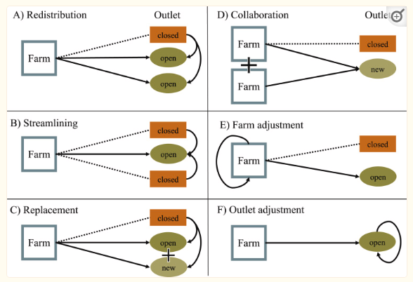
Figure 1: Six adaptation strategies by the farmers
(Source: Schreiber et al., 2022)

  - Development of marketing in creating value for the customers

The main goal of marketing is to add value for the consumer by satisfying their basic wants. For instance, the marketer picks various product attributes, costs, and distribution methods to increase accessibility for a certain good or service.

  - Identification of relevant stakeholders and assessment of their impact on marketing activities

Farmers, food producers, labour and workforces for agricultural activities, suppliers of raw materials and food yield, transport carriers, outlet owners, various organisations, non-governmental organisations (NGOs), and the government are all involved in the marketing process (Bammann, 2019). As a result, the marketing process is largely dependent on these stakeholders for the collection of data and information required for appropriate market research and supply chain analysis. Furthermore, communication and mutual coordination are fundamental parts of marketing that can result in successful marketing interventions that benefit farmers through the proper execution of each activity.

  - Understanding the marketing process and different stages of marketing

Marketing principles are four fundamental components that any marketer of marketing initiatives must adhere to. Product, pricing, place, and promotion are the four components that are often highlighted during a marketing intervention (Lilien et al., 2017). The marketing process, on the other hand, is a multi-stage activity that includes marketing analysis and market research, determining marketing goals and objectives, developing a marketing strategy and a marketing plan, implementing a marketing mix, and monitoring and controlling (Chernev, 2020). Each of the five stages of a marketing process is essentially important to accomplish the marketing goals conveniently.
In the current context, agribusiness must be addressed to a larger extent, along with different challenges and opportunities, as well as strengths and weaknesses. Firstly, a situational evaluation will be useful in analysing the whole company environment, including local, national, and worldwide markets, as well as the demand and supply ratio. As a result, food and agribusiness stakeholders are required to do comprehensive market research as well as a SWOT analysis. As per the views of David et al. (2019), SWOT analysis is useful for identifying internal strengths and weaknesses along with opportunities and threats. Local food supply networks were severely disrupted in this scenario, posing a big threat and resulting in considerable losses, although organic farming and plant-based meat products received significant attention, which can be a wonderful opportunity for food producers (Mordor Intelligence, 2023).
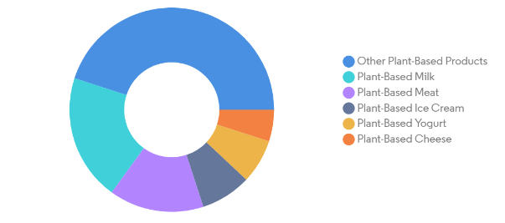
Figure 2: Increase of different plant-based products
(Source: Mordor intelligence, 2023)

  - Marketing environment role, research and marketing mix

The marketing environment is a significant aspect that decides a marketing strategy's performance, implementation of a marketing mix and success of marketing interventions. As per the view of Matović (2020), PESTLE analysis is one of the macro environment analysis tools that include political, economic, social, technological, legal and environmental impacts on a specific business or industry.

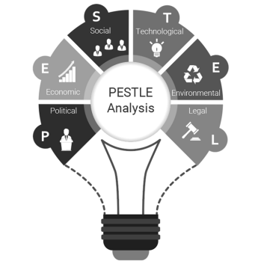
Figure 3: PESTLE analysis
(Source: AKMAN, 2020)

Market research involves collecting a variety of facts and data that may be used to examine client needs, current consumer trends, and competition. In this regard, Porter's five forces analysis can be used, which is one of the predominant analysis tools that describe the current market situation, including suppliers' and customers' bargaining powers, threats from competitors, and new entrants.

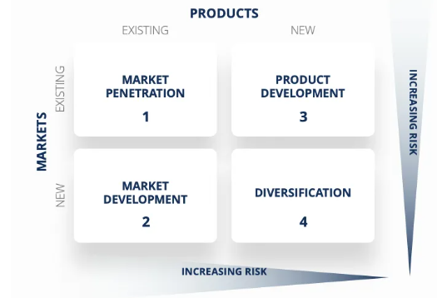
Figure 4: Ansoff Matrix
(Source: Corporate Finance Institute, 2023)

In contrast, the Ansoff Matrix is a product or market expansion grid that is often used to help the marketing plan and the stakeholders conceptualise the associated risk. However, as per the Ansoff Matrix insights, market penetration, market development, product development, and diversification are the four key areas to develop an effective growth strategy (Corporate Finance Institute, 2023). In this regard, agribusiness might be rejuvenated through new national and internal market development, penetration of the newer market, and diversification of conventional agri-food products into innovative food or plant-based items to generate growth opportunities.

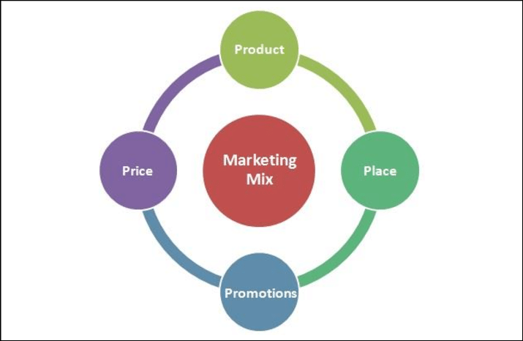
Figure 5: 4Ps of marketing
(Source: Sutawijaya and Soegoto, 2020)

Furthermore, marketing mix refers to marketing strategies and aspects that integrate certain marketing techniques linked with four important marketing factors, such as product, price, place, and promotion, commonly known as the 4Ps marketing mix approach (Asdi and Putra, 2020). It has been noticed that demand for food products and agricultural outputs has dropped significantly, and government limitations have also caused disruptions in product supply (Schreiber et al., 2022).
As a result, farmers may benefit from a competitive pricing strategy and organic food production within a confined geographic area. Furthermore, intra-state trade, worldwide exports, collaborations with supermarket and grocery brands for various food goods with competitive pricing, and the development of agricultural brands may all help with promotional efforts and sales growth.

Conclusion
Based on the findings of the preceding study, it is clear that the fundamentals of marketing are critical elements in meeting customer needs and providing significant value to customers. The primary goal of marketing is to identify specific customer requirements to successfully exploit consumer markets, avoid uncertain situations, and generate profit even in a changing marketplace competitive business environment. As a result of the COVID-19 epidemic, farmers in Québec faced substantial difficulties and developed a variety of coping mechanisms, which have been analysed in this study. Although many of the tactics may have been successful, they did not produce the expected results for the various food and agribusiness stakeholders. Considering that, a comprehensive marketing strategy has been suggested through this study which might be followed by the farmers to avoid further uncertain situations in the future and develop sustainable operations in the agricultural industry.

References
AKMAN, M.K. (2020) 'Defence management and PESTLE analysis', Ante Portas–Security Studies, 1(14), pp. 93-102.
Asdi, A. and Putra, A.H.P.K. (2020) 'The effect of marketing mix (4P) on buying decision: Empirical study on brand of Samsung smartphone product', Point Of View Research Management, 1(4), pp. 121-130.
Bammann, H. (2019) 'Participatory value chain analysis for improved farmer incomes, employment opportunities and food security'.
Chernev, A. (2020) 'The marketing plan handbook', Cerebellum Press.
Corporate Finance Institute (2023) What is the Ansoff Matrix? [Online] Available at: https://corporatefinanceinstitute.com/resources/management/ansoff-matrix/ (Accessed: 19 June 2023).
David, F.R., Creek, S.A. and David, F.R. (2019) 'What is the key to effective SWOT analysis, including AQCD factors', SAM Advanced Management Journal, 84(1), pp.25-33.
Lilien, G.L., Rangaswamy, A., and De Bruyn, A. (2017) Principles of Marketing Engineering and Analytics. 3rd edn. DecisionPro Inc.
Matović, I.M. (2020, September) 'PESTEL Analysis of External Environment as a Success Factor of Startup Business', In ConScienS Conference Proceedings (pp. 96-102), Scientia Moralitas Research Institute.
Mordor Intelligence (2023) CANADA PLANT-BASED FOOD AND BEVERAGES MARKET SIZE & SHARE ANALYSIS - GROWTH TRENDS & FORECASTS (2023 - 2028) [Online] Available at: https://www.mordorintelligence.com/industry-reports/canada-plant-based-food-and-beverages-market (Accessed: 19 June 2023).
Schreiber, K., Soubry, B., Dove-McFalls, C., and MacDonald, G.K. (2022) 'Diverse adaptation strategies helped local food producers cope with initial challenges of the Covid-19 pandemic: Lessons from Québec, Canada', Journal of Rural Studies, 90, pp. 124-133.
Surtawijaya, A.A.A. and Soegoto, D.S. (2020, January) 'Developing Strategic Marketing Plan for Artificial Flower Bouquet Business in Bandung', In International Conference on Business, Economic, Social Science, and Humanities–Economics, Business and Management Track (ICOBEST-EBM 2019) (pp. 29-31), Atlantis Press.

