ECIE4003

Additional Needs in Context

Portfolio

Student Number: 2115838

Yvonne Blachford

Element 1

Poster – Outlining good practice in terms of supporting learners with a specific learning need

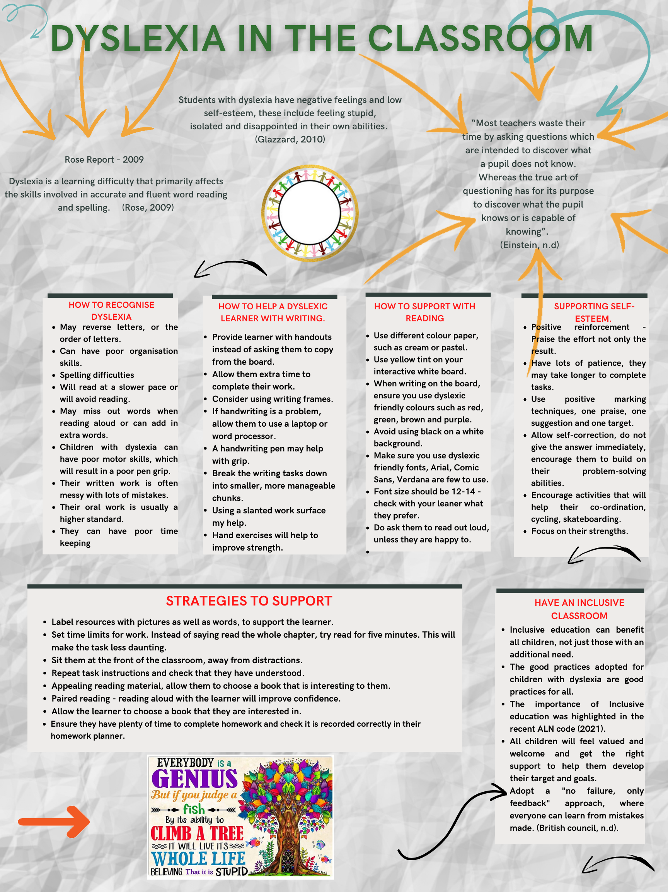
References

British Council (n.d.) Making your classroom dyslexia friendly Available at: https://www.britishcouncil.mk/sites/default/files/making_classrooms_dyslexia_friendly.pdf (Accessed: 16th October 2022).

Einstein, A. (n.d.) Albert Einstein Interviewed about Dyslexia Available at: https://www.ghotit.com/2011/02/einstein-dyslexia (Accessed: 15th October 2022).

Glazzard, J. (2010) The impact of dyslexia on pupils’ self-esteem. Available at: https://nasenjournals.onlinelibrary.wiley.com/doi/10.1111/j.1467-9604.2010.01442.x (Accessed: 15th October 2022).

Rose, J. (2009) Identifying and teaching children and young people with dyslexia and literacy difficulties. Available at: http://www.thedyslexia-spldtrust.org.uk/media/downloads/inline/the-rose-report.1294933674.pdf (Accessed: 15th October 2022).

Skitongifts (n.d.) Everybody is a genius Available at: Everybody Is A Genius But If You Judge A Fish Its Whole Life Believing That It Is Stupid 1208 (skitongifts.com) (Accessed: 14th October 2022)

Element 2
Essay - Explore the wide and complex spectrum of additional needs

The implementation of the Additional Learning Need (ALN) code 2021, has generated much debate and conversation regarding ALN and how learners should be supported in the classrooms. This essay is going to examine the vast and complicated spectrum of ALN, how education settings are meeting the needs of all the students and what barriers need to be removed for education to be truly inclusive. As schools are moving from the Special Educational Needs system (SEN) to the new ALN system, Wales has seen a 20% decrease in children identifying as having ALN, with the majority classed as having low or moderate learning needs (Dauncy, 2022). This essay will also explore some of the legislation and policies that are in place to ensure good practices are being maintained in schools and what rights learners and their parents or carers have if there is a dispute or disagreement.

Previously, identifying SEN was a relatively simple exercise for schools, it was widely viewed that children with needs was not an issue for educators, but more a medical problem, that should be catered for by charities and religious organisation (Scotens.org, n.d.). Due to parental pressure, advancement of teaching skills and training, it was recognised that more was needed for children with learning difficulties. The Warnock Committee was formed, the subsequent Warnock Report of 1978 recommended that schools for children with severe or multiple disabilities be educated in segregated special schools, with mainstream schools to continue to educate and meet the needs of the other children (The Warnock Report, 1978) The Warnock Report was considered to be a highly revolutionary and influential and which eventually led on the to 1981 Education Act (Lindsay et al, 2020). One of the main principles of this act was that children were no longer to be referred to as “handicapped”, but children with special educational needs (SEN) and the “statement of Education” that we still see today was introduced (Eductaion Act 1981, 1981). Despite these advancements, children with needs continued to be segregated and with that stigma followed. Looking at my own experience’s in secondary school, my earliest memories of pupils with needs was class sets, each child was assigned a class dependent on the academic ability, Form A assigned to the brightest to form D. Form E, was the “special education class”, here the children with hearing impairments, dyslexia, speech impairments were taught. By placing these children in form E, they were viewed as “dull” the bottom set by the other pupils, irrelevant of their cogitative ability.

Frederickson and Cline note in Special Educational Needs, Inclusion and Diversity, (Frederickson & Cline, 2015)that to “reflect adequately the rapidly changing, increasingly diverse society we live in” we need to delve much deeper, not only looking at the four main areas (Communication and Interaction, Cognitive and Learning, Social, Emotional and mental health, Sensory and physical) but we also need to consider how race, cultural, religious and poverty impacts on a child’s progress. In the department of Education 2015 Code of Practice it was noted that children’s needs may not be just identified in on one the four categories, but will often have needs in all four and these needs could change over time (Department of Education, 2015). Schools cannot just look at disability in terms of the medical model, where a person impairments are only looked at by what they are unable to do (Scope.org, 2022) in order to make sure education is accessible to all, schools must look at Mike Oliver’s social model of society, here schools will remove those barriers that could restrict learning and focus on what the child needs and not what is wrong with them (Hindmarsh et al, 2017). If you enter classrooms today, you will often hear the phrase Inclusive Education, this is a “teaching model whereby all students, regardless of ability, learn together, in one environment”. (FutureLearn, 2021). One strategy for this to be successful is “inclusive classrooms” (Cross & Walker-Knight, 1997) which has shown to improve, learning, awareness and empathy in all students. In the ALN code (2021) it highlights that education must include everyone, all learning together and that the system must adapt to the individual and not the other way around. These are a few examples of how a classroom can be inclusive for all, making sure that all font used is dyslexic friendly, create an environment where it is encourage to try and safe to fail, small group learning make the classroom inviting, organised and easily accessible.

It can be confusing and difficult for everyone to navigate their way through the numerous legislations and policies regarding education and how to best support a child and their individual needs. The most talked about in Wales at the moment, would probably be the ALN code 2021, which is changing all of the existing legislation on special education needs (Snapcymru, n.d.). Education settings are currently in the process of transferring over on to the new Individual Development Plans (IDP’s), it is hope that this new code will enable learners to get support sooner, that the process is more person centred and that appeals are simpler. United Nations recognise the importance of Inclusive Education with their Convention on the rights of person with disabilities, it highlights the rights of “an inclusive education for all persons with diabolises” (Unicef, n.d.). Each school will also have its own inclusive education policy, highlighting the steps and measure they will make to make education more accessible to all.

It is evident that additional learning needs looks very different to how it did fifty years ago and that it needs to continue to adapt and evolve to keep up with the increasingly changing and diverse society we live in (Frederickson & Cline, 2015). Educators will often have numerous children with a wide range of learning needs in their classroom, with many requiring different strategies to support. If you examine Autistic Spectrum Disorder (ASD) each child will warrant a separate plan to meet their needs. Educators also face the challenge of a multi-cultural classroom, where some societies still view ALN negatively and may resist support offered. It can difficult to identify speech and language difficulties in children who struggle to speak English. By following good practices such as pupil voice, pupil centred reviews and working with all professional involved with the child in inter-professional collaborations, (Edwards et al, 2009) schools will successively achieve Educational Inclusivity as defined by (Ofsted, 2001) “ its about equal opportunities for all pupils, its pays particular attention to the provision for, and achievement of, different groups of pupils”.

References

Cross, L., & Walker-Knight, D. (1997). Inclusion: Developing collaborative and cooperative school communities. Education Forum, 269-277.
Dauncy, M. (2022, October 18). Senedd research. Retrieved October 21, 2022, from Senedd Cymru: https://research.senedd.wales/research-articles/identifying-additional-learning-needs-has-the-bar-been-raised-or-was-it-previously-too-low/#:~:text=The%20removal%20of%20some%20pupils,was%20much%20sharper%20last%20year.
Department of Education. (2015). Special Educational Needs and Disability Code of Practice.
Eductaion Act 1981. (1981). Retrieved from www.parliment.uk.
Edwards et al. (2009). Improving Inter-professional Collaborations. London: Routledge Taylor & Francis Group.
Frederickson, N., & Cline, T. (2015). In Special Educational Needs, Inclusion and Diversity (3 ed., p. 3). Berkshire: Open University Press.
FutureLearn. (2021, October 21). What is inclusive education and how can you implement it? Retrieved October 10, 2022, from Futurelearn: https://www.futurelearn.com/info/blog/what-is-inclusive-education
Hindmarsh et al. (2017). A Concise Guide to Educational Studies. St albans: Critical Publishing.
Lindsay et al. (2020, January 29). Warnock 40 years on: The DEvelopment of Sepcila Educational Needs Since the Warnock Report: Implications for the Future. doi:doi.org/10.3389/feduc.2019.00164
Ofsted. (2001). Evaluating educational inclusion HMI 235. Office for Standards in Education. Retrieved from www.ofsted.gov.uk/publications
Scope.org. (2022, October 5). Social Model of Disability. Retrieved from Scope.og.uk: https://www.scope.org.uk/about-us/social-model-of-disability/
Scotens.org. (n.d.). The Development of Education for children (Ireland). Retrieved October 10, 2022, from http://scotens.org/sen/articles/develofspecialedroi.pdf
Snapcymru. (n.d.). The Special Educational Needs System is Changing. Retrieved October 14, 2022, from Snapcymru.og: https://www.snapcymru.org/get-support/new-aln-system/
The Warnock Report. (1978). Special Educational Needs Report of the Committee of Enquiry into the Education of Handicapped Children and Young People.
Unicef. (n.d.). Inclusive Education: Understanding Article 24 of the Convention on Rights of Persons with Disabilities. Retrieved October 4, 2022, from Unicef: https://www.unicef.org/eca/sites/unicef.org.eca/files/IE_summary_accessible_220917_0.pdf

Element 3
Explore and summarise the additional learning needs of a pupil using a person centred planning approach.
(Based upon Section 1C IDP : Profile (About me)
and
2A IDP : Description of the Child or young person’s additional learning needs (ALN))

Section 1C: Profile (About me)
• What is important to the learner

Girl likes to be independent, it is important to her that she tries activities at her own pace initially before adult support. She loves singing songs, reading books and her dinosaurs are her favourite toys.

• What is important for the learner

Girl needs to know you are talking to her, call her name clearly and loudly, touch her gently and he at her level and in her line of sight. She can find lots of noise and a busy environment overwhelming, provide Girl with a quiet area with some of her favourite books and toy dinosaurs to help her regulate.

• What is working and should be built on

Girl is starting to use her spoken words to communicate, to support her by repeating the word of the object she is pointing at and allow her the opportunity to say it before handing the object to her.

• What is not working and needs to change.

Girl does not like to interact with other children and can become distressed if they try to engage with her. Encourage her to play alongside others, drawing reference to what they are doing next to her. Also use action songs in small groups so that she can be part of the small group activities.

Section 2A: Description of the Child or young person’s additional learning needs (ALN)

Girl is a lovely little girl who has the ability to brighten up any room with her big smile. She has unilateral left sided hearing loss and recently diagnosed with significant delay in her speech and language. She has been referred for further assessment on the Early Years Neurodevelopmental Disorders Pathway.
Girl is currently experiencing difficulties in the following areas:

Communication and Interaction

Girl can be self-directed and shows no interest in wanting to engage or play with other children. She will engage in adult led activities, but this isn’t always consistent and it tends to be with highly motivating activities. Girl needs time to explore the activity independently and in a calm environment before she will participate with an adult. Girl’s speech is progressing, parents report that although she still repeats learnt phrases, and stories that she is familiar with she is using words in context and is starting on occasions to put two words together.

Cognition and Learning

Girl is able to follow most of the familiar routines in school and is able to follow key word instructions at home, It can be difficult to gain her attention. Parents report that she benefits from a good routine, and lots of repetition to support her understanding. When exploring new activities Girl finds it overwhelming if the environment is busy and will refuse to participate. Parents are keen for it to be recognised that she will engage in most activities if the right approach is taken. This is very important for them so that Girl has the same opportunities as other children and assumptions aren’t made that she doesn’t like something.

Sensory and/or Physical

Girl has Nelly has unilateral left sided hearing loss. Parents report it is yet to be established how much this is impacting on her as she is awaiting MRI scan and has been unable to compete hearing test due to delay in communication skills. Girl doesn’t appear to like things on her hands and needs support to engage in messy play. She will participate but needs time and support to explore the activity at her own pace without pressure and opportunities to re visit activities again even if she has refused to participate.

Behaviour, Emotional and social development

Girl can become frustrated when she can’t make her needs known, incidents are reducing now that her communications skills are developing. When upset in school she will bite toys, throw herself to the floor and cry. She will seek comfort from her key worker in school when she is ready, but in the first instance needs time to herself. It can sometimes be easy to settle her by offering a distraction but other times it can take a while for her to regulate. At home she will also reach to touch things that are hot and does not respond to “no that’s hot” and if not physically stopped from touching something hot or sharp she would.

Element 4
Discuss the potential support provided to your chosen pupil (utilising the key principles, approaches and policies that guide inclusive practice).
Based upon Section 2B IDP : Description and delivery of the child or young person’s additional learning provision (ALP)

I have provided 4 section boxes in this template 2B1, 2B2, 2B3, 2B4.
This will provide space for 4 ALPs

If you require more, copy and paste the section box as needed – each ALP should be contained in its’ own individual section box.

n.b. Each section box contains 858 title words – these do not count towards your word count for this element

Section 2B1: Description and delivery of the child or young person’s additional learning provision (ALP)
2B1.1) Intended outcome:  These outcomes should be SMART (Specific, Measurable, Achievable, Realistic,  Timebound). | Girl will play a game with an adult and another child so that she can develop her relations and enjoy shared experiences with others. She will do this for up to 3 minutes, at least once each nursery session.
2B1.2) ALP to be provided:  This should include how often (daily, weekly); the type of support; who provides the support. The description of the Additional Learning Provision (ALP) should be very clear and precise, the above could then be split into smaller goals and targets. |  | 2B1.3) Should the ALP be provided in Welsh? | 2B1.4) Organisation/  Service to provide the ALP, (e.g. NHS, Inclusion Service, Specialist Teacher, etc.): | 2B1.5) Start date: | 2B1.6) End / Review date:
Access to additional staff support for 12.5 hours a week  Nursery staff to set up a game for themselves and Girl to play the game, which should involve taking turns. Clearly communicate to Girl what will be happening and that it is your turn then Girl’s. Once Girl is confident in playing the game with nursery staff, invite another child to join the game. Again clearly explain to Girl what will be happening, “My go, then Boy’s go, then Girl’s go”. Point at yourself, the other child and Girl as you go through order of turn taking.  Nursery staff to sing action songs with Girl and at least one other child each session. Encourage Girl to sing the words and copy the actions. Try and use songs that involve the use of Girl and the other child’s name to reinforce that it is a shared experience. |  | Yes / No | The School  123 New Road  A Town  A City  SA11 1SS | 15.10.22 | 15.04.23
2B1.7) Rationale for the ALP listed above:  If there is a difference of opinion it should be recorded here e.g. a difference of opinion between the child, child’s parent or young  person and professionals. The section could explain how different opinions have been taken into consideration before a particular decision was reached. |  | Girl can be happy to participate in adult lead activities, but it isn’t always consistent. Girl also needs support to develop her social and interaction skills with other children. Providing regular opportunities each day for Girl to complete short fun activities with childcare staff and another children will help to build her confidence and tolerance of completing activities with others.
Section 2B2: Description and delivery of the child or young person’s additional learning provision (ALP)
2B2.1) Intended outcome:  These outcomes should be SMART (Specific, Measurable, Achievable, Realistic,  Timebound). | Child will use her spoken words to communicate so that she can let others around her know what she wants. These activities are to be completed every day.
2B2.2) ALP to be provided:  This should include how often (daily, weekly); the type of support; who provides the support. The description of the Additional Learning Provision (ALP) should be very clear and precise, the above could then be split into smaller goals and targets. |  | 2B2.3) Should the ALP be provided in Welsh? | 2B2.4) Organisation/  Service to provide the ALP, (e.g. NHS, Inclusion Service, Specialist Teacher, etc.): | 2B2.5) Start date: | 2B2.6) End / Review date:
Access to 12.5 hours additional staff support  Nursery staff to give Child choices wherever possible and support and encourage her to make a choice using her words. For example, ask Child if she would like to use “paints or pencils” to make a picture. If Child points or reaches towards the resource she wants say the word, “paints” and gesture for her to repeat the word. Allow her 3 times to say the word before handing her the object. Provide praise and positive reinforcement for when Child uses her words.  Nursery staff to read a book with Child each session. Ask Child a question about what is on the pages and encourage a verbal response “what is this?” whilst pointing at the picture of the dog. Allow Child time to respond repeat the question again and then provide the answer and encourage her to repeat the word. |  | Yes / No | The School  123 New Road  A Town  A City  SA11 1SS | 15.10.22 | 15.04.23
2B2.7) Rationale for the ALP listed above:  If there is a difference of opinion it should be recorded here e.g. a difference of opinion between the child, child’s parent or young  person and professionals. The section could explain how different opinions have been taken into consideration before a particular decision was reached. |  | Child’s speech is developing, she is starting to use words in context and will on occasions put two words together. Regular opportunities to support child in using her spoken words to communicate her needs and wants will support the development of her speech and language.
Section 2B3: Description and delivery of the child or young person’s additional learning provision (ALP)
2B3.1) Intended outcome:  These outcomes should be SMART (Specific, Measurable, Achievable, Realistic,  Timebound). | Girl will be able to respond to the word stop so that she can develop her independence skills and have the freedom to enjoy a wide range of activities.
2B3.2) ALP to be provided:  This should include how often (daily, weekly); the type of support; who provides the support. The description of the Additional Learning Provision (ALP) should be very clear and precise, the above could then be split into smaller goals and targets. |  | 2B3.3) Should the ALP be provided in Welsh? | 2B3.4) Organisation/  Service to provide the ALP, (e.g. NHS, Inclusion Service, Specialist Teacher, etc.): | 2B3.5) Start date: | 2B3.6) End / Review date:
Access to 12.5 hours additional staff support  Nursery staff to play games with Girl each day that involve “Stop and go”. Start off with games indoors such as racing the dinosaurs, the race starts on the word go, and they must stop when you say stop. Help Girl to respond to the word stop by  placing your hand on hers as she holds the dinosaur on the word stop and release when you say go. |  | Yes / No | The School  123 New Road  A Town  A City  SA11 1SS | 15.10.22 | 15.04.23
When Girl is responding to the word stop with games indoors try playing games that involve running outside. Again, use the words “go and stop”. Use a gentle hand on the shoulder or across the chest if needed to help Girl respond to the word stop. Reward Girl for good stopping with an activity of playing with a toy that she really enjoys.
2B3.7) Rationale for the ALP listed above:  If there is a difference of opinion it should be recorded here e.g. a difference of opinion between the child, child’s parent or young  person and professionals. The section could explain how different opinions have been taken into consideration before a particular decision was reached. |  | Girl finds it difficult to respond to the word stop, particularly when in open spaces which is a big concern for parents. Helping Girl to respond to the word stop through play and providing positive reinforcement will hopefully enable her to respond to “stop” in a variety of circumstances.
2B4.1) Intended outcome:  These outcomes should be SMART (Specific, Measurable, Achievable, Realistic,  Timebound). | Girl will be able to join in with a joint attention activity for up to 3 minutes 3 times throughout her session.
2B4.2) ALP to be provided:  This should include how often (daily, weekly); the type of support; who provides the support. The description of the Additional Learning Provision (ALP) should be very clear and precise, the above could then be split into smaller goals and targets. |  | 2B4.3) Should the ALP be provided in Welsh? | 2B4.4) Organisation/  Service to provide the ALP, (e.g. NHS, Inclusion Service, Specialist Teacher, etc.): | 2B4.5) Start date: | 2B4.6) End / Review date:
Access to additional staff support 12.5hrs a week  Girl to engage in with action songs and musical instruments with an adult supporting her and modelling the actions for her to copy.  Girl to play “what’s in the bag” with brightly coloured everyday objects with an adult supporting her and modelling the use of everyday objects for Girl to copy, these objects will need to be the same and minimal to help her understanding. |  | Yes / No | The School  123 New Road  A Town  A City  SA11 1SS | 15.10.22 | 15.04.23
2B4.7) Rationale for the ALP listed above:  If there is a difference of opinion it should be recorded here e.g. a difference of opinion between the Girl, Girl’s parent or young  person and professionals. The section could explain how different opinions have been taken into consideration before a particular decision was reached. |  | Girl is self-directed in her play and does not yet engage with others unless it is on her terms. Girl does not have an understanding of everyday objects, playing these games will support her joint attention and her understanding of everyday objects and their intended purpose.

