Assignment 2

Environmental Analysis of Automobile Industry – FORD

Module Name: The Global Business Environment
Module code: LCBB4005
Student Name: Mariana Larisa Neagoe (1921885)

Lecturer: Nadeem Mirza

Contents
1. INTRODUCTION 3
1.1 FORD – History and facts 4
2. IMPACT OF COVID 19 ON CAR INDUSTRY 5
2.1 COVID 19 IMPACT ON FORD 6
3. SURVIVAL FACTORS & SUCCESS FACTORS IN THE AUTOMOBILE INDUSTRY 7
3.1 MEGATRENDS FOR FORD AUTOMOBILE INDUSTRY 11
4. NEWSLETTER FROM FORD 11
5. CONCLUSIONS AND RECOMMENDATION 12
6. REFERENCES 14

INTRODUCTION
This report is analysing briefly the overall car industry in UK but mainly the impact of Covid-19 on FORD automobiles company, which are the success and survival factors that maintain FORD on a leading position on the market, which are the megatrends that are influencing FORD development and what are the plans of the company for the future.
According to SMMT (2022), UK car industry is one of the most important branches of the economy and 2022 was not the best year for it. First quarter registered a decrease of almost 100.000 new cars registering due to the pandemic and semiconductors shortages.
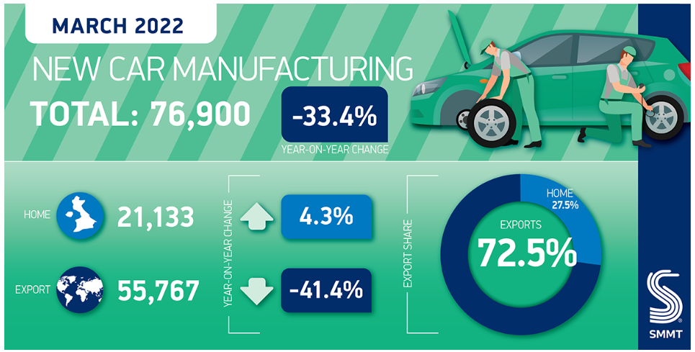
The overseas markets went down with 41.4% in March and the specialist say that this situation is similar to the financial crisis from 2009.
The fact that Swindon plant closed the gates in July 2021 determined a decrease in the US exports with 63.8% and in the EU with 24.5%.
On April 7 in ten cars were destined to export, EU markets taking the majority.
The UK car industry is still suffering the consequences of semiconductors shortages and the world does not seem to get better considering the Ukraine-Russian conflict, the energy prices boom and overall economic situation.

1.1 FORD – History and facts
The Ford blue oval trademark had been used for over 50 years and it is one of the most popular symbols in the world.
The founder of Ford Company was Henry Ford, the first-born of Willian and Mary Ford, on 30 July 1863 in Springwell’s, Michigan. Form early age he was attracted to everything that had to do with the mechanical things and this attraction become later a real passion that in time got him the ,,one of the greatest industrialists in the world’’ title. (FORD, 2022)
When he was 16, he left to Detroit and he became apprentice machinist. After 3 years he returned to Dearborn and he dedicated his time to operating and repairing steam.
In 1893 he was promoted to the Chief Engineer role for Edison Illuminating Company and from here he started to study more the internal combustion engines.
In 1908 Henry Ford introduced to the market the MODEL T, first vehicle destined to the personal transport, cheap and reliable, easy to handle and the success was huge.
In 1913, Ford designed his first assembly line at his first Ford factory in Highland Park, Michigan.
In 1919 Henry and his son, Edsel Ford became the sole owners of the company, his son took over the company’s presidency but when he died 1943, Henry Ford got back his CEO position.
In 1945 he resigned and was succeeded by Henry Ford II, his grandson.
Ford died in 1947, on 7th of April but we can say that Henry Ford has changed the life of many people and through his inventions he set the standard for the global industrial practice in first half of 20th Century.

IMPACT OF COVID 19 ON CAR INDUSTRY
COVID-19 had a huge impact on many economy sectors but automotive one was one of the worse due to the influence on the worldwide supply chain, the production slow down and the sales dropped noticeably. (Descrier, 2022)
The first lockdown from March 2020 obligers the manufacturers to put security measures in place to import Chinese-made part. While the legislation was sorted, the car industry registered a decrease in production of almost 921000 vehicles. (SMMT, 2022)
2021 did not bring big improvements to the sector as the manufacturers had to deal not only with the pandemic disruptions but also with the Brexit situation. The main disruptive factor were the semiconductors shortages.
The lockdown in 2020 brough a lot of insecurity and concern among people, in the light of these events the demand for new cars drops by 80% in April all over Europe, UK new car sales went down by a quarter.
In 2021 the situation got a little bit better, the car sales increased with 1% but it was still 29% less than 2019.
The used car market was not doing well either as it falls with 15% compared to previous years and the second lock down lead to a real collapse of second-hand car sales.
The decrease of new car production determined the increase of the prices for the used cars and dealers all over the country tried to take advantage of the customers.
The good thing in this crisis was the fact that people shifted towards electric cars rapidly, and in 2021 one from six new registered cars was electric. The figures show that in 2021 the dealers sold more cars then four years before together.
Another good aspect is that the supply chain become more transparent, the manufacturers can track the process from the beginning to the end.

COVID 19 IMPACT ON FORD
FORD MOTORS COMPANY faced some hardships as all the other automotive representants here in UK.
The factories from Bridgend, which is manufacturing FORD engines for all Europe, and Dagenham closed their gates for almost one month, due to the crisis induced by the suppliers. (BBC, 2020)
According to the Manufacturer (2020), Fleet News interviewed Neil Wilson, Ford fleet director to find out how the company was dealing with the customers issues on this pandemic. For FORD, mobile servicing represented a huge part of after sales service and they did all the best to help the customers to solve any problems during COVID-19 period.
The servicing centres were still opened, almost half of them but the fleet of mobile vans was in charge with the rest of maintenance and repairs service for the essential fleets.
As many other players of the automotive industry, FORD implemented a series of security measures to fight the spread of COVID-19 virus. They adopted new protocols regarding personal protective equipment, social distancing, sanitising the cars and opted for the contactless payment and document signatures.
Face-to-face meetings were replaced by video conferences and even now, after the restrictions were lifted, they continue to play an important role for the company’s working relationships.
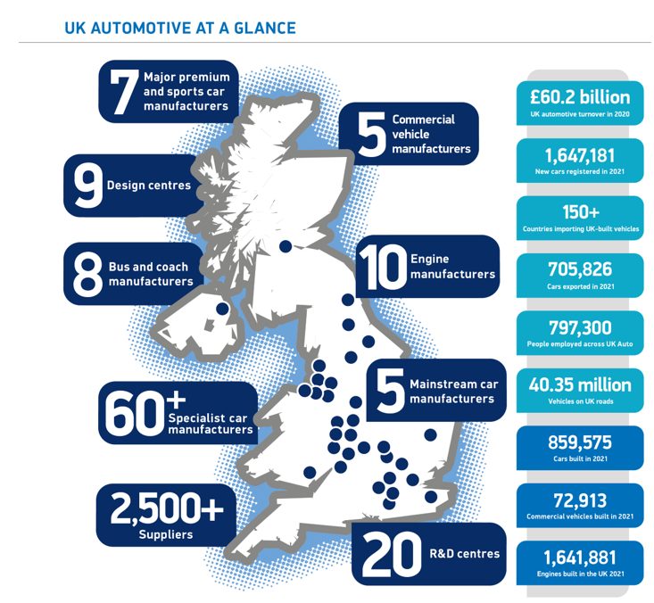
It is important that FORD is coming back on track quite rapidly, the operations in Asia registered a big and unexpected improvement. The used vehicles market is also opening again, and all this are signs that the company can get back it’s top position very soon.

SURVIVAL FACTORS & SUCCESS FACTORS IN THE AUTOMOBILE INDUSTRY
Automotive industry in UK has more than 60 billion turnover and brings almost 12 billion value to the economy, that is why is one of the most important sector of the economy. It creates almost 1 million jobs and 11% of the whole UK export is represented by automotive industry. (SMMT, 2022).
In this business the success and the survival on the market is determined by the quality, innovation, reliability, performance, and cost.(Orcanos, 2022)
Occupying a leader position as car manufacturer, in 2021 FORD reported a revenue of over 136 billion dollars with almost 130 billion more than 2020 but it was not still at the same level with the previous pandemic years.
In 2021, FORD manage to qualify as the fourth most desired brand in UK after Volkswagen, Audi, and BMW. The mother-company from Detroit manage to sell over 116 thousand units in UK and got a market share of 7%. (Carlier, 2022)
Quality of the Product
Diversity is the key word when we speak about FORD’s customers. That is why the company has a well-defined product strategy which is covering all their customers needs. There are producing:
- Cars
- SUV’s
- Crossovers
- Hybrids & EVs
- Trucks
- Vans
- Performance Vehicles
- Vehicle Accessories

Ford parts are sold by Motorcraft, a brand that is trying to meet the expectation of all customers and all driving conditions. (Shastry, 2022)
Year’s ago, Ford’s motto was: ,,Quality is Job1’’ as the company was determined to build reliable and long-lasting vehicles.
Nevertheless, 21st century put the automaker in difficulties and several products were recalled back to the factory. That is why they implemented a connectivity system that allows them to identify the issues that buyers experienced, and Ford engineers can solve them before the vehicle gets on the market. (Cole, 2021)
A Good Brand Image
According to Mathilde Carlier (2021), Ford has the highest value among automotive brands of more than 10 billion US dollars. It is situated on the 6th place on the global automotive sector.
In UK, in 2020 Ford had a market share of 9,28% which brought it the tile of the most popular manufacturer.
Innovation
Ford is keeping up with overall trends in the automotive industry.
- Is producing different range of vehicles, with in ternal combustion and electric, able to compete with all the manufacturers on the market.
- They are using a leading-edge technology for all the products that are delivered to the customers.
- The ICE FORD’s portfolio is meant to bring growth and profitability for the business on all aspects: cost, operations and quality.
- FORD+ plan is destined to accelerate the growth and bring value for FORD’s shareholders; EBIT margin is 10% and by 2030 the EVs will represent half of their market volume.

Reliability
Ford has been one of the most popular cars sold in UK over the years, Fiesta and Focus models were always on the top of the sales charts; is trying to cover all the features to attract the customers: benchmark pricing, technical innovation and family-focus car. Models like B-Max, C-Max, Kuga, EcoSport and Edge are all created to bring driver enjoyment through their class-leading chassis dynamics. (Trebilcock, 2022)
Performance
2022 will bring several new models from FORD covering all the existing vehicle class: smaller Bronco Sport SUV, all-electric Mustang Mach E and totally renewed F-150 pick-up. Together with the new ones, old oner are updated too with FORD’s Sync 4 operating system and Blue Cruise driver-assist technology.
Cost
Ford pride themselves with the rage of vehicles for all categories. That is why they implemented 2 pricing strategies:
- Market-Oriented Pricing – the strategy that rely mostly on competitors, demand, customer preferences etc. Low-income families are choosing Ford brands due to their low-fuel consumption characteristics.
- Premium Pricing Strategy – a strategy created for the luxury vehicles and the prices are a bit higher due to the options that comes with the models. (Shastri, 2022)
Efficient Channel of Distribution
Ford’s distribution is facilitated by a huge network whole over the world. Their distribution channels include dealerships, auto parts and financing companies.
They expand their manufacturing in Asia by setting up a plant in Chennai on 350 acres where they produced over 200.000 vehicles every year. Another plant set up in Asia is the one from Guajarati which is producing almost 240.000 cars per annum.(Shastri, 2022)

3.1 MEGATRENDS FOR FORD AUTOMOBILE INDUSTRY
The megatrends in the automotive industry are related to the digitalization, connectivity, customer needs and sustainability.
According to Charles Gaudet (2022), one of the Ford’s biggest factories in Cologne (Germany) was transformed into an innovation hub. They installed there the Material Flows Wireless Pats system which enables them to track the needed parts and ensure they are distributed in the right time.
Jim Farley, President and CEO of Ford said that ,,we serve others and improve lives… we try to make the world a better place.’’
Ford history as a pioneer in sustainability goes 23 years back. They were the first OEM preoccupied by sustainability, Bill Ford being a true environmental leader.
Ford goals for the future are to reduce emissions and waste from their manufacturing and by the help of innovation and technologies to reach a carbon free emission until 2050. This carbon neutralisation regards not only the vehicles but also the factories and suppliers of Ford.

4. NEWSLETTER FROM FORD

- According to Ford Media Centre, Ford Pro is presenting its all-electric successor to Europe’s best-selling van – the New Ford E-Transit Custom. This van is fitted with the full Ford Pro ecosystem of software and services. The production will start in 2023 in Kocaeli plan from Turkey.
- The European commercial vehicles will benefit of new fleet of vehicles with integrated software and digital services. This new business goal is to bring a global revenue of 45 billion dollars by 2025.
- ‘’Make it visible’’ is a mental health campaign created for the construction industry and together with the Lighthouse Construction Industry Charity, mental health first aiders will be provided on different construction sites in order to reduce the suicide rates among the construction workers.
- Ford is introducing the Geofencing Technology, its purpose is to reduce the number of accidents by creating virtual areas where the vehicles slow down. This will be a great help not only for the pedestrians but also for the drivers as it will reduce the number of the fines for speeding.

CONCLUSIONS AND RECOMMENDATION

Even though the pandemic was a big trial for automotive sector, 2022 changes is helping the cars industry to bounce back rapidly.
Ford implemented many strategies and policies, and this brought a net advantage among its competitors. Their secret is that they always keep in mind their customers preferences and they build up vehicles according to their desires and needs.
With a wide global distribution network, Ford maintain its position among the market leaders and the concern to create electric vehicles that are environmentally safe, to reduce the carbon emission to zero will strengthen even more their top place.
Fuel prices going up, the restrictions that left people without finances are determining and not in the leas, the trend in caring for the environment, will determine people to opt in for EV’s rather than internal combustion cars. The good thing is that Ford has the financial power to implement these changes and to compete with settled brands like Tesla etc.

6. REFERENCES

BBC, (2022), Coronavirus: Ford shuts down UK production due to virus, Available at: https://www.bbc.co.uk/news/uk-wales-51976376, (Accessed: 05 MAY 2022)
Carlier, M. (2021), Car brands: Ford - statistics & facts, Available at: https://www.statista.com/topics/6154/car-brands-ford/#topicHeader__wrapper, (Accessed: 05 MAY 2022)
Carlier, M. (2022), Comparison of leading car companies' market share in the United Kingdom in 2021, Available at: https://www.statista.com/statistics/300467/leading-car-companies-market-share-in-the-united-kingdom/#:~:text=In%202021%2C%20Ford%20was%20the,about%207.06%20percent%20that%20year, (Accessed: 08 MAY 2022)
Carlier, M. (2022), Ford - Statistics & Facts, Available at: https://www.statista.com/topics/1886/ford/#topicHeader__wrapper, (Accessed: 08 MAY 2022)
Descrier, (2022), How has Covid-19 affected the automotive market? Available at: https://descrier.co.uk/business/how-has-covid-19-affected-the-automotive-market/, (Accessed: 28 APR 2022)
Ford, (2022), Ford Media Center, Available at:
https://media.ford.com/content/fordmedia/feu/gb/en/news.html, (Accessed: 05 MAY 2022) Ford, (2022), The Henry Ford Story, Available at: https://www.ford.co.uk/experience-ford/history-and-heritage, (Accessed: 28 APR 2022)
Gaudet, C. (2022), How Ford Embraced Digital Transformation (and 4 Reasons Why B2B Businesses Should Do the Same), Available at: https://predictableprofits.com/how-ford-embraced-digital-transformation/,(Accessed: 05 MAY 2022)
Manufacturer, (2022), How are fleet manufacturers meeting the challenges of Covid-19? Ford responds, Available at: https://www.fleetnews.co.uk/news/manufacturer-news/2020/06/11/how-are-fleet-manufacturers-meeting-the-challenges-of-covid-19-ford-responds, (Accessed: 05 MAY 2022)
Orcanos, (2020), How to Succeed in the Automotive Industry? Available at:
https://www.orcanos.com/compliance/2020/01/19/whys-succeeding-automotive-industry/#:~:text=The%20top%20success%20factors%20%E2%80%93%20quality,as%20a%20critical%20success%20driver, (Accessed: 08 MAY 2022) Shastri, A. (2022), Comprehensive The Marketing Mix of Ford – With Detailed 4Ps, Available at: https://iide.co/case-studies/marketing-mix-of-ford/, (Accessed: 05 MAY 2022)
SMMT, (2022), Global supply challenges wipe 100,000 cars from UK automotive output in first quarter, Available at: https://www.smmt.co.uk/2022/04/global-supply-challenges-wipe-100000-cars-from-uk-automotive-output-in-first-quarter/, (Accessed: 10 APR 2022)
SMMT, (2022), SMMT Motor Industry Facts 2022, Available at: https://www.smmt.co.uk/reports/smmt-motor-industry-facts/, (Accessed: 05 MAY 2022)
Trebilcock, O. (2022), Should I buy a Ford? Available at:
https://www.which.co.uk/reviews/new-and-used-cars/article/car-brand-reviews/should-i-buy-a-ford-car-ayBT33e1HRNa, (Accessed: 08 MAY 2022)
UKEssays,(2018), Key Success Factors of the Ford Motor Company, Available at:
https://www.ukessays.com/essays/marketing/key-success-factors-of-ford-motor-company-marketing-essay.php#, (Accessed: 05 MAY 2022)

