
Student name: Glesni Loveridge
Student Number: 1804647
Report name: professional standards report
Module: professional development
Word count: 2600

Contents page

1.0 Activity 1 ……………………………………………............................ 3
1.1 Activity 2 ……………………………………………........................... 5
1.2 Activity 3 ……………………………………………...........................
1.3 Activity 4 ……………………………………………........................... 10

2.0. References …………………………………………….......................... 13

3.0 Appendix ……………………………………………................................... 15

List of Figures

Figure 1- The four concentric circles of HR professionalism (Source: (Chadwick, 2017).

Figure 2 – The 5 phases of a project (source: (Pathak, 2018).
Figure 3- Gantt Chart (Team Gantt.com, 2019).

Activity 1

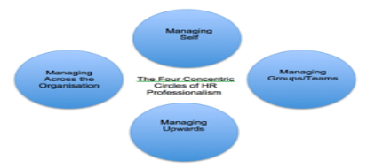
1.0 The term 'profession' can be referred to as anyone who earns their living from performing any activity, this activity must require a certain level of education, skill or training. Professionalism can be defined as someone that ‘makes proficient use of expert or specialist knowledge, exercise different thoughts and judgment, and makes a voluntary commitment to a set of principles. Such as a person need not be a member of an easily defined profession or a professional association, it is possible to work as a professional from a set of expertise and skills that is relatively unique to the individual (Lester, 2010). An example of professionalism is being on time, this is one of the first signs of professionalism. A person that arrives on time shows managers and other employees respect. Not only arriving on time for work but the client or staff meetings are included.

In professional workplaces, professional standards are a set of practices, ethics, and behavior that anybody must adhere to. HR professionals are responsible for adding value to a business in which they serve and contribute to the ethical success of that business.
(Source: (Chadwick, 2017).
Relate to Figure 1, this shows the four concentric circles of HR professionalism these being managing self, managing in groups and teams, managing upwards and managing across the organisation. Human resource professionals must follow a 'code of conduct' to gain the respect of management and employees. These include accountability, fairness, integrity and professional development (Nestor-Harper, 2020). There are also obligations grouped out for CIPD members to follow these include professional competence and behavior, ethical standards and integrity, representative of the profession and lastly stewardship. These four principles apply equally to all CIPD members regardless of their level it also is a commitment as set out in their code of professional conduct document (CIPD, 2020). The CIPD stands for chartered institute of personal development, the CIPD is a qualification is the main professional body to accredit and award professional human resources awards. There are three types of CIPD awards these are foundation level, intermediate level and advanced level (Study, 2019).

Activity 2
1.1 Group dynamics are described as sets of behaviors and psychological processes that can occur within a group working together or between other groups (Cartwright and zander, 1968). The term ‘group dynamics’ was delivered by Kurt Lewin (1943). Kurt Lewin believed there were two key ways to group dynamics one being intragroup dynamics. Intergroup dynamics are the behavior and psychological relationship between two or more groups also intergroup dynamics are related to the endowment, ideology, and behaviors. Whereas intragroup dynamics are the underlying processes that 'give rise to a set of pattern, roles, communion and collective objectives that typify a particular social group" (Staff, 2018).
An example of group dynamics is never shy away from conflict, conflict is a healthy part of a strong group, by getting issues resolved it helps to gain trust. Another example of the group dynamic is over-communicate, the more groups talk the stronger they get, this helps detect issues early and implement a fix quickly before escalation (Skloot, 2019).
Within a group as previously stated conflict is normal to have with team members with different roles. According to Dr. Meredith Belbin, there are nine clusters of behaviors these are called 'Team Roles'. The nine-team roles all have strengths and weaknesses. These nine team roles are resource investigator, team worker, co-coordinator, plant, monitor evaluator, specialist, shaper, implementer and completer finisher (Belbin.com, 2019). Also, Dr. Bruce Tuckman's cycle on team development helps understand group dynamics and how groups work effectively the stages forming, storming, norming and preforming which was created by Tuckman in 1965 explains that a team develops maturity and ability relationships establish. Both of these models enable groups to create and develop effectively. Human resource professionals must be aware that group dynamics are affected by the nature of individuals in the group, a leader, the structure of the group or team, power and status issues and commination structures or processes (Taylor and Woodhams, 2016). For groups to operate effectively HR professionals must understand that presence of different individuals with different agendas and needs will affect the balance of group environments (Taylor and Woodhams, 2016).
There are various forms of teams in an organisation including advice, action, project and production teams (Huczynski and Buchanan, 2017). For professionals to be successful, professionals must develop skills associated with collaborative working and conflict resolution. According to Thomas- Kilmann model each person has a natural approach to managing conflict. Below the Thomas Kilmann model identifies two dimensions when choosing a course of action in a conflict situation, these are assertiveness and cooperativeness. The difference between both is assertiveness if the degree to which you try to satisfy your own needs however cooperativeness is the degree to which you try to satisfy the other personal concerns. From this comes five conflict-handling models these being competing, accommodating, avoiding, compromising and collaborating (Mindtools.com, 2020).
When working in a group I used Thomas Kilmann's model to resolve conflict in the group we used the five conflict-handling models to compromise and make a decision on what was best an example being we couldn't decide what team roles suited who. Anther conflict resolution that I used when being involved in teamwork is brainstorming, appendix A shows my brainstorming map of when we had a conflict, this conflict was because we had different opinions on what role we wanted in our group. We settled this conflict by brainstorming what different skills we had and what we didn’t.
During a time in university group work has been a popular task throughout. An example of myself in a situation of being in charge of a team is when working on a group project. In a group, there are nine team roles according to Belbin thee being co-ordinator, plant, resource investigator, shaper, completer, implementer, monitor, team worker and specialist (Belbin, 2019). All of these team roles have strengths and weaknesses in which can be indemnified to match the right personality. As the team leader, roles such as provide direction, guidance and decision making were needed from me.

Activity 3

1.2

(Source: (Pathak, 2018).
Figure 2 shows the five stages of project management these being project imitation phase, this is when the project starts, names and defined at a broad level. Project planning is the next phase a plan is developed comprehensively of individual plans, for example, costs, scope, quality and risk, and resources. The project executing phase is when the project is developed and completed. Project monitoring and control phase can occur at the same time as the execution phase, this phase deals with measuring the project performance and progression. Lastly, project closure phase, is when the project is formally closed (Pathak, 2018).
Having experiences leading a group problem solving can be difficult if everybody expresses different thoughts. Some problem-solving technique’s I use within my group were brainstorming. By using this technique, helped evaluate everybody's ideas within the group. HR professionals often need to influence others to bring change or different ways of thinking. Other problem techniques such as listing pros and cons, this method is useful to see the for and against of different situations and to outline what is important. another is De Bono's Six Thinking Hats. Appendix B shows the six thinking hats that I used for problem-solving, this technique separates thinking into six defined goals. The white hat is used first to state the obvious of any material or situation, factual information can be useful have by identifying what you have and what you have absent. The second is a red hat, this is emotion, helps express feelings. The third is a yellow hat, by being optimistic and seeing the best scenarios, finding the correct evidence or benefitting. Fourthly black hat forcing to think negatively and then acting on the future problems, you can't head into a situation using just a blind positive manor. Fifthly green hat is all about creativity, approaching situations oppositely and thinking of alternatives are needed to see outside the box. Lastly blue hat, solutions help to stay in control throughout by being focused on seeing the bigger picture of solutions (Dose, 2018). When working in a group project with others a good way of measuring progression over time is creating a Gantt chart. Below figure 3 shows what a Gantt chart looks like, this is a brilliant way to keep track of deadlines, milestones and hours worked overtime. To create a Gantt chart, excel software allows you to prepare the worksheet and carry it out (Teamgantt.com, 2019).
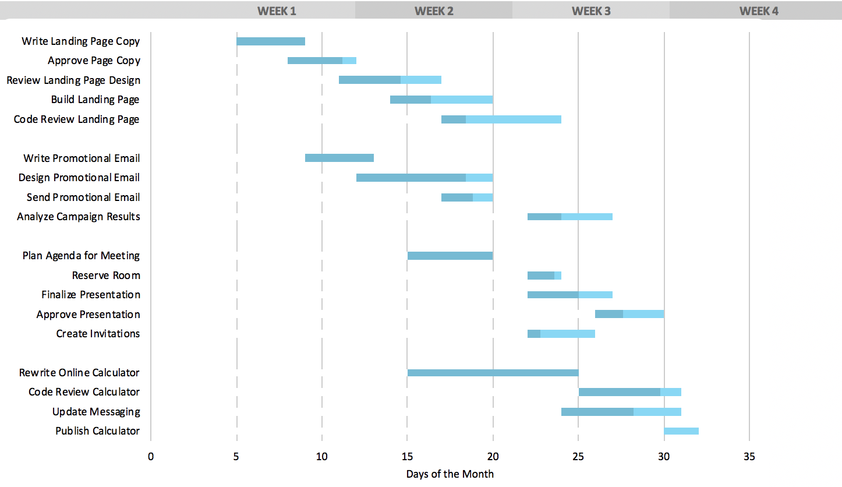
Figure 2- Gantt Chart (Source: Team Gantt.com, 2019).
An example of when I have used persuasion within a group dynamic is being overpowered due to be the leader of the group. According to Yemm (2008) "to successfully influence others, HR professionals must spend time thinking about their broad message and how they wish to convey it” (Taylor and Woodhams, 2016). Yemm (2008) argues that effective influencers posse’s friendliness, empowerment, vision, the ability to build alliances and bargaining skill (Taylor and Woodhams, 2016). The purpose of negotiating is to get a clear viewpoint upon a common course of action. Effective negotiation skills can help all professionals resolve situations where there has been conflicted in a group. For the best outcome if negotiation which is known as a 'win-win' situation, this is when different groups achieve a satisfactory outcome (Taylor and Woodhams, 2016).

Activity 4

1.3 The correct definition of CPD is "the maintenance and enhancement of the knowledge, expertise, and competence of professionals throughout their careers according to a plan formulated about the need of the professional, the employer, the profession and society' (Madden and Mitchell, 1993). The point of continuing professional development is to ensure that every individual enhances different skills abilities after they have formally qualified. CPD is important to professionals as it provides further learning. CPD also allows professionals to focus on what specific skills and knowledge they require over a short-term period, an example of twelve months, to be confident there is recognisable improvement within an individual's proficiency and skill set (CPD- The CPD certification Service, 2020). Appendix C shows my development plan for this year ahead. By creating this DPD will help progression along the way.
The continuous professional development cycle shows that professional development ‘is, like much other learning, best thought of as a circular series of activities.
According to skillsyouneed.com the processes of the cycle are identifying and planning, act and reflect, apply and share and lasting impact. All these processes start from identifying an individual’s development needs through planning and then carrying out learning activities to reflect on the learning, then you apply it and share with others.
The first stage identifying and planning a way of identifying your development needs is a skills audit, feedback from colleagues or managers about an area in which you are weaker will be received. This could open up a particular area in which a person is interested in and then continue to develop the knowledge. The second stage planning and carrying out the development, the activities could either be formal or informal learning the difference between is formal may involve training courses while informal could include video training. Thirdly reflecting on your learning, this is a vital part of continuing professional development. This stage can involve recording your activity whether if it is useful or not, this helps to reflect and make changes. Fourthly applying your learning this stage includes applying what you have learned to your profession. Fifthly sharing your learning with others, being able to teach others and sharing your learning is an important part of making sure you have fully internalized it (skillsYouNeed.com, 2020).
Appendix E shows a CIPD professional map with my reflection on what I need to develop and improve. According to CIPD, the professional map is to help drive change, manage complexity and navigate uncertainty. CIPD believes Individuals can use the new professional map to:
- Build capability in yourself, teams and organisations
- Develop expertise in emerging areas of practice
- Drive sustainable organisational change
- Be more confident, decisive and credible people professional
- Prove your value as an expert on people, work and change
(CIPD profession for the Future, 2019)

From reflecting on the CIPD professional map I can reflect on my learnings and identify what chosen behavior, knowledge and specialist knowledge I lack on for the future. One core behavior in which I could improve on would be working inclusively, CIPD describes this core behavior as working and collaborating across boundaries, effectively and inclusively, to achieve a positive outcome. From this, I can outline what I need to improve for an HR profession in the future. I need improvement with this core behavior as working collaboratively and effectively is out of my comfort zone, I preferably like being independent. I will do this by working and collaborating with different people to work on a positive outcome. One of the core knowledge in which improvement should be made by myself is digital working. CIPD describes digital working as understanding the digital environment and how to apply technology in a people context. Due to my underdeveloped skills within the digital workplace, I would lack knowing the latest technology offerings and understanding them. By adapting, accessing different software and learning this core knowledge will improve overtime and will be useful for future professionalism.
Lastly one of the specialist knowledge in which improvement can be made is learning and development. CIPD describes learning and development as ensuring workers have the knowledge, skills, and experience to fulfill individual and organisational needs and ambitions (CIPD, 2020). This specialised knowledge needs to be improved on my behalf because I need to get a better knowledge of the current and future capability needs of the organisation and also how to create a learning culture that drives engagement in continues professional development (CIPD, 2020).

2.0 References

CPD - The CPD Certification Service. (2020). The Importance of Continuing Professional Development (CPD). [online] Available at: https://cpduk.co.uk/news-articles/view/importance-of-cpd (Accessed 22 Dec. 2019).

Skillsyouneed.com. (2020). Continuous Professional Development (CPD) | SkillsYouNeed. [online] Available at: https://www.skillsyouneed.com/ps/continuing-professional-development.html (Accessed 30 Dec. 2019).

CIPD Profession for the Future. (2020). Profession for the Future. [online] Available at: https://peopleprofession.cipd.org (Accessed 1 Jan. 2020).

Lester, S. (2010) On professions and being professional. Available at:http://www.devmts.org.uk (Accessed 22nd December 2019).

Nestor-Harper, M. (2020). Human Resource Code of Conduct. [online] Smallbusiness.chron.com. Available at: https://smallbusiness.chron.com/human-resource-code-conduct-43968.html (Accessed 30 Dec. 2019).

CIPD. (2020). Code of Professional Conduct | CIPD. [online] Available at: https://www.cipd.co.uk/about/what-we-do/professional-standards/code (Accessed 20 Dec. 2019).

Study, P. (2019). Why should I study for a CIPD qualification? [online] TARGET jobs. Available at: https://targetjobs.co.uk/postgraduate-study/1042549-why-should-i-study-for-a-cipd-qualification (Accessed 20 Dec. 2019).

Kbmanage.com. (2018). Group Dynamics - What is it? Definition, Examples and More. [online] Available at: https://www.kbmanage.com/concept/group-dynamics (Accessed 22 Dec. 2019).

Staff, E. (2018). Elements of Group Dynamics- A Complete Review | ReadEssay.com. [online] Read essay. Available at: https://www.readessay.com/elements-group-dynamics/ (Accessed 22 Dec. 2018).

Belbin.com. (2020). The Nine Belbin Team Roles. [online] Available at: https://www.belbin.com/about/belbin-team-roles/ (Accessed 22 Dec. 2019).

Skloot, G. (2019). Examples of Group Dynamics. [online] Weekly Update. Available at: https://getweeklyupdate.com/blog/examples-of-group-dynamics/ (Accessed 20 Dec. 2019).

Taylor, S. and Woodhams, C. (2016). Studying Human Resource Management. 2nd ed. Exeter, p.84./ (Accessed 22 Dec. 2019).

Belbin.com. (2020). The Nine Belbin Team Roles. [online] Available at: https://www.belbin.com/about/belbin-team-roles/ (Accessed 22 Dec. 2019).

Pathak, R. (2018). [online] Available at: https://project-management.com/top-5-project-management-phases/ (Accessed 22 Dec. 2019).

Taylor, S. and Woodhams, C. (2016). 85. [online] Available at: https://www.amazon.co.uk/Studying-Resource-Management-Stephen-Taylor/dp/1843983125 (Accessed 28 Dec. 2019).

Teamgantt.com. (2019). Free Gantt Chart Template for Excel | Download | TeamGantt. [online] Available at: https://www.teamgantt.com/free-gantt-chart-excel-template (Accessed 2 Jan. 2020).

Teamgantt.com. (2019). Free Gantt Chart Template for Excel | Download | TeamGantt. [online] Available at: https://www.teamgantt.com/free-gantt-chart-excel-template (Accessed 2 Jan. 2020).

CIPD Profession for the Future. (2020). Learning and development | CIPD Profession Map. [online] Available at: https://peopleprofession.cipd.org/profession-map/specialist-knowledge/learning-development (Accessed 5 Jan. 2020).

3.0 Appendixes

Appendix A – Brainstorming mind map

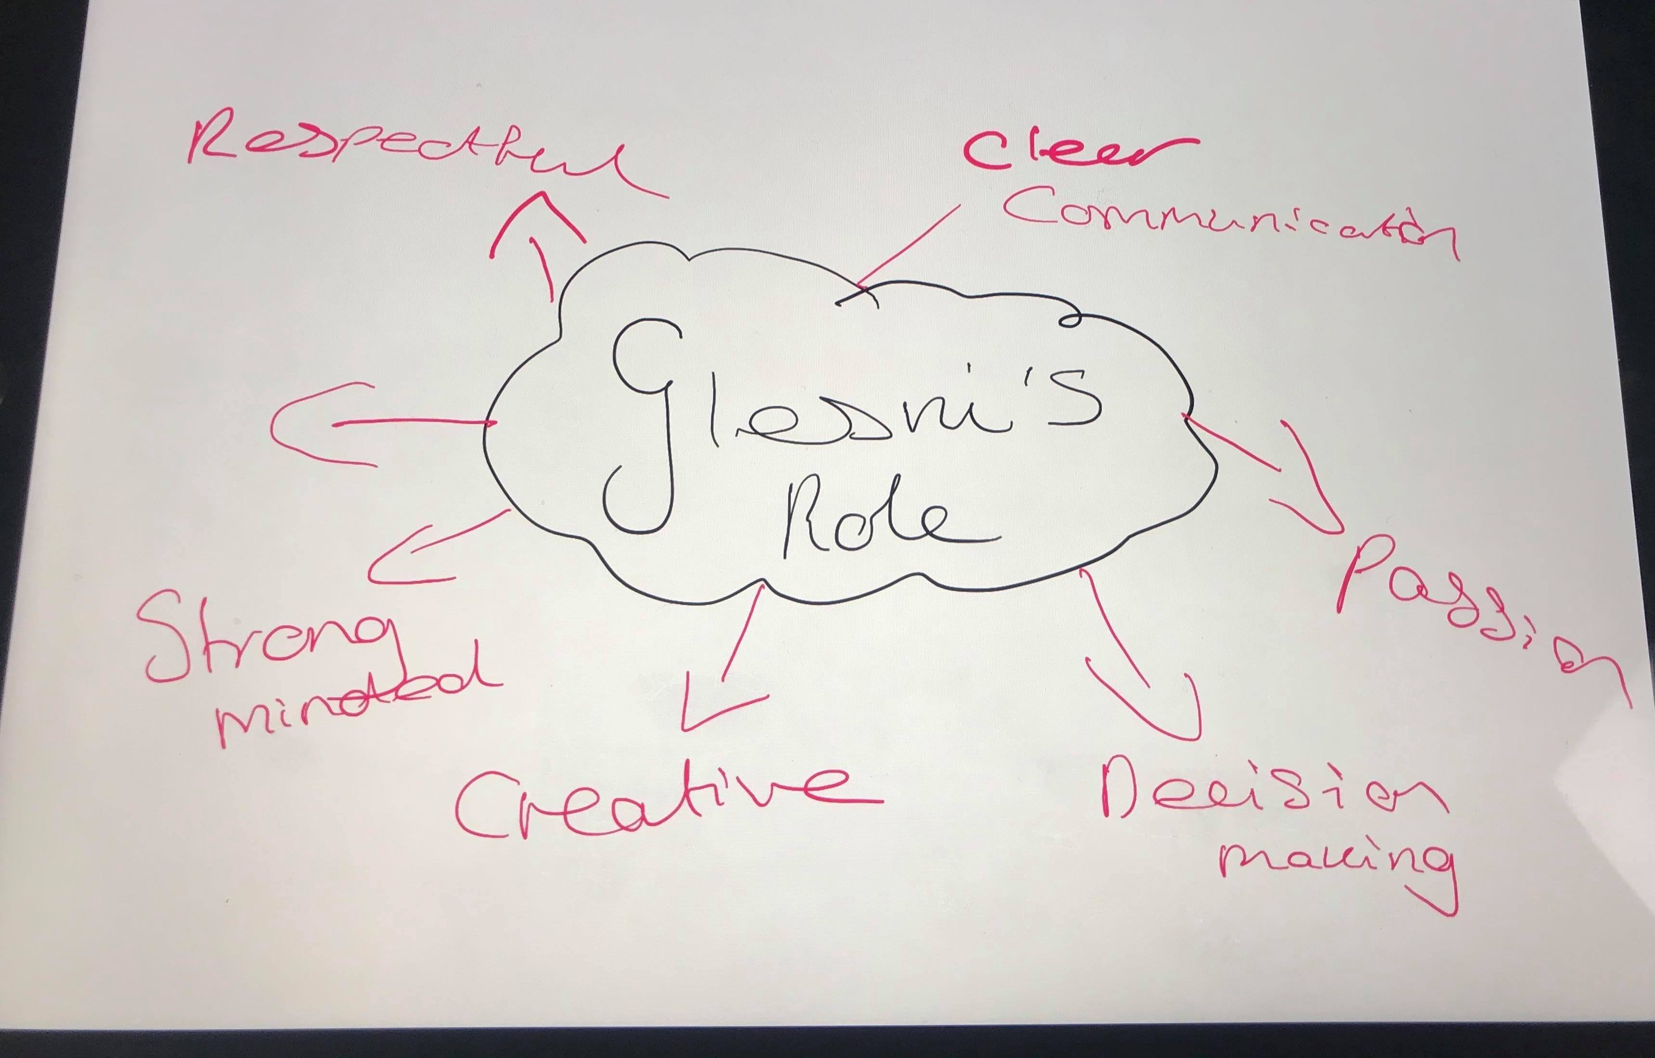

Appendix B – Six thinking hats

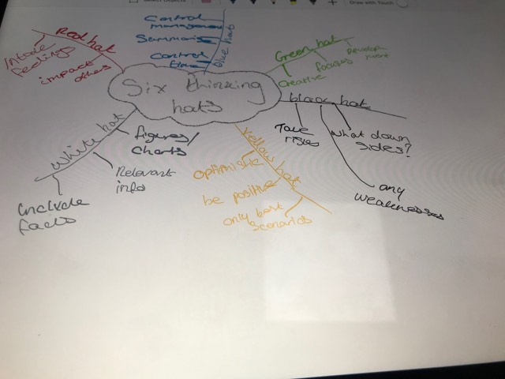

Appendix C – personal development plan

What do I want/need to learn | What will I do to achieve this? | What resources or support will I need? | What will my success criteria be? | Target dates for review and completion
Keep up to date with university work and not fall behind with scheduled assignments | - Allow enough time to complete tasks  - Be organised and have research before hand  - Practise skills learnt and motivate me to carry out a task | Advice and feedback from lectures | To find out if I have fallen behind or not, if haven’t fallen behind learn from it | September 2020
Gain experience by getting a good placement opportunity | - Find a placement in what interests me  - Learn from my chosen placement and take the opportunity  - Understand areas of industry which I desire to move onto | Completed CV with references. Contact with lectures | Getting a placement and learning about HR industry better | March  2020
Become motivated to get better grades in assignments | - Attend all lectures  - Complete work up to date  - Research  - Become more involved | Right books to interact with research better. Speak up to lectures ask for help | To get my targeted grades back | September  2020
Improve communication skills and be more outgoing | - Speak to more people  - Become more involved with group activities  - Be more open with ideas and interests | Friends | To become more confident | September  2020

Appendix E

