Principles of Health and Social Care Practice

Assignment Title: Component 2: Written Assignment (Essay)

Student Name: Silvia Franca
Student ID:2313472

A Critical Discussion of the Social Model of Disability and Its Implications for Person-Centred Care in Health and Social Care Policy and Practice

Introduction
The concepts of person-centred care have been one of the core principles in contemporary health and social care, and they focus on the concepts of dignity, autonomy, individual choice, and collaboration between service users and professionals. The successful provision of person-centred care is based on the conceptual frameworks that help practitioners to understand and shape the organisational culture, as well as to inform legislation and policy. The social model of disability is one of the most powerful of these models that redirects the focus not on the impairment of an individual but on the obstacles of society that limit participation. This essay is a critical analysis of the development and emergence of the social model of disability, major criticisms of this model, as well as the responses that have aimed to promote or even modify the model. Then it will examine how the concept has been utilised in the current health and social care policy and practice with references to tensions, challenges, and gaps, which occur in the process of implementation. To conclude, the essay will offer policy and practice recommendations based on the discussed topic, which will be connected to the module learning outcomes by assessing relevant legislation and discussing the use of effective partnership working as a way to foster truly person-centred care.

Emergence and Development of the Social Model of Disability
The social model of disability emerged in the 1970s in the disability movements that were led mainly by organisations, e.g., the Union of the Physically Impaired Against Segregation (UPIAS). The foundation of this movement was the challenge of the conventional assumptions of disability, where disabled persons were seen as marginalised not because of their disability but because of the societal, structural and attitudinal forces (Jamali and Karam, 2018). In comparison to the medical model that puts disability into a personal realm and defines the issue as a lack and treatment, the social model renegotiates the idea of disability as a consequence of not fitting in, inaccessible environments, and discrimination (UK Legislation, 2025). The model is built across the years to cover greater social determinants of health and wellbeing, so factors such as housing, education, employment and community participation can have an impact on the lives of people. The social model has affected global and national policy frameworks, such as the United Nations Convention on the Rights of Persons with Disabilities (UNCRPD), which emphasises the significance of autonomy, equality and non-discrimination, and legislation in the UK (including the Equality Act 2010 and the Care Act 2014).
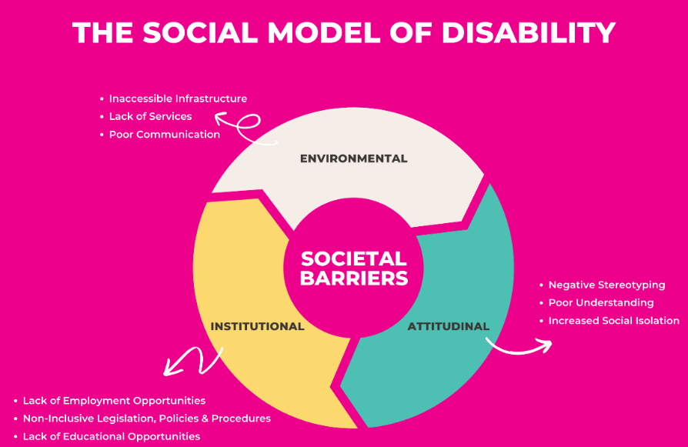
Figure 1: The Social Model of Disability
Source: (Will, 2020)
Despite this significance, the social model of disability has attracted much criticism. The model is simplistic, according to scholars such as Shakespeare (2006), since it is overly focused on social barriers to the extent of living the reality of living with impairment as a cause of pain, fatigue, or chronic illness. Others state that the model does not specifically subject intersectional factors such as race, gender, socioeconomic status or ageing to the perspective of disability, which affect disability experience in one way or another (Barnes, 2019). In addition, critics also contribute to the fact that the model is not always easy to apply to clinical environments where medical services are needed at the same time. In response, more holistic models such as the biopsychosocial model of the WHO and the International Classification of Functioning, Disability and Health (ICF) have been established, which give a more holistic approach, bringing together the social, medical and psychological approaches (Hogan, 2019). Disability activists assume that the social model remains one of the fundamental parts of the rights-based model of challenging discrimination and developing the person-centred, inclusive practice.

Application to Health & Social Care Policy and Practice

Influence on UK Legislation and Policy
The Social Model of Disability has been critical in shaping the contemporary health and social care legislation in the UK in their endeavours to protect the rights of people with disabilities. The Equality Act 2010 is in harmony with the principles of the social model, as it imposes anti-discrimination duties on the state and employers and an obligation to remove structural and attitudinal barriers for employers through reasonable adjustments (UK Legislation, 2025). These provisions recognise that organisational practices tend to be the cause of exclusion rather than impairment per se, and the person-centred approach is supported by the Care Act 2014 through a statutory wellbeing principle, being the statutory principle of autonomy, dignity, choice, and control. Its focus on individualisation, direct payment and creation of a care plan in conjunction signifies the social model viewpoint that people should be left to make their own impact on how they are assisted.
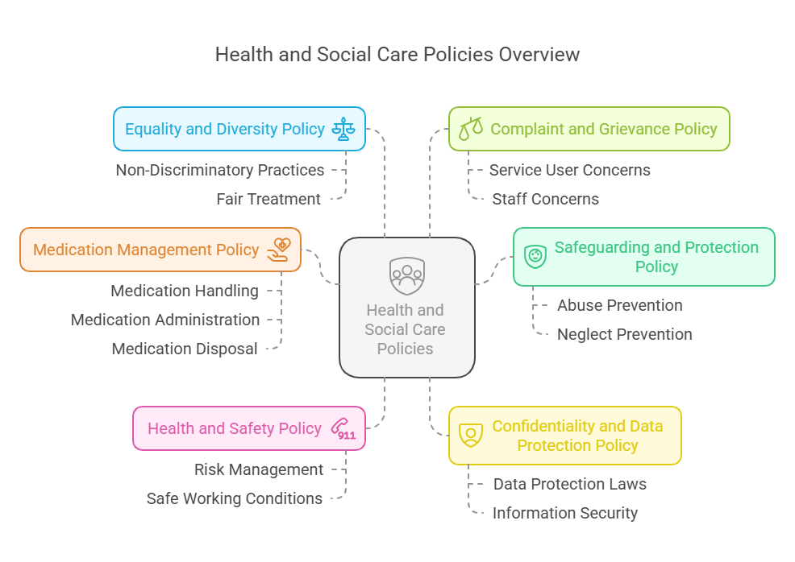
Figure 2: Health and Social Care Policies
Source: (Yean et al., 2020)
The Mental Capacity Act 2005 also concurs with the social model thinking because it promotes the idea of supported decision-making, which stands in contrast to the belief that autonomy is inevitably limited by cognitive impairment (UK Legislation, 2025). With the help of the NHS Long Term Plan, personalised care planning, shared decision-making and accessible information standards are included to eradicate the obstacles in engagement in healthcare. Combined, such structures institutionalise values of social models as legal requirements, which put precedence on equality, participation and removal of disabling obstacles to health and social care delivery.

Application in Practice Settings
The social model of disability is applied in the practices of adult social care that aim at attaining the removal of the environmental, attitudinal and organisational barriers to the lack of independence and wellbeing. The direct payment and the personal budgets give the individual the option and the control over the manner in which they are provided with support, and this is why they offer a high degree of independence and flexibility in living (Varkey, 2021). It is also possible to have professional dominance rather than partnership working as co-production of the care plans, in which the service users are actively involved in the decision-making process with the practitioners (Beauchemin et al., 2019). The other element is advocacy services like the independent advocates under the Mental Capacity Act that can help in the representation of the rights and preferences of the people, particularly in making complex decisions or in using the multi-agency process. According to the practical application, the use of the social model would involve access to things through the use of changes such as assistive technology, adapted houses, forms of communication that are accessible and inclusive, and community. The social care setting is pressing the adult members of staff to be ready to adopt the strength-based practices that focus on ability rather than disability (Thorne, 2025). The conflict situation might also be possible when individuals require medical assistance, and the social and clinical perspectives do not coincide. But, in adult social care, which is one of the most ingrained settings of the social model, the practice of person-centred care is advanced via empowerment, choice, and shattering the disabling barriers.

Problems and Limitations in Practice
The Social Model of Disability has a very strong legislative basis, and practically, it is hard to implement the model. It is the fact that the medical model has been the dominant one throughout and, more specifically, within the NHS, that is why the issue of disability may be viewed as one through the prism of clinical diagnosis, rather than a topic of social obstruction (Franco et al., 2020). The time scarcity, the shortage of manpower, and the increasing cases do not enable the practitioners to deliver indeed personalised care that is relationship-based and undermines the co-production that the social model of care suggests. In addition to that, training in disability rights is deficient, and equality laws suggest that not all professionals know their roles in the context of the field of reasonable adjustments or inclusive communication. The financial stringency in the health and social care sector leads to a reduction in the number of services, queues and resource shortages in the community, creating a gap between the ideals and the actual practice in policies (Casper et al., 2023). Poor interagency communications, fragmented systems and agencies with varying organisational cultures that tend to hamper partnership working that is needed to offer person-centred and barrier-free assistance are all present. This brings the predicament of the disabled being overly assisted, their biographies being duplicated in service, as well as delays in the delivery of care (Best, 2024). These constraints subject the earnest use of the social model to the sphere of restriction and underline the need for systemic investment, cultural transformation and better inter-agency coordination to allow disability to be approached as a social issue of rights rather than as an issue of a strictly medical approach.

Recommendations
The practical strategies are supposed to enhance the aspects of person-centred care, cut barriers, and adhere to the law in order to implement the social model of disability in the health and social care, considering the organisational, financial, and cultural constraints.
- Health and social care provision ought to reaffirm the efforts to comply with the Equality Act 2010 obligations so that reasonable adjustments are always made, which would go a long way to minimise structural and attitudinal obstacles faced by the disabled.
- Disability-rights and person-centred care training should also be made mandatory in all sectors, since it would promote better professional interpretation of the principles of the social model and have the potential to transform the organisational culture to be more inclusive and rights-based in their practice (Santana et al., 2018).
- The government agencies may devote more money to community-based support services, as better financial resources would boost early intervention, decrease dependence on crisis-based care, and leave the service users more independent.
- Policymaking and co-production should be prioritised, and disabled people should be actively involved in the process of policy formulation at the national and local levels; this would produce more policy that reflects lived experiences and would possibly eliminate gaps between the legislation and practice.
- Collaboration between health, social care, housing and voluntary agencies should be enhanced because multidisciplinary collaboration will be more efficient and result in more coordinated and person-centred support channels (Ekman et al., 2021).
- The services must integrate the standards of communication available, such as simple-read materials and the availability of interpreters that would make information inclusive and have the potential to enhance decision-making, autonomy and involvement in care planning.
- Policymakers and organisations need to understand that implementing it is likely to be constrained by a lack of resources and cultural resistance, i.e., long-term investment, leadership dedication and continued evaluation would be necessary to maintain significant changes.

Conclusion
The social model of disability offers a formidable basis for the interpretation and promotion of person-centred care in modern systems of health and social care. The essay has demonstrated how the model has developed out of the disability rights movement as a critique of deficit-based assumptions as well as how it has influenced prominent legislation and policy frameworks, including the Equality Act 2010, the Mental Capacity Act 2005 and the Care Act 2014. Despite its advantages, a calamity of the model in practice is the continuation of medicalised approaches, resources, training, and partner working fragmentation. The social model is still crucial, as it puts the disabled people in the position of active agents instead of passive receivers by focusing on autonomy, inclusion and elimination of barriers in society. In order to bring these ideals into practical action, more effective alignment between policy ideals and frontline action is necessary, backed with substantial funding support, successful inter-agency cooperation and continued dedication to co-production. The enduring usefulness of the social model of disability is in the fact that it provides person-centred, rights-based and socially just methods of care, which help to make sure that disabled individuals are empowered enough to take an active part in society.

References
Barnes, C., (2019) Understanding the social model of disability: Past, present and future. In Routledge handbook of disability studies (pp. 14-31). Routledge.
Beauchemin, M., Cohn, E. and Shelton, R.C., (2019) Implementation of clinical practice guidelines in the health care setting: a concept analysis. Advances in nursing science, 42(4), pp.307-324.
Best, J., (2024) But Seriously Folks*: The Limitations of the Strict Constructionist Interpretation of Social Problems. In Challenges and Choices (pp. 51-69). Routledge.
Casper, S., Davies, X., Shi, C., Gilbert, T.K., Scheurer, J., Rando, J., Freedman, R., Korbak, T., Lindner, D., Freire, P. and Wang, T., (2023). Open problems and fundamental limitations of reinforcement learning from human feedback. arXiv preprint arXiv:2307.15217.
Ekman, I., Ebrahimi, Z. and Olaya Contreras, P., (2021) Person-centred care: looking back, looking forward. European journal of cardiovascular nursing, 20(2), pp.93-95.
Franco, J.V.A., Arancibia, M., Meza, N., Madrid, E. and Kopitowski, K., (2020) Clinical practice guidelines: Concepts, limitations and challenges. Medwave, 20(3).
Hogan, A.J., (2019) Social and medical models of disability and mental health: evolution and renewal. Cmaj, 191(1), pp.E16-E18.
Jamali, D. and Karam, C., (2018) Corporate social responsibility in developing countries as an emerging field of study. International journal of management reviews, 20(1), pp.32-61.
Santana, M.J., Manalili, K., Jolley, R.J., Zelinsky, S., Quan, H. and Lu, M., (2018) How to practice person‐centred care: A conceptual framework. Health Expectations, 21(2), pp.429-440.
Thorne, S., (2025) Interpretive description: Qualitative research for applied practice (p. 354). Taylor & Francis.
UK Legislation, (2025) ‘Legislation.gov.uk’ (Legislation.gov.uk2025) https://www.legislation.gov.uk/
Varkey, B., (2021) Principles of clinical ethics and their application to practice. Medical principles and practice, 30(1), pp.17-28.

