BA (Hons) Management and Leadership – Skills for the Workplace
Workplace Culture and its impact on Organizational Efficiency


July 24, 2021
STUDENT NAME & NUMBER: Abdul ullah - 1912519
LECTURER: UJU UGOCHUKWU

TABLE OF CONTENT PAGE

- Introduction…………………………………………………………………2
- What is an organisation and its environment? ………………………2
  - Micro & Macro Environment (internal & external factor.…………....3
  - SWOT Analysis …………………………………………………………….3
  - The Porters 5 forces……………………………………………………….4
  - PESTLE ……………………………………………………………………...5
- PESTLE Analysis on McDonalds ……………………………………… 6,7,8
  - To conclude on PESTLE …………………………………………………8
- Cultural-Web at McDonalds ……………………………………………..9
- Ethical Dilemma …………………………………………………………..10
  - Sexual Harassment ………………………………………………………11
  - Gender Equality …………………………………………………………..11
- Conclusion & Recommendations ……………………………………..11.
- References ………………………………………………………………...12,13,14
- Appendix 1………………………………………………………………….15
- Appendix 2………………………………………………………………….16

- INTRODUCTION
“If at first you don’t succeed, try, try, try again”, a famous quote from the writer Edward William Hickson as so aptly put for the famous organisation that this report has been investigated and analysed by PESTEL analysis. From the early years when brothers Maurice and Richard McDonald started their first McDonalds Drive-through Restaurant. The model was then eventually bought by Ray Kroc, and then Ray formed McDonalds Corporation in 1955 … and now we can see McDonalds in nearly every continent around the world! McDonalds (2021). Fast forward to now the business model is the envy of the world, and a market leader, setting the benchmark for consistent menu and a speedy service. With a reassurance of profitability through their franchise due to their sheer recognition globally. Using advanced technological systems such as ERP, CRM and BIS, McDonalds will always be at the forefront of success and business efficiency with added great workplace culture.

- What is an organisation and its environment?
An organisation are groups of people in their job roles in pursuing a common goal for attaining results and standards of performance. There are many types of organisations (business structures) from a soul trader who invests with their own capital and are liable for all legal operations and liabilities. An example of a soul trader could be a privately owned florist or a vape shop. Whilst any variety of business like an accountant to an electrician can set up a private limited company, it can be a small or large business with the letters ‘Ltd’, at the end of a business name. A private limited company have limited liability and the owner(s) are called shareholders. Another type of organisation is a public limited company (PLC). An example of a PLC is the National Health Service known as the NHS, which is publicly funded by the UK’s government. In PLC’s shares are sold to the public and become shareholders in the company. These all conform in what is called a business structure. (see fig 1.)
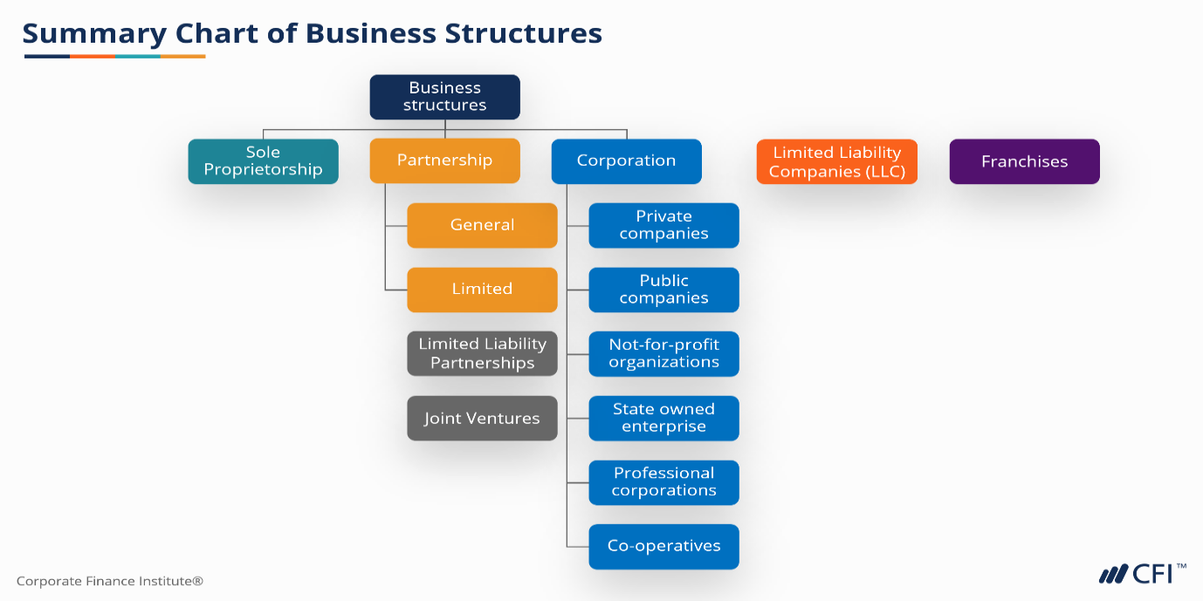
Fig 1. Types of business

All businesses work in what is called an ‘Organisation Environment’. Businesses that operate act and react to what is happening outside, external factors (known as the macro-environment), in their company, industry, or office. What affects business are external factors such as environmental factors, that affects business profitability, like the covid-19 pandemic or political factors that can affect the changes in a business to close whilst in a pandemic. With the organisation at the core, an analogy of a business is like an onion, which has many layers, market, industry sector, then the outer layer, the macro-environment.

2.1 Micro & Macro Environment (internal & external factors)
Within the macro-environment are external factors that affect businesses. This could be elements such as political or legal factors that can change a way a business operates, by the law of the land. Other external factors like, technological affects a business, for example a new technology that can be more influential in the business environment that can excel a business and its smooth running.
The micro-environment are factors that affects the business within (internally). This could be business competitors or new business entrants that can shape or affect a business. Customers also fall into the micro-environment. Loyal customers to a business or customers choosing to shop or do business elsewhere that could affect the business for better or worse. This is the organisation environment. See fig 2.
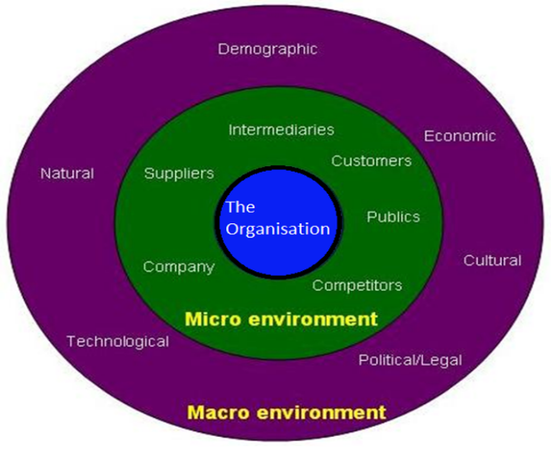
Fig 2.The Micro & Macro Environment

With all its complexity the business environment can be analysed. The internal and external environment can be analysed by SWOT analysis or Porters 5 forces. The external factor can be analysed by a PESTEL analysis.
2.2 SWOT Analysis is great for analysing a new or existing business which identifies 4 components of the business. SWOT is an acronym which means identifying a business’s:
- Strengths
- Weakness
- Opportunity and
- Threats
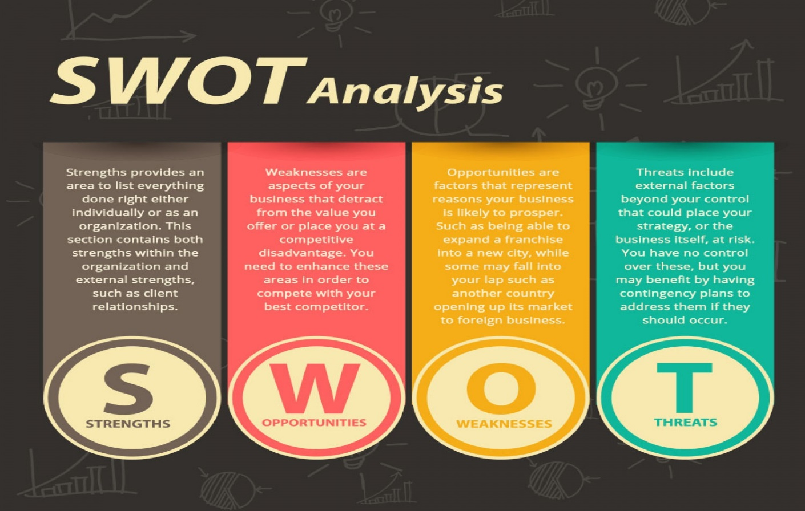 Fig 3. SWOT Analysis

2.3 The Porters 5 forces is a model that recognises the 5 competitive forces that helps identify the business strengths and weaknesses. Michael E Porter at Harvard Business School in 1979 in USA developed this analysis. The Porters 5 forces can be used in any industry to analyse the organisation for long term profitability of the business and enhance business strategies. The five forces are:
1. Power of customers
2. Power of suppliers
3. Competition
4. Threat of substitute products.
5. Potential new entrants

See fig 4.

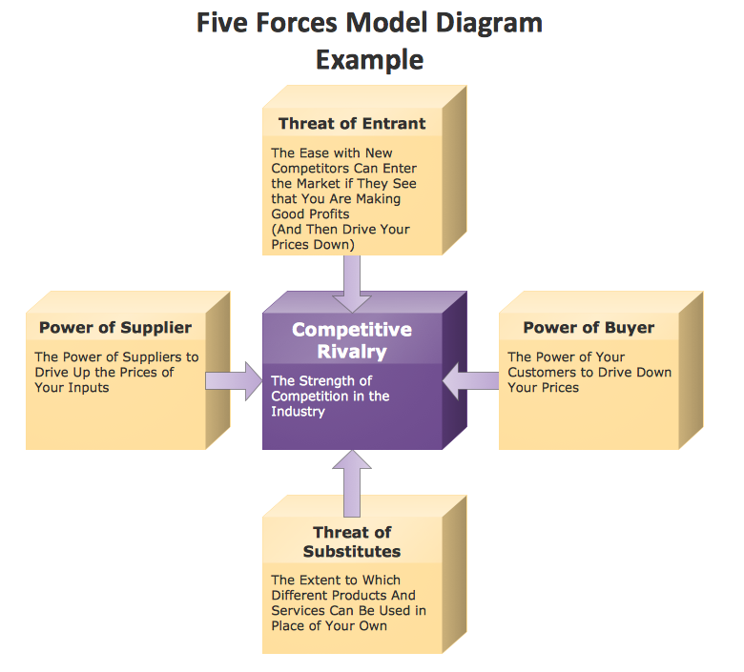
Fig 4. Porters five forces

2.4 PESTLE According to Morgan (2017) PESTLE Analysis examines the various MACRO (external factors) factors like political, economic, social, technological, which impacts its business including legal and environmental factors, (P E S T L E). The PESTLE Analysis highlights the various extrinsic framework which impacts a business. PESTLE is a vital tool for new and existing businesses. This analysis gives a holistic view from many angles to the organisation macro-environment. It also helps a business with the foresight of making new plans, ideas to fruition or products on to the market. PESTLE means:
- Political factors
- Economic factors
- Social factors
- Technological factors
- Legal factors
- Environmental factors

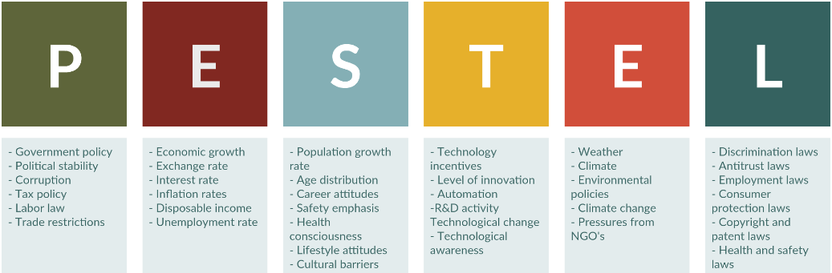
Fig 5. PESTEL Analysis

3. PESTLE Analysis on McDonalds
Political Factors: McDonalds operates in over 120 countries around the world mentioned in McDonalds (2021). So, it will obviously be subject to laws and regulations standards set by the country’s governments. Health regulations in Europe are similar but in America, Australia, Asia have their own laws and regulations helping the restaurants and the public for a better, safer practice on storing, preparing, and cooking foods. Many governments are concerned about obesity, and the impact that fast food industry have on the nation. Mentioned in GOV.UK (2016). UK food strategists calls for a £3 billion sugar and salt levy to combat and improve the UK’s diet according to an article by Butler & Carrington (2021). This would impact manufacturers of soft drinks and many restaurants selling sweet products, etc. Also salt contents has also been scrutinised to an unhealthy diet which affects many fast-food restaurants. These concerns were taken on board and McDonalds have been transparent on their products and offer a healthy option such as salads, fruit bags, and carrot sticks instead of fries. So, the political factors have become an opportunity for a healthier diet incorporated by McDonalds being more transparent about their foods, by cutting down on calories, salt and sugar content and offering a healthier option in line with the UK government laws and projections according to GOV.UK (2021).
Economic factors: McDonalds have a very young staff working in their fast-food restaurants. Most are students working part-time, whilst others work fulltime and work up the hierarchy system to get promoted to a training squad supervisor, floor manager, assistant manager, store manager to area manager. So, with such a young workforce, McDonalds are always taking on new staff as staff turnover is high. So, hiring and training is a big resource on McDonald’s. Other Factors are procuring materials in or out the country as different countries exchange rates are always changing and managers are always strategizing on procurements according to Wilson (2017)
Social factors: McDonalds is an American restaurant that sells its products and American Culture around the world. But not all countries welcome the American dream or its food in their countries. Such countries like Bermuda, Iran, North Korea, Jamaica, and many other countries according to the article in the Telegraph, Morris (2021) due to economic, religious, and political factors. Other elements such as religious factors have had their staple menu changed to suit its public in their own social surroundings in Asia at their local McDonalds in India. Indian’s and its population are made up from Hindu’s, Muslims, Buddhist, and Christians. But for the Hindus they worship the cow, and you will not find any beef or pork on their menu. Instead, they have a bespoke menu such as Aloo Tikki, Chicken Kebab Burgers, Chicken Wrap, Vege Wrap and Filet-O-Fish just to mention a few to suite their palate. There was a backlash from Hindus, when McDonalds said they certified their food as Halal which angered the right-wing Hindus. But there are no pork or beef on its menu to upset the Muslims or Hindus. Halal has to be shown and certified whilst operating in India where you have Muslims that only eat Halal foods. So, the chicken is certified to be Halal (which means permissible to eat in Arabic) for Muslims to consume. Kuchay (2019).
Technological factors: The technological factors at McDonalds have been ground-breaking, whether it is used in its restaurants or Apps on their smartphones or devices at home. McDonalds introduced its electronic kiosk system at their restaurants, reducing queues and labour costs, and leaning to a more efficient and speedier way of ordering a takeaway, or table service at their restaurants that was introduced in 2017 according to McDonalds (2021). They also introduced their own App through IOS and Android so you can order via your mobile phone. Also, in 2017 McDonalds introduced McDelivery through App logistical Partners, Uber and Just Eat. ‘McDelivery brings your McDonalds favourites straight to your door, for you to enjoy from the comfort of your own home’. McDonalds (2021). Delivering food via Just eat (JE) partners where JE sales increased 730% reports Denton (2021)
Legal factors: Mentioned in McDonalds (2021) McDonalds operates in over 120 countries around the world. So, the inevitability that McDonalds would have to adhere to the laws and regulations of that country. Legal requirements can vary from health implications and diet, laws of the land, tax, minimum wage and real estate where the outlets are on. In the UK most businesses have to pay business rates, when operating a restaurant. Also having to adhere to the food safety standards laws and regulations in the UK and human resource (HR). Obesity is a problem especially in children and adults alike according to GOV.UK (2021). So legally McDonalds and all fast-food shops have a moral obligation and laws set by UK laws to reduce calories, salt and sugar in foods and soft drinks. Tedstone (2016) reports the priority was to reduce 20% of sugar in certain foods by 2020 which will include salt, saturated fat and high calories that we purchase from takeaways.

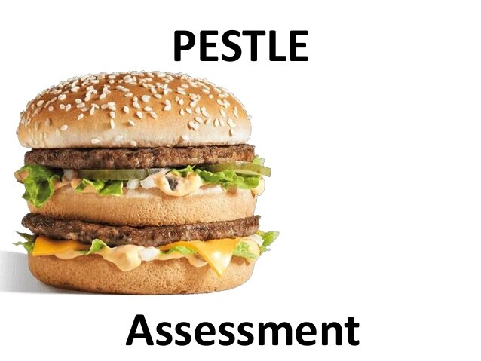
Environmental factors: McDonalds from their many controversies in the 80’s and 90’s that had given a bad press due to many activists and groups, that they didn’t like the global capitalist idea of an organisation that would impact our planet due to deforestation and killing animals. McDonalds quickly learned from those crises, and formed what they call, the GAC, Global Advisory Committee which was formed in 2003. Where McDonalds have experts around the world informing them on matters like, nutrition, waste, recycling their packaging and sustainability. McDonalds with its very successful business model have not had it easy. Through the high sales McDonalds had to face many challenges along the way. They had many negative press and lawsuits against them for over decades. Animal activists continue to disrupt the logistics from their depots around the UK. A spokesman for Animal Rebellion told BBC (2021) and reported that the activist was, ‘concerned for the rainforest deforestation, emitting greenhouse gases and killing billions of animals each year’. Stated by Mcspotlight (2021), in the 1980’s activist group called, London Green Peace, caused so much bad press and disruption to the McDonald’s brand with their manifesto of ‘What’s Wrong with McDonalds’. Stating they effected the rainforest by the packaging McDonalds supplied, and that the food was bad for the public with many other points that were alleged. In response to all this bad press McDonalds established the Global Environment Commitment. With renewable materials used in their packaging which 80% of their packaging which are recyclable. With all the bad PR, McDonalds were committed to a team of experts around the world on areas like nutrition, waste, and sustainability. McDonalds become more transparent and released updates on its practises from their Global Advisory Council (GAC) which was established in 2003. McDonalds (2021).
Fig 6. PESTLE Assessment

3.1 To conclude on the PESTLE analysis on all its macro-environmental segments analysed from political, economic, social, technological, law and environmental factors. The key drivers are:
- The people who work for McDonalds who strive and pursue high standards in the smooth operations of its company with a good human resource policy (HR). They are also intangible asset to the company.
- The continued growth of the company now the 4th largest employer in the world according to an article on BBC (2012)
- Quality and innovating new products added to their menu like the McSpicy, mentioned by Hodgkin (2021) & BBQ Bacon Stack. McDonalds (2021)
- Market position McDonalds are market leaders due to the market segmentation process in America, Europe, Asia/Middle East, Latin America/Canada,
The attractiveness of the McDonalds business environment is a very sexy, sound and profitable company, that attracts organisation culture to new employees as well as customers. For decades now the McDonalds business and its robust franchise system has been envied worldwide and have built a good business model. This business emanates trust, transparency, and expertise with great Human Resource (HR). McDonalds according to a BBC article, Alexander (2012) listed McDonalds being the fourth largest employer in the world. Now, the attractiveness and sustainability of this business model is now more welcoming.
4. Cultural-Web at McDonalds.
The Cultural Web was developed by Gerry Johnson and Kevan Scholes in 1992, it identifies and focuses on the organization's culture and if it needs changing. By using it, cultural web reveals cultural practices and beliefs, and work in line with business strategies.
The definition of ‘cultural web’ essentially is what people say in their organization,
“… this how we do things here!”
Cultural Web are about elements of organization stories, structure, power structure, routines and rituals control systems and logos/symbols. These elements are sometimes hard to understand. The explanations are holistic view of all the elements mentioned, combined with organization history, stories, of beliefs, knowledge, meanings and understanding according to Alvesson (2013).
It is a mix of layers and elements of significant attributes of work and ethics and good practices. The working environment that captures the essence of good working conditions, sense of belonging reward system and staff morale (see fig 7.). It is a culmination of factors that that are interconnected. (See appendix1.).
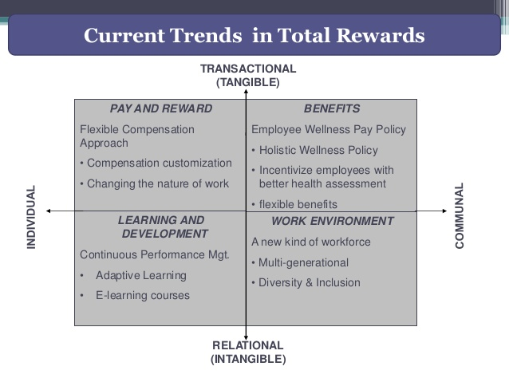 Fig 7. Current Trends in Total Rewards

The organizations vision and mission statements are paramount for employers, employees, and their clients/customers that will resonate the future success of the business. Atlassian (2021) establishes that the definition of a mission statement is fulfilling the criteria and objectives of the business by sustaining the objectives. It is what your business offers, your target market who you serve and why are you unique from your competitors. The definition of vision statement is the aiming high for success and the longevity and aspirations of the business. Having a long-term goal set and creating a sound and safe environment where employees and customers feeling confident with the fundamental core values of the organization.
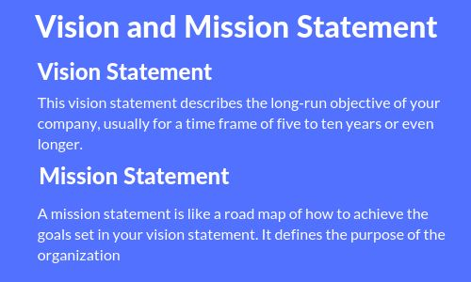
Fig 8. Vision & Mission Statement

5. Ethical Dilemmas
To find out what an ethical dilemma is, we need to understand the word ‘ethics?’ Ethics (noun) are moral principles that control or influence a person’s behaviour, a system of moral principles or rules of behaviour, the branch of philosophy that deals with moral principles. Ethical (adjective) relates to beliefs and principles about what is right and wrong, morally correct, or acceptable. ‘Dilemma’ means a situation that makes problems, often one in which you must make a very difficult choice between things of equal importance. The Oxford Dictionary (2021).
There are many ethical responsibilities that an organisation must adhere to legally (by law) and morally. Whether it be discrimination of race, gender, disabled, abled, religion being abused bullied or sexual misconduct. Craig and Campbell (2005). Every well-structured organisation and using a good HR system adopt policies in a code of conduct or a code of ethics. Which are moral guidelines and laws into discrimination and abuse. (See appendix 2)
5.1 Sexual Harassment is one ethical dilemma that has scorned society for decades. In 2018, Google offices around the world from London, New York, Dublin, and many other cities, (where Google offices were based around the world) staged a protest for the treatment of women and sexual harassment reported in the BBC. Lee (2018).
Resolution: Sexual harassment should be reported to the organisation straight away. There is a code of conduct in place to protect organisations staff and clients. All misconducts should be heard, investigated and the perpetrator suspended or prosecuted if found guilty.
.
5.2 Gender Equality is very sad and morally unfair. A person should get paid the same if they equally doing the same job whether they are male, female or transgender. But for decades again women have been given the short straw when it comes pay. There has always been a massive disparity a gulf when top level jobs and pay have always seen men at the top of the hierarchy and pay. Now a report in the New York Times states in the 125 years of the Olympics and of the 11,000 participants taking part in the Tokyo Olympics for the first time ever 49% are women according to the International Olympics Committee. Minsburg (2021).
Resolution: Talk to your superiors, managers, calmly contextualising what the shortcomings are so the managers can see that the person in question, works as a team player and all working for the common purpose and goals at work set by the organisation. If there is a gulf in disparity, then talk to your union (if a member) or jobs tribunal ombudsman.

6. Conclusion & Recommendations
To conclude the findings in this report is conclusive that the key drivers, driving the macro environment (external factors) are very strong. McDonalds is the benchmark for the best model in franchise being the market leaders for decades in the fast-food industry. Political, environmental, social and law factors have all played a significant part during the Covid-19 pandemic. Having endured two national lockdowns and restrictions to all restaurants, McDonalds and all restaurants in the UK have found it to be a challenging time. However, McDonald’s experience and knowledge management, using management tools such as, IS/IT and ERP have steadied the chain before during the Covid- 19 pandemic.
The report shows the culture of the company and stories shared, senior staff have worked up the hierarchical structure and newer employees love the social aspects of the culture feeling a sense of belonging and what the logo means to them. However, the findings in the report in the social factors of the PESTLE analysis, the staple menu was changed to suit the Indian market due to religious aspects and adapted well to the Indian culture with its changes to the menu. Still innovating – McDonalds keep their customers intrigued by offering new burgers and drinks to their menu.
McDonalds target market has always been the young. The report found the fast-food restaurants had greatly affected obesity in children. This had a global implication by governments to tackle obesity and reduce salt content as well as taxing sugar on soft drinks. If McDonalds came up with a healthier menu it would certainly cash in with its brand championing a new trend.

7. REFERENCES
2021. [image] Available at: <http://studylecturenotes.com/wp-content/uploads/2014/03/global-marketing-environment.jpg> [Accessed 23 July 2021].
2021. [image] Available at: <http://types of business - Bing images> [Accessed 23 July 2021].
2021. [image] Available at: <https://image.slidesharecdn.com/c571a750-bd94-4813-8533-5d5fc7b4c221-160223040209/95/mcd-external-analysis-2-638.jpg?cb=1456200158> [Accessed 23 July 2021].
2021. [image] Available at: <https://image.slidesharecdn.com/totalrewardsmgt-170201125410/95/total-rewards-mgt-report-ir-222-5-638.jpg?cb=1485953748> [Accessed 23 July 2021].
2021. [image] Available at: <https://www.assignmenthelpshop.com/blog/wp-content/uploads/2020/12/pestel-analysis.png> [Accessed 23 July 2021].
2021. [image] Available at: <https://www.careerpathsnw.com/wp-content/uploads/2016/06/swot-analysis_54534e77d19ce_w1500.jpg> [Accessed 23 July 2021].
2021. https://www.bing.com/images/search?view=detailV2&ccid=4C2mdzLP&id=C4A4D324648F1AC1987A337F137777A431F401. [image].
2021. https://www.conceptdraw.com/samples/resource/images/solutions/finance-&-accounting-charts/MARKETING-AND-SALE-DIAGRAMS-Charts-and-Diagrams-Five-Forces-Model-Diagram-Example.png. [image].
Atlassian. 2021. Mission vs. Vision Statements: Definitions and Examples. [online] Available at: <https://www.atlassian.com/work-management/project-management/mission-and-vision> [Accessed 23 July 2021].
BBC News. 2021. McDonald's sales are back above pre-Covid levels. [online] Available at: <https://www.bbc.co.uk/news/business-56913814> [Accessed 25 May 2021].
BBC News. 2021. McDonald's: Animal rights group blockades depots, activists say. [online] Available at: <https://www.bbc.co.uk/news/uk-57210428> [Accessed 25 May 2021].
Bhagat, R., McDivitt, A. and Baliga, B., 2017. Global Organizations – Challenges, Opportunities, and the Future - Oxford Scholarship Online Find In Library Find In Worldcat Global Organizations: Challenges, Opportunities, and the Future. 1st ed. Oxford: Published to Oxford Scholarship Online.
Dylus, A., 2017. The crisis of social market economy in the context of globalisation processes. Annales Etyka w Życiu Gospodarczym, [online] 20(8). Available at: <https://doaj.org/article/ea133818aecc415c9cf54d60861f4b48> [Accessed 23 July 2021].
Eater. 2021. McDonald’s Is Finally Launching a Mobile Order-and-Pay App in 2017. [online] Available at: <https://www.eater.com/2016/11/6/13541514/mcdonalds-mobile-ordering-pay> [Accessed 25 May 2021].
Eater. 2021. The McDonald's of the Future Has Table Service and Touch-Screen Ordering. [online] Available at: <https://www.eater.com/2016/9/27/13074630/mcdonalds-kiosks-digital-menu-chicago-future> [Accessed 25 May 2021].
Ethics, H., 2005. CMI Code of Ethics. 4th ed. [ebook] Management CMI, pp.1 - 10. Available at: <https://www.cmi.no/file/4313-.pdf> [Accessed 23 July 2021].

Express, 2021. 'I bet it’s not that spicy': McDonald's McSpicy burger causes heated customer debate. [online] p.1. Available at: <http://McDonald's news: McSpicy burger causes debate 'I bet it’s not that spicy' | Express.co.uk> [Accessed 23 July 2021].
Franchisedirect.co.uk. 2021. How has McDonald's been so successful for so long? | FranchiseDirect.co.uk. [online] Available at: <https://www.franchisedirect.co.uk/information/howhasmcdonaldsbeensosuccessfulforsolong/> [Accessed 25 May 2021].
Hogan, M., 2021. The Contentious Tale of the McDonald’s “I’m Lovin’ It” Jingle. [online] Pitchfork. Available at: <https://pitchfork.com/thepitch/1227-the-contentious-tale-of-the-mcdonalds-im-lovin-it-jingle/> [Accessed 25 May 2021].
In: Oxford Advanced learner's dictionary. 2021. Ethical dilemma. [online] Available at: <https://www.oxfordlearnersdictionaries.com/definition/english/ethical> [Accessed 23 July 2021].
Kuchay, B., 2021. McDonald’s faces boycott threats in India for serving halal meat. [online] Aljazeera.com. Available at: <https://www.aljazeera.com/economy/2019/8/26/mcdonalds-faces-boycott-threats-in-india-for-serving-halal-meat> [Accessed 25 May 2021].
Lee, D., 2021. Google staff walk out over women's treatment. [online] BBC News. Available at: <https://www.bbc.co.uk/news/technology-46054202> [Accessed 24 July 2021].
Mats Alvesson (2013) Understanding Organizational Culture. Los Angeles: SAGE Publications Ltd. Available at: https://search-ebscohost-com.ezproxy.uwtsd.ac.uk/login.aspx?direct=true&db=nlebk&AN=1099442&site=ehost-live (Accessed: 22 July 2021).
Mcdonalds.com. 2021. 404 Page Not Found | McDonald's UK. [online] Available at: <https://www.mcdonalds.com/gb/en-> [Accessed 25 May 2021].
Mcdonalds.com. 2021. History | McDonald's UK. [online] Available at: <https://www.mcdonalds.com/gb/en-gb/newsroom/history.html> [Accessed 25 May 2021].
Mcdonalds.com. 2021. McDonald’s UK - Burgers, Fries, Salads & More | McDonald's UK. [online] Available at: <https://www.mcdonalds.com/gb/en-gb.html> [Accessed 25 May 2021].
Mcspotlight.org. 2021. London Greenpeace - History and Past Campaigns. [online] Available at: <https://www.mcspotlight.org/people/biogs/london_grnpeace.html> [Accessed 25 May 2021].
Minsburg, T., 2021. When Gender Equality at the Olympics Is Not So Equal. [online] Nytimes.com. Available at: <https://www.nytimes.com/2021/07/22/sports/olympics/olympics-athletes-gender.html> [Accessed 24 July 2021].
Morgan, P., 2017. The business student's guide to study and employability. 1st ed. LONDON: SAGE.
Morris, h., 2021. 10 countries where McDonald's is not welcome. [online] The Telegraph. Available at: <https://www.telegraph.co.uk/travel/lists/the-countries-that-banned-mcdonalds/> [Accessed 25 May 2021].
MSN. 2021. Britons' lockdown takeaway habit helps Just Eat orders soar by 730% in the first six months of 2021 - but investors aren't so convinced as shares slide. [online] Available at: <https://www.msn.com/en-gb/money/other/britons-lockdown-takeaway-habit-helps-just-eat-orders-soar-by-730-25-in-the-first-six-months-of-2021-but-investors-arent-so-convinced-as-shares-slide/ar-AAMbHds?ocid=BingNewsSearch> [Accessed 24 July 2021].
Tedstone, A., 2016. Pubic Health Matters. [Blog] Obesity and the environment – the impact of fast food, Available at: <https://publichealthmatters.blog.gov.uk/2016/10/21/obesity-and-the-environment-the-impact-of-fast-food/> [Accessed 20 July 2021].
The Guardian, 2021. Food strategy calls for £3bn sugar and salt tax to improve UK’s diet. [online] p.1. Available at: <https://www.theguardian.com/politics/2021/jul/15/food-strategy-calls-for-3bn-sugar-and-salt-tax-to-improve-uks-diet> [Accessed 23 July 2021].
Tom Craig and David Campbell (2005) Organisations and the Business Environment. Amsterdam: Routledge. Available at: https://search-ebscohost-com.ezproxy.uwtsd.ac.uk/login.aspx?direct=true&db=nlebk&AN=130268&site=ehost-live (Accessed: 23 July 2021).
UK.GOV, 2016. Childhood Obesity: A Plan for Action.

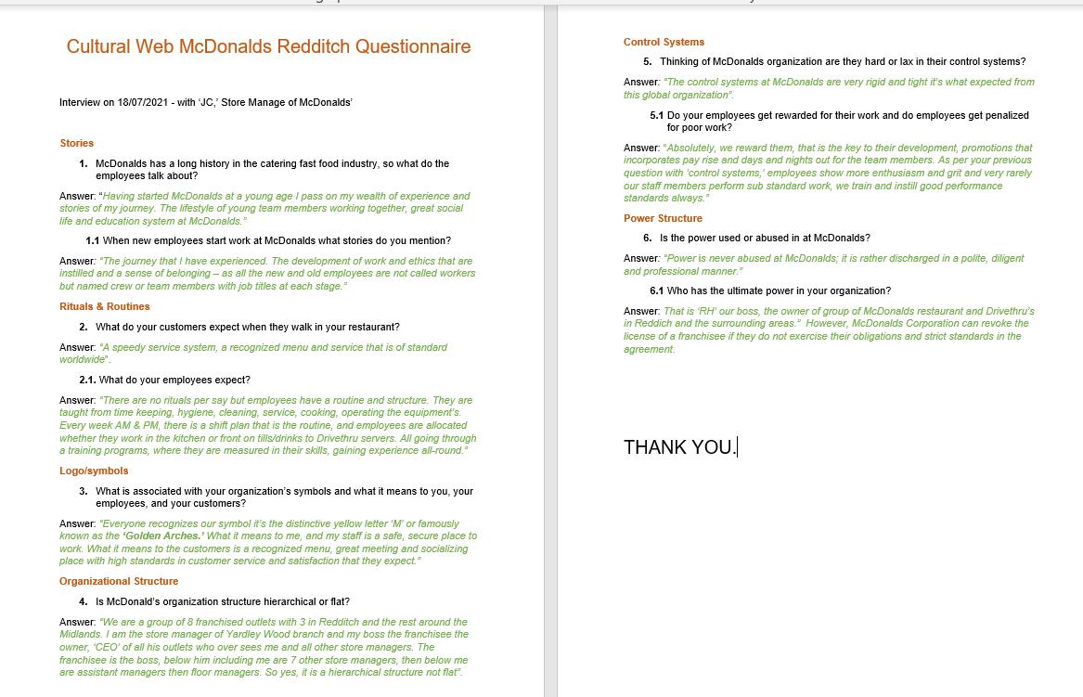
8. APPENDIX 1

APPENDIX 2



