Gurpartap Khatkar (2218525)

HTML & Css Web development

Table of Contents
No table of contents entries found.

Introduction
This report gives an overview of the web development assignment completed by me. The assignment needed a web application that met specific requirements. The report tells you about how we did it, the problems we had, and how we solved them.

Requirements
The website is created on the local pub my family own. It provides a brief introduction to the pub with some photos. The purpose of the website is to advertise the pub to new customers and for customers to check details about pub. The menu, the operating hours and contact information can all be found on there.

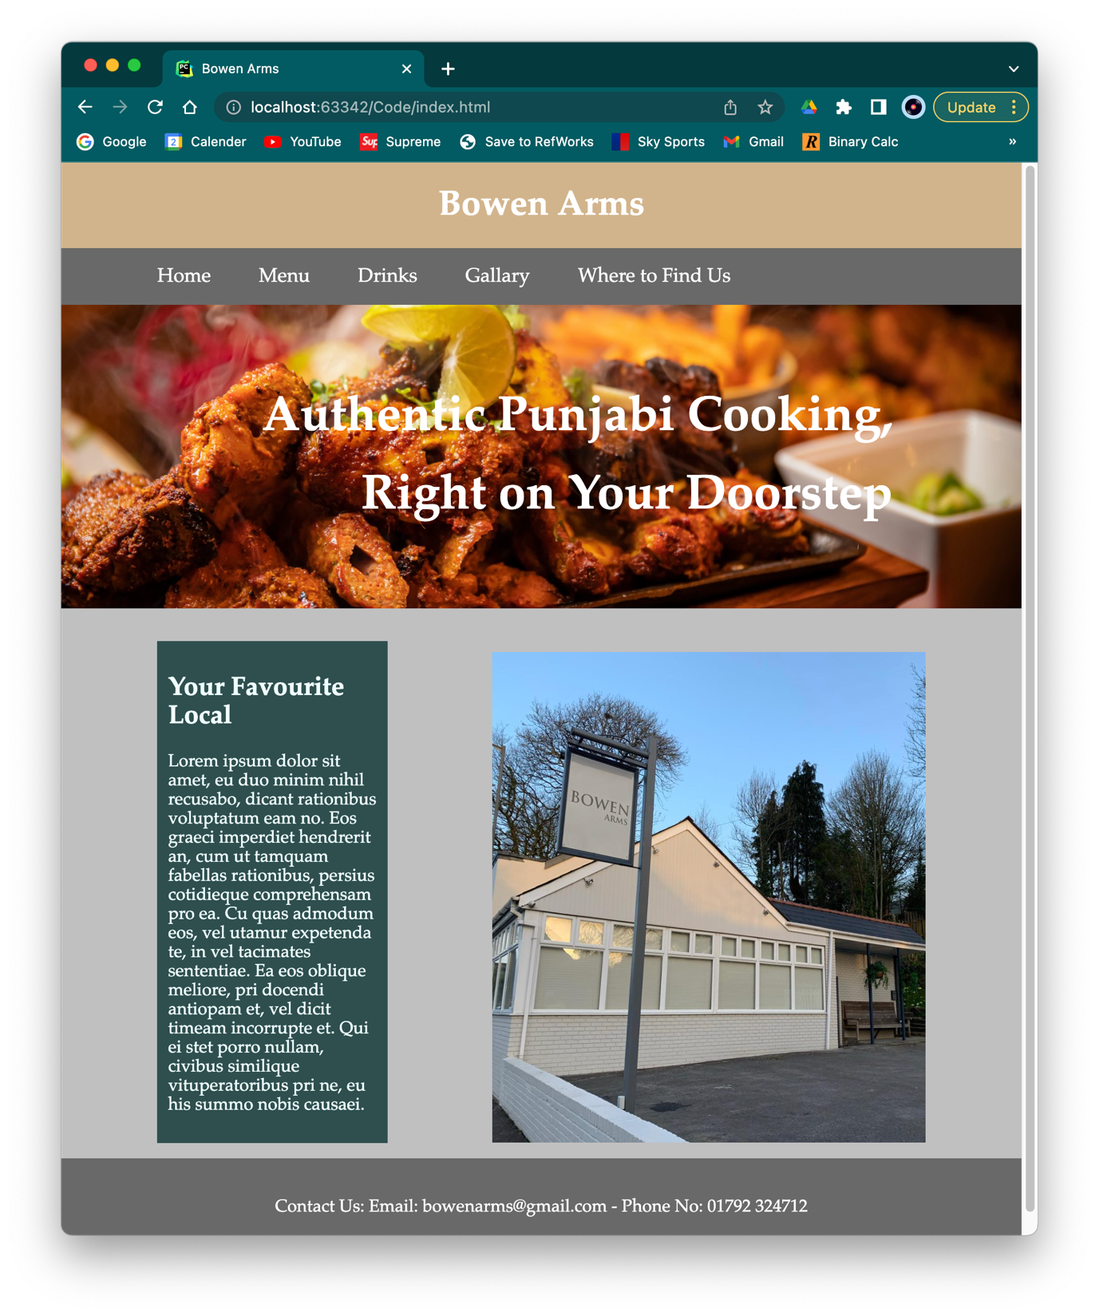
Implementation

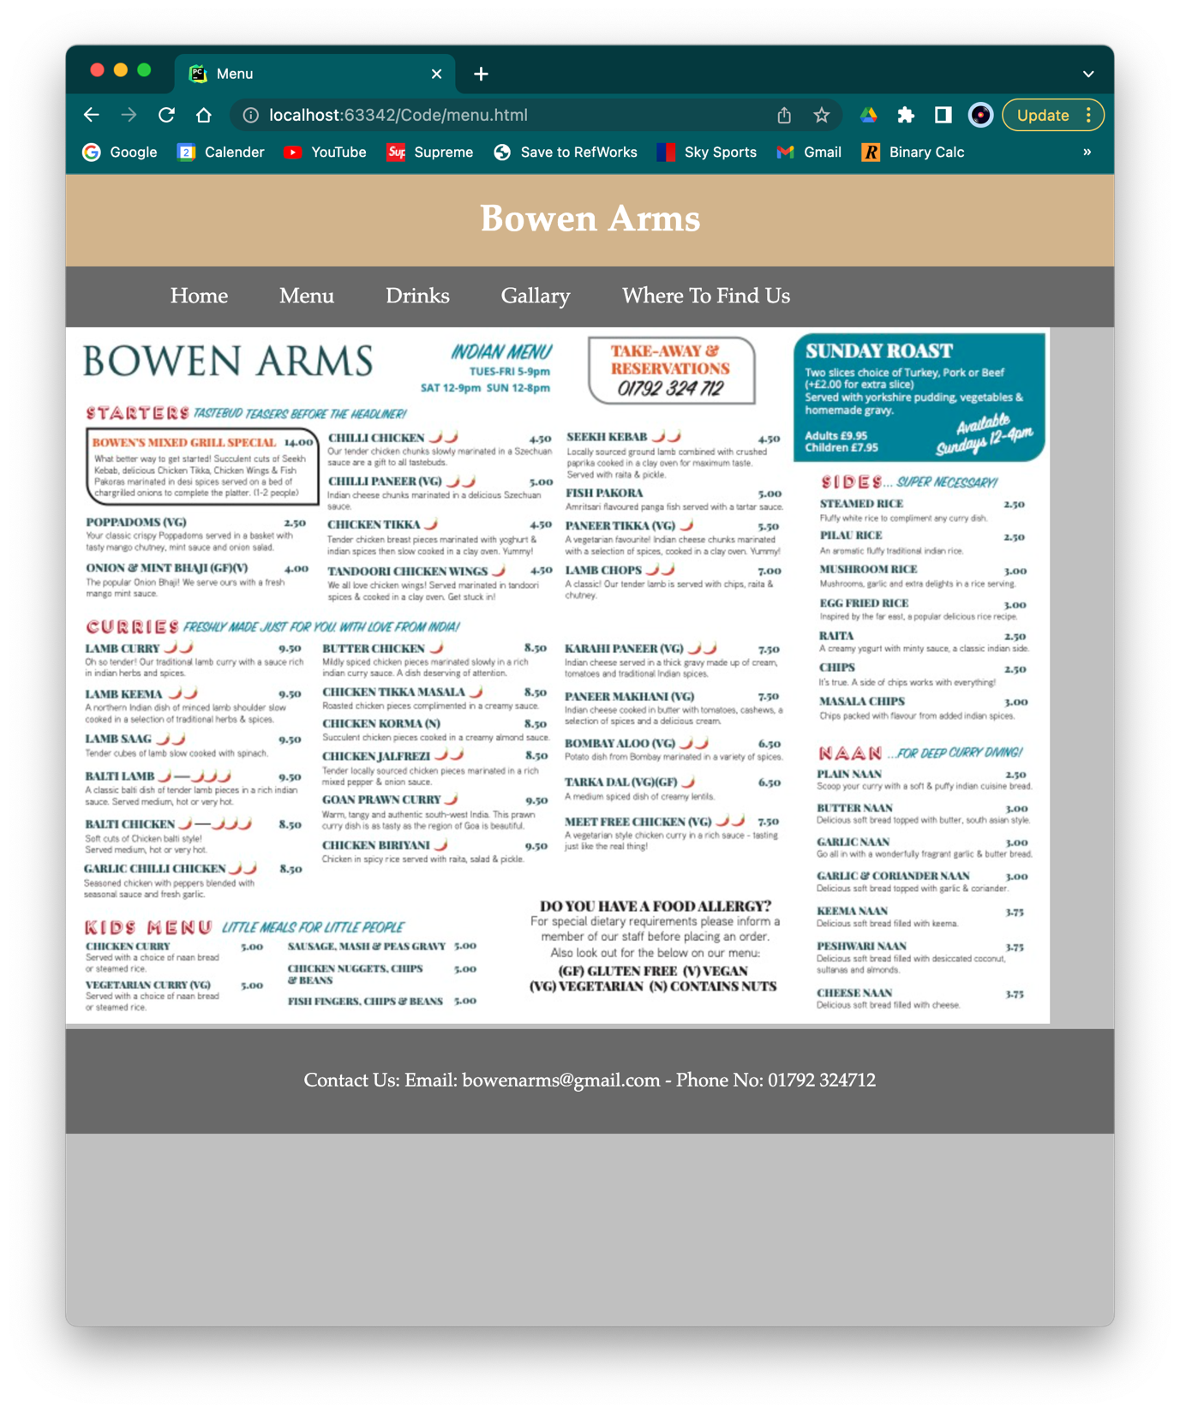

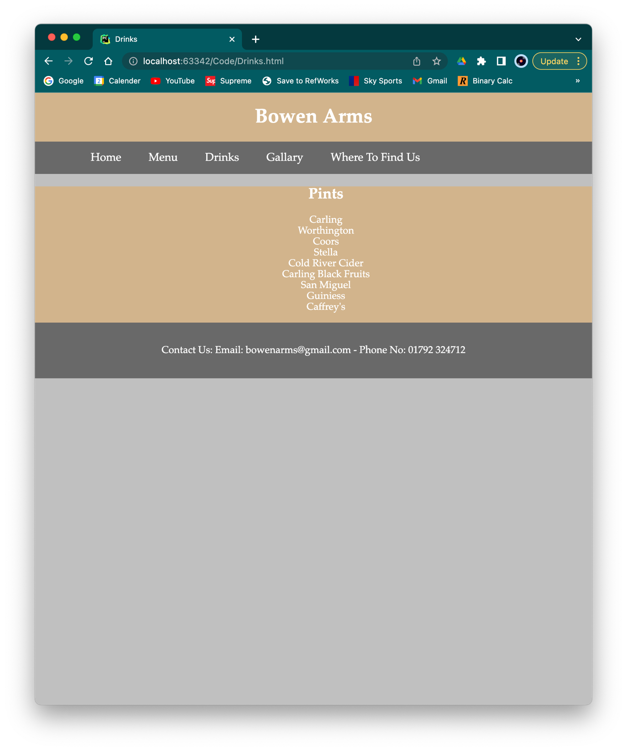

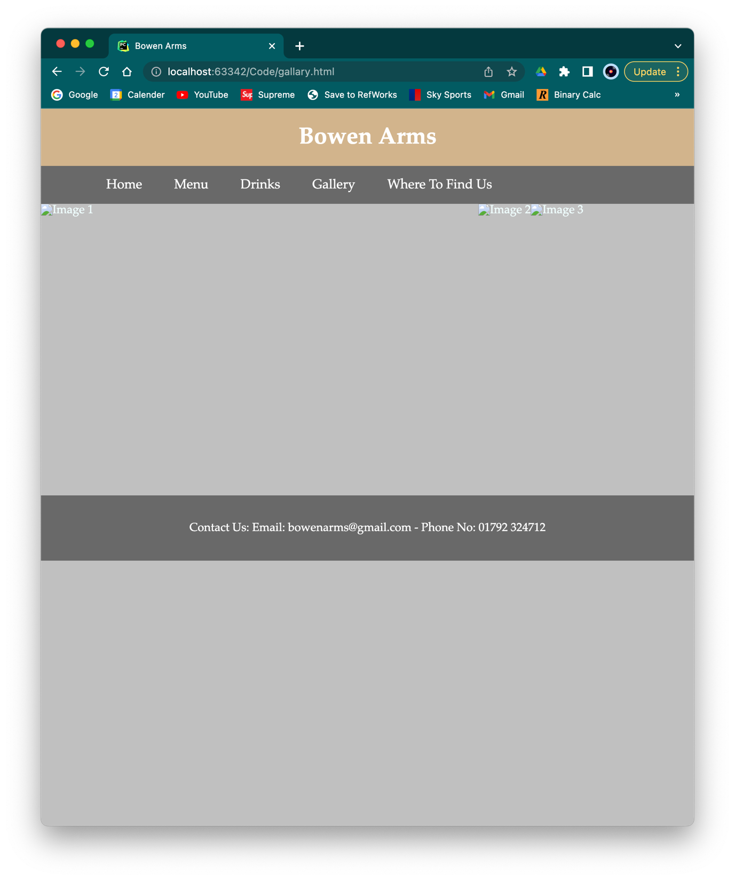

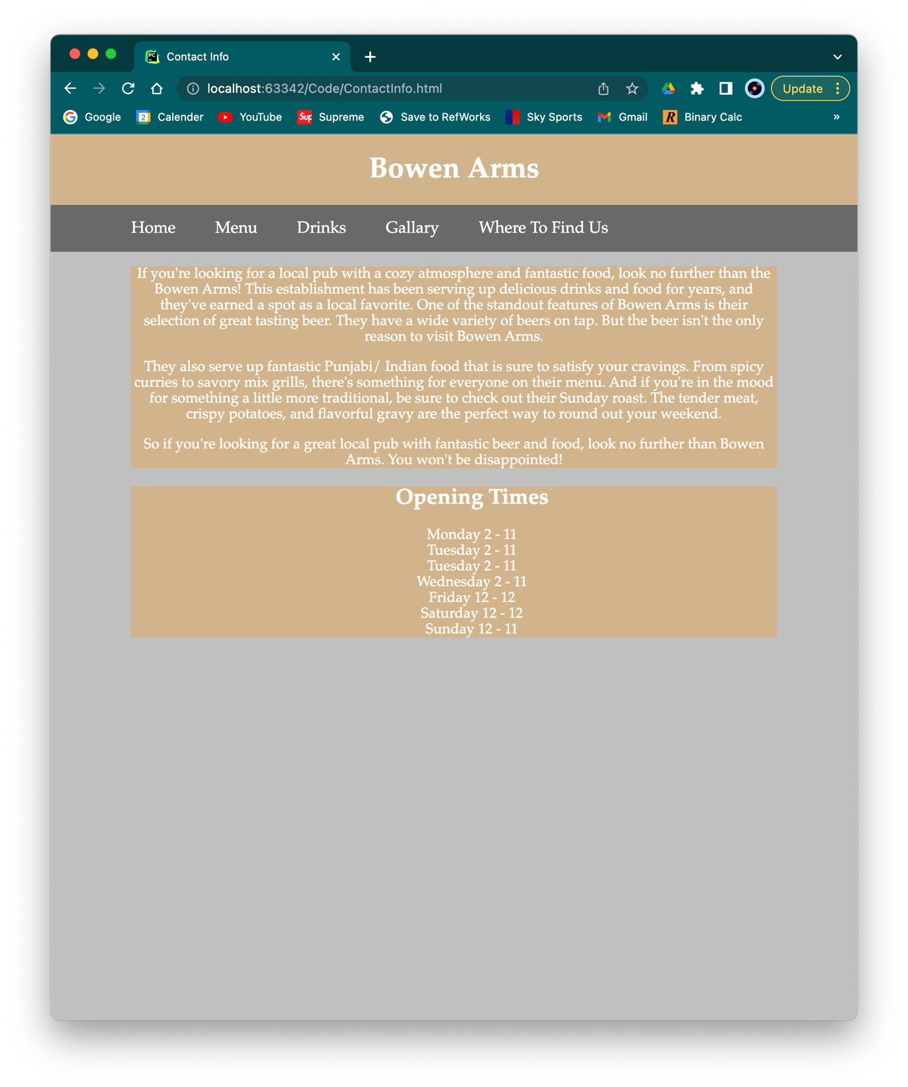

Validation
Using an online validator, I validated both my CSS and HTML code to check for errors.
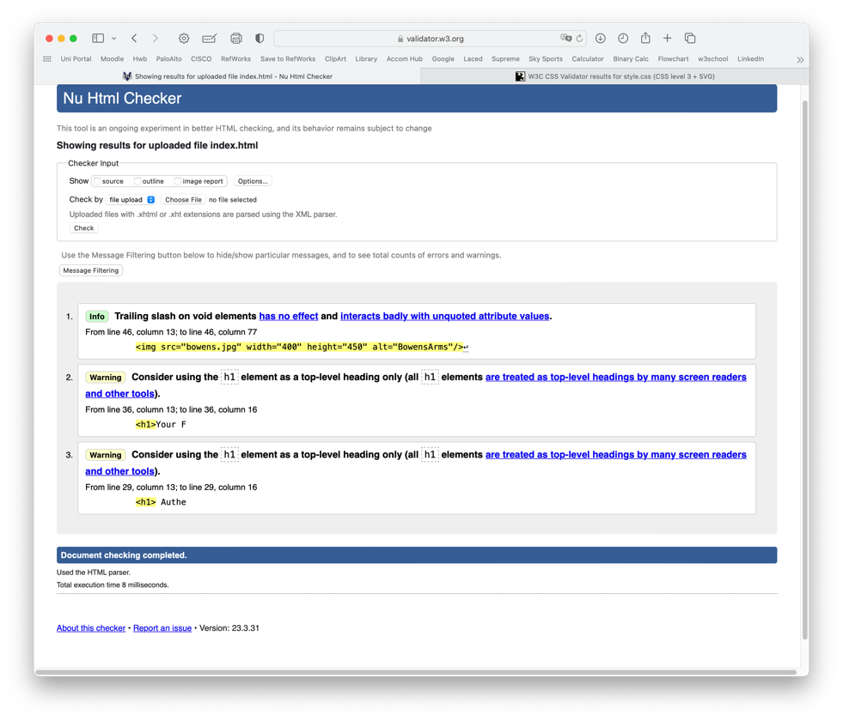
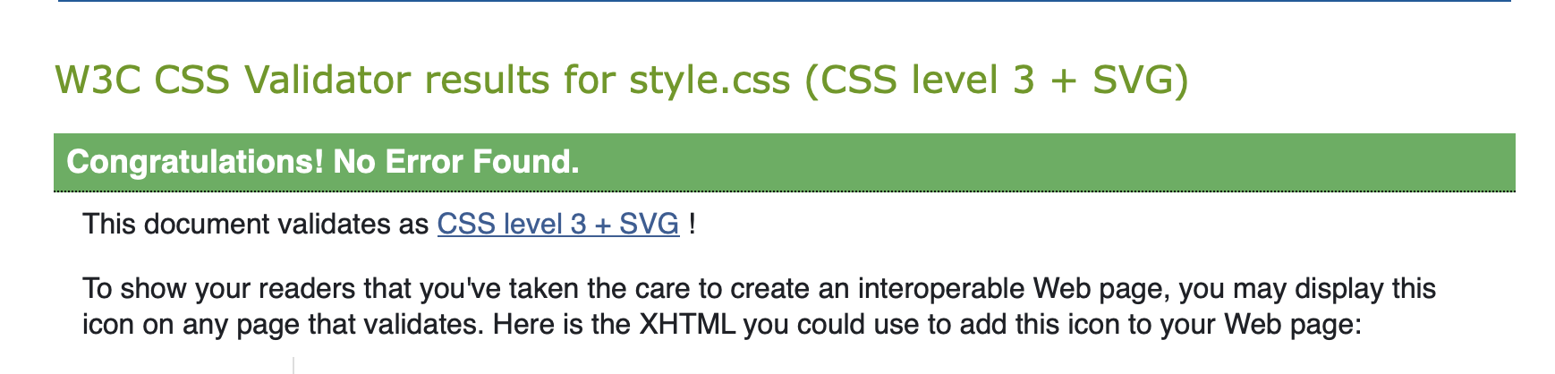
With my CSS, I had no errors at all.
As we can, after checking my HTML, I had a few warnings. This was mainly some syntax errors that don’t cause too much harm. To make sure I can better improve my syntax is not include unnecessary.

Evaluation
When it comes to website design, a crucial factor to keep in mind is the usefulness of the website. Usefulness refers to the ability of a website to meet the needs of its users, both in terms of usability and utility. In this article, we will explore the importance of usefulness in website design and how it can impact user engagement and overall success of a website.

Usefulness
Usability is the ease of use and learnability of a website. A website that is easy to use and navigate will encourage users to spend more time on it and come back in the future. Usability is essential in creating a positive user experience. If a website is difficult to use, users will quickly become frustrated and leave the site. This can lead to high bounce rates, low engagement, and ultimately, a loss of potential customers. To ensure a website is usable, it is essential to consider factors such as clear navigation, intuitive design, and the use of standard web conventions.

Search Engine Optimisation
Search engine optimization (SEO) is an essential aspect of any online business. SEO can help increase the visibility and traffic of a website leading to the business experiencing a huge boost in customer interaction. To optimize a webpage for search engines, there are several factors to consider. These include:
- Keywords
- Title Tags
- Header Tages
- Content
- Internal and External Links
- Mobile Responsiveness.

<!DOCTYPE html>
<html lang="en">
<head>
<meta charset="UTF-8">
<title>Bowen Arms</title>
<link rel="stylesheet" type="text/css" href="style.css">
</head>
<body>
<header id="main-header">
<div class="container">
<h1>Bowen Arms</h1>
</div>
</header>
<nav id="navbar">
<div class="container">
<ul>
<li><a href="index.html">Home</a> </li>
<li><a href="menu.html">Menu</a></li>
<li><a href="Drinks.html">Drinks</a></li>
<li><a href="gallary.html">Gallary</a></li>
<li><a href="ContactInfo.html">Where to Find Us</a></li>
</ul>
</div>
</nav>
<section class="introMsg">
<div class="container">
<h1> Authentic Punjabi Cooking, Right on Your Doorstep</h1>
</div>
</section>
<div class="container">
<section id="main">
<h1>Your Favourite Local</h1>
<p>If you're looking for a local pub with a cozy atmosphere and fantastic food, look no further than the Bowen Arms! This establishment has been serving up delicious drinks and food for years, and they've earned a spot as a local favourite.</p>
</section>
<aside id="sidebar">
<img src="bowens.jpg" width="400" height="450" alt="BowensArms"/>
</aside>
</div>
<footer id="main-footer">
<p>Contact Us: Email: bowenarms@gmail.com - Phone No: 01792 324712</p>
</footer>
</body>
</html>

<!DOCTYPE html>
<html lang="en">
<head>
<meta charset="UTF-8">
<title>Bowen Arms</title>
<link rel="stylesheet" type="text/css" href="style.css">
</head>
<body>
<header id="main-header">
<div class="container">
<h1>Bowen Arms</h1>
</div>
</header>
<nav id="navbar">
<div class="container">
<ul>
<li><a href="index.html">Home</a> </li>
<li><a href="menu.html">Menu</a></li>
<li><a href="Drinks.html">Drinks</a></li>
<li><a href="gallary.html">Gallery</a></li>
<li><a href="ContactInfo.html">Where To Find Us</a></li>
</ul>
</div>
</nav>
<div class="image-container">
<img src="pump3.jpg" alt="Image 1" width="600" height="400">
<img src="food.jpg" alt="Image 2">
<img src="wines.jpg" alt="Image 3">
</div>
<footer id="main-footer">
<p>Contact Us: Email: bowenarms@gmail.com - Phone No: 01792 324712</p>
</footer>
</body>
</html>

<!DOCTYPE html>
<html lang="en">
<head>
<meta charset="UTF-8">
<title>Menu</title>
<link rel="stylesheet" type="text/css" href="style.css">
</head>
<body>
<header id="main-header">
<div class="container">
<h1>Bowen Arms</h1>
</div>
</header>
<nav id="navbar">
<div class="container">
<ul>
<li><a href="index.html">Home</a> </li>
<li><a href="menu.html">Menu</a></li>
<li><a href="Drinks.html">Drinks</a></li>
<li><a href="gallary.html">Gallary</a></li>
<li><a href="ContactInfo.html">Where To Find Us</a></li>
</ul>
</div>
</nav>
<div id="pub-menu">
<img src="MainMenu.jpg" alt="pub menu">
</div>
<footer id="main-footer">
<p>Contact Us: Email: bowenarms@gmail.com - Phone No: 01792 324712</p>
</footer>
</body>
</html>

<!DOCTYPE html>
<html lang="en">
<head>
<meta charset="UTF-8">
<title> Contact Info </title>
<link rel="stylesheet" type="text/css" href="style.css">
</head>
<body>
<header id="main-header">
<div class="container">
<h1>Bowen Arms</h1>
</div>
</header>
<nav id="navbar">
<div class="container">
<ul>
<li><a href="index.html">Home</a> </li>
<li><a href="menu.html">Menu</a></li>
<li><a href="Drinks.html">Drinks</a></li>
<li><a href="gallary.html">Gallery</a></li>
<li><a href="ContactInfo.html">Where To Find Us</a></li>
</ul>
</div>
</nav>
<section id="times">
<ul>
<h1>Opening Times</h1>
<li>Monday 2 - 11</li>
<li>Tuesday 2 - 11</li>
<li>Tuesday 2 - 11</li>
<li>Wednesday 2 - 11 </li>
<li>Friday 12 - 12</li>
<li>Saturday 12 - 12</li>
<li>Sunday 12 - 11</li>
</ul>
</section>
<section id="address">
<h1>Location</h1>
<p>Address: 4 Birchgrove Road, Swansea, SA7 9JR</p>
<p>What3Words: collides.breeze.into</p>
</section>
<footer id="main-footer">
<p>Contact Us: Email: bowenarms@gmail.com - Phone No: 01792 324712</p>
</footer>

<!DOCTYPE html>
<html lang="en">
<head>
<meta charset="UTF-8">
<title>Drinks</title>
<link rel="stylesheet" type="text/css" href="style.css">
</head>
<body>
<header id="main-header">
<div class="container">
<h1>Bowen Arms</h1>
</div>
</header>
<nav id="navbar">
<div class="container">
<ul>
<li><a href="index.html">Home</a> </li>
<li><a href="menu.html">Menu</a></li>
<li><a href="Drinks.html">Drinks</a></li>
<li><a href="gallary.html">Gallary</a></li>
<li><a href="ContactInfo.html">Where To Find Us</a></li>
</ul>
</div>
</nav>
<section id="drinks">
<ul>
<h1>Pints</h1>
<li>Carling</li>
<li>Worthington</li>
<li>Coors</li>
<li>Stella</li>
<li>Cold River Cider</li>
<li>Carling Black Fruits</li>
<li>San Miguel</li>
<li>Guiniess</li>
<li>Caffrey's</li>
</ul>
<footer id="main-footer">
<p>Contact Us: Email: bowenarms@gmail.com - Phone No: 01792 324712</p>
</footer>

body{
background-color: #C0C0C0;
color: azure;
font-family: "Palatino", serif;
font-size: 16px;
left: 1.6em;
margin: 0;
}
.container{
width: 80%;
margin: auto;
overflow: hidden;
}
#main-header{
text-align: center;
background-color: #D2B48C;
color: white;
}
#navbar{
background-color: #696969;
color: white;
}
#navbar ul{
padding: 0;
list-style: none;
}
#navbar li{
display: inline;
}
#navbar a {
font-size: 18px;
padding-right: 40px;
}
a{
color: white;
text-decoration: none;
}
a.hover{
color: white;
}
#main-footer{
background-color: #696969;
color: white;
text-align: center;
padding: 20px;
box-sizing: border-box;
height: 100%;
width: 100%;
margin: 0;
display: table;
}
#main{
float: left;
width: 30%;
background: #2F4F4F;
padding: 10px;
box-sizing: border-box;
}
#sidebar{
float: right;
width: 55%;
padding: 10px;
}
.introMsg{
background-image:url("mixgrill.jpg");
background-size: 1000px ;
background-position: center right;
min-height: 250px;
text-align: center;
margin-bottom: 30px;
}
.introMsg h1{
text-align:right;
color: white;
font-size: 45px;
line-height: 1.6em;
padding: 30px;
}
#pub-menu{
display: block;
margin-left: auto;
margin-right: auto;
}
.row {
display: flex;
flex-wrap: wrap;
padding: 0 4px;
}
.image-container {
display: flex;
}
#main-text{
text-align: center;
background-color: #D2B48C;
color: white;
}
#times{
text-align: center;
background-color: #D2B48C;
color: white;
list-style-type: none;
}
#times ul{
list-style-type: none;
}
#drinks{
text-align: center;
background-color: #D2B48C;
color: white;
list-style-type: none;
float: initial;
}
#drinks ul{
list-style-type: none;
}
#address{
text-align: center;
background-color: #D2B48C;
color: white;
list-style-type: none;
float: initial;
}

#main{
float: left;
width: 30%;
background: #2F4F4F;
padding: 10px;
box-sizing: border-box;
}
#sidebar{
float: right;
width: 55%;
padding: 10px;
}
.introMsg{
background-image:url("mixgrill.jpg");
background-size: 1000px ;
background-position: center right;
min-height: 250px;
text-align: center;
margin-bottom: 30px;
}
.introMsg h1{
text-align:right;
color: white;
font-size: 45px;
line-height: 1.6em;
padding: 30px;
}
#pub-menu{
display: block;
margin-left: auto;
margin-right: auto;
}
.row {
display: flex;
flex-wrap: wrap;
padding: 0 4px;
}
.image-container {
display: flex;
}
#main-text{
text-align: center;
background-color: #D2B48C;
color: white;
}
#times{
text-align: center;
background-color: #D2B48C;
color: white;
list-style-type: none;
}
#times ul{
list-style-type: none;
}
#drinks{
text-align: center;
background-color: #D2B48C;
color: white;
list-style-type: none;
float: initial;
}
#drinks ul{
list-style-type: none;
}
#address{
text-align: center;
background-color: #D2B48C;
color: white;
list-style-type: none;
float: initial;
}

#drinks{
text-align: center;
background-color: #D2B48C;
color: white;
list-style-type: none;
float: initial;
}
#drinks ul{
list-style-type: none;
}
#address{
text-align: center;
background-color: #D2B48C;
color: white;
list-style-type: none;
float: initial;
}

