Name: Melisha khan
Student ID: 2433171
Module code: LHCS4003
Module: Introduction to health and social care
Lecturer: Emanuelle Asante
Title: portfolio – two tasks

[DATE

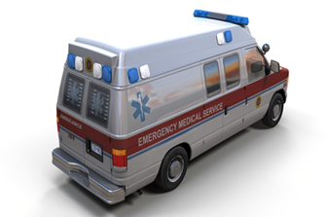
You can save lives, help people that are hurt or ill. Everyday is different and every call brings new situations that includes and demands quick decision making and flexibility as it is all unexpected. Although, I believe that I can work well under pressure and reassure people who are frightened and in pain that everything will be ok. Furthermore, this role you get the chance to be more advance with other technologies that you may be working with. However, working in an ambulance it’s not all repetitive and there’s new challenges you will face every day. Also, with this service as well its all unpredictable so you would never know what to expect when a call comes in so then you can improve working skills and develops a better understanding in the work you are doing.
Ambulance service
The current function of this service is to provide urgent medical care and transportation in emergencies and non- emergencies situations and provide the best care as possible. As of now the primary function of this service today is for a more rapid response dial 999 for critical conditions like heart attacks and breathing problems. Secondly is prehospital care which is CPR, defibrillation and wound care and stabilising the patient before hospital arrival. Also, there is as well as London’s air ambulance trauma team, this bring the hospital to the most injured patients when time is critical. For The ambulance service is currently 10 NHS trusts in England some of which are now foundations.

For category 1 calls which are most life threating incident, that target is an average response time of less than 7 minutes. In December 2024, the average response time was 8 minutes and 40 seconds going way over the average response time. Therefore, category 2 calls that had a target of 30 minutes rose to 47 minutes and 26 seconds going way past the targeted time. According to the 2023 NHS staff survey 39%of the ambulance worker respondents stated they often or aways felt burnt out from work staff members were over working themselves and they would experience high rates of emotional exhaustion – one of the key components of burnout. In 2024 only 35.8% of ambulance trust staff agreed that in their organisation there were enough staff to do their jobs properly.
In the 1890s it was left to the police, firefighters, or taxi drivers to staff a fleet of wheeled stretchers called litters to deliver patients to the nearest hospital to be treated. A few years later the ambulance fleet was horse-drawn vehicles being the primary means of transport these were used till September 14th,1912. However, the first ambulance appeared in 1904, and it could carry one stretcher up to 15mph. Years later the local city council took over the ambulance duties as the second WW2 approached. The 21st century approached where colour coded yellow cycles units were used in 2003.

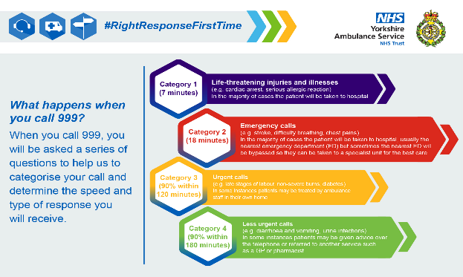
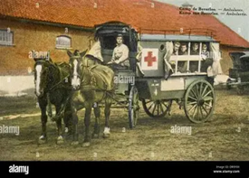

Task 2- Essay
The national health service (NHS) was founded in the United Kingdom on July 5th, 1948, because of citizens having restricted access to medicinal resources and facilities. This caused health disparities in society mainly due to World war 2, where there were more injuries and deaths and not enough medical supplies and health care professionals available, before the NHS was launched healthcare was mostly available for the upper class as they were ones who could afford it, as opposed to the proletarian of society in the 1940s. Additionally, people of the working class only had access to voluntary healthcare services which were not as effective as private services that the upper class were using, the second world was illustrated the importance of a better healthcare system that was always there and was more accessible for people regardless of how they were classed in society or based in their income. The need for an improved healthcare system was evident as injuries and death pointed out weakness of the healthcare that was already put in place.
The Beveridge report of 1942 was a crucial aspect in changing the healthcare system. It recognised five main “giants” that needed to be dealt with: disease, want, squalor, idleness, and ignorance. Its main objective was to create a society where poverty was eradicated by providing social security to all. Furthermore, Aneurin Bevan who was the minister of health during this time, played a pivotal role in creating the NHS as he turned his vision fir free health care into reality for everyone in the UK. He was the main force behind the NHS that made it come alive, due to his ideology that healthcare is a basic human right, which is why we have it all today. The NHS was built with three core principles in mind: being available to all regardless of their financial status, being free and healthcare being based on a patients need rather than their reality.

In NHS has undergone radical structural changes since its foundation since 1948. While the original plan was an entirely centralised, state-run system. The NHS today especially in England is much more complex, fragmented, and decentralised. Some changes have had mixed impacts in the efficiency and equality of health care delivery. The NHS organisational structure in England is managed via a multi-layer system. The department of health and social care (DHSC) is a government department responsible for over seeing health and social care policy in England. It ensures the efficient functioning of the national health service (NHS) and other health organisations by laying down the overall health policy and providing necessary funds. The (DHSC) includes formulating health policies this develops and implementing health and social care policies to improve the healthcare systems.it manages the planning and delivery of the NHS service. Health education England focuses on the training and education of health care professionals. The (DHSC) also includes local authorities so it manages health intivations and manages the public’s health protection. With the NHS structure as well there is the Health Education England (HEE) this is an essential part of the UK’s healthcare system. This dedicated to training and education about healthcare for future professionals. The (HEE) ensures healthcare workforce is well prepared and equipped with necessary skills to deliver high quality to the patient. The health and social care act 2022, NHS England also allocates funds to Integrated care boards (ICBs). Like NHS England, (ICBs) deal with funds for distributions to the NHS trusts so that patient care across the country is adequately financed and monitored. The IBS replaced clinical commission groups (CCGs) to enhance local healthcare delivery and integration. The ICBs focuses on specialising healthcare needs for the local areas. They are involved with communities, charities, and local government in a bid to make healthcare services respond effectively to local needs and resources are used to deliver responsive healthcare to population needs. By encouraging partnerships and community involvement, ICBs encourage more integrated and coordinated health care services, results 78in improving patient outcomes and overall functioning of the health system.

References:

British Medical Association (2020). Integrated care systems (ICSs). [online] The British Medical Association is the trade union and professional body for doctors in the UK. Available at: https://www.bma.org.uk/advice-and-support/nhs-delivery-and-workforce/integration/integrated-care-systems-icss? [Accessed 19 Oct. 2025].

Jones, I. (2024). (“More than third of ambulance patients wait at least 30 minutes ... - MSN”) [online] Expressandstar.com. Available at: https://www.expressandstar.com/uk-news/2024/12/05/more-than-third-of-ambulance-patients-wait-at-least-30-minutes-for-ae-
handover/? [Accessed 18 Oct. 2025].

Londonsairambulance.org.uk. (2025). Home | London’s Air Ambulance. [online] Available at: https://www.londonsairambulance.org.uk/?utm_source=Microsoft&utm_medium=paid-search&utm_campaign=K00C057A04&utm_content=microsoft_brand&msclkid=75a69472eb5319b6eaebfc9cde680f40 [Accessed 14 Oct. 2025].

Nsw.gov.au. (2025). Reasons to become a Paramedic -. [online] Available at: https://www.ambulance.nsw.gov.au/careers/paramedic/reasons-to-become-a-paramedic? [Accessed 11 Oct. 2025].

Rdht.org.uk. (2024). Early Ambulances | Ripley and District Heritage Trust. [online] Available at: https://www.rdht.org.uk/early-ambulances/ [Accessed 17 Oct. 2025].

Suhaani, S. (2024b). Structure of the NHS in 2024 - How The NHS in England Works - Health And Care Systems & NHS England in 2024. [online] The UKCAT People. Available at: https://www.theukcatpeople.co.uk/post/structure-of-the-nhs-how-the-nhs-in-england-works-health-and-care-systems [Accessed 18 Oct. 2025].

