EFFECTIVE TEAM WORK AND COMMUNICATION

Executive summary
This report is associated with teamwork and communication in health and social care. This study has chose a well-known healthcare organization of UK that id Care UK. Analysis of the skills and employment functions has been done for understand the knowledge and importance of the subject. Moreover, practical skills related to the topic are also discussed in this study. Based upon the issues of communication and teamwork, statements are judged using relevant theories and model. Furthermore, a firm conclusion has been drawn at the end based on the generated findings and analysis of the topic.

Table of Contents
Introduction 4
Discussion 5
1. Knowledge and importance of communication skills and teamwork in Care UK 5
2. Research based literature with application of theories 6
3. Analysis on the issues found in healthcare 8
4. Practical application and deployment using theories 9
5. Skills for professional practice 10
Conclusion and recommendation 11
Reference list 12
Bibliography 13

Introduction
Teamwork and communication skills are two important elements in every organization that requires to be developed in order to perform every tasks and activities effectively. In health and social care, it is important to have proper coordination with every health service professionals and support providers for enhancing effectiveness of social care. In this study, Care UK has been considered for discussing the issues and presenting practical application of the work services. This health and social care organization is specially known for providing care and support to the older groups of people and deal with mental health problem users (Careuk.com, 2019). The organization is having 40 bedrooms that are spread on three floors where support users are treated effectively by the health staffs. The main aim of the study is to understand the importance of effective communication and teamwork using real life examples of Park field Nursing Home and other relevant theories.

Discussion

1. Knowledge and importance of communication skills and teamwork in Care UK
Using effective communication skills and teamwork, employers in healthcare are able to understand the level of satisfaction in providing proper services. As opined by Gafa et al. (2018), poor non-technical skills consisting of teamwork and communication may result in the medical errors and patient safety incident. Hence, it is important to understand the techniques of communication improvement and teamwork contribution for enhancing the culture of patient safety.
Communication skills
Being a healthcare professional, communication skills should be given a top priority. In my healthcare professionalism, while working in Care UK, I think that good communication skills are required for developing active listening skills in order to respond to the patient need and concerns by assessing their body language effectively. For example, in Care UK, while treating individual suffering from mental health problem and psychiatric disorder, speaking to them directly has helped in understanding the message clearly. On the other hand, for dealing with old patients, it is important to maintain eye contact and speak slowly so that they understand the type of medication required for their treatment. As mentioned by Ercegovac (2008), using short message and simple words in communicating with the older client is helpful for mitigating issues in providing health services.
Teamwork management
Multidisciplinary teams in healthcare helps in benefitting both patients and health professionals. This helps in improving health outcomes and delivers satisfaction among clients. In my healthcare profession, I found that teamwork management is highly required for distributing the tasks among every staffs. As suggested by Belbin (2010), Belbin’s theory is useful for understanding the significance of every health professionals and supporting staffs along with clear responsibilities. Applying Belbin’s theory in team management of Care UK, the patient’s medication system can be planned according. This is because; the treatment procedure of mental health sufferers is a lifelong process that needs to be planned in a coordinative way. As per the analysis of healthcare of UK region, it has been found that due to disorder team plan, about 70% of the patients died due to devoid of emergency admissions (Morgan, 2016). Hence, it can be said that if the team activities are strong, it can bring quality improvement and improve the financial performance of the healthcare system.

2. Research based literature with application of theories
In today’s context, it has been found that healthcare professionals are required to work in team for providing quality and continuing healthcare services. According to Tuckman and Harper (2012), effective communication and teamwork is vital for increasing safety of the healthcare users. This study mentioned that communication is a process that is used for exchanging information among individual, departments and organizations.
Application of theories to discuss about communication and teamwork in social care
In context of healthcare, Montano and Kasprzyk (2015) stated that use of theory of planned behaviour could firmly help in enhancing the attitude and beliefs so that individual can understand the ideology and behavioral intentions. In my healthcare profession of Care UK, I have observed that due to lack of collaboration and planning in medication system of mental disorder patients, the treatment procedure became ineffective in nature. Hence, using the concepts of planned behaviour theory; healthcare professionals can understand the mind of patients and help them to develop communication strategy accordingly. This theory helps in understanding of disease prevention behaviour, birth control behaviour and other types of medications that is important for making health services effective.
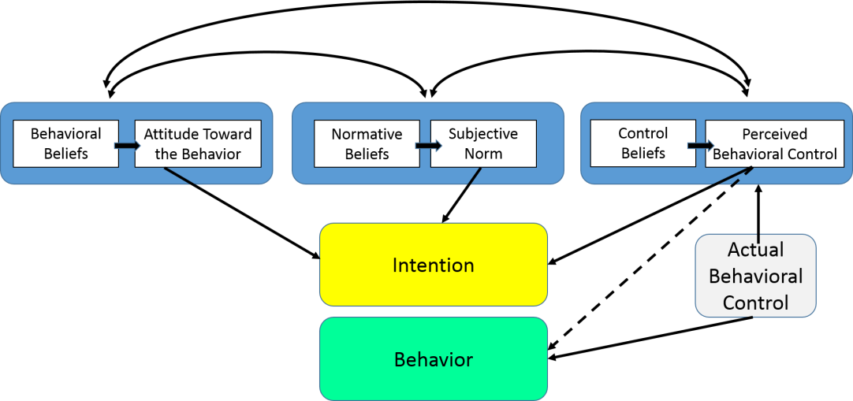
Figure 1: Theory of planned behaviour
(Source: Montano and Kasprzyk, 2015)
In another perspective, Sapienza et al. (2015) opined that Lasswell’s model is developed for modernizing the communication strategies so that health service professionals can communicate with every patient effectively. For example, this theory advise that in complex situation of healthcare, it is important for the healthcare professionals to keep mind cool and deal with the patients calmly. Moreover, in Care UK, this theory can be applied for communicating with the care needed individual and people suffering from mental health issues. Communication with these service users can become simpler by breaking the components in sender, message, medium, receiver and feedback.
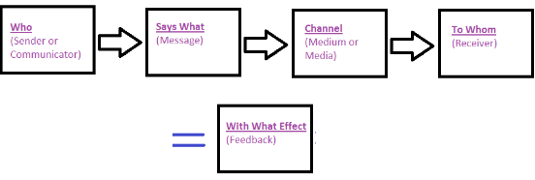
Figure 2: Lasswell’s model
(Source: Sapienza et al. 2015)
Another theory known as Peplau’s interpersonal relations theory suggest that developing effective relationship among client and health support provider is helpful for conducting therapeutic process effectively. The staged of communication and teamwork are define by this theory using orientation phase, identification phase, exploitation phase, and resolution phase. This theory is used for achieving some common goals in healthcare organization where support providers can convince the patients in treatment, which further helps in the building of trust and brand loyalty for the healthcare system (Fernandes and Naidu, 2017).
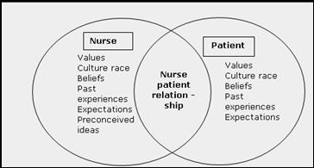
Figure 3: Peplau’s interpersonal relations theory
(Source: Fernandes and Naidu, 2017)

3. Analysis on the issues found in healthcare
In my healthcare profession of UK, I noticed and analyzed that different treatment process failed due to not having proper collaboration among the team members. Based on my experience, I found that there is a communication gaps among different personnel of health professionals, such as caregivers, nurses and doctors. In fact as per the estimation, it has been found that growing caseloads, complex record system and limited resources create discrepancies in the treatment process of the patients. The main issues that has occurred in my
Long waiting times: In Care UK, complaints from patients come as they have to wait for long times. This occurs due improper coordination among the health staffs members. This creates a gap in the setting appointment with the doctors. Hence, communication between staffs, physicians and patients can prevent the issues of pre-booking schedules that is the main reason for long waiting time in healthcare.
Workplace conflict: Disagreements among the opinions can result in the occurrence of serious conflict in healthcare. In Care UK, it has been found that while treating patients of mental disorder, several healthcare providers suggest different ways of medication that ultimately result in workplace conflict. As per analysis and taking ideas from Tuckman and Harper (2012), I gathered knowledge that these kinds of situation occurs due to improper teamwork management and unable to understand the problems faced by the support users due to ineffective listening skills. In this case, it can be said that by using effective managerial techniques and convincing power, these types of situations can be overcome effectively.
Increase stress: Another issue that I found in my healthcare centre due to the effect of ineffective communication and teamwork is increase stress. As mentioned by Ghaferi and Dimick (2016), lack of communication and poor coordination are the unnecessary reason of causing stress. For an example, once in the operation theatre of Care UK, I was supposed to work with support providers and other caregivers to operate a critical mental disorder patient. I provided them verbal instructions about the handling process in the OT. However, the operation was not successful due to lack of active listening skills and other inter-personal skills.

4. Practical application and deployment using theories
In my profession, I found that having a brief knowledge on communication skills and team management ability, every operations and treatment of patients get successful. In meeting and discussion that has held in my health centre, I found that staffs have deficit in understanding other’s viewpoint due to lack of patience and improper collaboration. In Care UK, healthcare professionals mainly deal with mental health patients where there is a requirement of understanding every opinion of the support users. In this case, dealing with delicate patients requires effective communication skill in order to feel them better and mitigating the health diseases. By using Peplau’s interpersonal relations theory, I have enhanced by relationship with the patients, which has helped in mitigating the communication gap. Using Tuckman’s theory of team development can bring team effectiveness where support users can feel free to express their issues and problems to the healthcare professionals (based on views of Natvig and Stark, 2016).
Using four stages of Tuckman’s theory, such as Forming, Storming, Norming and performing, relationships among different departments present in Care UK can be enhanced. For an example, in one scenario of the healthcare, I along with one of my colleague in Care UK were asked for handling a patient together, however, due to lack of collaboration, the treatment of the patient was stopped. In this case, my colleague felt irritated and tried to impose new medication process in middle of the prescribed medicine that I gave to the patient for recovery. Hence, in this case, use of Tuckman theory can help in developing every stages of medication and roles can be dividing accordingly based on the experience level of the healthcare professional skills and knowledge.

5. Skills for professional practice
Developing group strategies by conducting meetings and discussion for setting goals and objectives of the healthcare operations is effective for reducing the complexity in work. Use of Belbin’s team structure theory, can help in developing meaningful schedules and help in delegating the tasks among different health support providers and support providers (Belbin, 2012). Other skills that are important to minimize the generated issues and enhancing the healthcare professional practices in Care UK are enhancing written communication skills and personal presentation skills. In-group work delivering, improving personal skills effectively can maintain a systematic order in every activity. Based on the study of Belbin (2010), communication with the clients should be developed along with clarity of expressions, syntax, grammar skills as well as punctuations in order to build a mutual relationship with the client. It has been observed that written communication skill is important for writing the prescribed medicines to the patients in a well format structure. Otherwise, support users might face difficulties in understanding the instructions related to the medicines that should be taken to recover the disease.
Based on my experience, I think I have to work on my collaboration skills and verbal communication skills for developing multi-disciplinary teams in the healthcare. While delivering social service and health support to the care users of Care UK, I need to improve my listening skills and enhance my vocabulary in order to deliver effective service to the old clients. This would help in the increasing of client satisfaction and recovery of the disease will occur in a more effective and systematic way.

Conclusion and recommendation
From the entire discussion, it has been found that Care UK requires providing communication training and teamwork training to all the healthcare professionals and support providers in order to solve the issues and recover the complexity analyzed in the healthcare centre. It has been found that the healthcare organization can provide implement leadership strategies and power distribution strategy for delegating the tasks to potential personnel. This would help in bringing effectiveness in the team culture and mitigate the communication gap among the health personnel. On the other hand, having a brief knowledge of communication skills both verbal and non-verbal can help in strengthening the relationship with the healthcare service users. Issues such as long waiting time and increased level of stress can be mitigated by establishing policies and work ethics in a systematic manner. Hence, it can be concluded by saying that developing effective communication skills and teamwork are highly required to solve both external and internal issues of Healthcare organization.

Reference list
Belbin, M.R. (2012) Team roles at work. 2nd edn. Oxford: Butterworth-Heinemann.
Belbin, R.M. (2010) Teamroles at Work. Butterworth-Heinemann Title; 2 edition Magin, M. (2004) Making teams Work: 24 Lessons for working together successfully. McGraw-Hill Pub.
Careuk.com 2019. About us. Available at: http://www.careuk.com/ [accessed on: 19.03.19]
Ercegovac, Z. (2008) Information Literacy, search strategies, tools & resources for high school students and college freshmen, Linworth Pub. 2nd ed.
Fernandes, S. and Naidu, S., 2017. Promoting Participation in Self Care Management among Patients with Diabetes Mellitus: An Application of Peplau’s Theory of Interpersonal Relationships’. International Journal of Nursing Education, 9(4), pp.129-34.
Gafa, M., Fenech, A., Scerri, C. and Price, D., 2018. Teamwork in healthcare organisations. Pharmacy Education, 5(2).
Ghaferi, A.A. and Dimick, J.B., 2016. Importance of teamwork, communication and culture on failure‐to‐rescue in the elderly. British Journal of Surgery, 103(2), pp.e47-e51.
Montano, D.E. and Kasprzyk, D., 2015. Theory of reasoned action, theory of planned behavior, and the integrated behavioral model. Health behavior: Theory, research and practice, pp.95-124.
Morgan, P. (2016). The Business Student’s Guide to Study and Employability. Sage Publications
Natvig, D. and Stark, N.L., 2016. A project team analysis using Tuckman's model of small-group development. Journal of Nursing Education, 55(12), pp.675-681.
Sapienza, Z.S., Iyer, N. and Veenstra, A.S., 2015. Reading Lasswell's model of communication backward: Three scholarly misconceptions. Mass Communication and Society, 18(5), pp.599-622.
Tuckman, B.W. and Harper, B.E. (2012) Conducting educational research. 6th edn. United States: Rowman & Littlefield Publishers.

Bibliography
Adair, J.E. (2009) Effective Teambuilding: How to make a winning team. London: Pan Books
Alvesson, M., Willmott, H., Alvesson, P.M. and Willmott, P.H. (1996) Making sense of management: A critical introduction. 2nd edn. Thousand Oaks, CA: Sage Publications
Blanchard, K.H., Hersey, P. and Johnson, D.E. (2000) Management of organizational behavior: Leading human resources. 8th edn. United Kingdom: Prentice Hall
Bown, G. and Brady, C. (1991) Successful manager (women in management Workbook series). Kogan Page, Limited, London, United Kingdom
Collins, J.C. and Jim, C. (2001) Good to great [why some companies make the leap ... And others don’t]. 4th edn. New York, NY: HarperCollins Children’s Book Group
Covey, Stephen R. (1989) The 7 Habits of Highly Effective People: Powerful Lessons in Personal Change. 5th edn. New York: Simon and Schuster.
Dalley, D., and Burton, L. Developing your Influencing Skills: How to influence people by increasing your credibility, trustworthiness and communication skills (2010) Universe of Learning Ltd.
Maund, A. Schriek, M. and Tinkler, P. (2017). Certificate in Higher Education: Skills for the Workplace Student Yearbook. Sage Publications

