jacob nicklin
Student number: 230580 18/12/2023 Module code: ACCA4023
Web and database concepts

Contents
Introduction 2
Requirements 3
Implementation 4
Validation 11
Evaluation 13
References 15
Bibliography 15
Appendices 16
Main Page (appendices) 16
The Album (appendices) 41
Speak To Me (appendices) 49
Breathe (appendices) 58
On The Run (appendices) 68
Time (Appendices) 76
The Great Gig In The Sky (appendices) 83

Introduction

This report for “Web and Database Concepts” will look into my construction of a HTML and CSS website based on the popular Space Rock band “Pink Floyd” and their album “Dark Side Of The Moon” [1]. In this report you will find how I constructed, coded, got my information on, validated and overall created the website. This report will contain screenshots as evidence of the working website and HTML and CSS code being used.

Requirements

The main purpose of my website will be to look at the first 5 songs of “Dark Side Of The Moon” and the 50 years its been since it’s creation and to also explore the meanings behind each of the songs and more importantly, what those songs mean to me. This website would also be targeted at Pink Floyd fans of all ages, genders and anyone who has a general love for the band. In that sense, this website acts as a “fan page” not acting for profit or for a cause, but just celebrating my love for the band and showcasing it to others.
My biggest goal is for the main page to include some sort of animation of Pink Floyd, the most achievable animation is animating a white line into a triangle and having 6 rainbow colours shoot out the other side, thus recreating the iconic album cover art through CSS animation.
My standard goals are to create a navigation bar, have individual CSS pages for the individual HTML documents as I create more pages and also create some sort of gallery that showcases some pictures of the band and a few posters, along with including a few items from my own memorabilia.
The Subject matter will look at each of the “Travel section” of the album, which are the first 5 songs:
- Speak To Me [2]
- Breathe (In The Air) [3]
- On The Run [4] [5]
- Time [6]
- The Great Gig In The Sky [7]
I wish to look into these songs, discover their meanings and look at the history behind them as well.

Implementation

Main Page Screenshot(s)

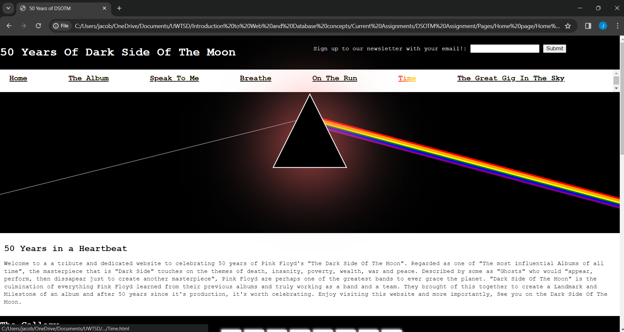

Album page screenshot(s) 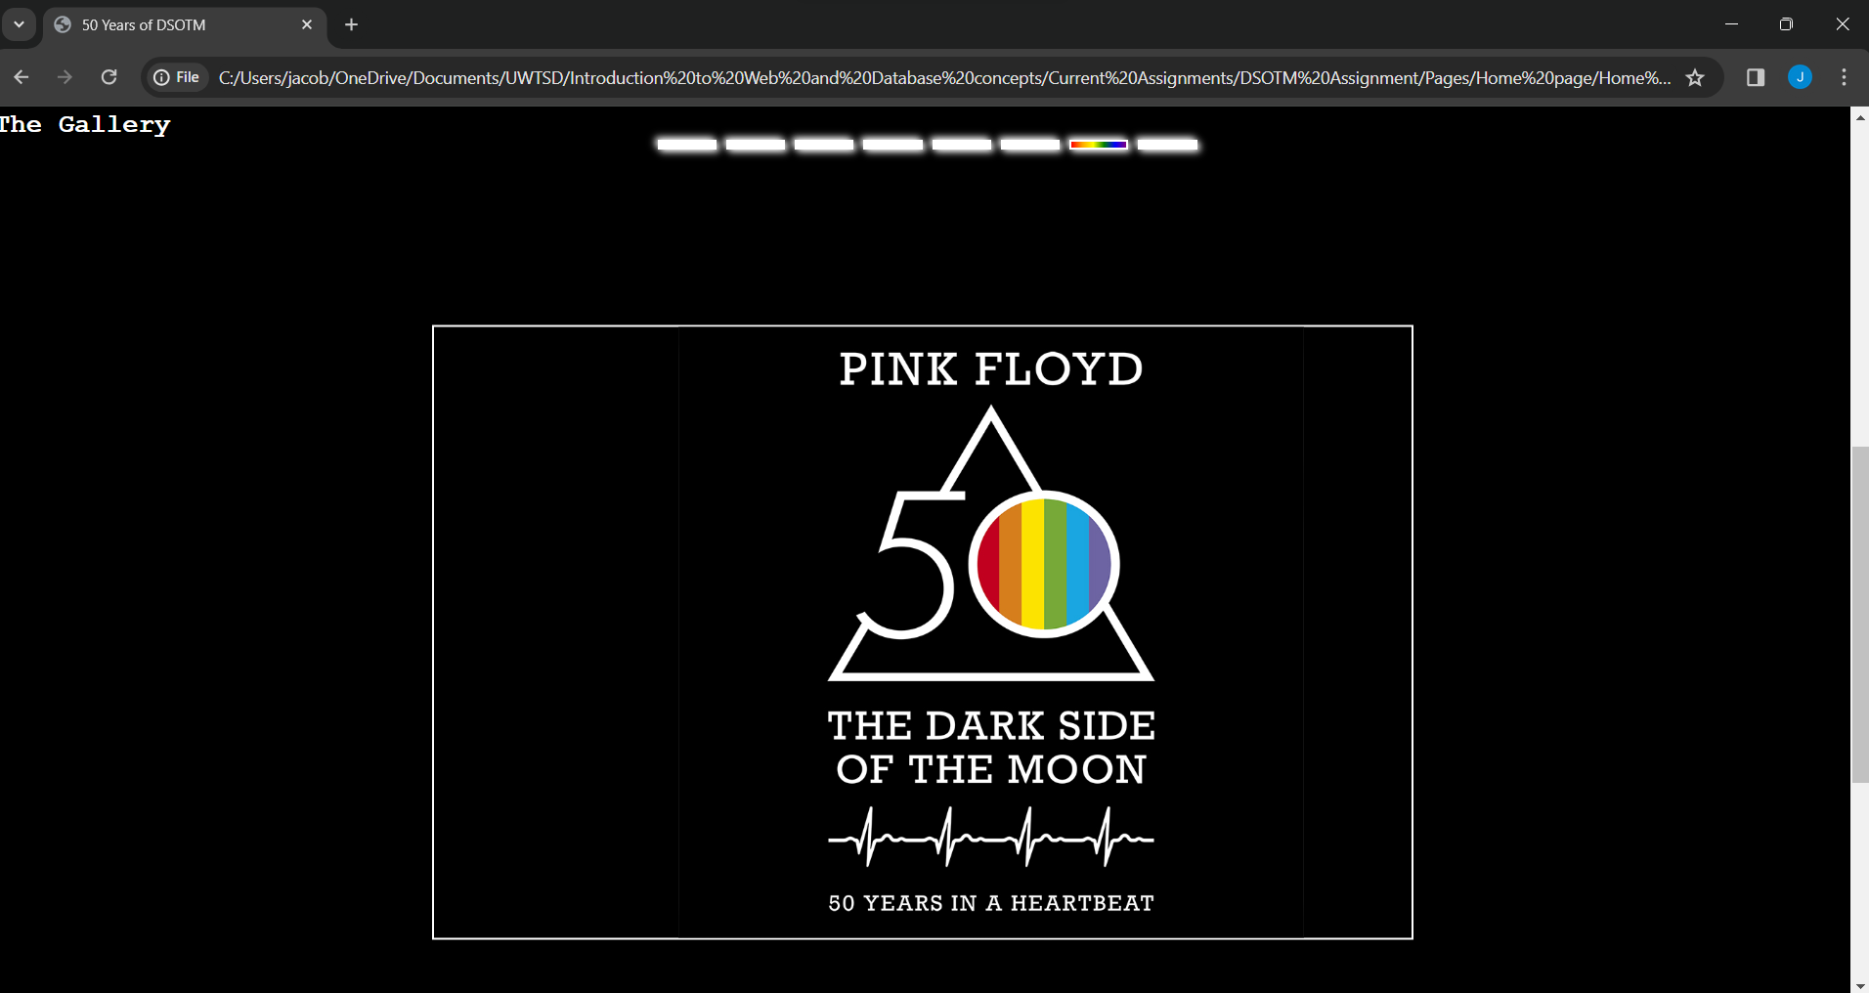
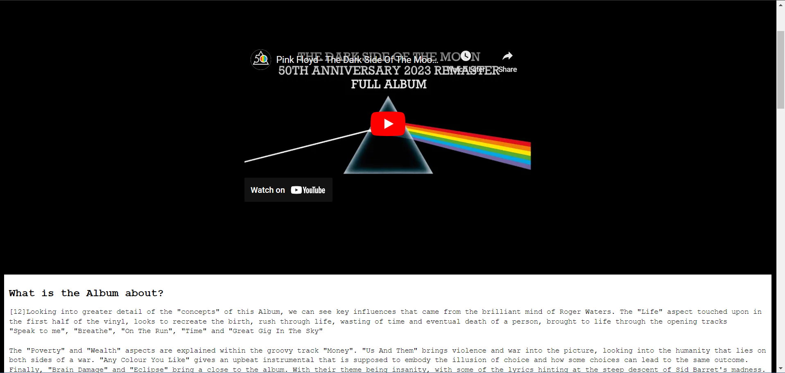

Speak To Me Page screenshot(s)
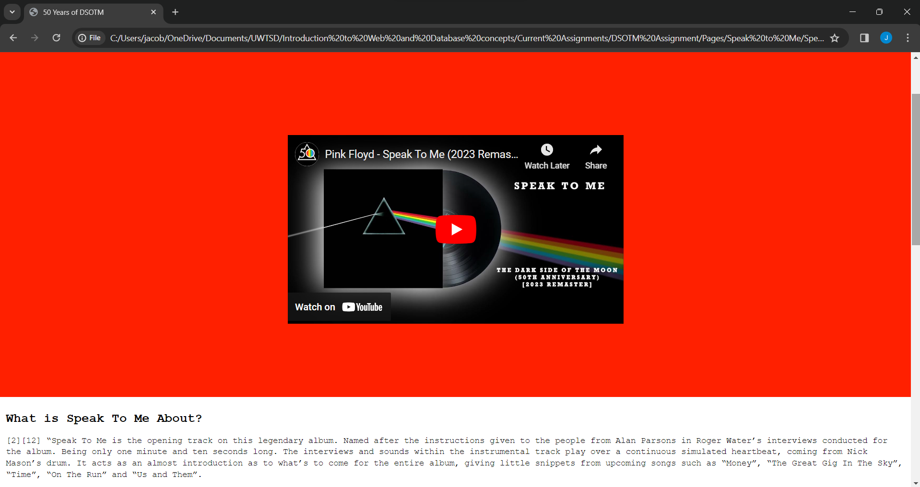

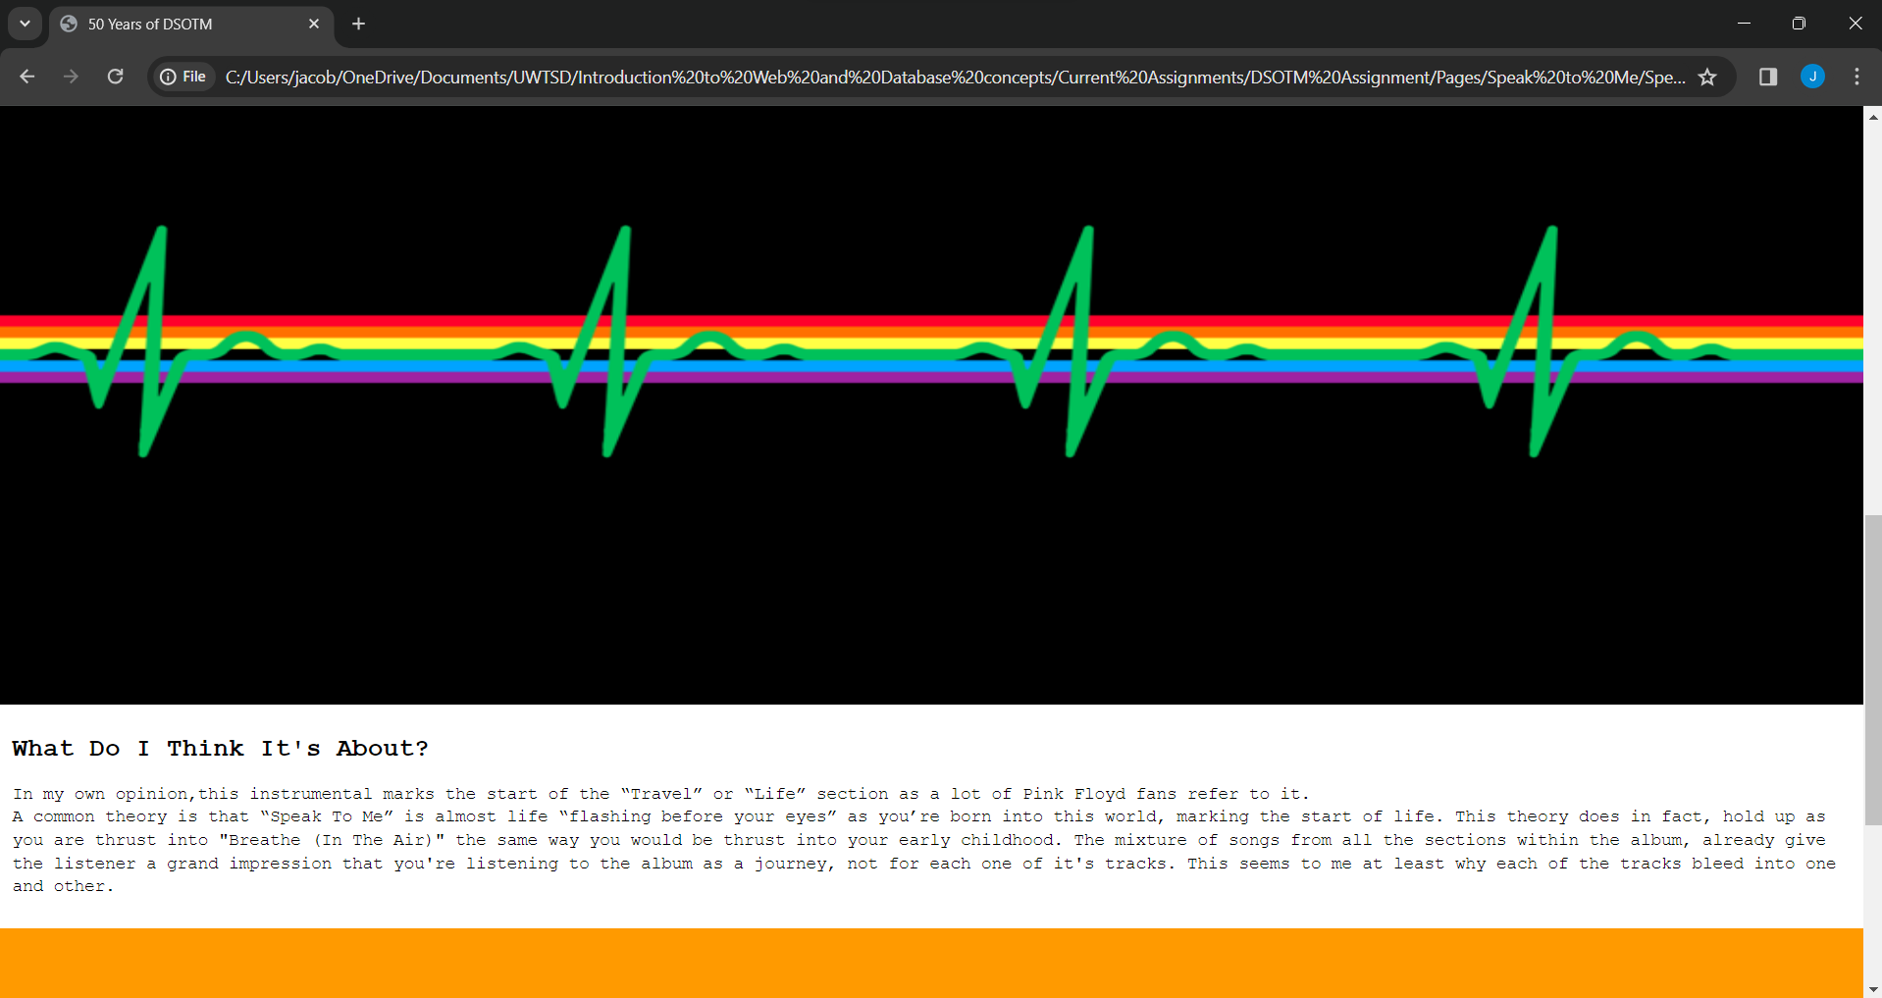
Breathe page Screenshot(s)
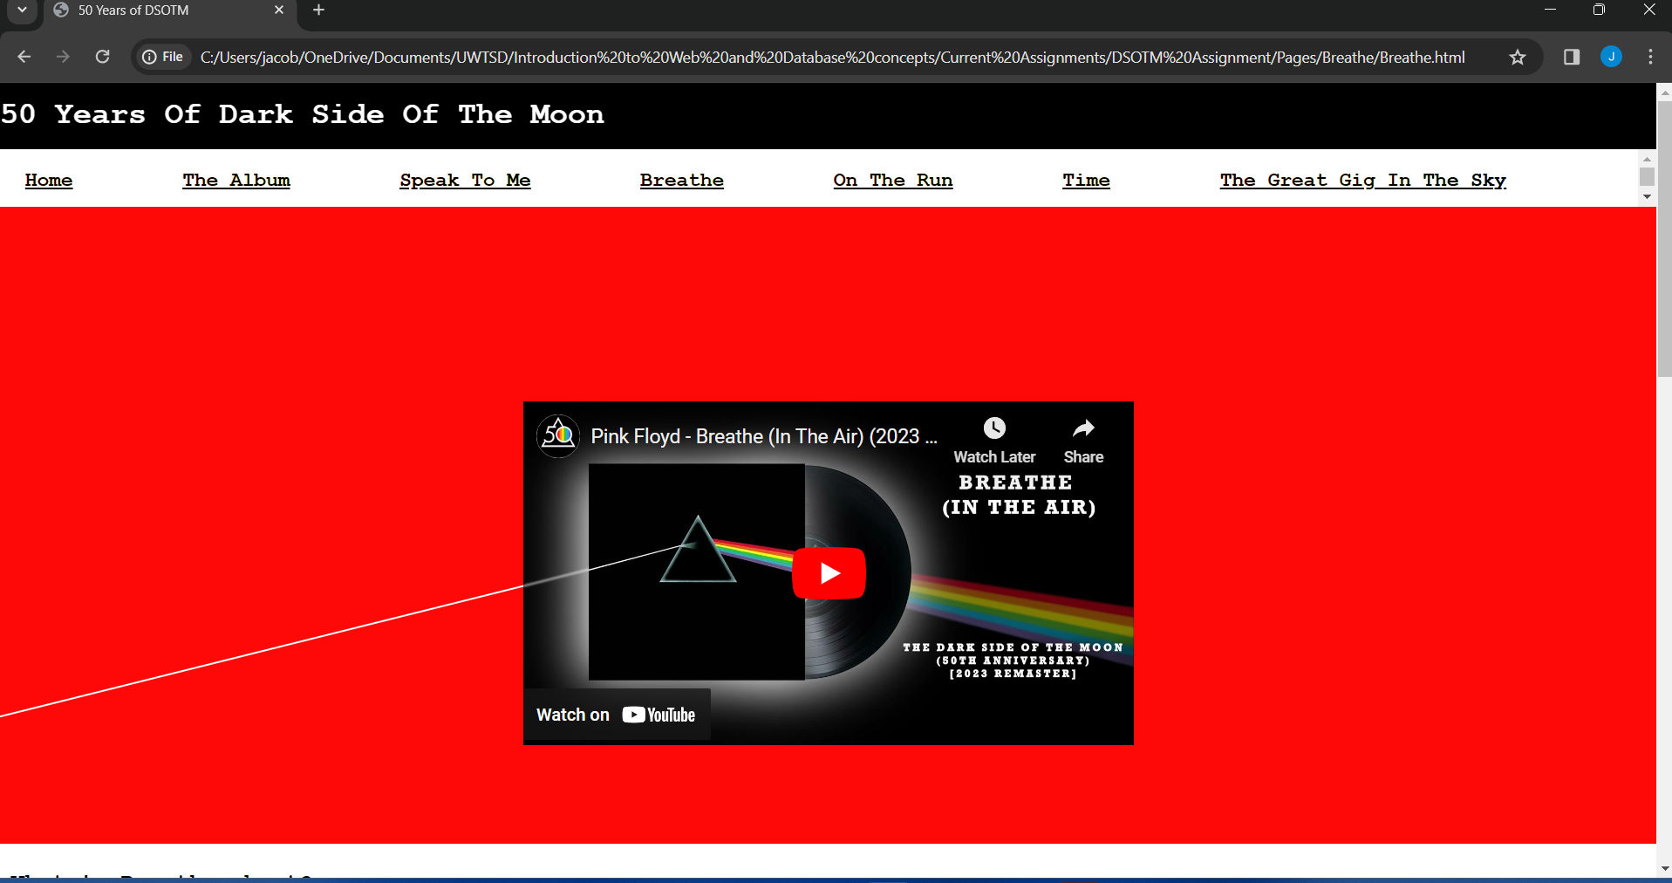

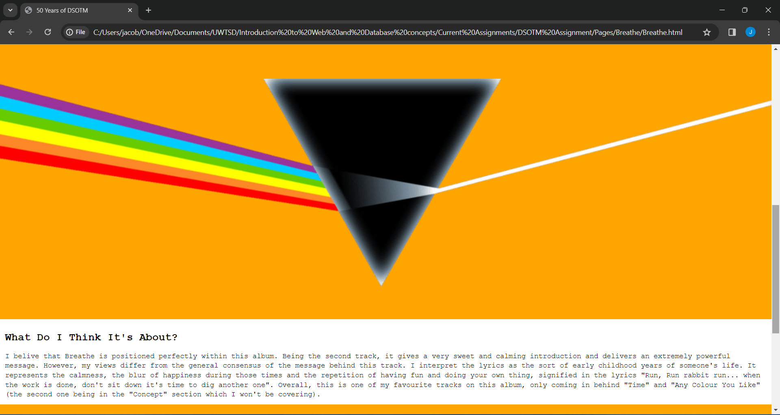
On The Run page Screenshot(s)
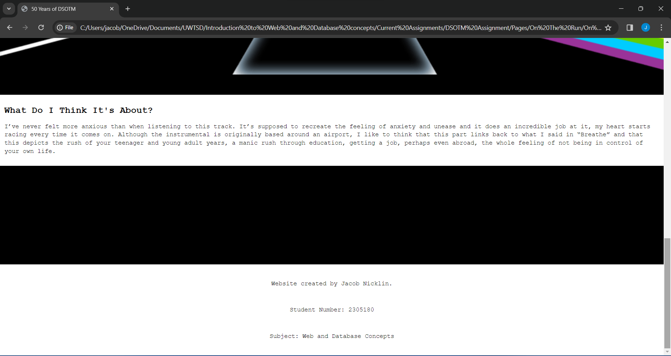
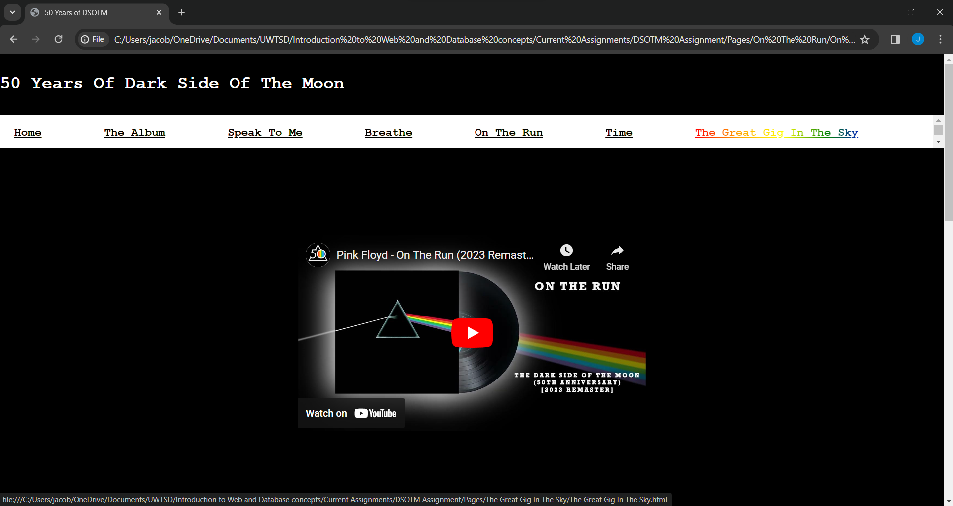
Time Page screenshot(s)
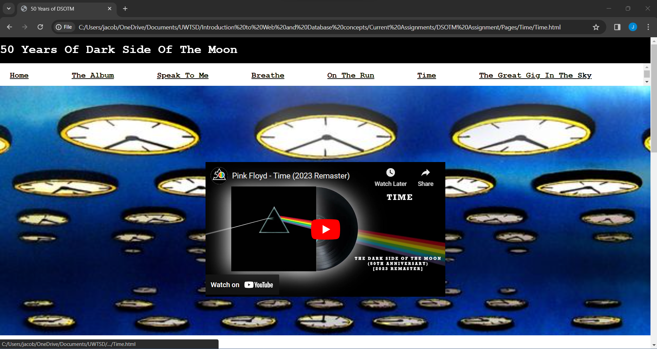
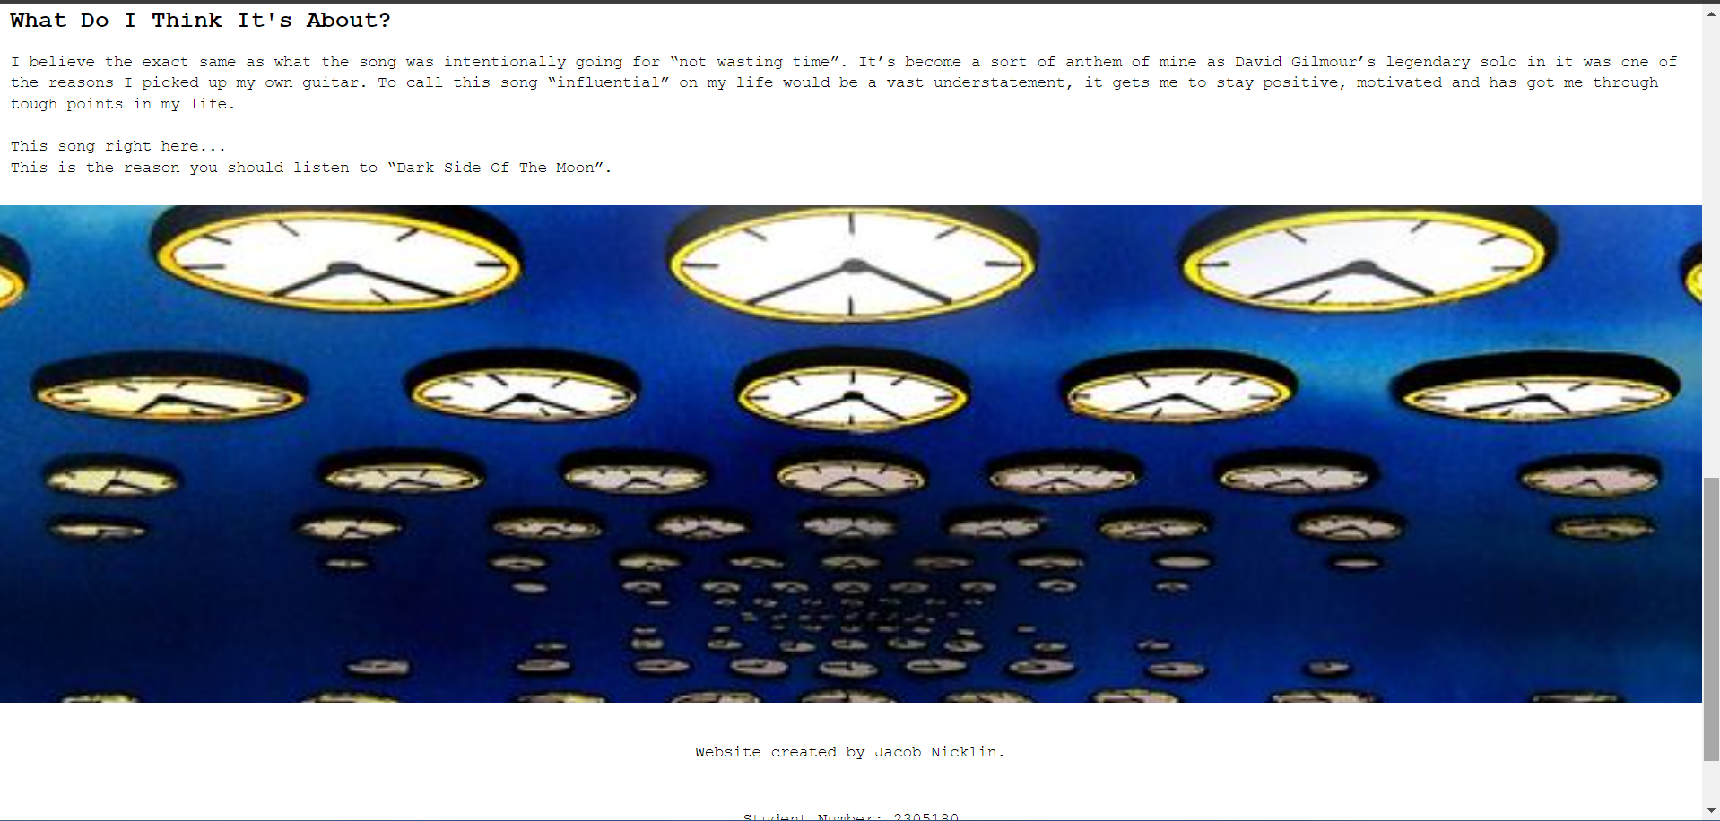
Great Gig In The Sky page screenshot(s)
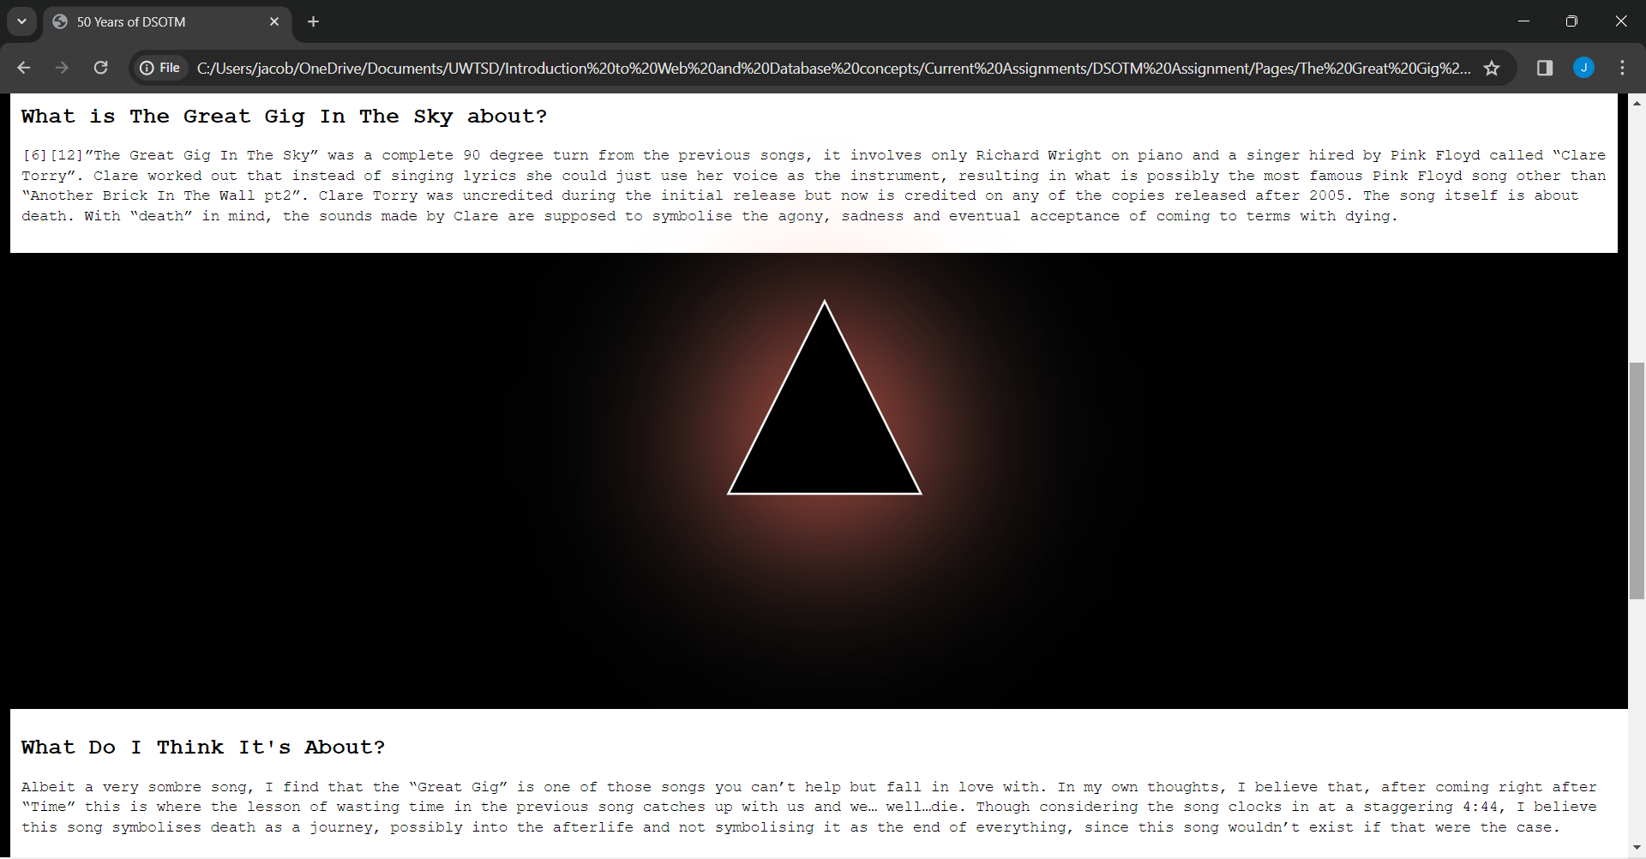
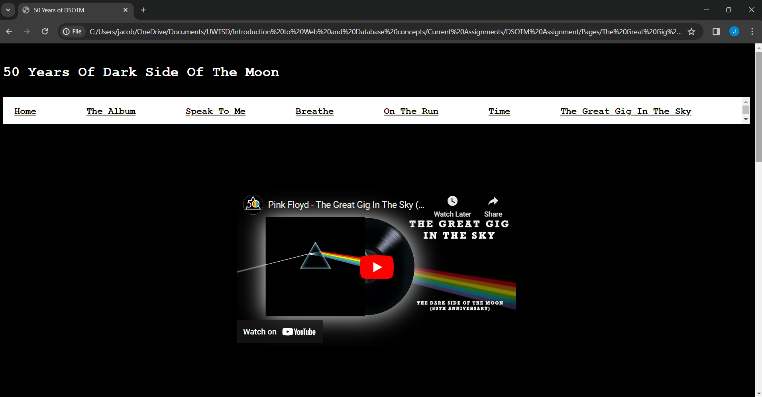

Validation
Upon Validating my HTML code, I was presented with a small handful of the same errors:
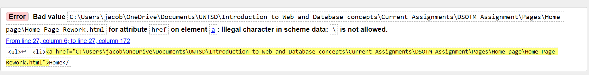
This error occurred for each one of the navigation bar links in my document. It indicates the links for the files I am using shouldn’t be using a “\” and it does not provide a solution to how I can solve this. I have searched online for an answer but cant seem to find a solution to this problem, which affects all the navigation links if they are not on my laptop.
I know that this is happening as I am using local files to create my website and not dedicated servers like big pages such as social medias or google use.
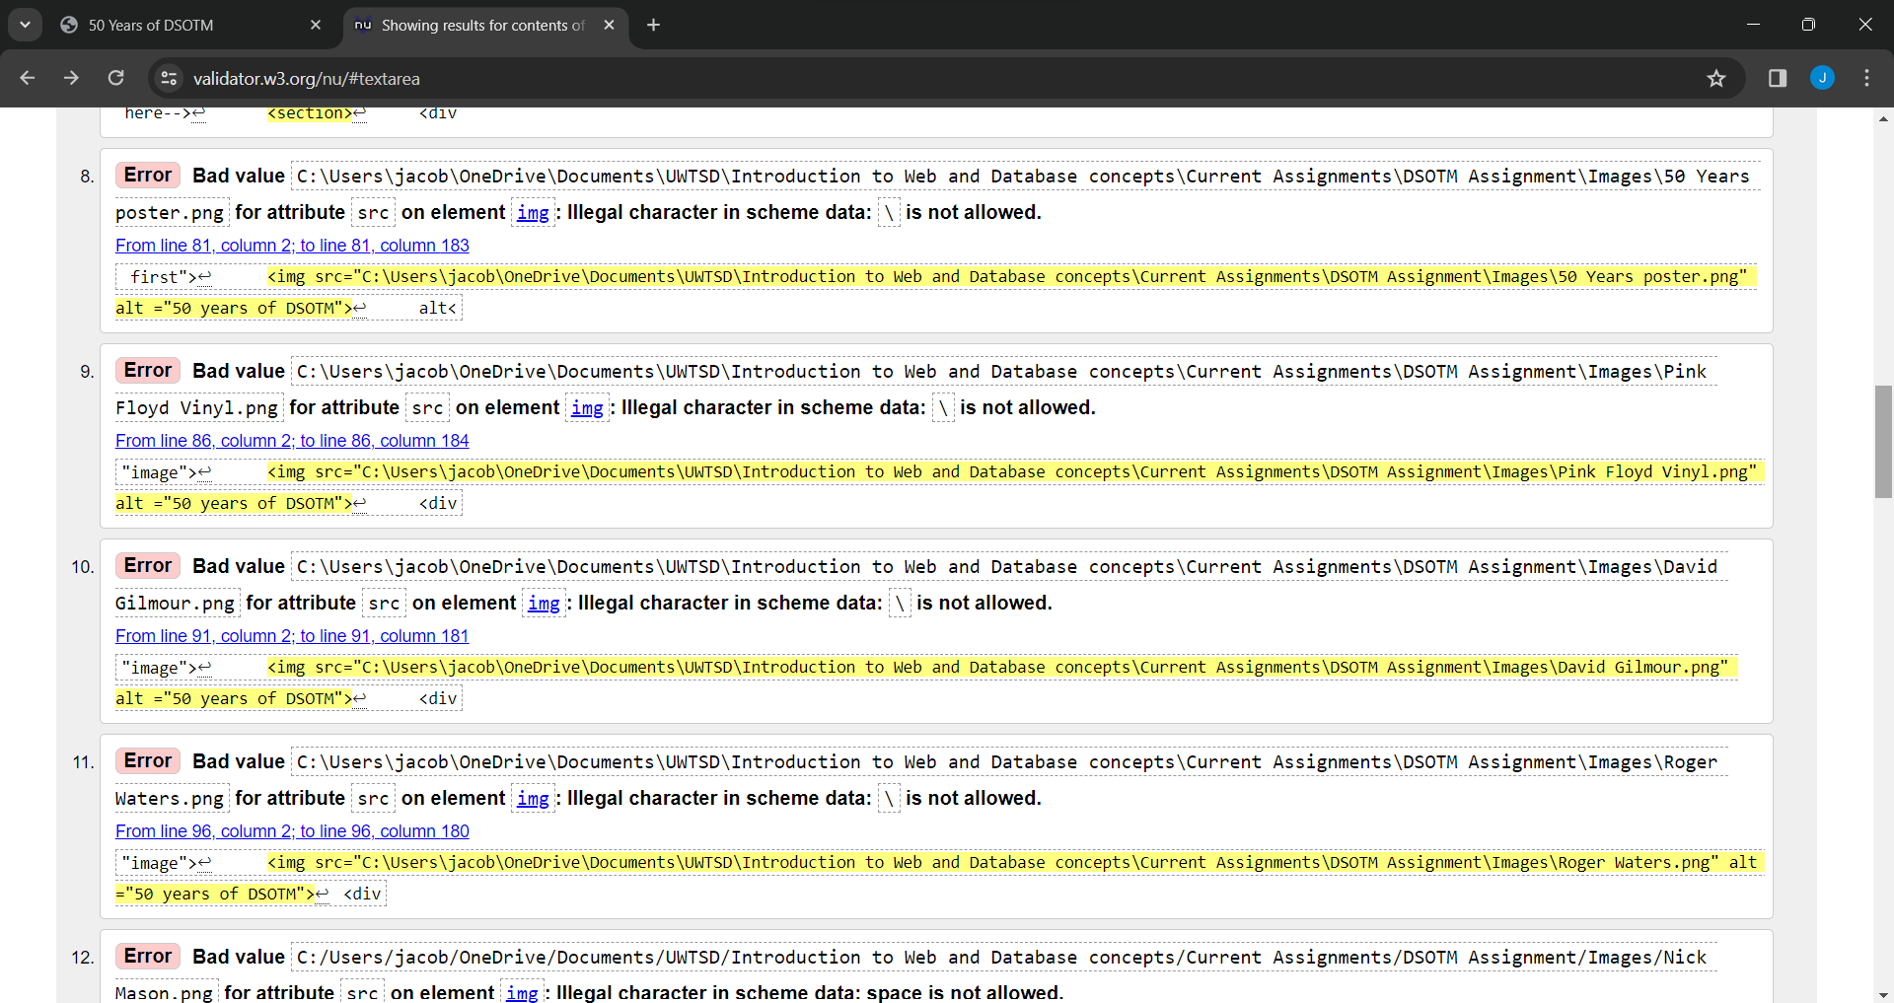
Once again, a similar error to the navigation bar, except this one is for images. Likewise with the navigation bar, I searched for a similar solution to this, but could not find anything.

One of the ways explained using “file:///” but upon using this with the navbar it would not open the links anymore, which confused me.
Considering my HTML code was over 140 lines of code, to have 2 errors across 17 links is not too bad. However, this might affect opening up the files through the navbar, so people viewing the documents will have to open them up individually through file explorer, rendering the navbar completely useless.

CSS code:
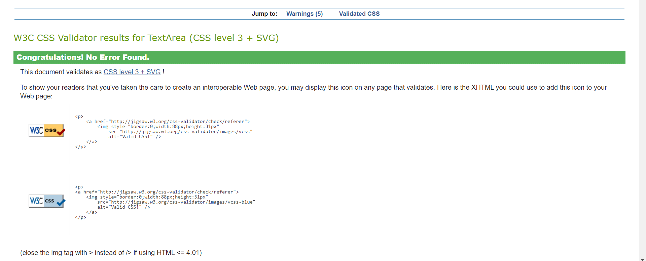

My main page CSS code encountered zero errors! This was extremely good as the main page had over 500 lines of code that made up the gallery, animation, navbar, text and more. To have no errors means the code is done to the best of my ability.

Evaluation

Including the current navigation bar problems with local files, my website isn’t that accessible.
However, if we move past those few errors and look at each page, it runs quite smoothly, with very little problems. The animation I managed to create from using CSS’s “keyframes” property along with a large amount of <div> in html, allowed me to piece by piece create moving coloured lines and a glowing prism using a Unicode triangle(“▲”) and some glowing text effects through the w3schools [8] resource.
I also added an email input and scrollable image gallery into the main page which came out great on both ends, especially the photo gallery which has a smooth scroll when you click one of the 8 buttons.
The only animation that I needed help on was the breathing effect, in which I used this similar code [9] to get the breathing colours on the pages “Breathe” and “Speak To Me”.
The other pages turned out really well as well, all my information for those pages was derived from one book “The Making of The Dark Side Of The Moon” by John Harris [10], However, I felt that giving my own opinion would really have appealed to audiences who viewed my website (had the links worked okay).
Usefulness wise, I think my website provides a very brief yet detailed insight into the first half of the “Dark Side Of The Moon” album and pays very nice tribute with it’s animation. It’s something I think fans of Pink Floyd would enjoy and be able to perhaps learn something new about the band or the album that they didn’t know before. And for the average person, it might expand their horizons on music to even go and listen to the album for the first time.
With the absolute metric tonne of knowledge that is widely available on Pink Floyd and “Dark Side Of The Moon” I feel as if my website isn’t too well search engine optimised, but certainly wouldn’t be on page 10-100 of google, I feel that the animation has to be worth something towards optimising it and that it almost acts as a “fun fact” website, meaning that fans can get information extremely quickly. Also, if fans of Pink Floyd are looking for the “Travel section” then the website could well be near the top due to it only covering that section of the album.
As far as accessibility goes, my website is very standard black and white, as that is what the album cover’s colours mostly are. This theme holds up across 5/7 pages, with the only two being the least accessible “Speak To Me” and “Breathe” which have a rotating system of colours to give a “breathing” effect. Guidelines 1.3 in WCAG talks about adaptability, in which my page is responsive to resizing and has clear to see text at all times, so it is fairly adaptable. However, one thing that could use with improvement is text resizing even when in full screen. The text for the information is a bit small and I could add a slider in that increases the size of the text.

Browser extensions within chrome, which I used the most for this website, would be a massive help and although I do believe that certain extensions would have some interference, I believe most impairment extensions such as “narrator” or “auto scroll” would interface quite well with my website.

References

Bibliography

[1] | P. Floyd, Composer, Dark Side Of The Moon. [Sound Recording]. Harvest Records. 1973.
[2] | N. Mason, Composer, Speak To Me. [Sound Recording]. Harvest Records. 1973.
[3] | G. W. Waters, Composer, Breathe (In The Air). [Sound Recording]. Harvest Records. 1973.
[4] | W. Gilmour, Composer, On The Run. [Sound Recording]. Harvest Records. 1973.
[5] | K. J, “On The Run Meaning,” NeuptunePinkFloyd, 9 February 2018. [Online]. Available: https://www.neptunepinkfloyd.co.uk/on-the-run-lyrics-pink-floyd-dark-side-of-the-moon. [Accessed 26 December 2023].
[6] | W. W. G. Mason, Composer, Time. [Sound Recording]. Harvest Records. 1973.
[7] | R. Wright, Composer, The Great Gig In The Sky. [Sound Recording]. Harvest Records. 1973.
[8] | W3schools, “How to Create Glowing Text,” 2023. [Online]. Available: https://www.w3schools.com/howto/howto_css_glowing_text.asp. [Accessed 15 January 2024].
[9] | B. D. Sahagun, “Breathing Color,” 17 November 2017. [Online]. Available: https://codepen.io/briandys/pen/xPPdEL. [Accessed 27 December 2023].
[10] | J. Harris, The Dark Side Of The Moon: The making of the Pink Floyd Masterpiece, Dublin: Harper Perennial 2006, 2006.

Appendices

Main Page (appendices)
  - Html:
<!DOCTYPE html>
<html lang="en">
<head>

<meta charset="utf-8" >
<meta name="viewport" content="width=device-width, initial-scale=1.0">
<title>50 Years of DSOTM</title>
<link rel="stylesheet" type="text/css"
href="Mainpagecustomisation.css">

</head>
<body>
<!--Title-->
<header id="MainTitle">
<h1>50 Years Of Dark Side Of The Moon</h1>
<form action="NewsletterEmail">
<label for="email">Sign up to our newsletter with your email!:</label>
<input type="email" id="email" name="email">
<input type="submit">
</form>
</header>

<!--NavBar-->
<nav id="topnav">
<ul>
<li><a href="C:\Users\jacob\OneDrive\Documents\UWTSD\Introduction to Web and Database concepts\Current Assignments\DSOTM Assignment\Pages\Home page\ Home Page Rework.html">Home</a></li>
<li><a href="C:\Users\jacob\OneDrive\Documents\UWTSD\Introduction to Web and Database concepts\Current Assignments\DSOTM Assignment\Pages\Album\The Album.html">The Album</a></li>
<li><a href="C:\Users\jacob\OneDrive\Documents\UWTSD\Introduction to Web and Database concepts\Current Assignments\DSOTM Assignment\Pages\Speak to Me\Speak To Me.html">Speak To Me</a></li>
<li><a href="C:\Users\jacob\OneDrive\Documents\UWTSD\Introduction to Web and Database concepts\Current Assignments\DSOTM Assignment\Pages\Breathe\Breathe.html">Breathe</a></li>
<li><a href="C:\Users\jacob\OneDrive\Documents\UWTSD\Introduction to Web and Database concepts\Current Assignments\DSOTM Assignment\Pages\On The Run\On The Run.html">On The Run</a></li>
<li><a href="C:\Users\jacob\OneDrive\Documents\UWTSD\Introduction to Web and Database concepts\Current Assignments\DSOTM Assignment\Pages\Time\Time.html">Time</a></li>
<li><a href="C:\Users\jacob\OneDrive\Documents\UWTSD\Introduction to Web and Database concepts\Current Assignments\DSOTM Assignment\Pages\The Great Gig In The Sky\The Great Gig In The Sky.html">The Great Gig In The Sky</a></li>

</ul>
</nav>
<!--Insert animation stuff here-->
<section>
<div class="WholeAnimation">
<div class="animation1">▲</div>
<div class="animation2"></div>
<div class="redline"></div>
<div class="orangeline"></div>
<div class="yellowline"></div>
<div class="greenline"></div>
<div class="blueline"></div>
<div class="purpleline"></div>
</div>
<!--Line stuff goes here-->
</section>

<!--Introduction-->
<div class="container">
<section id="paragraphIntro">
<h2>50 Years in a Heartbeat</h2>
<p>Welcome to a a tribute and dedicated website to celebrating 50 years of Pink Floyd's "The Dark Side Of The Moon".
Regarded as one of "The most influential Albums of all time", the masterpiece that is "Dark Side" touches on the themes of death, insanity, poverty, wealth, war and peace.
Described by some as "Ghosts" who would "appear, perform, then dissapear just to create another masterpiece", Pink Floyd are perhaps one of the greatest bands to ever grace the planet.
"Dark Side Of The Moon" is the culmination of everything Pink Floyd learned from their previous albums and truly working as a band and a team.
They brought of this together to create a Landmark and Milestone of an album and after 50 years since it's production, it's worth celebrating.
Enjoy visiting this website and more importantly, See you on the Dark Side Of The Moon.</p>
</section>
</div>

<section>
<!--Gallery container-->
<h2>The Gallery</h2>
<div class="Gallery-container">
<div class="slides">
<input type="radio" name="common" id="btn1" checked>
<input type="radio" name="common" id="btn2">
<input type="radio" name="common" id="btn3">
<input type="radio" name="common" id="btn4">
<input type="radio" name="common" id="btn5">
<input type="radio" name="common" id="btn6">
<input type="radio" name="common" id="btn7">
<input type="radio" name="common" id="btn8">

<!--1--><div class="image first">
<img src="C:\Users\jacob\OneDrive\Documents\UWTSD\Introduction to Web and Database concepts\Current Assignments\DSOTM Assignment\Images\50 Years poster.png" alt ="50 years of DSOTM">
alt<div class="overlay">50 Years of DSOTM</div>
</div>

<!--2--><div class="image">
<img src="C:\Users\jacob\OneDrive\Documents\UWTSD\Introduction to Web and Database concepts\Current Assignments\DSOTM Assignment\Images\Pink Floyd Vinyl.png" alt ="50 years of DSOTM">
<div class="overlay">My own DSOTM Vinyl</div>
</div>

<!--3--><div class="image">
<img src="C:\Users\jacob\OneDrive\Documents\UWTSD\Introduction to Web and Database concepts\Current Assignments\DSOTM Assignment\Images\David Gilmour.png" alt ="50 years of DSOTM">
<div class="overlay">David Gilmour</div>
</div>

<!--4--><div class="image">
<img src="C:\Users\jacob\OneDrive\Documents\UWTSD\Introduction to Web and Database concepts\Current Assignments\DSOTM Assignment\Images\Roger Waters.png" alt ="50 years of DSOTM">
<div class="overlay">Roger Waters</div>
</div>

<!--5--><div class="image">
<img src="C:/Users/jacob/OneDrive/Documents/UWTSD/Introduction to Web and Database concepts/Current Assignments/DSOTM Assignment/Images/Nick Mason.png" alt ="50 years of DSOTM">
<div class="overlay">Nick Mason</div>
</div>

<!--6--><div class="image">
<img src="C:\Users\jacob\OneDrive\Documents\UWTSD\Introduction to Web and Database concepts\Current Assignments\DSOTM Assignment\Images\Richard Wright.png" alt ="50 years of DSOTM">
<div class="overlay">Richard Wright</div>
</div>

<!--7--><div class="image">
<img src="C:\Users\jacob\OneDrive\Documents\UWTSD\Introduction to Web and Database concepts\Current Assignments\DSOTM Assignment\Images\Syd Barrett.png" alt ="50 years of DSOTM">
<div class="overlay">Sid Barrett</div>
</div>

<!--8--><div class="image">
<img src="C:\Users\jacob\OneDrive\Documents\UWTSD\Introduction to Web and Database concepts\Current Assignments\DSOTM Assignment\Images\Pink Floyd All Members.png" alt ="50 years of DSOTM">
<div class="overlay">Pink Floyd</div>
</div>
</div>
</div>
<div class="navigator">
<label for="btn1" class="bar"></label>
<label for="btn2" class="bar"></label>
<label for="btn3" class="bar"></label>
<label for="btn4" class="bar"></label>
<label for="btn5" class="bar"></label>
<label for="btn6" class="bar"></label>
<label for="btn7" class="bar"></label>
<label for="btn8" class="bar"></label>

</div>
</section>

<div class="footer">

<p>Website created by Jacob Nicklin.<br>
Student Number: 2305180<br>
Subject: Web and Database Concepts</p>

</div>

</body>
</html>
  - CSS:
/*Main page*/
body{
background-color:#000000;
color:#fff;
font-family:Rockwell,Courier Bold,Courier,Georgia,Times,Times New Roman,serif;
font-size:2vh;
line-height:6.047vh;
margin:0;
}
/*Newsletter email*/
form{
position: relative;
left: 50vw;
top: -10vh;
}
/*navigation bar customisation*/
.container{
width:99%;
margin:auto;
width: auto;

}
#main-header{
position: absolute;
background-color:white;

}
#topnav{
position: relative;
background-color:white;
color:white;
width: auto;
height: auto;
overflow: auto;
top: -6vh;

}
#topnav ul{
padding:0;
padding-bottom:0;
list-style: none;
height: 3.5vh;
resize: both;

}
#topnav li{
display: inline;
width: auto;
}
#topnav a{
font-size:2.5vh;
padding-right:6vw;
}
a{
color: black;
font-weight: bold;
background: linear-gradient(90deg, red, orange, yellow, green, blue, purple);
background-clip: text;
-webkit-background-clip: text;
margin:auto;
z-index: 2;
position: relative;
top: -2vh;
right: -1.5vw;

}
a:hover {
color: transparent ;
transition: 500ms ease;
}
/*Animation*/

/*prism*/
body {
position: absolute;
padding: 1.37vh;
background-color: black;

}

.WholeAnimation .animation1{
text-align: center;
position: absolute;
width: 100%;
height: 2.5vw;
top: 30vh;
font-size: 20vw;
z-index: 1;
color: black;
-webkit-text-stroke: 2px white;
text-shadow:
100px white,
80px red,
120px orange,
140px Yellow,
340px Blue,
250px Purple;

animation: emit 2s infinite ease alternate;
animation-delay: 3.2s;
}
.WholeAnimation .animation1:after {
content:"";
position: absolute;
font-size: 13px;
font-family: "Trebuchet MS", sans-serif;
text-shadow: none;
left: 0;
right: 0;
top: 300px;
letter-spacing: 2px;
}
@keyframes emit{

0%{
text-shadow: 0 0 300px white,
0 0 150px red;

}

50%{
text-shadow: 0 5 450px white,
0 0 350px blue;

}
100%{
text-shadow: 0 0 200px white,
0 0 45px yellow;
}

}
/*animated white line*/
body{
margin: 0;
padding: 0;
background: black;

}
.WholeAnimation .animation2{
width: 45.9%;
height: .3%;
background: transparent;
position: absolute;
top: 65vh;
left: -45vw;
transform: translate(-50%, -50%);
transform: rotate(-14deg);
}
.WholeAnimation .animation2::before{
content:"";
position: absolute;
top: 0;
left: -43.62vh;
width:110.6%;
height: 50%;
background: white;
animation: animate 7s forwards;

}
@keyframes animate{

0%{
left: 0;
}
50%{
left: 100%;
}
100%{
left: 100%;
}

}
/*red line*/
body{
margin: 0;
padding: 0;
background: black;
overflow-x: hidden;

}
.WholeAnimation .redline{
width:50vw;
height: 5px;
background: red;
position: absolute;
top: 300px;
left: 50.2vw;
transform: translate(-50%, -50%);
transform: rotate(15deg);
}
.WholeAnimation .redline::before {
content: "";
position: absolute;
top: 0;
left: 0;
width: 100%;
height: 100%;
background: black;
animation: animate 14s forwards;
animation-delay: 3.2s;
}
@keyframes animate {
0% {
left: 0;
}

50% {
left: 100%;
}

0% {
left: 100%;
}
}
@keyframes animate{

0%{
left: 0;
}
50%{
left: 100%;
}
100%{
left: 100%;
}
}
/*orange line*/
body{
margin: 0;
padding: 0;
background: black;
overflow-x: hidden;

}
.WholeAnimation .orangeline{
width:50vw;
height: 7px;
background: orange;
position: absolute;
top: 305px;
left: 50.34vw;
transform: translate(-50%, -50%);
transform: rotate(15deg);
}
.WholeAnimation .orangeline::before {
content: "";
position: absolute;
top: 0;
left: 0;
width: 100%;
height: 100%;
background: black;
animation: animate 14s forwards;
animation-delay: 3.4s;
}
@keyframes animate {
0% {
left: 0;
}

50% {
left: 100%;
}

0% {
left: 100%;
}
}
@keyframes animate{

0%{
left: 0;
}
50%{
left: 100%;
}
100%{
left: 100%;
}

}
/*Yellow line*/
body{
margin: 0;
padding: 0;
background: black;
overflow-x: hidden;

}
.WholeAnimation .yellowline{
width:50vw;
height: 5px;
background: Yellow;
position: absolute;
top: 311px;
left: 50.4vw;
transform: translate(-50%, -50%);
transform: rotate(15deg);
}
.WholeAnimation .yellowline::before {
content: "";
position: absolute;
top: 0;
left: 0;
width: 100%;
height: 100%;
background: black;
animation: animate 14s forwards;
animation-delay: 3.6s;
}
@keyframes animate {
0% {
left: 0;
}

50% {
left: 100%;
}

0% {
left: 100%;
}
}
@keyframes animate{

0%{
left: 0;
}
50%{
left: 100%;
}
100%{
left: 100%;
}

}
/*Green Line*/
body{
margin: 0;
padding: 0;
background: black;
overflow-x: hidden;

}
.greenline{
width:50vw;
height: 5px;
background: Green;
position: absolute;
top: 315px;
left: 50.5vw;
transform: translate(-50%, -50%);
transform: rotate(15deg);
}
.greenline::before {
content: "";
position: absolute;
top: 0;
left: 0;
width: 100%;
height: 100%;
background: black;
animation: animate 14s forwards;
animation-delay: 3.8s;
}
@keyframes animate {
0% {
left: 0;
}

50% {
left: 100%;
}

0% {
left: 100%;
}
}
@keyframes animate{

0%{
left: 0;
}
50%{
left: 100%;
}
100%{
left: 100%;
}

}
/*Blue line*/
body{
margin: 0;
padding: 0;
background: black;
overflow-x: hidden;

}
.blueline{
width:50vw;
height: 5px;
background: Blue;
position: absolute;
top: 320px;
left: 50.9vw;
transform: translate(-50%, -50%);
transform: rotate(15deg);
}
.blueline::before {
content: "";
position: absolute;
top: 0;
left: 0;
width: 100%;
height: 100%;
background: black;
animation: animate 14s forwards;
animation-delay: 4s;
}
@keyframes animate {
0% {
left: 0;
}

50% {
left: 100%;
}

0% {
left: 100%;
}
}
@keyframes animate{

0%{
left: 0;
}
50%{
left: 100%;
}
100%{
left: 100%;
}

}
/*Purple line*/
body{
margin: 0;
padding: 0;
background: black;
overflow-x: hidden;

}
.purpleline{
width:50vw;
height: 5px;
background: purple;
position: absolute;
top: 325px;
left: 51vw;
transform: translate(-50%, -50%);
transform: rotate(15deg);
}
.purpleline::before {
content: "";
position: absolute;
top: 0;
left: 0;
width: 100%;
height: 100%;
background: black;
animation: animate 14s forwards;
animation-delay: 4.2s;
}
@keyframes animate {
0% {
left: 0;
}

50% {
left: 100%;
}

0% {
left: 100%;
}
}
@keyframes animate{

0%{
left: 0;
}
50%{
left: 100%;
}
100%{
left: 100%;
}

}
/*container with paragraph*/
#paragraphIntro{
background-color: white;
color: black;
float: left;
width: 100%;
padding: 10px;
box-sizing: border-box;
line-height: .5cm;
margin: auto;
margin-top: 8cm;
}
/*gallery*/

body{
background: black;
}
.Gallery-container{
position: absolute;
top: 150%;
left: 50%;
height: 500px;
width: 800px;
background: black;
transform: translate(-50%, -50%);
border: 2px solid #fff;
overflow: hidden;
}
.navigator{
display: flex;
position: absolute;
left: 50%;
bottom: 20px;
transform: translate(-50%);
}
.navigator .bar{
height: 5px;
width: 45px;
background: white;
cursor: pointer;
border: 2px solid #fff;
margin-left: 8px;
box-shadow: 2px 2px 6px white, -2px -2px 6px white;
}
.navigator .bar:hover{
background: linear-gradient(90deg, red, orange, yellow, green, blue, purple);
}
input[type="radio"]{
position: absolute;
visibility: hidden;
}
.slides{
display: flex;
height: 100%;
width: 625%;
}
.image{
width: 20%;
transition: 0.4s ease;
padding-left: 100px;

}
img{
width:100%;
height: 100%;

}
#btn1:checked ~ .first{
margin-left: 2%;
}
#btn2:checked ~ .first{
margin-left: -14%;
}
#btn3:checked ~ .first{
margin-left: -36%;
}
#btn4:checked ~ .first{
margin-left: -64%;
}
#btn5:checked ~ .first{
margin-left: -94%;
}
#btn6:checked ~ .first{
margin-left: -116%;
}
#btn7:checked ~ .first{
margin-left: -138%;
}
#btn8:checked ~ .first{
margin-left: -158%;
}
.footer{
position: absolute;
left: 0;
bottom: -150vh;
width: 100%;
background-color: white;
color: black;
z-index:3;
text-align: center;
}

The Album (appendices)
  - HTML:
<!DOCTYPE html>
<html>
<head>

<meta charset="utf-8" />
<meta name="viewport" content="width=device-width, initial-scale=1.0">
<title>50 Years of DSOTM</title>
<link rel="stylesheet" type="text/css"
href="Album customisation.css">

</head>
<body>
<!--Title-->
<header id="Main Title">
<h1>50 Years Of Dark Side Of The Moon</h1>

</header>

<!--NavBar-->
<nav id="topnav">
<ul>
<li><a class"active" href="C:\Users\jacob\OneDrive\Documents\UWTSD\Introduction to Web and Database concepts\Current Assignments\DSOTM Assignment\Pages\Home page\Home Page Rework.html">Home</a></li>
<li><a href="C:\Users\jacob\OneDrive\Documents\UWTSD\Introduction to Web and Database concepts\Current Assignments\DSOTM Assignment\Pages\Album\The Album.html">The Album</a></li>
<li><a href="C:\Users\jacob\OneDrive\Documents\UWTSD\Introduction to Web and Database concepts\Current Assignments\DSOTM Assignment\Pages\Speak to Me\Speak To Me.html">Speak To Me</a></li>
<li><a href="C:\Users\jacob\OneDrive\Documents\UWTSD\Introduction to Web and Database concepts\Current Assignments\DSOTM Assignment\Pages\Breathe\Breathe.html">Breathe</a></li>
<li><a href="C:\Users\jacob\OneDrive\Documents\UWTSD\Introduction to Web and Database concepts\Current Assignments\DSOTM Assignment\Pages\On The Run\On The Run.html">On The Run</a></li>
<li><a href="C:\Users\jacob\OneDrive\Documents\UWTSD\Introduction to Web and Database concepts\Current Assignments\DSOTM Assignment\Pages\Time\Time.html">Time</a></li>
<li><a href="C:\Users\jacob\OneDrive\Documents\UWTSD\Introduction to Web and Database concepts\Current Assignments\DSOTM Assignment\Pages\The Great Gig In The Sky\The Great Gig In The Sky.html">The Great Gig In The Sky</a></li>

</ul>
</nav>
<div class="Youtube">
<iframe width="560" height="315" src="https://www.youtube.com/embed/k9ynZnEBtvw?si=MFB1TVxmhocPyUbF" title="YouTube video player" frameborder="0" allow="accelerometer; autoplay; clipboard-write; encrypted-media; gyroscope; picture-in-picture; web-share" allowfullscreen></iframe>
</div>
<!--Intro-->
</section>
<div class = "container">
<section id ="infoAlbum">
<h2>What is the Album about?</h2>
<p>[12]Looking into greater detail of the "concepts" of this Album, we can see key influences that came from the brilliant mind of Roger Waters.
The "Life" aspect touched upon in the first half of the vinyl, looks to recreate the birth, rush through life, wasting of time and eventual death of a person,
brought to life through the opening tracks<br> "Speak to me", "Breathe", "On The Run", "Time" and "Great Gig In The Sky"<br><br>
The "Poverty" and "Wealth" aspects are explained within the groovy track "Money". "Us And Them" brings violence and war into the picture,
looking into the humanity that lies on both sides of a war. "Any Colour You Like" gives an upbeat instrumental that is supposed to embody
the illusion of choice and how some choices can lead to the same outcome. Finally, "Brain Damage" and "Eclipse" bring a close to the album.
With their theme being insanity, with some of the lyrics hinting at the steep descent of Sid Barret's madness.<br><br> I will be looking into greater detail about the "Travel" Section, which includes the tracks:
"Speak to me"<br>
"Breathe"<br>
"On The Run"<br>
"Time"<br>
"The Great Gig In The Sky"</p>
</div>
</section>

<div class="Banner">
<img src="C:\Users\jacob\OneDrive\Documents\UWTSD\Introduction to Web and Database concepts\Current Assignments\DSOTM Assignment\Images\DSOTM Banner.png" />
<div class="overlay"></div>
</div>

<div class = "container">
<section id ="OpinionAlbum">
<h2>What Do I Think It's About?</h2>
<p>As I listen to the full Album, I can't explain, but it puts me on a journey every single time. It's an album that really makes me think about my own actions,
such as wasting time, how I'm not getting any younger, the allure of money, the raging wars across the world and how I can keep myself sane. <br><br>
The Album as a whole is a masterpiece. Do I think that there will be future, innovators of music in my lifetime? absolutely. But this album walked so those future artists could run.
The Album cover is quite possibly one of the most recognisable art pieces in recorded history, given even more purpose with the rainbow colours on it acting as a flag of the LGBTQ community in recent years, with the cover art showing the freedom of choice in such a matter.<br>
<br>Overall. The influence this album had on the whole World is completely incomprehensible. "Dark Side Of The Moon" is almost a musical pilgrimage you take. In a sense, you haven't "really" listened to music until you've at least played that album once.</p>
</div>
</section>

<div class="Banner2">
<img src="C:\Users\jacob\OneDrive\Documents\UWTSD\Introduction to Web and Database concepts\Current Assignments\DSOTM Assignment\Images\DSOTM Banner.png" />
<div class="overlay"></div>
</div>

<div class="footer">

<p>Website created by Jacob Nicklin.<br>
Student Number: 2305180<br>
Subject: Web and Database Concepts</p>

</div>

</body>
</html>
  - CSS:
/*album page*/
body{
background-color:#000000;
color:#fff;
font-family:Rockwell,Courier Bold,Courier,Georgia,Times,Times New Roman,serif;
font-size:14px;
line-height:1.6cm;
margin:0;
overflow-x: hidden;
}
/*navigation bar customisation*/
.container{
width:99%;
margin:auto;
width: auto;

}
#main-header{
background-color:white;
color; #fff;

}
#topnav{
background-color:white;
color:fff;
width: auto;
height: auto;
overflow: auto;
}
#topnav ul{
padding:0;
padding-bottom:auto;
list-style: none;
height: 3.5vh;
resize: both;

}
#topnav li{
display: inline;
width: auto;
}
#topnav a{
font-size:2.5vh;
padding-right:6vw;
}
a{
color: black;
font-weight: bold;
background: linear-gradient(90deg, red, orange, yellow, green, blue, purple);
background-clip: text;
-webkit-background-clip: text;
margin:auto;
z-index: 2;
position: relative;
top: -2vh;
right: -1.5vw;

}
a:hover {
color: transparent ;
transition: 500ms ease;
}
/*Youtube video*/
body{
position: absolute;
padding: 10px;
padding-top: -20vh;
padding-bottom: -5px;
background-color: black;
}
.Youtube{
position: absolute;
left: 0;
top: 40vh;
width: 100%;
color: black;
text-align: center;
}
#infoAlbum{

background-color: white;
color: black;
float: left;
width: 100%;
padding: 10px;
box-sizing: border-box;
line-height: .5cm;
margin: auto;
margin-top: 80vh;
z-index: 2;
overflow: hidden;
}
img{
width:100%;
height: 100%;
z-index: -1;
overflow-x: hidden;
}
#OpinionAlbum{

position: absolute;
background-color: white;
color: black;
float: left;
width: 100%;
padding: 10px;
box-sizing: border-box;
line-height: .5cm;
margin: auto;
margin-top: -20vw;
overflow-x: hidden;
}
.Banner2{
position: relative;
top: 10vh;
width:100%;
height: 60%;
z-index: -1;
transform: rotate(180deg);
overflow-x: hidden;
}

.footer{
position: absolute;
left: 0;
bottom: -70vh;
width: 100%;
background-color: white;
color: black;
z-index:3;
text-align: center;
}

Speak To Me (appendices)
  - Html
<!DOCTYPE html>
<html>
<head>

<meta charset="utf-8" />
<meta name="viewport" content="width=device-width, initial-scale=1.0">
<title>50 Years of DSOTM</title>
<link rel="stylesheet" type="text/css"
href="Speak To Me customisation.css">

</head>
<body>
<!--Title-->
<header id="Main Title">
<h1>50 Years Of Dark Side Of The Moon</h1>

</header>

<!--NavBar-->
<nav id="topnav">
<ul>
<li><a class"active" href="C:\Users\jacob\OneDrive\Documents\UWTSD\Introduction to Web and Database concepts\Current Assignments\DSOTM Assignment\Pages\Home page\Home Page Rework.html">Home</a></li>
<li><a href="C:\Users\jacob\OneDrive\Documents\UWTSD\Introduction to Web and Database concepts\Current Assignments\DSOTM Assignment\Pages\Album\The Album.html">The Album</a></li>
<li><a href="C:\Users\jacob\OneDrive\Documents\UWTSD\Introduction to Web and Database concepts\Current Assignments\DSOTM Assignment\Pages\Speak to Me\Speak To Me.html">Speak To Me</a></li>
<li><a href="C:\Users\jacob\OneDrive\Documents\UWTSD\Introduction to Web and Database concepts\Current Assignments\DSOTM Assignment\Pages\Breathe\Breathe.html">Breathe</a></li>
<li><a href="C:\Users\jacob\OneDrive\Documents\UWTSD\Introduction to Web and Database concepts\Current Assignments\DSOTM Assignment\Pages\On The Run\On The Run.html">On The Run</a></li>
<li><a href="C:\Users\jacob\OneDrive\Documents\UWTSD\Introduction to Web and Database concepts\Current Assignments\DSOTM Assignment\Pages\Time\Time.html">Time</a></li>
<li><a href="C:\Users\jacob\OneDrive\Documents\UWTSD\Introduction to Web and Database concepts\Current Assignments\DSOTM Assignment\Pages\The Great Gig In The Sky\The Great Gig In The Sky.html">The Great Gig In The Sky</a></li>

</ul>
</nav>
<section>
<div class="Youtube">
<iframe width="560" height="315" src="https://www.youtube.com/embed/FEacDWPWfJU?si=EQkAeXT7TR1yyhfF" title="YouTube video player" frameborder="0" allow="accelerometer; autoplay; clipboard-write; encrypted-media; gyroscope; picture-in-picture; web-share" allowfullscreen></iframe>
</div>
<!--Intro-->
</section>
<div class = "container">
<section id ="infoSpeakToMe">
<h2>What is Speak To Me About?</h2>
<p>[2][12] “Speak To Me is the opening track on this legendary album. Named after the instructions given to the people from Alan Parsons in Roger Water’s interviews conducted for the album. Being only one minute and ten seconds long. The interviews and sounds within the instrumental track play over a continuous simulated heartbeat, coming from Nick Mason’s drum. It acts as an almost introduction as to what’s to come for the entire album, giving little snippets from upcoming songs such as “Money”, “The Great Gig In The Sky”, “Time”, “On The Run” and “Us and Them”. <p>
</div>
</section>

<div class="Banner">
<img src="C:\Users\jacob\OneDrive\Documents\UWTSD\Introduction to Web and Database concepts\Current Assignments\DSOTM Assignment\Images\DSOTM Banner.png" />
<div class="overlay"></div>
</div>

<div class = "container">
<section id ="OpinionSpeakToMe">
<h2>What Do I Think It's About?</h2>
<p>In my own opinion,this instrumental marks the start of the “Travel” or “Life” section as a lot of Pink Floyd fans refer to it.<br>
A common theory is that “Speak To Me” is almost life “flashing before your eyes” as you’re born into this world, marking the start of life. This theory does in fact, hold up as you are thrust into "Breathe (In The Air)" the same way you would be thrust into your early childhood.
The mixture of songs from all the sections within the album, already give the listener a grand impression that you're listening to the album as a journey, not for each one of it's tracks. This seems to me at least why each of the tracks bleed into one and other. </p>
</div>
</section>
<div class="footer">

<p>Website created by Jacob Nicklin.<br>
Student Number: 2305180<br>
Subject: Web and Database Concepts</p>

</div>
</body>
</html>
  - CSS:
/*Main page*/
/*Main page*/
html
{

animation: 20s infinite alternate ease-out colorChange;
}

@keyframes colorChange{
0%
{
background-color: white;
}
17%
{
background-color: red;
}
34%
{
background-color: orange;
}
51%
{
background-color: green;
}
68%
{
background-color: yellow;
}
85%
{
background-color: blue;
}
100%
{
background-color: purple;
}
}
body{
color:#fff;
font-family:Rockwell,Courier Bold,Courier,Georgia,Times,Times New Roman,serif;
font-size:14px;
line-height:1.6cm;
margin:0;

}
h1 {
display: block;
font-size: 2em;
margin-block-start: .0em;
margin-block-end: .0em;
margin-inline-start: 0px;
margin-inline-end: 0px;
font-weight: bold;
background-color: black;
}
/*navigation bar customisation*/
.container{
width:99%;
margin:auto;
width: auto;

}
#main-header{
background-color:white;
color; #fff;

}
#topnav{
background-color:white;
color:fff;
width: auto;
height: auto;
overflow: auto;
}
#topnav ul{
padding:0;
padding-bottom:auto;
list-style: none;
height: 3.5vh;
resize: both;

}
#topnav li{
display: inline;
width: auto;
}
#topnav a{
font-size:2.5vh;
padding-right:6vw;
}
a{
color: black;
font-weight: bold;
background: linear-gradient(90deg, red, orange, yellow, green, blue, purple);
background-clip: text;
-webkit-background-clip: text;
margin:auto;
z-index: 2;
position: relative;
top: -2vh;
right: -1.5vw;

}
a:hover {
color: transparent ;
transition: 500ms ease;
}
.Youtube{
position: absolute;
left: 0;
top: 40vh;
width: 100%;

color: black;
text-align: center;
}
#infoSpeakToMe{
position: absolute;
top: 100vh;
background-color: white;
color: black;
float: left;
width: 100%;
padding: 10px;
box-sizing: border-box;
line-height: .5cm;
margin: auto;

z-index: 2;
overflow: hidden;
}
img{
position: absolute;
top: 100vh;
padding-top: 10vh;
padding-bottom: 10vh;
width:100%;
height: 85%;
z-index: -1;
overflow-x: hidden;
}
#OpinionSpeakToMe{

position: absolute;
top: 150vh;
background-color: white;
color: black;
float: left;
width: 100%;
padding: 10px;
box-sizing: border-box;
line-height: .5cm;
margin: auto;
margin-top: 20vw;
overflow-x: hidden;
}
.footer{
position: absolute;
left: 0;
bottom: -175vh;
width: 100%;
background-color: white;
color: black;
z-index:3;
text-align: center;
}

Breathe (appendices)
  - HTML:
<!DOCTYPE html>
<html>
<head>

<meta charset="utf-8" />
<meta name="viewport" content="width=device-width, initial-scale=1.0">
<title>50 Years of DSOTM</title>
<link rel="stylesheet" type="text/css"
href="Breathe customisation.css">

</head>
<body>
<!--Title-->
<header id="Main Title">
<h1>50 Years Of Dark Side Of The Moon</h1>

</header>

<!--NavBar-->
<nav id="topnav">
<ul>
<li><a class"active" href="C:\Users\jacob\OneDrive\Documents\UWTSD\Introduction to Web and Database concepts\Current Assignments\DSOTM Assignment\Pages\Home page\Home Page Rework.html">Home</a></li>
<li><a href="C:\Users\jacob\OneDrive\Documents\UWTSD\Introduction to Web and Database concepts\Current Assignments\DSOTM Assignment\Pages\Album\The Album.html">The Album</a></li>
<li><a href="C:\Users\jacob\OneDrive\Documents\UWTSD\Introduction to Web and Database concepts\Current Assignments\DSOTM Assignment\Pages\Speak to Me\Speak To Me.html">Speak To Me</a></li>
<li><a href="C:\Users\jacob\OneDrive\Documents\UWTSD\Introduction to Web and Database concepts\Current Assignments\DSOTM Assignment\Pages\Breathe\Breathe.html">Breathe</a></li>
<li><a href="C:\Users\jacob\OneDrive\Documents\UWTSD\Introduction to Web and Database concepts\Current Assignments\DSOTM Assignment\Pages\On The Run\On The Run.html">On The Run</a></li>
<li><a href="C:\Users\jacob\OneDrive\Documents\UWTSD\Introduction to Web and Database concepts\Current Assignments\DSOTM Assignment\Pages\Time\Time.html">Time</a></li>
<li><a href="C:\Users\jacob\OneDrive\Documents\UWTSD\Introduction to Web and Database concepts\Current Assignments\DSOTM Assignment\Pages\The Great Gig In The Sky\The Great Gig In The Sky.html">The Great Gig In The Sky</a></li>

</ul>
</nav>
<section>
<div class="animation2"></div>
<div class="Youtube">
<iframe width="560" height="315" src="https://www.youtube.com/embed/jcz0YxYl6Ac?si=kBMCmHfLhIwIie3B" title="YouTube video player" frameborder="0" allow="accelerometer; autoplay; clipboard-write; encrypted-media; gyroscope; picture-in-picture; web-share" allowfullscreen></iframe>
</div>
</section>
<div class = "container">
<section id ="infoBreathe">
<h2>What is Breathe about?</h2>
<p>[3][12] Speak To Me” bleeds into a calm and almost serene instrumental for another two and a half minutes, but then the first lyrics of this album are spoken and the first message arrives to “breathe, breathe in the air. Don’t be afraid to care”. Breathe was based around an earlier project off the album “Meddle” by Pink Floyd.
A 23 minute song called “Echoes” is a collection of different soundscapes that took up the entire B-side of the vinyl it was released on.<br>
David Gilmour used these guitar sounds he used on that album as a learning curve to the riffs and sounds he created during that track.
</div>
</section>

<img src="https://www.iconspng.com/uploads/pink-floyd-dark-side-of-the-moon.png"/>

<div class = "container">
<section id ="OpinionBreathe">
<h2>What Do I Think It's About?</h2>
I belive that Breathe is positioned perfectly within this album. Being the second track, it gives a very sweet and calming introduction and delivers an extremely powerful message.
However, my views differ from the general consensus of the message behind this track. I interpret the lyrics as the sort of early childhood years of someone's life. It represents the calmness, the blur of happiness
during those times and the repetition of having fun and doing your own thing, signified in the lyrics "Run, Run rabbit run... when the work is done, don't sit down it's time to dig another one".
Overall, this is one of my favourite tracks on this album, only coming in behind "Time" and "Any Colour You Like" (the second one being in the "Concept" section which I won't be covering).
</div>
</section>
<div class="footer">

<p>Website created by Jacob Nicklin.<br>
Student Number: 2305180<br>
Subject: Web and Database Concepts</p>

</div>
</body>
</html>
  - CSS:
/*Main page*/
html
{
background-color: black;

animation: 20s infinite alternate ease-out colorChange;

}

@keyframes colorChange{
0%
{
background-color: white;
}
17%
{
background-color: red;
}
34%
{
background-color: orange;
}
51%
{
background-color: green;
}
68%
{
background-color: yellow;
}
85%
{
background-color: blue;
}
100%
{
background-color: purple;
}
}
body{
color:#fff;
font-family:Rockwell,Courier Bold,Courier,Georgia,Times,Times New Roman,serif;
font-size:14px;
line-height:1.6cm;
margin:0;

}
h1 {
display: block;
font-size: 2em;
margin-block-start: .0em;
margin-block-end: .0em;
margin-inline-start: 0px;
margin-inline-end: 0px;
font-weight: bold;
background-color: black;
}
#MainTitle{
background-color:black;
padding-top: -5px;

}

/*navigation bar customisation*/
.container{
width:99%;
margin:auto;
width: auto;

}
#main-header{
background-color:white;
color; #fff;

}
#topnav{
background-color:white;
color:fff;
width: auto;
height: auto;
overflow: auto;
}
#topnav ul{
padding:0;
padding-bottom:auto;
list-style: none;
height: 3.5vh;
resize: both;

}
#topnav li{
display: inline;
width: auto;
}
#topnav a{
font-size:2.5vh;
padding-right:6vw;
}
a{
color: black;
font-weight: bold;
background: linear-gradient(90deg, red, orange, yellow, green, blue, purple);
background-clip: text;
-webkit-background-clip: text;
margin:auto;
z-index: 2;
position: relative;
top: -2vh;
right: -1.5vw;

}
a:hover {
color: transparent ;
transition: 500ms ease;
}
body{
margin: 0;
padding: 0;

}
.animation2{
width: 45.9%;
height: .5%;
background: transparent;
position: absolute;
top: 91.2vh;
left: -45vw;
transform: translate(-50%, -50%);
transform: rotate(-14deg);
}
.animation2::before{
content:"";
position: absolute;
top: 0;
left: -90.62vh;
width:110.6%;
height: 50%;
background: white;
animation: animate 14s forwards;

}
@keyframes animate{

0%{
left: 0;
}
50%{
left: 100%;
}
100%{
left: 100%;
}

}

.Youtube{
position: absolute;
left: 0;
top: 40vh;
width: 100%;

color: black;
text-align: center;
}
#infoBreathe{

background-color: white;
color: black;
float: left;
width: 100%;
padding: 10px;
box-sizing: border-box;
line-height: .5cm;
margin: auto;
margin-top: 80vh;
z-index: 2;
overflow: hidden;

}
img{
padding-top: 10vh;
padding-bottom: 10vh;
width:100%;
height: 100%;
z-index: -1;
overflow-x: hidden;
transform: rotate(180deg);
}
.container{
width:99%;
margin:auto;
width: auto;

}

#OpinionBreathe{

position: absolute;
background-color: white;
color: black;
top: 235vh;
float: left;
width: 100%;
padding: 10px;
box-sizing: border-box;
line-height: .5cm;
margin: auto;
margin-top: -20vw;
overflow-x: hidden;
}
.footer{
position: absolute;
left: 0;
bottom: -175vh;
width: 100%;
background-color: white;
color: black;
z-index:3;
text-align: center;
}

On The Run (appendices)
  - HTML
<!DOCTYPE html>
<html>
<head>

<meta charset="utf-8" />
<meta name="viewport" content="width=device-width, initial-scale=1.0">
<title>50 Years of DSOTM</title>
<link rel="stylesheet" type="text/css"
href="On The Run Customisation.css">

</head>
<body>
<!--Title-->
<header id="Main Title">
<h1>50 Years Of Dark Side Of The Moon</h1>

</header>

<!--NavBar-->
<nav id="topnav">
<ul>
<li><a class"active" href="C:\Users\jacob\OneDrive\Documents\UWTSD\Introduction to Web and Database concepts\Current Assignments\DSOTM Assignment\Pages\Home page\Home Page Rework.html">Home</a></li>
<li><a href="C:\Users\jacob\OneDrive\Documents\UWTSD\Introduction to Web and Database concepts\Current Assignments\DSOTM Assignment\Pages\Album\The Album.html">The Album</a></li>
<li><a href="C:\Users\jacob\OneDrive\Documents\UWTSD\Introduction to Web and Database concepts\Current Assignments\DSOTM Assignment\Pages\Speak to Me\Speak To Me.html">Speak To Me</a></li>
<li><a href="C:\Users\jacob\OneDrive\Documents\UWTSD\Introduction to Web and Database concepts\Current Assignments\DSOTM Assignment\Pages\Breathe\Breathe.html">Breathe</a></li>
<li><a href="C:\Users\jacob\OneDrive\Documents\UWTSD\Introduction to Web and Database concepts\Current Assignments\DSOTM Assignment\Pages\On The Run\On The Run.html">On The Run</a></li>
<li><a href="C:\Users\jacob\OneDrive\Documents\UWTSD\Introduction to Web and Database concepts\Current Assignments\DSOTM Assignment\Pages\Time\Time.html">Time</a></li>
<li><a href="C:\Users\jacob\OneDrive\Documents\UWTSD\Introduction to Web and Database concepts\Current Assignments\DSOTM Assignment\Pages\The Great Gig In The Sky\The Great Gig In The Sky.html">The Great Gig In The Sky</a></li>

</ul>
</nav>
<section>
<div class="Youtube">
<iframe width="560" height="315" src="https://www.youtube.com/embed/G0wOOlwXLgA?si=FNj04zdfBOB0YwaF" title="YouTube video player" frameborder="0" allow="accelerometer; autoplay; clipboard-write; encrypted-media; gyroscope; picture-in-picture; web-share" allowfullscreen></iframe>
</div>
</section>

<div class = "container">
<section id ="infoOnTheRun">
<h2>What is On The Run about?</h2>
<p>[4] [12] [14] On The Run takes a sharp turn from the peacefulness of breathe, changing the key and tempo to a much quicker and rushed setting.
Roger Waters developed this song as he had a fear of flying during his touring years as a performer.
The Instrumental itself is supposed to depict the sonic soundscape of an airport through a very stressed, anxious and worried person.
Complete with manic laughter, airport “last call” messages and whirring noises in the background </p>
</div>
</section>
<img src="https://www.iconspng.com/uploads/pink-floyd-dark-side-of-the-moon.png"/>

<div class = "container">
<section id ="OpinionOnTheRun">
<h2>What Do I Think It's About?</h2>
<p>I’ve never felt more anxious than when listening to this track. It’s supposed to recreate the feeling of anxiety and unease and it does an incredible job at it, my heart starts racing every time it comes on.
Although the instrumental is originally based around an airport, I like to think that this part links back to what I said in “Breathe” and that this depicts the rush of your teenager and young adult years, a manic rush through education, getting a job, perhaps even abroad,
the whole feeling of not being in control of your own life.</p>
</div>
</section>
<div class="footer">

<p>Website created by Jacob Nicklin.<br>
Student Number: 2305180<br>
Subject: Web and Database Concepts</p>

</div>
</body>
</html>
  - CSS:
html
{
background-color: black;
}

body{

color:#fff;
font-family:Rockwell,Courier Bold,Courier,Georgia,Times,Times New Roman,serif;
font-size:14px;
line-height:1.6cm;
margin:0;

}
#MainTitle{
background-color:black;
padding-top: 5px;
}

/*navigation bar customisation*/
.container{
width:99%;
margin:auto;
width: auto;

}
#main-header{
background-color:white;
color; #fff;

}
#topnav{
background-color:white;
color:fff;
width: auto;
height: auto;
overflow: auto;
}
#topnav ul{
padding:0;
padding-bottom:auto;
list-style: none;
height: 3.5vh;
resize: both;

}
#topnav li{
display: inline;
width: auto;
}
#topnav a{
font-size:2.5vh;
padding-right:6vw;
}
a{
color: black;
font-weight: bold;
background: linear-gradient(90deg, red, orange, yellow, green, blue, purple);
background-clip: text;
-webkit-background-clip: text;
margin:auto;
z-index: 2;
position: relative;
top: -2vh;
right: -1.5vw;

}
a:hover {
color: transparent ;
transition: 500ms ease;
}
.Youtube{
position: absolute;
left: 0;
top: 40vh;
width: 100%;

color: black;
text-align: center;
}
#infoOnTheRun{

background-color: white;
color: black;
float: left;
width: 100%;
padding: 10px;
box-sizing: border-box;
line-height: .5cm;
margin: auto;
margin-top: 80vh;
z-index: 2;
overflow: hidden;

}
img{
padding-top: 10vh;
padding-bottom: 10vh;
width:100%;
height: 100%;
z-index: -1;
overflow-x: hidden;
}
.container{
width:99%;
margin:auto;
width: auto;

}

#OpinionOnTheRun{

position: absolute;
background-color: white;
color: black;
top: 235vh;
float: left;
width: 100%;
padding: 10px;
box-sizing: border-box;
line-height: .5cm;
margin: auto;
margin-top: -20vw;
overflow-x: hidden;
}
.footer{
position: absolute;
left: 0;
bottom: -175vh;
width: 100%;
background-color: white;
color: black;
z-index:3;
text-align: center;
}

Time (Appendices)
  - HTML:
<!DOCTYPE html>
<html>
<head>

<meta charset="utf-8" />
<meta name="viewport" content="width=device-width, initial-scale=1.0">
<title>50 Years of DSOTM</title>
<link rel="stylesheet" type="text/css"
href="Time.css">

</head>
<body>
<!--Title-->
<header id="Main Title">
<h1>50 Years Of Dark Side Of The Moon</h1>

</header>

<!--NavBar-->
<nav id="topnav">
<ul>
<li><a class"active" href="C:\Users\jacob\OneDrive\Documents\UWTSD\Introduction to Web and Database concepts\Current Assignments\DSOTM Assignment\Pages\Home page\Home Page Rework.html">Home</a></li>
<li><a href="C:\Users\jacob\OneDrive\Documents\UWTSD\Introduction to Web and Database concepts\Current Assignments\DSOTM Assignment\Pages\Album\The Album.html">The Album</a></li>
<li><a href="C:\Users\jacob\OneDrive\Documents\UWTSD\Introduction to Web and Database concepts\Current Assignments\DSOTM Assignment\Pages\Speak to Me\Speak To Me.html">Speak To Me</a></li>
<li><a href="C:\Users\jacob\OneDrive\Documents\UWTSD\Introduction to Web and Database concepts\Current Assignments\DSOTM Assignment\Pages\Breathe\Breathe.html">Breathe</a></li>
<li><a href="C:\Users\jacob\OneDrive\Documents\UWTSD\Introduction to Web and Database concepts\Current Assignments\DSOTM Assignment\Pages\On The Run\On The Run.html">On The Run</a></li>
<li><a href="C:\Users\jacob\OneDrive\Documents\UWTSD\Introduction to Web and Database concepts\Current Assignments\DSOTM Assignment\Pages\Time\Time.html">Time</a></li>
<li><a href="C:\Users\jacob\OneDrive\Documents\UWTSD\Introduction to Web and Database concepts\Current Assignments\DSOTM Assignment\Pages\The Great Gig In The Sky\The Great Gig In The Sky.html">The Great Gig In The Sky</a></li>

</ul>
</nav>
<section>
<div class="Youtube">
<iframe width="560" height="315" src="https://www.youtube.com/embed/yl-Ms_ek-kE?si=FQXniKJk5TiTDiiB" title="YouTube video player" frameborder="0" allow="accelerometer; autoplay; clipboard-write; encrypted-media; gyroscope; picture-in-picture; web-share" allowfullscreen></iframe>
</div>
</section>

<div class = "container">
<section id ="infoTime">
<h2>What is Time about?</h2>
<p>[5][12] Time starts off with a lot of ticking clocks, before exploding into a culmination of alarms, bells, ringing until it fades away. The sounds of the clocks were created once again by sound engineer Alan Parsons, who would go on to create the “Alan Parsons Project” and gain his own claim to fame.
Nick Mason makes use of the rototoms, a very quick and almost bongo-like drum sound, this gives a very empty feeling to the whole song.
The song itself, is aimed at “not wasting time” and living every day as it comes.
</div>
</section>

<div class = "container">
<section id ="OpinionTime">
<h2>What Do I Think It's About?</h2>
<p>
I believe the exact same as what the song was intentionally going for “not wasting time”.
It’s become a sort of anthem of mine as David Gilmour’s legendary solo in it was one of the reasons I picked up my own guitar.
To call this song “influential” on my life would be a vast understatement, it gets me to stay positive, motivated and has got me through tough points in my life.
<br><br>This song right here...<br> This is the reason you should listen to “Dark Side Of The Moon”.</p>

</div>
</section>
<div class="footer">

<p>Website created by Jacob Nicklin.<br>
Student Number: 2305180<br>
Subject: Web and Database Concepts</p>

</div>
</body>
</html>
  - CSS:
/*Main page*/

body{
color:#fff;
font-family:Rockwell,Courier Bold,Courier,Georgia,Times,Times New Roman,serif;
font-size:14px;
line-height:1.6cm;
margin:0;
background-image: url(https://m.media-amazon.com/images/M/MV5BOGM2Y2VmM2MtOTI0NS00N2NlLTk1MzItY2Y4NjVmODQxZWM0XkEyXkFqcGdeQXVyMjQ0NzE0MQ@@._V1_.jpg);
background-repeat: no-repeat;
background-attachment: fixed;
background-size: cover;

}
h1 {
display: block;
font-size: 2em;
margin-block-start: .0em;
margin-block-end: .0em;
margin-inline-start: 0px;
margin-inline-end: 0px;
font-weight: bold;
background-color: black;
}
#MainTitle{
background-color:black;
padding-top: 5px;
}

/*navigation bar customisation*/
.container{
width:99%;
margin:auto;
width: auto;

}
#main-header{
background-color:white;
color; #fff;

}
#topnav{
background-color:white;
color:fff;
width: auto;
height: auto;
overflow: auto;
}
#topnav ul{
padding:0;
padding-bottom:auto;
list-style: none;
height: 3.5vh;
resize: both;

}
#topnav li{
display: inline;
width: auto;
}
#topnav a{
font-size:2.5vh;
padding-right:6vw;
}
a{
color: black;
font-weight: bold;
background: linear-gradient(90deg, red, orange, yellow, green, blue, purple);
background-clip: text;
-webkit-background-clip: text;
margin:auto;
z-index: 2;
position: relative;
top: -2vh;
right: -1.5vw;

}
a:hover {
color: transparent ;
transition: 500ms ease;
}
.Youtube{
position: absolute;
left: 0;
top: 40vh;
width: 100%;
color: black;
text-align: center;
}
#infoTime{

background-color: white;
color: black;
float: left;
width: 100%;
padding: 10px;
box-sizing: border-box;
line-height: .5cm;
margin: auto;
margin-top: 80vh;
z-index: 2;
overflow: hidden;

}
#OpinionTime{

position: absolute;
background-color: white;
color: black;
top: 200vh;
float: left;
width: 100%;
padding: 10px;
box-sizing: border-box;
line-height: .5cm;
margin: auto;
margin-top: -20vw;
overflow-x: hidden;
}
.footer{
position: absolute;
left: 0;
bottom: -175vh;
width: 100%;
background-color: white;
color: black;
z-index:3;
text-align: center;
}

The Great Gig In The Sky (appendices)
  - HTML:
<!DOCTYPE html>
<html>
<head>

<meta charset="utf-8" />
<meta name="viewport" content="width=device-width, initial-scale=1.0">
<title>50 Years of DSOTM</title>
<link rel="stylesheet" type="text/css"
href="TheGreatGig.css">

</head>
<body>
<!--Title-->
<header id="Main Title">
<h1>50 Years Of Dark Side Of The Moon</h1>

</header>

<!--NavBar-->
<nav id="topnav">
<ul>
<li><a class"active" href="C:\Users\jacob\OneDrive\Documents\UWTSD\Introduction to Web and Database concepts\Current Assignments\DSOTM Assignment\Pages\Home page\Home Page Rework.html">Home</a></li>
<li><a href="C:\Users\jacob\OneDrive\Documents\UWTSD\Introduction to Web and Database concepts\Current Assignments\DSOTM Assignment\Pages\Album\The Album.html">The Album</a></li>
<li><a href="C:\Users\jacob\OneDrive\Documents\UWTSD\Introduction to Web and Database concepts\Current Assignments\DSOTM Assignment\Pages\Speak to Me\Speak To Me.html">Speak To Me</a></li>
<li><a href="C:\Users\jacob\OneDrive\Documents\UWTSD\Introduction to Web and Database concepts\Current Assignments\DSOTM Assignment\Pages\Breathe\Breathe.html">Breathe</a></li>
<li><a href="C:\Users\jacob\OneDrive\Documents\UWTSD\Introduction to Web and Database concepts\Current Assignments\DSOTM Assignment\Pages\On The Run\On The Run.html">On The Run</a></li>
<li><a href="C:\Users\jacob\OneDrive\Documents\UWTSD\Introduction to Web and Database concepts\Current Assignments\DSOTM Assignment\Pages\Time\Time.html">Time</a></li>
<li><a href="C:\Users\jacob\OneDrive\Documents\UWTSD\Introduction to Web and Database concepts\Current Assignments\DSOTM Assignment\Pages\The Great Gig In The Sky\The Great Gig In The Sky.html">The Great Gig In The Sky</a></li>

</ul>
</nav>
<section>
<div class="Youtube">
<iframe width="560" height="315" src="https://www.youtube.com/embed/2PMnJ_Luk_o?si=ghAZbH2MnXa_J6Rk" title="YouTube video player" frameborder="0" allow="accelerometer; autoplay; clipboard-write; encrypted-media; gyroscope; picture-in-picture; web-share" allowfullscreen></iframe>
</div>
</section>

<div class = "container">
<section id ="infoGGITS">
<h2>What is The Great Gig In The Sky about?</h2>
<p>[6][12]”The Great Gig In The Sky” was a complete 90 degree turn from the previous songs, it involves only Richard Wright on piano and a singer hired by Pink Floyd called “Clare Torry”.
Clare worked out that instead of singing lyrics she could just use her voice as the instrument, resulting in what is possibly the most famous Pink Floyd song other than “Another Brick In The Wall pt2”. Clare Torry was uncredited during the initial release but now is credited on any of the copies released after 2005. The song itself is about death.
With “death” in mind, the sounds made by Clare are supposed to symbolise the agony, sadness and eventual acceptance of coming to terms with dying.</p>
</div>
</section>

<!--Insert animation stuff here-->
<section>
<div class="WholeAnimation">
<div class="animation1">▲</div>
<div class="animation2"></div>
<div class="redline"></div>
<div class="orangeline"></div>
<div class="yellowline"></div>
<div class="greenline"></div>
<div class="blueline"></div>
<div class="purpleline"></div>
</div>
<!--Line stuff goes here-->
</section>

<div class = "container">
<section id ="OpinionGGITS">
<h2>What Do I Think It's About?</h2>
<p>Albeit a very sombre song, I find that the “Great Gig” is one of those songs you can’t help but fall in love with.
In my own thoughts, I believe that, after coming right after “Time” this is where the lesson of wasting time in the previous song catches up with us and we… well…die.
Though considering the song clocks in at a staggering 4:44, I believe this song symbolises death as a journey, possibly into the afterlife and not symbolising it as the end of everything, since this song wouldn’t exist if that were the case.
</p>
</div>
</section>
<div class="footer">

<p>Website created by Jacob Nicklin.<br>
Student Number: 2305180<br>
Subject: Web and Database Concepts</p>

</div>
</body>
</html>
  - CSS:
/*Main page*/

body{
color:#fff;
font-family:Rockwell,Courier Bold,Courier,Georgia,Times,Times New Roman,serif;
font-size:14px;
line-height:1.6cm;
margin:0;
background-color: black;

}
#MainTitle{
background-color:black;
padding-top: 5px;
}

/*navigation bar customisation*/
.container{
width:99%;
margin:auto;
width: auto;

}
#main-header{
background-color:white;
color; #fff;

}
#topnav{
background-color:white;
color:fff;
width: auto;
height: auto;
overflow: auto;
}
#topnav ul{
padding:0;
padding-bottom:auto;
list-style: none;
height: 3.5vh;
resize: both;

}
#topnav li{
display: inline;
width: auto;
}
#topnav a{
font-size:2.5vh;
padding-right:6vw;
}
a{
color: black;
font-weight: bold;
background: linear-gradient(90deg, red, orange, yellow, green, blue, purple);
background-clip: text;
-webkit-background-clip: text;
margin:auto;
z-index: 2;
position: relative;
top: -2vh;
right: -1.5vw;

}
a:hover {
color: transparent ;
transition: 500ms ease;
}

.Youtube{
position: absolute;
left: 0;
top: 40vh;
width: 100%;
color: black;
text-align: center;
}
#infoGGITS{

background-color: white;
color: black;
float: left;
width: 100%;
padding: 10px;
box-sizing: border-box;
line-height: .5cm;
margin: auto;
margin-top: 80vh;
z-index: 2;
overflow: hidden;

}
/*Animation*/

/*prism*/
body {
position: absolute;
padding: 1.37vh;
background-color: black;

}

.WholeAnimation .animation1{
text-align: center;
position: absolute;
width: 100%;
height: 2.5vw;
top: 140vh;
font-size: 20vw;
z-index: 1;
color: black;
-webkit-text-stroke: 2px white;
text-shadow:
100px white,
80px red,
120px orange,
140px Yellow,
340px Blue,
250px Purple;

animation: emit 2s infinite ease alternate;

}
.WholeAnimation .animation1:after {
content:"";
position: absolute;
font-size: 13px;
font-family: "Trebuchet MS", sans-serif;
text-shadow: none;
left: 0;
right: 0;
top: 100vh;
letter-spacing: 2px;
}
@keyframes emit{

0%{
text-shadow: 0 0 300px white,
0 0 150px red;

}

50%{
text-shadow: 0 5 450px white,
0 0 350px blue;

}
100%{
text-shadow: 0 0 200px white,
0 0 45px yellow;
}

}
#OpinionGGITS{

position: absolute;
background-color: white;
color: black;
top: 225vh;
float: left;
width: 100%;
padding: 10px;
box-sizing: border-box;
line-height: .5cm;
margin: auto;
margin-top: -20vw;
overflow-x: hidden;
}
.footer{
position: absolute;
left: 0;
bottom: -175vh;
width: 100%;
background-color: white;
color: black;
z-index:3;
text-align: center;
}

