

Jordan Bailey (HND Web Development)

Module: Programming I (ACCA4004)

Assignment: Programming 1

Lecturers: Mike Dacey & Tim Bashford

March 2018

What are variables and why are they important in writing programs?
Variables play an extremely vital role in programming today. A variable can be seen as a name that represents data that’s intended to be used in a program . Variables also have types. The type of a variable will depend on what data needs to be stored. Types can range from numbers to strings. There are several variable types to choose from, each having its own purpose. The 4 most recognised and used include:

- Integers
Integers (written as ‘int’) are mainly used when working with whole numbers and can represent both positives and negatives.

- Doubles & Floats
Just like integers, floats also hold a numeric value. However, floats are used strictly when a number has a fractional value and is not solely a whole number.

- Strings
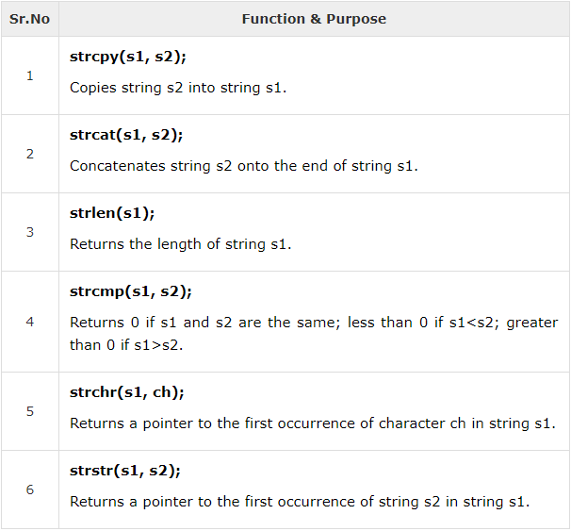
A string is a one-dimensional array that contains characters (chars) followed with a null character (\0). There are C-Strings which are formed using char and arrays as well as object strings which are more flexible and are not set a maximum or minimum length. Strings are generally used to form words or statements and there are many functions that can be used to modify them. [1]

[2]

- Booleans
A Boolean is unlike any other variable in that you can only hold one of two values – either true or false (true being represented by 1 and false being represented by 2). Booleans are extremely helpful when determining if a statement is true or false.

The example code below declares the type of variable being used, the name of the variable and lastly the value that it contains.

- Declaring variables

int number = 5;

double decimal = 2.4;

char str[4] = "Strings";

The following is a program declaring variable types and their inputted data.

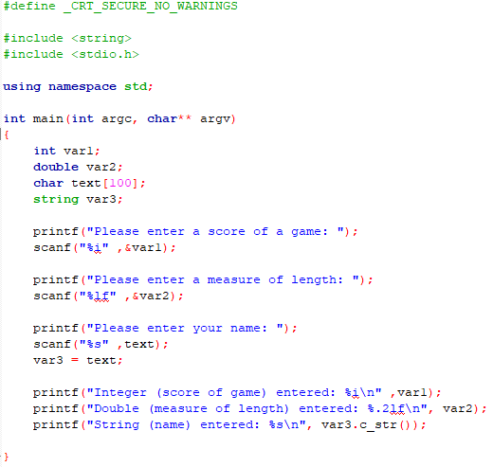

For loops & counting loops
For loops (commonly referred to as counting loops) are used when programmers want to perform a certain task multiple times without having to write the same code more than once. They are deemed extremely efficient and can save time whilst keeping code clean and easy to maintain. A for loop always starts at 0, and will count up and execute the code within the loop until the max counter is hit – hence the name counting loops. You can set the max counter of a loop by either using a value or a variable. Using a variable allows the user to set the counter themselves. Below is a program that asks the user to declare a length, once a value is inputted, the for loop will then perform the task the number of times declared in the variable. The program will then output an X shape using asterisks.
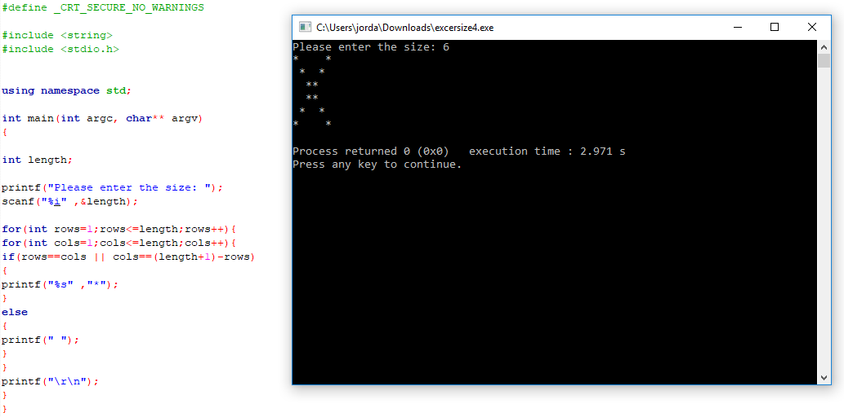

The above program essentially uses a nested for loop, which prints asterisks and spaces reliant on the length set by the user. When the counter is equal to the maximum counter set, the program will then stop performing the loop and move on to the next piece of code.

Arguments in Functions and their purpose
Arguments (commonly referred to as parameters) are variables that are passed to functions when called in main. Functions are capable of using multiple arguments, each argument separated by a comma. When a program begins to run, it’s first point of call is main(). When a function is called in main, the program then finds said function and begins to execute the code. Once the code is executed, the program will then revert back to main() and resume with the program at the place where the function was originally called. Functions allow programmers to add structure to their programs and are primarily used to achieve individual tasks. In C++, there are some useful functions built in, these are called library functions. Furthermore, programmers also have the capabilities to create their own functions for specific tasks.

Classes in Object Orientated Programming
Classes are primarily used in C++ to describe one or multiple objects and are widely used in Object Orientated Programming (OOP). Classes have three main labels – Public, Private & Protected. These are called access specifiers and classes can have multiple of them.
Public classes allow the class to be accessed anywhere in the program. Private classes make the class inaccessible to the program and lastly protected can be seen as similar to the private class, however it can be accessed in any child classes (commonly called derived classes). [3]

Interpretation
The source code for an application was provided. In this section the source code will be analysed and explained, and will be tested and debugged.

The program creates an array of numbers of MAXNUMBERS (integers) and initialises the numbers array to 0. The program then displays some header text of what the program does. The menu is then displayed using the DisplayMenu() function and then awaits user input for the menu options. The program will then decide which function to call based on the chosen menu option.

If option 1 is selected, then the program will ask the user to input a total of 3 numbers. Option 2 will display the smallest number out of the 3 and option 3 will display the largest number. Option 4 should display the numbers the user entered however the switch statement in case 4 incorrectly called the IsQuitting() function. Lastly, option 5 asks the user if they would like to quit the program (isQuitting() function). The user has to enter YES in capitals to exit. Any other number inputted in the menu section will just refer back to the menu.

- Testing
When testing the program for the first time, scanf was not declared in the scope. Adding the <cstdio> library and had to be added before the program would run successfully.

When testing the menu, options 1-3 worked and ran successfully. However option 4 (displaying all numbers) prompted the program to exit instead (option 5). In the function ProcessMenu(), the 4th case statement incorrectly called the function IsQuitting() instead if displaying said numbers. A new function was needed to replace case 4 in the switch statement.

References

[1] | "C++ Strings: Using char array and string object," Programiz, [Online]. Available: https://www.programiz.com/cpp-programming/strings. [Accessed 14 March 2018].
[2] | "C++ Strings," tutorialspoint, [Online]. Available: https://www.tutorialspoint.com/cplusplus/cpp_strings.htm. [Accessed 18 March 2018].
[3] | "C++ Class Access Modifiers," [Online]. Available: https://www.tutorialspoint.com/cplusplus/cpp_class_access_modifiers.htm. [Accessed 17 March 2018].

Appendix 1:

Exercise 1:
#define _CRT_SECURE_NO_WARNINGS

#include <string>
#include <stdio.h>

using namespace std;

int main(int argc, char** argv)
{
int var1;
double var2;
char text[100];
string var3;

printf("Please enter a score of a game: ");
scanf("%i" ,&var1);

printf("Please enter a measure of length: ");
scanf("%lf" ,&var2);

printf("Please enter your name: ");
scanf("%s" ,text);
var3 = text;

printf("Integer (score of game) entered: %i\n" ,var1);
printf("Double (measure of length) entered: %.2lf\n", var2);
printf("String (name) entered: %s\n", var3.c_str());

}

Exercise 2:

#define _CRT_SECURE_NO_WARNINGS

#include <string>
#include <stdio.h>

using namespace std;

int main(int argc, char** argv)
{

int choice;
double rad;
double areaCircle;
double base;
double height;
double areaTriangle;

printf("Press 1 to calculate the area of a circle or 2 for the area or a triangle: ");
scanf("%i" ,&choice);

if (choice == 1)
{
printf("Enter the radius of a circle: ");
scanf("%lf" ,&rad);

areaCircle = 3.14 * (rad * rad);

printf("The area of the circle is: %.2lf" ,areaCircle);
}
else if (choice == 2)
{
printf("Enter the base of the triangle: ");
scanf("%lf" ,&base);

printf("Enter the height of the triangle: ");
scanf("%lf" ,&height);

areaTriangle = (base * height) / 2;

printf("The area of the triangle is %.2lf" ,areaTriangle);

}

}

Exercise 3:

#define _CRT_SECURE_NO_WARNINGS

#include <string>
#include <stdio.h>

using namespace std;

int main(int argc, char** argv)
{

int gravelQuantity;
gravelQuantity = 0;
double numberOfTons;
numberOfTons = 0;
double prePrice;
prePrice = 0;
double totalPrice;
totalPrice = 0;
double payPrice;
payPrice = 0;
double endPrice;
endPrice = 0;

printf("Please enter the quantity of gravel required: ");
scanf("%i" ,&gravelQuantity);

printf("How much is the cost of gravel per tonne?" );
scanf("%lf" ,&prePrice);

totalPrice = prePrice * gravelQuantity;

if (gravelQuantity >= 5 && gravelQuantity <= 8)
{
payPrice = totalPrice * 2 / 100;
endPrice = totalPrice - payPrice;
printf("Total price is %.2lf and you saved a total of %.2lf" ,endPrice,payPrice);
}
else if (gravelQuantity >= 9 && gravelQuantity <= 40)
{
payPrice = totalPrice * 4 / 100;
endPrice = totalPrice - payPrice;
printf("Total price is %.2lf and you saved a total of %.2lf" ,endPrice,payPrice);
}
else if (gravelQuantity > 40)
{
payPrice = totalPrice * 6 / 100;
endPrice = totalPrice - payPrice;
printf("Total price is %.2lf and you saved a total of %.2lf" ,endPrice,payPrice);
}
else
{
printf("Unfortunately you are not eligible for a discount. Your total price comes to %.2lf" ,totalPrice);
}

}

Exercise 4:
#define _CRT_SECURE_NO_WARNINGS

#include <string>
#include <stdio.h>

using namespace std;

int main(int argc, char** argv)
{

int length;

printf("Please enter the size: ");
scanf("%i" ,&length);

for(int rows=1;rows<=length;rows++){
for(int cols=1;cols<=length;cols++){
if(rows==cols || cols==(length+1)-rows)
{
printf("%s" ,"*");
}
else
{
printf(" ");
}
}
printf("\r\n");
}
}
Exercise 5:
TaxCalculator.cpp

#define _CRT_SECURE_NO_WARNINGS

//#include "stdafx.h"
#include <conio.h> // For pause
#include <string>
#include <stdarg.h>
#include <Windows.h> // To change cursor position
#include <cstdio>
#include "TaxCalculator.h"

using namespace std;

// Get the prices from the user.
void GetPrices(double thePrices[], int size)
{
for (int index = 0; index < size; index++){
scanf("%lf", &thePrices[index]);
}
}

// Get the total tax.
double GetTotalTax(double thePrices[], int size)
{
double totalPrice = 0.0;
for (int index = 0; index < size; index++){
totalPrice += thePrices[index];
}
return totalPrice * TAXMULTIPLIER;
}

TaxCalculator.h
#define _CRT_SECURE_NO_WARNINGS

//#include "stdafx.h"
#include <conio.h> // For pause
#include <string>
#include <stdarg.h>
#include <Windows.h> // To change cursor position
#include <cstdio>
#include "TaxCalculator.h"

using namespace std;

// Get the prices from the user.
void GetPrices(double thePrices[], int size)
{
for (int index = 0; index < size; index++){
scanf("%lf", &thePrices[index]);
}
}

// Get the total tax.
double GetTotalTax(double thePrices[], int size)
{
double totalPrice = 0.0;
for (int index = 0; index < size; index++){
totalPrice += thePrices[index];
}
return totalPrice * TAXMULTIPLIER;
}

main.cpp
#include <iostream>
#include "TaxCalculator.h"
#include <cstdio>

using namespace std;

int main()
{
double thePrices[MAXNUMBERS];
double totalTax = 0.0;
double averageTax = 0.0;

// Enter 5 prices.
printf("Please enter 5 prices.\n");
GetPrices(thePrices, MAXNUMBERS);

// Two new lines.
printf("\n\n");

// Display the total tax.
totalTax = GetTotalTax(thePrices, MAXNUMBERS);
printf("Total Tax: %.2lf\n", totalTax);

// Display the average tax.
averageTax = totalTax / MAXNUMBERS;
printf("Averate Tax: %.2lf\n", averageTax);

return 0;
}

Exercise 6:

Main.h
#pragma once

const int MAXNUMBERS = 3;
const int MAXINPUTCHARS = 100;

void InitialiseNumbers(int numbers[], int size);
void DisplayHeader(void);
void DisplayMenu(void);
int ReadNumber(string prompt);
void IgnoreInput(void);
void ClearText(int x, int y, int length);
bool ProcessMenu(int option, int numbers[]);
void DisplayNumbers(int numbers[]);
void GetNumbers(int numbers[]);
int FindSmallest(int numbers[]);
int FindLargest(int numbers[]);
bool IsQuitting();
void WriteText(string text, int x, int y);
void SetCursorPosition(int x, int y);
string FormatText(const char *format, ...);
void ClearConsole(void);
void Pause(void);

Menu.cpp
// AssignCode_Menu.cpp : Defines the entry point for the console application.
//

#define _CRT_SECURE_NO_WARNINGS

//#include "stdafx.h" // *** removed stdafx.h due to using codeblocks
#include <conio.h> // For pause
#include <string>
#include <stdarg.h>
#include <Windows.h> // To change cursor position
#include <cstdio> // *** added cstdio library as scanf was not declared in this scope
using namespace std;

#include "Main.h"

int main()
{
int theNumbers[MAXNUMBERS];
int chosenOption = 0;
bool quit = false;

InitialiseNumbers(theNumbers, MAXNUMBERS);

while (quit == false)
{
DisplayHeader();
DisplayMenu();
chosenOption = ReadNumber("Please choose an option: ");
quit = ProcessMenu(chosenOption, theNumbers);

ClearConsole();
}

return 0;
}

void InitialiseNumbers(int numbers[], int size)
{
for (int index = 0; index < size; index++)
{
numbers[index] = 0;
}
}

void DisplayHeader(void)
{
WriteText("*******************************************************************************", 0, 0); // Top left hand corner of screen is x = 0, y = 0
WriteText("* This application is designed to allow you to choose numbers *", 0, 1); // Next line down is x = 0, y = 1, etc
WriteText("* and finds the biggest and the smallest value *", 0, 2);
WriteText("*******************************************************************************", 0, 3);
}

void DisplayMenu()
{
WriteText("Select an option", 20, 8); // Display menu at at x = 20, y = 8
WriteText("1. Enter the numbers", 20, 9);
WriteText("2. Find the smallest", 20, 10);
WriteText("3. Find the largest", 20, 11);
WriteText("4. Display all numbers", 20, 12);
WriteText("5. Quit", 20, 13);
}

int ReadNumber(string prompt)
{
int number = -1;
int inputCharCount;

WriteText(prompt, 20, 14);
inputCharCount = scanf("%i", &number);
if (inputCharCount == 0) // Wasn’t a number, so ignore what they typed in!!
{
IgnoreInput();
}

ClearText(20, 14, prompt.length() + inputCharCount); // Clear the text at this line

return number;
}

void IgnoreInput(void)
{
char ch;
while ((ch = getchar()) != '\n' && ch != EOF);
}

void ClearText(int x, int y, int length)
{
// Write space ' ' characters starting at x, y for 'length' times
string spaces(length, ' ');
WriteText(spaces, x, y);
}

bool ProcessMenu(int option, int numbers[])
{
string message;
bool quit = false;

switch (option)
{
case 1:
GetNumbers(numbers);
break;
case 2:
WriteText(FormatText( "The smallest value is %i", FindSmallest(numbers)), 20, 15);
Pause();
break;
case 3:
WriteText(FormatText("The largest value is %i", FindLargest(numbers)), 20, 15);
Pause();
break;
case 4:
DisplayNumbers(numbers); //added DisplayNumbers() function and Pause();
Pause();
break;
case 5:
quit = IsQuitting();
break;
default:
WriteText("Unknown option value entered", 20, 15);
Pause();
break;
}

return quit;
}

// Display the numbers on the screen (vertically)
void DisplayNumbers(int numbers[])
{
int y = 15;
for (int index = 0; index < MAXNUMBERS; index++)
{
WriteText(FormatText("%i", numbers[index]), 20, y);
y++;
}
}

void GetNumbers(int numbers[])
{
for (int index = 0; index < MAXNUMBERS; index++)
{
numbers[index] = ReadNumber("Enter number: ");
}
}

int FindSmallest(int numbers[])
{
int smallest = numbers[0];

for (int index = 0; index < MAXNUMBERS - 1; index++) // <-- subtract 1
{
if (numbers[index + 1] < smallest)
{
smallest = numbers[index + 1];
}
}

return smallest;
}

int FindLargest(int numbers[])
{
int largest = numbers[0];

for (int index = 0; index < MAXNUMBERS - 1; index++) // <-- subtract 1
{
if (numbers[index + 1] > largest)
{
largest = numbers[index + 1];
}
}

return largest;
}

bool IsQuitting()
{
char input[100];
string response;

bool quit = false;

WriteText("Do you really wish to quit? ", 20, 13);
scanf("%99s", input);

response = input;

if (response == "YES")
{
quit = true;
}

return quit;
}

void WriteText(string text, int x, int y)
{
SetCursorPosition(x, y);
printf(text.c_str());
}

// JUST USE THIS FUNCTION
// This function positions cursor in Console window,
// and you DON'T need to understand it!!!
void SetCursorPosition(int x, int y)
{
static HANDLE handle = NULL;
if (!handle)
{
handle = GetStdHandle(STD_OUTPUT_HANDLE);
}
COORD coords = { x, y };
SetConsoleCursorPosition(handle, coords);
}

// JUST USE THIS FUNCTION
// This function does creates a string
// using a format string and values i.e.
// FormatText("Number is %i", 5) returns "Number is 5",
// and you DON'T need to understand it!!!
string FormatText(const char *c_format, ...)
{
char ch[100];
va_list args;
va_start(args, c_format);
vsnprintf(ch, 100, c_format, args);
va_end(args);
return string(ch);
}

// JUST USE THIS FUNCTION
// This function clears the screen,
// and you DON'T need to understand it!!!
void ClearConsole(void)
{
system("cls");
}

void Pause(void)
{
// Pause
while (1) { if (_kbhit()) break; }
_getch(); // Clear the keypress
}

