Rhian Pittard 2011588 EAEE4003

Early Years Settings Handbook to promote positive
And successful childhood transitions.
A Keyworker’s Guide.

“Every child is a different kind of flower and altogether make this world a beautiful garden” (Anonymous, 2020).


(source: freedesignfile.com, 2020).

1.

Rhian Pittard 2011588 EAEE4003

Contents: Page Number:
- The Importance of Transitions in Early Years 3

- Introduction on how the Handbook is to be used 6

- The role of the adult 8

- The needs of the child 10

- Partnerships 13

- Interventions

- Proposed Outcomes

- Reference List

3.
Rhian Pittard 2011588 EAEE4003
The Importance of Transitions in Early Years.
Transitions will be an inevitable part of every child’s journey and successful transitions take a lot of planning and preparation (Early Education, 2018). Children will need help and support to adjust when moving to a new setting and their individual needs must be the priority when developing a successful transition plan. The article also states that happy and well settled children, learn better and have a higher level of well-being (Early Education, 2018).
From the moment a child is born, they look to seek out people with whom they can form an attachment. Babies will look to find a closeness with a familiar person who will comfort them when they feel scared or vulnerable. It is vital for a baby or young child to have this closeness from an incredibly young age as it helps them to feel safe and secure and will aid them to develop healthily. This information is also relevant to other care givers, including key workers, as well as the child’s parents as children can benefit from a wider network of positive attachment relationships (Freud, no date).
Bowlby suggests that children are born with programming which can help them to form attachments with others. He also believes that attachment behaviours are triggered by an emotion or feeling, such as, fear, insecurity or separation and when these things happen to a child, their programme is activated, which cause them to look for someone who they have created an attachment with (health research funding, 2020).
It is also said that Bowlby believed that if an early emotional bond is formed between parent and child, then the child will have a healthy development, whereas if there is a lack of bond, it could have an impact on the child throughout their life (Vinney, 2019).
Bronfenbrenner’s theory looks at the factors which can have a direct impact on a child’s development, mainly the environment and the systems of relationships the child has within that environment (Aubrey and Riley, 2019). To support his theory, Bronfenbrenner developed a structure with five individual layers, microsystem, mesosystem, exosystem, macrosystem and the chronosystem, which he believed each layer had an effect on the development of each child and the interactions
4.
between each one creating a unique experience for each individual child (Aubrey and Riley, 2019).
The first layer, microsystem, is where the individual child forms relationships and interactions with people in their immediate surroundings, for example, at home or nursery/school setting. The second layer, mesosystem, is where interactions and relationships are formed between extended people from within the microsystem, these could include the relationships between teachers/practitioners and the child’s family (FirstDiscoverers, 2020). These first two layers are when positive relationships need to be formed in order to fully support the child’s individual development.
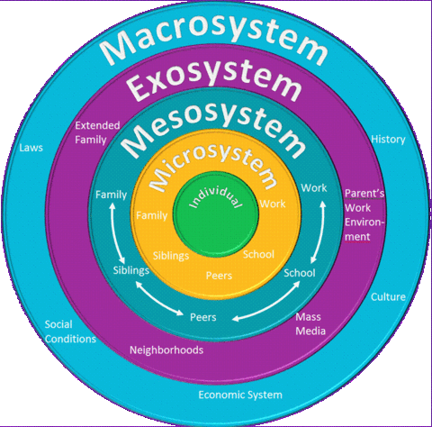(source: blogspot.com, 2015).
As children find transitions that involve changes to their relationships with people, they depend on to be most difficult, it is important for transitions to be smooth and gradual and not sudden and unexpected. This kind of transition can make it more difficult for the child to adjust to their new surroundings (Trodd, 2012).
According to Perry (2015), relationships are the most important area around a successful transition. These are relationships amongst children, parents/carers, practitioners and multi agencies. It is critical that everyone needs to feel like they are in this together and everything that is done is for the benefit of the individual child. Perry (2015) also states that if a sense of belonging is felt amongst the afore mentioned parties, then it can be said that the transition has been a successful one.

5.
The Flying Start Transition Guide Handbook (2017), states that in order for transitions to be carried out successfully, it is important for positive relationships to be established between the child, their family and all adults that are involved with the process.
If a child is exposed to positive experiences throughout their early childhood, it can help to build a healthy brain, however if a child is exposed to more negative experiences, such as neglect or trauma, then this can cause harm to the development of a child’s brain (NSPCC Learning, 2020).
According to Shonkoff et al, with the help of just one positive and supportive adult and child relationship in the early years, these negative, harmful effects can be reduced and can help a child’s brain to have the opportunity to continue to develop in a more healthy manner (Jarvis, 2018).
Below shows the affect trauma can have a young child’s brain development.
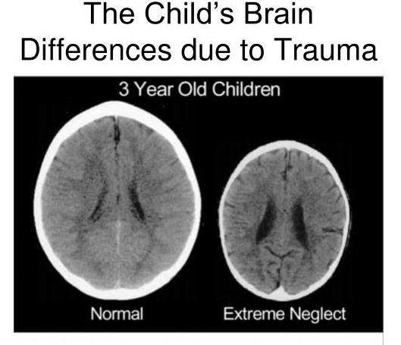
(Source: SlideServe, 2020).

6.
Introduction on how the Handbook is to be used.
The role of a keyworker is of an important one and is someone who helps children to feel safe and cared for, especially when they are settling a child into a childcare setting for the very first time. Children flourish when they are part of loving and secure relationships and key workers are able to take on this role within the setting and will form relationships with the child and their parents/carers (Early Years Matters, 2020).
Keyworkers working with babies and toddlers need to develop ways in which they listen to them and become aware of their individual needs and wants. This is known as ‘serve and return’. Throughout their early years, babies and young children are developing neural connections in their brain at an alarming pace and these connections are strengthened by positive interactions between a child and a responsive adult, in this instance, the child’s key worker. These interactions make a child’s brain stronger and can help the child to grow and reach their full potential (Harvard University, no date).
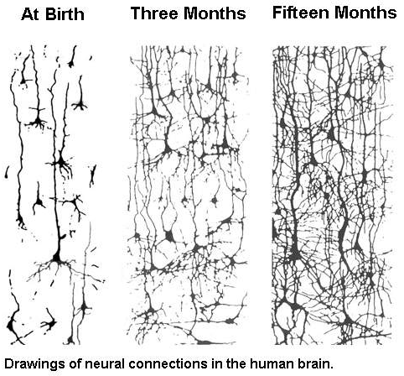(Source:cereschildcare.com, no date).

7.
Bowlby’s theory included the four stages of development: pre- attachment, attachment in the making, clear cut attachment and goal corrected partnership. Attachment in the making occurs between 2-6 months of age and is when a child begins to show signs of preference to a particular person, usually the main care giver. Clear cut attachment happens between the age of 6 months and 3 years of age and it is at this stage where a child can begin to suffer with separation anxiety and will cry for their main caregiver (Psychology Unlocked, 2020). As this handbook is specifically designed to be used by keyworkers who work with children aged between 0-2 years of age, these stages of development are crucial for the keyworkers to make themselves familiar with as they will become the main caregiver to the child during their time at the setting.
According to Erikson, children go through a stage of trusting and mis trusting, and this usually begins at birth and continues through until the approximate age of 18 months. During this time, a child will become uncertain of their surroundings and will look towards familiar adults for stability. By ensuring that the child receives consistent and reliable care, they will feel safe and secure within a new environment and be able to develop a sense of trust and build on their relationships. If this does not happen and the child receives inconsistent and unreliable care, it may cause them to develop a sense of mistrust and anxiety, which can result in a lack of confidence in a new environment (McLeod, 2018).
Piaget believed that children’s own curiosity would develop their desire to learn and the most effective way of enabling this to happen was to provide children with an environment which helps to promote curiosity and challenges them. This kind of learning needs the support of key workers and practitioners as they can provide this kind of experience for the children and are there to support them when needed (Aubrey and Riley, 2019).
Bronfenbrenner believes that there are wider factors, such as economic and cultural aspects, that can have a direct impact on a child’s learning and development. These factors need to be considered when settling a child into a new setting, as well as remembering that a child’s unique biology will play a crucial part in their development and more importantly their learning (MacBlain, 2018).

8.
The role of the adult.
Children are surrounded by many different role models, such as parents, siblings, extended family, and practitioners within their childcare setting. These role models will provide the children with examples of behaviour that they are able to observe and imitate and the children will do this in many different ways. Bandura demonstrated this learnt behaviour with his BoBo doll experiment in 1961 (McLeod, 2016).
Bandura’s theory is one which he believes in learnt behaviour through observing and imitating and this theory has led both parents and practitioners to recognise the importance of being positive and appropriate role models to children in the setting (Cherry, 2019). Whereas Watson and Skinner both believed in a behaviourist theory, where rewards and punishments are used to control student’s behaviour and to help teach them new skills (Drew, 2020). The behaviourists theory may not be typically used within a setting, but practitioners/keyworkers should respect parents’ views if this is what they choose to do at home.
A key worker is a named practitioner who will be responsible for a child who is starting at the setting and this person is there to help the child feel safe and secure when settling in. The role of a key worker is important for both the child and their parents and communication between the key worker and the parents is essential, before and during the child’s time at the setting (Early years careers, 2015).
The key worker will need to work alongside the child’s parents/caregivers in order to support the child’s emotional well-being, which will enable them to form an attachment with the child and to help make their transition from home a smooth and successful one (Pacey, no date). The transition policy of the setting is put in place in order for the key worker and fellow practitioners to be able to support the parents as well as the child with the transition. This will be done by providing the parents with all the necessary information with regards to their child’s learning at the setting, making sure that a key worker is in place before the child starts, ensuring that all practitioners are aware of the child’s name before starting and by doing this, hopefully the parents will feel less anxious about being separated from their child (Ely and Caerau Children’s Centre, 2017).
9.
Before starting at the setting, the key worker would have had the opportunity to meet the parents and the child when they complete the registration pack. This gives the parent the chance to be able to express any concerns they may have with regards to the settling in process. During this time, the key worker can explain the polices that are in place, with regards to stay and play sessions, taster sessions and any forms of communication the key worker will have with the parents.
The role of the key worker includes them carrying out observations on the child and these are used to identify any concerns they may have, the next area of development for the child and to follow the child’s interests. This follows the approach of Dewey that the individual child should be at the centre of learning and they should be given the opportunity to develop following their own interests. Dewey believes that a learner-centred pedagogy should be developed whereby children are encouraged to progress and experiment based on their individual interests and not by a didactic approach (Aubrey and Riley, 2019).
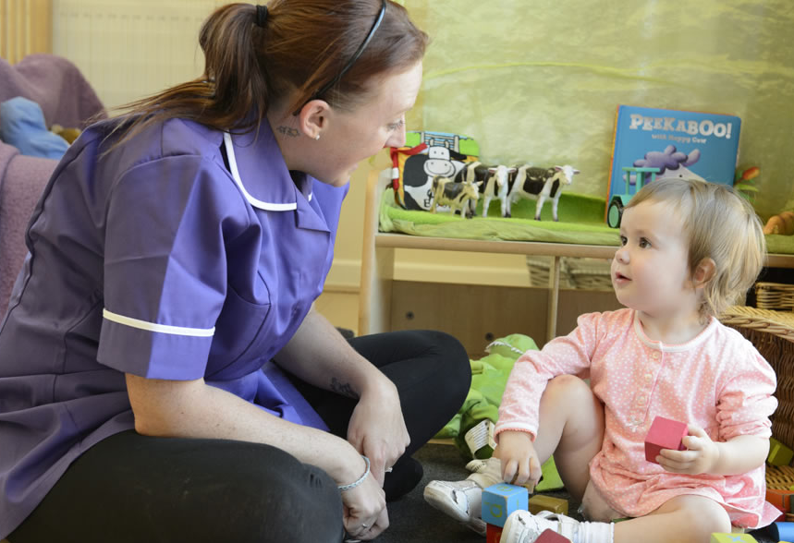
(source: treetopsblackpool.co.uk, no date)
The key worker is an important role model to the child and needs to be someone they can rely on. Children will concentrate and learn more efficiently if they are relaxed so by having a key worker who is tuned into their individual needs will help support them in their development (Pacey, no date).

10.
The needs of the child.
In order for transitions to be successful ones, they should be the main priority for settings and need to be planned with children’s individual needs in mind. These transitions should be in place in order to build confidence and resilience through gradual changes, so there are bridges to cross and not hurdles to jump (Hunt, 2017).
To enable key workers/practitioners to be able to provide a smooth transition for a child, they need to observe the child and listen/tune into their individual needs and interests. Article 12 of the UNCRC states that each child has the right to express their own views and that these views should be respected (Trodd, 2012).
Vygotsky believes that social interaction plays a major role in the cognitive development of a child. Vygotsky’s theory is based on his idea of the ‘zone of proximal development’ – which he describes as the level of development achieved when a child engages in social behaviour. These skills can be developed further with support from adults or peers and this is where the importance of the key worker observing and listening to the child comes in to play in order to help the child progress and develop their skills to the next level (InstructionalDesign.org, 2020).
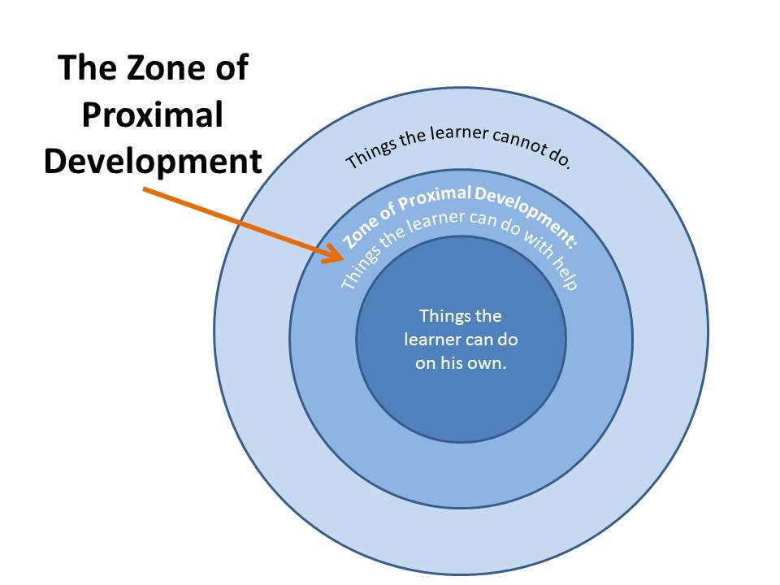 (source: cuppacocoa.com,2014).

Babies and young children learn and develop holistically, which means that lots of different areas develop at the same time and they are all interlinked with each other. This typically happens between the ages of birth to three years of age, so there are many benefits in babies and young children being given the opportunities and
11.
experiences that take into consideration all areas of development and learning (Brodie, 2018). A holistic approach is where children can be taught in an environment which is natural as well as engaging and this kind of approach focuses more on emotional, psychological, and social growth and development of children (American Montessori Consultants, 2017).
Montessori believed that if children are given a sense of freedom with their education and opportunities to choose their own learning experiences, within reason, then a child can remain interested in activities for longer periods of time and return to these chosen experiences until they had mastered it (Aubrey and Riley, 2019).
Montessori’s theory included a series of stages in a child’s development and the first stage was ‘an absorbent mind’ and occurs between birth and three years of age. Montessori believed that during this time is where a young child is growing spiritually as well as physically and these first three years of a child’s life are crucial to their development as this is when a child will form their personality (Robin, 2019).
Maslow’s hierarchy of needs is a theory that is based on 5 basic categories of needs which are shown in the diagram below.
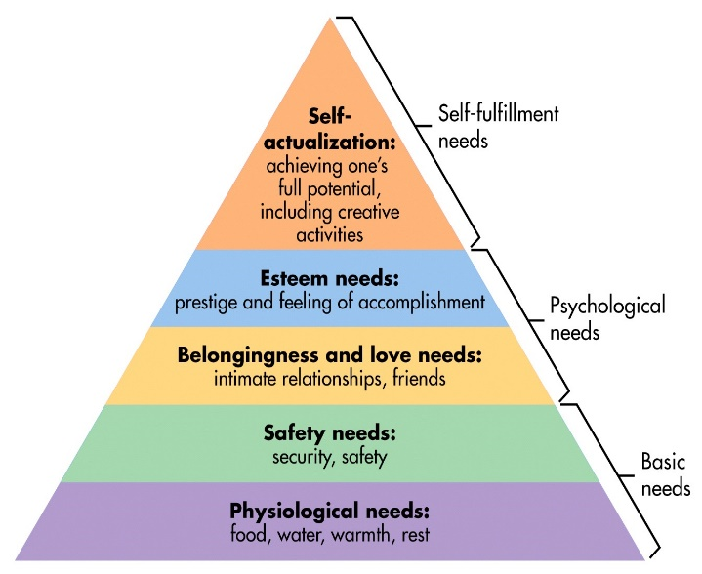(source: wordpress.com, 2011).
According to Maslow, the previous needs, need to have been met in order for the next level of needs to be considered. The first category is based on basic needs, such as

12.
food, water, and shelter and these have to have been met in order for the next level category to be considered. The child’s key worker will be responsible for providing opportunities for these needs to be met by the child and will also play an important part in the next category of needs as children need to feel safe and secure within the setting (Hopper, 2020).
Play is important for a child’s development and as article 31 of the UNCRC states, every child has the right to play (Unicef, no date). Key workers need to ensure that they are giving every child the opportunity to play within the setting. According to Locke, a child’s mind is like a blank slate and by saying this he believes that the environment and experiences form the mind. Locke also states that a child’s development comes from the relationships and opportunities children have with parents and caregivers. He believes that learning should be achieved through play (Researchomatic, 2011).
Bruner played a crucial part in helping people to gain a better understanding of how children play and how they build on their knowledge. Bruner developed the term ‘scaffolding’, which is the way in which a child builds on information and skills they already have. He believes that a child’s play is developed by their curiosity (Component Playgrounds, 2015).

“When you asked me what I did in school today and I say, ‘I just played’. Please don’t misunderstand me. For you see, I am learning as I play, I am learning to enjoy and be successful in my work. Today I am a child, and my work is play.”
(Anita Wadley, 1974)

13.
Partnerships.
The Early Years Foundation Stage (EYFS) states that a partnership consists of parents/caregivers, families and key workers/practitioners all working together to help benefit children. This partnership must be built on trust, openness, and responsibility from all of the involved parties (Winter, 2017).
Transitions should be viewed as milestones for children and have a direct impact on their development. It is vital that transition is done correctly for each child and should be seen as a process they have to go through which involves the children, practitioners and parents working together (Early Years Matters, 2020).
By keyworkers working closely with the child’s parents and families, it gives the opportunity for information to be shared between all parties with regards to the child’s development and learning and to recognise and support any children that may need some extra help in a specific area. This information can then be passed on to the relevant outside agencies, such as the child’s health visitor, speech and language team or the play team, who will then form another partnership with the child’s parent/caregiver and key worker (Early Years Matters, 2020).
 (source: andreakihlstedt.com, 2020).
As well as forming a positive relationship with the child, a key worker also needs to build a positive and effective relationship with the child’s parents. These partnerships are so important when planning transitions as parents know their child the best and will be able to share relevant information with regards to their child’s development and any concerns they may have. The key worker should communicate with the child’s parents at the beginning and end of day and also by completing a daily diary for the

14.
child, which will be given to the parent at the end of every day (Early Years Careers, 2016).

