MelodyHwb Database
Databases and Application Development (ACCA5026)
Rachid Aboulachouaq (2237654)
Word Count:1073
​​
Table of Contents
MelodyHwb Database 0
Entity Relational Diagram 2
Tables 3
Customer 3
Products 4
Order 5
Servicing 6
Repair 6
Optimisation 6
Security & Data Compliance 7
Conclusion 8
References 8

​​

Entity Relational Diagram
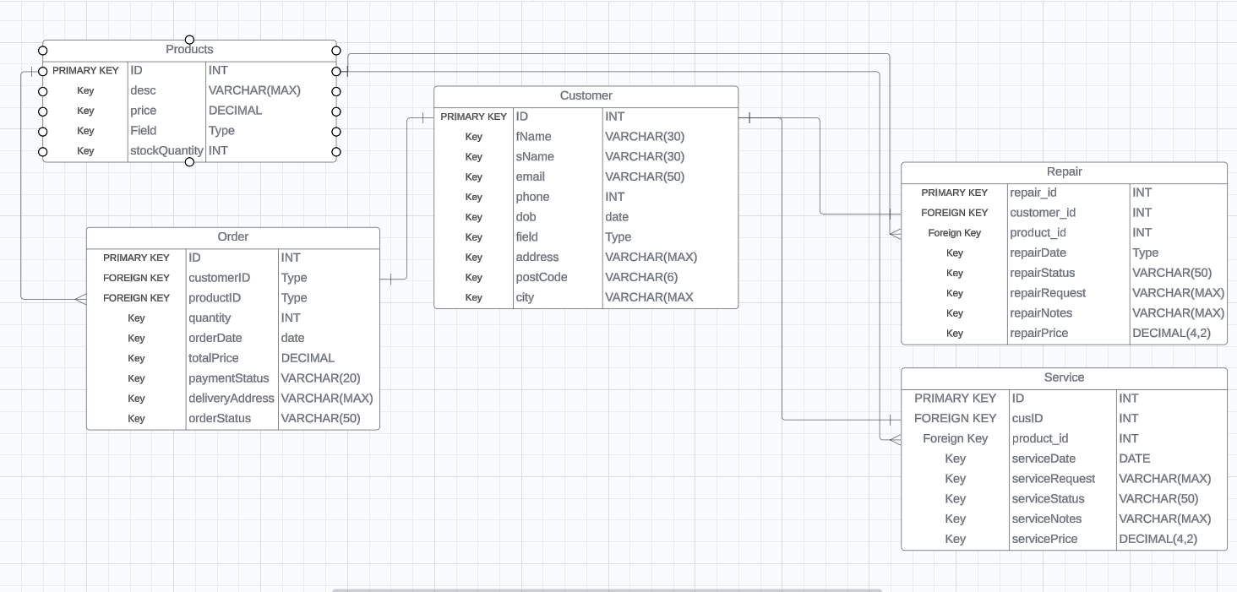
The entity relational diagram (ERD) provides a visual map of the database and the contained tables and relationships that are needed by the MelodyHwb business. As is see from the above we can clearly see the different entities contained within the database and the attributes they have. The ERD also provides a view of the relationships between the entities and the cardinality of those relationships i.e. 1:1, 1: M. Some constraints between the entities can also be taken from this, such as seeing the primary key of each table, as well as corresponding foreign keys in other tables.

Tables

Customer
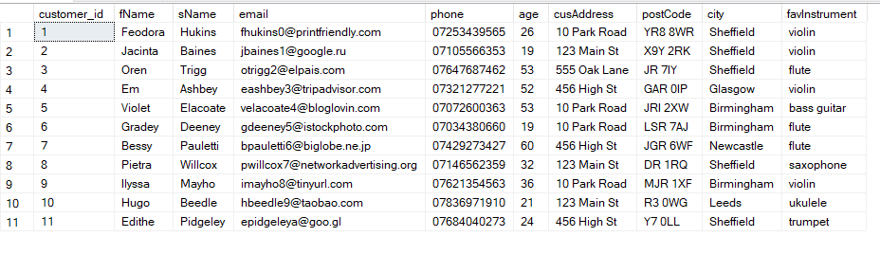The customer profile table is an essential part of the database. This will store the customer details such as name, contact address and phone number. The business can use this in many ways, such as retaining information for speedier checkouts for the customers. The customer ID can be used to cross reference the other tables to provide marketing information such as order history, service history and repair history. The addition of a ‘Favourite Instrument’ column allows for customers to select their favourite musical instrument, which is useful for the business to provide targeted marketing relating to their favourite instrument. Customer ID is added as an INT to create a more straightforward relational model for the database entities. Email and customer address are set to VARCHAR(MAX) to accommodate long or multiple values.

Products
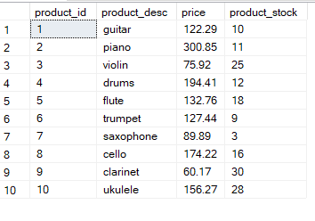
The product table is also essential for inventory management in the business. Knowing how many items the business has in stock can help them restock and also forecast cashflow into the business. Price is utilised using a DECIMAL data type set to two decimal places so that accurate sales and pricing can be made. It is possible to set up alerts when stock drops below a certain number, and this can help save on workload for employees. Product ID is another aspect of referential constraints, such as ensuring that orders have the correct products delivered. Transactions can be implemented to automatically deduct stock quantity when orders are made.
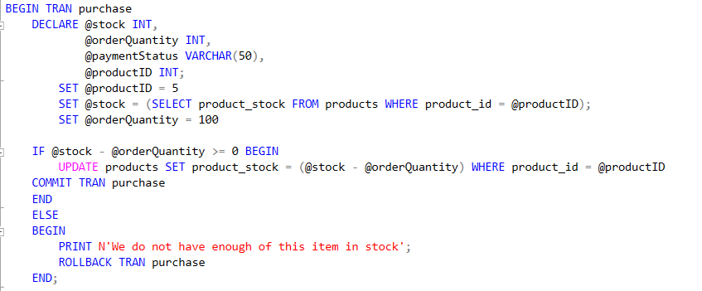

Order
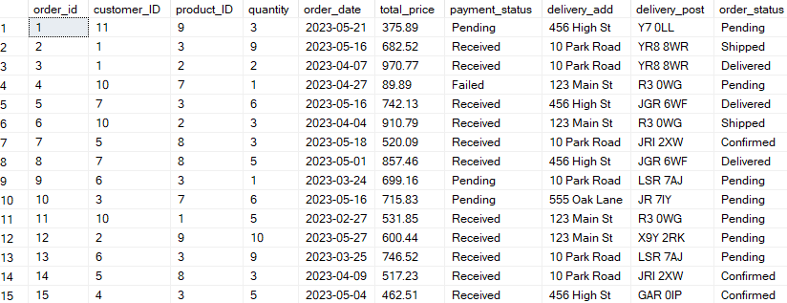
The order table is another essential aspect of the business, allowing for a record of sales and orders to be kept for MelodyHwb such as the total price of the order and the quantity of items ordered. The date of order is included to facilitate any returns needed withing a certain period and also the most popular times of the year sales may be made. The status of payment and the status of order are also included in the table to provide real time update on the progress of the customer orders and whether they have paid. The customer_ID and product_ID are foreign keys and maintain referential integrity of the database in this regard, as the existence of values not in the other tables compromises data integrity in the database. Delivery address and postcode can be changed by the customer according to their preferences. Shipping labels and invoices can also be created from the data stored within this table. Order history can also be pulled form this data with use of PK-FK constraints.
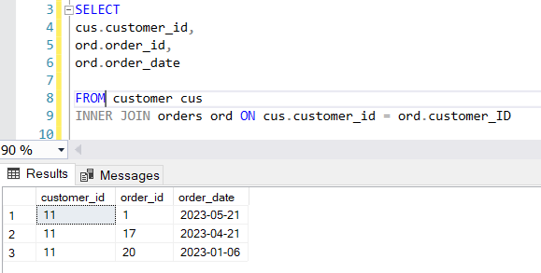

Servicing
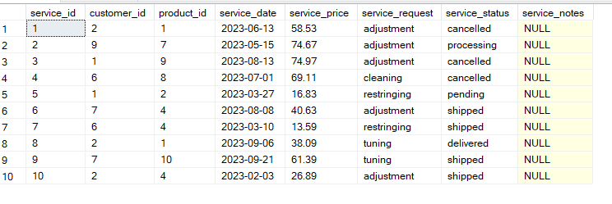
The servicing table is also very useful for MelodyHwb as it allows for an additional revenue stream. The customer and what product is recorded in the table, as well as the date of the service, allowing them to book another service when it is due. The type of service that is needed and any additional technician notes are recorded

Repair
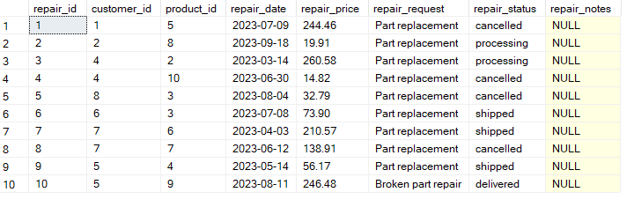
The repair table is very similar to the service table with dates of the repair appointments and the type of request.

Optimisation
MelodyHwb is able to optimise the way they operate the business by utilising the database in different ways. One example of this is cashflow revenue. The business will be able to create a stored procedure and view to pull sales data from the order table, as well as revenue from servicing and repair table, and create a comprehensive report that can be run each month which will save time on financial accounting side of the business.
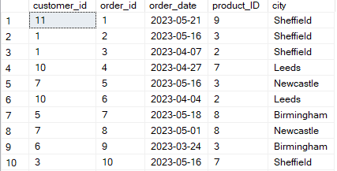

Other reports can also be created to support the business, such as most and least popular items according to geographical location. Marketing campaigns can be created based off this data to boost sales and revenue of theses items and also to promote similar items.

Security & Data Compliance
As the business will now be storing confidential and personal data, they must have an effective plan in place, or they could be breaking the law and put their customers at risk.
One example of this is to ensure that their staff have data protection and compliance training. By ensuring their staff are aware of the dangers and risks, they will be able to act more watchful when dealing with such information. This could be as simple as keeping the computer screen turned away from prying eyes in the shop. More effectively, implementing staff logins for the business computers, as well as logins for accessing the database. This prevents any unauthorised persons from accessing the data on the database, whether physically or virtually. Additionally, staff roles could be assigned, such as store operative and manager access to create another layer of protection for customers and staff.

The company should also deem how long that keeping a customer’s data is needed for. They could implement a ‘non-active’ period for certain customer profiles, depending on when they last made an order in the store. After that period of time, around 3-4 years, they should make sure to delete any personal data they have stored for that customer. In addition to this, as they allow for under 18 customers to create profile, they also have an added duty of care to ensure this data is well protected.

Conclusion
To conclude, MelodyHwb adopting an entity relational database will provide massive growth for the business through effective management. The ER Database will reduce data redundancy that may have occurred within the business before. The constraints and relationships implemented will maintain referential integrity and will reduce the likelihood of duplicate values appearing in places they shouldn’t be, reducing confusion and the misallocation of resources [1]. Entity relational databases are also extremely flexible and scalable to the business, so as the business grows, so too will the database [2]. The flexibility of the database is also worth noting, as it is easy to maintain and alter without detrimentally affecting the other parts of the database [2].

References
[1] "Advantages and Disadvantages of an ER-Model." https://www.geeksforgeeks.org. https://www.geeksforgeeks.org/advantages-and-disadvantages-of-an-er-model/ (accessed 07/01/).
[2] D. Thakur. "What is ER-Model?Advantages and Disadvantages of E-R Model." https://ecomputernotes.com/. https://ecomputernotes.com/fundamental/what-is-a-database/advantages-and-disadvantages-of-e-r-model (accessed 07/01/).

