

Furnace Fall Project Proposal

Bradley Godwin

University OF WALES TRINITY SAint DAVID ​

Reason and relevance if the project:

The primary customer product for galvanised steel is the automotive market, where the steel is formed for the outer body panels. This part is crucial for surface quality as this surface is what is visible to the end customer. Therefore the surface quality of the galvanised steel requires no surface defects that would show up after pressing and painting. During the steel making process defects occur frequently which need to be cut out therefore effecting the over prime yield of the product. But this is vital to achieve customer satisfaction and results.
Over the last several years there has been a sever defect that has caused a large number or reworks, rejections and customer complaints. The defect which has been classified as “Furnace Falls” is produced from the Zodiac furnace where the debris falls onto the steel and then get rolled into the steel by the furnace rolls. The defect cannot be coated over by the zinc galvanised coating as this does not allow a clear surface to adhere on therefore leaves large black defects on the bottom surface of the steel. This is easily seen by the customer and will cause contamination within the pressing process. As seen in figure three the furnace fall appear linearly on the surface of the steel throughout the entire 3000m of the coil and falls randomly without any cause. Therefore it is difficult to predict the cause behind the debris within the furnace to fall.
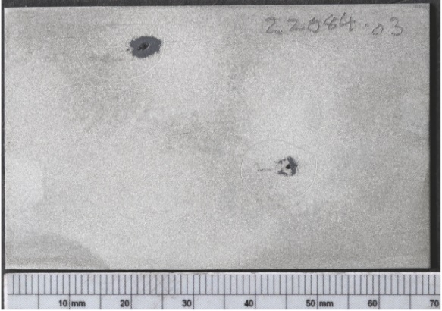
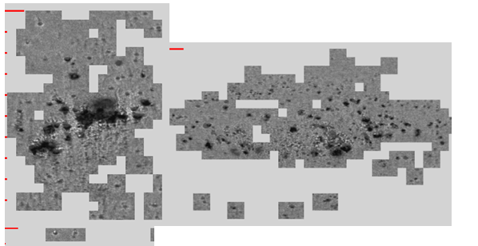

Figure 1 – Cluster defect TLR Figure 2- Image of the furnace fall

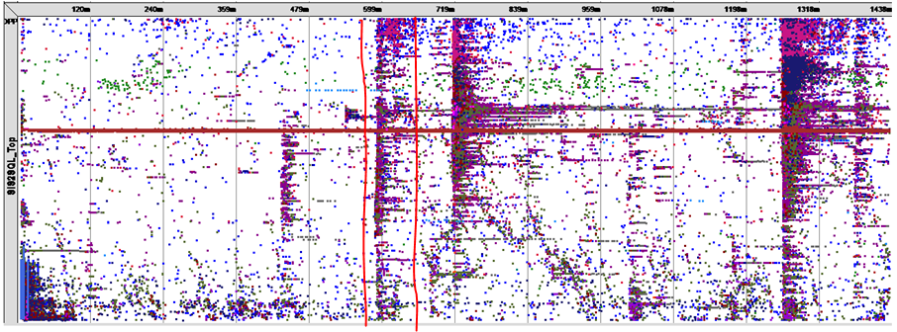
The defect was first noticed over one year ago, but the defect was light and could be easily discarded and reworked with minimal prime yield loss. But the Over the last 3 years the defect has then gotten to a critical point where the prime yield loss is now between 30-40% on the full finish material, which is the outer body on cars. Therefore as discussed the customer is then dissatisfied as they do not receive the tonnage they have ordered and the coils have to be recreated putting through the entire steel making process again.
Figure 3- TLR coil map
Some analysis has already been carried out by the port talbot test house from the customer complaint samples, this showed that contained in the defects was elements including, carbon, chromium, nickel, iron, zinc and various other tramp elements. More samples have then been taken during the rework process so that further SEM and OES can be carried out on the samples to prove the definitive cause behind the defect. On top of this it is understood on the location within the furnace as from figure 3 on the TLR map as the debris falls from the furnace onto the roll it then gets rolled in, as the roll is then rotating this causes a roll mark, therefore a tail can be seen on the maps. A pitch can then be calculated from one defect to the other and a pitch of 1364mm has been identified from over twenty separate furnace falls. is can be identified as rolls four, six and eight.
As discussed some pre work has been completed before the major project improvement had been kicked off allowing for a Definition within the DMAIC process. The importance of the project is to understand on why there is Inconel within the defect as Inconel is used for its properties of not being able to oxidise under extreme conditions and can withstand extreme heat.

Aim of the project

Due to the complexity and scale of the project a project team is created by the senior management team comprised up of all functions of the zodiac plant including technical, production, engineering and electrical. The scale at which the issue is costing the business and due to unsatisfied customer not receiving their coils, A large investment has been given to the project team to totally eliminate the defect from the furnace and all resources available by TATA. Therefore the overall aim of the project is to totally remove the defect and to ensure that is does not come back. This will be carried out using six sigma problem solving methodology as this is considered suitable for this process. The aim for the project is to try and complete the project and fix the furnace within 3-6 months. As there is a risk to the business around the loss of customers.

Time Line:

As discussed the project team has been given three to six months to eliminate the defect. The project will be tracked through an A3 tracker and there will be two week team meeting to go over the project details, actions completed and next steps. The start of the project will be to analyse the defect to understand the chemistry make up and the size of the defect. Over 50 samples have already been taken of the defect and three months of analysis through all different production runs will be calculated to identify any root causes. From the analysis the DMAIC six sigma process will be followed to ensure that the root cause is identified, eliminate the defect and to ensure that the process remain sustainable so recurrence does not happen.

Cooperative industrial partners

As discussed due to the complexity of the project it was discussed that information and knowledge would be discussed between TATA Europe sites including Imjauden, shotton, Mauberge and Segal. As all of these sites have a galvanising line therefore may have some experience with this type of defect. Technical specialists within each of the galvansing lines will be contacted to discuss their experience and how they produce.

Facilities and software required:

- Port talbot test house: OES and SEM
- Llanwern Labs live testing and sample collection
- Swansea research centre- Further analysis of samples
- AFL rework line- Samples and analysis

Software:
- TLR- Images of defect and severity
- Spotifre- Analysis
- Minitab
- SQL

