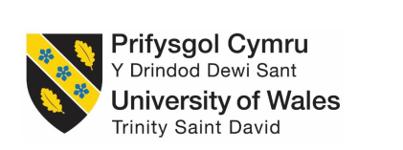

Name: Jevgenija Hlebnikova
Student Number: 1705773
Module Tittle: Managing enterprise in the 21st century BMSK4006
Assignment Title: Managing Enterprise in the 21st Century
Module Lecturer’s Name: Dr Husam Helmi

Table of Contents
Introduction: 3
Description: 3
Feelings: 4
Group Discussion: 4
Presentation Skill: 4
Communication Skill: 4
Time Management and Planning: 5
Evaluation: 5
Analysis: 6
SWOT Analysis: 6
Business Plan and Advertising: 7
Conclusion: 7
Action Plan: 8
My Future Planning as a Professional: 8
References: 9

Introduction:
Group discussion and team work is important for any academic and professional purposes. Team work is effective for business and enterprises and thus this report contains about the personal experience and observation of myself regarding the report. I will write a reflective report and I will use Gibbs Reflection Model for better analysis. The cycle actually has six parts and I will analyze those six parts based on my practical experience and theoretical knowledge.
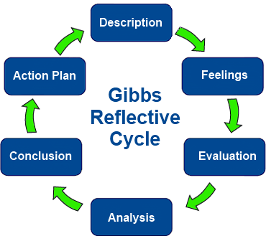
Figure: Gibbs Reflective Cycle
Source: https://canadianparamedicine.ca/an-introduction-to-reflective-practice-for-paramedics-and-student-paramedics/

Description:
Now a days, entrepreneurship among the young generation is increasing and various enterprises are also developing with different ideas and with new business portfolios. In this report, I am going to analyze and describe about the 21st century’s enterprise, what I learnt of enterprise and business solution, my personal experience and observation of the group project that I did, about my presentation skill and typing skill, my communication skills in a very reflective way. Enterprise solution and a pure knowledge of enterprise solution is necessary and thus I will going to write a brief about my overall experience while I was doing the group report. In this report, I will relate my experience and observation with theories to relate what I actually learnt from the assigned task. This report is overall about my personal development plan related to enterprise and our group project about our group project.

Feelings:
Experiences are the key factor for both academic and professional knowledge. According to Rashford, he stated that academic experiences are the base of professional career (Rashford, 2009) So, I think during the group project about 21st century’s enterprise solution and the business type, I had a lot of unknown experiences like how to manage a group task, how to develop writing skill, how to communicate both verbal and non-verbal communication with group members, group discussion. I also have the idea about how to make a report, how to make a presentation slide and referencing them etc. According to Sarah & Paul, for the globalization and digitalization, hard and soft skills should be learnt from the academic background of a candidate (Paul, 2012). Skills that I acquired from the project about enterprise of 21st century is given below-

Group Discussion:
As we have done our project with a group, so I had a lot of experience about our group discussion. Our topic was certain and I mostly did my part with the help of secondary data sources. According to Miller, he stated that secondary data are readily available and mostly used for research purpose (Miller, 2013). So, I mostly found in that time everyone is giving different opinion and by mixing everyone’s idea, we always got a solution. In this regard, I may say that group discussion is the best possible means of solving a specific problem.

Presentation Skill:
When I was finished with the report, I had to make my own presentation slide. In this section, I have learnt about how to make a presentation slide, how to prepare assignments with appropriate referencing and various work of Microsoft Office. In few days back, I had a fear of giving presentation. Now, I am prepared for presentation and I have no fear about giving presentation. Confidence, self-esteem and smartness are the main factor for giving the best presentation I think.

Communication Skill:
Taylor said that communication is the process where people interacting with each other with meaningful words and sounds (Taylor, 2011). I have learnt some practical and different approaches of communication among my group members. I am familiar with group study, verbal and non-verbal communication and about situation handling. Communication is the key factor for any working or academic project for an individual like me.

Time Management and Planning:
Managing time is the hardest issues for aby work. Practically when I was going to do my part, I was quite nervous and stopped the work. But after some successful group discussions with my fellow group members, I made a good use of time and it was great. I utilized all the available sources of information via internet, book and journals and gathered data by three/four weeks.

Evaluation:
I have observed that during the group discussion, I talked with my fellow group members and always ready to give something extra. Which actually enabled the knowledge of mine into a very reflective and practical one. I have studied a lot about 21st century and the enterprises of UK. In UK, entrepreneurship is increasing day by day. So, our group tasks was to develop a project and I have done with some parts of the group. During my project, I have some difficulties and problems. Like sometimes my group members were too much busy to talk. But all over it was a great observation of group discussion and team work.
When it came for the assignment of individual part, I was scared. I have done my part with the help of external and some internal data sources and the hardest part of my assignment was the referencing and citation part. But I was able to do it on my own. I also had to know about the presentation slide and various referencing and image adding process in the PowerPoint slide. The main observation of my project that we had done every single topic with a very practical way. In order to keep that each and every group members were advised by our group leader. From this perspective, I have learnt about the group and leadership approaches which actually gave an idea of communication which is very much fruitful for me both in academic and professional career.
During the project, I analyzed market situation which actually enabled my theoretical knowledge into practical knowledge. Market situation actually is the process of analyzing the SWOT analysis. According to Johnson, he stated that internal analysis of the company is dependent on the SWOT analysis which enables the competitiveness in the market (Johnson, 2001). From market analysis part, I have learnt about SWOT analysis and how to make a business plan for a company or for a business.
Advertising in the part of marketing and I have learnt about advertising and its implications in the business during my project. I have read various journal and articles about 21st century’s advertisement in the companies in the UK. I have found that a business plan and successful project depends on the promotional activities taken by the company (Mike, 2016). Marketing concepts are needed and thus I have acquired knowledge about advertising. I have gained about the various types of advertisement and its uses in business. It actually helped me to understand a practical method of doing strategies for the enterprise solution in the 21st century.

Analysis:
Many concepts have been hypnotized in our report and I had some theories of marketing and management. The theories I learnt are SWOT analysis theory, marketing strategy planning and some advertising methods which are the part of IMC (Integrated Marketing Communication). According to Kotler, IMC tools are important for planning a business and for different promotional activities (Kotler, 2009).

SWOT Analysis:
SWOT analysis is the understanding of a business’s internal condition depending on four key factors. For 21st century’s enterprise management, I have acquired that from the SWOT theory, a company can easily find the potential strengths and weakness and can gather the data of opportunities and threats. I mixed SWOT theory with our project to do market analysis and market situation of our business and make a plan for it. From the project, I have used the SWOT theory with the help of internal information and plan of a company and matched it for our group project.
SWOT analysis actually helped me to understand about company’s internal communication and process in terms of its competitors. So, now I can easily explain and elaborate any report with the help of this SWOT theory.
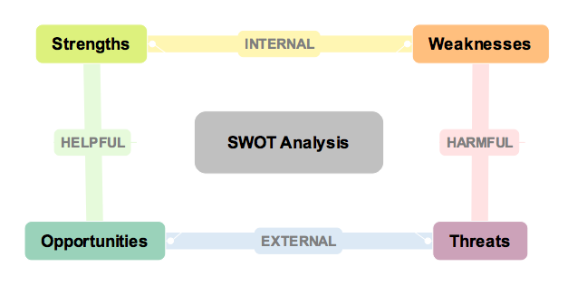
Figure: SWOT Analysis
Source: (TimCohn, 2017)

Business Plan and Advertising:
Business plan is important for analyzing market, situation, sales strategies and some financial issues. I have gathered various data of some companies to make our project and thus came to know a lot about a business plan. As I have done with market analysis, market share and different approaches, I am now capable of making a business plan of my own.
Advertising is effective communication now a days for marketers. I have used advertising theory in our group project as a promotional plan. I have learnt about advertising and the various advertisement procedures for a company. I am known to different advertising tools like TVC (TV commercial), billboard advertising and many more things.

Conclusion:
This age is the age of technology and digitalization. With the help of digitalization and various technological advancement, opportunities are increasing. Enterprise and entrepreneurship already created a chance to expand business market and different business portfolios. I think, for the 21st century, various techniques should be implemented by the companies and individuals should have some extra skills. While making this group project, I had a positive and negative situations regarding my tasks. But with the help of SWOT theory, business plan, I now can make market analysis, market share analysis and advertising strategy for a new company. With the help of those theories and terminologies, I made a change in my personal development plan and set my goals for my professional career.

Action Plan:
From this project, we had made a report using MS Office and made a presentation too. So, I have learnt how to use MS Office and hoe to make presentation slides. I have gathered information and techniques about Harvard referencing system for the report as we were told to do so. I can make market analysis and business plan with a presentation which actually helped me both in my academic and professional career. As a student, I am right now have experiences with the theoretical knowledge of market analysis, SWOT and done with a project which actually helped me to develop my personal development plan. I am now capable of making any report on a company, can make SWOT analysis and can interpret secondary data which will help on my analytical knowledge.

My Future Planning as a Professional:
Future planning is necessary for every candidates now a days. This is the age of globalization and competition is high. To sustain in this competitive market, I have to make myself self-oriented, confident and motivational. As a professional, I should have some skills including both soft skills and hard skills. According to Marsh, he stated that employees in the 21st century must have IT knowledge and communication skills to distinguish themselves with other candidates (Marsh, 2012). I will develop my communication skills and different hard skills and soft skills. IT knowledge are important as companies are becoming tech oriented now a days. I should have well known about various software and tools with different applications. It will develop myself and personal development plan for reaching out a milestone of my future career. I should have the strong analytical ability for researching and collecting data and information. SWOT analysis, business plan and various methods of data interpretation will help me to do so. I have learnt various skills and knowledge in a practical way from this group project. I have learnt about enterprises and different unknowns businesses and business platforms. I have gathered various data and information from secondary sources like internet, journals and newspapers which actually helped me to think and analyze critically about the business market in the same industry. Collecting data isn’t an easy task to do. I have managed a suitable time for data collection and thus I have acquired time management and planning for myself in the task. I am developing my personal development plan according to my academic knowledge and experiences for achieving my goals and objectives in the future.

References:
1. Johnson. (2001). Exploring Corporate Strategy. Text and Cases of UK Enterprises(11), 345-367.
2. Kotler, P. Bliemel, W, F. (2009). Marketing Management (Vol. 2). Chicago: Pearson Publication.
3. Marsh, R. (2012). Skills for Employablity. In Marsh, Employability (Vol. 2, pp. 234-278). Grey Publication.
4. Mike. (2016). Business Ideas and Development. University of Middleburgh, Department of Marketing and Management. Boston: Hudson Publication.
5. Miller. (2013). Business Skills and Research Methods. Harvard University, Department of Marketing. NY: Smith Work Press.
6. Paul, S. &. (2012). Digital Skills and Employee Behavior. Effective Enterprise Solution for the Young Leaders, UK, 1(34), 78-90.
7. Rashford, N, S. (2009). Organizational Culture and Behavior (Vol. 2). NY: Hudson Publication.
8. Taylor. (2011). Communication and Motivation for Managers. (Vohra, Ed.) Effective Commmunication Skills and Theories, 2(4), 49-90.
9. TimCohn. (2017). Retrieved from Tim Cohn's Blog: https://timothycohn.com/2010/07/13/a-simple-swot-analysis-diagram/

