Staff shortage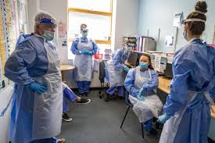
lecturer-Charles Nimoh | BMSW4004
proper care, uk
Tehreem Arshad

Contents
Introduction……………………………………………………………………………….2
Decision Making………………………………………………………………………….2
Problem…………………………………………………………………………………….2
Impact………………………………………………………………………………………2
Pestel Analysis……………………………………………………………………………3
Fishbone Analysis…………………………………………………………………………4
Alternative Solutions………………………………………………………………………5
Evaluation………………………………………………………………………………….6
Action Plan…………………………………………………………………………………6
Conclusion …………………………………………………………………………………7
References………………………………………………………………………………….8

Introduction-
The purpose of this report is to discuss the nature of a problem and make decision based on the strategies used. Problems are a main part of the environment. Problem solving does not begin with a clear structure however problems are rather made known by the environment. It is within human abilities to point out the problem. Problems can be faced in work environments or by as an individual (Kim & Grunig, 2011). A person who can understand the problem at a workplace or personal level and makes a connection to it has a better chance to find a solution.
The act of problem solving comes with creative thinking as mentioned in the article (Cakir, et al., 2021). It depends on the intellectual skills to identify and solve a problem. It is the ability to pick the right choice to solve the problem based on the information received on a particular situation. To be able to solve a problem and decide is the main aspect of solving a problem.
Decision Making-
Decision making consist of more knowledge, thinking, the ability to question, make a suitable plan regards to the problem. A decision can only be made after having all the information on the background of the problem as in what caused it. Decision making requires intellectual skills and elimination of choices that help to solve a problem.
Problem-
This report highlights the problem of staff shortage in Proper Care, UK. Staff shortage can be easily understood as the meaning is very clear. Less number of workers to carry out a task or a job whether it is on day-to-day basis or in a health environment as mentioned by (Iacobucci, 2022). It is the lack of available staff to deliver the quality of care to the patients and relatives. Staff shortage has been seen across globally, within the NHS hospitals and health care sector.
Staff shortage has been reported by NHS England and health providers on a wider scale of more than 100,000 FTE (Macdonald, 2020). Nature of the problem include
- giving wrong medication to patients (Kiekkas, et al., 2009)
- strain of overwork on health care professionals (Hasson & Arnetz, 2008)
- 41,000 vacancies in Nursing (Macdonald, 2020)
- Bursary Removal (Macdonald, 2020)
- High number of female staff (Chur-Hansen, 2022)
- Staffing issues in GP (Loussouarn, et al., 2021)
- Brexit (Macdonald, 2020)
- Geographical areas (SCHANG, et al., 2014)
Although there are many positions available within NHS England problem of staff shortage remains the same. There are many factors contributing to staff shortage. NHS and Health care demands a lot of experience and knowledge.
Impact-
Brexit caused many European nurses to return to their home countries. The government has removed bursary starting courses from August 2017 (Macdonald, 2020) which resulted in extraction of students from Health sector as the students faced financial difficulties.
Staff shortage results in more work pressure, less rest and poor quality of service delivered to patients and their relatives. The impact of staff shortage has been felt across the UK and has become a long-term problem which requires a hypothetical solution.
Shortage of health inspectors (Kmietowicz, 2015) has resulted in poor inspection of machinery and technology used to provide health services.
High number of nurses are female which shows a lot of expectation and strain on female. NHS needs to make this job more welcoming to male society.
Staff shortage has caused a long wait to receive urgent care (Iacobucci, 2021). Patients must wait longer to receive care and some of them pay extra to be seen by a health professional.
Pestel Analysis-
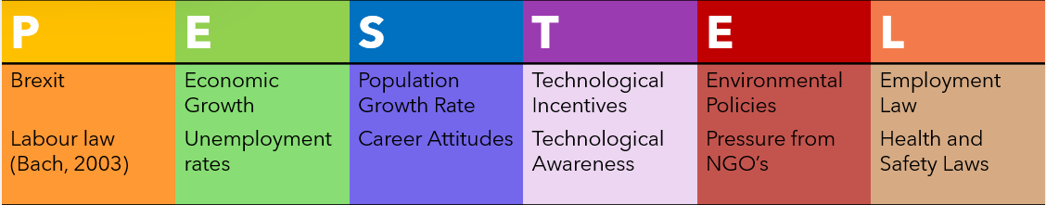
Pestel Analysis was carried out to show how the factors mentioned above contribute to the problem Staff shortage.
Brexit-
According to the article (Macdonald, 2020) after Brexit came into place EU citizens must pay more than UK citizens. The financial cost for both citizens should be covered by the funding provided by the Government. The growing cost of medicine courses and the fact that one must cover it themselves has led to students dropping out. Less student’s enrolment leads to staff shortage.
UK health professionals have showed appreciation for EU medical staff. EU nationals must get the new settlement for UK which is more costly and time consuming. EU nationals have chosen to leave UK which resulted as less staff available to work in health care professions. Brexit has made staff shortage more challenging and difficult, and assurance of job security is very important for EU staff as described in (Iacobucci, 2016). As a result of EU staff leaving the UK, many UK patients have missed out on the treatment.
Labour Law-
Labour law assures the safety bond between employers and the employees. The laws and NHS laws recruitment is same when it comes to recruiting the staff. Employers need to check whether staff has a right to work in UK. It links to Brexit as many EU NHS staff had to leave UK which led to staff shortage.
Economical-
NHS being the strongest organisation there has been an increase on supply and demand for health care facilities. As the cost of machines and medicines is increasing not many people can pay for all the treatment. All the health care staff working under one organisation NHS literally means the staff always must work under someone and many people decided to leave Health care jobs to build their own business which will offer them liability and long-term benefits.
Unemployment rates-
NHS and health sector has faced funding pressures which results in staff leaving as there is less money available to provide treatment. Since unemployed people reap free prescriptions many staff members decide to leave work.
Population growth-
As the number of populations is on rise number of medical staff available to treat in health care is not sufficient. Increase in population demands trained and qualified staff as the number of sick people needing care is bigger than the staff available. Staff has seen pressure on them, and they prefer to work somewhere else rather than health care.
Career Attitudes-
NHS and health care professionals need better career options available for them to keep working in this field. As heath care jobs require longer hours the question of work life balance is always a challenge for staff and thus contributes to staff shortage.
Technological Incentives-
Growing number of technological apps such as the NHS app itself eliminates the need of one-to-one care. Many facilities are available online which clearly means the number of staff needed at workplace is not much of a concern. Staff has been replaced by technology so many health care staff choose to work somewhere else rather than hospitals.
Technological Awareness-
Not many staff members are comfortable using digital technology for example they prefer using pen and paper to document patients’ health however as technology is on rise all the data about patients and medicine is logged electronically which led to staff shortage as many staff members cannot keep up with the digital world.
Environmental policies-
Climate changes demands more health services available, and the staff cannot keep up with the demand. Previously the beginning of Covid-19 put major pressure on health care organisation. Staff had to overwork or even stay in hospitals away from their families to stop the spread of the disease. Such challenges tend to make one leave these health jobs.
Pressure from NGO’S-
NHS and health care has pressure and priorities. To overcome the challenges of Covid-19 the health staff faced longer work hours and less pay which is not a good factor and led to staff leaving health care.
Employment, health, and safety laws-
Although the laws have put in place to assure their job safety and staff safety long working hours have shown a strain on health professionals.
Fishbone Analysis-
A fishbone diagram has been used to see the factors that has led to staff shortage in Proper Care, UK.
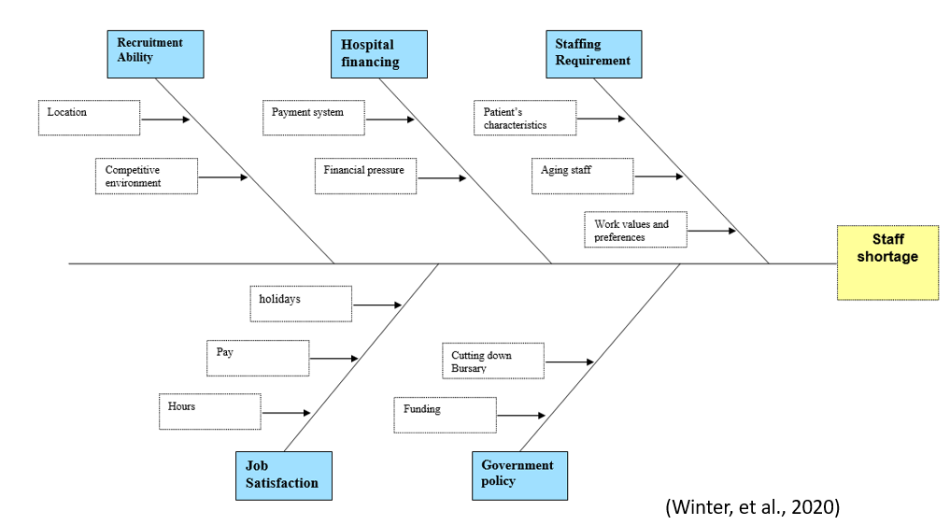

Factors mentioned in the fishbone diagram above lead to staff shortage. The location of the workplace may not suit some staff, health field is very competitive thus many workers choose to divert their career off the health field. Payment plan does not justify the long hours and stress present in this field. Medical students have a lot of financial pressure for them to continue their career in heath field. Patients demands and requirement for work in a health sector has led to staff shortage. There is a lot of work on nurses and given the number of hours required staff do not feel obliged to stick to health care. Nurses retire early, they overwork and losing passion for the profession they feel disheartened which leads to making mistakes and medical errors while on the job. This leads to staff shortage as the staff is tired and do not wish to work in this field.
Cutting down bursary and funding for medical students is one of the main factors of staff shortage. Financial pressure has led to students drop out.
Alternative Solutions-
There is a list of solutions that can benefit increase the number of staff such as
- Recruit more nurses
- Financial support
- Providing tuition fee
- Better career choice
- Pay and reward
- Equality
- Opportunity
- Up to date with technology
- Recruit migrants
By enrolling a higher number of student nurses staff shortage can see a decline. Getting into health profession is very competitive and there is less spaces available.
Government must help with supporting students financially so they can keep learning about health services rather quitting this job and applying somewhere else to meet their needs and demand. Government should also cover any extra tuition fee as health profession is very challenging and students require extra support. By working as a health professional better career options should be made available rather than one staff member to work 12 hours for rest of their life. Moving up the ladder within health field should be made easier by providing funding and decreasing number of hours. Better pay and reward should also be put into place to reduce staff shortages. Reward has always been the highlight of any work field. Better pay and reward always attract more workers and they want to do their best to deliver the services.
All the members of care home or a hospital should be treated equally. Geographical areas discriminate some staff members by paying them less or making them over work. Respect should be carried out in all the field regardless of their age and race.
Opportunity to learn more, earn more and implement knowledge and better understanding and pay could reduce staff shortage.
The Staff should receive training to use technology and made comfortable, so they do not see technology as a threat to leave work.
Recruiting medical staff from abroad should be made easy and providing immigrants with all the work and safety rights and securing their future could reduce staff shortage.
Evaluation-
PMI analysis was carried out to choose out the best solution possible to increase staff.
Solutions | Plus | Minus | Interest
Recruit more staff | More staff | require more institutes and lecturers | Better services
Financial support | More students will enrol | Pressure on Government | Increase in number of staff
Tuition fee | Reduces pressure on students | Pressure on Government | Knowledge will be made easy
Better career | Offer security | Always need to recruit as staff will be moving up | Staff will want to be a part of health field
Pay and reward | Motivation | Staff who do their best might not be chosen | Quality of services will improve

Evaluation
Action Plan-
Action | Description | Time Frame | Staff responsible
Recruit | Get more staff | 20th of August 2022 | Educational management
Finance | Offer funding | 1st of September 2022 | Government
Fee | Offer extra tuition support | per term beginning Jan 2023 onwards | Government
Career | Provides security | 1st of September | Management
Pay and reward | Encouragement | 25th of August | Head of the department

The success solution is pay and reward as it will make all the staff to strive for reward and everyone will do their best to achieve reward. To seek the reward and acknowledgement staff will not only work hard also deliver best service to patients.
Conclusion-
The best solution that will encourage staff to do their best is pay and reward as all the staff will do their best to get the best pay and reward and it will result in better service delivered in any health care field.

References
Cakir, R., Korkmaz, O., Idil, O. & Ugur Erdogmus, F., 2021. The effect of robotic coding education on preschoolers’ problem solving and creative thinking skills. Thinking skills and creativity, Volume 40, p. 100812.
Chur-Hansen, A., 2022. Preferences for female and male nurses: the role of age, gender and previous experience – year 2000 compared with 1984. Journal of advanced nursing, 37(2), pp. 192-198.
Hasson , H. & Arnetz, J. E., 2008. Nursing staff competence, work strain, stress and satisfaction in elderly care: a comparison of home-based care and nursing homes. Journal of clinical nursing, 17(4), pp. 468-481.
Iacobucci, G., 2016. Brexit could worsen NHS staff shortages, doctors warn. BMJ (Online), Volume 353, pp. i3604-i3604.
Iacobucci, . G., 2021. Long waits for NHS treatment are forcing patients to go private, warns Labour. BMJ (Online), Volume 374, pp. n2392-n2392.
Iacobucci, G., 2022. Covid-19: NHS trusts declare “critical incidents” because of staff shortages. BMJ (Online), Volume 376, pp. o3-o3.
Kiekkas, P., Aretha, D., Karga, M. & Karanikolas, M., 2009. Self report may lead to underestimation of wrong dose medication errors. British journal of clinical pharmacology, 68(6), pp. 963-964.
Kim, J.-N. & Grunig, J. E., 2011. Problem Solving and Communicative Action: A Situational Theory of Problem Solving. Journal of communication, 61(1), pp. 120-149.
Kmietowicz, Z., 2015. Staff shortages and lack of data continue to blight England’s NHS and care regulator. BMJ (Online), Volume 351, pp. 4000-h4000.
Loussouarn, C., Franc, C., Videau, Y. & Mousquès, J., 2021. Can General Practitioners Be More Productive? The Impact of Teamwork and Cooperation with Nurses on GP Activities. Health economics, 30(3), pp. 680-698.
Macdonald, M., 2020. The health and social care workforce gap. [Online]
Available at: https://commonslibrary.parliament.uk/the-health-and-social-care-workforce-gap/#:~:text=Providers%20across%20NHS%20England%20are%20reporting%20a%20shortage,retention%20challenges%2C%20with%20an%20estimated%20122%2C000%20FTE%20vacancies.
[Accessed Thursday August 2022].
SCHANG, L., MORTON, A., DASILVA, P. & BEVAN, . G., 2014. From data to decisions? Exploring how healthcare payers respond to the NHS Atlas of Variation in Healthcare in England: Geographic Variation in Health Care - 40 Years of Small-Area Variation. Health policy (Amsterdam), 114(1), pp. 79-87.

