Directory
Abstract 1
1.Normalised 1
2.Database Creation 2
Tables Creation 2
Foreign keys constraints 4
Check constraints 5
Populate datas 6
Membership_type 6
Member 6
Class type 7
instructor 8
Instructor qualifications 9
Member staff 9
rooms 10
Implementation 11
（1）update member status 11
（2） class booking 12
(3) close a class 17
Transaction 20
3. Performance Tuning Enhancement 21
Indexes 21
Evaluation of Design and Implementation 22
4.Several important concepts are related 22
Rollback 22
Indexing 22
Triggers 23
Transactions 23
Functions 24
Commit 24
Procedures 24
References 24

Abstract

In this paper, the ERD design and database implementation of ALC business requirements are completed. The design part forms the conceptual design of the database through the requirement analysis, and clarifies the attributes of each entity and the relationship between different entities. And it's shown through the ERD.The implementation part completes the business scenario by creating tables, populate data into tables and create procedures, functions and triggers. The data rollback and commit are simulated by transaction. And using index to improve database performance.1. Entity Relationship Diagram.

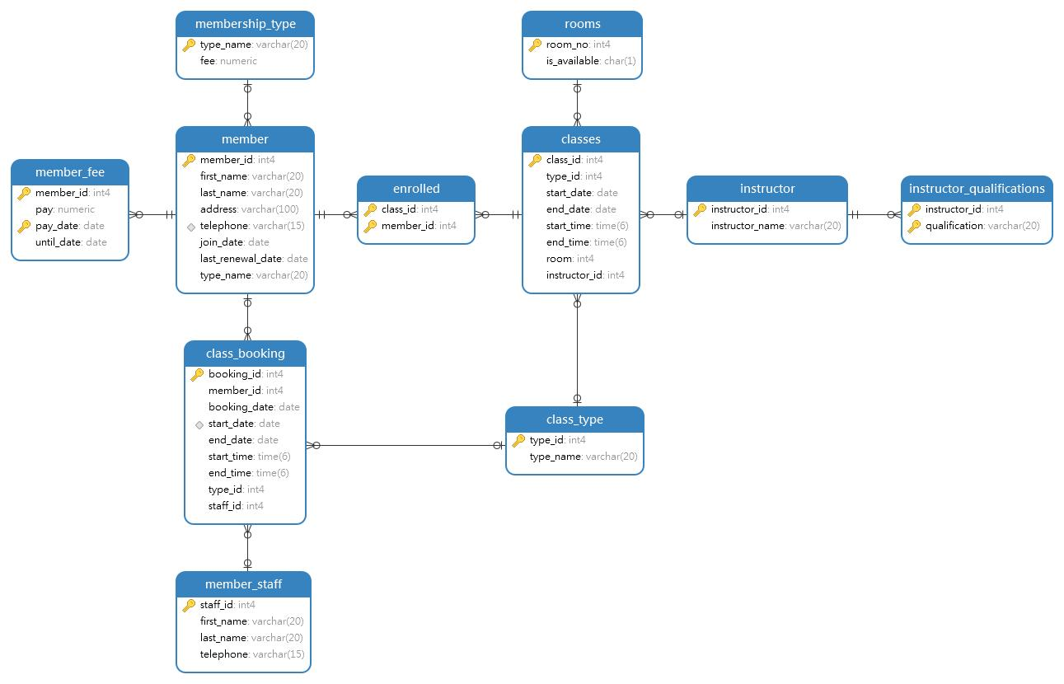

1.Normalised
membership_type (type_name,fee)

member (member_id,first_name,last_name,address,telephone,join_date,last_renewal_date,type_name)

member_fee (member_id,pay,pay_date,until_date)

class_type (type_id,type_name)

instructor (instructor_id,instructor_name)

instructor_qualifications (instructor_id,qualification)

member_staff (staff_id,first_name,last_name,telephone)

class_booking (booking_id,member_id,booking_date,start_date,end_date,start_time,end_time,type_id,staff_id)

classes (class_id,type_id,start_date,end_date,start_time,end_time,room,instructor_id)

enrolled (class_id,member_id)

rooms (room_no,is_available)

2.Database Creation
Create table alc;

Tables Creation
create table membership_type(
type_name varchar(20) primary key,
fee numeric
);

create table member(
member_id int primary key,
first_name varchar(20) not null,
last_name varchar(20) not null,
address varchar(100),
telephone varchar(15),
join_date date,
last_renewal_date date,
type_name varchar(20)
);

create table member_fee(
member_id int,
pay numeric,
pay_date date,
until_date date,
primary key (member_id, pay_date)
);

create table class_type(
type_id int primary key,
type_name varchar(20) not null
);

create table instructor(
instructor_id int primary key,
instructor_name varchar(20) not null
);

create table instructor_qualifications(
instructor_id int,
qualification varchar(20),
primary key (instructor_id,qualification)
);

create table member_staff(
staff_id int primary key,
first_name varchar(20) not null,
last_name varchar(20) not null,
telephone varchar(15)
);

create table class_booking(
booking_id int primary key,
member_id int,
booking_date date,
start_date date,
end_date date,
start_time time,
end_time time,
type_id int,
staff_id int
);

create table classes(
class_id int primary key,
type_id int,
start_date date,
end_date date,
start_time time,
end_time time,
room int,
instructor_id int
);

create table enrolled(
class_id int,
member_id int,
primary key (class_id,member_id)
);

create table rooms(
room_no int primary key,
is_available char(1)
);

Foreign keys constraints

alter table member add constraint fk_member_type foreign key (type_name) references membership_type(type_name);

alter table member_fee add constraint fk_memberfee_id foreign key (member_id) references member(member_id);

alter table classes add constraint fk_classes_type foreign key (type_id) references class_type(type_id);

alter table instructor_qualifications add constraint fk_instid foreign key (instructor_id) references instructor(instructor_id);

alter table class_booking add constraint fk_book_mem foreign key (member_id) references member(member_id);
alter table class_booking add constraint fk_book_staff foreign key (staff_id) references member_staff(staff_id);
alter table class_booking add constraint fk_book_type foreign key (type_id) references class_type(type_id);

alter table classes add constraint fk_class_room foreign key (room) references rooms(room_no);
alter table classes add constraint fk_class_instruct foreign key (instructor_id) references instructor(instructor_id);

alter table enrolled add constraint fk_enroll_class foreign key (class_id) references classes(class_id);
alter table enrolled add constraint fk_enroll_member foreign key (member_id) references member(member_id);

Check constraints

-- check constraint
-- check constraint: telephone
alter table member add constraint chk_telephone check (telephone ~'^(\d*)$');
-- check constraint: fee
alter table member_fee add constraint chk_member_fee check (pay in (550,800,1200));

-- check constraint: booking start date must later than booking date
alter table class_booking add constraint chk_start_date check (start_date >= booking_date);

-- check constraint: room's avaiable is True or False
alter table rooms add constraint chk_ava check(is_available in ('T','F'));

Populate datas

Membership_type
create or replace procedure insert_membership(membership varchar(20), fee numeric)
language plpgsql
as $$
begin
insert into membership_type values (membership, fee);
commit;
end;
$$;

truncate membership_type cascade;
call insert_membership('Week Day',550);
call insert_membership('Weekend',800);
call insert_membership('All week',1200);

select * from membership_type;
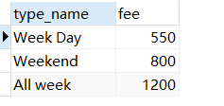

Member
create or replace procedure insert_member(first_name varchar(20), last_name varchar(20),address varchar(100),telephone varchar(15), join_date date)
language plpgsql
as $$
declare
member_next int;
begin
select case when max(member_id) is null then 1 else max(member_id)+1 end into member_next
from member;
insert into member(member_id,first_name, last_name,address, telephone, join_date) values (member_next,first_name, last_name, address, telephone, join_date);
commit;
end;
$$;

call insert_member('Lucy','Chan','12 Gower Street, London WC1E 6BT', '123456789',current_date );
call insert_member('John','Biden', '452 Appletree Avenue, Maidenstone, Kent MA6 3TY','7852369544',current_date );
call insert_member('Donald','Trump','55 Gerrard Street, London, EC5U 2HV', '74896317',current_date );
call insert_member('Ross','Spike','12 Gower Street, London WC1E 6BT', '15342344234',current_date );
call insert_member('Linsay','Doll','452 Appletree Avenue, Maidenstone, Kent MA6 3TY','31231221',current_date );
call insert_member('Mike','Doll','452 Appletree Avenue, Maidenstone, Kent MA6 3TY','31212323',current_date );

select * from member;

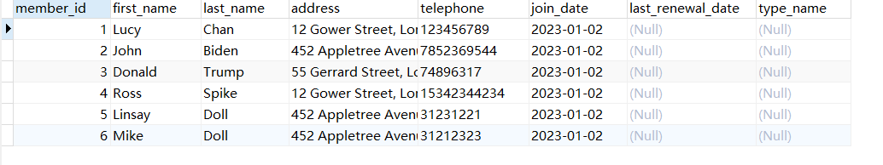

Class type
drop procedure if exists insert_class_type;
create or replace procedure insert_class_type (typeid int, type_name varchar(20))
language plpgsql
as $$
begin
insert into class_type values (typeid, type_name);
commit;
end;
$$;

truncate class_type cascade;
call insert_class_type(1,'Squash');
call insert_class_type(2,'Tennis');
call insert_class_type(3,'5 a Side Football');
call insert_class_type(4,'Badminton');
call insert_class_type(5,'Netball');

select * from class_type;

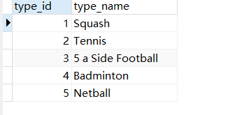

instructor
drop procedure if exists insert_instructor;
create or replace procedure insert_instructor(insid int, insname varchar(20))
language plpgsql
as $$
begin
insert into instructor values (insid, insname);
commit;
end;
$$;
truncate instructor cascade;
call insert_instructor(1,'John Elliot');
call insert_instructor (2,'Paula Joyce');
call insert_instructor (3,'Ethan Jacobson');
call insert_instructor (4,'John Jacobson');
call insert_instructor (5,'Tuner Jacobson');

select * from instructor;
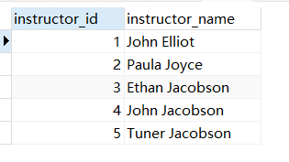

Instructor qualifications
drop procedure if exists insert_instructor_quali;
create or replace procedure insert_instructor_quali(insid int, qualification varchar(20))
language plpgsql
as $$
begin
insert into instructor_qualifications values (insid, qualification);
commit;
end;
$$;
truncate instructor_qualifications cascade;
call insert_instructor_quali(1,'Squash');
call insert_instructor_quali(2,'Tennis');
call insert_instructor_quali(3,'5 a Side Football');
call insert_instructor_quali(4,'Badminton');
call insert_instructor_quali(5,'Netball');

select * from instructor_qualifications;

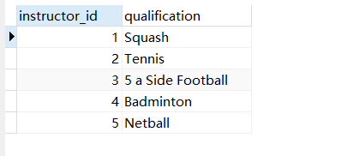

Member staff
drop procedure if exists insert_member_staff;
create or replace procedure insert_member_staff(sid int, firstname varchar(20), lastname varchar(20), telephone varchar(15))
language plpgsql
as $$
begin
insert into member_staff values (sid, firstname, lastname, telephone);
commit;
end;
$$;
truncate member_staff cascade;
call insert_member_staff(1,'Abraham','Lincoln','1452365');
call insert_member_staff(2,'Scottie','Wallen','14554355');
call insert_member_staff(3,'Perry','Gore','1452376');

select * from member_staff;

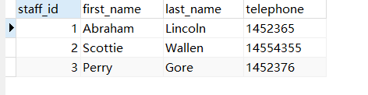

rooms
drop procedure if exists insert_rooms;
create or replace procedure insert_rooms(rno int, is_avail char(1))
language plpgsql
as $$
begin
insert into rooms values(rno, is_avail);
commit;
end;
$$;
truncate rooms cascade;
call insert_rooms(1,'T');
call insert_rooms(2,'T');
call insert_rooms(3,'T');
call insert_rooms(4,'T');
call insert_rooms(5,'T');
call insert_rooms(6,'T');

select * from rooms;

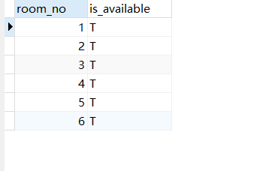

Implementation

（1）update member status
Function Description: When a member pays the fee, the member status will be updated automatically. The membership expiration date is one year after the start date. (1) Trigger and function：
drop trigger if exists update_member_type on member_fee;
drop function if exists update_member_type;

create or replace function update_member_type()
returns trigger
language plpgsql
as $$
declare
typename varchar(20);
begin
select distinct type_name into typename from membership_type where fee=new.pay;
update member set type_name=typename where member_id=new.member_id;
update member set last_renewal_date=current_date;
return new;
commit;
end;
$$;

create trigger update_member_type after insert on member_fee
for each row execute procedure update_member_type();

(2) Procedure：
create or replace procedure insert_member_fee (firstname varchar(20), lastname varchar(20), pay numeric, pay_date date)
language plpgsql
as $$
declare
memberid int;
begin
select member_id into memberid from member where first_name=firstname and last_name=lastname;
if not found then
raise exception 'Invalid member %',firstname ||' '|| lastname;
rollback;
end if;
if pay_date is null then
pay_date:=current_date ;
end if;
insert into member_fee values(memberid, pay, pay_date, (pay_date:: timestamp + '12 month')::date);
commit;
end;
$$;

(3) test record:
truncate member_fee;

call insert_member_fee ('Lucy','Chan',550,null);
call insert_member_fee ('John','Biden',800,'2022-12-31');
call insert_member_fee ('Donald','Trump',1200,null);
call insert_member_fee ('Ross','Spike',1200,null);
call insert_member_fee ('Linsay','Doll',1200,null);
call insert_member_fee ('Mike','Doll',1200,null);

select * from member_fee;
select * from member;
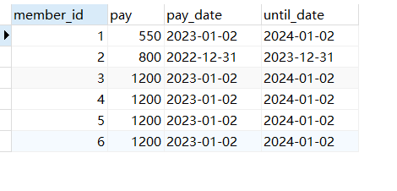

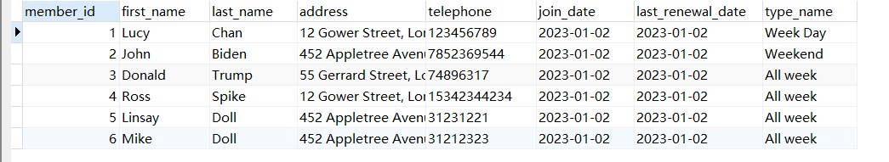

（2） class booking
Realize that when a member books a course, it will automatically detect the number of reserved members of the same class type at the same time, automatically form a class when the number of reserved members reaches 6, automatically select optional room and instructor, and associate a member with the class.

(1) Trigger and function：
create or replace function viable_classes()
returns trigger
language plpgsql
as $$
declare
book_no int;
class_next int;
rno int;
instructorid int;
typeName varchar(20);
classid int:=0;
rec class_booking;
begin
select count(booking_id) into book_no from class_booking
where type_id=new.type_id
and start_date=new.start_date
and end_date=new.end_date
and start_time=new.start_time
and end_time=new.end_time;

select room_no into rno from rooms where is_available='T' limit 1;
if not found then
-- rno:=(select room_no from rooms limit 1);
raise notice 'rollback, There is no empty room';
return new;
rollback;
end if;
select type_name into typeName from class_type where type_id=new.type_id;

select instructor_id into instructorid
from instructor_qualifications where qualification =typeName limit 1;

select case when max(class_id) is null then 1 else max(class_id)+1 end into class_next from classes;
select class_id into classid from classes where type_id=new.type_id and start_date=new.start_date and end_date=new.end_date and start_time=new.start_time and end_time=new.end_time;
if not found then
classid:=0;
end if;
if book_no<6 then
raise notice 'rollback, not enough 6';
return new;
rollback;
end if;

if classid=0 and book_no >=6 then
insert into classes values (class_next,new.type_id, new.start_date, new.end_date, new.start_time, new.end_time, rno,instructorid);
update rooms set is_available='F' where room_no=rno;

for rec in select * from class_booking where type_id=new.type_id and start_date=new.start_date and end_date=new.end_date and start_time=new.start_time and end_time=new.end_time
loop
insert into enrolled values (class_next, rec.member_id);
end loop;
end if;

return new;
commit;
end;
$$;

create trigger check_booking after insert on class_booking
for each row execute procedure viable_classes();

(2) procedure:
create or replace procedure insert_class_booking(firstname varchar(20), lastname varchar(20), startdate date, enddate date, starttime time, endtime time, classtype varchar(20),
staffname varchar(40))
language plpgsql
as $$
declare
memberid int;
typeid int;
staffid int;
booking_next int;

begin
select member_id into memberid from member where first_name=firstname and last_name=lastname;
if not found then
rollback ;
end if;

select type_id into typeid from class_type where type_name=classtype;
if not found then
rollback ;
end if;

select staff_id into staffid from member_staff where first_name||' '||last_name=staffname;
if not found then
rollback ;
end if;

select case when max(booking_id) is null then 1 else max(booking_id)+1 end into booking_next
from class_booking;

insert into class_booking values (booking_next, memberid, current_date ,startdate, enddate, starttime, endtime, typeid, staffid);

commit;
end;
$$;

(3) load data and test record:
truncate class_booking;
truncate classes cascade;

call insert_class_booking('Lucy','Chan','2023-01-05','2023-01-17','10:00:00.000','18:00:00.000','Squash','Abraham Lincoln');
call insert_class_booking('John','Biden','2023-01-05','2023-01-17','10:00:00','18:00:00','Squash','Abraham Lincoln');
call insert_class_booking('Donald','Trump','2023-01-05','2023-01-17','10:00:00','18:00:00','Squash','Abraham Lincoln');
call insert_class_booking('Ross','Spike','2023-01-05','2023-01-17','10:00:00','18:00:00','Squash','Abraham Lincoln');
call insert_class_booking('Linsay','Doll','2023-01-05','2023-01-17','10:00:00','18:00:00','Squash','Abraham Lincoln');
call insert_class_booking('Mike','Doll','2023-01-05','2023-01-17','10:00:00','18:00:00','Squash','Abraham Lincoln');

select * from class_booking;
select * from classes;
select * from rooms;
select * from enrolled;

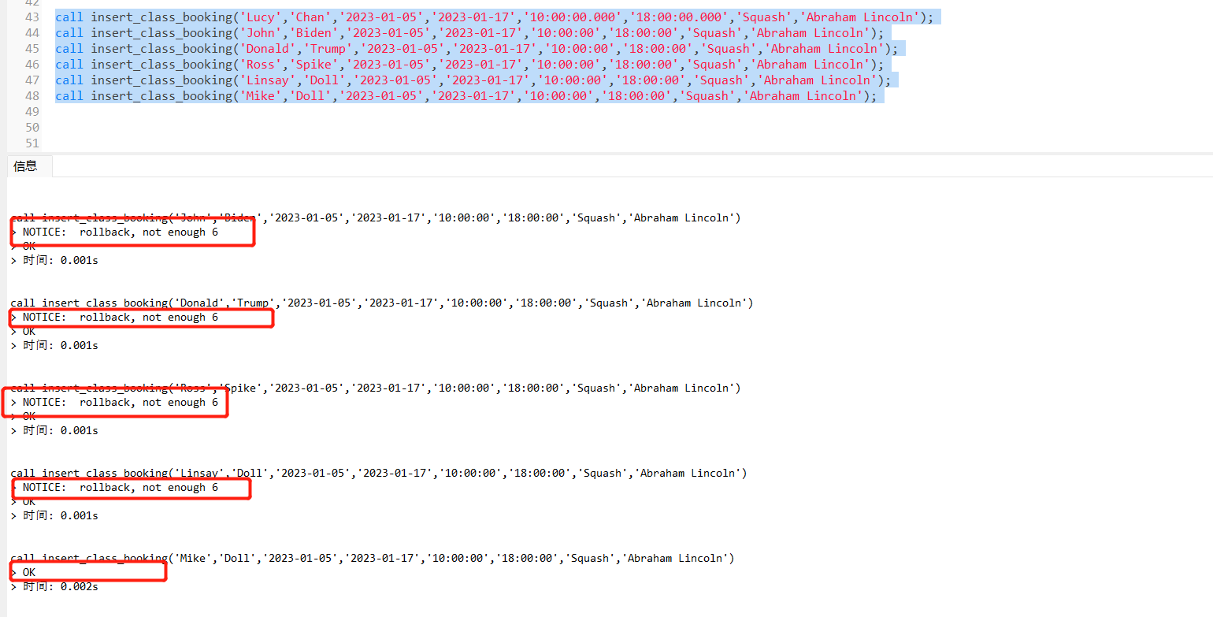

By executing the class booking procedure, information about the composition of the class and enrolls is automatically triggered when loading Article 6 data. In addition, the instructor and room are selected for this class, and the status of the selected room is changed to False (indicating that it is not reserved).
The following is the test result:

Class_booking: You can see that the table contains six pieces of data that uses the stored procedure populate
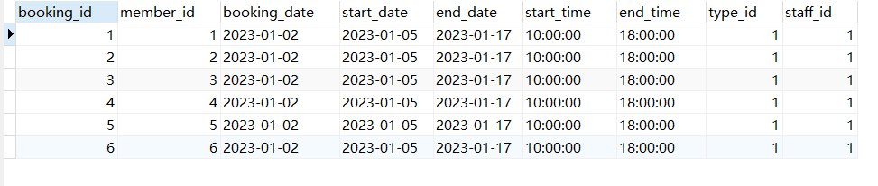

Class table: You can see that the above six members make up a class:

Room table: It can be seen that the room no selected by the class is 1, and the available state of this room is F
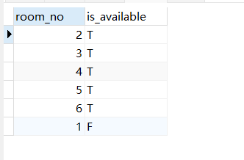
enrolled table: The enrolled table contains information about class 1 and member_id 1-6
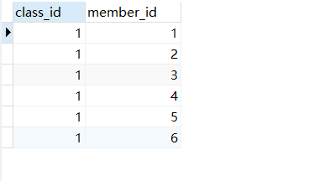

(3) close a class
Function: When the class is finished, delete the class from the database, set the room status to available, and automatically delete the enrolls information and booking information. (1) Trigger and function：

-- when a class is finished, then delete the class and update the room's status

create or replace function close_class()
returns trigger
language plpgsql
as $$
begin
update rooms set is_available='T' where room_no=old.room;
return old;
commit;
end;
$$;

create trigger after_delete_classes after delete on classes
for each row execute procedure close_class();

-- when a class is finished, then delete the class enrolled and class booking.

create or replace function close_enrolls()
returns trigger
language plpgsql
as $$
begin
delete from enrolled where class_id=old.class_id;
delete from class_booking where start_date=old.start_date and end_date=old.end_date and start_time=old.start_time and end_time=old.end_time;
return old;
commit;
end;
$$;

create trigger before_delete_classes before delete on classes
for each row execute procedure close_enrolls();

（2） procedure:

create or replace procedure delete_classes(classid int)
language plpgsql
as $$
begin
delete from classes where class_id=classid;
commit;
end;
$$;

(3) test
call delete_classes(1);

select * from classes;

select * from enrolled;

select * from rooms;

select * from class_booking;

Class table: You can see that after close class, the previous class information has been deleted:
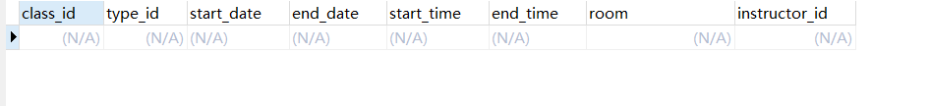
enrolled table: The class and member information in the enrolled table has been deleted
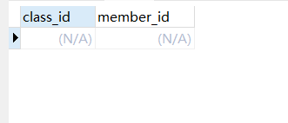
Room table: It can be seen that the room no selected by the class before is 1, and the available state of this room has been changed to T
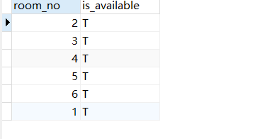
Class_booking: You can see that the booked course information in this table has been deleted
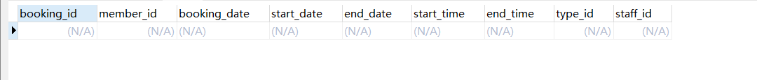

Transaction

Rollback scenario： a new member Jack Chan want to add, assuming the memberid is 10, when the staff helping him pay the fee, he just regret, so the member need to cancel.

start transaction;

insert into member(member_id,first_name, last_name,address, telephone, join_date)
values(10,'Jack','Chan','12 Gower Street, London WC1E 6BT', '123456789',current_date);

insert into member_fee values(10, 550, current_date, (current_date:: timestamp + '12 month')::date);

update member set type_name='Week Day' where member_id=10;
rollback ;

select * from member;
select * from member_fee;
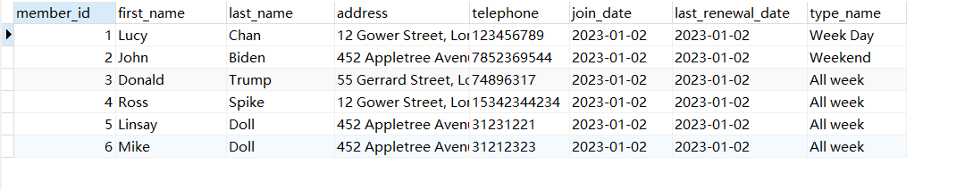
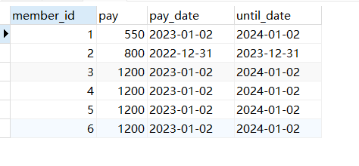
Submission scenario: a new member Jack Chan just returns and the staff continues handle his membership.

start transaction;

insert into member(member_id,first_name, last_name,address, telephone, join_date)
values(10,'Jack','Chan','12 Gower Street, London WC1E 6BT', '123456789',current_date);

insert into member_fee values(10, 550, current_date, (current_date:: timestamp + '12 month')::date);

update member set type_name='Week Day' where member_id=10;
commit;

select * from member;

select * from member_fee;

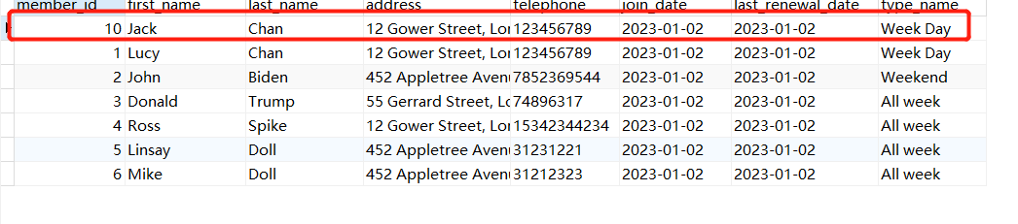

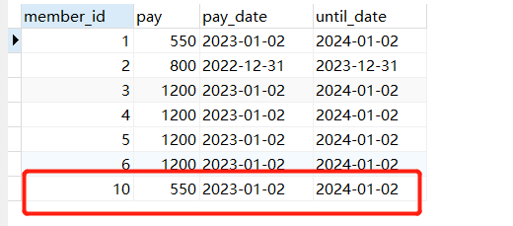

3. Performance Tuning Enhancement

Indexes
-- Create a secondary index on the payment date of the member, because in the ALC scenario, the start date of the member needs to be looked at frequently to determine the status of the member
create index idx_paydate on member_fee(pay_date);

-- Create a secondary index on start_date of class_booking. This field is often used as a query condition because reservations that match a class are often grouped into a class
create index idx_startdata on class_booking (start_date);

-- Create a secondary index on the contact phone number of the member table. In this business scenario, the member status needs to be confirmed according to the phone information. Creating an index by telephone can speed up the query
create index idx_phone on member(telephone);

Evaluation of Design and Implementation
The ERD in this design has been standardized. In order to meet the requirements of class opening for business scenarios, more than 6 members must be booked. Therefore, the class table and class_booking table designed in this design have similar table structures for this scenario. In addition, trigger audit the booking information is used for this scenario. when it meets the requirements, the booking class information is automatically grouped into class information.
The database design of ALC in this design can be used in multi-user scenarios. When deploying a database, you should specify that the isolation level of the database is at least repeatable read, which ensures that the database does not suffer from dirty reads and lost updates. If the performance requirement is not very high, use the serialized isolation level whenever possible. Using the serialized isolation level avoids phantom reads and ensures data consistency requirements.

4.Several important concepts are related

Rollback
A transaction usually begins with a BEGIN TRANSACCTION and ends with a COMMIT or ROLLBACK. COMMIT Commits all the operations of the transaction. Specifically, the hard disk will contain data from the updated database that has been rewritten, and the transaction ends normally. ROLLBACK Indicates a rollback. That is, if a transaction fails during running, all operations in the database are cancelled by the system and the transaction is rolled back to its original stateThe operation here refers to an update to the database^{[1]}.

Indexing
If you think of a table as a book, an index is like a table of contents or a bookmark in a book. It can help you quickly find the content you want to search, so it is called an index. Indexes are used to quickly find records with specific values. All MySQL indexes are kept as B-trees. Such as If there is no index, MySQL must scan the entire table from the first record until it finds a match when executing the query.The required records. The more records there are in the table, the more expensive this operation becomes. If the search criteria are already on the column.By creating an index, MySQL quickly knows the location of the target record without scanning any records. If the table has 1000.Records. Finding records by index is at least 100 times faster than scanning them sequentially^{[2]}.

Triggers
A trigger is a special stored procedure that is triggered by an event.Live it out. The purpose of triggers is to enforce data integrity and enforce business rules.Triggers are queried from DBA_TRIGGERS, USER_TRIGGERS data dictionary.A nice Triggers can disable or roll back irregular changes, thus canceling attempts to modify data.What do you mean, for example, explain, arcade games we have played it, through a pass, through the next level, there is a pass not through from the first level. The trigger is similar to this.Here's the official explanation:The trigger is considered part of a single transaction, so the transaction can be restored by the original trigger, and the entire transaction will be restored automatically if a serious error (such as a user disconnection) is detected during the transaction.His role is obvious, and he can take care of the integrity of the data^{[3]}.

Transactions
A transaction is a single unit of work. If the transaction is successful, all the information modified during the transaction is identified and becomes permanent in the database. If a transaction is found to be incorrect and must be cancelled or replied to, all modifications will be cleared. Transact-SQL explicit or implied transactions initiated under a MARS session become batch range transactions. Batch range transactions that are not automatically replied to by SQL Server when a batch is completed are not recognized or replied to^{[4]}.

Functions
In SQL, there are several basic function types and types. The basic types of functions are:
1.Aggregate function: The Aggregate function operates on a list of values and returns a single value.
2.Scalar function : The operation of the Scalar function is oriented towards a single value and returns a single value based on the input value.

Commit
When you write an SQL statement, click Execute and see the data change, or change, but the data does not change. If you want to change the data in the database, you must add a commit statement at the end of the SQL statement^{[5]}.

Procedures
A stored procedure is one or more SQL commands stored in a database as executable objects.In plain English, a stored procedure is simply a set of SQL statements that accomplish certain operations. Compilation of the stored procedure occurs at creation time and does not require recompilation each time it is executed. In contrast, the SQL statement is recompiled every time it is executed Therefore, using stored procedures can improve the database execution speed.When a complex operation is performed on the database, this complex operation can be encapsulated in a stored procedure and used in conjunction with the transaction provided by the database.Stored procedures can be reused, reducing the workload of database developers.High security, you can set that only certain users have access to specified stored procedures^{[6]}.

References
[1] Su Bo. Research on Database Construction, Management and Maintenance Strategy Based on SQL Language [J]. Information and Communication, 20, 33(8):186-187.
[2] Yang Junli. Construction of SQL Database and Its Security Management and Maintenance [J]. Microcomputer Applications, 2018,34 (6):71-73.
[3] ZHANG Jingbo. Construction of SQL Database and Analysis of Security Maintenance Methods [J]. Heilongjiang Science and Technology, 2017(6):196.
[4] Wu Wanjun. Research on the Construction and Security maintenance of SQL database [J].
Digital Technology and Application, 2016(3):210.
[5] He Wencai. Research on SQLite Database Encryption based on Android platform. Computer applications and software (in Chinese),2019(10):310-315,333.
[6] ZHANG Jie, YUAN Litian. Discussion on database in SQL Server database application program.Security [J]. Digital Technology and Application. 2017(08):203-205.

