

Programme: Master of Business Administration

Module: International Marketing: Principles and Practices
Module code: LCMB7026

Assignment Title: Assessment component 1
Individual report

Topic: International Market Entry Strategy and Marketing Mix of Adidas in Japan and the UK

Lecture name: Tushara Balendran
Name: Abhishekkumar Pethani
Student ID: 2525424

Table of Contents
Section 1: Report on the International Market Entry Strategy and Marketing Mix 3
1.1 Introduction 3
1.2 Company Background 3
1.3 A Comparative Analysis of the Market in Japan and the UK: PESTLE Application 3
Political 3
Economic 4
Social 5
Comparative Hofstede Cultural Analysis (6 Dimensions) 5
Advantages and Disadvantages of the Hofstede Model 6
Technological 6
Legal 7
Environmental 7
Similarities and Differences of the PESTLE Analysis 8
1.4 A Comparative Analysis of STP and Marketing Mix 8
1.4.1 STP Analysis 8
1.4.2 Marketing Mix (7Ps) 10
Similarities and Differences of the 7Ps 18
1.5 An Analysis of the Brand's Market Entry Strategy in the UK 18
1.6 Ethical Issues Related to the Brand's Marketing Mix in Japan 19
1.7 Strategic Recommendations: STP Evolution 19
1.8 Conclusion 20
Section 2: Gibbs' Reflective Cycle 21
2.1 Gibbs' Reflective Cycle: Definition 21
2.2 Description: The Research Task 21
2.3 Feelings 22
2.4 Evaluation: Strengths and Weaknesses 22
2.5 Analysis: What the Three Methods Taught Me 22
2.6 Conclusion 23
2.7 Overall Skills Gained 23
2.8 Action Plan 23
Reference List 24

Section 1: Report on the International Market Entry Strategy and Marketing Mix

1.1 Introduction
This report examines the international marketing strategy of Adidas, comparing its approach in the United Kingdom (Country A) and Japan (Country B). It applies PESTLE analysis and Hofstede's cultural dimensions to the macro-environment, compares Segmentation, Targeting and Positioning (STP) and the extended 7Ps marketing mix, evaluates Adidas' UK market entry method, discusses ethical issues in Japan, and closes with country-specific recommendations for evolving the STP strategy. The analysis draws on secondary sources — academic literature, company disclosures and market-research data — and uses established international-marketing frameworks throughout so that findings for the two markets can be compared on a like-for-like basis.

1.2 Company Background
Adidas, founded in Germany in 1949 by Adolf Dassler, is one of the world's leading sportswear and lifestyle brands, built on innovation, performance and strong brand equity. It entered Japan in 1970 through local distribution operations. Adidas pursues an integrated international strategy, adapting products and marketing to local markets: the UK is a mature, competitive sportswear market with informed, sustainability- and fashion-conscious consumers, while Japan is a highly developed market where quality, technological precision and brand image drive consumer choice, alongside strong cultural expectations around retail service and design (de Mooij and Hofstede, 2010). These contrasts, individualistic and trend-led in the UK versus quality- and relationship-oriented in Japan, provide a strong basis for analysing international marketing adaptation. Globally, Adidas employs around 60,000–65,000 people and operates a portfolio spanning footwear, apparel, accessories and licensed categories (fourweekmba.com, 2026), giving it the scale to run parallel, locally adapted strategies in both markets without losing overall brand coherence. Adidas' vision is to be the world's leading sports brand, and its purpose statement is "Through sport, we have the power to change lives."

1.3 A Comparative Analysis of the Market in Japan and the UK: PESTLE Application

Political
UK: The political climate is stable with clear, well-established trade law (Davies et al., 2021). Post-Brexit customs requirements have added complexity, but government support for innovation, sustainability and digital trade creates opportunity.
Japan: Japan's political and economic institutions are stable with minimal corruption (Calder, 2021), and government policy actively welcomes foreign investment and innovation.
Comparative evaluation: Both markets are politically low-risk with sound legal systems, but the UK faces more regulatory change post-Brexit while Japan offers longer-term policy stability, meaning Adidas' UK political-risk planning must be more adaptive year-to-year than its Japan planning.

Economic
UK: The UK offers high purchasing power and a developed retail sector. Despite inflation reaching 9% (Race, 2022), demand for premium sportswear has remained strong, aided by digital and omnichannel retailing.
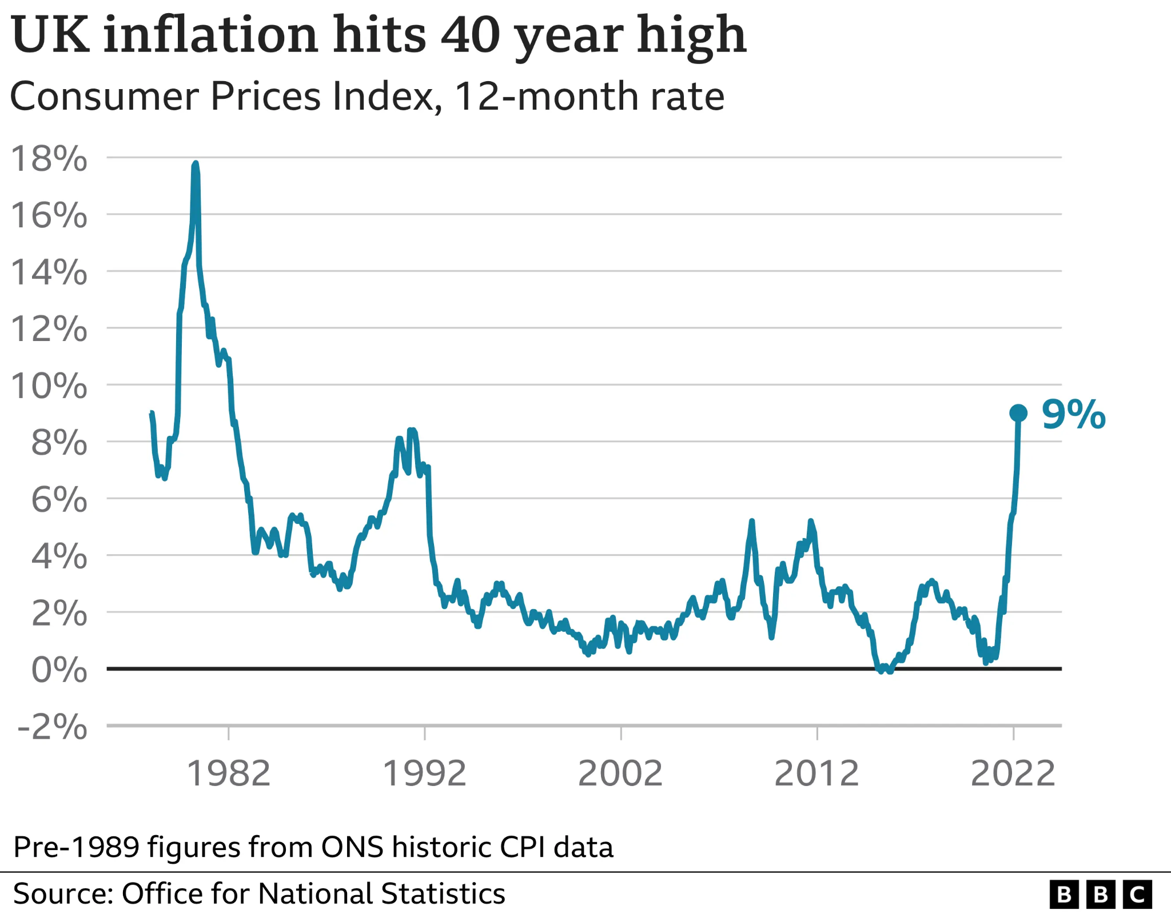
Figure 1: Rising inflation in the UK
Source: Race, 2022
Japan: Japan remains one of the largest global economies, with GDP growth of around 4% (McVey et al., 2026); despite broader economic headwinds, consumers continue to pay for quality foreign brands.
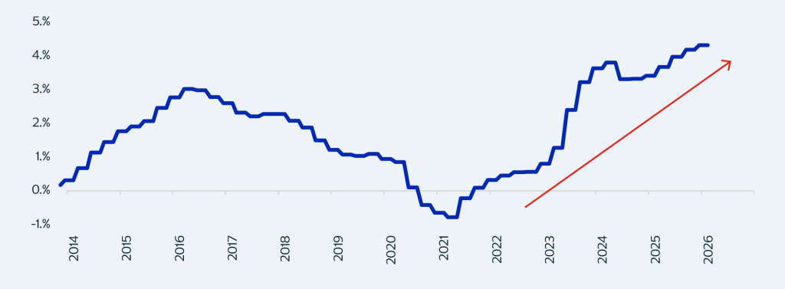
Figure 2: Japan GDP growth
Source: McVey et al., 2026
Comparative evaluation: Both economies support Adidas' premium pricing, but UK demand is more sensitive to economic downturns than Japan's.

Social
UK: The UK is culturally diverse with high sport participation (Godfrey et al., 2020); younger consumers prioritise sustainability, trends and digital engagement.
Japan: Brand image, precision and functionality are central to Japanese consumers, and sportswear is closely tied to lifestyle and social identity (Sueda and Seo, 2024), producing strong brand loyalty once trust is earned.
Comparative evaluation: Interest in active lifestyles is high in both markets, but UK consumers prioritise individuality and sustainability while Japanese consumers prioritise quality, reliability and trust.

Comparative Hofstede Cultural Analysis (6 Dimensions)
Hofstede's model compares national culture across six dimensions (theculturefactor.com, 2026):
- Power Distance: Japan scores higher (54) than the UK (35), reflecting greater acceptance of hierarchy in Japanese organisations.
- Individualism: The UK (76) is markedly more individualist than Japan (62), favouring personal achievement, self-expression and distinctive style.
- Motivation Towards Success (Masculinity): Japan scores very highly (95) versus the UK (66); Japanese consumers value excellence, discipline and continuous improvement, aligning well with Adidas' performance-innovation positioning.
- Uncertainty Avoidance: Japan is very high (92) against the UK's low score (35), meaning detailed product information and consistent service quality matter far more to Japanese buyers.
- Long-Term Orientation: Japan scores near the maximum (100) versus the UK's 60, reflecting a preference for perseverance and long-term brand relationships over the UK's relatively more short/medium-term outlook.
- Indulgence: The UK (69) is notably more indulgent than Japan (42), indicating a stronger UK emphasis on leisure and self-reward.
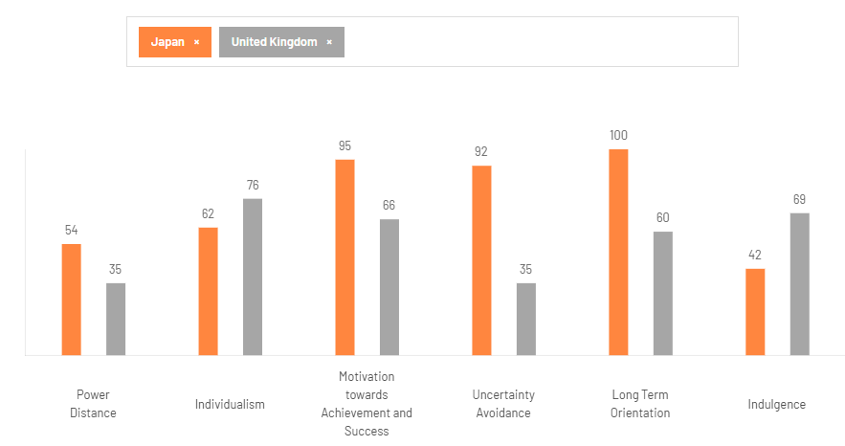
Figure 3: Hofstede country comparison, Japan vs UK
Source: theculturefactor.com, 2026

Advantages and Disadvantages of the Hofstede Model
The model's strengths are its broad country coverage, quantifiable scores that support cross-market comparison, and wide adoption in international marketing planning, making it useful here for anticipating how UK and Japanese consumers might respond differently to the same campaign. Its limitations include treating national cultures as homogeneous when real consumers vary considerably by age, region and subculture; data that is now decades old and may understate generational change (younger Japanese and British consumers show converging digital and individualist behaviours); and a risk of stereotyping that can oversimplify strategic decisions if used without supporting local research (Godfrey et al., 2020).

Technological
UK: Digital infrastructure and e-commerce adoption are strong (ons.gov.uk, 2024); mobile apps, data analytics and omnichannel retail improve efficiency and customer experience.
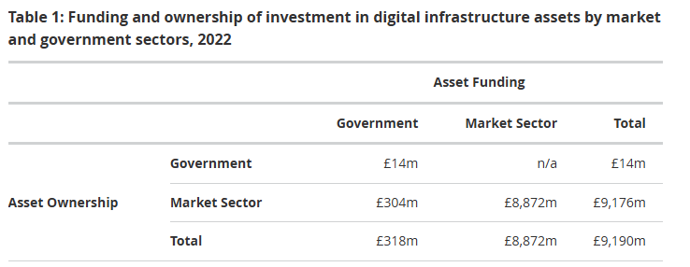
Figure 4: Investment in UK digital infrastructure
Source: ons.gov.uk, 2024
Japan: Japan is a global leader in technological innovation, smart retail and automation (Sugimoto, 2020), with growing digital payment adoption supporting personalised retail experiences.
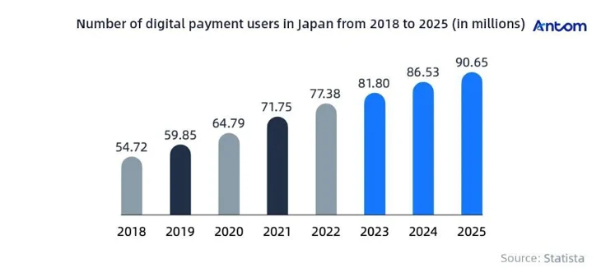
Figure 5: Growth in digital payment users in Japan
Source: knowledge.antom.com, 2026
Comparative evaluation: Both markets have mature digital ecosystems, though the UK is somewhat further ahead in retail automation and online shopper interaction.

Legal
UK: UK law is extensive across consumer protection, labour relations, product safety, environment and advertising (Howells, 2020), requiring compliance on sustainability claims, working conditions and data privacy.
Japan: Japanese law places heavy emphasis on product quality, intellectual property, consumer safety and labour standards (Ali, Ilyas and Ahmadeen, 2024), with rigorous pre-market quality assurance and labelling requirements.
Comparative evaluation: Both nations regulate robustly, but Japan emphasises product-quality assurance while the UK regulation is broader across consumer rights, employment and environmental responsibility.

Environmental
UK: Sustainability strongly influences UK purchasing; government policy supports carbon reduction, recycling and the circular economy, reinforcing Adidas' sustainable sourcing initiatives.
Japan: Japan has well-established energy-efficiency and waste-minimisation policy (Rezania et al., 2023), and consumers expect visible evidence of corporate environmental responsibility.
Comparative evaluation: Environmental sustainability is a shared priority, but Japanese consumers focus more on durability and material efficiency while UK consumers focus more on sourcing ethics and sustainability claims.

Similarities and Differences of the PESTLE Analysis
Across all six factors, the UK and Japan are both politically stable, economically supportive of premium pricing, legally rigorous and increasingly environmentally conscious, giving Adidas a broadly favourable operating environment in each. The key differences lie in emphasis: UK factors lean towards individual choice, regulatory change (post-Brexit) and digital convenience, whereas Japanese factors lean towards collective trust, technical precision and long-term consistency. Practically, this means Adidas can use one global product engine but must localise messaging, service standards and compliance detail for each market.

1.4 A Comparative Analysis of STP and Marketing Mix

1.4.1 STP Analysis
Segmentation is the process of dividing a broad consumer market into smaller groups of buyers with shared characteristics or needs, typically using demographic, geographic, psychographic and behavioural variables (Kotler and Armstrong, 2021).
Demographic segmentation: In the UK, Adidas targets consumers aged roughly 10–24 with medium-to-high disposable income. In Japan, demographic focus centres on young adults and urban professionals with high purchasing power and strong fashion awareness (adidas.jp, 2026).
Geographic segmentation: UK segmentation spans major cities and university towns with strong retail and sporting infrastructure. Japanese geographic segmentation is more concentrated, focused on Tokyo, Osaka and Yokohama, where fashion consciousness and sports participation are highest.
Psychographic segmentation: UK psychographics centre on fitness, fashion, sustainability and an active lifestyle. Japanese psychographics centre on craftsmanship appreciation, technological curiosity and status-conscious quality-seeking, particularly among "style-driven" urban professionals.
VALS of both countries: The VALS framework (Mitchell, 1983) segments consumers by primary motivation (ideals, achievement, self-expression) and resources. Adidas' typical UK consumer maps most closely to Experiencers and Achievers — resourceful, trend-led and self-expressive. The typical Japanese consumer maps more closely to Thinkers and Achievers — informed, quality-driven and motivated by well-earned success rather than novelty alone.
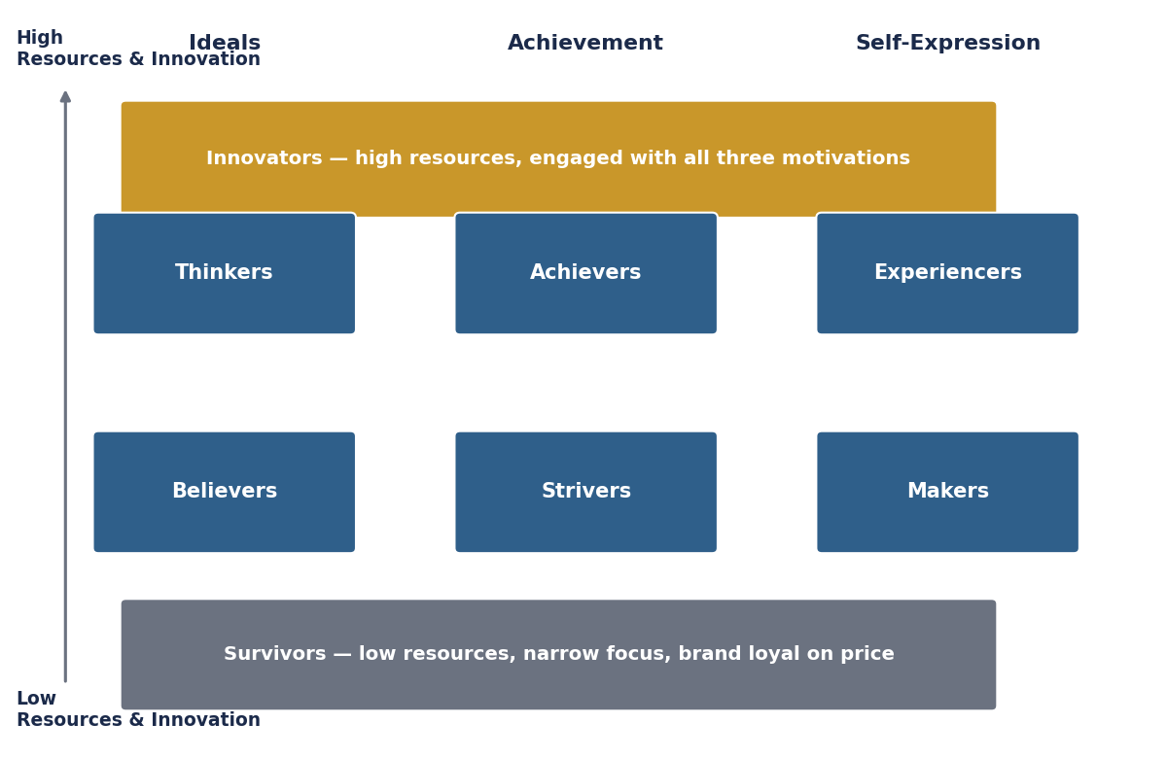
Figure 6: VALS framework applied to Adidas' UK and Japan consumers
Source: adapted from Mitchell, 1983
Behavioural segmentation is also used in both markets — grouping consumers by usage rate, occasion and brand loyalty — with heavy sport participants and collectors treated as high-value repeat buyers in the UK, and loyal, low-switching long-term customers treated as the priority group in Japan.
Comparative evaluation: Both markets use demographic, geographic, psychographic and behavioural segmentation, but UK segmentation is organised around diversity and individuality while Japanese segmentation is organised around quality-seeking and long-term value.
Targeting is the evaluation and selection of one or more segments to serve with a tailored marketing offer (Kotler and Armstrong, 2021).
Adidas uses differentiated marketing in the UK, developing distinct offers for multiple segments — athletes (Ultraboost), streetwear fans (Originals) and sustainability-conscious buyers — rather than one undifferentiated approach. In Japan, targeting is more narrowly differentiated toward style-driven professionals, fitness-conscious urban adults and technology-seeking performance buyers who will pay for exclusivity (adidas.jp, 2026). A concentrated (concerted) marketing approach is also visible in each market's flagship-store strategy: UK flagship stores concentrate marketing effort on London's high-footfall, brand-defining locations, while Japan's flagship stores in Tokyo and Osaka concentrate resources on a small number of premium, high-margin urban segments rather than spreading investment broadly.
Comparative evaluation: Targeting is more broadly differentiated in the UK (multi-segment, style-and-cause led) and more narrowly, quality-and-service led in Japan (Schlegelmilch, 2022).
Positioning is the act of designing a brand's offer and image to occupy a distinct, valued place in the target consumer's mind relative to competitors (Kotler and Armstrong, 2021).
In the UK, Adidas positions itself as a sportswear and lifestyle brand built on emotional connection with athletes, musicians and designers. In Japan, Adidas positions itself as an innovative, technically excellent brand, using limited editions and premium retail experiences to signal authenticity and craftsmanship.
Benefit positioning is evident in both markets: the UK message centres on the functional-emotional benefit of self-expression through sport and style, while the Japanese message centres on the functional benefit of engineering precision and durability. User positioning is also present: UK campaigns feature athletes, footballers and cultural figures that reflect the aspirational UK user, while Japanese campaigns feature professional athletes and Japanese designers that reflect the discerning, craftsmanship-focused Japanese user.
Perceptual map — rivals, price and quality: Positioning Adidas against Nike, Puma and New Balance in the UK, and Nike, Uniqlo and Asics in Japan, on price and quality axes shows Adidas consistently occupying the high-price, high-quality quadrant in both markets, close to Nike, but is perceived as more style-led in the UK and more craftsmanship-led in Japan (see Figure 7).
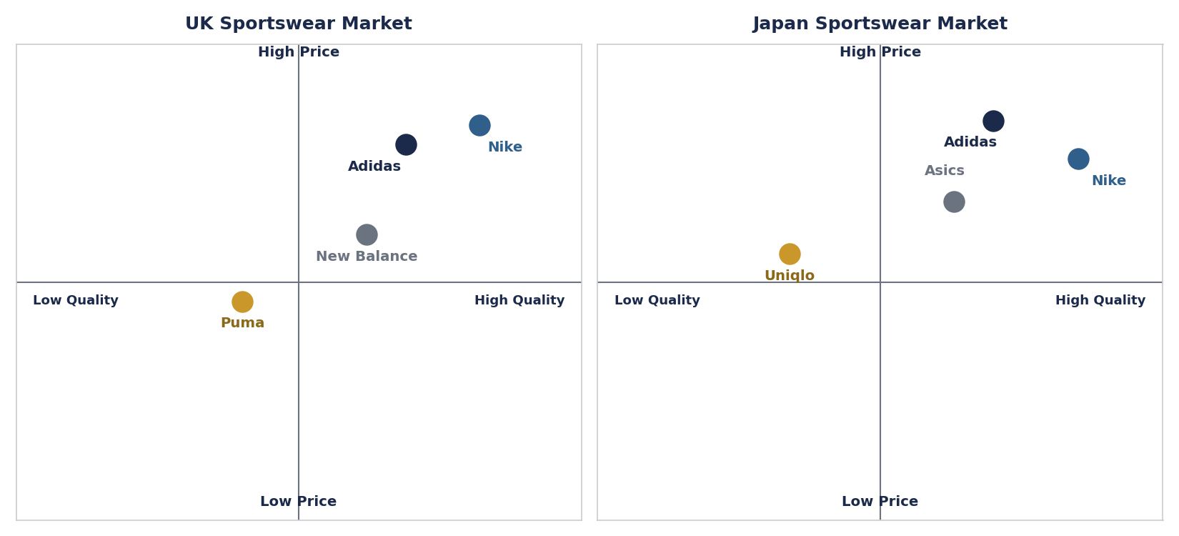
Figure 7: Perceptual map — price and quality, UK and Japan sportswear markets
Source: self-developed
Similarities and differences of STP: In both countries Adidas segments by demographic, geographic, psychographic and behavioural variables, targets multiple premium-oriented segments, and positions itself in the high-price/high-quality quadrant. The core difference is what earns the premium: individuality, style and sustainability in the UK versus technical precision, exclusivity and long-term trust in Japan.

1.4.2 Marketing Mix (7Ps)
The marketing mix is the set of controllable tactical tools — traditionally the 4Ps, extended for services to 7Ps — that a firm blends to produce the response it wants in the target market (McCarthy, 1960; Booms and Bitner, 1981). Figure 8 summarises the 7Ps applied throughout this section.
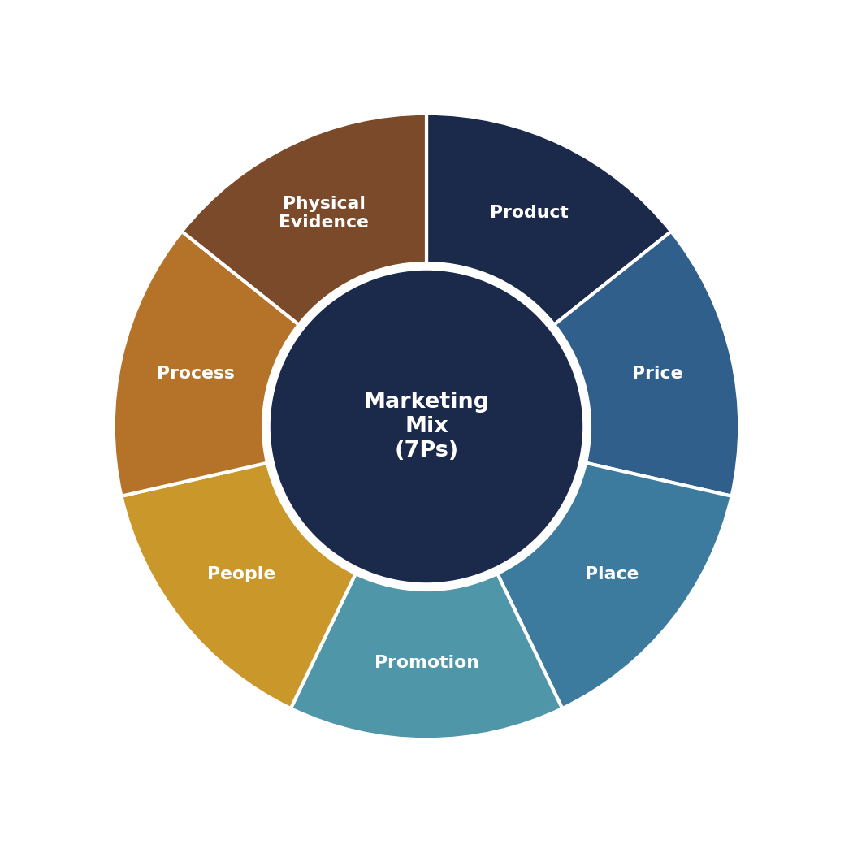
Figure 8: The 7Ps Marketing Mix framework
Source: adapted from Booms and Bitner, 1981

Product
UK: Adidas offers a wide sportswear, apparel, accessories and lifestyle range, including Originals, Ultraboost running shoes, football kits and recycled-material collections (adidas.co.uk, 2026), with consumers valuing variety, customisation and sustainability.
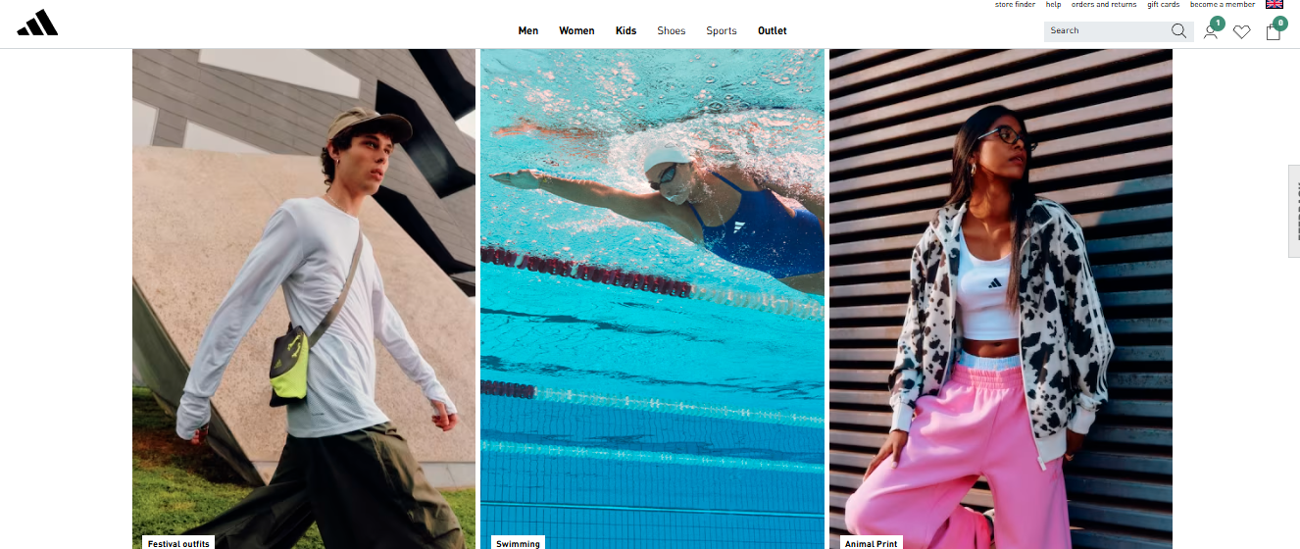
Figure 9: Adidas product range, UK
Source: adidas.co.uk, 2026
Japan: The Japanese range emphasises technological innovation, craftsmanship, durability and precision engineering, with lightweight, ergonomic design prioritised by consumers.
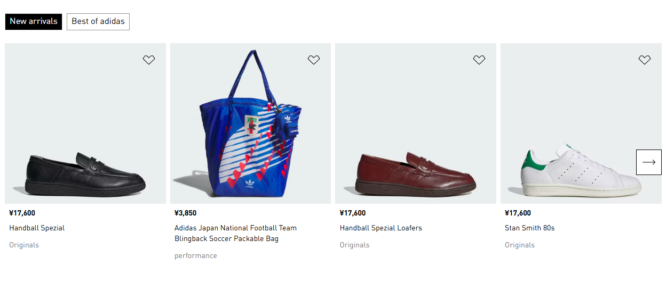
Figure 10: Adidas product range, Japan
Source: adidas.jp, 2026
Width and depth: Adidas' product width (the number of distinct product lines — footwear, apparel, accessories, equipment) is broadly similar in both markets. A brand extension widens this further: Adidas has extended its core sportswear width into eyewear and fragrance under licence, leveraging brand equity into adjacent categories in both countries. Depth (the number of variants within one line) differs: the UK running-shoe line runs from entry-level Duramo through to flagship Ultraboost Light, while the Japanese line historically had a gap at the elite-performance tier. Line filling — adding a new item to close a depth gap, illustrated in Figure 11 with the Japan-specific addition of an elite racing model — allows Adidas to capture performance buyers it would otherwise lose to Asics or Nike.
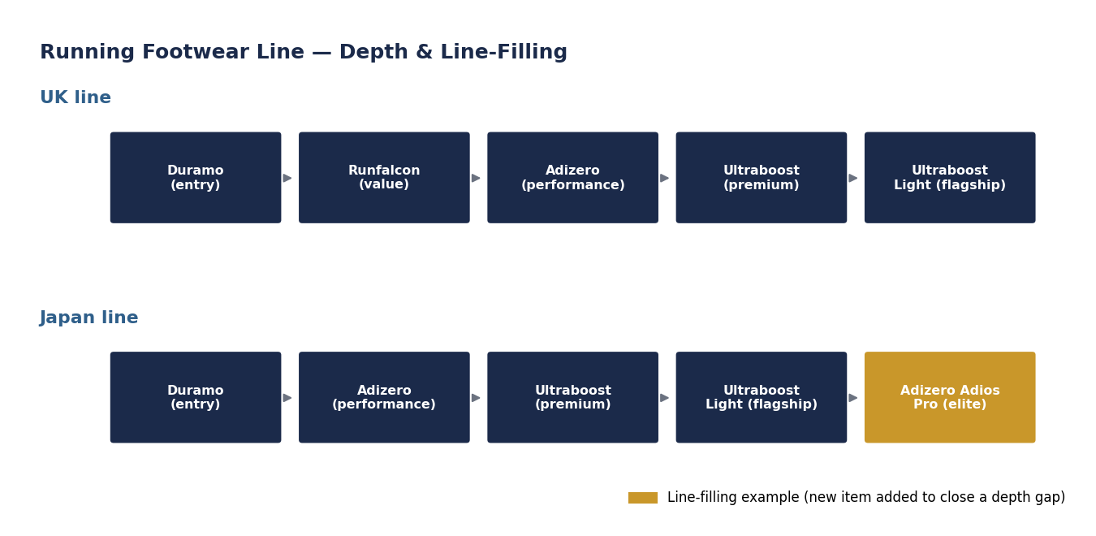
Figure 11: Product depth and line-filling example, running footwear
Source: self-developed
Comparative evaluation: Both markets receive Adidas' full product width, but UK depth leans towards style and sustainability variants while Japanese depth leans towards precision-performance variants.

Price
Price is the amount of money charged for a product, or the value customers exchange for the benefits of owning or using it (Kotler and Armstrong, 2021). Several factors can shift price in each market: input and labour costs, exchange-rate movements, local competitor pricing, tariffs (notably post-Brexit customs costs in the UK), and consumer willingness-to-pay for quality signalling in Japan (Lee and Winterich, 2022).
UK: Adidas uses premium pricing but offers tiered price points to reach different segments, balancing price against promotions to stay competitive with Nike and Puma.
Japan: Premium pricing is also used, but Japanese consumers show lower price sensitivity, often inferring quality from price rather than the reverse.
Exchange rate: Because Adidas prices in local currency while sourcing and reporting in euros, sterling and yen depreciation against the euro raises landed cost and margin pressure in both markets; a weaker pound has periodically pushed UK retail prices up, while yen weakness has made Japan a relatively cheaper market for foreign tourists buying Adidas products, occasionally pressuring domestic Japanese margins.
Comparative evaluation: Both markets sustain premium pricing, but the UK relies more on discounting and promotional pricing while Japan sustains higher list-price loyalty.

Promotion
Integrated Marketing Communication (IMC) is the coordinated use of multiple promotional tools — advertising, PR, sales promotion, digital and personal selling — so that they deliver one consistent brand message (Kotler and Armstrong, 2021).
Media usage — UK: TV, digital media, football sponsorship and influencer/social media marketing dominate, supported by sustainability-themed campaigns (Navarro, 2026).
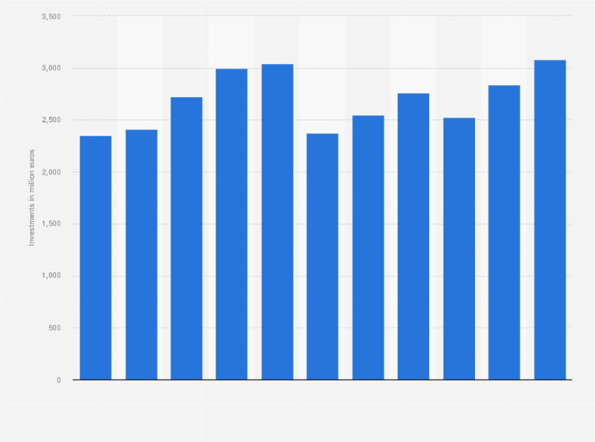
Figure 12: Adidas marketing/POS expenditure, UK
Source: Navarro, 2026
Media usage — Japan: Promotion favours product quality, technological storytelling and collaborations with Japanese designers and professional athletes, communicated through targeted digital and in-store media.
Promotion mix combination: The UK combines advertising, sponsorship, digital/social promotion and PR heavily, weighted towards emotionally engaging, shareable content built around football and music culture; Japan combines advertising, celebrity/designer collaboration and experiential in-store promotion more heavily than mass discounting, weighted towards demonstrating technical credibility and craftsmanship.
Sales promotion: UK sales promotion includes seasonal discounts, loyalty app rewards and bundled offers, used relatively frequently to drive footfall. Japanese sales promotion is more limited and selective — limited-edition drops and loyalty perks rather than broad discounting — to protect the premium price image.
Digital promotion: Both markets use app-based personalisation, social media content and e-commerce advertising; the UK leans further into influencer-led social commerce, while Japan leans further into app-based loyalty and exclusive digital drops.
Comparative evaluation: Both use IMC across similar channels, but UK promotion is more lifestyle/discount-oriented while Japanese promotion is more innovation/exclusivity-oriented.

Place
Place refers to the activities that make the product available to target consumers where and when they want it (Kotler and Armstrong, 2021).
Channel of distribution: Adidas uses an omnichannel structure in both countries — flagship stores, factory outlets, authorised retailers, department stores and e-commerce (Figure 13 illustrates the channel structure; Figure 14 shows the global manufacturing/supply footprint feeding both markets).
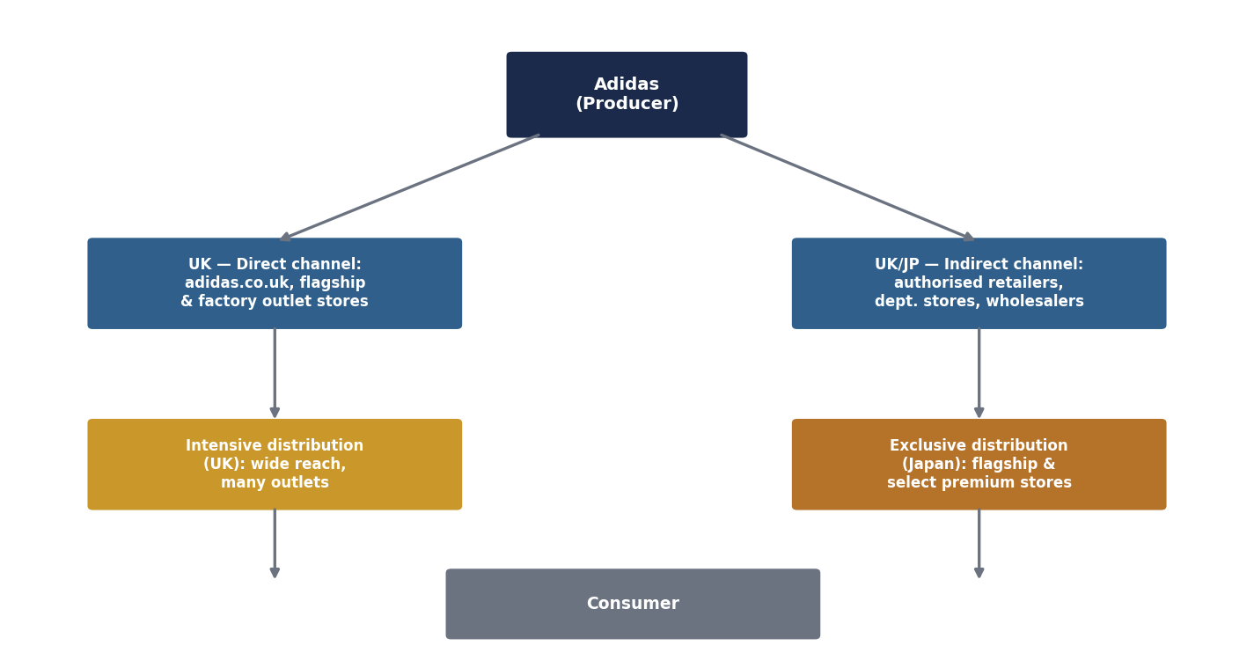
Figure 13: Channel of distribution — UK and Japan
Source: self-developed
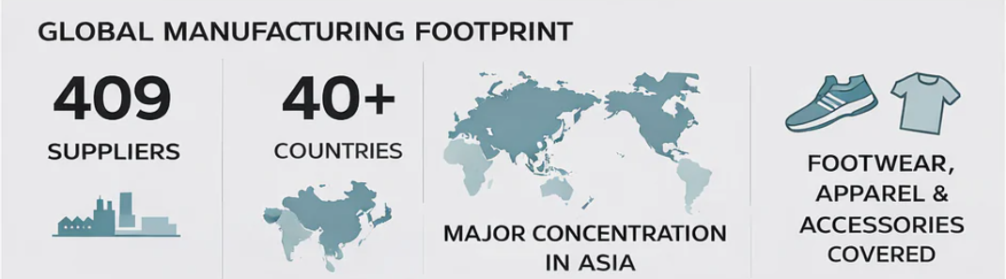
Figure 14: Global manufacturing footprint supplying Adidas' UK and Japan markets
Source: Sellersunionchina.com, 2025
Intensive vs exclusive distribution: The UK leans towards intensive distribution — broad availability across many retail formats to maximise convenience and reach. Japan leans towards exclusive distribution — a smaller number of flagship and authorised premium stores in Tokyo and Osaka, protecting the premium brand experience (adidas.jp, 2026).
Direct channel distribution: Both markets sell directly via Adidas-owned e-commerce and flagship stores, giving Adidas first-party customer data and full control of brand presentation; this direct channel is comparatively more central to the UK's wholly-owned retail strategy discussed in Section 1.5.
Comparative evaluation: Distribution networks are strong in both countries, but the UK emphasises wide, convenient access while Japan emphasises a curated, premium physical and digital experience.

People
Country-level headcount is not fully disclosed by Adidas, but available data provides useful approximations. Adidas Japan K.K. reports approximately 1,256 employees (Nikkei Compass, 2026), while UK corporate filings show Adidas (U.K.) Limited's directly employed headcount as over 250 staff at a corporate level (Endole, 2026), with total UK workforce (including retail store staff) considerably larger given its extensive store network; Adidas' global headcount was approximately 59,000–65,000 over 2019–2022 (fourweekmba.com, 2026), shown in Figure 15.
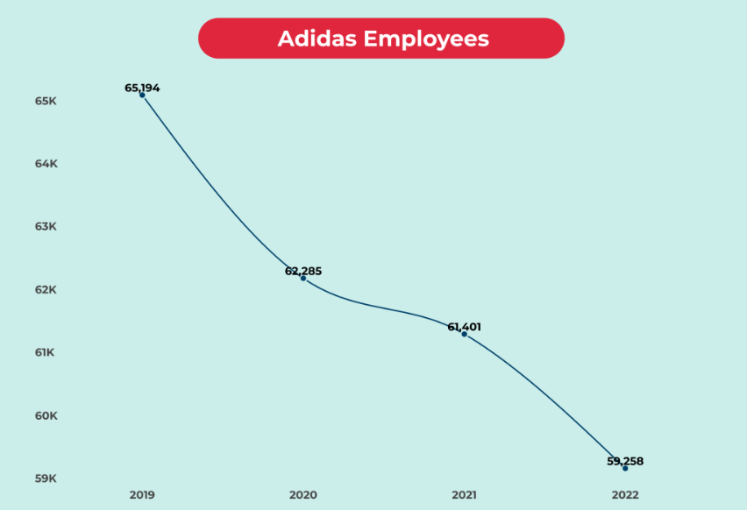
Figure 15: Adidas global employee numbers, 2019–2022
Source: fourweekmba.com, 2026
Training and motivation — UK: Staff receive product, customer-service, digital-retail and sustainability training; inclusive workplace policies support motivation and customer satisfaction (Singh and Rani, 2025).
Training and motivation — Japan: People management is grounded in professionalism, discipline, courtesy and respect (Rayhan, 2023), with intensive product and service-detail training supporting Japan's precision-service culture; internal progression and mastery of process are strong motivators, consistent with Japan's high Long-Term Orientation score.
Comparative evaluation: Both countries invest heavily in staff development, but UK motivation leans on flexibility, inclusion and informal customer rapport, while Japanese motivation leans on mastery, consistency and formal service discipline.

Process
Service delivery and workflow — UK: Integrated online/offline journeys, secure payment, fast delivery, click-and-collect and flexible returns are supported by AI-driven personalisation and data analytics.
Service delivery and workflow — Japan: Retail processes prioritise accuracy, consistency and efficiency, with well-trained staff, ergonomic store layout and tightly controlled stock and quality assurance (Zou et al., 2025).
Customer complaint process: In the UK, complaints are typically handled through multi-channel customer service (phone, email, live chat, social media), supported by a formal returns/refund policy and escalation route. In Japan, complaint handling emphasises face-to-face resolution, formal apology and swift corrective action in line with cultural expectations of service precision and harmony, with digital complaint channels used more conservatively than in the UK.
Comparative evaluation: Both processes are efficient, but UK priorities are convenience and digital flexibility while Japanese priorities are precision, consistency and relational repair.

Physical Evidence
Website: Both adidas.co.uk and adidas.jp function as key physical-evidence touchpoints, reinforcing the brand through design, navigation and localisation (placeholders for current homepage screenshots are provided in Figure 16 for the student to insert).
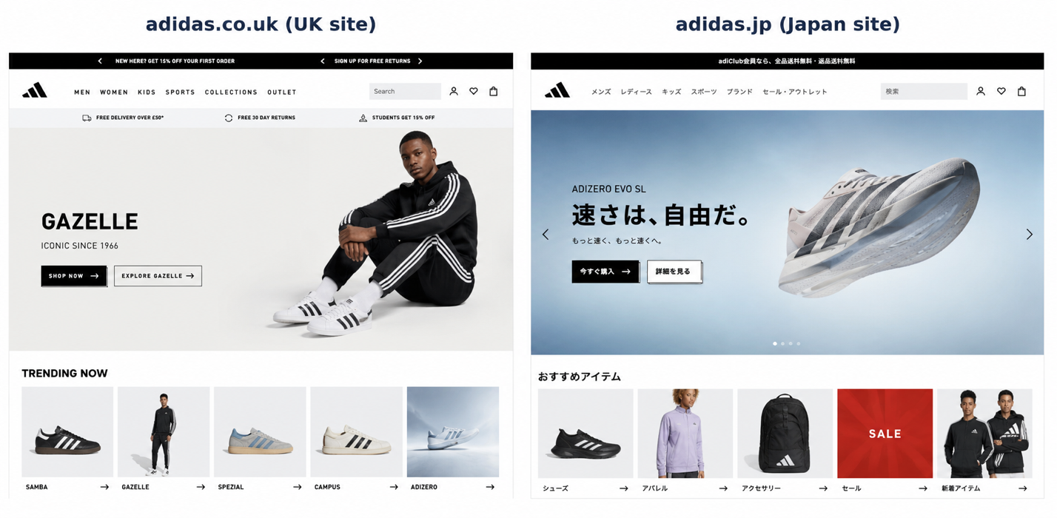
Figure 16: Website placeholders — adidas.co.uk and adidas.jp
Source: to be inserted by student
Packaging design: UK packaging leans towards recycled-content boxes with sustainability messaging and take-back QR codes; Japanese packaging leans towards rigid, minimalist premium boxes with tissue-wrap presentation reflecting gift-giving culture (Figure 17 illustrates both concepts).
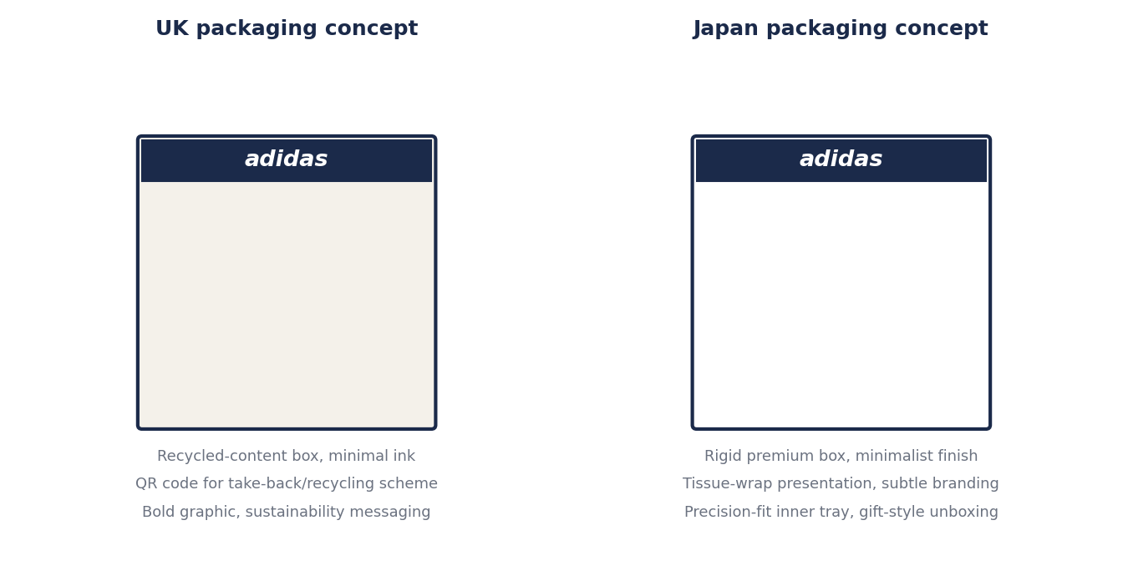
Figure 17: Illustrative packaging design concepts, UK and Japan
Source: self-developed
UK stores: contemporary flagship design, sustainable materials, interactive in-store technology.
Japan stores: cleanliness, organisation and detail-oriented visual merchandising (Stoica, 2024) reinforce a premium, sophisticated retail environment.
Comparative evaluation: Both markets present a consistent Adidas identity adapted to local taste — innovation and shopping experience in Japan, elegance and premium presentation in the UK.

Similarities and Differences of the 7Ps
Across all seven elements, Adidas keeps a consistent premium, innovation-led brand core in both countries while adapting depth, price sensitivity handling, promotion style, distribution intensity and service tone to match UK individualism/convenience versus Japanese precision/exclusivity.

1.5 An Analysis of the Brand's Market Entry Strategy in the UK
Adidas entered the UK via Foreign Direct Investment (FDI), establishing a wholly owned subsidiary and building its own retail and distribution network (Holtbrügge and Schuster, 2024). This was chosen because the UK is a large, sports-friendly, digitally mature market with high purchasing power and strong demand for quality, sustainable sportswear (Storm, Jensen and Nielsen, 2024), justifying the capital investment required for full ownership.
Advantages: management independence, stronger IP protection, consistent product quality and faster decision-making (Burrell et al., 2023); direct customer data access supports fine-tuned, customer-centric marketing and a seamless omnichannel journey; collaborations with football clubs, athletes and influencers strengthen brand recognition.
Disadvantages: FDI requires substantial upfront capital and carries higher financial exposure than lower-commitment entry modes such as licensing or franchising; it is slower to scale than partnering with an established local retailer; and it exposes Adidas fully to UK-specific regulatory, currency and competitive risk (from Nike, Puma and Under Armour) rather than sharing that risk with a local partner. Fixed store and payroll costs are also harder to unwind quickly if UK demand weakens, which increases downside exposure compared with an asset-light franchise model.

1.6 Ethical Issues Related to the Brand's Marketing Mix in Japan
Ethical practices (two examples): (1) Adidas has expanded its use of recycled materials and low-impact production in its Japanese product range, giving environmentally conscious consumers a genuine, traceable sustainable option (Almusaed et al., 2024). (2) Adidas has strengthened compliance with Japan's data protection law, being transparent about how customer data collected through its Japanese e-commerce and loyalty platforms is used, which builds consumer trust (Howells, 2020).
Unethical or ethically questionable practices (two examples): (1) Heavy reliance on celebrity and social-media influencer endorsement in Japan can pressure younger consumers into status-driven over-consumption to conform to fashion norms (Zhao et al., 2024). (2) Marketing the sustainable product range prominently, while it remains a small share of the total portfolio, risks greenwashing — creating a more sustainable brand impression than the overall product range supports.
Overall, Adidas demonstrates a genuine and improving commitment to responsible marketing in Japan, but the tension between commercial promotion and ethical restraint, particularly around influencer marketing and sustainability claims, remains an area requiring ongoing management attention (Kihara, 2024).

1.7 Strategic Recommendations: STP Evolution
UK recommendation: Adidas should evolve its segmentation to place more weight on sustainability-driven and Gen Z digital-native segments, targeting them with differentiated, cause-linked campaigns, and reposition selected product lines around verified circularity credentials rather than broad lifestyle appeal alone, strengthening differentiation from Nike and Puma.
Japan recommendation: Adidas should evolve its segmentation to more explicitly capture the growing urban wellness and longevity-focused older-adult segment alongside its current youth/professional focus, target this group with a differentiated offer emphasising comfort and craftsmanship, and reposition around "trusted long-term quality" messaging that plays directly to Japan's high Long-Term Orientation and Uncertainty Avoidance scores.
Across both markets, Adidas should also continue expanding digital personalisation and omnichannel integration (Galluccio and Agrell, 2022) and broaden accessible price points without diluting premium credibility (Almusaed et al., 2024), supporting inclusivity while protecting brand equity. Evolving STP in this way — rather than holding segmentation, targeting and positioning static — allows Adidas to track shifting consumer priorities in each market and defend its premium position as competitors adapt.

1.8 Conclusion
Adidas successfully balances a consistent global brand identity with meaningful local adaptation across the UK and Japan. PESTLE and Hofstede analysis show both markets as stable and premium-price-supportive but culturally distinct; STP and the 7Ps show Adidas adjusting segmentation emphasis, product depth, pricing tolerance, promotion style, distribution intensity and service tone to match individualistic, convenience-led UK consumers versus precision- and trust-led Japanese consumers. Its UK market entry via FDI reflects a market attractive enough to justify full ownership and control. Ethical management of influencer marketing and sustainability claims in Japan, alongside continued STP evolution in both markets, will be central to sustaining Adidas' competitive position internationally.

Section 2: Gibbs' Reflective Cycle

2.1 Gibbs' Reflective Cycle: Definition
Gibbs' Reflective Cycle (Gibbs, 1988) is a structured, six-stage model of reflective learning — Description, Feelings, Evaluation, Analysis, Conclusion and Action Plan — that guides the reflector from recounting an experience through to concrete future action. Its cyclical structure (Figure 18) means reflection does not stop at a single conclusion but feeds directly into a plan for doing things differently next time, making it well suited to reflecting on an extended research and report-writing task such as this one.
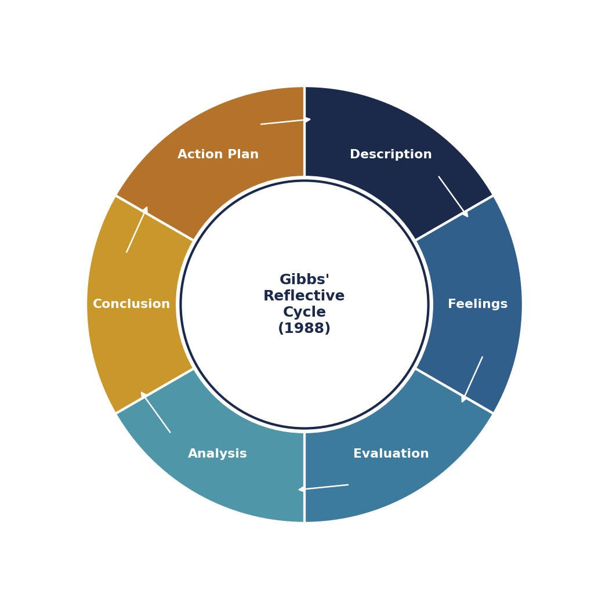
Figure 18: Gibbs' Reflective Cycle
Source: adapted from Gibbs, 1988

2.2 Description: The Research Task
This task required producing a 5,000-word international marketing report comparing Adidas' strategy in the UK and Japan, covering PESTLE, Hofstede's cultural dimensions, STP, the 7Ps marketing mix, market entry strategy, ethical marketing issues and strategic recommendations. The work involved sourcing and synthesising academic literature, market data and company disclosures, applying multiple theoretical frameworks consistently across two very different markets, and presenting findings within a fixed structure and word count. I began by mapping the full assignment brief into a section-by-section outline, then researched each framework in turn, gathering UK and Japan evidence in parallel so that comparative points could be drawn directly rather than added retrospectively. Building and interpreting the supporting diagrams — the perceptual maps, the distribution-channel diagram and the product-depth diagram in particular — was a substantial part of the research task in its own right, since each required me to translate written analysis into a visual argument.

2.3 Feelings
Before: At the outset I felt confident about the marketing theory itself but apprehensive about the volume of research required to compare two markets credibly, and uncertain whether I could keep the word count under control while covering every required framework in adequate depth.
After: Having completed the report, I feel a stronger sense of accomplishment and genuine improvement in my ability to apply multiple frameworks to the same case without treating them as isolated exercises. Some frustration remained around finding precise, citable country-level data (for example, exact UK employee headcount), which was less available than expected.

2.4 Evaluation: Strengths and Weaknesses
Strengths: I structured the report systematically, moved logically from macro-environment through STP to the operational 7Ps, and maintained a consistent UK/Japan comparative format throughout, which made the analysis easier to follow and cross-check against the module's assessment criteria.
Weaknesses: My early drafting under-used quantitative evidence, relying too heavily on narrative comparison rather than citing specific figures; some sections were also initially written in isolation from one another, creating minor repetition between the PESTLE and STP comparative-evaluation paragraphs that required later editing to remove. I also found country-level operational data (such as UK-specific employee headcount) harder to source reliably than company-wide figures, which meant some claims needed to be framed with appropriate caveats rather than stated as precise facts — a useful lesson in academic honesty when primary data is genuinely unavailable.

2.5 Analysis: What the Three Methods Taught Me
Hofstede's model taught me that quantified cultural comparison is powerful for anticipating broad behavioural differences (for example, Japan's high Uncertainty Avoidance explaining its demand for detailed product information) but risks oversimplifying real consumer diversity if treated as the whole picture rather than one input among several.
STP taught me that segmentation, targeting and positioning must be read together, not separately — Adidas' positioning only makes sense once its targeting choices are understood, and its targeting choices only make sense once its segmentation logic is clear. Applying this chain consistently across two markets improved my ability to build a coherent strategic argument rather than a list of disconnected facts.
The 7Ps taught me that a marketing mix is genuinely interdependent: Japan's exclusive distribution choice, higher price tolerance and precision-service culture are not separate decisions but reinforce one shared positioning, which deepened my understanding of marketing mix coherence beyond simply listing each P in turn.
Together, these three methods showed me that international marketing analysis is strongest when frameworks are used to build one integrated argument about why a company adapts as it does, rather than as independent checklists.

2.6 Conclusion
Overall, this task improved both my theoretical understanding and my ability to communicate structured comparative analysis under a strict word limit. If I were to repeat it, I would gather quantitative data earlier in the process, draft the comparative-evaluation summaries after all country-specific content was finished (to reduce repetition), and allocate word count more deliberately across sections from the start rather than adjusting after most sections were already drafted.

2.7 Overall Skills Gained
This task developed my research and source-evaluation skills, my ability to apply and integrate multiple marketing frameworks, my academic writing and referencing discipline, and my capacity to write concisely under a fixed word limit without losing analytical depth.

2.8 Action Plan
Time management: I will build a section-by-section word-count and deadline plan before drafting future reports, rather than after, using interim checkpoints to catch scope creep early instead of cutting content under time pressure near the deadline.
Numerical analysis: I will strengthen my ability to locate, interpret and correctly cite quantitative data (financial figures, survey statistics, index scores) earlier in the research process, and practise presenting such data visually (as in the charts and diagrams used throughout this report) so that future analysis is evidenced numerically rather than narratively by default.
Applying both commitments consistently should reduce late-stage rewriting and produce more evidence-based, better-paced work in future assignments.

Reference List
adidas.co.uk (2026) READY TO MAKE HISTORY. Available at: https://www.adidas.co.uk/
adidas.jp (2026) Available at: https://www.adidas.jp/
Ali, F., Ilyas, A. and Ahmadeen, S. (2024) 'Regulations in Japan', in Global Regulations of Medicinal, Pharmaceutical, and Food Products. CRC Press, pp. 153–167. Available at: https://www.researchgate.net/profile/Faraat-Ali/publication/380324325_Regulations_in_Japan
Almusaed, A., Yitmen, I., Myhren, J.A. and Almssad, A. (2024) 'Assessing the impact of recycled building materials on environmental sustainability and energy efficiency', Buildings, 14(6), p.1566. Available at: https://www.mdpi.com/2075-5309/14/6/1566
Booms, B.H. and Bitner, M.J. (1981) 'Marketing strategies and organization structures for service firms', in Donnelly, J.H. and George, W.R. (eds.) Marketing of Services. Chicago: American Marketing Association, pp. 47–51. Available at: https://www.scirp.org/reference/referencespapers?referenceid=2530717
Burrell, R., Jee, S.J., Hötte, K. and Ring, C. (2023) 'Intellectual property rights, climate technology transfer and innovation in developing countries', INET Oxford Working Paper. Available at: https://oms-inet.files.svdcdn.com/staging/files/intellectual-property-rights-2023-14.pdf
Calder, K.E. (2021) Crisis and Compensation: Public Policy and Political Stability in Japan. Princeton: Princeton University Press. Available at: https://books.google.com/books?id=LuUXEAAAQBAJ
Davies, B., Lalot, F., Peitz, L., Heering, M.S., Ozkececi, H., Babaian, J., Davies Hayon, K., Broadwood, J. and Abrams, D. (2021) 'Changes in political trust in Britain during the COVID-19 pandemic in 2020', Humanities and Social Sciences Communications, 8(1). Available at: https://www.nature.com/articles/s41599-021-00850-6.pdf
de Mooij, M. and Hofstede, G. (2010) 'The Hofstede model: Applications to global branding and advertising strategy and research', International Journal of Advertising, 29(1), pp. 85–110. Available at: https://www.tandfonline.com/doi/abs/10.2501/S026504870920104X
Endole (2026) Adidas (U.K.) Limited – Company information. Available at: https://open.endole.co.uk/insight/company/01075951-adidas-u-k-limited
fourweekmba.com (2026) Adidas Employees, FourWeekMBA. Available at: https://fourweekmba.com/adidas-employees/
Galluccio, A. and Agrell, P.J. (2022) 'Industry 4.0 in focus: The adidas speedfactory', Université catholique de Louvain, pp. 21–32. Available at: https://thesis.dial.uclouvain.be/bitstreams/8d8f2a06-1cff-4b7f-8713-c65a86fdbe02/download
Gibbs, G. (1988) Learning by Doing: A Guide to Teaching and Learning Methods. Oxford: Further Education Unit, Oxford Polytechnic. Summary available at: https://www.ed.ac.uk/reflection/reflectors-toolkit/reflecting-on-experience/gibbs-reflective-cycle
Godfrey, M., Kim, J., Eluère, M. and Eys, M. (2020) 'Diversity in cultural diversity research: A scoping review', International Review of Sport and Exercise Psychology, 13(1), pp. 128–146. Available at: https://www.researchgate.net/profile/Manon-Eluere/publication/333225410_Diversity_in_cultural_diversity_research_a_scoping_review
Holtbrügge, D. and Schuster, T. (2024) 'The Internationalization Strategy of adidas', in The Internationalization of Firms. Nomos Verlagsgesellschaft, pp. 21–44. Available at: https://balleis.de/wp-content/uploads/2025/06/Case-Studies-from-the-NA%C2%BCrnberg-Metropolitan-Area_3rd-edition.pdf
Howells, G. (2020) 'Protecting consumer protection values in the fourth industrial revolution', Journal of Consumer Policy, 43(1), pp. 145–175. Available at: https://link.springer.com/content/pdf/10.1007/s10603-019-09430-3.pdf
Kihara, J.W. (2024) 'The long-term impact of abandoning ethical standards on organizational success and profitability', African Journal of Emerging Issues, 6(4), pp. 46–59. Available at: https://ajoeijournal.org/sys/index.php/ajoei/article/download/556/670
knowledge.antom.com (2026) Selling to consumers in Japan? Here's what you need to know, Antom. Available at: https://knowledge.antom.com/selling-to-consumers-in-japan-heres-what-you-need-to-know
Kotler, P. and Armstrong, G. (2021) Principles of Marketing. 18th edn. Harlow: Pearson Education. Available at: https://www.pearson.com/en-us/subject-catalog/p/principles-of-marketing/P200000005954/9780135766361
Lee, S. and Winterich, K.P. (2022) 'The price entitlement effect', Journal of Marketing Research, 59(6), pp. 1141–1160. Available at: https://journals.sagepub.com/doi/pdf/10.1177/00222437221094301
McCarthy, E.J. (1960) Basic Marketing: A Managerial Approach. Homewood, IL: Richard D. Irwin. Available at: https://archive.org/details/basicmarketingma0000ejer
McVey, H.H., Corcoran, A.T., Hua, C. and Liu, A. (2026) Thoughts from the Road: Japan March 2026. KKR. Available at: https://www.kkr.com/insights/2026-japan-thoughts-from-the-road
Mitchell, A. (1983) The Nine American Lifestyles: Who We Are and Where We're Going. New York: Macmillan. Available at: https://books.google.com/books/about/The_Nine_American_Lifestyles.html?id=R67ZAAAAMAAJ
Navarro, J.G. (2026) adidas Group: marketing & POS spend 2015-2025, Statista. Available at: https://www.statista.com/statistics/540836/adidas-marketing-spend/
Nikkei Compass (2026) Adidas Japan K.K. – Company information. Available at: https://www.nikkei.com/compass/company/hFMsJ5iimg4MfHUa3GD53L
ons.gov.uk (2024) Redefining investment in digital infrastructure in the UK. Office for National Statistics. Available at: https://www.ons.gov.uk/economy/economicoutputandproductivity/productivitymeasures/articles/redefininginvestmentindigitalinfrastructureintheuk/2024-07-31
Race, M. (2022) UK inflation hits 40-year high of 9% as energy bills soar, BBC News. Available at: https://www.bbc.com/news/business-61483175
Rayhan, A. (2023) 'Living with honor: Exploring the ethical values of Japanese society and education', ResearchGate. Available at: https://www.researchgate.net/profile/Abu-Rayhan-11/publication/373328817_LIVING_WITH_HONOR_EXPLORING_THE_ETHICAL_VALUES_OF_JAPANESE_SOCIETY_AND_EDUCATION
Rezania, S., Oryani, B., Nasrollahi, V.R., Darajeh, N., Lotfi Ghahroud, M. and Mehranzamir, K. (2023) 'Review on waste-to-energy approaches toward a circular economy in developed and developing countries', Processes, 11(9), p.2566. Available at: https://www.mdpi.com/2227-9717/11/9/2566
Schlegelmilch, B.B. (2022) 'Segmenting targeting and positioning in global markets', in Global Marketing Strategy: An Executive Digest. Cham: Springer, pp. 129–159. Available at: https://link.springer.com/chapter/10.1007/978-3-030-90665-8_6
Sellersunionchina.com (2025) Where are Adidas shoes made? Available at: https://sellersunionchina.com/where-are-adidas-shoes-made/
Singh, N. and Rani, J. (2025) 'Experimental retail: Conceptualizing immersive and memorable shopping journeys', in Retail Innovations in Business Models. IGI Global, pp. 31–50. Available at: https://www.researchgate.net/profile/Namrata_Kishnani2/publication/393898326_igi_global_book_retail_innovations
Stoica, M. (2024) 'Visual merchandising across cultures', in Modern Paradigms in the Development of the National and World Economy, pp. 82–89. Available at: https://ibn.idsi.md/sites/default/files/imag_file/p-82-89_1.pdf
Storm, R.K., Jensen, T.K. and Nielsen, K. (2024) 'Swedish elite sport: External evaluation', Idrættens Analyseinstitut. Available at: https://www.idan.dk/media/y20nottr/swedish-elite-sport.pdf
Sueda, R. and Seo, Y. (2024) 'Understanding consumer perception of sustainable fashion in Japan', Sustainability, 16(23), p.10223. Available at: https://www.mdpi.com/2071-1050/16/23/10223
Sugimoto, Y. (2020) An Introduction to Japanese Society. Cambridge: Cambridge University Press. Available at: https://www.cambridge.org/highereducation/books/an-introduction-to-japanese-society/BDDBED76B55D3280F44210E8D6B78298
theculturefactor.com (2026) Country comparison tool. Available at: https://www.theculturefactor.com/country-comparison-tool?countries=japan%2Cunited%2Bkingdom
Zhao, A.L., Dermody, J., Koenig-Lewis, N. and Hanmer-Lloyd, S. (2024) 'Cultivating sustainable consumption', Journal of Consumer Behaviour, 23(2), pp. 1014–1031. Available at: https://onlinelibrary.wiley.com/doi/pdfdirect/10.1002/cb.2261
Zou, Y., Zhao, C., Childs, P., Luh, D. and Tang, X. (2025) 'User Experience Design for Online Sports Shoe Retail Platforms', Behavioral Sciences, 15(3), p.311. Available at: https://www.mdpi.com/2076-328X/15/3/311

