
Student name: | Tahmina Akter Mili | Student ID number: | 2525073
Programme: | Master of Business Administration
Module: | International Marketing Principles and Practices (LCMB7026_LON)
Module code: | LCMB7026
Lecturer: | Tushara Balendran
Assignment Title: | International Marketing Strategy of Toyota: A Comparative Analysis of Japan and India | Word count (or equivalent): | 5090
Submission Date: | 13.08.2026

AI Use Acknowledgement
I recognize the use of artificial intelligence (AI) in the preparation of this report, which is limited. The main use of the AI tools was to aid my understanding in selected academic concepts, specifically PESTLE analysis, Hofstede's cultural dimensions, STP, the 7Ps marketing mix, and Carroll's CSR framework. These were employed as a learning aid to explain the concepts and their use in an international marketing context. I have conducted the research, selection, and evaluation of academic and industry sources, made comparisons between Toyota's strategies in Japan and India, analysed them critically, made recommendations and final academic judgements all by myself. I was accountable for checking the quality and appropriateness of the information that was used and that the final report was my own understanding, analysis and interpretation.

Contents
AI Use Acknowledgement 2
Introduction 8
International Marketing 8
Introduction of Toyota Motor Corporation 8
Selected Countries 8
Purpose of the Report 9
Company Background 9
Toyota's History and Global Expansion 9
Toyota's Operations in India 10
PESTLE Framework 10
Political Factors 11
Economic Factors 11
Social Factors 13
Cultural Factors 13
Technological Factors 15
Legal Factors 15
Environmental Factors 16
Comparative STP Strategy 17
Market Segmentation 17
Geographic Segmentation 18
Demographic Segmentation 19
Psychographic Segmentation (AIO Model) 20
VALS Framework 21
Behavioural Segmentation 23
Targeting Strategy 24
Positioning Strategy 25
Similarities and Differences of Toyota's STP Strategy in Japan and India 26
Comparative Marketing Mix (7Ps) 27
Marketing Mix 27
Product 27
Price 28
Place 29
Promotion 29
People 29
Process 30
Physical Evidence 30
Market Entry Strategy (India) 31
Ethical Marketing Evaluation – India 32
Environmental Sustainability and Product Responsibility 33
Carroll's CSR Evaluation 33
Stakeholder Implications 34
Recommendations 34
Recommendations for Japan 34
Recommendations for India 35
Conclusion 35
Reflective Essay: Using Gibbs' Reflective Cycle 37
Description 37
Feelings 37
Evaluation 38
Analysis 38
Conclusion 39
Action Plan 39
References 40

List of Tables
Table 1: Comparison of Economic Factors in Japan and India (Author) 13
Table 2: Comparison of Social and Cultural Factors between Japan and India (Cultural Factor, 2026) 15
Table 3: Similarities and Differences between Japan and India (PESTLE Analysis) (Author) 17
Table 4: Characteristics of Effective Market Segmentation (Author) 18
Table 5: Demographic Segmentation of Toyota (Author) 20
Table 6: Comparison of Market Segmentation in Japan and India (Author) 24
Table 7: Toyota's Target Markets in Japan and India (Sheel Achnani, 2025) 25
Table 8: Comparison of Toyota's Positioning Strategy in Japan and India (Author) 26
Table 9: Similarities and Differences of Toyota's STP Strategy (Author) 27
Table 10: Comparison of Toyota's Marketing Mix in Japan and India (Author) 31

List of Figures
Figure 1: Toyota Logo (Toyota, 2025) 8
Figure 2: History of Toyota Motors (Abdeldayem et al., 2023) 10
Figure 3: PESTLE Analysis (Kotler & Keller, 2022) 11
Figure 4: GDP Growth Rate India and Japan (World Bank, 2026) 12
Figure 5: Hofstede Factors Comparison for Japan and India (Cultural Factor, 2026) 14
Figure 6: Toyota Target Marketing Strategy (Elliott et al., 2026) 18
Figure 7: Toyota Geographic Segmentation (Patil, 2026) 19
Figure 8: AIO Model (Putri et al., 2025) 21
Figure 9: VALS Framework (Rienecker et al., 2026) 22
Figure 10: Perceptual Map (Kumar et al., 2022) 25
Figure 11: Marketing Mix (7Ps) (Kotler & Keller, 2022) 27
Figure 12: Toyota's Product Comparison (Iskamto & Wicaksono, 2023) 28
Figure 13: Toyota's Distribution and Service Channels (Ishii & Kikumori, 2025) 29
Figure 14: Toyota Dealerships in Japan and India (Brouthers et al., 2022) 30
Figure 15: Toyota Distribution Channels (Kormakova et al., 2023) 32
Figure 16: Carroll Pyramid (Palhau et al., 2024) 33
Figure 17: Gibbs Cycle (Achnani, 2025) 37

Introduction

International Marketing
International marketing is the process of planning and implementing marketing activities across national markets by adapting products and marketing strategies to different economic, cultural and business environments (Kotler and Keller, 2022).

Introduction of Toyota Motor Corporation
Toyota Motor Corporation is a Japanese multinational auto manufacturer, founded in 1937 by Kiichiro Toyoda and headquartered in Toyota City, Aichi Prefecture, Japan. The company has grown to become one of the world's biggest automotive manufacturers with manufacturing facilities, research centres, and sales networks in over 170 countries and regions (Toyota, 2025).
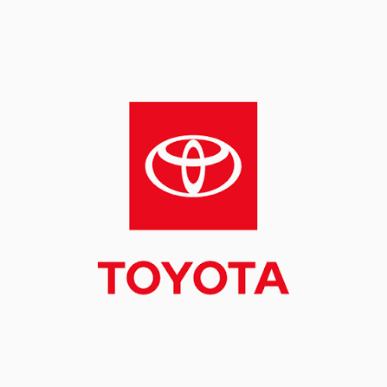
Figure 1: Toyota Logo (Toyota, 2025)
Toyota's competitiveness in the international market is evident as it sold around 10.8 million cars worldwide in 2025. The company's purpose is to make people happy for all with a sustainable mobility, and its vision is to make a future based on safe, eco-friendly and innovative mobility (Toyota, 2025).

Selected Countries
This report is a comparison of the international marketing strategy adopted by Toyota in its home country, Japan and in one of the major markets that it operates in, India. Toyota entered the Indian market in 1997 with its venture Toyota Kirloskar Motor (TKM) with the Kirloskar Group. The collaboration helped Toyota to manufacture in India, increase the distribution network, adapt its offerings to Indian tastes and preferences, and ensure that the company's global standards are maintained (Mathew & Burgess, 2023).

Purpose of the Report
This report critically assesses the international marketing strategy of Toyota by comparing and contrasting the Japanese and Indian markets, the STP (Segmentation, Targeting and Positioning) strategy, 7Ps marketing mix, market entry strategy and ethical marketing practices within the context of PESTLE.

Company Background

Toyota's History and Global Expansion
Toyota Motor Corporation was founded in 1937 by Kiichiro Toyoda when he split off from Toyoda Automatic Loom Works. Toyota started manufacturing passenger cars for the Japanese market, and began exporting their first cars to the United States in 1957. Currently, Toyota has manufacturing plants in more than 25 countries and regions, and sells vehicles in over 170 countries, allowing them to respond to the market demand level in a corresponding area efficiently, while maintaining quality standards globally. Its business model is to standardise the global product and adapt it locally by manufacturing in various regions, having a wide network of suppliers, and continuously improving (Kaizen), which increases operational efficiency and customer satisfaction (Abdeldayem et al., 2023).
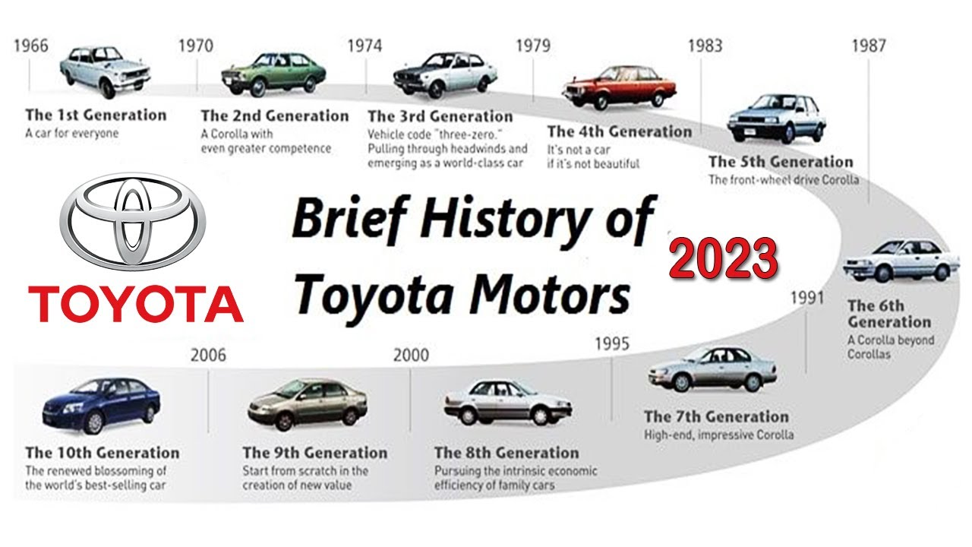
Figure 2: History of Toyota Motors (Abdeldayem et al., 2023)

Toyota's Operations in India
The Indian market is one of the key global markets for Toyota due to the growing middle-class population and the rapid growth of the Indian automobile industry. Toyota entered India in 1997 through a joint venture with the Kirloskar Group, establishing Toyota Kirloskar Motor (TKM). The collaboration allowed Toyota to learn about the local market and understanding of its people, create a significant network of dealerships, and manufacturing plants in Bidadi, Karnataka, which lowered production expenses and boosted the efficiency of their supply chain (Sarangal et al., 2023).

PESTLE Framework
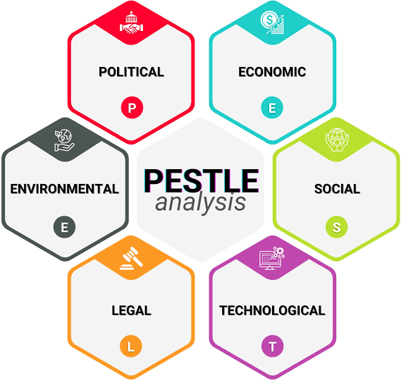
Figure 3: PESTLE Analysis (Kotler & Keller, 2022)

Political Factors
Japan provides Toyota with a more predictable policy environment for its technology-led strategy, particularly through government support for hybrid, hydrogen and advanced automotive manufacturing. This will help Toyota's R&D and commercialization ability to build a more high-tech offering in its familiar domestic ecosystem. On the other hand, in India the 100% FDI policy, Make in India, and PLI Scheme, provide a better location-based advantage by incentivizing the growth of local manufacturing by Toyota Kirloskar Motor, which could boost the country's cost competitiveness and supply chain efficiency (Mittal, 2024). Hence, the policy environment for technological leadership is more stable for Toyota in Japan while localisation and cost-effectiveness is more attractive in India. On the other hand, the Indian manufacturer is finding greater flexibility in production but will need to be more responsive to changing the product line in India and adjust prices faster.

Economic Factors
For Toyota, there are different economic opportunities in Japan and India. The GDP growth of India is at 7.6% in FY26, 7.1% in FY25, and expected to remain 6.6% in FY27, which is higher than that of Japan's more developed economy (World Bank, 2026).
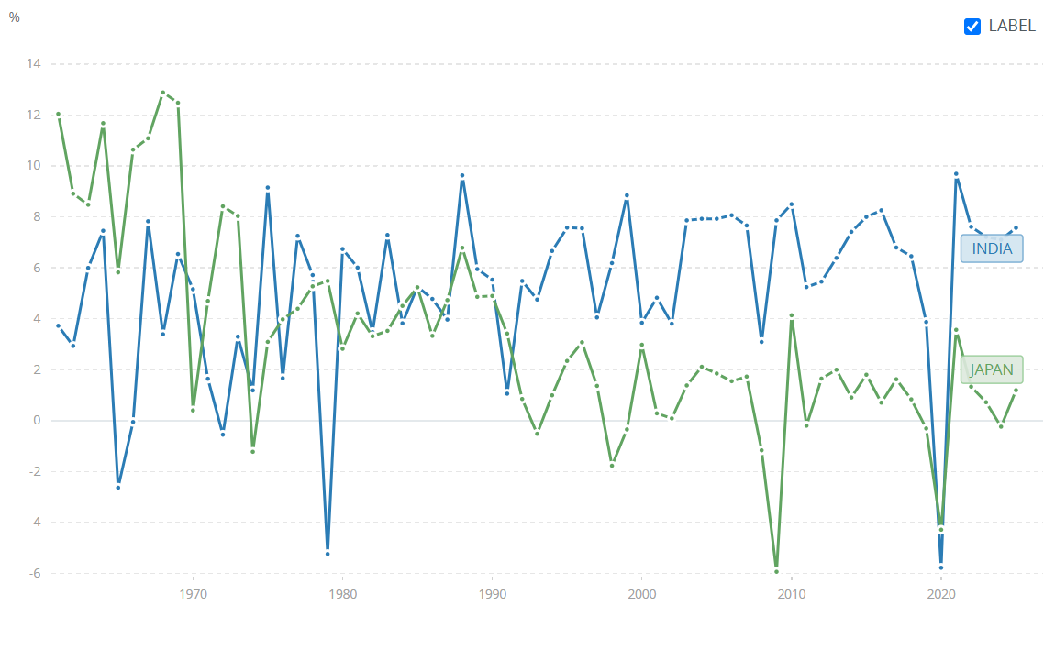
Figure 4: GDP Growth Rate India and Japan (World Bank, 2026)
For Toyota, this makes India more appealing for volume growth, but the demand in the country is bound to be dependent on the premium pricing as the purchasing power is not very high. Thus, the fuel economy, value, and affordability have to be integrated into models like the Innova HyCross and Urban Cruiser Hyryder. The headline inflation in India has maintained an average of 1.7% from April to December 2026 with a peak of 4.38% in June 2026 (World Bank, 2026), thus putting inflation in India under changing cost and pricing conditions (Aman et al., 2025). Therefore, Toyota has to focus on the value and localisation aspects in India with the application of technology and premium positioning in Japan.
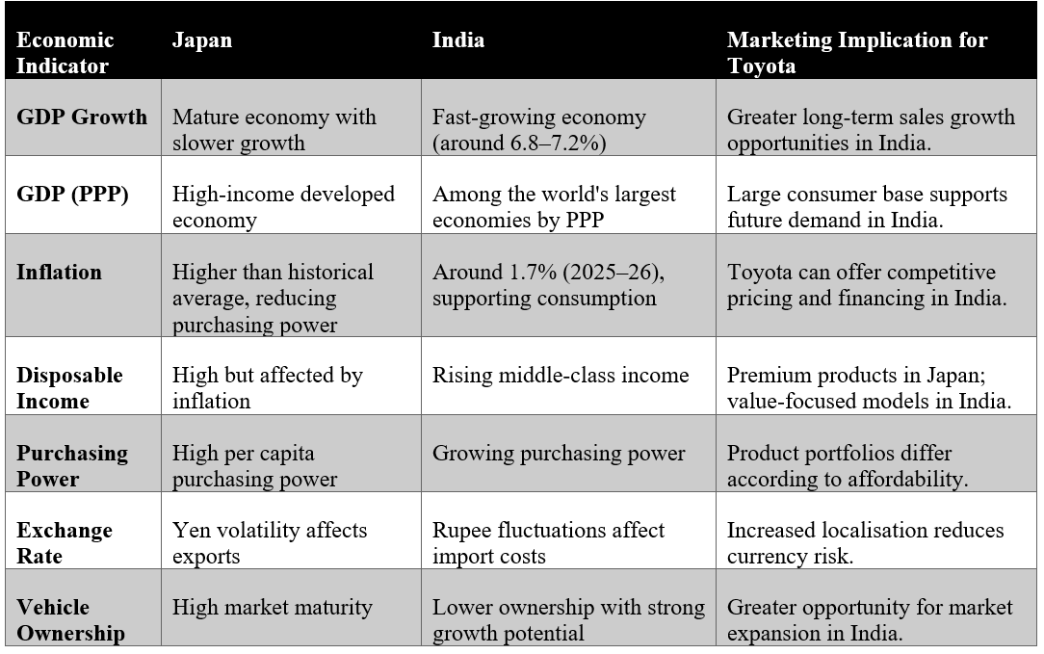
Table 1: Comparison of Economic Factors in Japan and India (Author)

Social Factors
There are significant social differences, presenting Toyota with different positioning opportunities in Japan and India. The Japanese market has 92% of its population living in urban areas and this is also the ageing market, which prefers smaller vehicles, reliability, and are technologically advanced, with Toyota's hybrid capabilities and safety orientation being of major importance. On the other hand, the younger population in India, high urbanisation and larger family sizes make spacious SUVs and MPVs more relevant on how value, fuel efficiency and family utility can make a difference in vehicle choice (Hartoyo et al., 2023).

Cultural Factors
Hofstede also provides evidence of significant cultural differences, such as India has higher score on Power Distance (77) compared to Japan (54), Individualism (62) vs (24), Masculinity (95) vs (56), Uncertainty Avoidance (92) vs (40) and Long-Term Orientation (100) vs (51) (Cultural Factor, 2026).
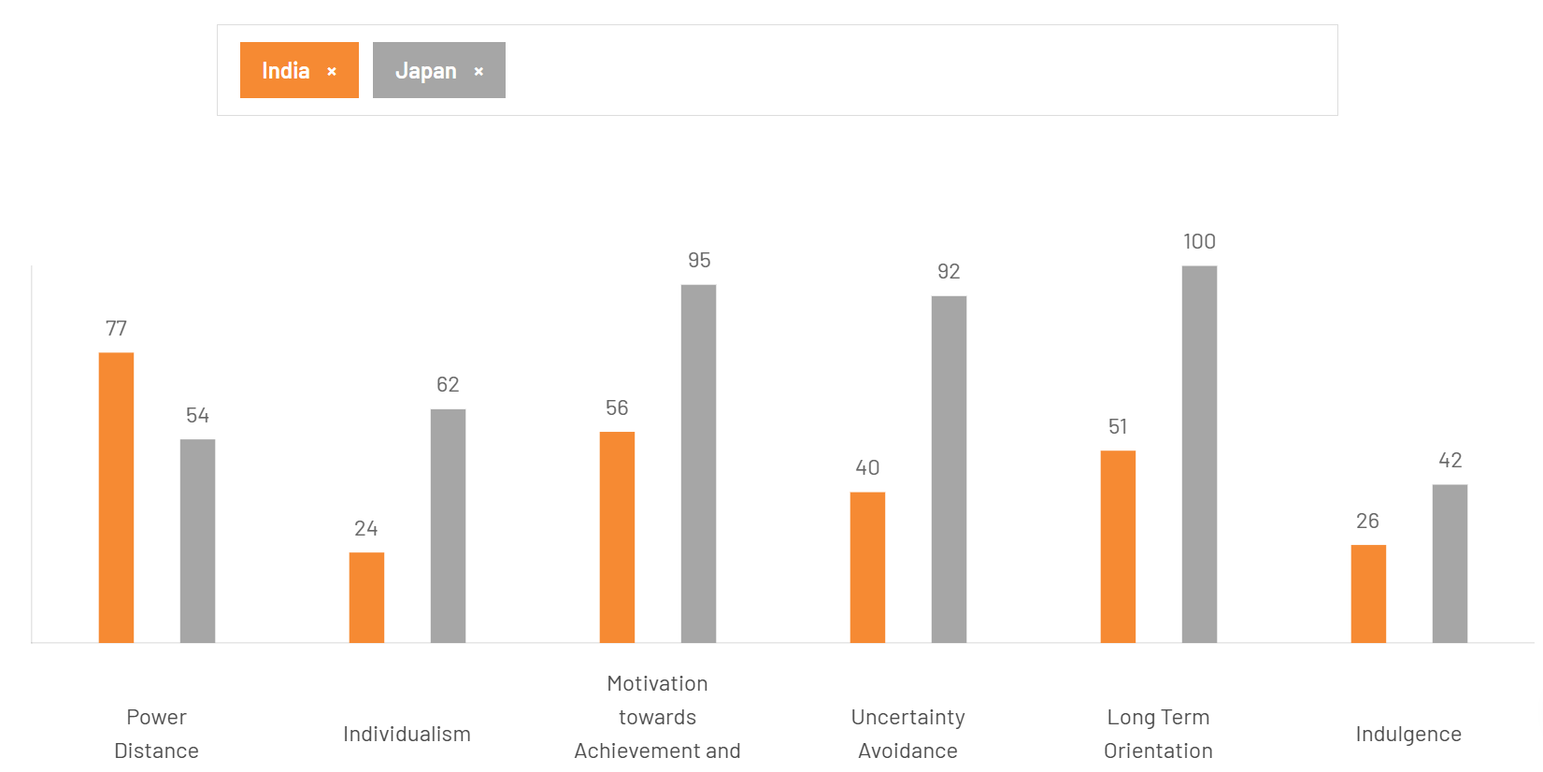
Figure 5: Hofstede Factors Comparison for Japan and India (Cultural Factor, 2026)
The differences benefit Toyota to place more emphasis on status and family value in India, while Japan offers more opportunities to target its engineering quality, reliability, safety and long-term ownership. Hence, the positioning can't be the same: Toyota should stress on the technological reliability and long-term value, whereas India should focus on practical value, space, fuel efficiency, and status-oriented appeal.
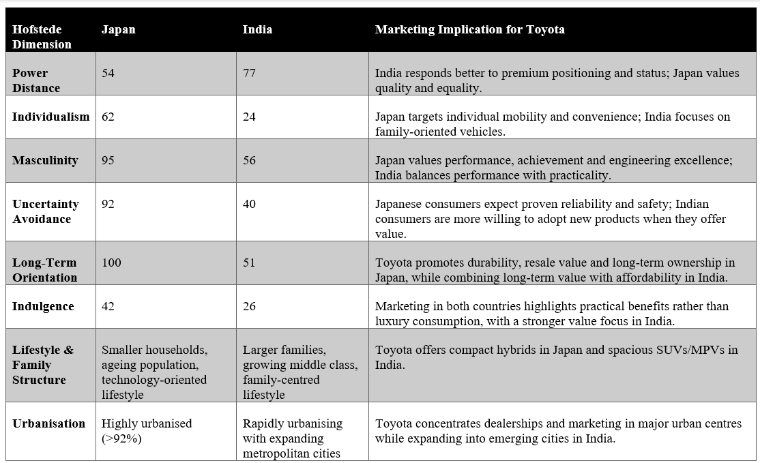
Table 2: Comparison of Social and Cultural Factors between Japan and India (Cultural Factor, 2026)

Technological Factors
Japan gives Toyota a stronger technological platform through advanced automation, AI, robotics, connected vehicles and established hybrid capabilities, supporting its technology-led positioning. The opportunities are different in India: expanding digitalisation and internet penetration, facilitating digital dealerships, and less attractive charging infrastructure, and slower EV adoption, making a pure EV offer more unattractive initially (Khan & Pervin, 2024). Therefore, Toyota should standardize its fundamental technological capabilities for both markets, while adapting them to communicate with both markets. Toyota needs to highlight fuel efficiency, affordability, and usability of hybrid technology in India, while advanced engineering, connectivity, and innovation will be the focus in Japan. This is not a measure of different levels of technical readiness but of different levels of market readiness.

Legal Factors
Strict vehicle safety, consumer protection, and environmental laws in Japan make the compliance costs higher, but also further strengthen Toyota's quality-driven image and technology investments. On the other hand, India's BSVI emission norms, enhanced crash-safety norms and consumer protection laws mandate Toyota to adjust its product specs and quality management processes to meet local needs and standards. More importantly, India’s high import duties on completely built vehicles make importing Toyota models less cost-effective than local manufacturing, strengthening the strategic case for Toyota Kirloskar Motor to increase localisation (Patil, 2026). Hence, the laws governing Japan further stress Toyota's quality and technology, whereas the legal system in India has a direct impact on Place and Price by promoting local manufacturing and competitive pricing.

Environmental Factors
The 2050 carbon-neutral goal in Japan implies different strategic challenges for Toyota than India's 2070 "net zero" target. Japan’s earlier target strengthens the need for Toyota to maintain its technological leadership in hybrids, hydrogen and battery-electric vehicles, supporting a sustainability-focused brand position. At present, in India, the hybrid portfolio comprising of Toyota Urban Cruiser Hyryder and Camry Hybrid would be more viable commercially as compared to BEVs alone due to its longer transition period and weaker charging infrastructure (Kumar et al., 2025). But increasing pressure to develop BEVs comes with a risk that Toyota's hybrid strategy might lose competitiveness with the improvement of the infrastructure in India. Hence, Toyota has to standardise its environmental technology capabilities and shift its product focus to a higher speed on BEVs in Japan, while hybrid is the transition product in India.
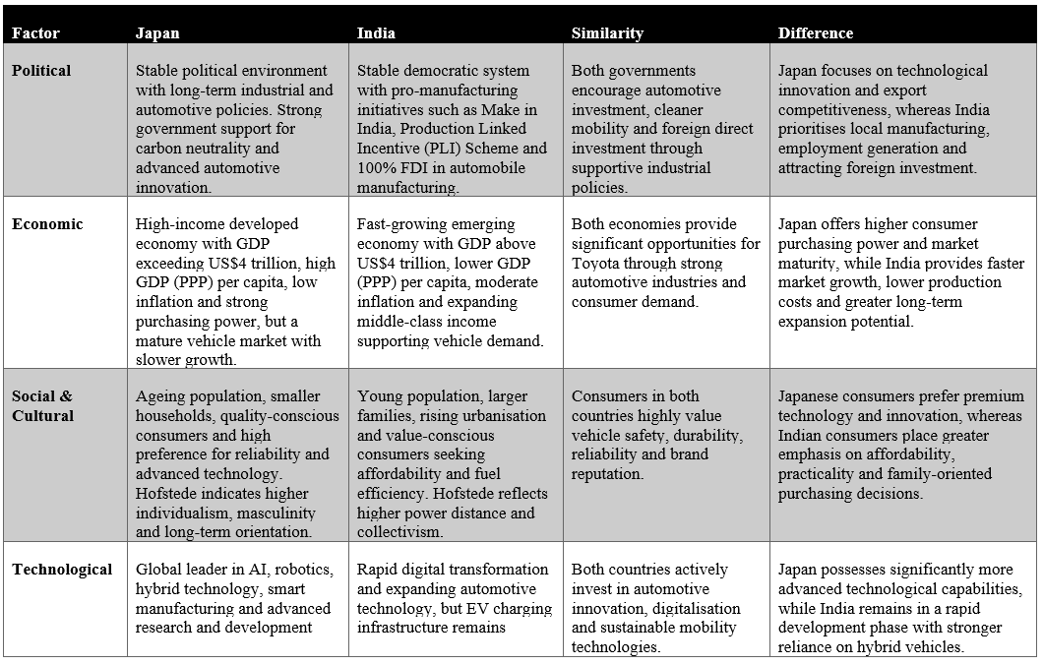
Table 3: Similarities and Differences between Japan and India (PESTLE Analysis) (Author)

Comparative STP Strategy

Market Segmentation
Market segmentation helps Toyota understand that there are segments which have similar needs and purchasing behaviour enabling them to come up with a more meaningful marketing strategy (Elliott et al., 2026).
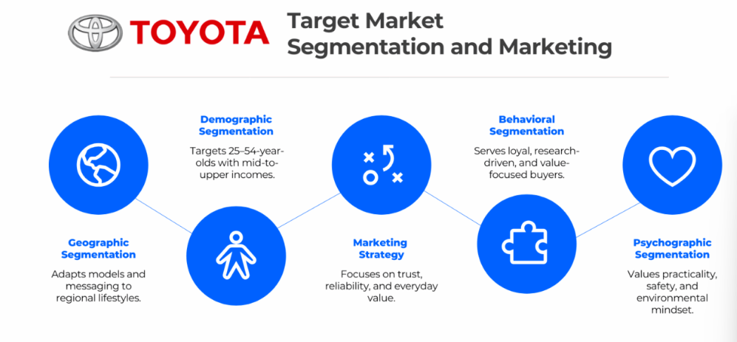
Figure 6: Toyota Target Marketing Strategy (Elliott et al., 2026)
For Toyota, each of these variables is of different importance in Japan as compared to India. While technology, environmental preference, age and urban mobility have a special relevance in Japan, income, family structure, urbanisation, and vehicle preferences drive the opportunity in India. Therefore, Toyota must have a consistent base brand offering but allow for a different focus of the segments it wants to emphasize in each country.
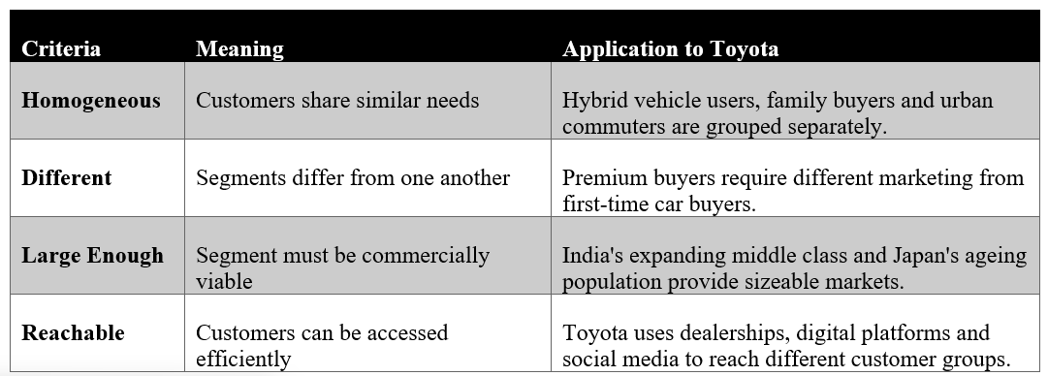
Table 4: Characteristics of Effective Market Segmentation (Author)

Geographic Segmentation
Toyota's strategy value is different in both markets. In Japan, Toyota can focus on highly urbanised cities such as Tokyo, Osaka, Yokohama and Nagoya, where limited space, congestion and environmental expectations support demand for compact, fuel-efficient and hybrid vehicles (Ito & Kato, 2025). The segmentation in the Japanese market is, therefore, primarily a way to prioritize product and communication decisions in a well-established market.
India needs a geographical diversification of growth. Toyota put focus on Tier-1 and Tier-2 cities, such as Bengaluru, Delhi, Mumbai, Hyderabad, Chennai, and Pune, where the growing income, better infrastructure, and urbanisation are driving the demand for SUVs and hybrid vehicles (Shalender & Shanker, 2023). Geographic segmentation is thus helpful to Toyota in deciding the region where they should introduce the dealerships and how much marketing investment, they should put in and how much market coverage they should provide in India, unlike Japan.
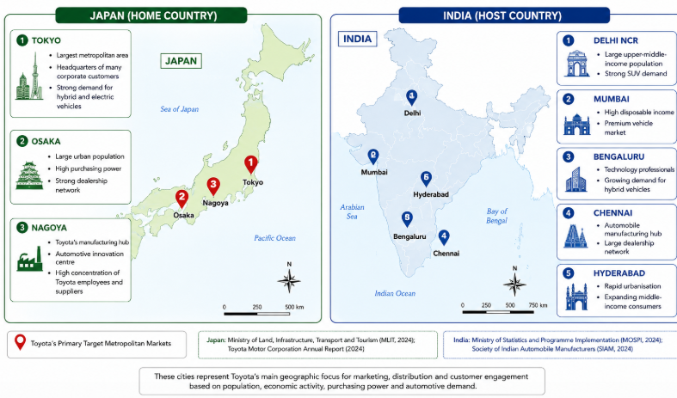
Figure 7: Toyota Geographic Segmentation (Patil, 2026)

Demographic Segmentation
Demographic segmentation also produces various strategic opportunities. Safety, reliability, comfort, and efficiency are key factors in Japan due to an aging population, lower family sizes, and high incomes. Toyota can therefore appeal to older consumers and working professionals with models like the Toyota Prius, Toyota Corolla Hybrid, and Toyota Crown, stressing on long-term reliability, safety technology, and efficient mobility (Biswas et al., 2023). India has a wider demographic opportunity. Toyota aims at adults in their 30s to 50s who are professionals, business owners, and upper middle-class families. As the size of the family grows, and the purchasing power of the people also increases, there is an increase in demand for bigger-sized vehicles like the Innova HyCross, Urban Cruiser Hyryder, and Fortuner (Suprayitno, 2024). Hence, Toyota's demographic approach in India should link the affordability and usability with family needs and social status. Compared with Japan, demographic segmentation is consequently more closely linked to vehicle category and market expansion in India.
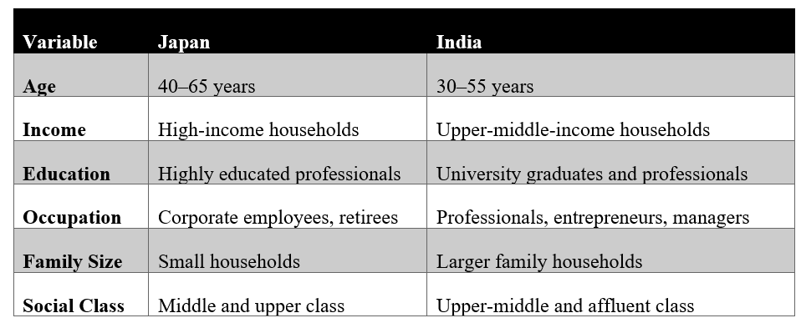
Table 5: Demographic Segmentation of Toyota (Author)

Psychographic Segmentation (AIO Model)
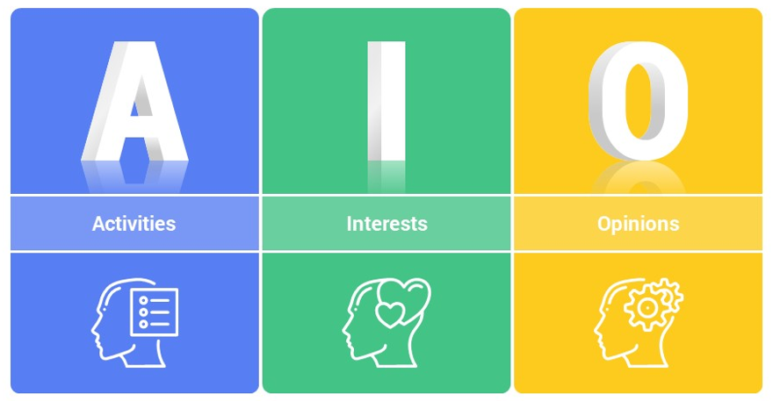
Figure 8: AIO Model (Putri et al., 2025)
Psychographic segmentation offers Toyota the chance to modify the benefits offered to customers instead of altering its products. Consumers who appreciate order, environmental responsibility, reliability, and technological innovation offer a good match with Toyota's hybrid technology, intelligent safety systems, and connected-vehicle services (Putri et al., 2025).
In India, psychographic attributes are more strongly associated with one's professional success and social mobility and family comfort. Both functional benefits (space and reliability) and symbolic benefits (achievement and progress) can be delivered by Toyota's Fortuner and Hyryder vehicles (Wibowo et al., 2025). Thus, Toyota should not communicate technology similarly: Japanese communication can focus on engineering and environmental performance, whereas Indian communication can be linked to innovation, family benefits, and aspirations.

VALS Framework
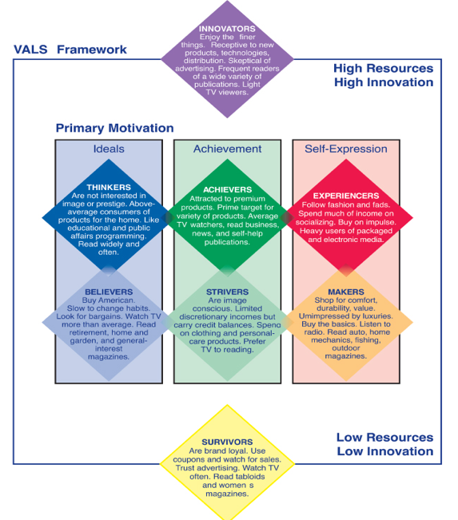
Figure 9: VALS Framework (Rienecker et al., 2026)
The VALS framework also helps Toyota to identify the relevant personality-based segments. Thinkers and Innovators are especially applicable in Japan. Thinkers value quality, reliability, and informed purchasing, but Innovators are more accepting of hybrid technology and smart safety and sustainable mobility (Rienecker et al., 2026). Toyota can thus leverage its brand identity and prove its quality to support its current brand image.
Achievers and Innovators are better strategic fit in India. For the Achievers, their car might represent success professionally and socially, while for Innovators, it could be an aspect of connected technologies and environmentally responsible mobility (Rienecker et al., 2026). The comparison suggests that the technology can stay the same, but the benefit offered by the technology must be different; credibility and engineering excellence in Japan and achievement and modernity in India.

Behavioural Segmentation
There is also behavioural segmentation which further highlights the difference between Toyota's both markets. It's a great replacement opportunity for existing Toyota owners and loyal customers in a mature market in Japan. The quality, after-sales service, and hybrid technology offered by Toyota can help persuade current customers to replace old vehicles for newer ones (Ito & Kato, 2026). Therefore, Toyota should be able to rely on customer retention, loyalty, and product improvements as a defense of its solid market position.
The opportunity to gain new customers and switch them to Toyota is higher in India. The first-time buyers of a SUV, Toyota customers, fleet users, and those who are moving from Hyundai, Maruti Suzuki, and Tata Motors are all included in the relevant segments (Ito & Kato, 2026). Toyota, therefore, must do more marketing with a focus on acquisition, especially when a customer is weighing the ownership cost and practical value of cars between brands.
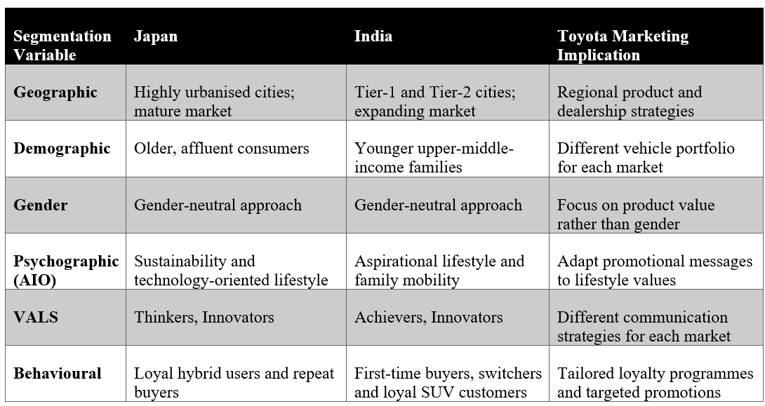
Table 6: Comparison of Market Segmentation in Japan and India (Author)

Targeting Strategy
Toyota uses a differentiated targeting strategy because the needs and purchasing conditions of its priority segments differ between Japan and India. Toyota caters to eco-conscious and technology-loving customers with its hybrid products, and premium and SUV buyers create the demand for higher-priced vehicles in Japan. In India, the focus is more on middle income families, urban professionals and fleet/commercial buyers; with the Innova HyCross, Fortuner, and Urban Cruiser Hyryder catering to various mobility and value needs (Sheel Achnani, 2025). This differentiation is strategically appropriate as the use of a single target profile would be inappropriate without considering the differences in purchasing power, the different levels of household needs, as well as the different levels of market maturity. For Toyota, the key advantage is that it can maintain a consistent global brand based on quality and reliability while allocating different products and marketing resources to the most attractive segments in each country. So, Japan is more oriented towards a target approach that uses technology and sustainability, while India needs to focus more on value, family utility, and commercial demand.
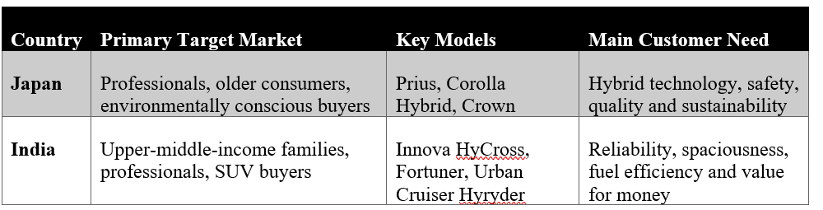
Table 7: Toyota's Target Markets in Japan and India (Sheel Achnani, 2025)

Positioning Strategy
Toyota employ benefit and competitive positioning, but they are different in both markets. Toyota's positioning in Japan is built around the aspects of reliability, advanced hybrid technology, safety, and engineering quality, with models like the Prius, Corolla Hybrid and Crown (Panigrahi & Bisoy, 2021).
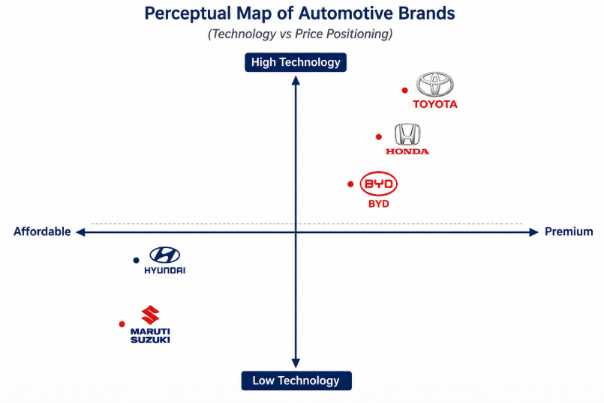
Figure 10: Perceptual Map (Kumar et al., 2022)
Toyota's reliability, fuel efficiency, family space, durability, and after sales service, especially the Innova HyCross, Fortuner, and Urban Cruiser Hyryder, is more prominent in India. It thus differentiates the brand from Maruti Suzuki and Hyundai in terms of perceived quality and ownership value (Kumar et al., 2022). The perceptual map shows that in Japan Toyota is perceived to have a better premium and technology position, whereas in India the better position is more related to reliability and practical family value.
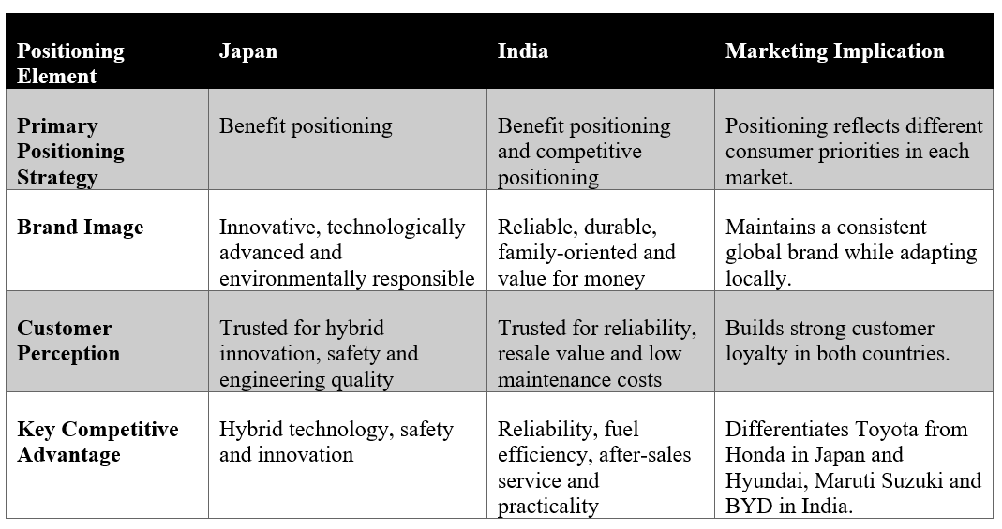
Table 8: Comparison of Toyota's Positioning Strategy in Japan and India (Author)

Similarities and Differences of Toyota's STP Strategy in Japan and India
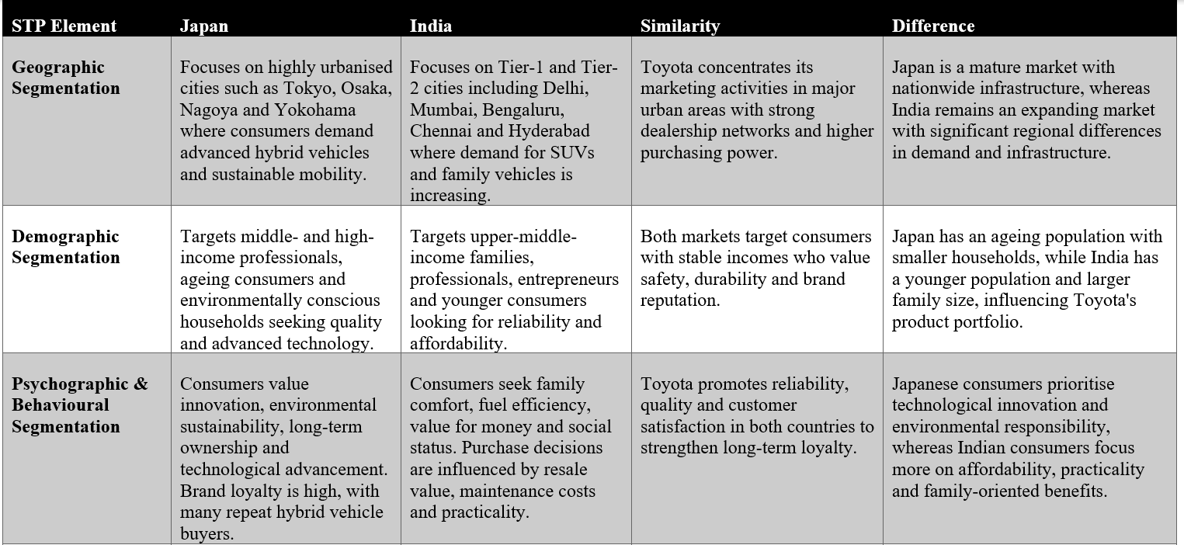
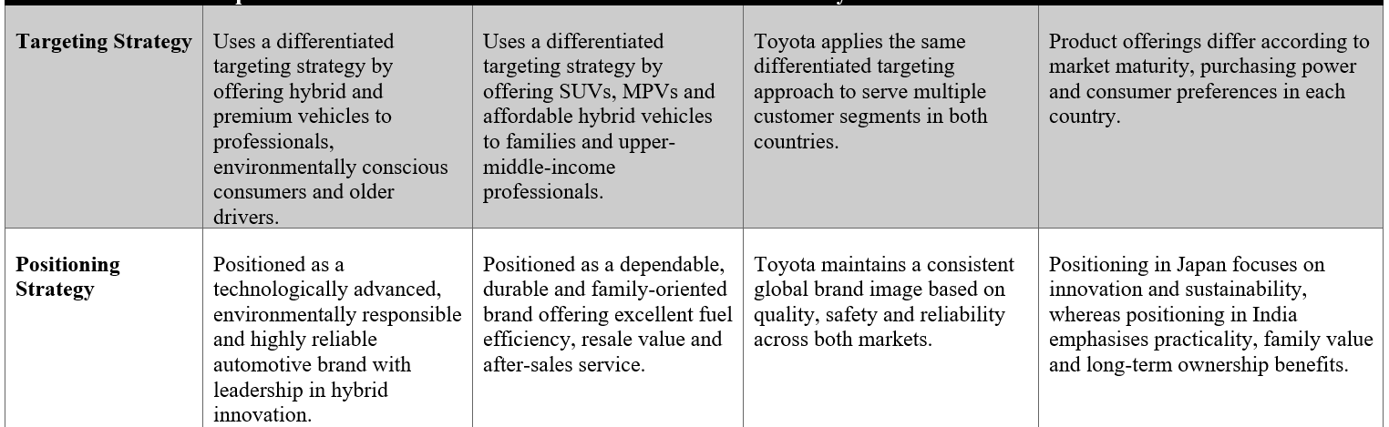
Table 9: Similarities and Differences of Toyota's STP Strategy (Author)

Comparative Marketing Mix (7Ps)

Marketing Mix
Marketing mix (7Ps) is a strategic framework used by organisations to meet the needs of their customers and thus gain competitive advantage in various international markets (Kotler & Keller, 2022).
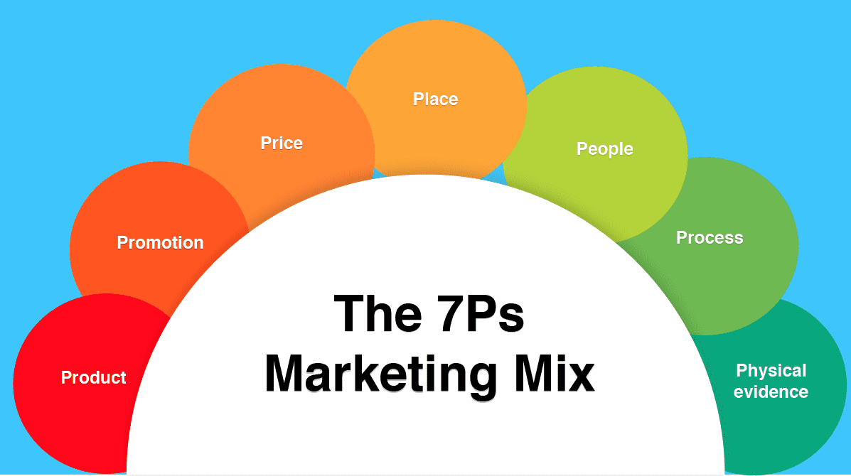
Figure 11: Marketing Mix (7Ps) (Kotler & Keller, 2022)

Product
Toyota is implementing selective adaptation in Japan and India. In Japan, it has a wide product width, including compact cars, hybrids, SUVs, and high-end models, and a deep product depth with several variations in its existing models including Prius, Corolla, and Crown models and hybrids. The width has more significance in India for SUVs, MPVs, as well as smaller cars such as the Innova HyCross, Fortuner, Urban Cruiser Hyryder and Glanza (Iskamto & Wicaksono, 2023).
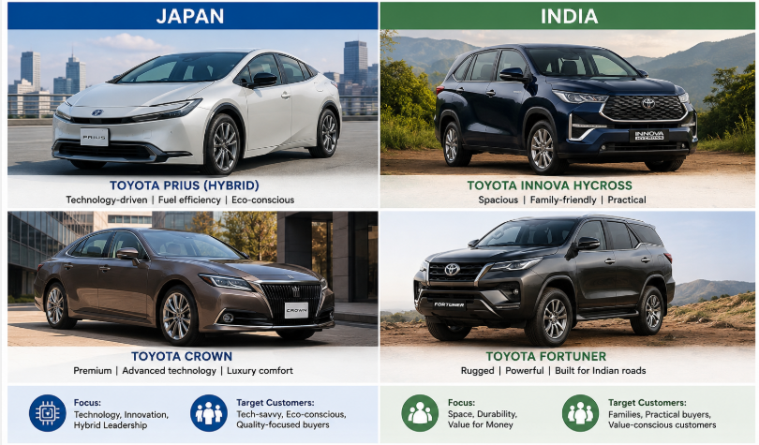
Figure 12: Toyota's Product Comparison (Iskamto & Wicaksono, 2023)
This is indicative of India's greater family and value needs. Toyota thus creates a consistent quality and brand image internationally, varying only the model range, powertrain, and features as per local demand.

Price
Toyota's pricing should vary, depending on the conditions of purchase. The price sensitivity of Indian consumers is more pronounced than the purchasing power of Japanese consumers, with localization and financing playing a more significant role in the Indian case, while Japanese consumers are more interested in technology and quality based value. Toyota's shareholding of 89% in TKM and local manufacturing helped in cost control in India (Tavor et al., 2023). This implies that Toyota will be able to defend a more robust technology-value proposition in Japan, and offer locally manufactured models coupled with competitive financing terms, to mitigate affordability issues in India.

Place
Toyota's existing dealership and service network ensures the availability of the vehicles and their continued use by customers. Geographical spread is a necessity in India as Toyota grows in urban and emerging markets. Distribution expansion was vital, as TKM had a total of 1,157 customer touchpoints till April 2025 in India (Ishii & Kikumori, 2025).
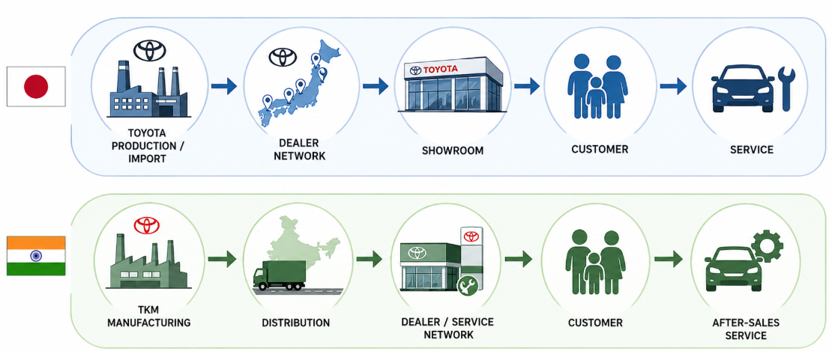
Figure 13: Toyota's Distribution and Service Channels (Ishii & Kikumori, 2025)

Promotion
Toyota can apply IMC to link up the advertising, Digital media, dealership, Public relations, and Personal selling together. Hybrid technology, engineering, and environmental performance can be incorporated into communication in Japan. The same level of reliability has to be conveyed in India via family safety, fuel efficiency, and durability. For example, digital advertising can create awareness, dealership test drives can support evaluation, and sales staff can convert interest into purchase (Guterres & Freitas, 2024). The key difference is therefore not Toyota's core message but how the message is translated into local purchase benefits.

People
People are important since there's a need for individual interaction during the purchase of the vehicle. In March 2026, Toyota had a total direct employment of 73,133 workers at Toyota Motor Corporation and permanent 6,466 workers at TKM (Rienecker et al., 2026). Training of all markets should continue to reflect Toyota's international standards but in the Indian market there is a need for enhanced focus on customer finance, profit and family benefits and a variety of customer needs.

Process
Toyota can standardize the core process, and adjust the customer journey accordingly. The Japanese have their own systems of established digital and dealership-based enquiry, configuration, test-drive, purchase ,and after-sales processes, which customers can navigate. Financing assistance, test drives, online enquiries, and service support are more significant in curbing purchases in India (Kormakova et al., 2023). Thus, Toyota should continue to have consistent quality controls, but they should adjust the sales and service process to meet local customers' expectations.

Physical Evidence
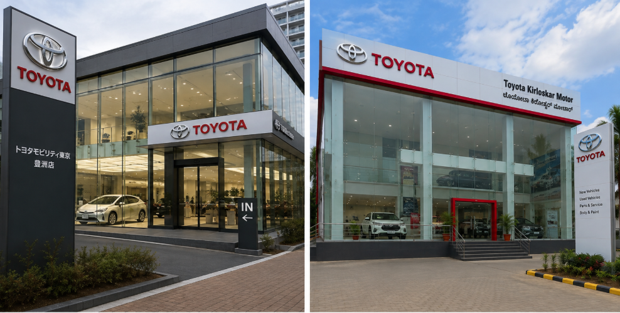
Figure 14: Toyota Dealerships in Japan and India (Brouthers et al., 2022)
Toyota's retail outlets, dealerships, websites, signage, and vehicle presentation drive reliability and quality. Japanese works need to further develop the “image” through technology, and Indian dealerships need to convey “trust, family suitability and value” (Brouthers et al., 2022).
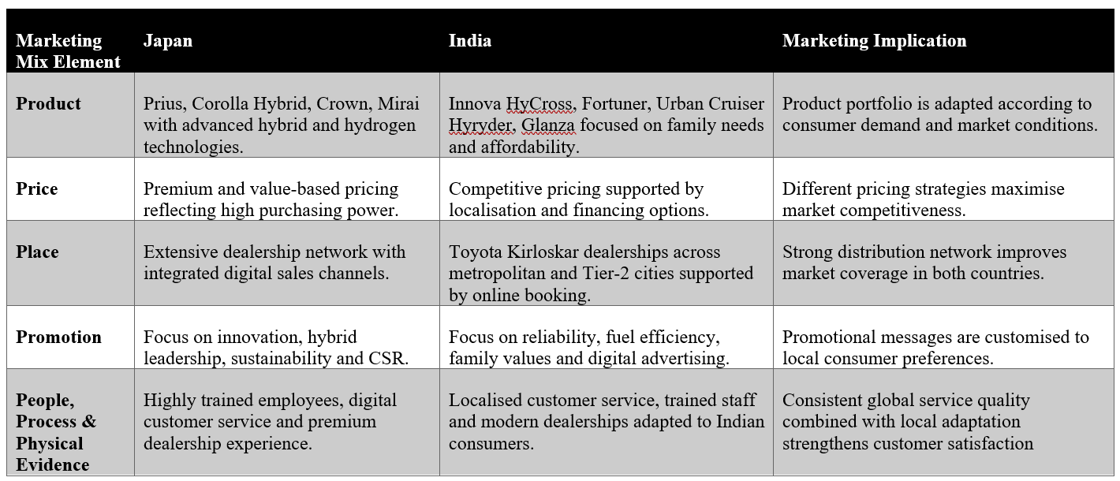
Table 10: Comparison of Toyota's Marketing Mix in Japan and India (Author)

Market Entry Strategy (India)
Toyota entered in India in 1997 with a joint venture Toyota Kirloskar Motor (TKM) with Kirloskar group. A joint venture was strategically preferable to exporting because Toyota needed local knowledge of India's regulatory environment, suppliers and consumer preferences, while avoiding the full commitment and risk of a wholly owned operation. Kirloskar's local skills supplemented Toyota's manufacturing skills and quality systems, and enabled Toyota to produce locally, instead of relying so much on imported cars. This was pivotal as India's high import duty on complete vehicles makes manufacturing them locally cheaper. This is why TKM is able to help Toyota keep costs in check and provide vehicles that meet Indian requirements, such as the Innova HyCross, Fortuner, and Urban Cruiser Hyryder. In comparison to a wholly owned subsidiary, Toyota allows for less control, but gains more local market knowledge and manufacturing ability in comparison to exporting (Kormakova et al., 2023). Hence, the JV will continue to be a viable solution for Toyota as localisation, cost competitiveness, and customer adaptation are more critical in India than the mere transfer of Toyota's operating model.
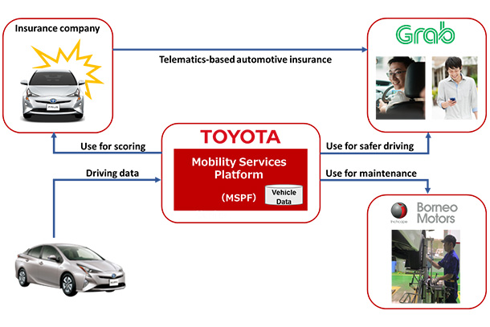
Figure 15: Toyota Distribution Channels (Kormakova et al., 2023)

Ethical Marketing Evaluation – India
Toyota's ethical marketing in India can be assessed in terms of the principles of Carroll's CSR framework and Stakeholder Theory. Instead of viewing ethics as a company-wide problem, the important thing to consider is whether Toyota's marketing and product decisions provide a balanced value to Indian customers, government, employees, communities, and the environment (Palhau et al., 2024).
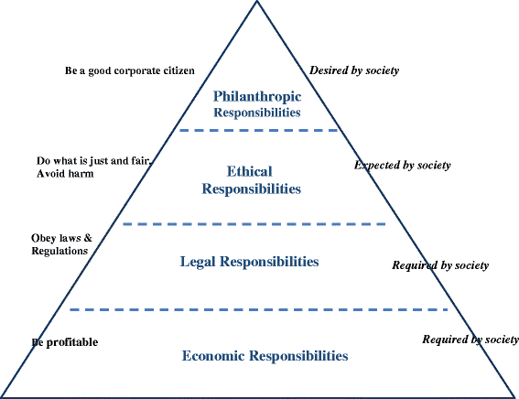
Figure 16: Carroll Pyramid (Palhau et al., 2024)

Environmental Sustainability and Product Responsibility
Toyota's hybrid lineup, especially the Urban Cruiser Hyryder, provides an ethical advantage to the Indian consumer, as it offers them the option of lower emission mobility without relying solely on charging infrastructure. This is to support the environmental stakeholders and India's shift towards cleaner transport. Beyond the immediate impact on the community, Toyota Kirloskar Motor extends its benefits through education, skill development, and road-safety initiatives, further contributing to the broader well-being of the community (Palhau et al., 2024). But this advantage must be weighed against Toyota's continued dependence on hybrid technology, and the growing demand from stakeholders for all-electric cars.

Carroll's CSR Evaluation
As per Carroll's theory, economic responsibility of Toyota is evident as they are making commercially viable vehicles for Indian consumers and legal responsibility of Toyota is evident due to its compliance to the safety and environmental norms of India. Its ethical responsibility extends to providing transparency regarding vehicle testing, product claims, and environmental communication. The Daihatsu safety-testing scandal illustrates the need for Toyota to tighten up quality governance throughout its broader group, even if the problem is within a subsidiary (Patil, 2026). Philanthropy is exemplified through the education, skills and road-safety programs at TKM

Stakeholder Implications
The stakeholder view is that Toyota's approach is providing benefits to the customer in terms of safer and lower emission vehicles, benefiting employees with skills development, benefiting communities with CSR programmes, and benefiting government by supporting environmental objectives. Environmental stakeholders, however, can have a greater expectation for the development of BEVs to be faster, and customers can suffer the consequences of any loopholes in safety assurance (Suprayitno, 2024). This would help protect trust, and reinforce Toyota's ethical stance in India.

Recommendations

Recommendations for Japan
According to the STP analysis, the Japanese market is mature and aging, with Toyota having a high level of loyalty among existing consumers, and with its positioning in the environment and technology segment, the company has the potential of gaining more customers from younger professionals and eco-conscious consumers (Suprayitno, 2024). Hence, Toyota needs to be more aggressive in digital targeting towards the younger segment, advertising BEVs, connected mobility and intelligent driving through personalised digital campaigns. The results will be greater engagement with younger age groups and greater uptake of newer technologies. KPIs: digital enquiries, test-drive bookings, BEV sales and conversion rates.
The 7Ps analysis also identified an opportunity to improve Process and Physical Evidence through AI-powered customer support, virtual showrooms, online vehicle customisation and predictive-maintenance applications. The services would enhance convenience and further solidify Toyota's brand identity as a technology-driven brand in Japan (Tavor et al., 2023). KPIs: Online configuration completions, App usage, Digital bookings, and customer satisfaction.
Last, but not least, Toyota’s quality and sustainability reporting needs to be improved to be more independent, especially after the quality-assurance issues in its wider group. Clear reporting will limit risk to reputation and foster trust among all stakeholders. KPIs: independent published audits, indicators of customer trust, indicators of sustainability disclosure coverage.

Recommendations for India
The STP analysis revealed greater growth potential for middle-income families, urban professionals, and SUV/MPV buyers; and Geo segmentation revealed opportunities outside of Tier-1 cities. Targeted distribution and localised marketing should be used to enter selected Tier-2 and Tier-3 cities, and Toyota should provide affordable hybrid options to encourage uptake, as well as using localised communication (Achnani, 2025). This would help to further expand Toyota's presence without compromising its reputation in reliability. KPIs: new-city sales, dealership coverage, test drives and market share.
In addition, price sensitivity and localisation was identified in the economic and 7Ps analysis. Toyota should increase local sourcing and provide flexible financing while communicating fuel efficiency, family safety and lower ownership costs. This would help to lower affordability obstacles and help make Toyota's offering more competitive. The (KPIs are local-content ratio, financing uptake, sales conversion, and average customer acquisition cost.

Conclusion
This report evaluated Toyota's international marketing strategy by comparing its operations in Japan and India. The PESTLE analysis highlighted that due to some variations in political, economic, social, technological, legal, and environmental factors, Toyota should change its marketing strategy in international markets but not completely standardise it. The analysis revealed that the Toyota's strategy of segmentation, targeting, positioning is effective in achieving differentiated targeting in each country due to the firm's approach of having a global brand positioning that has not been compromised by the quality, reliability, and innovation. Toyota's strengths in the evaluation of the 7Ps marketing mix were the flexibility with which they can change their products, pricing, distribution, and promotion strategies in response to changing market situations.

Reflective Essay: Using Gibbs' Reflective Cycle
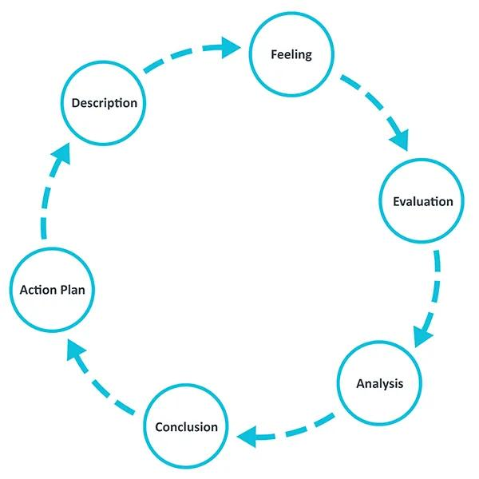
Figure 17: Gibbs Cycle (Achnani, 2025)

Description
This report involved critically analysing Toyota Motor Corporation's international marketing strategy by comparing its operations in Japan and India. It was necessary to use several international marketing theories and frameworks, such as the PESTLE framework, Hofstede's Cultural Dimensions, the 7Ps Marketing Mix, Entry Mode theory, and Carroll's CSR Pyramid. The goal was not only to explain these theories but to also illustrate how they can be applied to Toyota's marketing strategies in both countries.
Data sources included in the research process were academic journals and books, Toyota's annual reports, government publications, and industry reports. Special attention has been paid to compiling up recent data on the economic performance, consumer attitudes, policies relating to the environment, and automotive market trends to ensure analysis is current.

Feelings
At the beginning of the report it was challenging to integrate several marketing concepts across the same organisation, instead of presenting the theories individually. The main challenge was comparing Toyota's strategy in Japan and India because the two markets differ in economic development, consumer behaviour, culture and automotive conditions. Although I planned to describe Toyota's activities, I felt that I needed to include reasons why Toyota adopts different approaches and what this means for its competitiveness to explain. Finding recent or reliable GDP, inflation, and vehicle markets, government policies data also needed careful selection of sources. As I worked on the research, I become more confident of the link between the evidence and Toyota's actual marketing decisions.

Evaluation
The research process is successful as I'm able to integrate the PESTLE, Hofstede, STP, and the 7Ps instead of applying them individually as theories. PESTLE was useful to me to understand the different political, economic, social, technological, legal, and environmental factors affecting Toyota in Japan and India. Hofstede helped me think about the cultural differences, whilst STP and the 7Ps helped me to explore how Toyota responds to them by segmenting, targeting, and positioning and making marketing-mix decisions. My first attempt was, however, too descriptive. I tended to include what Toyota was doing without really investigating if it was the right thing to do and if it really works in each country. So I adjusted the report by making the comparison to the two markets more directly and making the evidence more closely relate to Toyota's strategic implications.

Analysis
The application of STP proved helpful in this regard as it demonstrated that Toyota cannot appeal to the Japanese and Indian markets similarly. For the mature market in Japan, ageing population and higher technology and environmental interest are important – reliability, hybrid technology and long term value. Price sensitivity and higher growth potential, higher family sizes are more key factors in the Indian market for SUVs and MPVs, and for affordability and fuel efficiency. By comparing these two, I realized that Toyota can keep a consistent brand globally and change its market priorities according to the local market.
This was followed by the 7Ps analysis which furthered my understanding. I discovered that there is more to adapt than products. The price can be modified based on purchasing power, cost, product distribution based on market coverage, and promotion based on consumer preference and communication. I also learned more about critical analysis as I started to ask myself, "What does a Toyota strategy do? Does it give us a competitive advantage or does it present a risk? Where EV infrastructure is not fully established, for instance, Toyota's hybrid power could be beneficial, but the hybrid could become a competitive risk as EVs gain momentum.

Conclusion
This report has made me realize that theory and analysis on international marketing are needed. The report has enhanced my knowledge of the process used by organisations to adapt their marketing strategies in various countries while maintaining their competitiveness globally. I have also acknowledged the need to draw on the latest evidence, to compare different views and to critically apply and evaluate academic theories and concepts rather than describe them. Overall, I feel more confident in my ability to research and produce evidence-based marketing analysis on my own.

Action Plan
In future reports, I will begin with a country-by-country research plan in which I will compare and contrast the markets of Japan and India from the beginning instead of analyzing each country market individually. I will use evidence to develop theory, and then apply them directly to Toyota. I will also include measurable evidence and KPIs to assess the effectiveness of Toyota's various strategies in place, instead of just describing what Toyota does. Finally, I will enhance my critical analysis by comparing alternative strategies and evaluating their implications for Toyota, and will rely more on the use of academic and industry sources that are more reliable.

References
Abdeldayem, M., Aldulaimi, S.H., Abu-AlSondos, I.A., Mokdad, S.S. El and Baqi, A. (2023). Assessing the Role of Toyota Distribution and Logistical Network in the Context of Global Challenge Mitigation. 2023 9Th International Conference on Optimization and Applications (ICOA), pp.1–6. doi: https://10.1109/icoa58279.2023.10308778
Achnani, S. (2025). AI in Advertising: Enhancing Targeting, Creative Optimization, and Campaign Performance in Digital Media. Econova, [online] 2(2), pp.1–26. doi: https://10.63084/econova.v2i2.71
Aman, M., Rajesh, R. and Vyas, V. (2025). Supply chain disruptions in COVID-19 and market performances of firms: A study in the Indian automobile sector. Measuring business excellence. doi: https://10.1108/mbe-07-2023-0093
Biswas, S., Behera, S. and Choudhury, N.B.D. (2023). A Brief Review on the Barriers of Electric Vehicle Adoption and Present Scenario in India. Lecture Notes in Electrical Engineering, pp.539–550. doi: https://10.1007/978-981-99-4795-9_51
Brouthers, K.D., Chen, L., Li, S. and Shaheer, N. (2022). Charting new courses to enter foreign markets: Conceptualization, theoretical framework, and research directions on non-traditional entry modes. Journal of International Business Studies, 53(9). doi: https://https://www.ncbi.nlm.nih.gov/pmc/articles/PMC9030681/
Cultural Factor (2026). Country comparison tool. [online] Theculturefactor.com. Available at: https://www.theculturefactor.com/country-comparison-tool?countries=india%2Cjapan
Elliott, M., Galeotti, A., Koh, A. and Li, W. (2026). Market Segmentation Through Information. The Review of Economic Studies. Available at: https://academic.oup.com/restud/advance-article/doi/10.1093/restud/rdag067/8709777
Guterres, A. de and Freitas, J. da C. (2024). THE EFFECT OF MARKETING STRATEGY AND PROMOTION ON SALES VOLUME, AT TOYOTA AUTO TIMOR-LESTE COMPANY. Multifinance, [online] 2(2), pp.12–18. doi: https://10.61397/mfc.v2i2.215
Hartoyo, H., Manalu, E., Sumarwan, U. and Nurhayati, P. (2023). Driving Success: A Segmentation of Customer Admiration in Automotive Industry. Journal of Open Innovation: Technology, Market, and Complexity, [online] 9(2), p.100031. Available at: https://www.sciencedirect.com/science/article/pii/S2199853123001336
Hino, S. (2024). Inside the Mind of Toyota: Management principles for enduring growth. doi: https://10.4324/9781003578826
Ishii, R. and Kikumori, M. (2025). Influence strategies in dual distribution channels: Examining their effects on distributor opportunism. Industrial Marketing Management, 123, pp.1–11. doi: https://10.1016/j.indmarman.2024.09.001
Iskamto, D. and Wicaksono, A.E. (2023). Computational Architecture of Digital Marketing of Toyota Corporation. Jurnal Penelitian Pendidikan IPA, [online] 9(SpecialIssue), pp.1249–1253. doi: https://10.29303/jppipa.v9ispecialissue.7233
Ito, H. and Kato, K. (2025). Can Toyota’s Woven City Be Considered a Smart City? Routledge eBooks, pp.187–205. doi: https://10.4324/9781003471417-12
Ito, H. and Kato, K. (2026). Redefining Toyota’s Woven City as a “glocal” innovation ecosystem for integrated sustainable development. Journal of Innovation and Entrepreneurship, 14(1). doi: https://10.1186/s13731-025-00488-7
Khan, Md.R. and Pervin, Most.T. (2024). Technology disruption and its application in organisational management theories: A case study on Toyota Motor Corporation. International Journal of Services and Operations Management, 49(2), pp.198–220. doi: https://10.1504/ijsom.2024.141998
Kormakova, I., Kruhlyanko, A., Peniuk, V., Ursakii, Y. and Verstiak, O. (2023). Actual Strategies for Businesses Penetrating Foreign Markets in the Modern Economy: Globalisation Aspect. International Journal of Professional Business Review: Int. J. Prof.Bus. Rev., 8(5), p.117. doi: https://https://dialnet.unirioja.es/descarga/articulo/8957050.pdf
Kotler, P. and Keller, K. (2022). Marketing Management, Global Edition, 16/E. Open Library. Pearson.
Kumar, A., Shrivastav, S.K. and Bhattacharyya, S. (2022). Measuring strategic fit using big data analytics in the automotive supply chain: Data source triangulation-based research. International Journal of Productivity and Performance Management. doi: https://10.1108/ijppm-11-2021-0672
Kumar, M.P., Velpula, S. and Saiprakash, C. (2025). The Role of Hydrogen Fuel Cells in Evolving Electric Vehicle Market. 2025 IEEE 1st International Conference on Smart and Sustainable Developments in Electrical Engineering (SSDEE), [online] pp.1–6. doi: https://10.1109/ssdee64538.2025.10968109
Kumar Shalender and Shanker, S. (2023). Building Innovation Culture for the Automobile Industry: Insights from the Indian Passenger Vehicle Market. Apple Academic Press eBooks, pp.131–148. doi: https://10.1201/9781003314837-8
Mathew, S. and Burgess, J. (2023). Two Decades of Industrial Disputation at an Indian Auto Plant: Lean Production versus Local Cultural Values. The Economic and Labour Relations Review, 34(2), pp.263–278. doi: https://10.1017/elr.2023.17
Mittal, D. (2024). Effect of Self-Reliant Policy on FDI in India: Case Study of Automobile Multinationals. SSRN Electronic Journal. doi: https://10.2139/ssrn.4976197
Palhau, M., Sá, J.C., Ávila, P., Dinis-Carvalho, J., Rodrigues, C. and Santos, G. (2024). Toyota Way – the Heart of Toyota Production System and its Impact on Sustainable Company Growth. Quality Innovation Prosperity, 28(3), pp.23–45. doi: https://10.12776/qip.v28i3.2073
Panigrahi, P.K. and Bisoy, S.K. (2021). Localization strategies for autonomous mobile robots: A review. Journal of King Saud University - Computer and Information Sciences, 34(8). doi: https://10.1016/j.jksuci.2021.02.015
Patil, D. (2026). Overview of Automotive Policies, Evolution of Automotive Regulations, and Striking a Balanced Approach for Harmonization. SAE Technical Paper Series, [online] 1. doi: https://10.4271/2026-26-0242
Putri, K.A., Nasukha, K.S., Febriyanti, M.Y. and Rasyid, S. (2025). A Comparative Study of Honda and Toyota Brands in Hybrid Vehicle Sustainability Using the Competitive Profile Matrix (CPM) Framework. EPJ Web of Conferences, 328, p.01037. doi: https://10.1051/epjconf/202532801037
Rienecker, J., Mpofu, K., Naman, G., Datta, S., Jun, Z., Danielsson, O. and Thorsen, F. (2026). Auditing Preferences for Brands and Cultures in LLMs. [online] arXiv.org. Available at: https://arxiv.org/abs/2603.18300
Sarangal, R., Kumar, A., Bathla, D., Chauhan, P., Dangwal, A. and Mehta, M. (2023). Strategic Alliance Between Toyota and Suzuki: Is It a Win for Toyota or a Loss for Suzuki? Www.igi-global.com, pp.206–214.
Suprayitno, D. (2024). Analysis Of Customer Purchase Interest In Digital Marketing Content. Journal of Management, [online] 3(1), pp.171–175. Available at: https://myjournal.or.id/index.php/JOM/article/view/130
Tavor, T., Gonen, L.D. and Spiegel, U. (2023). Customer Segmentation as a Revenue Generator for Profit Purposes. Mathematics, 11(21). doi: https://10.3390/math11214425
Toyota (2025). Overview | Profile | Company | Toyota Motor Corporation Official Global Website. [online] Toyota Motor Corporation Official Global Website. Available at: https://global.toyota/en/company/profile/overview/
Wibowo, A., Asyraf, N., Fahmi, M. and Wibowo, S. (2025). Analysis of Hybrid Car Competitiveness in Indonesia: A Comparative Study of Toyota Hybrid and Suzuki Hybrid. EPJ Web of Conferences, 328, p.01054. doi: https://10.1051/epjconf/202532801054
World Bank (2026). GDP growth (annual %) - India, Japan. [online] World Bank. Available at: https://data.worldbank.org/indicator/NY.GDP.MKTP.KD.ZG?locations=IN-JP

