M.Foster– 1807714 - BMSK4003_LON

DIGITAL SKILLS AND RESEARCH METHODS

Table of Contents

Technology Today Page 1.
Evaluating the use of Modern Technology (Cloud Computing) in the Workplace Page 1.
Cloud Computing in the Workplace Page 2. Communication, Creativity
Social Media uses in the Workplace Page 3.
Social Media and Marketing (Inc. screenshots of online presence) Pages 4+5.
Information Gathering Page 6.
References Page 7.

Digital technology is the wave of the future. Our working, personal and social lives are literally dominated by this modern digital technology. This assignment will describe how digital technology and social networking is used in the workplace.
Technology Today.
“Most of the technologies that we have used in the past have been eclipsed by the remarkable technology that we use today. Advances in their design have occurred in tandem with the advances in technology in this digital era, with many large products being redesigned and miniaturized into amazingly small sizes. While we may laugh at the fact that anyone ever found this technology to be cutting-edge, we can’t discount its place in history as a forerunner for all the technology that wouldn’t exist today without its dinosaur ancestry” (Depot, 2010).
Evaluating the use of Modern Technology (Cloud Computing) in the workplace.
“Whatever product or service you provide, you need to compete. Your competitors use technology, so you need to as well. Having the latest technology allows your company to stay competitive and provide the best quality service or products as possible. Technology has given us a level of communication never seen before. We can literally connect with any one of our employees, leaders, and co-workers anytime, anywhere. In fact, with many employees believing that face-to-face meetings will be obsolete soon, the norms of office communication could be the next major change impacting the workplace. Technology helps in keeping the business fully organized. Employers and managers can easily supervise workplace activities that help in keeping everything on track. It fixes the responsibility, accountability, and timed delivery of tasks assigned to people. Now, data can be regularly maintained in a software program and keep detailed records without errors. It’s important to study and utilize different hardware and software solutions that can improve employee productivity. Businesses nowadays rely on many tools to overcome challenges of executing on strategy every day. It enables managers to more easily track progress during every phase of goal completion and offer immediate reinforcement or coaching to keep performance and deadlines on track. The workplace is transforming fast and so are the needs of today’s workforce as they experience the rapid evolution of technology. It is important to understand the integral and beneficial aspects of technology in the workplace to have a successful business” (Araujo).
Technology has revolutionised the workplace, we no longer have typewriters, we have fewer filing cabinets and its rare you’ll see an office camera laying around these days, they have all been replaced with the computer, this computer enables us to type, to store data files, send messages and even take photos in seconds!!! It’s all about speed and efficiency, sharing and storing, and the ability to connect remotely and communicate worldwide.
Below I am going to point out how Cloud Computing can be used effectively in the work place.
Communication.

“Many businesses are using various business communication technologies to change the way their employees interact and communicate while at work. Employees can use various communication tools to interact or exchange information at work. For example, employees from different departments in a company can use text messaging services or video conferencing tools like Skype to share and exchange information. Virtual communication tools like Skype can be used to share screens and this can help workers to share projects while in different departments, the same application can be used to support group decision making. Also, communication technologies can be used in the customer service department to serve customers on time” (Ramey, 2013).

Creativity.

“Workers can use different business technologies to create innovative business ideas which can be used in business growth and expansion. Many companies create technological challenges and reward employees who come up with creative ideas using technology. Employees can use internet technology to innovate ways of promoting a business online. Social enterprise networks like Yammer.com can be used by employees to socialize and interact with other creative employees from different organizations, this interaction will result into information exchange and it also encourages brain storming on various work-related issues” (Ramey, 2013).

Saves time.

“Technology can be used to automate various tasks at work; this automation will guarantee efficiency and will also increase on production at work. The use of computers to accomplish specific tasks at work creates room of making corrections on instant and it also reduces on human errors. Using databases to capture and store information can facilitate quick decision making at work. Employees can easily access business information via one single database; this information can be edited and saved for later use. Use of internal networks at the workplace can help in sharing of gadgets like printers and scanners, so employees do not have to move to different departments to share technological tools” (Ramey, 2013).

Mobility.

“The use of internet and computers to work has eliminated space and time boundaries. Employees can work from anywhere at any time, this mobility makes employees stay in control of their jobs. Technological tools like virtual meeting applications save us time, we don’t have to be in meetings physically, yet information and data will be shared in real-time. For example, mobile workforce management software allows field workers to access real-time work order information when they’re on the job” (Ramey, 2013).

Social Media uses in the Workplace.
“Social media can benefit a company in a variety of ways including advertising and marketing and finding potential employees. Advertising and marketing are two huge parts of a successful company. Companies can use social media for advertising a new product or idea in hopes of it reaching a larger audience. Advertising and marketing are factors that want to get people’s attention and make them want to buy a product or invest in the company. Using social media platforms such as Instagram, Facebook and Twitter are good ways to appeal to a much larger audience then just signs and billboards. With these platforms people from all over the world can see what the company is promoting. This gives the company the potential to make a much larger profit. Larger profits and a larger audience can help the company grow and flourish in new ways. Another way companies can benefit from social media is the ability to search and select potential employees. If a company is looking at hiring a new employee they can use various social media platforms such as Facebook, Instagram, and Twitter to search that person and see if they believe that they are a good fit to be working for the company. If a potential employee acts inappropriately on social media that is a good indication of who they are as a person and how they may act in the workplace. The company should not want to bring an inappropriate or negative person into the workplace so that is a good way of removing that person from potential hires” (Griffin, 2017).
As a supervisor at my workplace I have a lot of responsibilities to our customers and our driver’s in our parcel delivery depot. More times than not drivers will be trying to get through on the landline to find out certain information regarding a delivery their attempting or trying to inform us of any problems but can’t get through because we’re busy. I decided to create a group on social media platform WhatsApp for the driver’s so that if they were unable to get through to customer services on the landline they could simply send a message through WhatsApp and someone in the office will be able to assist them. It works very well and helps us to keep updated with our driver’s whilst their on the road.

Screenshot of whatsapp platform created for drivers at my workplace.


Below I will discuss how social media can be used for marketing.
“Most small businesses are careful about what type of marketing strategies they invest in. When you have a limited marketing budget, it’s important that you spend it wisely to get the most for your money. Marketing through social media is one of the most versatile and cost-effective strategies that small businesses can use to reach their target audience and boost sales over time. That’s why 97% of marketers are using social media to reach their audiences” (smith, 2018).
Customers on social media.
“One of the best reasons for your small business to be marketing through social media is that your customers are spending time on these channels. According to Statistics, 70% of the population has at least one social media profile. And by 2018, the number of worldwide social media users is expected to reach about 2.5 billion people. With so many consumers using social media every day, this presents a great opportunity for small businesses who want to reach their online audience” (smith, 2018).
Marketing through social media.
“95% of online adults ages 18 to 34 are likely to follow a brand on social media. However, when users follow brands and engage with their social media profiles, it is because they find the content and information in these social media campaigns valuable. Whether they are looking for deals, enjoy entertaining content, or just want to learn more about the brand, social media users are open to engaging with brands on social media channels. The reason why consumers may be more receptive to your brand message on social media is because social media allows you to be more conversational and show a different side of your brand. The content that you publish on these channels contributes to your brand personality and helps you demonstrate your brand voice. On social media, you are able to make authentic connections with your leads and customers, rather than just delivering direct marketing messages. This is something that consumers are generally more responsive to” (smith, 2018).
Marketing through social media can help increase brand recognition.
“Another benefit of marketing through social media is that it helps you improve visibility, and thus increase recognition for your brand. Your business social media profiles present new opportunities to share your content and really present your brand’s voice and personality. By posting compelling content that adds value for your target audience, you are making your brand both more accessible and familiar for new leads and current customers. For example, let’s say that a new lead stumbles upon your brand on social media. They may not have heard of your company before, but through your social media content, they are able to learn more about your brand and the value that you provide. This same situation can apply to your current customers. After seeing your social media content on multiple networks, existing customers are able to become better acquainted with your business, which may increase their interest in a repeat purchase” (smith, 2018).
Marketing through social media is cost effective.
“One of the greatest benefits of marketing through social media is that it helps you cut marketing costs without sacrificing results. Most of your social media results will come from investing time in creating and publishing content as well as having conversations with your fans and followers. The good news is that even just a few hours a week can have significant results” (smith, 2018).
Your competition is on social media.
“No matter what industry you are in or who your target market is, there is a good chance that your competitors are already present and involved on social media channels. This not only suggests that there is opportunity for your brand to do well on these channels, but it means that some of your potential customers may already be talking with the competition as we speak. If you want to remain competitive in the digital marketplace, it’s vital that you start working toward building a presence on social media. Social media content allows you to not only show a little bit of your brand personality, but it also presents an effective outlet for demonstrating your industry expertise and knowledge. This is one of the best ways to set you apart from the competition and bring in more relevant online traffic” (smith, 2018).
LinkedIn online presence screenshot.
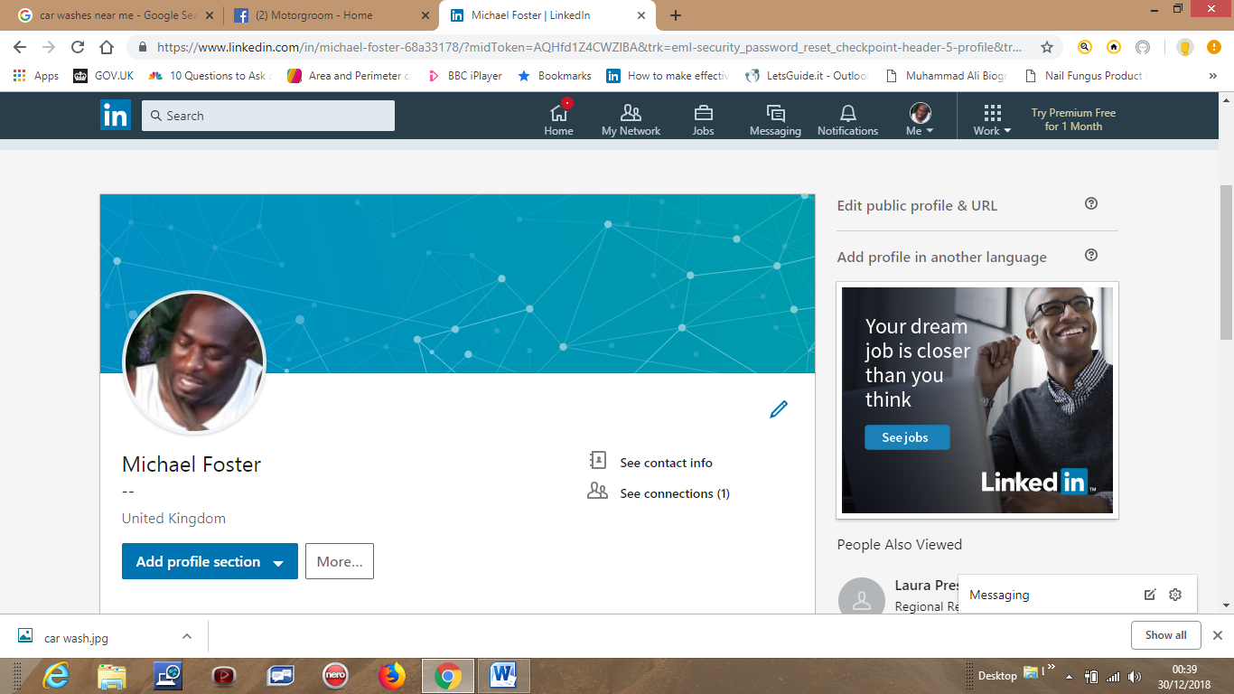
Facebook business online presence.

Information gathering.
“One of the biggest advantages of social media is real-time. In the past, gathering audience demographics was laborious and expensive. Today, any brand can gather real-time audience demographics on a regular basis. Facebook Insights offers you a wealth of data on your audience. If you partner that information with the Audience Insights piece of Ad Manager, you have everything you need for understanding your Facebook audience and being able to successfully target the audience you're aiming for. Go to the People tab of your Facebook Insights page. Under the Your Fans tab, you'll find your basic audience demographics. Facebook will show you your fans and also how that number stacks up to all Facebook fans. Just below this graphic, you will get a geographic breakdown of where those fans are located” (Syme, 2014).
References.

Bibliography
Araujo, A. (n.d.). The importance of technology in the wokplace. Retrieved from Nova Medical centre: https://n-o-v-a.com/blog/the-importance-of-technology-in-the-workplace/
Brown, M. (2011, December 9). Use of social media in the workplace. Retrieved from Mayer Brown: https://www.mayerbrown.com/public.../TheUseofSocialMediainTheWorkplace.pdf
Depot, W. d. (2010, Febuary 17). Blast from the past, vintage technologies we no longer use. Retrieved from WDD: https://www.webdesignerdepot.com/2010/02/blast-from-the-past-vintage-technologies-that-we-no-longer-use/
Griffin, A. (2017, December 01). Social media in the workplace. Retrieved December 29, 2018, from Hastac: https://www.hastac.org/blogs/alysongriffin14/2017/12/01/social-media-workplace
Ramey, K. (2013, Feb 05). The advantages and disadvantages of technology in the workplce. Retrieved from use of technology: https://www.useoftechnology.com/technology-workplace-2/
smith, K. (2018, January 02). 15 Reasos why marketing through socail media is a must for small businesses. Retrieved Decembeer 29, 2018, from Lyfe Marketing: https://www.lyfemarketing.com/blog/marketing-through-social-media/
Syme, C. (2014, June 24). How to use social media to gathervaluable marketing data. Retrieved December 2018, 29, from Social media today: https://www.socialmediatoday.com/content/how-use-social-media-gather-valuable-marketing-data

