

Cloud Engineering Principles and Practice
Student ID: 2532979
Module code: ACCA7027
Submission date: 17-Aug-2026
Word count: 5000
Lecturer: Renuga Jayakumar

Table of Contents
1. Introduction 3
2. Cloud Technology: Docker and Containerisation 3
2.1 Principles of Virtualisation 3
2.2 Containerisation advantages 4
2.3 Docker Image 5
2.4 Operating a Container and pushing to Docker Hub 8
2.6 Container Networking 11
3. Cloud Computing Concepts 14
3.1 Load Balancing 14
3.2 Scalability 14
3.3 Application Gateways 15
3.4 Complimentary Character Load balancing and scalability 16
3.5 Benefits to Customer-Facing Services 16
4. Driving Forces and Serverless Computing 17
4.1 Key Motivators To Cloud Growth 17
4.2 Serverless Computing 18
4.3 Serverless vs. Containerisation comparison 19
5. Conclusion 20
References 22

1. Introduction
Cloud computing has basically pioneered the future of the modern software development and software management of infrastructure. Companies operating in all fields have been shifting towards cloud computing systems which offer a more flexible solution, less initial capital outlay and can be scaled out and in dynamically with demand. Along with this change, a new significant facilitator of the cloud-native application development process has surfaced in the form of containerisation technology namely Docker [1].
This report critically discusses the different kinds of cloud computing technologies, and important demonstrations have been conducted on an Intel-based macOS system using the docker desktop version 4.84.0. The report is structured according to three key areas viz, the principles and practical implementation of Docker containerisation and virtualisation, image creation, volumes, networking and publishing to Docker Hub the three main clouds concepts of load balancing, scalability and application gateways as well as mentioning the forces behind the rapid global expansion of cloud services including a comparative discussion on serverless computing and containerisation as two conflicting approaches in clouds delivery of applications.

2. Cloud Technology: Docker and Containerisation

2.1 Principles of Virtualisation
Containerisation is a technology that is based on virtualisation. Defining virtualisation in the simplest sense one can refer to the process of creating a toxification of physical facilities in form of servers, storage facilities, and networks using solely software so that two or more different environments may use the same physical computer. This is done by means of a software layer referred to as a hypervisor which lies between the physical hardware and the virtualised environments it serves [2].
There are two types of hypervisors. Hypervisor hypervisors are hypervisors that run code directly on the physical hardware, without any underlying operating system (also known as bare-metal or type 1). Typical include VMware ESXi and Microsoft Hyper-V which are applicable in the enterprise data centres. Type 2 hypervisors, typically application-based themselves, are called like any other program or host, such as the Oracle VirtualBox or the HyperKit engine of Docker Desktop on MacOS. Each virtual machine that a hypervisor constructs is a complete operating system, virtualised processor, memory address space and storage, and as such,the spaces can be completely isolated on shared utilities [3].
Hardware utilisation is the advantage of virtualisation. In the past, the physical servers was being used were often underused at only 10-20 percent capacity and the majority of the compute resources was left unused. The virtualisation provides a possibility of single server to assist a number of virtual machine at a certain time hence optimising hardware investment. Virtualisation is the manner that a physical data centre infrastructure is divided into the compute instances which are being offered by them to their customers in the case of cloud providers as AWS, Microsoft Azure and Google cloud.
Docker Desktop can run on Intel-based Macs, with the Linux kernel environment required by Docker containers served by a lightweight Linux virtual machine - run using HyperKit - as the engine [4]. This is a point to consider; containerisation does not push virtualisation aside but rather, it is its continuation. The virtual machine gives the kernel and the containers that execute on the virtual machine portion the same kernel and need not divide their operating system instances and therefore, thereby conserving resource utilization.

2.2 Containerisation advantages
Containerisation does not work on hardware level but on the operating system level. A container is not a complete machine and hardware (including an OS kernel) virtualised, but only the application and dependencies, including libraries, configuration files and runtime environment and is only a self-contained, portable package. Containers Forwarding on a given host share the host OS kernel, being much lighter-weight and efficient compared to virtual machines.
Docker has emerged as the most desired containerisation environment apparently introducing a formalised and intuitive interface of creating, managing and distributing containers. Docker uses a layer based image system that is based on the Union File System. Any command contained within a Dockerfile will create a read-only layer on top of the prior one. As a container is started a thin writable layer is added by Docker on top of these immutable layers. Images share layers (e.g. base operating system layer) that they share (only once on disk) and are shared by all images that use them making storage highly efficient [5].
OCI has standardised the image format and the runtime specification, i.e. Docker images can run on any OCI-compliant runtime, be it containerd or Podman, or any other implementation. It requires such standardisation so as to avoid a lock-in by vendors at the container runtime level. The key benefits of containerisation are its portability, consistency, isolation, speed and resource efficiency. Portability Behavior of a container deployed to a staging server, cloud VM or a Kubernetes cluster is identical due to the fact that a laptop developer created it since everything is contained in the image. Coherency paves the way to the end of the ancient issue of environment discrepancies the it works on my machine aspect that has always led to vexations between development and operations teams.

2.3 Docker Image
To demonstrate the process of containerisation, a custom Docker image will be created to serve a simple web page on the Apache HTTP Server. To start with it was necessary to create a project folder in the local macOS system and two files: a Dockerfile and an HTML page [6].
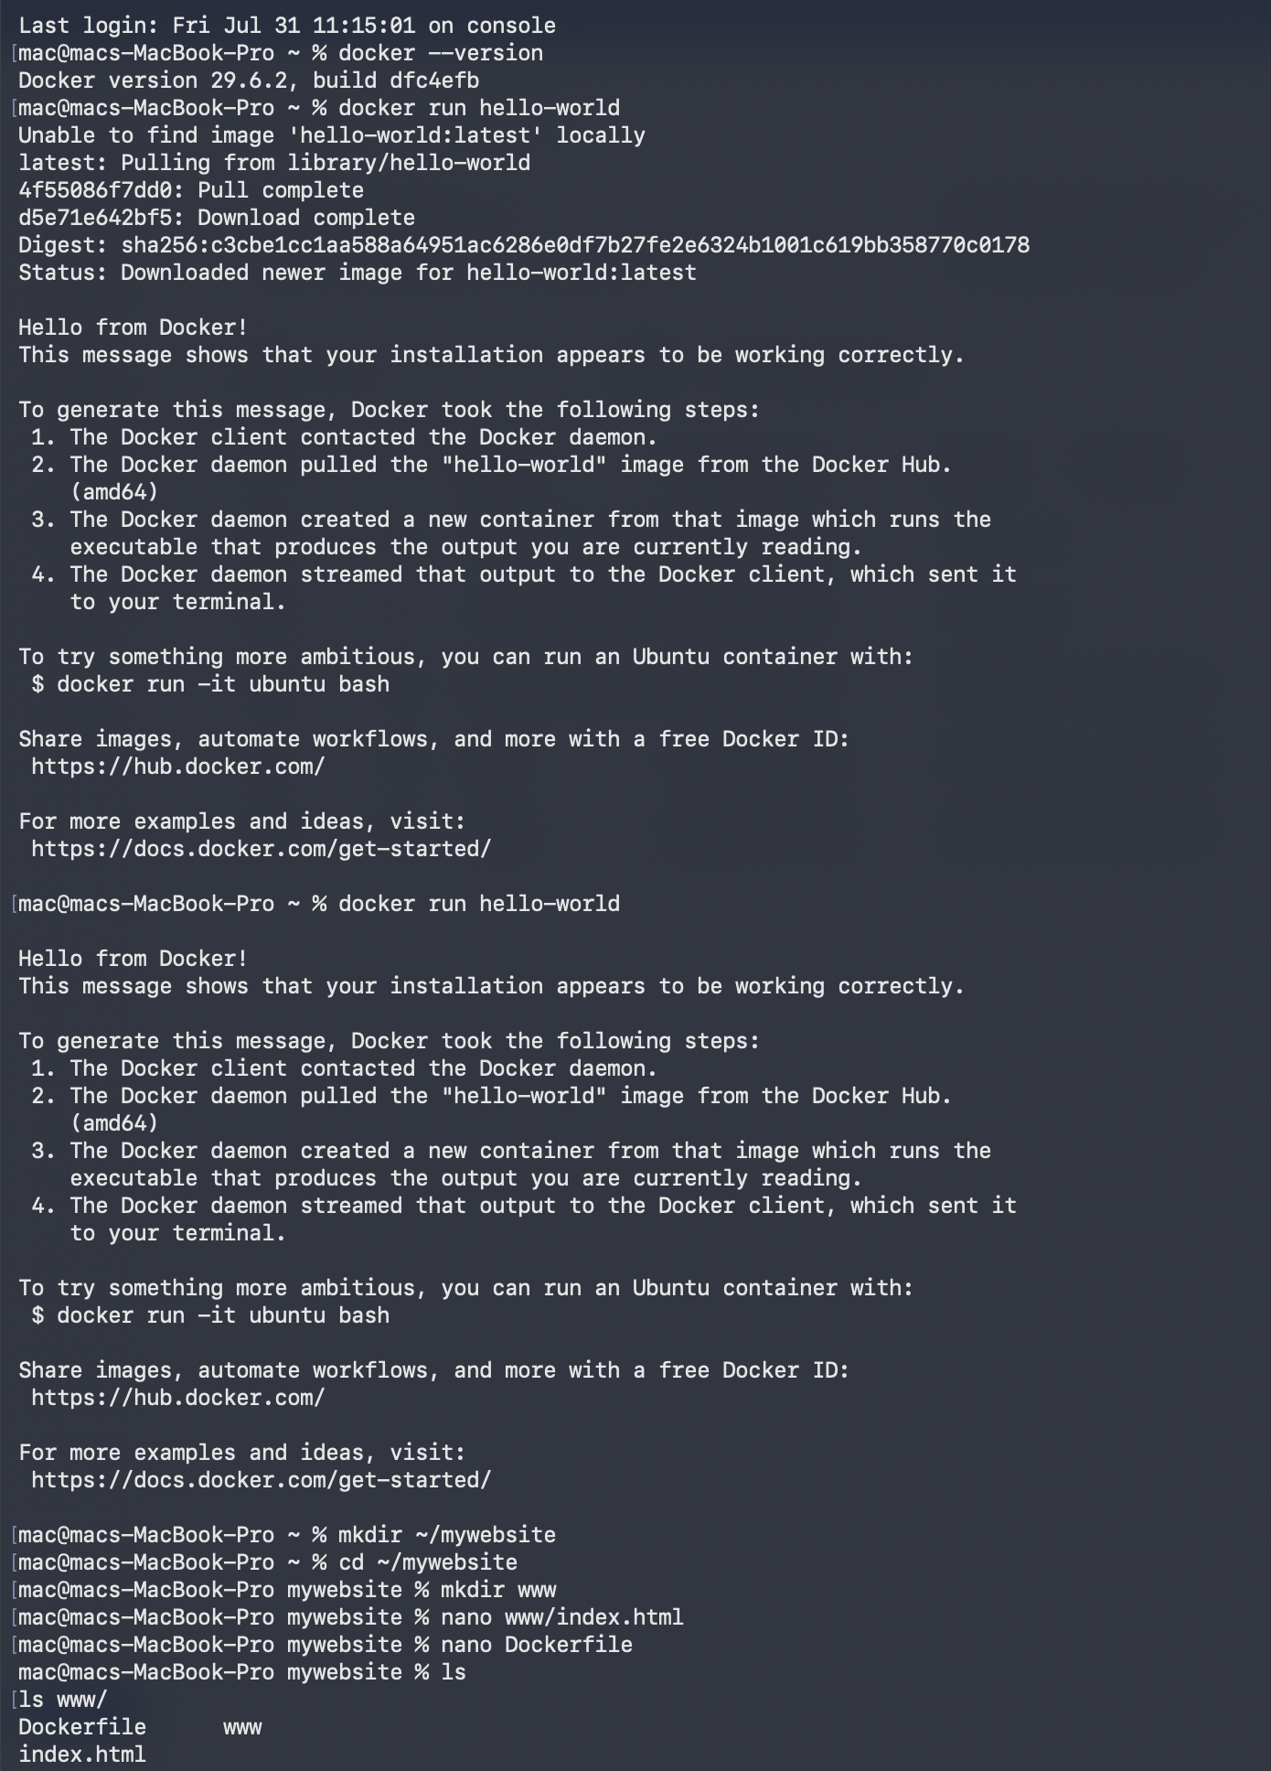
There are three instructions in the Dockerfile. FROM command recognizes the picture of the Apache HTTP Server as the official picture in the Docker Hub: the base picture is determined as httpd:2.4. The COPY command will copy the data in the local www/ folder - the HTML file - and into the Apache document root in the image at /usr/local/apache2/htdocs/. Based on the EXPOSE instruction documents, the bin is listening on port 80 on a HTTP traffic.
This is informed by the following docker command, docker build -t goku5002/mywebsite:v1 with the last dot in the command meaning current directory as the build context. Each of eight build steps was run by Docker with base image layers downloaded through Docker Hub, the HTML contents and then to export the whole image with the tag of goku5002/mywebsite:v1. The build completed in approximately 10 seconds and this indicates the increase in speed of the Docker layer caching whereby the lower section of the layers are only required to be downloaded once and can be recycled by subsequent builds.
The request to have the image tag format is captured as a user-name/ repository: tag. It is automatically mapped with the repository structure on Docker Hub and the push command is straightforward. This is the v1 tag of the image, and is able to roll back and roll forward versions [7].

2.4 Operating a Container and pushing to Docker Hub
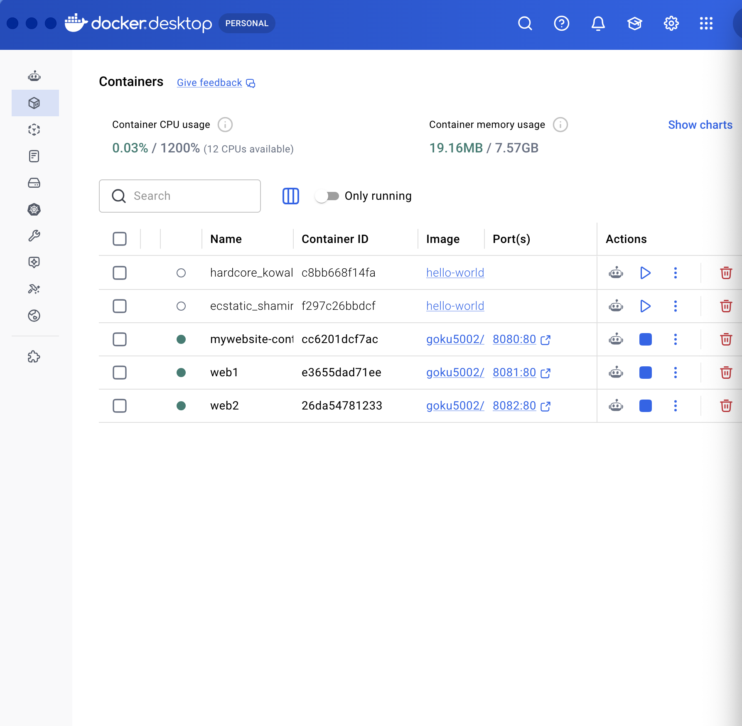

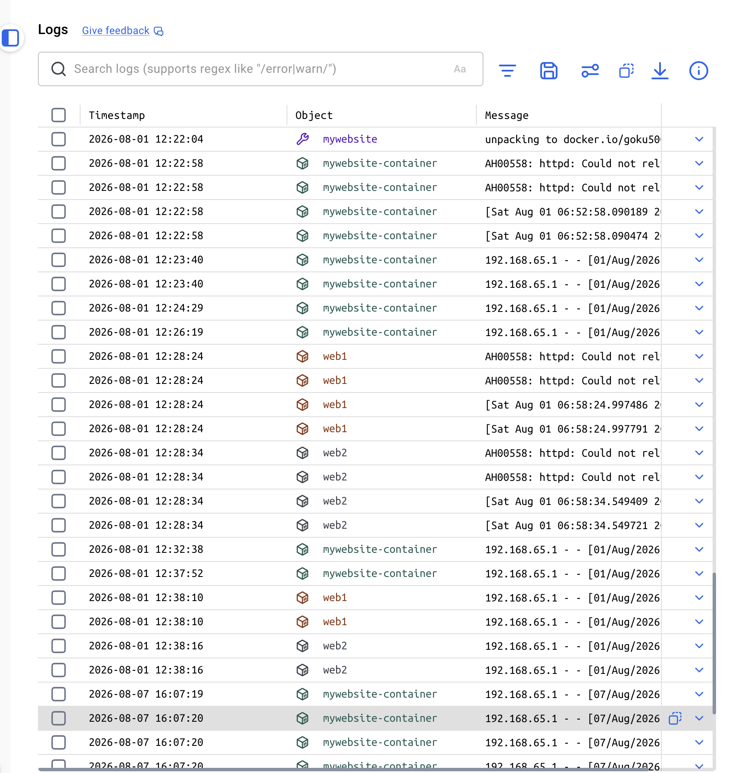
The image was created and a container was spawned using the docker run command with the -d option to run in the detached (background) mode, -p 8080:80 option to port-map port 80 with the host computer to port 80 in the container and the -name option to give it a human-readable name. Docker ps command was used to make sure that the container was operational and displayed the status of up and whether it had proper port mapping 0.0.0.0:8080->80/tcp running.
The browser visits to http: localhost:8080 ensured that the containerised Apache server was correct in serving the HTML page and displaying the heading of the page Welcome to Docker and the programme specifics. This is the only demonstration that has drawn the whole containerisation process together; the image is described in a Dockerfile, built-up, and then run in its own as a service which is a living and accessible service.
To press the button, docker login was stored to login to Docker Hub and docker login confirmed that it had logged in with the already existing account of goku5002. This was to be followed by pushing of the image by Docker push goku5002/mywebsite:v1. Each of the layers was pushed by Docker, and validation of all the eight layers displayed, and lastly it gave a digest hash, to confirm the integrity of the image. The photo was immediately hieratic at docker.io/goku5002/mywebsite in such a way that any Docker-enabled device can retrieve it and run it anywhere on the planet without the need to get the original code [8].
2.5 Container Volumes
The ephemerality of the internal representation of file system of Docker containers is one of their fundamental features. The files contained in one of the containers at the time it was active can remain the duration it lasts before the given container itself exists. All the data saved in the container is lost forever at the point when the container is stopped and removed. This does not apply to stateless applications (such a web servers of stateless content). However, with stateful applications - databases and user upload storage and log aggregation systems, data persistence is a highly valued requirement. The solution to this is reached by use of Docker volumes.
A Docker volume is a storage container, which is managed by Docker, but entirely independent of the file system of a container, in a daemon-controlled section of the host file system. This volume was termed as volume mydata and was created using docker volume create mydata-volume. The docker volume inspect command revealed the parameters: the volume has been exported on 2026-08-01, the local driver and the mountpoint of this driver is /var/lib/docker/volumes/mydata-volume/_data in the Linux VM of the host [9].
The amount of this volume was loaded into a container as the Apache document root with an -v flag with the command: mydata-volume:/usr/local/apache2/htdocs/. This implies that files created into the container at /usr/local/apache2/htdocs/ are really written to the host volume, and would continue to exist even after the container shutdown. To demonstrate persistence we began executing the container with the following docker run volume-demo and showered it with docker stop volume-demo and docker rm volume-demo. The docker run volume ls that then followed indicated that mydata-volume was still there with the driver being local indicating that the data stored in mydata-volume was not lost when the whole container was destroyed. This constitutes the notable advantage of the volume storage and container-internal storage.

2.6 Container Networking
Docker offers a dynamic structure of networking, which allows containers to interact among themselves and the external system in either a regulated and secluded way. Docker by default sets up three networks: bridge, the default network, that the standalone containers will use, enabling use of network address translation to ensure that the outgoing is allowed out of the structure; host, which removes the isolation between the container and the host, creating direct access to the network interfaces in the host; and none, which removes networking entirely [10].
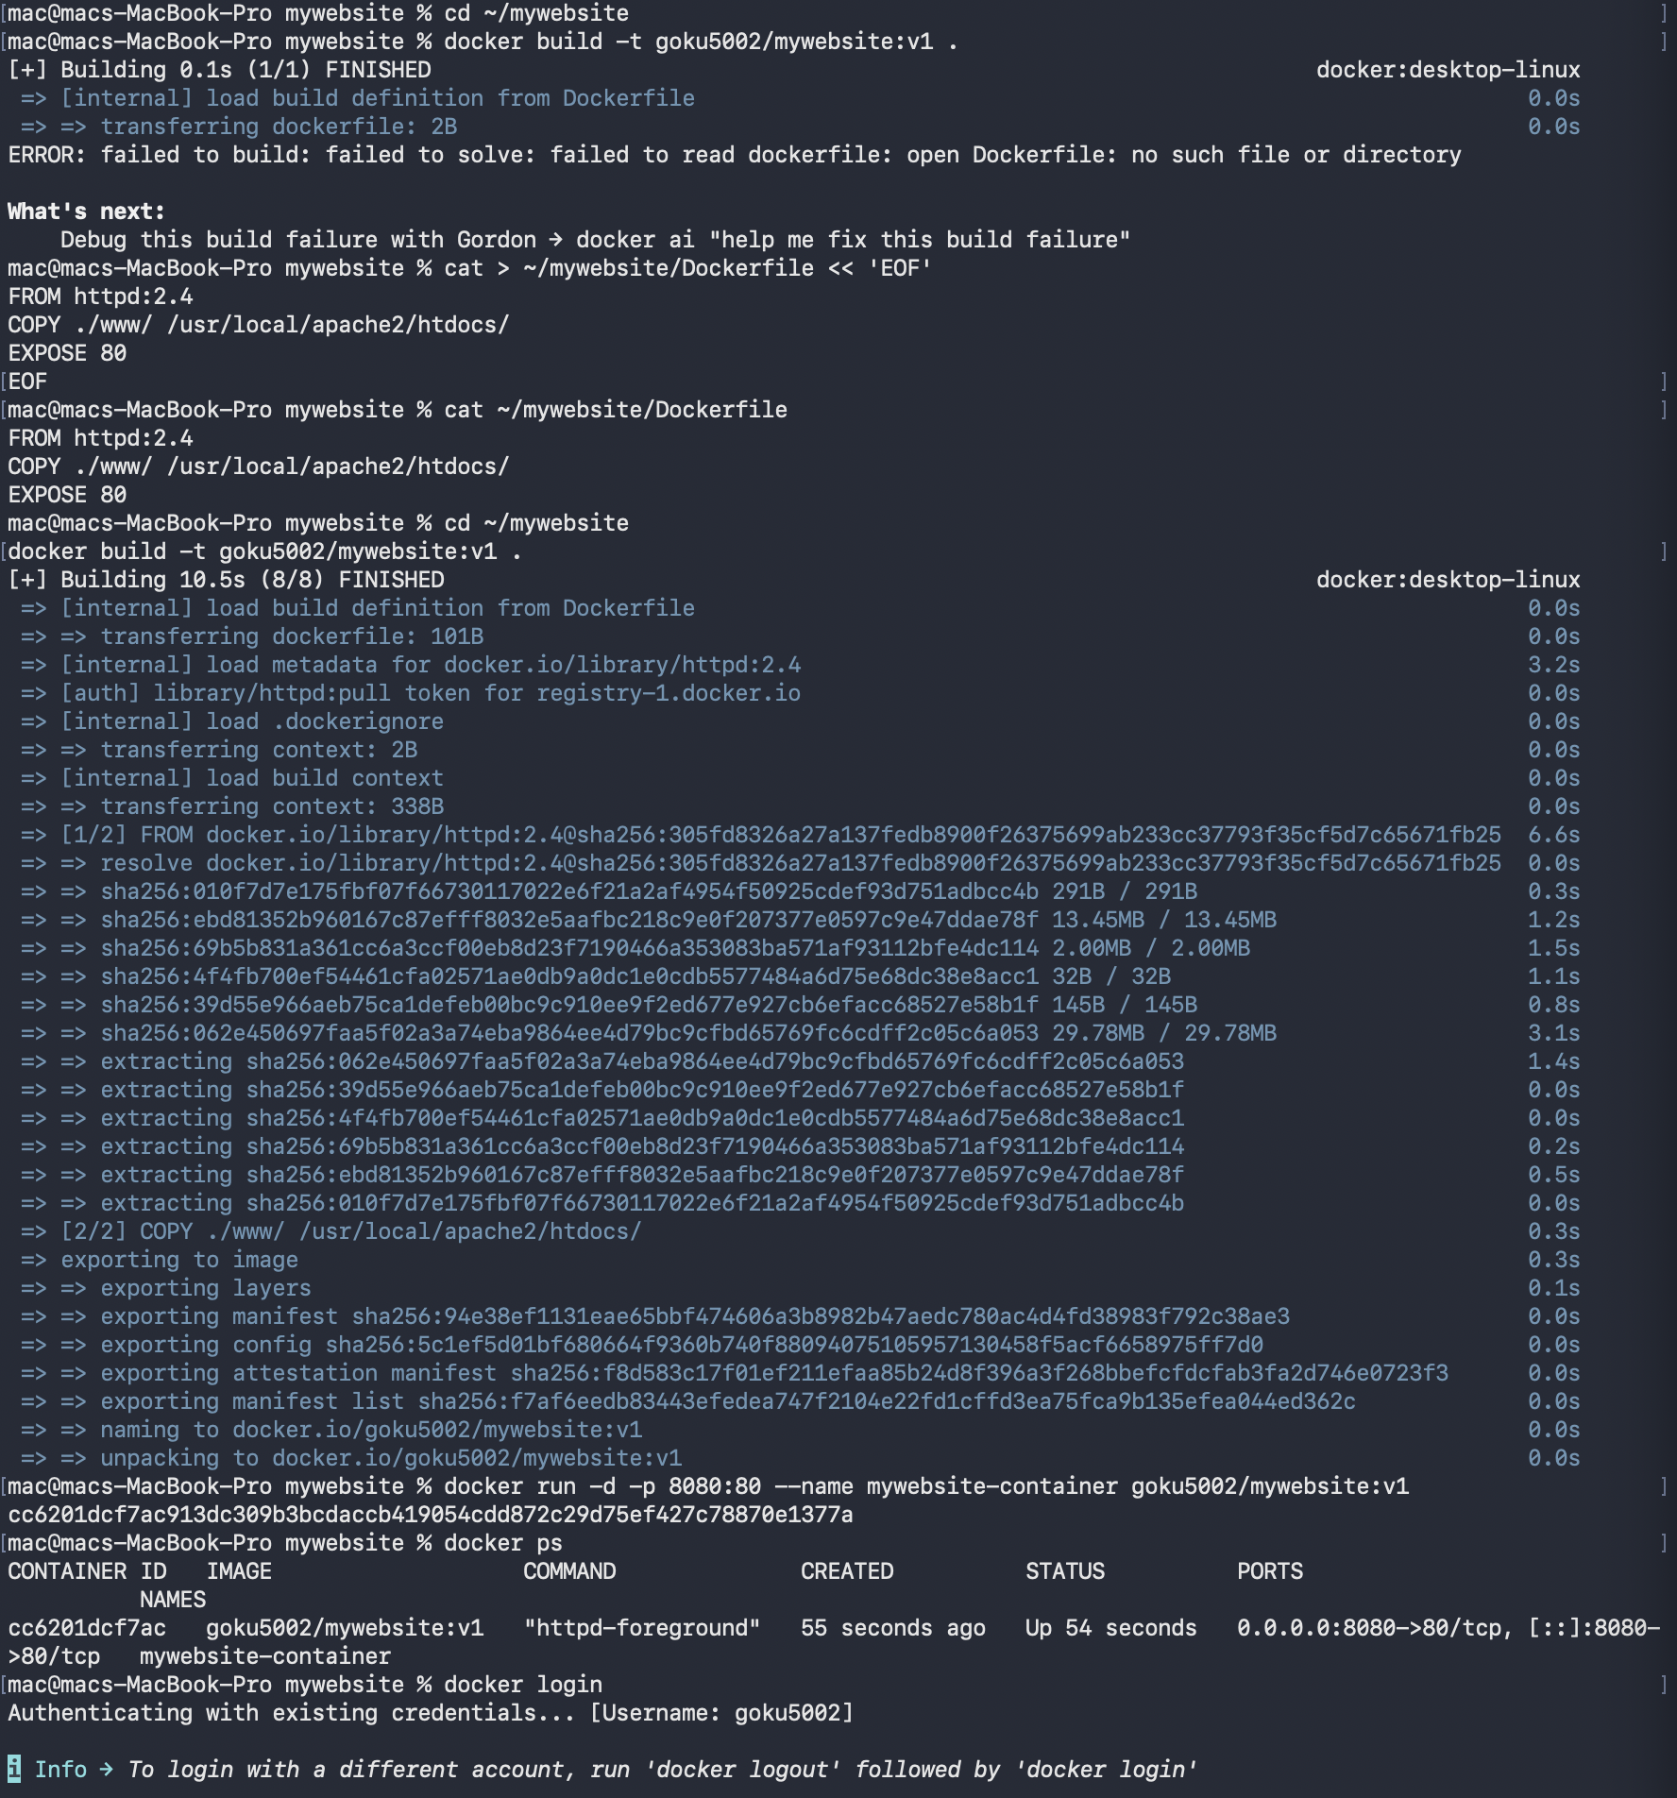
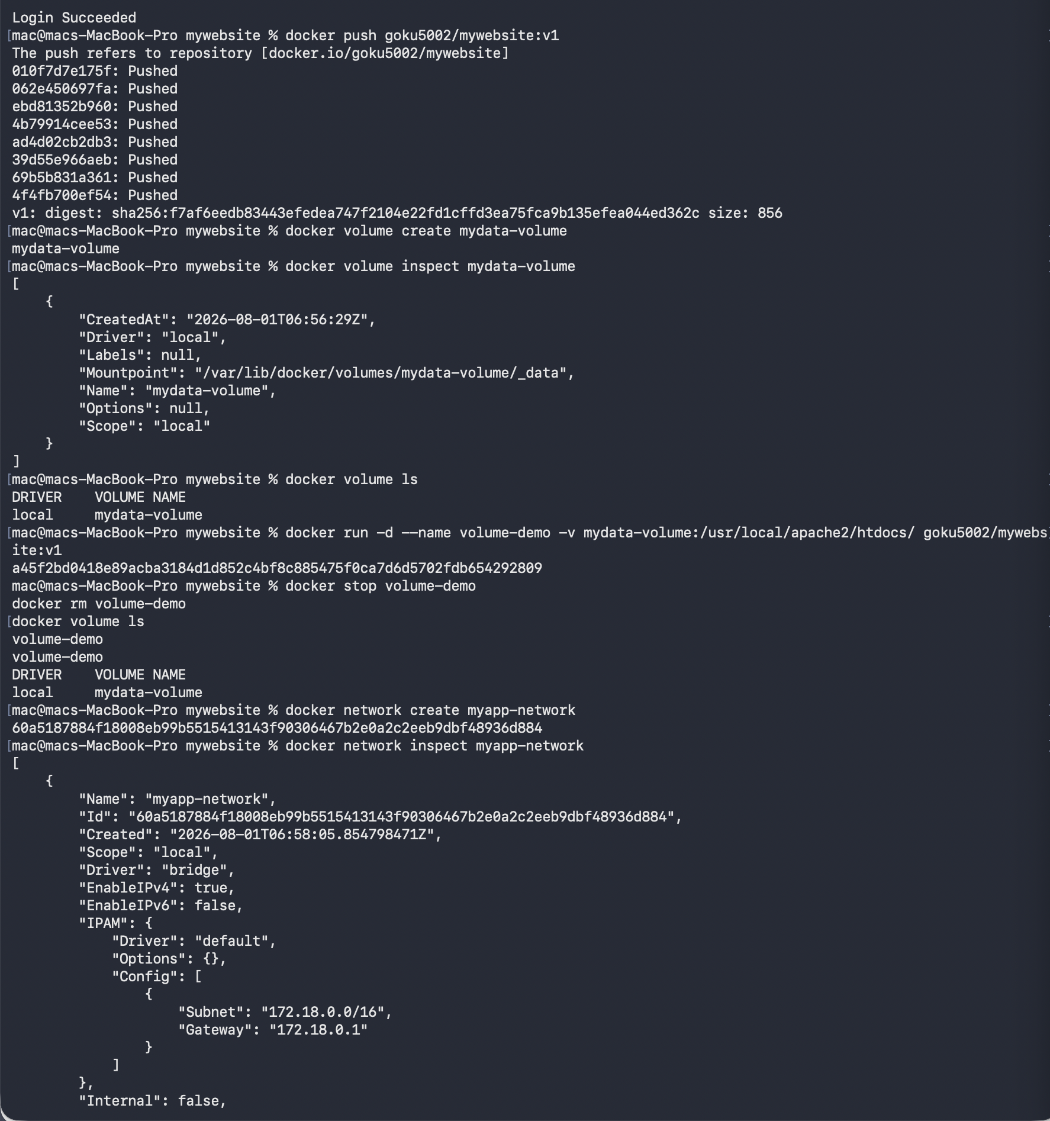
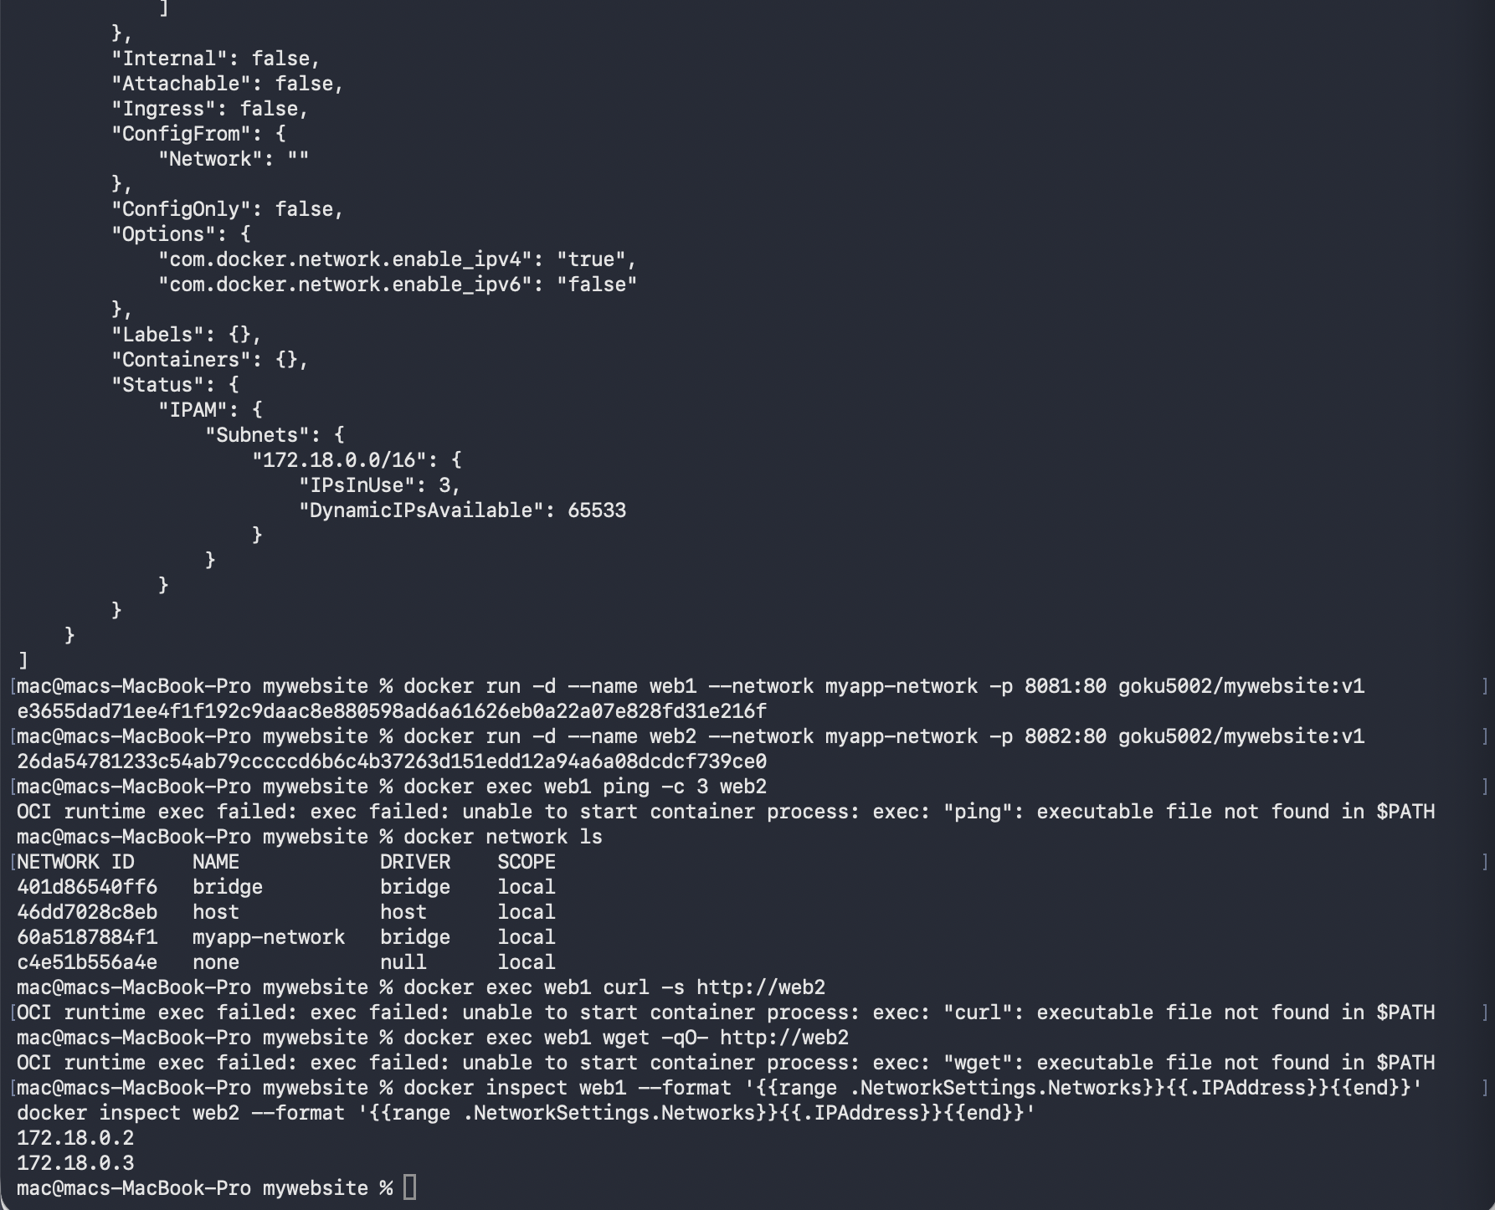
When the functions of multi-container applications rely on the containers being able to find and know about one another, custom user-defined bridge networks offer much greater functionality. Most importantly however, they include a built-in DNS resolution of Docker since it allows the use of the containers to identify each other by their name assigned to each container without the containers requiring knowledge of the assigned DIp address that might change and be dynamic.
Docker network create myapp-network allowed developing a unique network. The docker network inspect command helped in understanding the full setup completely: the network is set to bridge driver, has a subnet 172.18.0.0/16 and a default gateway of this network is 172.18.0.1 and (IPv4) is configured.
In order to expose access to this network it was necessary to launch two containers in the web1 and web2 containers that were mapped to distinct ports on the host (8081 and8082) in order to have access to the network simultaneously. The Go template version of docker inspect was employed to get the IP addresses of the two containers. Checks of the outputs showed that web1 was assigned 172.18.0.2 and web2 was assigned 172.18.0.3 which were within myapp-network subnet. The docker network ls command has given a list of all the four networks; default bridge, host and none networks and the user-created myapp-network [11].
This is a topology of network which demonstrates how the applications are functionally structured in Docker by using microservices. A web application can be made up of a web server container, an API container and a database container, all operating on a bespoke Docker network. This container name refers to the web server as somewhere called API, the API as somewhere called database in Docker and this DNS automatically resolves such names to the corresponding IP addresses regardless of the ordering in which the containers are started or the dynamic way in which they have addressed them.

3. Cloud Computing Concepts

3.1 Load Balancing
A load balancing can be referred to as the distribution of the traffic into a network into more than one backend server or service so that a bottleneck of performance or a point of failure of any single backend server or service does not occur. Load balancing is not only significant as a performance optimisation in relation to cloud computing, but load balancing is a significant component of the architecture which is the foundation of high availability and fault tolerance.
Microsoft Azure uses the services of load balancing in a number of complementary services. Azure Application Gateway is a Layer 7 (application layer) load balancer, which is knowledgeable in the HTTP and HTTPS traffic, allowing advanced routing choices based on URL routes, hostnames, cookies and request headings. It enables disabling of traffic on the gateway layer, or HTTPS packets are decrypted on the gateway layer as opposed to per each of the backent servers, eliminating the cryptographic burden on the application instances. Azure load balancer will be positioned to Layer 4 ( transport layer), which will distribute both TCP and UDP traffic based on the source IP, destination IP, protocol and port based on the application-level content. To balance its worldwide traffic, the Azure Front door would aid HTTP load balancing on a number of various regions of Azure and anycast routing so as to reroute the users to its nearest physical location [12].

3.2 Scalability
Scalability would then be said to be the ability of the system to expand or reduce according to the need of the demand ratioed to the capacity. There are two scalabilities of cloud computing: vertical scaling (also referred to as scaling up) Upgrading an already existing instance with a larger number of virtual CPUs, memory or storage. This is easy to put in place, but has constraints: the maximum size of any one VM is there, and a vertical upgrade will generally take a short time to restart. Scaling out can also be referred to as horizontal scaling; scaling out involves increasing the number of instances of a certain service distributing the extra workload to more smaller units.
Horizontal scaling is very desirable in cloud architecture because other causes of failure are eliminated, the capacity can be introduced gradually and even required to be fully automated [13]. Azure Virtual machine scale sets allow a single run of a group of identical VMs, and with auto-scaling policies that monitor performance metrics (like CPU utilization, memory load, or application-specific metrics reported by an Azure Monitor). The scale automatically deploys new VM instances and loads them into the load balancer once a metric has met a given threshold, e.g. average CPU utilisation above 70 percent. When there is a fall in demand, the graceful draining of the active connection cases and closing connections down ensures that the costs are minimized. Azure Kubernetes Service is also further-developed and auto-scales clusters (adding and removing nodes) and pods (adding and removing application replicas) on a horizontal scale.

3.3 Application Gateways
Application gateway is a sophisticated web traffic controller, or application traffic controller, which runs on the application layer of the network stack, and offers much more functionality than a conventional load balancer. Azure Application Gateway also has built-in Web Application Firewall, based on the OWASP Core Rule Set on inspection of incoming requests on HTTP/HTTPS protocol before they reach the backend application servers. This causes security implementation to come to one central point rather than one to be implemented on the server of every application.
Other features are HTTP-to-HTTPS redirection to enforce encrypted connections, sessions affinity on cookie based session affinity; enforce so that requests made by a particular user always reach the same instance of the backend server (useful when applications use the server memory to store session state), and health probing, where the gateway periodically sends test requests to each instance of the backend server and automatically removes non-responsive instances [14].
The relationship that exists between the application gateway, load balancer and backend pool discloses an interconnected layer of managing traffic. The gateway decodes the pure internet traffic, imposes security policy, terminates the protocol called SSL and routes traffic to appropriate backend pool. The requests are delivered to healthy instances by the load balancer which is within the gateway. Auto-scaling makes sure that the pool of instances is adjusted to the amount of traffic being received by the gateway.

3.4 Complimentary Character Load balancing and scalability
The notions of load balancing and scalability are in architecture inseparable: both notions lose their worth to a considerable extent when deprived of the other. Non scaled load balancing distributes the traffic across the servers of a pool of servers of a defined size. It is very effective during times of normal traffic but not during times of traffic bursts - no matter how proportionally the load is distributed there simply are no enough servers. This system is not scaleable and the load balancer only makes sure that the rest of the servers collapse in the same manner [15].
With scalability and not load balancing, the opposite is true. Additional instances can be provisioned soon, although without a method to allocate traffic between instances, new instances do not get requests and the existing instances are overwhelmed. The unused capacity is still experiencing impaired performance in unused capacity, where the unused capacity is idle.
They constitute a self regulating dynamic system. The auto-scaling agent monitors rising load, and creates new instances; the load balancer can monitor these new instances with its health probe mechanism and it then starts to loadbalance the new instances by sending traffic to them. Instead, the load balancer smoothes the load as well by gracefully removing instances off the rotation table prior to being terminated by auto-scaling, allowing the load balancer to remove instances with requests in flight on it without ending the load balancing process. Elastic cloud architecture is based on this, a closed-loop, between monitoring, scaling and distribution and traffic model.

3.5 Benefits to Customer-Facing Services
Performance, availability, security and even cost, all quick and easy to achieve as a single attribute, are offered by load balancing, scalability and application gateways together but would have been both devices of impractical constraint within the confines of the traditional fixed capacity infrastructure [16].
To the customer, the most noticeable advantage is being able to do the same work regardless of the number of simultaneous users using the service. The load balancer is used to avoid a bottleneck of a single server, auto-scaling provides enough capacity when and where required and the WAF application gateway defends the data of the customer against web based attacks. All the communication can be terminated by the gateway itself using the help of the SSL that consequently encrypts all the communication with zero cost to the application servers.
The combination as an operator will help in the elimination of the need to give infrastructure at a desired peak capacity that can only realize a few times. Instead, the normal traffic is served with base infrastructure and only on demand when additional capacity has been brought in automatically and at minimum costs when it is not in use and then it is brought in accordingly [24].

4. Driving Forces and Serverless Computing

4.1 Key Motivators To Cloud Growth
A mix of economic, technological and operational factors has precipitated an increase in cloud computing as an exclusive technology to the leading fashion in the business IT infrastructure [17].
The most generally quoted driver is the cost efficiency. The cloud computing is applied in order to convert the level of capital cost into the cost of operation. Organisations are not required to purchase physical servers, networking devices and data centre infrastructure, which are depreciated with time, and have to be maintained, regardless of whether they are being used, (or not); they are simply charged on the utilised compute, storage and network resources. This opens up a great barrier to entry into enterprise grade infrastructure in the situation of start-ups and small businesses. To a scale large enough to reach the organizational level, it avoids over-provisioning which is expensive to provide in the past to meet peak load.
Elasticity and flexibility is the second driving force. Traditional, on-premises infrastructure can take weeks or months to buy, deliver and install. The cloud resources can be deployed with API call within seconds and allow the organisations to react to market conditions, experiment and deploy and contract capacity within near real-time. It is this ability to design and deliver new products and functions in short periods of time, especially when dealing with the competitive markets where the strategic differentiator is agility, that makes the agility particularly handy [18].
Cloud data centres are found in the geographical locations and would be readily accessible and accessible internationally. The global providers have dozens of regions all over the world, so organisations can implement the applications close to their users to maintain low latency and fulfil the data residency and sovereigntyies requirement, i.e. their data has to be stored in a specific geographic location. In the past, to attain Global infrastructure, dedication hardware and colocation contracts were immensely invested across other countries.
Cloud adoption has been powered by the DevOps movement and a catalyst by the movement. Continuous integration and continuous delivery, infrastructure as code, and automated testing are typical Devops practices that are in harmony with cloud platforms making all infrastructure operations accessible via programmable APIs. Section 2 unveils the reality that containerisation is a direct enabler of the DevOps pipelines that deliver constant and predictable environments that can be trusted by trustworthy CI/CD [25].

4.2 Serverless Computing
The other abstraction of cloud service is Functions as a Service (which is also known as Serverless computing). Serverless providers demand that the developer implement the actual business logic of the application, including discrete, stateless functions, and don’t care about all the infrastructure, in aspects where the runtime environment needs to be controlled by the application developer, and where VMs need to be controlled by the application developer [19].
When deployed in a serverless model by use of the cloud platform, functions and objects go into a slumber state. They are just put in place in reference to a particular event: an API gateway has been called with a set of HTTPs, a file uploaded to an object storage, a message on a queue sent to, a timer set to go off. Cloud system automatically utilizes the needed computing power to perform the task, accomplish it and support the power. There is no extra charge to the developer of the compute time it has used in execution other than the number of milliseconds that it used and the invocations.
The most popular platform is AWS Lambda which allows serverless functions written in Python, Node.js, Java, Go and a number of others. Azure Functions can do the same with an inbuilt integration of the all the other elements of the Azure framework including the binding that enable data to be easily read and written to an azure service like Cosmos DB, Service bus, Blob Storage and Event grid without making a direct call to the SDKs. Google Cloud Run and Google Cloud Functions are both similar services within the Google Cloud [20].
The serverless operate mode is exactly the opposite of Containers/ VM. No servers to attend to in the system, all patches that the operating system requires are not required, no capacity planning activities are to be carried out and, even idle resources in systems which are not getting requests are not charged. Auto-scaling is continuous and, in essence, indefinite: any time one million calls to a function are made concurrently, the platform will cleverly use the necessary muscle in milliseconds without any settings.

4.3 Serverless vs. Containerisation comparison
Containerisation and serverless computing have exactly equal numbers of drivers - of decreasing cost, of increasing flexibility and accelerating development - but they trade-off in two radically different ways on one of a set of central dimensions.
Granularity and control are the most fundamental difference. Every execution that an application can require is contained within a Docker container, which the developer can control in all ways, such as OS libraries, version of dependencies, version of application server configuration, and process model. It is a form of control which allows the container to execute multi-threaded and complex applications which have complex internal condition. A serverless function, on the other hand, is deliberately small in size: it is a single function, and a single task, in a runtime environment that is completely controlled by the cloud provider. The underlying infrastructure is not alterable by the developer, and is a trade off in what can be done during a single run of a single function, but a benefit in that it is simpler to work with [21].
Cold start latency is also a feasible useful parameter to serverless deployments. Container-based applications It is long-lived processes, meaning that when not serving a request, it stays in memory to provide low-latency response to all subsequent requests irrespective of the service process-time it has been idle. Two scenarios may lead to a cold start in serverless functions; 1) to needed load the runtime itself and initialise the execution environment and load the code of the function followed by 2) process the original request. This initialisation may impose hundreds of milliseconds to many seconds of extra latency on the system and is an issue where extra latency is particularly of interest (as may include a user facing API). The containers completely eradicate cold wins by upholding continuous processes [24].
Containerisation is favoured by Portability and Vendor lock-in. Containers designed based on the OCI standard are usable on all cloud services, on-prem optionally or even on a developer laptop just as easily. These functions are also worthless or which are directly related to the event model, the type of triggers, and the context, in which the cloud provider has to be implemented. The process to lift an Azure Function into AWS Lambda would need the entirety of re-writing integration code of an event trigger in an Azure Function, reconfiguring of all event triggers and even minor refactoring of application logic to instead use the alternative binding model. It is a material risk to organisations as organisations have a multi-cloud or hybrid cloud strategy that is reliant on this vendor [22].
The two models have very different Cost structure. Zero cost idle Serverless functions are highly cost effective with an intermittent or random workload as the service level is zero; and the service cost per-request is extremely low following 24 hours of idle time which is effectively no cost following 23 hours of idle time. Container-based services also have to be billed based on the resources utilized to operate the instances even without or with a low volume of traffic. A scale serverless is of course less stable and is more expensive than a container per request at a scale at which workload is overwhelming and continuous, but again, more likely to be less stable than workloads perceived to be high.
Operational complexity is perhaps one of the most practically crucial trade-offs of the majority of organisations. Serverless can eliminate the experience of managing containers, the operation of a Kubernetes cluster, configuration of scaling of nodes, container security patches, and resource limit tuning. Serverless is capable of drastically lowering the barriers associated with production applications to groups of developers that do not have infrastructure engineers experienced with them [23].

5. Conclusion
This report has not only provided the theoretical aspects of core cloud computing technologies, but has experimented with them in a practical fashion. The whole containerisation process was performed using practical demonstrations with an Intel Mac without Docker Desktop: a custom Dockerfile was compiled to configure an Apache web server image, that image was built then used as a living object as a web server at localhost:8080, data persistence was demonstrated using the named volumes which survived container removal, inter-container communication was demonstrated using a custom Docker network and automatic allocation of IP address, and the completed image was pushed to Docker Hub to be used worldwide.
The load balancing concepts, scalability concepts and the application gateway concepts have been learned through the Microsoft Azure exemplifying how each of the three technologies can be utilized individually, and in combination with each other to achieve a flexible, secure, and high-availability infrastructure demanded by the contemporary cloud applications. The complementary relationship between the auto-scaling and load balancing processes by which the cloud architectures deliver resilience at scale is so beneficial is that both the dynamically scaled capacity as provided by the auto-scaling processes and the dynamically redistributed traffic as provided by the load balancing processes are scaled dynamically.
The driving forces analysis proved that the economy is changing capital to operational expenses, agility that is created by elasticity, and the inherent compatibility between the cloud platforms and DevOps current practices drive the adoption of clouds. Comparison of serverless computing and containerisation with each other showed that there were two similar, yet different cloud-native models of development, varying with tradeoffs based on control, portability, latency, cost, and complexity of operation. They are not necessarily more superior to each other and it depends on the type of work load, capability of the team and strategic requirements of the organisation to consider the aspects of independence to the vendor and cost control.

References
[1] | Y. Al-Dhuraibi, F. Paraiso, N. Djarallah, and P. Merle, ‘Elasticity in Cloud Computing: State of the Art and Research Challenges’, IEEE Transactions on Services Computing, vol. 11, no. 2, pp. 430–447, Mar. 2020, doi: 10.1109/tsc.2017.2711009.
[2] | M. Amaral, J. Polo, D. Carrera, I. Mohomed, M. Unuvar, and M. Steinder, ‘Performance Evaluation of Microservices Architectures Using Containers’, 2015 IEEE 14th International Symposium on Network Computing and Applications, pp. 27–34, Sep. 2020, doi: 10.1109/nca.2015.49.
[3] | M. Armbrust, A. Ghodsi, R. Xin, and M. Zaharia, ‘Lakehouse: A New Generation of Open Platforms That Unify Data Warehousing and Advanced Analytics’, 2021. Accessed: Aug. 12, 2026. [Online]. Available: https://www.cidrdb.org/cidr2021/papers/cidr2021_paper17.pdf
[4] | Azure, ‘Azure Functions Overview’, 2025. Accessed: Aug. 12, 2026. [Online]. Available: https://learn.microsoft.com/en-us/azure/azure-functions/functions-overview
[5] | E. Casalicchio, ‘Container Orchestration: A Survey’, Systems Modeling: Methodologies and Tools, pp. 221–235, Oct. 2020, doi: 10.1007/978-3-319-92378-9_14.
[6] | S. de Capitani di Vimercati, S. Foresti, S. Paraboschi, and P. Samarati, ‘Enforcing Corporate Governance’s Internal Controls and Audit in the Cloud’, 2020 IEEE 13th International Conference on Cloud Computing (CLOUD), pp. 453–461, Oct. 2020, doi: 10.1109/cloud49709.2020.00067.
[7] | EdB-MSFT, ‘Autoscale in Microsoft Azure - Azure Monitor’, 2024. Accessed: Aug. 12, 2026. [Online]. Available: https://learn.microsoft.com/en-us/azure/azure-monitor/autoscale/autoscale-overview
[8] | S. Eismann et al., ‘Serverless Applications: Why, When, and How?’, IEEE Software, vol. 38, no. 1, pp. 32–39, Jan. 2021, doi: 10.1109/ms.2020.3023302.
[9] | greg-lindsay, ‘What Is Azure Application Gateway’, Sep. 2023. Accessed: Aug. 12, 2026. [Online]. Available: https://learn.microsoft.com/en-us/azure/application-gateway/overview
[10] | J. Haris, P. Gibson, J. Cano, N. B. Agostini, and D. Kaeli, ‘SECDA: Efficient Hardware/Software Co-Design of FPGA-based DNN Accelerators for Edge Inference’, 2021 IEEE 33rd International Symposium on Computer Architecture and High Performance Computing (SBAC-PAD), pp. 33–43, Oct. 2021, doi: 10.1109/sbac-pad53543.2021.00015.
[11] | J. M. Hellerstein et al., ‘Serverless Computing: One Step Forward, Two Steps Back’, Dec. 2020. doi: 10.48550/arXiv.1812.03651.
[12] | P. Mell and T. Grance, ‘The NIST Definition of Cloud Computing’, NIST, vol. 800, no. 145, Sep. 2020, doi: 10.6028/nist.sp.800-145.
[13] | Microsoft, ‘What Is Azure Load Balancer? - Azure Load Balancer’, Feb. 2025. Accessed: Aug. 12, 2026. [Online]. Available: https://learn.microsoft.com/en-us/azure/load-balancer/load-balancer-overview
[14] | S. Oh, H. Cho, S.-H. Kim, W. Lee, and E. Lee, ‘Corrigendum to “Continuous Object Tracking Protocol With Selective Wakeup Based on Practical Boundary Prediction in Wireless Sensor Networks” Computer Networks Volume 162 (2019) 106854’, Computer Networks, vol. 164, p. 106938, Dec. 2020, doi: 10.1016/j.comnet.2019.106938.
[15] | H. Shafiei, A. Khonsari, and P. Mousavi, ‘Serverless Computing: A Survey of Opportunities, Challenges, and Applications’, ACM Computing Surveys, vol. 54, no. 11, Feb. 2022, doi: 10.1145/3510611.
[16] | H. Taguchi, X. Liu, and T. Murata, ‘Graph Convolutional Networks for Graphs Containing Missing Features’, Future Generation Computer Systems, vol. 117, pp. 155–168, Apr. 2021, doi: 10.1016/j.future.2020.11.016.
[17] | USENIX, ‘Firecracker: Lightweight Virtualization for Serverless Applications | USENIX’, 2022. Accessed: Aug. 12, 2026. [Online]. Available: https://www.usenix.org/conference/nsdi20/presentation/agache
[18] | B. Varghese and R. Buyya, ‘Next Generation Cloud Computing: New Trends and Research Directions’, Future Generation Computer Systems, vol. 79, no. 3, pp. 849–861, Feb. 2020, doi: 10.1016/j.future.2017.09.020.
[19] | G. A. S. Cassel, V. F. Rodrigues, R. da Rosa Righi, M. R. Bez, A. C. Nepomuceno, and C. André da Costa, ‘Serverless Computing for Internet of Things: A Systematic Literature Review’, Future Generation Computer Systems, vol. 128, pp. 299–316, Mar. 2022, doi: 10.1016/j.future.2021.10.020.
[20] | B. Cheng, G. Solmaz, F. Cirillo, E. Kovacs, K. Terasawa, and A. Kitazawa, ‘<Italic>FogFlow</Italic>: Easy Programming of IoT Services Over Cloud and Edges for Smart Cities’, IEEE Internet of Things Journal, vol. 5, no. 2, pp. 696–707, Apr. 2020, doi: 10.1109/jiot.2017.2747214.
[21] | A. Kapsalis, P. Kasnesis, I. S. Venieris, D. I. Kaklamani, and C. Z. Patrikakis, ‘A Cooperative Fog Approach for Effective Workload Balancing’, IEEE Cloud Computing, vol. 4, no. 2, pp. 36–45, Mar. 2020, doi: 10.1109/mcc.2017.25.
[22] | Y. Gan et al., ‘An Open-Source Benchmark Suite for Microservices and Their Hardware-Software Implications for Cloud & Edge Systems’, Proceedings of the Twenty-Fourth International Conference on Architectural Support for Programming Languages and Operating Systems, Apr. 2020, doi: 10.1145/3297858.3304013.
[23] | E. Jonas et al., ‘Cloud Programming Simplified: A Berkeley View on Serverless Computing’, arXiv:1902.03383 [cs], Feb. 2020, Accessed: Aug. 12, 2026. [Online]. Available: https://arxiv.org/abs/1902.03383
[24] | X. Chen, Q. Shen, P. Cheng, Y. Xiong, and Z. Wu, ‘RuleCache: Accelerating Web Application Firewalls by on-Line Learning Traffic Patterns’, 2022 IEEE International Conference on Web Services (ICWS), pp. 229–239, Jul. 2022, doi: 10.1109/icws55610.2022.00044.
[25] | C. Pahl, A. Brogi, J. Soldani, and P. Jamshidi, ‘Cloud Container Technologies: A State-of-the-Art Review’, IEEE Transactions on Cloud Computing, vol. 7, no. 3, pp. 677–692, Jul. 2020, doi: 10.1109/tcc.2017.2702586.

Link
Link: https://uowtsd-my.sharepoint.com/:v:/g/personal/2532979_student_uwtsd_ac_uk/IQAmmIGshlFqRYydS0w9UnbTAdpyoEjV9yTPXQX_wdsvkWA?nav=eyJyZWZlcnJhbEluZm8iOnsicmVmZXJyYWxBcHAiOiJPbmVEcml2ZUZvckJ1c2luZXNzIiwicmVmZXJyYWxBcHBQbGF0Zm9ybSI6IldlYiIsInJlZmVycmFsTW9kZSI6InZpZXciLCJyZWZlcnJhbFZpZXciOiJNeUZpbGVzTGlua0NvcHkifX0&e=oznmpe

