Module Name and Code: Foreign Languages and Cultural Awareness (BMIH5003)
Component 2
Module Type: Report
Module Leader: Lisa Bassler
Wordcount: 1073 excluding executive summary
Student Name: Tatiana Raileanu
Student ID: 2211942

Table of Contents
Table of Contents 2
Executive Summary 3
Introduction 5
The culture and customs of France 6
Comparison of France with the UK 6
Importance of cultural intelligence and sensitivity are important for hotel personnel 6
Country Analysis of France 7
Comparison of Culture Visualisation and Leadership Visualisation of Frace and England as the Results of Globe Project 8
Conclusion 12
Recommendations 13
References 14

Executive Summary

Cultural awareness is referred to as the ability to recognise as well as understand others' values, customs and beliefs. Being culturally aware is very important for the hospitality industry as this helps in building relationships with their customers. Based on this information this report has shed light on the diverse culture of France. The country analysis reflected the development of France in a business context. The improvement of the hospitality industry along with the growth revenue of France for this has been discussed further. The importance of cultural awareness along with sensitivity for the hotel personnel to improve the business in France has been discussed. The last part of the report has concluded that provision training, recruiting local people and feedback mechanisms can improve cultural awareness among the hotel personnel.

Introduction
Culturally aware staff are very important for any hotel industry as this helps to ensure that the customers feel respected and welcomed while staying in a hotel. The following report will focus on the cultures of France and shed light on the importance of cultural awareness in France. Discussing the culture of France and presenting the comparison of French culture with the English culture a country analysis of France will be bright forward. The business environment of France will explain the level of growth of the country as well. The last section of the report will recommend some possible solutions for making hospitality more culturally aware.

The culture and customs of France
France has a diverse cultural landscape influenced by its past, art, food, and way of life. French culture is characterised by elegance and sophistication, as seen in the famous artworks of the Louvre and iconic landmarks such as the Eiffel Tower. Delights from the kitchen, like cheese, wine, and croissants, are essential to being French. Social mores place a strong emphasis on decorum and respect for the arts. The French enjoy long lunches, lively markets on the streets, and a passion for fashion, movies, and literature (Explore France, 2022).

Comparison of France with the UK
Both two countries, France and The UK have several cultural as well as business context differences. Compared to the English, French people are initially reserved and interested in other diverse cultures. Different types of culture can also make the business aspects of the two countries diverse as well. France and the UK both have thriving business environments with a wide range of industries. While France concentrates on the luxury goods, aviation, and automotive sectors, the UK places more emphasis on financial services, technological advances, and creative industries. Every nation has distinct legal systems and cultural quirks that affect how businesses operate and approach the market (Vollmer et al., 2020).

Importance of cultural intelligence and sensitivity are important for hotel personnel
Cultural intelligence refers to the ability to understand values and work well with people having different cultural overviews. Along with sensitivity, cultural intelligence is very important for any hotel personnel as through these guests of the hotel feel more welcomed and valued while staying in the hotel. This also helps the hotel staff to foster guests' loyalty and positive word recommendation. Cultural sensitivity can enhance guest experience along customer service can be improved by making the staff culturally intelligent (Habas, 2020).

Country Analysis of France
The different political aspects of France point out that the country provides enough support to the personalities and the organisations willing to start up the hotel industry within the economy. A cordial type of relationship and leadership style is followed between the employees and the managers of the hospitality industry. This helps in the generation of adequate revenue by maintaining an effective relationship between all the sectors of work. Grants from government organisations are also provided to these areas to develop their business and to serve the needs of the tourists visiting a particular place. Thus, all the major works related to the working capacity of this sector are adequately brought out by France according to the aspects of the GLOBE Project (BBC, 2024).

Comparison of Culture Visualisation and Leadership Visualisation of Frace and England as the Results of Globe Project
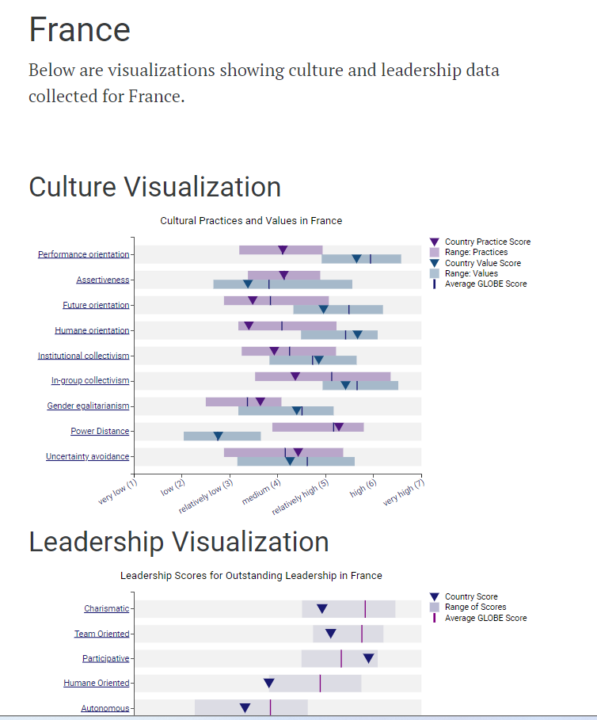
Figure: Culture and Leadership data of France as the results of Globe Project
Source: (Globe Project, 2024)

Analysis
The leadership style used in France is friendly and involves communication between the organization's executives and its workforce. This facilitates the development of hotel operations and enhances the business elements of the nations to effectively generalise performance. This aspect of improving the firm's organisational performance also involves the development of customer relationships. According to the result of the Globe Project, the business culture of France is performance-oriented and assertive. The leadership style of most French leaders is charismatic and team-oriented which will also help Diversity Hotel & Spa to become successful in this country (Globe Project, 2024).
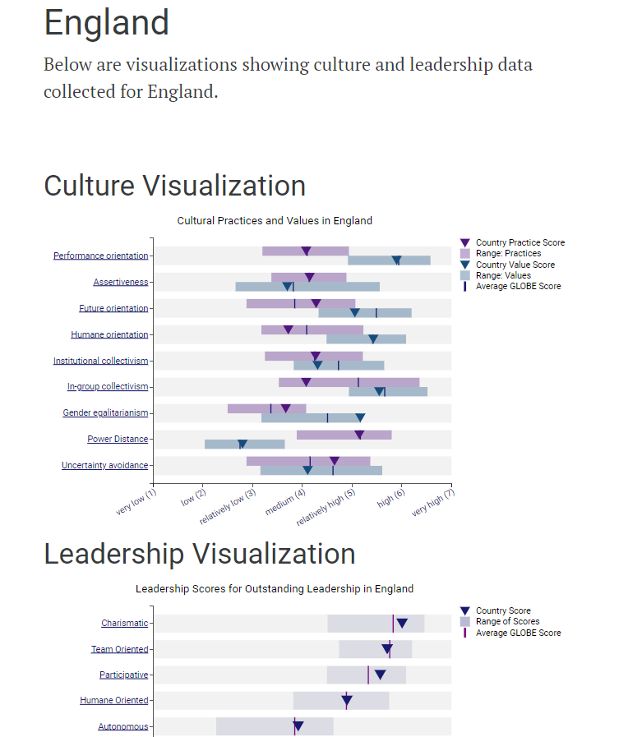
Figure: Culture and Leadership data of England as the results of Globe Project
Source: (Globe Project Results, 2024)

Analysis
The hospitality sector in the UK, including hotels, has a formal leadership style. In the process of keeping the right activities going, this aids in maintaining a framework that is business-oriented. The process of creating the leadership culture that the nation adheres to is heavily influenced by the national society of the entire country. This aids in defining the kind of procedure that organisations employ to enhance the commercial aspects. As per the result of the Globe Project, the range value of performance orientation is high which helps the Diversity Hotel and Spa to become successful in this country (Liyanage, 2020).

Conclusion
The above-discussed report has highlighted the culture of France and discussed its culture along with customs to make it clear that it is suitable for hospitality business expansion. The country analysis and business growth of the country have proved that this country has a huge growth revenue in business. Along with that the importance of cultural intelligence and sensitivity for hotel personnel and what recommendations can enhance these two aspects to hotel personnel has been mentioned.

Recommendations
- Recruitment of the local candidates
Several local people must be selected to take part in the managerial levels of the hotel industry to serve the needs of the individuals visiting the areas. This will help in improving the communication practices within the Diversity Hotel & Spa and thus the needs of the candidates can also be fulfilled. The different policies can be used in such a way as to increase the influence of these people to mitigate communication issues (Pessach et al., 2020).
- Provision of training
Adequate training must be provided to all the employees and the managers present within the hotel to develop their performing capacity. This will also help the chosen hotel Diversity Hotel & Spa in moulding themselves to the choices and the requirements of the operating country. Hence operating performance will also take luck and the issues which are occurring due to communication and other problems will also be reduced (Wigglesworth et al., 2023).
- Development of a feedback mechanism
This framework will allow for understanding the choices and the demands of the tourists and the other personnel visiting these properties. These all collected comments can be used to develop the lacking areas within Diversity Hotel & Spa to increase the potential occurring issues (Burko et al., 2020).

References
BBC, (2024). France country profile. [Online] Available at: https://www.bbc.com/news/world-europe-17298730 [Accessed 19 February 2024].
Burko, Y., Seluzicki, A., Zander, M., Pedmale, U.V., Ecker, J.R. and Chory, J., (2020). Chimeric activators and repressors define HY5 activity and reveal a light-regulated feedback mechanism. The Plant Cell, 32(4), pp.967-983.
Explore France, (2022). Embarking on a cultural odyssey: unveiling the charms of France culture. [Online] Available at: https://www.france.fr/en/paris/article/discovering-french-culture [Accessed 19 February 2024].
Globe Project Results, (2024). England (visualizations showing culture and leadership data collected for England). [Online] Available at: https://globeproject.com/results/countries/GBR%3Fmenu=list.html#list [Accessed 21 February 2024].
Globe Project, (2024). France (visualizations showing culture and leadership data collected for France). [Online] Available at: https://globeproject.com/results/countries/FRA%3Fmenu=list.html#list [Accessed 21 February 2024].
Habas, C., (2020). Cultural & Language Barriers in the Workforce. [Online]Available at: https://smallbusiness.chron.com/cultural-language-barriers-workforce-11928.html [Accessed 19 February 2024].
Liyanage, M., (2020). Miseducation: decolonising curricula, culture and pedagogy in UK universities (Vol. 23, pp. 1-59). Oxford: Higher Education Policy Institute.
Pessach, D., Singer, G., Avrahami, D., Ben-Gal, H.C., Shmueli, E. and Ben-Gal, I., (2020). Employees recruitment: A prescriptive analytics approach via machine learning and mathematical programming. Decision Support Systems, 134, p.113290.
Vollmer, L., Foxon, G., Danev, V., Berard, I., Benazet, F. and Walzer, S., (2020). PMD17 Comparison of Market Access Routes of Digital Health Applications in France, Germany and the UK. Value in Health, 23, p.S579.
Wigglesworth, H., Huddy, V., Knowles, R. and Millings, A., (2023). Evaluating the impact of sling provision and training upon maternal mental health, wellbeing and parenting: A randomised feasibility trial. Plos one, 18(11), p.e0293501.

