
UK tourism and hospitality industry essay
UK Tourism and Hospitality BMTP4011

November 25, 2022
Word Count: 1046
University of Wales Trinity Saint David
Clyde Carmelo Seisun (2220481)

This essay will outline a destination within the UK to see the impacts of the global pandemic on the economic growth on tourism in the destination. On top of the economic growth of the destination, the author will also outline the visitor typology, expectations and experiences. The destination chosen is London. The reason this destination was chosen is because London is a very big tourist attraction to both international and British citizens, because of this a wide range of people with different niches visit London and have very different reasons to visit the capital city. Some may visit because they want to say they have been to London while others may visit to see the modern day Royal Family and see their heritage and past in the Tower of London. The author will outline all of these different visitors to provide recommendations and help to the stakeholders of London tourist destinations for future sustainability.
Based on (Assembly, 2022)’s meeting, tourism in London is trying to bring it back to its original stature. They outline 10 (ten) recommendations to encourage both international and domestic tourists to return to London. Some of the recommendations that were recommend are:
• The Mayor and London & Partners should renew the 2017 Tourism Vision for London to reflect the impact of COVID-19 and the 2018 declaration of the climate emergency and ensure that it is joined up with the Government’s Tourism Recovery Plan. (Assembly, 2022)
• There needs to be clear and consistent messaging from the Mayor and the Government about the COVID-19 safety and any future public health guidance related to businesses across London’s tourism industry. (Assembly, 2022)
• The Mayor and London & Partners should provide further information to the Economy Committee about the planned international tourism campaign, including which countries will be targeted and what targets will be set to determine the success of the campaign. (Assembly, 2022)
These recommendations are due to the massive decline in Tourism in London as Tourism is an essential part of London’s economy, employing 700,000 people – one in seven of the capital’s jobs. It continues to suffer due to the substantial reduction in the number of overseas visitors. (Assembly, 2022)
People can also visit London as a location for staycations. A staycation is a holiday spent in one's home country rather than abroad, or one spent at home and involving day trips to local attractions. (Oxford Dictionary, 2010)
Some of the things that domestic visitors to London can do are:
•Visit The London Eye, it is the UK’s most popular paid tourist attraction – it’s the perfect place to get a bird’s-eye view of the city’s contemporary architecture (Wilson-Powell, 2020)
• Visit Madame Tussauds, it is a museum for life-size replicas of celebrities and historical icons. (Wilson-Powell, 2020)
• Visit Hyde Park, it is one of London’s most expansive green spaces while also being a royal park! (Wilson-Powell, 2020)
There are also an expansive amount of locations that people can stay in to spend the night while staying in London for both cheap and luxury. (Visit London, 2019)
London's cultural experience has broad appeal across all age groups, with young and old rating this their number one driver for visiting. This was the main motivation for at least a third of leisure tourists in each age category. (Wilks & Mazza, 2015)
For all ages, there were different types of trends. Some examples of these trends include domestic tourists and older visitors mostly visiting London for West End Shows. While overseas and younger visitors would mostly visit for attractions and would go to at least one during their visit. (Wilks & Mazza, 2015)
Approximately a third of the tourists to London would not purchase any attraction tickets during their visit to London – however domestic tourists are more likely to purchase tickets to the attractions. (Wilks & Mazza, 2015)
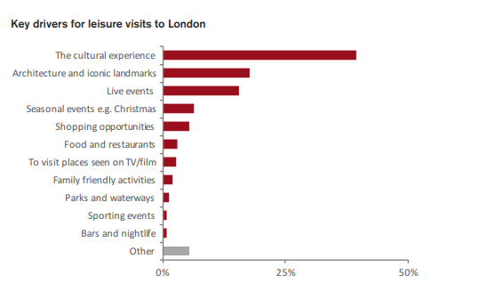
Figure 1 Key drivers for leisure visits to London

This chart shows the key drivers for leisure visits to London, it shows that a huge portion of all leisure visits are for the cultural experience and the second highest is the architecture and iconic landmarks while bars and nightlife are the least popular reasons people visit London for leisure. (Wilks & Mazza, 2015)

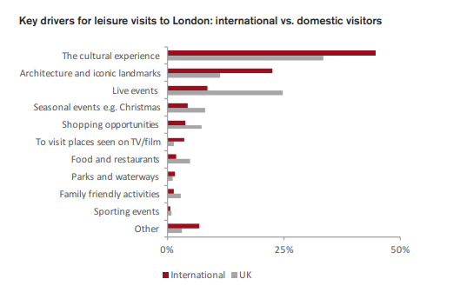
Figure 2 Key drivers for leisure visits to London: UK vs International

This chart shows the key drivers for leisure visits to London but comparing them between international and domestic tourists. It shows that the cultural experience is still the highest and biggest driver but compared to international, the next highest is live events such as concerts, festivals and conferences. While the lowest reason for leisure visits to London is sporting events for domestic travellers. (Wilks & Mazza, 2015)
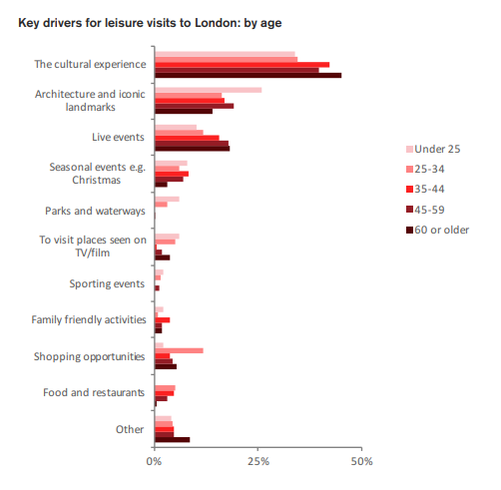
Figure 3 Key drivers for leisure visits to London by age

This chart shows the key drivers for leisure visits to London but comparing them between the different age groups. Once again, the highest key driver is the cultural experience but the second highest for over 60 year olds is live events while architecture and iconic landmarks are the second highest for under 25s up to 59 years old. While the lowest for all age groups are sporting events and close second last are food and restaurants for under 25s. (Wilks & Mazza, 2015)

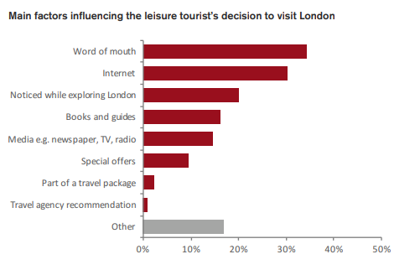
Figure 4 Main factors that influence a tourist's decision to visit London

There are also many factors that influence a tourists’ decision to visit London. As shown in the chart above, the biggest factor is word of mouth while the second biggest factor is via the Internet. But this also shows the lowest factor being a travel agency recommendation. (Wilks & Mazza, 2015)

To conclude, London seems to be mostly visited for cultural reasons and architecture and iconic landmarks. A way to increase sustainability to London is by making it easier for tourists to walk, cycle or use public transport and by enhancing Wi-Fi connectivity across London for the benefit of visitors. (London Assembly, 2017)
On top of those sustainability recommendations, ways to increase tourism to London would also include providing visitors with information to help them do more and see more in London and ensuring London can sustain and accommodate growing numbers of visitors that should be coming in after the opening of the country and end of the Pandemic. (London Assembly, 2017)

Bibliography
Assembly, L., 2022. London Calling: Rebuilding London’s tourism industry. [Online]
Available at: https://www.london.gov.uk/who-we-are/what-london-assembly-does/london-assembly-publications/london-calling-rebuilding-londons-tourism-industry-0#:~:text=Tourism%20is%20an%20essential%20part,the%20number%20of%20overseas%20visitors.
[Accessed 15 November 2022].
London Assembly, 2017. Supporting the Tourism sector. [Online]
Available at: https://www.london.gov.uk/programmes-strategies/business-and-economy/supporting-londons-sectors/supporting-tourism-sector
[Accessed 15 November 2022].
Oxford Dictionary, 2010. Definition of Staycation. [Online]
Available at: https://www.google.com/search?q=staycation+definition&rlz=1C1ONGR_en-GBGB933GB933&oq=staycation+definition&aqs=chrome.0.69i59j35i39j69i59j0i512j0i30l3j69i60.1886j1j9&sourceid=chrome&ie=UTF-8
[Accessed 15 November 2022].
Visit London, 2019. Staycations in London. [Online]
Available at: https://www.visitlondon.com/staycations-in-london
[Accessed 15 November 2022].
Wilks, L. & Mazza, M., 2015. London's Cultural Tourists. [Online]
Available at: https://files.londonandpartners.com/l-and-p/assets/our-insight-londons-cultural-tourists.pdf
[Accessed 15 November 2022].
Wilson-Powell, G., 2020. Must-Visit Attractions in London. [Online]
Available at: https://theculturetrip.com/europe/united-kingdom/england/london/articles/20-must-visit-attractions-in-london-uk/
[Accessed 15 November 2022].

Table of Figures
Figure 1 Key drivers for leisure visits to London 2
Figure 2 Key drivers for leisure visits to London: UK vs International 2
Figure 3 Key drivers for leisure visits to London by age 3
Figure 4 Main factors that influence a tourist's decision to visit London 4

