Name:_Aidan Griffiths________________________________

Student Number: 2501271________________________
__________________________________________________________

WORKSHEET 3 – TESTING (Lap Times)

- Original code:
#define _CRT_SECURE_NO_WARNINGS
#include <stdio.h>
#include <string.h>
#include <math.h>

void main()
{
float time[5];
float overall = 0;
float average = 0;
float fast = 100000;
float slow = 0;
float target = 0;
int count = 1;
int targetCount = 0;

printf("Please enter the lap times...\n");

for (int i = 0; i < 5; i++)
{
printf("Lap %d:", count);
scanf("%f", &time[i]);
if (time[i] < 30 || time[i] > 90)
{
printf("ERROR! Please ensure you enter a real lap time!");
printf("Please enter the lap times...\n");
scanf("%f", &time[i]);
}

overall = overall + time[i];
count = count + 1;
average = overall / 5;
}

printf("What is your target lap time?\n");
scanf("%f", &target);

if (target < 30)
{
printf("ERROR! Please ensure you enter a realistic target time!");
printf("Please enter a target lap time...\n");
scanf("%f", &target);
}

for (int i = 0; i < 5; i++)
{
if (time[i] <= fast)
{
fast = time[i];
}
}

for (int i = 0; i < 5; i++)
{
if (time[i] > slow)
{
slow = time[i];
}
}

for (int i = 0; i < 5; i++)
{
if (time[i] < target)
{
targetCount = targetCount + 1;
}
}
printf("The overall time is: %.2f\n", overall);
printf("The average time is: %.2f\n", average);
printf("The fastest lap time is: %.2f\n", fast);
printf("The slowest lap time is: %.2f\n", slow);
printf("%d of your laps were faster than your target lap time...\n\n", targetCount);

printf("Lap 1 was %.2f\n", time[0]);

count = 2;

for (int i = 0; i < 4; i++)
{
if (time[i] > time[i + 1])
{
printf("lap %d was faster than the previous lap\n", count);
count = count + 1;
}
else if (time[i] < time[i + 1])
{
printf("lap %d was slower than the previous lap\n", count);
count = count + 1;
}
else if (time[i] = time[i + 1])
{
printf("lap %d was the same as the previous lap\n", count);
count = count + 1;
}

}
}

- Code Testing
For each test below, run your code and show the results of the scenarios below. Present a screenshot of what happened when the programme ran. Did the programme behave correctly or did it do something unexpected, and if so, why?

- Test a lap time for your programme:
- 42 seconds
- 2 seconds
- -4 seconds
- 53444 seconds
- Test the target lap time – show that the values entered are reasonable

- Using the same five lap times as the sample output ie

Lap 1: 42.3
Lap 2: 42.1
Lap 3: 44
Lap 4: 44
Lap 5: 39.4

Examine each statistic (1-6) and comment on whether the correct answer(s) are displayed or not. (If any statistics were incomplete after Phase 1 (code completed in class) simply write “Unfinished”)

- Test two further sets of lap times of your own choice.

Test: 42 Seconds

Screenshot(s) of output:
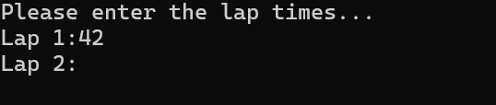
Result: Did the programme behave as expected ie syntactically and logically correct?
YES
If YES, comment on what happened.
If NO, what went wrong and why? Suggest how things could be improved
The lap time of 42 seconds was accepted by the system and asked for the 2nd lap time.

Test: 2 Seconds

Screenshot(s) of output:
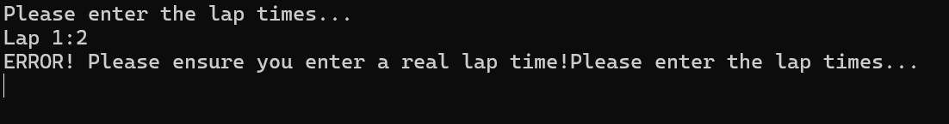
Result: Did the programme behave as expected ie syntactically and logically correct?
YES
If YES, comment on what happened.
If NO, what went wrong and why? Suggest how things could be improved
The system did not allow 2 seconds to be entered as it is not possible to complete the race in 2 seconds.

Test: -4 Seconds

Screenshot(s) of output:
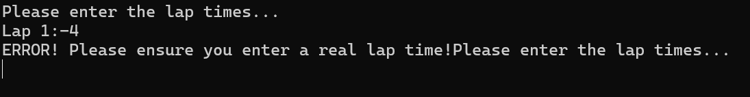
Result: Did the programme behave as expected ie syntactically and logically correct?
YES
If YES, comment on what happened.
If NO, what went wrong and why? Suggest how things could be improved
The system does not accept -4 seconds as it is impossible to complete the race in -4 seconds.

Test: 53444 Seconds

Screenshot(s) of output:
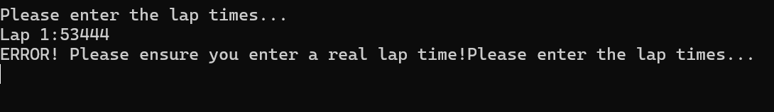
Result: Did the programme behave as expected ie syntactically and logically correct?
YES
If YES, comment on what happened.
If NO, what went wrong and why? Suggest how things could be improved
The system does not accept 53444 seconds as the time for the race is between 30 and 90 seconds.

Test: Target Lap Time

Screenshot(s) of output:
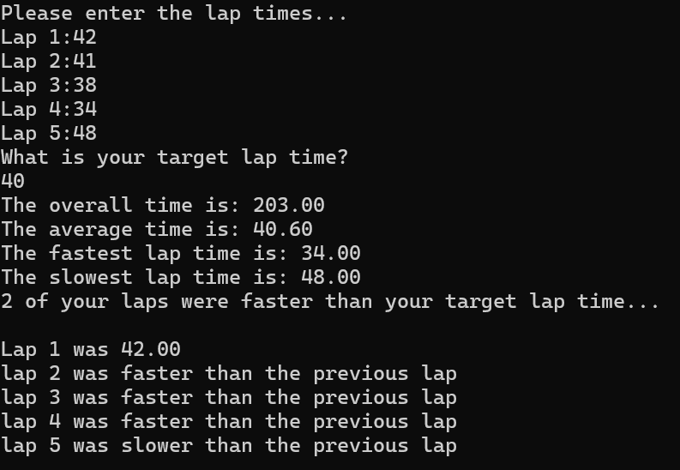
Result: Did the programme behave as expected ie syntactically and logically correct?
YES
If YES, comment on what happened.
If NO, what went wrong and why? Suggest how things could be improved
The system accepted all lap times and the target lap time and produced the results of how many of the entered lap times were faster than the target lap time.

Test: Statistics

Screenshot(s) of output:
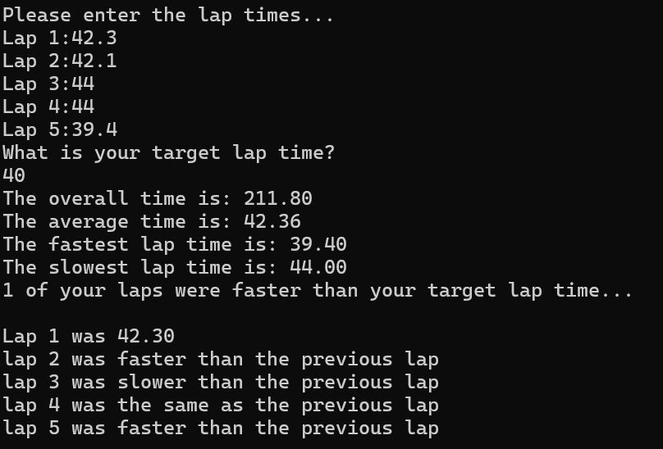
Result: Did the programme behave as expected ie syntactically and logically correct?
YES
If YES, comment on what happened.
If NO, what went wrong and why? Suggest how things could be improved
The system produced the correct statistics

Test: 2 Further statistics

Screenshot(s) of output:
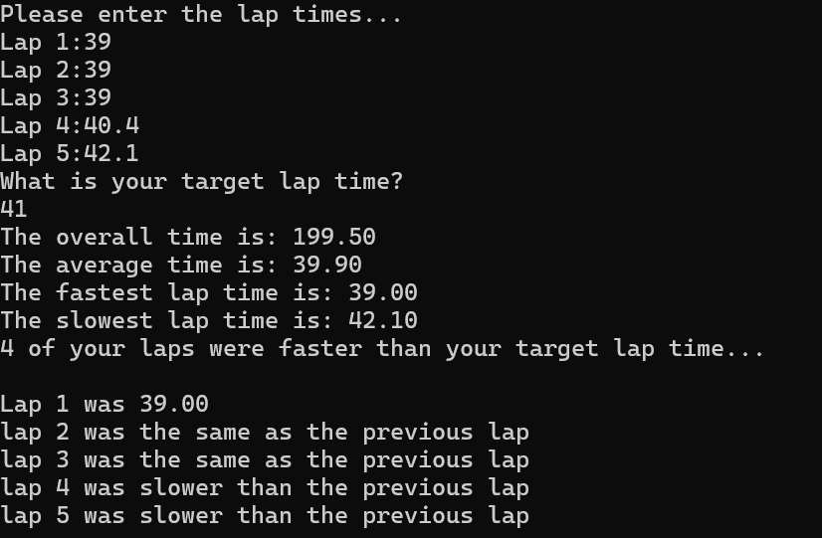
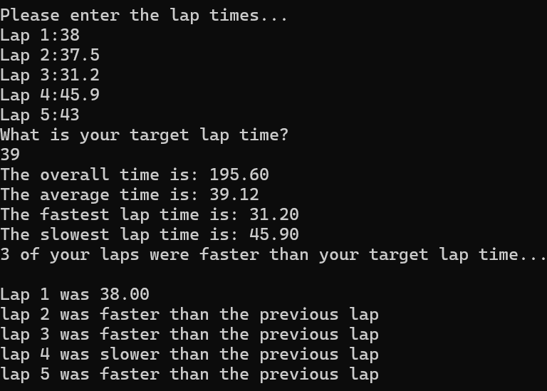
Result: Did the programme behave as expected ie syntactically and logically correct?
YES
If YES, comment on what happened.
If NO, what went wrong and why? Suggest how things could be improved
The system successfully produced the correct statistics for both sample outputs.

- Consider the results of the above tests and revisit your original code in order to address any tests that failed and/or improve code efficiency.

(Note: you may not be able to solve all of the problems that were encountered, but solve as many as you can.)

Paste your full revised code here :

#define _CRT_SECURE_NO_WARNINGS
#include <stdio.h>
#include <string.h>
#include <math.h>

void main()
{
float time[5];
float overall = 0;
float average = 0;
float fast = 100000;
float slow = 0;
float target = 0;
int count = 1;
int targetCount = 0;

printf("Please enter the lap times...\n");

for (int i = 0; i < 5; i++)
{
printf("Lap %d:", count);
scanf("%f", &time[i]);
if (time[i] < 30 || time[i] > 90)
{
printf("ERROR! Please ensure you enter a real lap time!");
printf("Please enter the lap times...\n");
scanf("%f", &time[i]);
}

overall = overall + time[i];
count = count + 1;
average = overall / 5;
}

printf("What is your target lap time?\n");
scanf("%f", &target);

if (target < 30)
{
printf("ERROR! Please ensure you enter a realistic target time!");
printf("Please enter a target lap time...\n");
scanf("%f", &target);
}

for (int i = 0; i < 5; i++)
{
if (time[i] <= fast)
{
fast = time[i];
}
}

for (int i = 0; i < 5; i++)
{
if (time[i] > slow)
{
slow = time[i];
}
}

for (int i = 0; i < 5; i++)
{
if (time[i] < target)
{
targetCount = targetCount + 1;
}
}
printf("The overall time is: %.2f\n", overall);
printf("The average time is: %.2f\n", average);
printf("The fastest lap time is: %.2f\n", fast);
printf("The slowest lap time is: %.2f\n", slow);
printf("%d of your laps were faster than your target lap time...\n\n", targetCount);

printf("Lap 1 was %.2f\n", time[0]);

count = 2;

for (int i = 0; i < 4; i++)
{
if (time[i] > time[i + 1])
{
printf("lap %d was faster than the previous lap\n", count);
count = count + 1;
}
else if (time[i] < time[i + 1])
{
printf("lap %d was slower than the previous lap\n", count);
count = count + 1;
}
else if (time[i] = time[i + 1])
{
printf("lap %d was the same as the previous lap\n", count);
count = count + 1;
}

}
}

