

Adam Foley

Systems Thinking Design Report

University of Wales: Trinity Saint David
ACDA5021: Systems Engineering

BEng
Academic Year: 2025 - 2026

Supervisor: Dave Holley
Associate Supervisor: Jenni Steen
April 2026

Academic integrity declaration
I declare that:
- the thesis submitted has been written by me alone.
- the thesis submitted has not been previously submitted to this university or any other.
- that all content, including primary and/or secondary data, is true to the best of my knowledge.
- that all quotations and references have been duly acknowledged according to the requirements of academic research.
I understand that to knowingly submit work in violation of the above statement will be considered by examiners as academic misconduct.

Abstract
This report shall apply system engineering principles using a systems-engineering toolset to solve an engineering design problem for the safe disposal of mines within an operating environment. The process resulted in the development of an Explosive Ordnance Disposal (EOD) system, which utilises a modular design to easily retrofit onto common military vehicles such as a Toyota hi-lix, whilst effectively performing its required duties.

Table of Contents
Academic integrity declaration i
Abstract ii
List of Figures iv
List of Abbreviations v
1 Introduction 6
2 Customer Requirements 8
3 Required Functionality 10
4 Quality Function Deployment (QFD) 11
5 Concept Derivation & Selection 15
6 Noises & Controls 19
7 Disposal 21
8 Conclusion 23
9 References 24
Appendices 25
Appendix A - Design Brief 25
Appendix B – Complete Manufacturing Process 27

List of Figures
Figure 1 - Pairwise Comparison of Requirements 9
Figure 2 - QFD 1 11
Figure 3 - QFD 1 Functional Importances 12
Figure 4 - Functional Decomposition 13
Figure 5 - QFD 1 Advanced 13
Figure 6 - QFD 1 Advanced Functional Importances 14
Figure 7 - Function Means Analysis 15
Figure 8 - System Pugh 16
Figure 9 - QFD 2 17
Figure 10 - QFD 2 Performance 18
Figure 11 - Booster Pellet P-Diagram 19
Figure 12 - What Why Diagram 20

List of Abbreviations
OME | Ordnance, Munitions & Explosives
SE  QFD  SME  SET  FMA  B&D  EOD  GPR  NQR  IM  FAE | Systems Engineering  Quality Function Deployment  Subject Matter Expert  Systems Engineering Toolset  Function Means Analysis  Breakdown & Analysis  Explosive Ordnance Disposal  Ground Penetrating Radar (GPR)  Nuclear Quadrupole Resonance (NQR)  Insensitive Munition  Fuel Air Explosive

Introduction
This report will detail the Systems Engineering methodology applied to the case study investigated within a work-based group project on an OME related Engineering design brief shown below:
- The design scenario is that we have a column of supplies (Medical) traversing desert terrain. The approved route will come across a mined area.
- The teams are required to design a portable (Land Rover or Hi-Lux) mine detection, clearing and marking system to ensure safe passage for this and future convoys.
Further details of the environmental details and key requirements that the device must comply with can be see in the full brief shown in Annex A.
The Systems Engineering Toolset was used to assist this design process by identifying the following information:
- Key customer requirements.
- Critical system functionality.
- Concept derivation and design choices
- Potential failure modes.
- Critical design features.
- The manufacturing processes involved.
- Critical process steps.
- Process control measures.
- Waste and end of life disposal.
Systems engineering is a structured, multidisciplinary approach to designing and managing complex systems, so they meet stakeholder needs within constraints such as cost, schedule, and performance. It takes a holistic view [1], focusing on how system components interact to deliver overall capability rather than treating them in isolation. Through processes like requirements definition, design development, and verification, systems engineering ensures that the final system is both fit for purpose and functions effectively across its lifecycle. [2]

Customer Requirements
The first stage of this Systems Engineering process and toolset was to establish the customer requirements. Following a group discussion and review on the design brief shown in Annex A, the following customer requirements were established:
- The system shall defeat the mine threat in a minimal timescale.
- The system shall not be vulnerable to MANPADs.
- The system shall not produce UXO.
- The system shall defeat every mine in the desired area.
- The system shall be insensitive to bullet, fragmentation attack.
- The system shall mark the area cleared of mines.
- The system shall not render the road impassable by its use
- The system shall always detect buried mines within a horizontal distance of 30cm.
- The system shall always detect buried mines up to a depth of 15cm.
- The system shall be suitable for use with mines up to 15 Kg NEQ.
- The system shall be suitable for use with mines fuzed with pressure, tripwire, tilt-switch and remote triggers.
- The system shall operate reliably for the full duration of minefield clearance tasks without unplanned loss of function.
- The system must not harm or kill any persons.
- The system should conform to OME Safety Regulations
- The system shall be transportable by light vehicle.
- The system shall be suitable for use in sandy desert environments (AECTP-230 zones A1, B2, C1) [3]

Following this, the requirements were scored against each other using a Pairwise comparison of requirements. This was completed to establish the ‘critical’ requirements of utmost importance whilst understanding the requirements that were less important. The purpose of this was to establish was key requirements should be prioritised when pursuing concepts and ideas throughout the later stages in the toolset. The critical requirements gained from the exercise can be seen below in Figure 1.
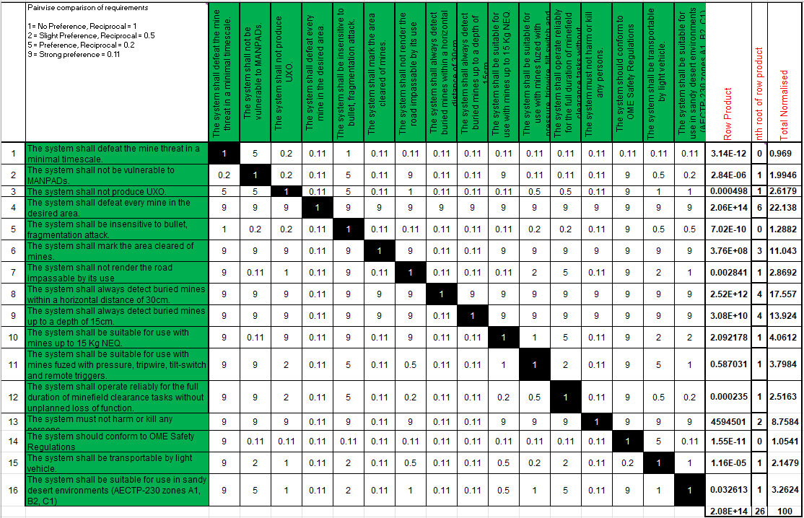
Figure 1 - Pairwise Comparison of Requirements

Required Functionality
Following the initial identification of the Customer Requirements and specific Key Requirements, an exercise to obtain the Required Functionality of the system was undertaken. The result of this were the following functions:
- Transport system to minefield – The System was required to be transported by whatever medium to the site in which it is required to operate.
- Deploy the system – The system must be able to be deployed, by whatever way decided.
- Detect Mines – The system must be able to detect the mines at the minefield.
- Defeat Mines – The system must be able to defeat the mines at the minefield following an initial detection.
- Confirm Clearance – The system must have a working capability to confirm that each mine has been cleared.
- Mark Cleared Area – The system must be able to mark the area cleared to render it passable to whomever.
- Undeploy System – The system must be able to leave the minefield and be transported to a storage facility or future minefield.
Effectively, these functions were the fundamentals required to develop a system that would perform to the requirements. They were kept extremely basic to prevent any solutionising from occurring, prior to the formal evaluation of ideas later in the Systems Engineering toolset.

Quality Function Deployment (QFD)
QFD was first developed in Japan, a county recognised for their quality improvement processes and procedures, as a ‘structured method that uses the seven management and planning tools to identify and prioritize customers’ expectations quickly and effectively.’ [4] It is a methodology used to understand the core components of a customer’s request, translate them into technical requirements and using the combination of characteristic to set measurable targets to improve and prioritise to prevent the optimisation of less important customer requirements at the detriment of key customer requirements. The use of QFD, and this Systems Engineering Toolset (SET) as a whole, allows for the introduction of performance parameters which in turn pulls the subjectiveness/ opinion out of the decision-making process as there are clear areas of concern through mathematical outputs.
Within the SET used, the Customer Requirements were evaluated against the Required Functionality of the System, with the use of a weighting score shown as the ‘importance’ column of which the values were obtained from the previous Pairwise Comparison shown in Figure 1.

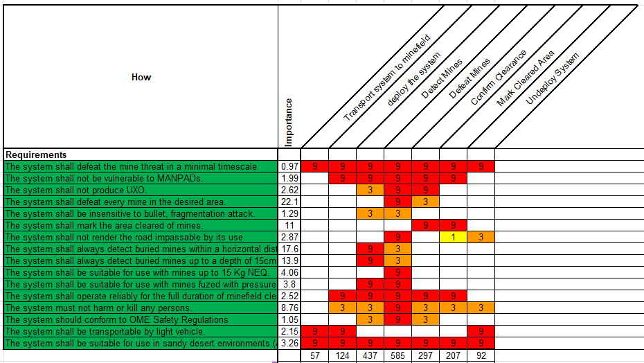
Figure 2 - QFD 1
Figure 2 shows the Design QFD 1 with the review and comparison of the Customer Requirements vs the Functional Requirements, as described previously. The outputs of which can be seen as the bottom scores, which feed into the Functional Importances Diagram at Figure 3.

Figure 3 - QFD 1 Functional Importances
The diagram above shows the output received from QFD 1, the purpose of which was to highlight the most important functions within the system to prioritise when designing and developing the concepts and subsequent solution.

After QFD 1, the functional importance was determined as explained previously. This subsequently led to the decomposition of these functions shown in Figure 4:
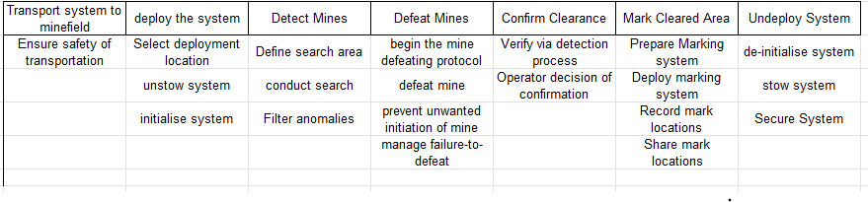
Figure 4 - Functional Decomposition
The purpose of which was to establish the sub-functions that are required to form the overarching top-level functions. For example, ‘Defeat Mines’ is a top-level function, which can be broken down into the following sub-functions:
- Begin the Mine Defeating Protocol.
- Defeat the Mine.
- Prevent Unwanted Mine Initiation.
- Manage Failure to defeat.
This shows how a simple function is much more advanced than it initially appears. This information could then be imported into the QFD 1 matrix to obtain a more advanced Functional Importance to pursue within the remainder of the SET. This information is shown within Figure 5 & Figure 6 respectively.

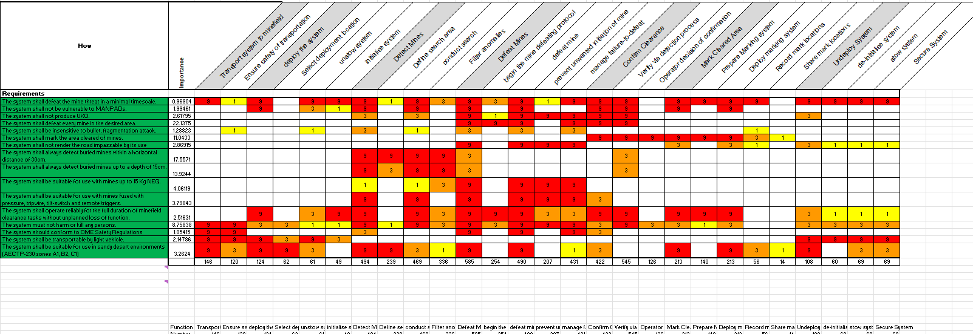
Figure 5 - QFD 1 Advanced

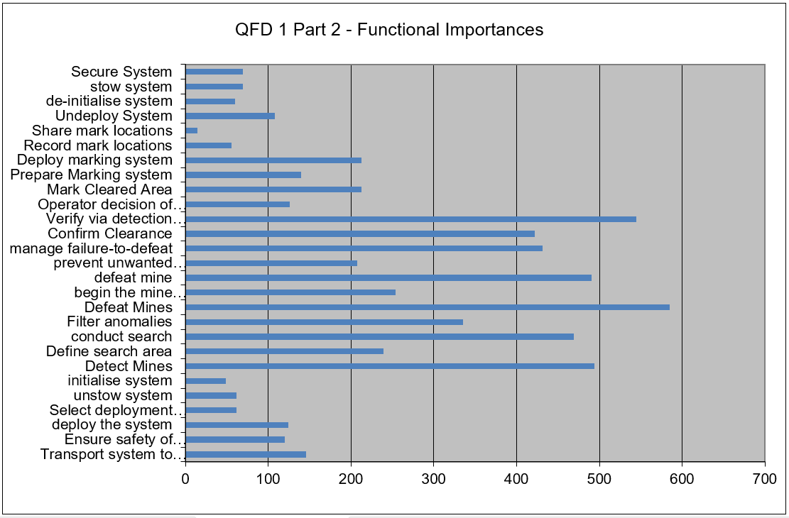
Figure 6 - QFD 1 Advanced Functional Importances

This information would be used later on within the SET to evaluate and mark each concept suggested.

Concept Derivation & Selection
Following the Function Means Analysis (FMA) establishing of the Customer Requirements and Functional Requirements necessary for the design of a system to fulfil the customers needs, an FMA was created, shown in Figure 7. This was completed by understanding the ways in which each function, extracted from the functional decomposition, could be ‘resolved’ or met through mechanical means. For example, ‘Detect Mines’ this function could be met through any of the following options:
- Ground Penetrating Radar (GPR)
- Nuclear Quadrupole Resonance (NQR)
- (Sniffer) Dogs
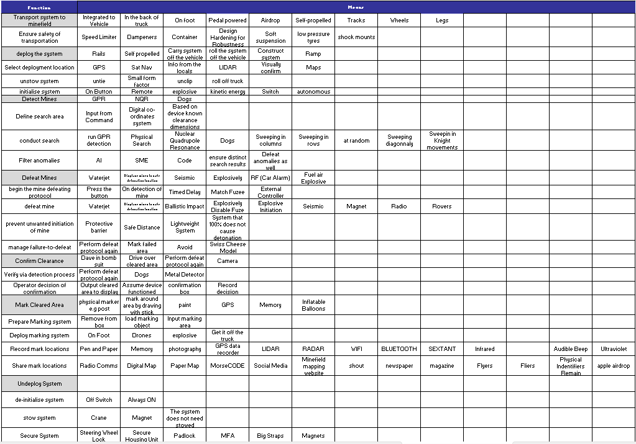
Figure 7 - Function Means Analysis
The purpose of this exercise was to collate every way possible to complete each function, to invent a variety of concepts that could meet the customers brief.

Following the FMA, three concepts were established:
- Concept 1: ‘Rocket Rake’ – This is a system that operates by launching a rake using a rocket motor, before driving forwards and dislodging mines.
- Concept 2: Tube Launched Fuel Air Explosive (FAE) – This is a system operated using FAE launched from a tube and initiating mines throughout a large area at once.
- Concept 3: Water Cannon – This is a system that uses a robot with a high-pressure water cannon to destroy mines, operated by a human.
Following this initial concept identification process, a System Pugh, shown in Figure 8, was used to identify the strongest design to take forwards, which was the Mine Displacer ‘Rocket Rake’.

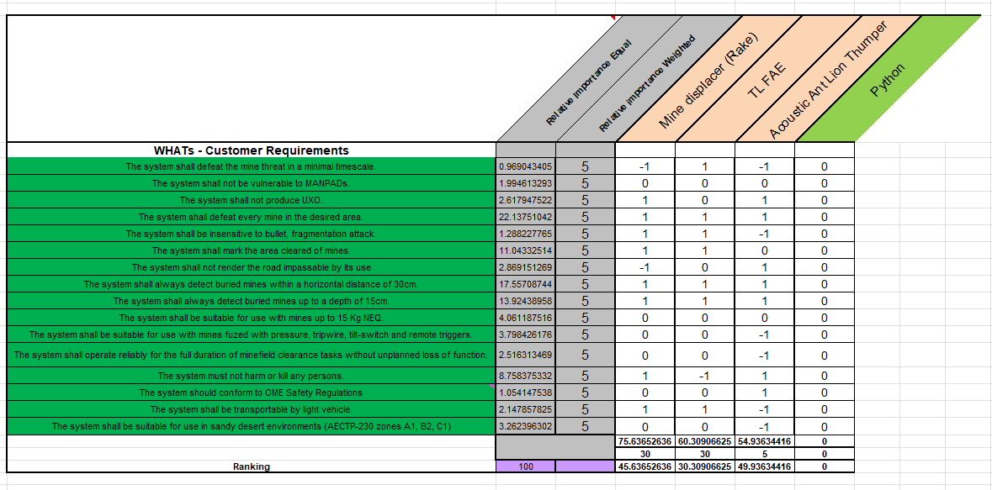
Figure 8 - System Pugh
The System Pugh uses the initial Customer Requirements, alongside a relative importance matrix, obtained though QFD comparison in addition to a ‘manual’ relative importance weighting which was left equal throughout on this occasion and scores each concept against each requirement using the following key:
- ‘-1’: Performs worse than Python.
- ‘0’: Performs as well as Python.
- ‘1’: Exceeds Pythons performance.
‘Python’ is a combat proven EOD system that is proven to operate in this scenario, so it was scored at 0 for each requirement, to enable a baseline comparison.
The Pugh Matrix was an invaluable tool to assess each concept; however, it must be recognised that a complete assessment would not be able to be conducted without the manufacturing of prototype systems and a real life or CAE test regime.
Following the identification of Concept 1 – The ‘Rocket Rake’ as the clear victor, QFD 2 was used. QFD involved the in-depth assessment of the concept using the ‘means’ that the design used, extracted from the FMA against the functions taken from the earlier functional decomposition. This can be seen in Figure 9.
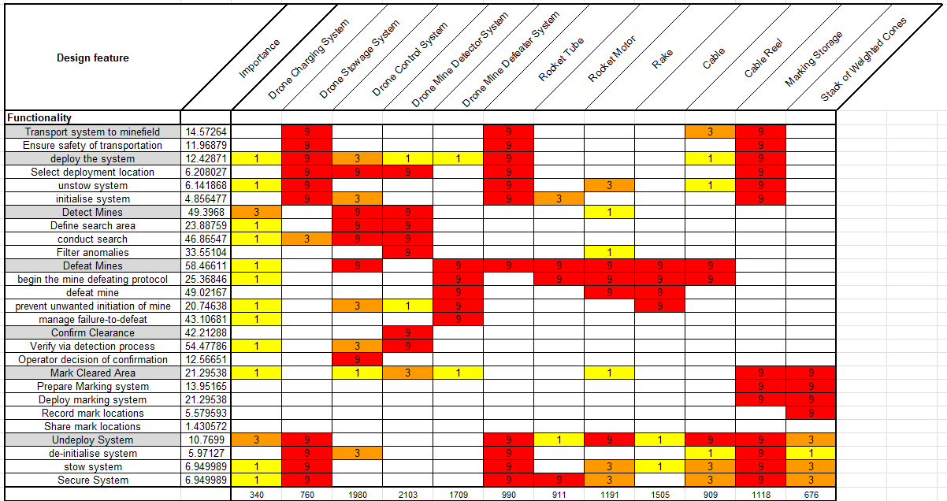
Figure 9 - QFD 2
The performance of the Design Features used within the ‘Rocket Rake’ concept can be visually identified in Figure 10.

Figure 10 - QFD 2 Performance

Noises & Controls
Following the completion of the System Design QFD 1 & 2 processes, described in depth previously, it is essential to capture and mitigate the external noises & controls experienced by the system. Noises are variables which effect the performance of the system which come in three different forms [5]:
- External: This is variation experienced through real world environmental conditions, such as temperature & humidity or operating conditions.
- Unit to Unit: This is a variation between real world identical units, e.g. slight changes to material properties or manufacturing tolerances allowing minute differences between finished artefacts.
- Deterioration: This is a variation that occurs over time due to ‘wear and tear’ experienced from ageing or through life degradation.
Control Factors are controls put in place to mitigate the noise factors experienced within the system/ process being tracked.
The specific manufacturing process investigated for noise and control factors was the production of a booster pellet. To get to this stage, a full QFD 1 & QF2 process was carried out for the manufacturing of a booster pellet and can be seen in Appendix B. Following this, a P-Diagram was created, seen in Figure 11, capturing all the noise factors and controls for the process.
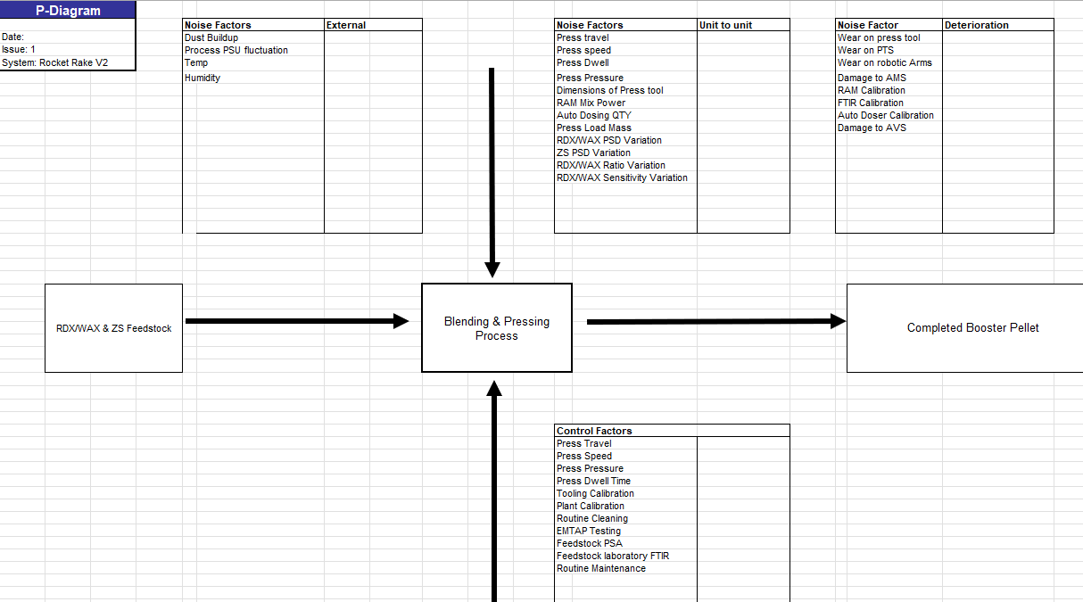
Figure 11 - Booster Pellet P-Diagram
Following the creation of the P-Diagram and identification of the noise / control factors influencing the process, a ‘What Why’ diagram was produced, seen in Figure 12. The purpose of which was to identify the most and least important variation experienced within the system and how they would react to the control parameters put in place, identifying whether all variations would be sufficiently addressed.

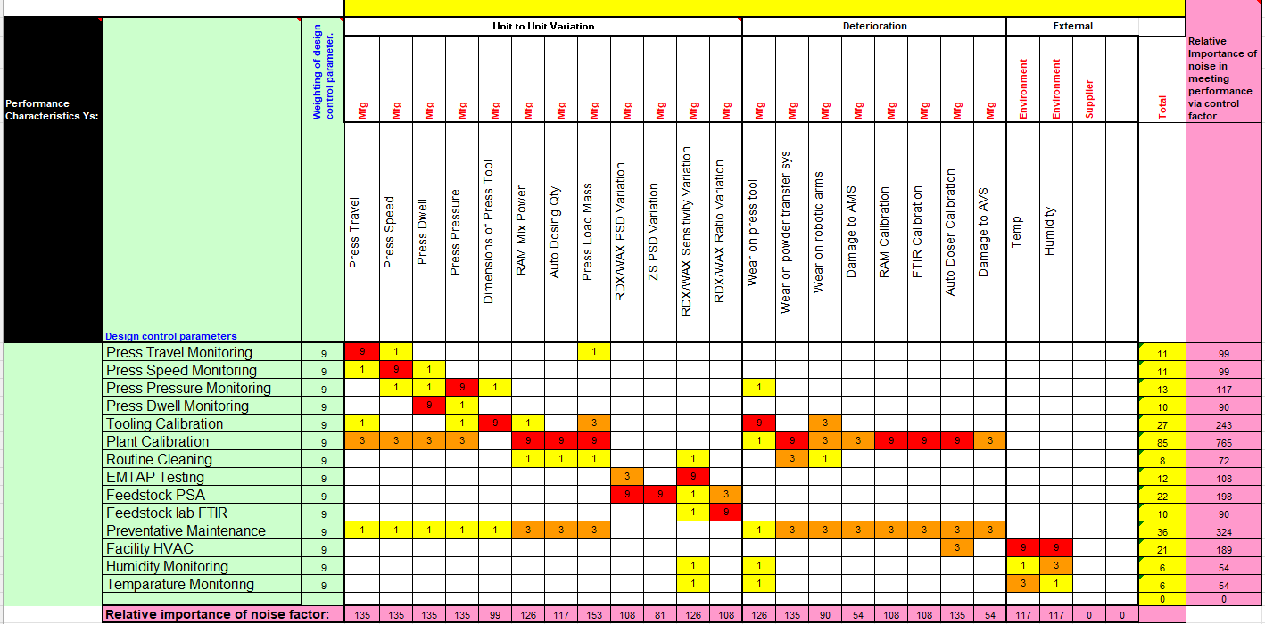
Figure 12 - What Why Diagram

Disposal
Within this group project, the area of the EOD system that was investigated was the Breakdown and Disposal (B&D) of the system. The use of Systems Engineering methodology through the SET provided, prevented the outdated ideologies of a regimented design process. Without the application of Systems Engineering, you would simply follow the process below:
- Design EOD System
- Produce a Prototype
- Test System
- Repeat the above until there are no issues remaining within the system.
This process would be extremely wasteful, the cost burden though prototype production, excessive time delays and repeated design stages for a system that could still experience failure is useless.
With the application of the SET, B&D can be considered at all stages; for example:
Customer Requirements: These requirements do not solely cover how the system must perform, they also relate to how it should store and how they can be broken down and disposed of. Following the investigation into B&D of EOD systems, the following requirements were implemented, all of which cover safety and environmental requirements pertinent to the safe breakdown and disposal of OME related items.
- The system should conform to OME Safety Regulations
  - DSA02.OME Regulations
  - The Explosives Regulations 2014
  - The Carriage of Dangerous Goods and Use of Transportable Pressure Equipment Regulations 2009, OME must be classified under the explosives class and assigned both a UN number and Hazard division. [6]
- The system must not harm or kill any persons.
- The system shall be transportable by light vehicle.
- The system shall be suitable for use in sandy desert environments (AECTP-230 zones A1, B2, C1)
If disposal cannot meet these constraints (e.g., unsafe transport conditions), requirements must be refined or the system architecture reconsidered.
Pairwise Comparison: These prioritised requirements, ensuring that critical factors such as operator safety dominate design decisions. Low-priority features that hinder safe breakdown are eliminated. The future designs would lean toward simplicity and reliability in a B&D scenario.
Functional Requirements: Within this section, the bare functions of the system were defined. Using the knowledge from B&D, requirements such as Transportation to and from the operating environment were specified, ensuring that B&D would be considered from the outset. The inclusion of this prevented late-stage redesign caused by unidentified disposal functions.
QFD1: This section, shown in Figure 2, prioritised the requirements against the required functions identified, this allowed for the identification of engineering parameters that would affect disposal the most, forcing trade-offs to be resolved early rather than during testing/ production phases.
Functional Decomposition: This is where the identification of B&D factors could be pinpointed, through the transportation and neutralisation of the OME within the operating environment.
Function-Means Analysis: This is where physical components could be mapped across into the theoretical functions to provide clear solutions for the B&D and begin to develop ideas to feed into a concept which conforms to B&D safe ideology. Ideas to address safety concerns when transporting the EOD device included the following:
- Speed Limiter
- Soft Suspension/ Dampener
- Container
- Shock Mounts
All of which would reduce the likelihood of an unwanted detonation when conducting B&D activities and any ideas that could introduce OME instability would be rejected.
System Pugh: This diagram shown in Figure 8, allowed the assessment of every concept against the initial customer requirements. This made sure that safety, including that in B&D activities, would constantly be assessed and that when any non-compliances or weaknesses were found, the team could go back to the drawing board and identify measures to improve.
Design QFD2: This was a more in-depth functional assessment, in comparison to QFD1, where the complete functional decomposition was entirely assessed against all the design features included within the proposed concept.

Conclusion
By integrating B&D considerations across all stages of the Systems Engineering Toolkit, the design was iteratively refined to ensure that safety, transportability, and neutralisation could be achieved under realistic operational conditions. This approach enabled the:
- Early identification of critical safety requirements
- Selection of inherently safer materials and components
- Development of transport and disposal methodologies aligned with operational constraints
Utilising B&D throughout the SET reduced lifecycle risk, minimised the likelihood of unsafe failure states, and ensured that the final system could be safely and effectively neutralised under all anticipated conditions. The toolset and Systems Engineering approach allowed for the early identification of key safety features required designing OME into a system, from the identification of render safe procedures, routine disposals and compliance with key legislation such as the Explosives Regulations 2014 and DSA02.OME to ensuring safe handling, transport, and operation to minimise the risk of accidental initiation through controlled design, adherence to ALARP principles, and appropriate use of insensitive munitions (IM) where possible.

References

[1] | R. D. Arnold and J. P. Wade, “A Definition of Systems Thinking: A Systems Approach,” Procedia Computer Science, vol. 44, no. 1, pp. 669-678, 2015.
[2] | Encyclopedia, “SEH 2.0 Fundamentals of Systems Engineering,” NASA, 6 February 2019. [Online]. Available: https://www.nasa.gov/reference/2-0-fundamentals-of-systems-engineering/. [Accessed 10 April 2026].
[3] | N. S. O. (NSO), “NATO Standard AECTP-230 - Climatic Conditions,” June 2025. [Online]. Available: https://www.forsvaret.no/en/organisation/centre-of-excellence-cold-weather-operations/new-course-avilable-nato-in-the-north/NATO%20STANDARD%20AECTP-230%20CLIMATIC%20CONDITIONS%20JUNE%202025.pdf/_/attachment/inline/81ab86ab-057b-471a-a400-f346bc9078b6:763e. [Accessed 1 May 2026].
[4] | “What is Quality Function Deployment (QFD)?,” American Society for Quality (ASQ), [Online]. Available: https://asq.org/quality-resources/qfd-quality-function-deployment. [Accessed 16 April 2026].
[5] | “P-Diagram: How to Design Robust Six Sigma Processes,” Lean Outside the Box, 16 January 2026. [Online]. Available: https://leanoutsidethebox.com/p-diagram/. [Accessed 23 April 2026].
[6] | U. Government, “The Carriage of Dangerous Goods and Use of Transportable Pressure Equipment Regulations 2009,” Gov Legislation, 1 July 2009. [Online]. Available: https://www.legislation.gov.uk/uksi/2009/1348/regulation/1/made. [Accessed 2 May 2026].

Appendices

- Design Brief
- The design scenario is that we have a column of supplies (Medical) traversing desert terrain. The approved route will come across a mined area.
- The mined area is within a steep walled pass. Go-around is difficult, if not impossible. A persistent ground to air MANPAD threat makes helicopter use too risky. As we need to open up the route for civilian medical transport for subsequent convoys the road route is much preferred.
- Time on the operation is critical. The emphasis is on a rapid move in, clear the objects and move on.
- The indigenous population do not have easy access to helicopter transport. The mission is the get the convoy. (Nothing heavier than a Land Rovers or ubiquitous Toyota trucks) carrying their delicate cargo through the mined area and leave the area clear for subsequent transport.
- I will present several mine clearing options as a functional guide. The grand Panjandrum, the progression from Conger to Viper to Python, flails, and rollers.
- Unfortunately, the use of Python is banned because there is a perceived vulnerability against bullet / fragment attack and also that misfires or capture would afford the opportunity of furnishing any hostiles with explosive resources.
- There is also an issue with transporting heavy vehicles to the location. There’s a driveshaft/gearbox issue with the low loaders required to bring heavy vehicles forward. Someone forgot to fit the gaiters that keep the dust out. Most of the fleet is awaiting spare parts or have been reserved for combat missions rather than humanitarian exercises.
- The teams are required to design a portable (Land Rover or Hi-Lux) mine detection, clearing and marking system to ensure safe passage for this and future convoys.
- The customer needs to know design, functionality, subcomponent design, critical feature identification, critical manufacturing process controls, (Or what is it? What does it do? Can you make it? What are the tricky bits? How are you going to make sure it works?)

– Complete Manufacturing Process


